**Programming Assignment 4: Image Classification**

In this programming assignment, we will develop 2 image classification networks to recognize RGB color images. We will be using the CIFAR-10 dataset which have RGB images and 10 different categories.

**Network 01**

This network has 3 convolutional layers, 2 max pooling layers, 2 fully connected layers and a Softmax activation function. We got an accuracy of 62.9% for the training data and an accuracy of 58.98% for the test data after training 30 epochs.

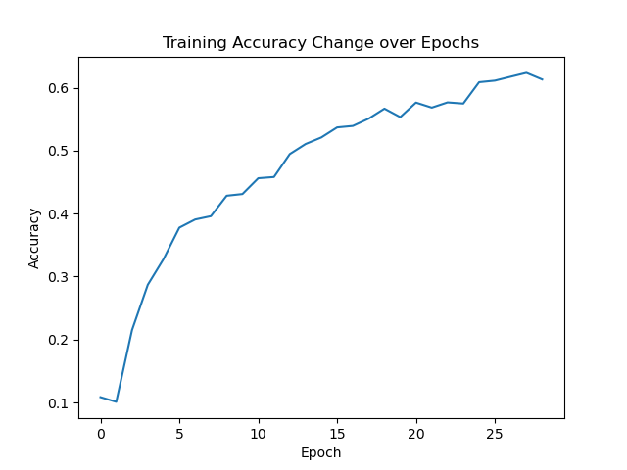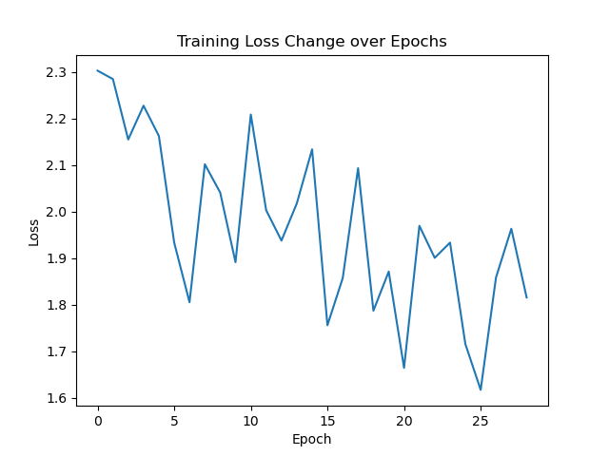

**Network 02**

This network has 4 convolutional layers, 2 max pooling layers, 2 fully connected layers and a Softmax activation function. We got an accuracy of 57.63% for the training data and an accuracy of 55.67% for the test data after training 30 epochs.

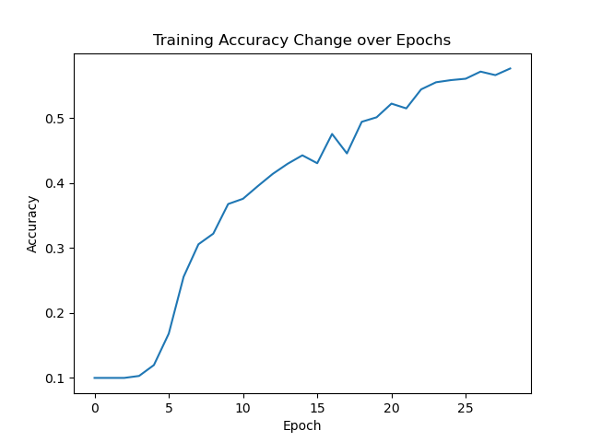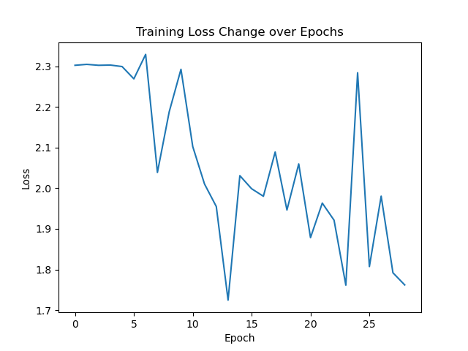

When the number of convolutional layers was increased by 1, the accuracy seemed to decrease by about 3%. I’m not sure why.