**Programming Assignment 5: Image Segmentation**

In this assignment the goal is to implement both Standard Image Binarization and Otsu Thresholding in order to perform image Thresholding. Thresholding for this assignment is defined as making a pixel either completely white (Pixel Intensity = 255) or completely black (Pixel Intensity = 0) based on whether the Pixel’s Actual Intensity between 0-255 is above or below a certain Pixel Intensity value. Segmenting an image in this manner makes it easier to identify distinct key points in an image.

So we will be implementing 2 methods of Thresholding. The first method is Standard Image Binarization where we manually choose the Threshold value between 0-255. We will test 3 threshold values and see the results. The second method is called Otsu Thresholding where we create an algorithm that automatically finds the best Threshold value for a particular image.

The Results are shown below :

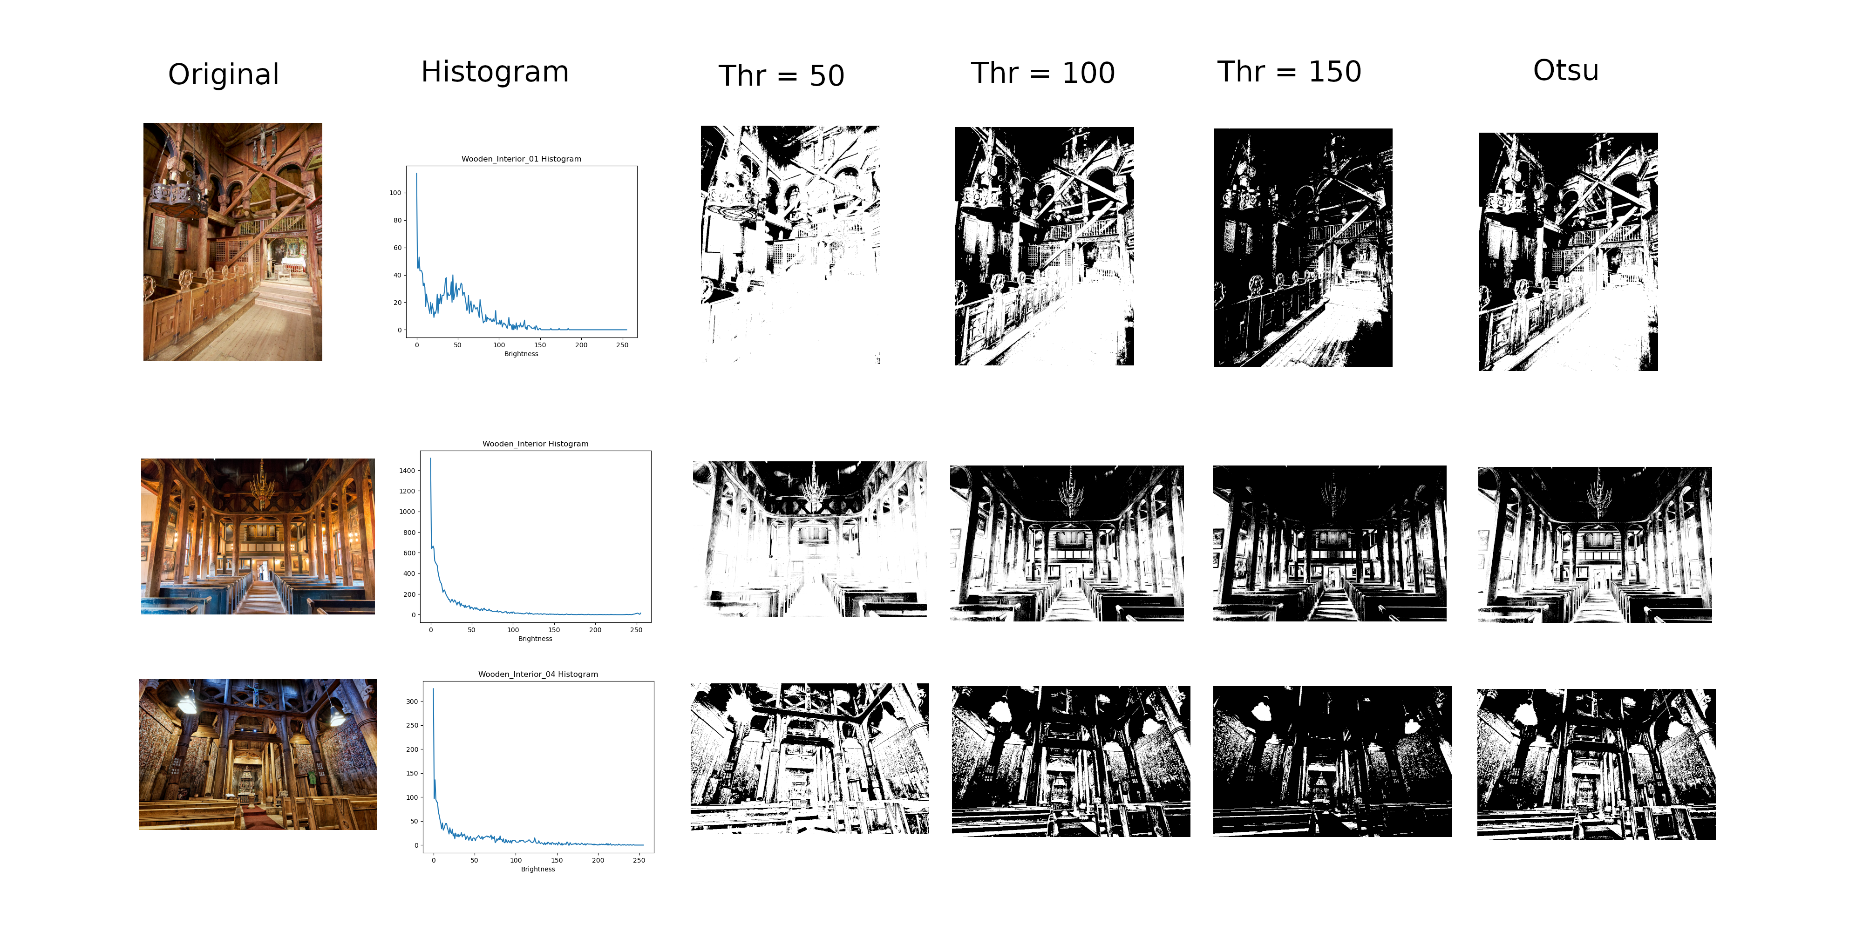(Note that Higher Resolution images are stored in the Output_Images folder of the project.)