**Programming Assignment 3: Autoencoder**

In this assignment, we created 2 autoencoders. The first Autoencoder was built using a Fully Connected Neural Network. The second Autoencoder was built using a Convolutional Neural Network. Autoencoders to put it simply, use a neural network in order to compress and then decompress data by finding key features and then reconstructing images based off those key features.

The results are shown in the image below:

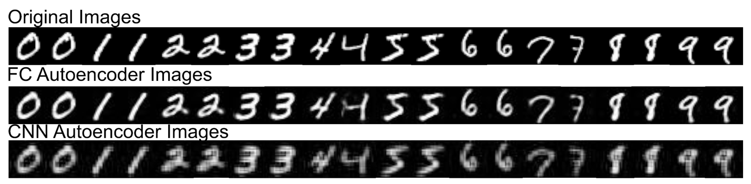

As you can see the Fully Connected Autoencoder reconstructs images much closer to the original then the CNN Autoencoder. However, the FC Autoencoder has a lot more parameters

**Fully Connected Autoencoder**

1. Number of Parameters in Encoder: 233,856
2. Number of Parameters in Decoder: 234512
3. Total: 468,368

**Convolutional Autoencoder**

1. Number of Parameters in Encoder: 4800
2. Number of Parameters in Decoder: 5857
3. Total: 10,657

So, you can see in the image above that the Fully Connected Autoencoder is able to more accurately reconstruct an image then the Convolutional Autoencoder. However, the FCC Autoencoder has 98% more parameters then the CNN Autoencoder.