**Problem 1** (Written Question 10 points). Consider the decision tree shown in the diagram below. The counts shown in the leaf nodes correspond to the number of training records associated with the nodes.

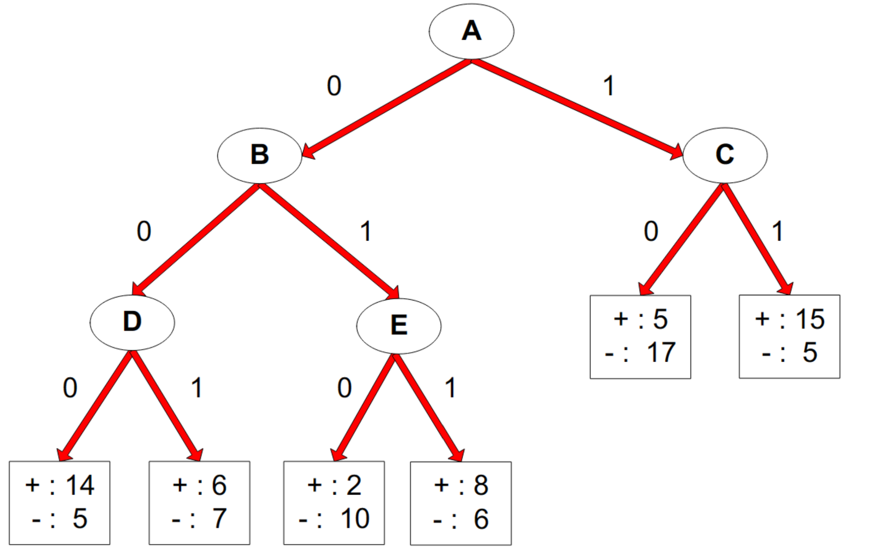

(1) What is the training error rate for the tree? Explain how you get the answer.

(2) Given a test instance T={A=0, B=1, C=1, D=1, E=0}, what class would the decision tree above be assigned to T? Explain how you get the answer.

**Problem 2** (Written Question 15 points).

(1) Are decision trees a linear classifier?

(2) What are the weaknesses of decision trees?

(3) Is Misclassification errors better than Gini index as the splitting criteria for decision trees?

Note that: For Coding Questions, please **do not** directly call linear regression and non-linear regression built-in functions in existing library packages such as scikit-learn. You may call basic computation functions built in Numpy.

**Problem 3** (Coding Question 25 points)

Please implement a Linear Regression to find the best linear model for the provided HW2_linear_data.csv. Please plot the result using “matplotlib.pyplot”.

Note that

1. The linear model is in the following format Y=mX+c
2. Use MSE as the loss function
3. You may use “pandas” to read the csv file and load the values into two vectors X and Y.
4. Use Gradient Descent for the training. You may choose fixed learning rate (such as 0.0001) and epochs (such as 1000) without considering mini-batch.
5. The result will look like the following image.

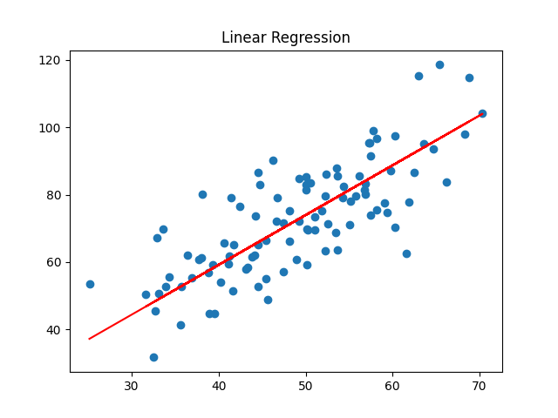

**Problem 4** (Coding Question 25 points):

Please implement a non-linear regression to find the best cubic function model for the

provided HW2_nonlinear_data.csv. Please plot the result, too.

1. The cubic function is in the following format: Y=aX^3+bX^2+cX+d
2. Use MSE as the loss function.
3. Use Gradient Descent for the training. You may choose fixed learning rate (such as 0.000001 (1e-6)) and epochs (such as 10000) without considering mini-batch. It may take 10-15 seconds to finish the running for 10000 steps. Please be patient.
4. The result will look like the following

