Assignment 01: Deep Learning-Based Pneumonia Detection Using Chest X-Ray Images

Introduction:

According to the World Health Organization, Pneumonia is considered the single leading cause of mortality in children. Pneumonia is an infection of the lungs and is caused by a variety of organisms including bacteria, viruses and/or fungi.

To help treat pneumonia, chest x-rays are taken to try to diagnose and confirm the diagnosis of pneumonia as quickly and accurately as possible in order to improve survivability of patients as early detection before the illness progresses to advanced stages improves chances of recovery.

Deep learning algorithms can be used in this application. These algorithms have many advantages for this application. In areas where there are a high number of pneumonia cases and/or a small amount of trained personnel who can read these x-rays… A deep learning app can be used to make up for that disparity. With an off-the-shelf consumer PC with a modern GPU… These algorithms can be run and save lives when human doctors are overworked or simply not available.

Experiment Design:

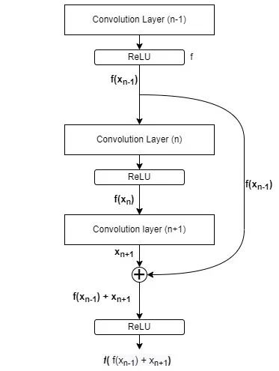
The deep learning network is called ResNet18. ResNet18 is a variant of the Residual Network architecture. Essentially, the Residual Network architecture allows a Deep Learning Network to have many layers without causing issues… Specifically vanishing gradients. It uses skip connections. The ResNet-18 architecture is 18 layers deep and is smaller then then the 50 layer ResNet-50 in order to fit onto smaller GPUs. ResNet uses skip connections which are shown to the right which allows data from previous layers to be sent to layers further down which can minimize chances of vanishing gradients.

For this report, a comparison in performance between ResNet-18 trained from scratch and ResNet-18 with pretrained weights will be done. Pretrained weights are the model configuration that was created from previous training … They are used to save time and computing power as the weights can be used and then fine- tuned for different applications.

Dataset Information:

The dataset is divided into 2 classifications: Normal and Pneumonia. So it will be a binary classification problem.
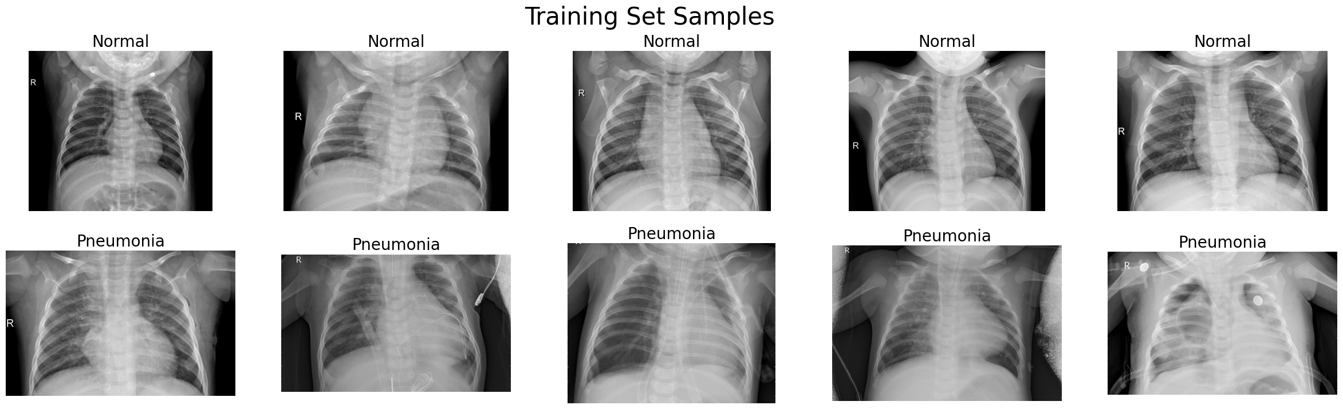
The training set distribution is as follows:

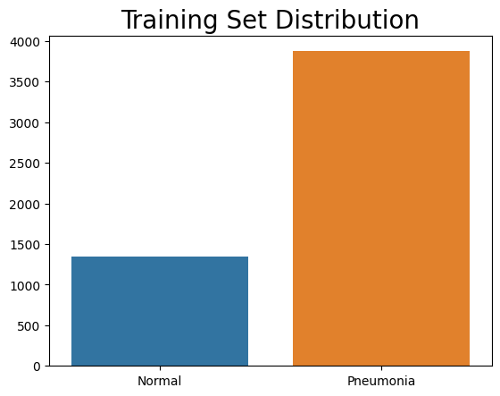

Training Specifications:

These training specifications were used for both networks:

1. GPU: Laptop RTX 4090 16GB of VRAM
2. Batch Size: 128
3. Epochs: 40
4. Gradient Clipping: None
5. Weight Decay: 0.0001
6. Learning Rate: 0.0001
7. Weighted Loss for Data Class Imbalance

Training Information

Below are the graphs of training accuracy over time:

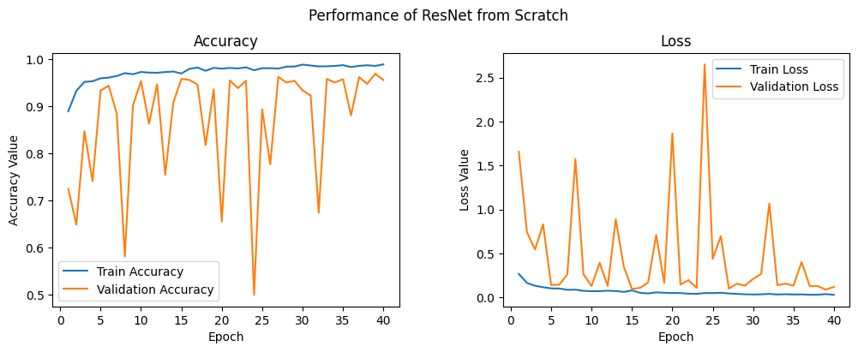
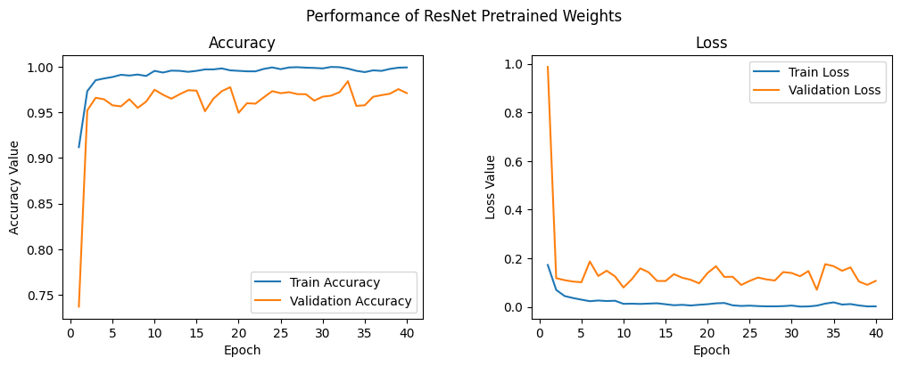

As you can see, the pre-trained weights made training smoother.

After training, the accuracy of prediction from the model trained from scratch was 86.85%. The accuracy of prediction from the model with pre-trained weights was 90.1%

The Recall of both models was 99%

Failure Cases

Below are the failure cases of misclassified images:

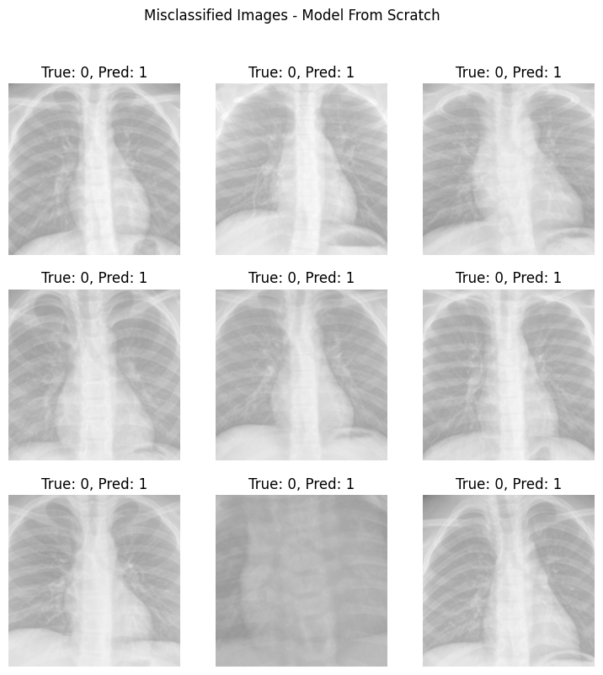
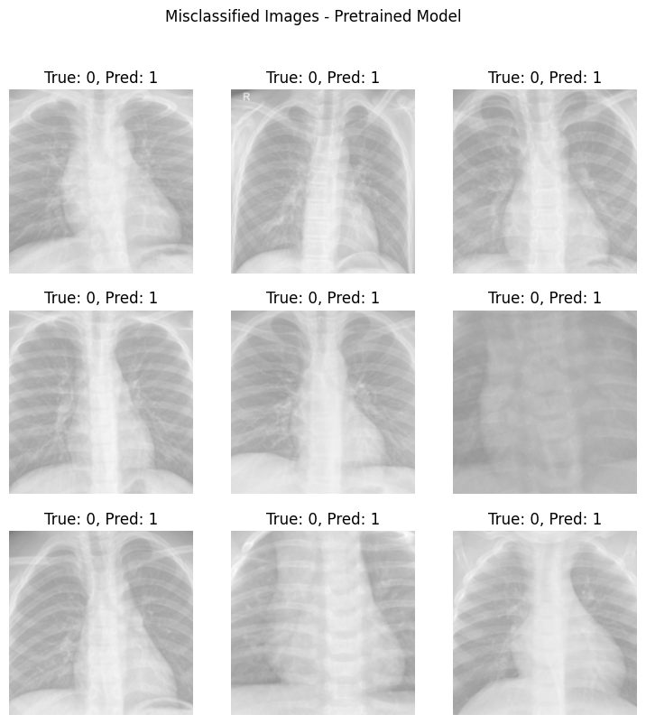

I suspect that the reason these failed was simply because the images were too light. When doing the data augmentation, the greyscale changes made the image too washed out which made it difficult to distinguish between things.

Conclusion

Using pre-trained weights, the classification accuracy was increased from 87% to 90%. I suspect that the misclassifications during training occurred with images that were too washed out. When it comes to life and death of patients, 90% classification accuracy might not be enough. It is more important to not miss a positive pneumonia, then it is to falsely classify a negative as a positive. To test the ability for the model to identify all the positives, the Recall was calculated and this was 99% meaning that 99% of all pneumonia cases were identified with some false positives due to a precision score of 83% for both models. This lower precision score fine as long as almost all the pneumonia cases are correctly identified… Since for saving human lives… It is better to falsely read the x-ray and have the doctor look over it and correct it, then to miss the disease all together.

