Assignment 02: Deep Learning-Based Brain Tumor Segmentation Using MRI

Introduction:

Brain tumors are growths of cells in the brain or near it on the nerve tissues or the pituitary or pineal gland. They can also grow on the membranes that cover the surface of the brain. Brain tumors can be benign or malignant. Benign brain tumors may grow over time and press on the brain. However the much more dangerous malignant tumors. Malignant tumors may grow quickly and can invade or destroy brain tissues.

Magnetic Resonance Imaging (MRI) is used to detect brain tumors in a non-invasive manner. Where machine learning algorithms come into play are in taking these Brain MRI images, and quickly segmenting the parts of the brain that might contain brain tumor tissue. Brain tumor tissue have the higher water content, disrupt the blood brain barrier, and/or have different blood flow properties which distinguish them in an MRI image.

Experiment Design:

The dataset that will be used is the 2016 and 2017 Brain Tumor Image Segmentation (BraTS) dataset. First we will use the ITK-SNAP software to view the dataset. The Brain Tumor images are stored in a proprietary format that is basically a combination of slices of 2D images stored in 3D. The ITK-SNAP software is able to view this proprietary format and navigate through the different slices in 3 directions. Next a Unet network will be constructed and used to train on segmentation tasks for these brain tumor images. The metrics that will be used are accuracy, the Dice Score, and the Hausdorff Distance score.

Dataset Information:

The dataset consists of brain tumor images stored in a specialized format. There are the images and the ground truth segmented images. Within this dataset, we will have training and test images. The below image shows the raw MRI image and the ground truth segmented image:

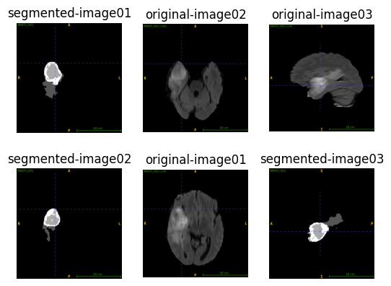

Training Specifications:

These training specifications were used.

1. GPU: Laptop RTX 4090 16GB of VRAM
2. Batch Size: 8
3. Epochs: 10
4. Total Parameters: 31,032,321
5. Training Time: 102 minutes

Training Information

Below are the graphs of training progress:

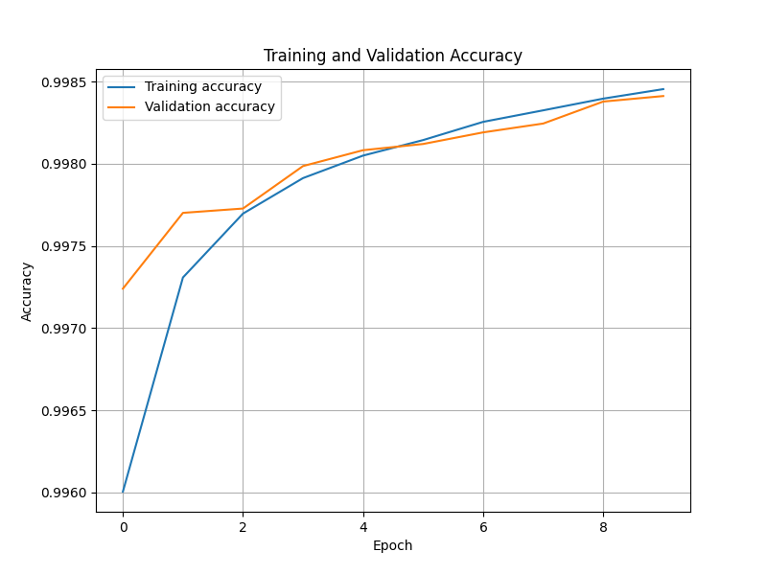

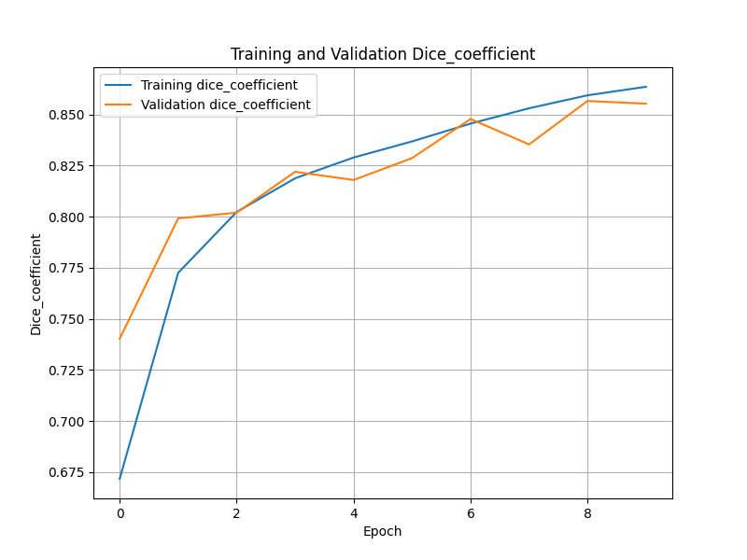

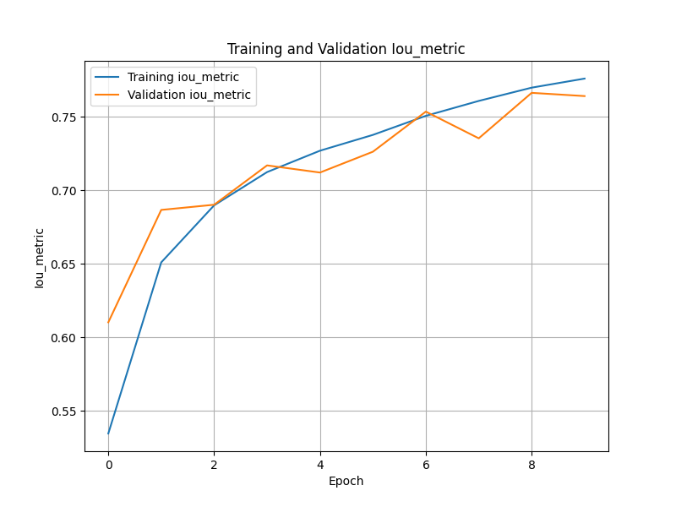

Because of time constraints, I was not able to do the Hausdorff distance calculation for loss. Here are some of the predicted images versus the ground truth versus the input images:

