Assignment 03: SAM
Author: Lam Nguyen
Due Date: 11Sep2025

Report: SAM2

In this assignment, we are implementing the (SAM2) Segment Anything Model 2 onto the Cambridge-Driving Labeled Video Database (CamVid). The SAM2 model is a foundation model meant towards solving promptable visual segmentation in images and videos. SAM2 is a simple transformer architecture with streaming memory for real-time video processing.
The CamVid dataset provides ground truth labels that associate each pixel with of 32 semantic classes.

Specifically for this assignment, we will compare the image masks generated from the SAM2 model with the ground truth masks included with the CamVid dataset. Next, a parameterized SAM2 model will be created that can be tuned in an attempt to improve performance over the baseline SAM2 model. DICE Scores will be used to compare the different models and the generated masks with the ground truth labels.

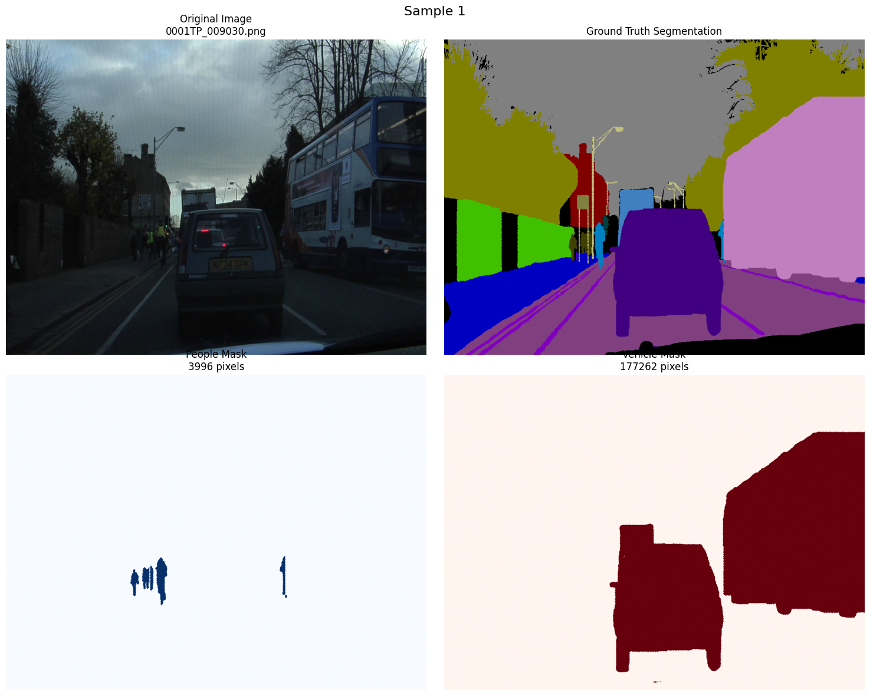
Figure 1: Sample Image with Ground Truth Masks from Dataset

Results from Evaluation with Baseline SAM2 Model:

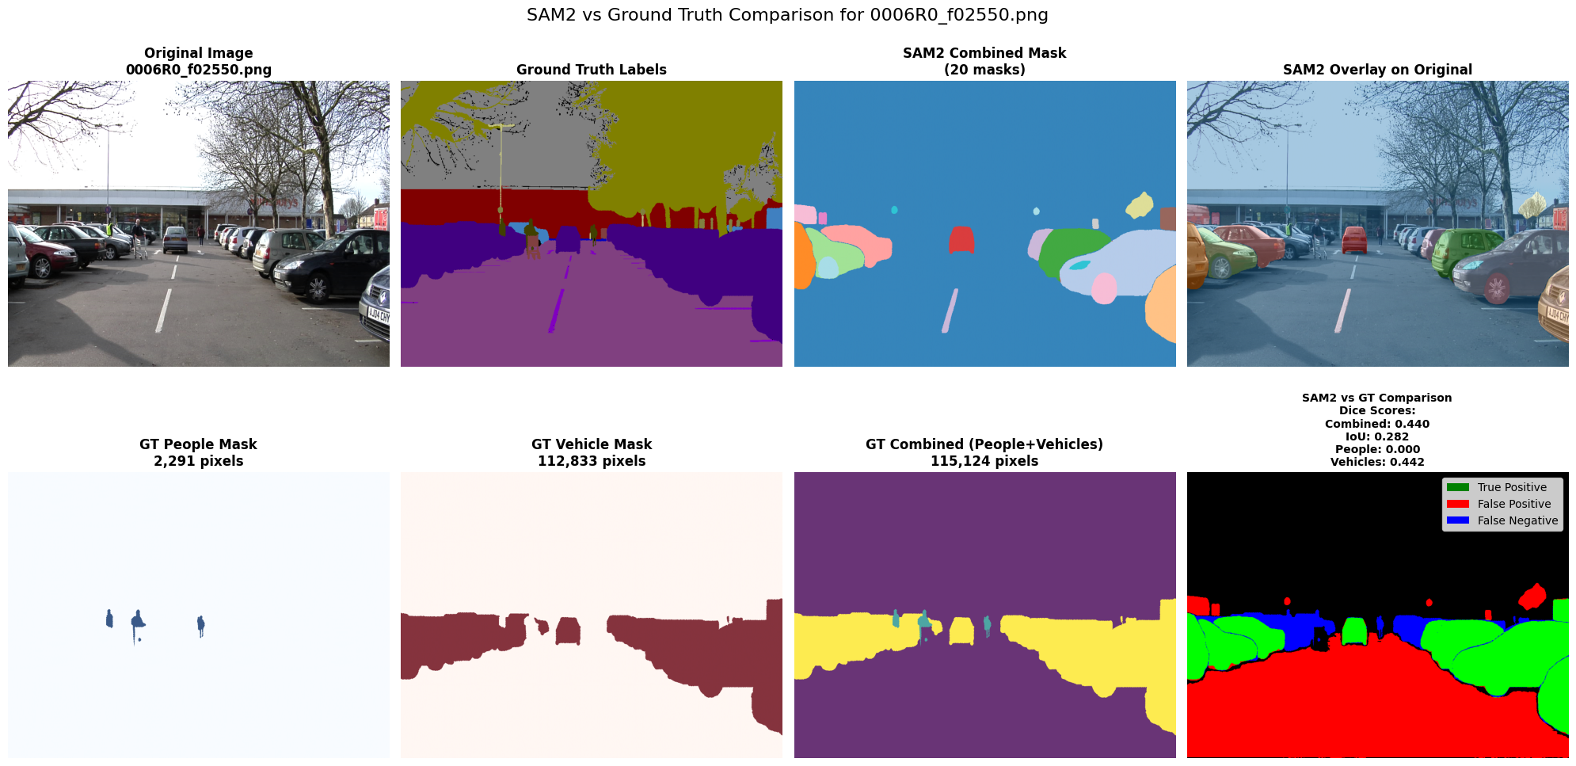
Figure 2: Generated Masks for Vehicles and People from Baseline SAM2

============================================================
=== SAM2 Baseline EVALUATION RESULTS ===
============================================================

DATASET STATISTICS:
Total samples processed: 100
Failed samples: 0
Samples with people: 93
Samples with vehicles: 98

PERFORMANCE STATISTICS:
Total evaluation time: 938.32 seconds
Average processing time per image: 9.336 seconds
Average masks generated per image: 30.1

SEGMENTATION PERFORMANCE (DICE SCORES):
Combined (People + Vehicles):
Average Dice Score: 0.1448 ± 0.1504
Average IoU Score: 0.0861 ± 0.1007

People Only:
Average Dice Score: 0.0135 ± 0.0268
Average IoU Score: 0.0070

Vehicles Only:
Average Dice Score: 0.1384 ± 0.1550
Average IoU Score: 0.0829

SCORE DISTRIBUTION:
Combined Dice Scores:
Min: 0.0000
Max: 0.6803
Median: 0.0979
25th percentile: 0.0254
75th percentile: 0.2068

============================================================
EVALUATION COMPLETE!
Main Result: Average Dice Score = 0.1448

Results from Experiment with Parameterized SAM2 Model:

Parameters Changed:

'high_precision': {
'name': 'High Precision',
'description': 'Focus on fewer, higher quality masks',
'points_per_batch': 32,
'min_mask_region_area': 100.0, # Larger minimum area
'max_mask_area_ratio': 0.6, # Smaller maximum area
'aspect_ratio_filter': (0.2, 5.0), # Remove very elongated masks
'circularity_threshold': 0.1, # Some shape constraint
'remove_edge_masks': True, # Remove masks touching edges
'merge_overlapping': True, # Merge similar masks
'overlap_threshold': 0.3
}

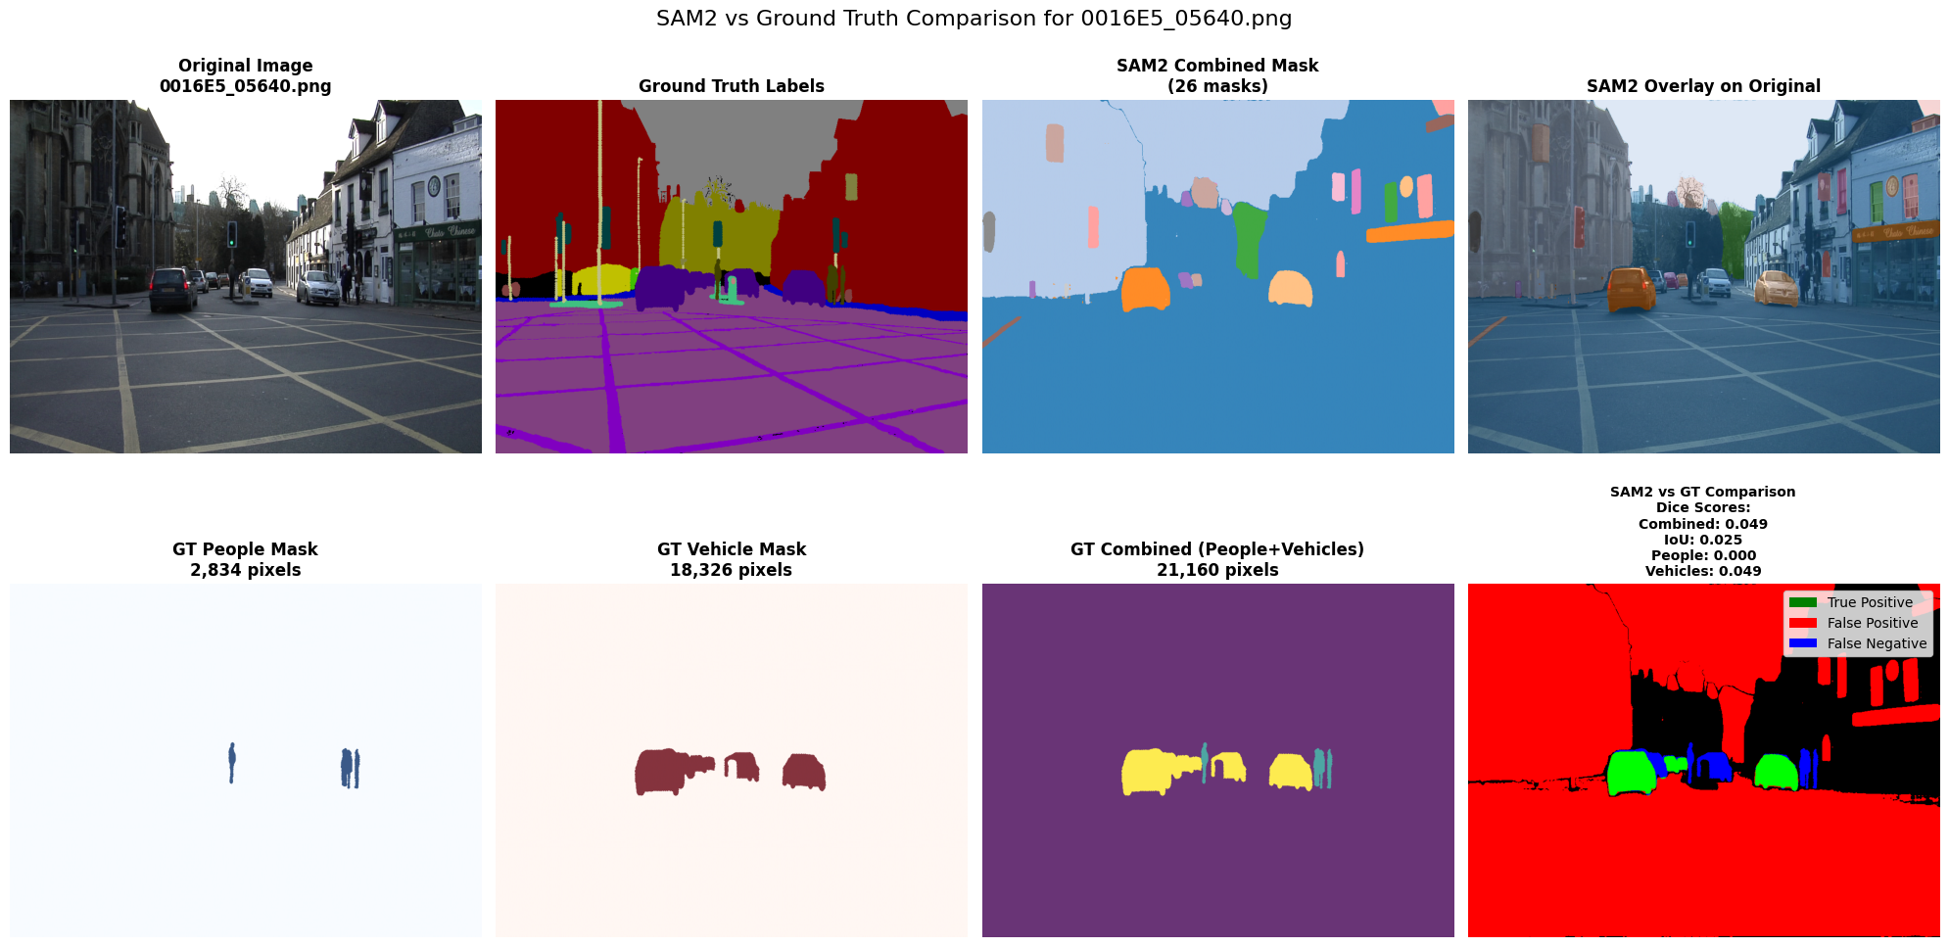
Figure 3: Sample Image Comparing Generated Masks with Ground Truth Labels

============================================================
=== SAM2 EVALUATION RESULTS ===
============================================================

DATASET STATISTICS:
Total samples processed: 100
Failed samples: 0
Samples with people: 93
Samples with vehicles: 98

PERFORMANCE STATISTICS:
Total evaluation time: 1158.84 seconds
Average processing time per image: 11.547 seconds
Average masks generated per image: 26.9

SEGMENTATION PERFORMANCE (DICE SCORES):
Combined (People + Vehicles):
Average Dice Score: 0.1445 ± 0.1519
Average IoU Score: 0.0861 ± 0.1016

People Only:
Average Dice Score: 0.0125 ± 0.0253
Average IoU Score: 0.0065

Vehicles Only:
Average Dice Score: 0.1391 ± 0.1560
Average IoU Score: 0.0835

SCORE DISTRIBUTION:
Combined Dice Scores:
Min: 0.0000
Max: 0.6803
Median: 0.0974
25th percentile: 0.0232
75th percentile: 0.2091

============================================================
EVALUATION COMPLETE!
Main Result: Average Dice Score = 0.1445
============================================================

Conclusion:

As shown in the results, the SAM2 model did miss some results compared to the ground truth labels. Also, I was able to create a parameterized SAM2 model that could be played around with to see if performance could be improved over baseline. Due to time constraints, I wasn’t able to play around with the parameters enough in order to improve performance over baseline for identifying cars and humans. However, given more time, it would be possible.

