Assignment 06: Stable Diffusion
Author: Lam Nguyen
Due Date: 30Sep2025

Report: Stable Diffusion

Introduction

In this assignment we are comparing 2 stable diffusion models on image generation of ten text prompts. The 2 models that inference will be done using are Stable Diffusion XL(SDXL) and Stable Diffusion XL Turbo (SDXL Turbo). Stable Diffusion XL is trained on 1024x1024 images and produces higher resolution images then previous Stable Diffusion Models at the expense of higher computing power usage and time. SDXL Turbo is a distilled and optimized version of of SDXL designed for rapid image generation. It uses less computing resources and takes less time but also tends to produce a lower quality image.

Results

Here are some examples of an image generated for a given prompt (SDXL on Left, SDXLTurbo on Right):

Figure 1: SDXL Turbo
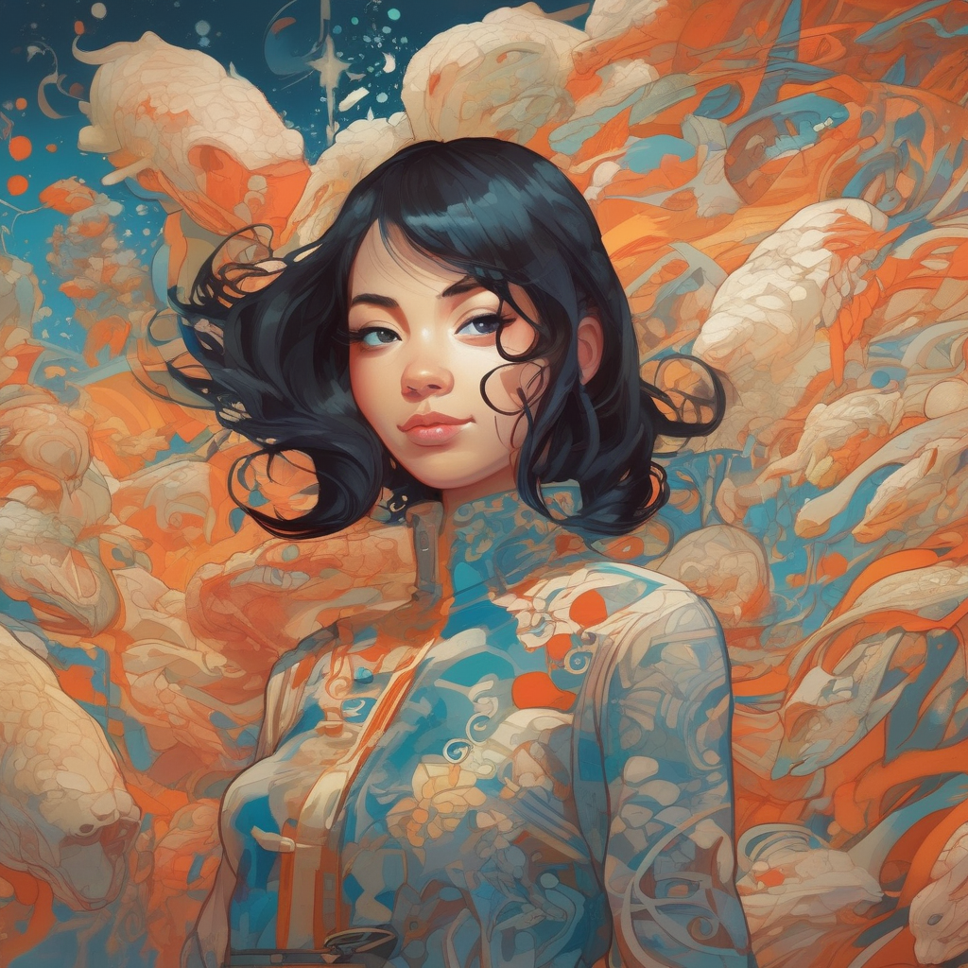Figure 2: SDXL
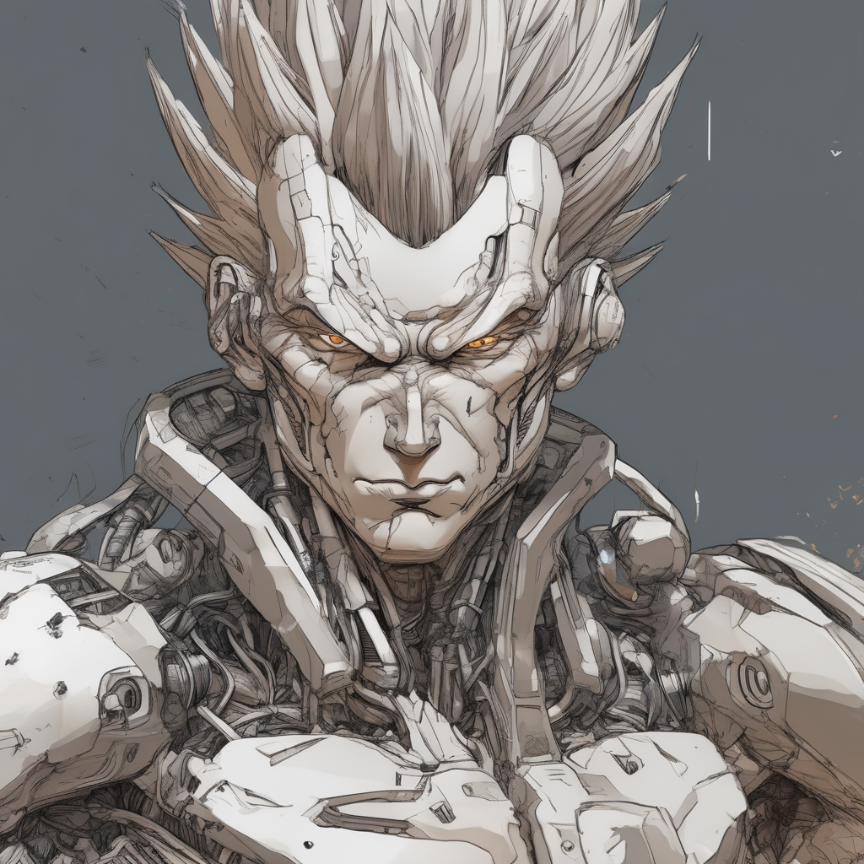Figure 3: SDXL
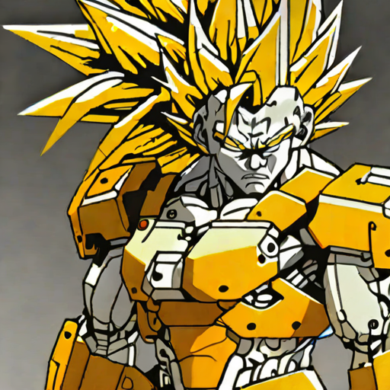Figure 4: SDXL Turbo

The average generation time for SDXL was 40.6 seconds. The average generation time for SDXL Turbo was 2.95 seconds. A single Nvidia RTX A6000 GPU was used for these generations.

The FID score between the 2 models was 114.7

Insights

SDXL is able to generate more elaborate and high definition images then SDXL Turbo for a given prompt. However it takes about 14x as long to generate the image and also requires at least 18 GB of VRAM compared to SDXL Turbo which can be used on a single GPU with less then 16GB of VRAM. However the quality of images is much higher on SDXL, so in my opinion, it is worth it for the higher resource usage and time. However, there could be scenarios where the smaller SDXL Turbo model is better.. For example, an artist doesn’t have a lot of computing power but just wants a rough draft of an image to provide inspiration…. A lower quality image might actually be better because it won’t get in the way of the artist’s vision.

