Assignment 02: Object Detection
Author: Lam Nguyen
Due Date: 04Sep2025

Report: Object Detection

In this assignment, we are comparing different models in inferencing on the Coco 2017 Dataset. Coco 2017 is a large scale object-detection, segmentation and captioning dataset. It contains 330,000 images, a little over 200,000 of which are labeled. There are 80 object categories.

There are four models used:

- Faster R-CNN
- DETR
- DINO
- Grounding Dino

Faster R-CNN introduces a region proposal network that works in one step with the main object detection part of the network. The combination of two main steps into one increases the speed of this network compared to other Recurrent Neural Network architectures.

DINO V3 is one of the newest and highest performing image models. It doesn’t require fine-tuning is zero-shot meaning that it can predict objects even if it has not been trained on that object type.. Its key architecture is a teacher student network that works across many vision tasks.
DETER (Detection Transformer) is an object detection model that eliminates the need for custom components like non-maximum suppression, etc… It uses the transformer architecture. It directly predicts a set of objects in an image by framing detection as a set prediction problem, matching predictions to ground truth objects using unique bipartite matching loss.

Grounding-DINO combines the DINO network for image detection with language understanding. It does this by fusing image and text features through a cross-modality encoder. It is zero-shot.

Here are some images output:

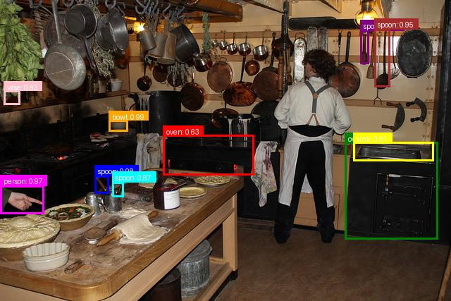
Figure 1: DETR Model

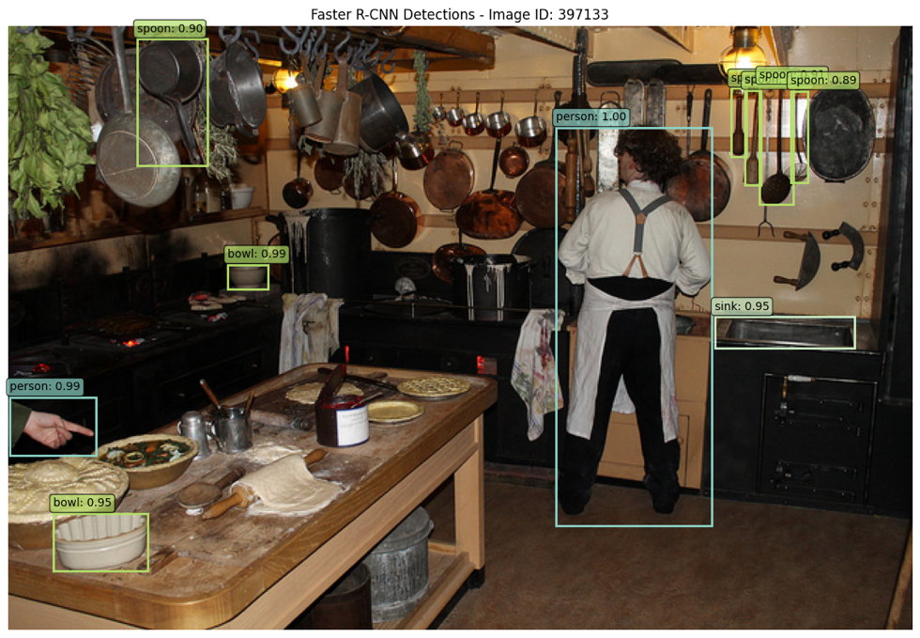
Figure 2: R-CNN

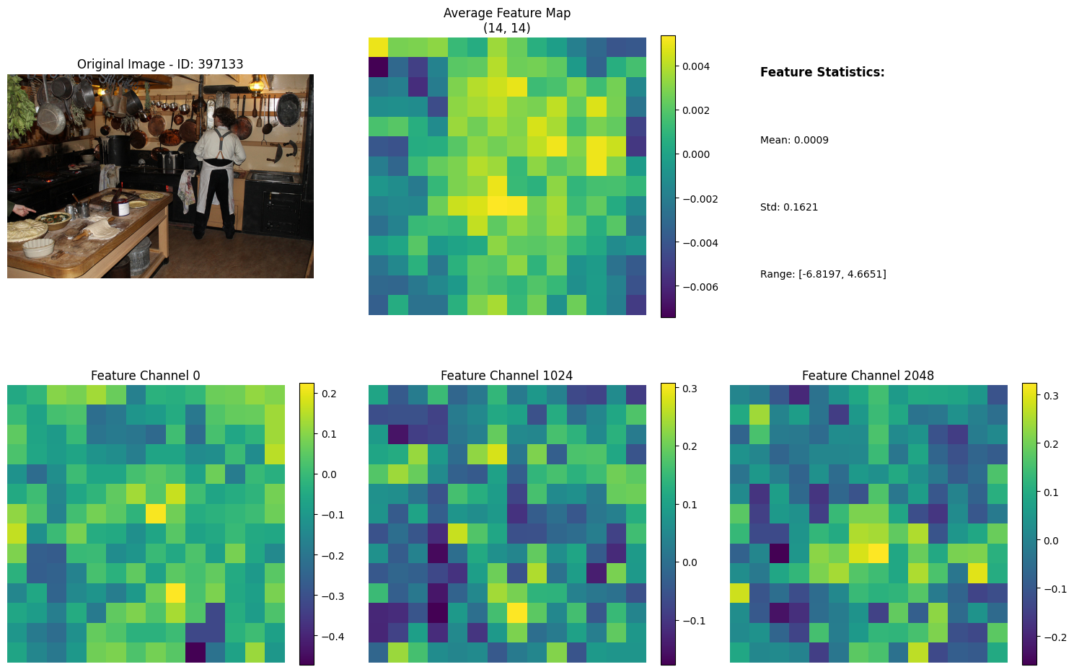
Figure 3: DinoV3 Feature Map

Figure 4: Grounding Dino

Insights:

The Faster R-CNN took around 4 seconds to do inference through a set of 100 images. It had around 9.4 detections per image and could fit in about 1GB of ram. DinoV3 took the about 5 minutes to run through 100 images and took about 14 GB of VRAM. It did not use bounding boxes and created a heatmap of similar objects. DETR took about 1.6GB of VRAM and took about 5.8 seconds to do inference on a set of 100 images. It got about 8.72 detections per image. Finally, Grounding-Dino took around 5.8 GB of VRAM. It got 11.3 detections per image on average and took the longest at around 12 seconds.

Overall, the least accurate model was Faster R-CNN but it took the least resources and operated the fastest. Generally, the Dino models took the most system resources and were slower but detected the most objects per image. So depending on ones computing resources, one can choose between higher resource uses and higher object detection, or lower resource usage and lower detection…

