Assignment 01: ResNet-18 vs ViT
Student: Lam Nguyen
Due Date: 28Aug2025

In this project, we compare the effectiveness of ResNet-18 and ViT when classifying on the Human Action Recognition Dataset.

Here is the graph of the training progress between the 2 models:

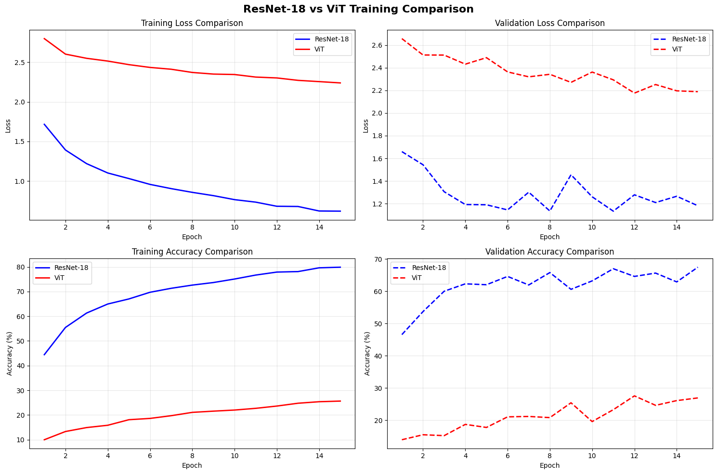
Here are some predictions of both models on test images:
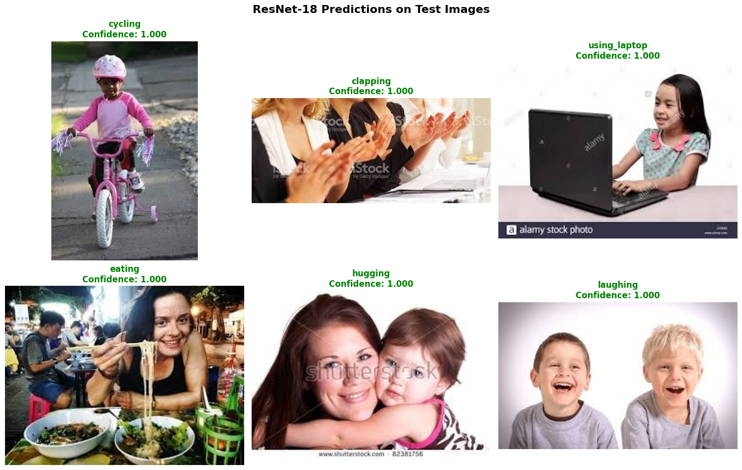

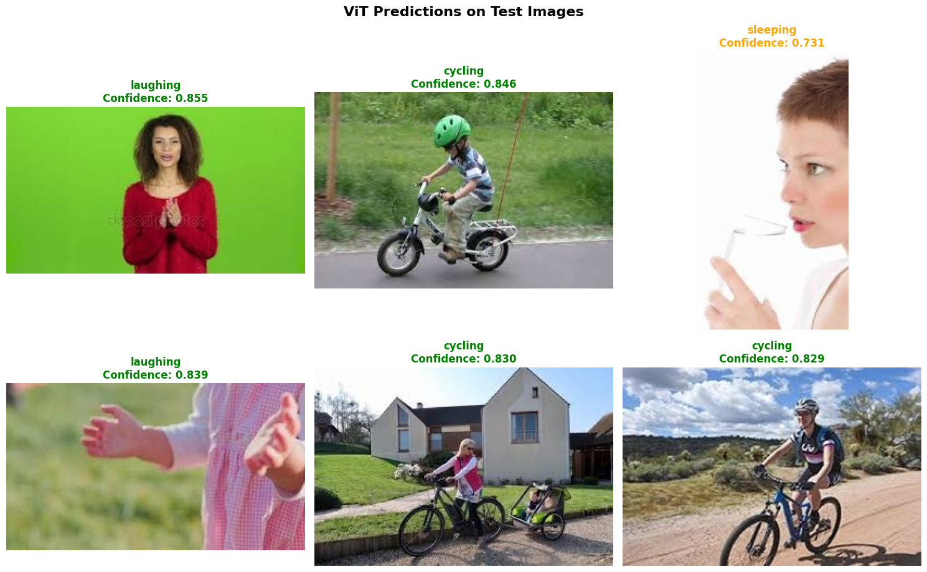

Conclusion:

The training of ResNet-18 was about 12x faster then ViT. The inference speed of Resnet-18 was on average 5.88ms/batch of 32 images versus 71.73ms per batch of 32 images for ViT. Also the accuracy was higher during training for ResNet-18 vs ViT at 79.88% for ResNet-18 vs 25.62% for ViT. So at least in in the way the models were set up, ResNet-18 is much faster and performs at a much greater accuracy then ViT. This might be due in part in the way the ViT model was set up. Possibly using different pretrained weights or altering the model structure would improve accuracy on the HAR dataset.

