Assignment 09: Framepack
Author: Lam Nguyen
Due Date: 06Nov2025

Report: Framepack

Introduction

In this assignment we are generating video using the Human Actions Video Recognition Dataset. From this dataset we will get the categories that will be used as prompts as well as a first frame. The models we will be using are the Wan 2.1 model and the Framepack model. We will then compare the similarity of these videos using the Frechet Video Distance Metric.

Both the Wan 2.1 and Framepack models are open source video generation models that can use text and/or an image as input to create a video.

Wan2.1 is designed on the mainstream diffusion transformer paradigm. It uses the new spatio-temporal variational autoencoder (VAE), scalable training strategies, large-scale data construction, and automated evaluation metrics.

Framepack is the other video generation model. It uses a next-frame prediction neural network structure that generates videos progressively. Framepack compresses input contexts to a constant lenfth so that the generation workload is invariant to the video length.

Results

Since these are videos, it isn’t practical to show them in this report. However, they are included in a separate folder with this report. However, here are some screenshots for a given prompt:

Figure 2: Wan2.1: Person clapping
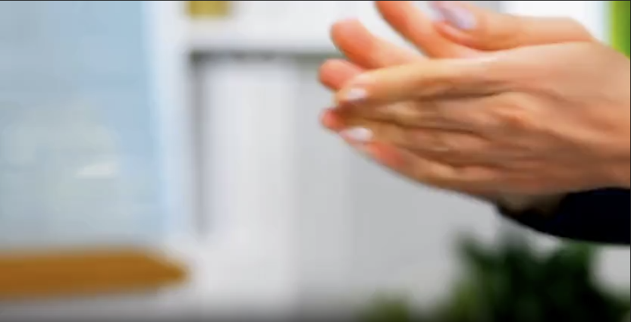Figure 1: Framepack: Person Clapping

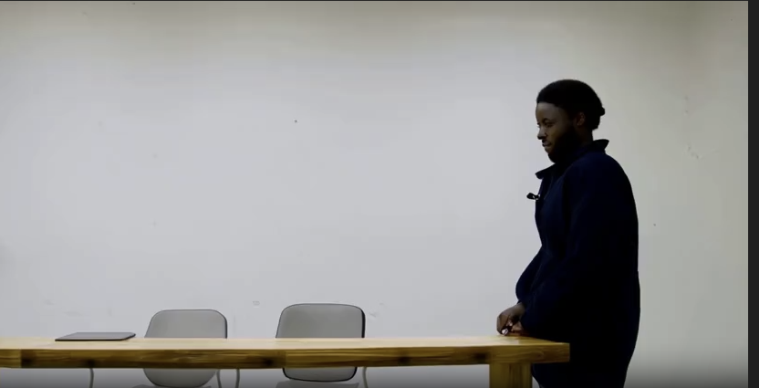Figure 4: Framepack: A person sitting in a clear indoor environment
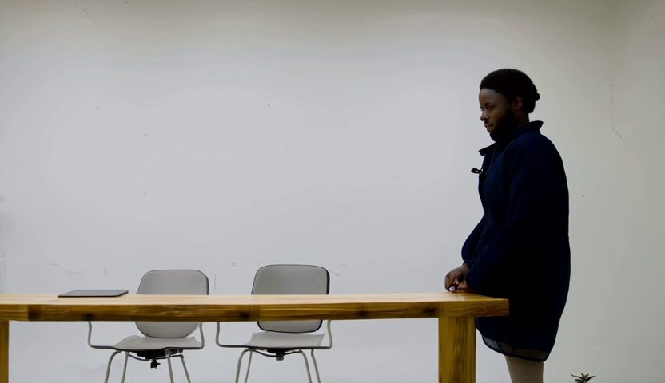Figure 3: Wan2.1 A person sitting in a clear indoor environment

The FVD score between the outputs of the 2 models was on average 0.3123 which means the videos are very similar. This is probably because Framepack used the first frame of the video generated by the Wan2.1 model.

Insights and Obstacles

Both models generate similar results of similar quality. And they both took a significant amount of time on a single GPU. There were a few obstacles with these models. The main obstacle was the high amount of VRAM that these models require. Although the repos say that these models can fit on consumer GPUs, in order to get higher resolution in 720p, standard GPUs cannot be used. An A6000 with 48GB of VRAM is not enough for 720p video. Also a lot of the stock code in the Github repositories for both models use more then 48GB of VRAM and even with a memory optimized model can use more then 24GB of VRAM… The only consumer GPU that can handle this is an RTX 5090. Although these are technically open source models, GPU computing power is a huge barrier to entry.

However with a lot of memory optimizations, Framepack is able to fit on less then 10GB of VRAM and is able to create videos of acceptable quality. So for most regular people, this would be the model to use.

Wan 2.1 can be used if one is able to afford very expensive GPUs.

