Assignment 04: CLIP
Author: Lam Nguyen
Due Date: 18Sep2025

Report: CLIP

Introduction

In this assignment, we are implementing the CLIP model and variations of this model and fine-tuning the model on the Human Actions Recognition (HAR) dataset.Specifically, besides CLIP, A-CLIP and SIGLIP will be fine-tuned and compared on the HAR dataset.

CLIP (Contrastive Language-Image Pretraining is a Vision-Language Model that is able to understand both image and texts by learning to associate them in a shared space. Unlike traditional Deep learning models, CLIP is able to perform zero-shot tasks or the ability to adapt to new data without retraining the entire model. CLIP is trained on 400 million image-text pairs from the internet. CLIP takes an image and kist of text prompts, and then assigns probabilities to each prompt; choosing the highest probability.

A-CLIP (Attentive Mask Contrastive Language-Image Pretraining) was created in an attempt to improve the training efficiency of CLIP by using the image token removal strategy. Essentially what A-CLIP does to improve training efficiency is to remove irrelevant data while attempting to keep semantics. Using random masking would destroy the meaning of sentences and images, however A-CLIP selectively removes irrelevant data.

SiGLIP (Sigmoid Language Image Pretraining) is a method that replaces softmax-based contrastive loss used in CLIP with a simpler pairwise sigmoid loss function. This approach operates solely on individual image-text pairs without requiring a global view of all pairwise similarities for normalization. The advantage of this is that it improves computational efficiency and allows easier distribution of training between multiple GPUs.

We will be fine-tuning these models on the Human Action Recognition (HAR) dataset. This dataset consists of 27 different actions with label pairs.

Results

Due to time constraints, I was not able to get the A-CLIP model running and fine-tuned. It is a relatively new model and hasn’t been implemented in Huggingface. However I was able to get SiGLIP and CLIP running and fine-tuned. Each model was trained for 10 epochs on an Nvidia A6000 GPU. CLIP took about 37 GB of VRAM to perform fine-tuning and 66 minutes to complete training. After the Fine-tuning, the validation accuracy was 80.59%. SIGLIP took about 11.5GB of VRAM and about 39 minutes to complete training. After fine-tuning, SIGLIP was able to get a validation accuracy of 86.97%

CLIP Training Progress
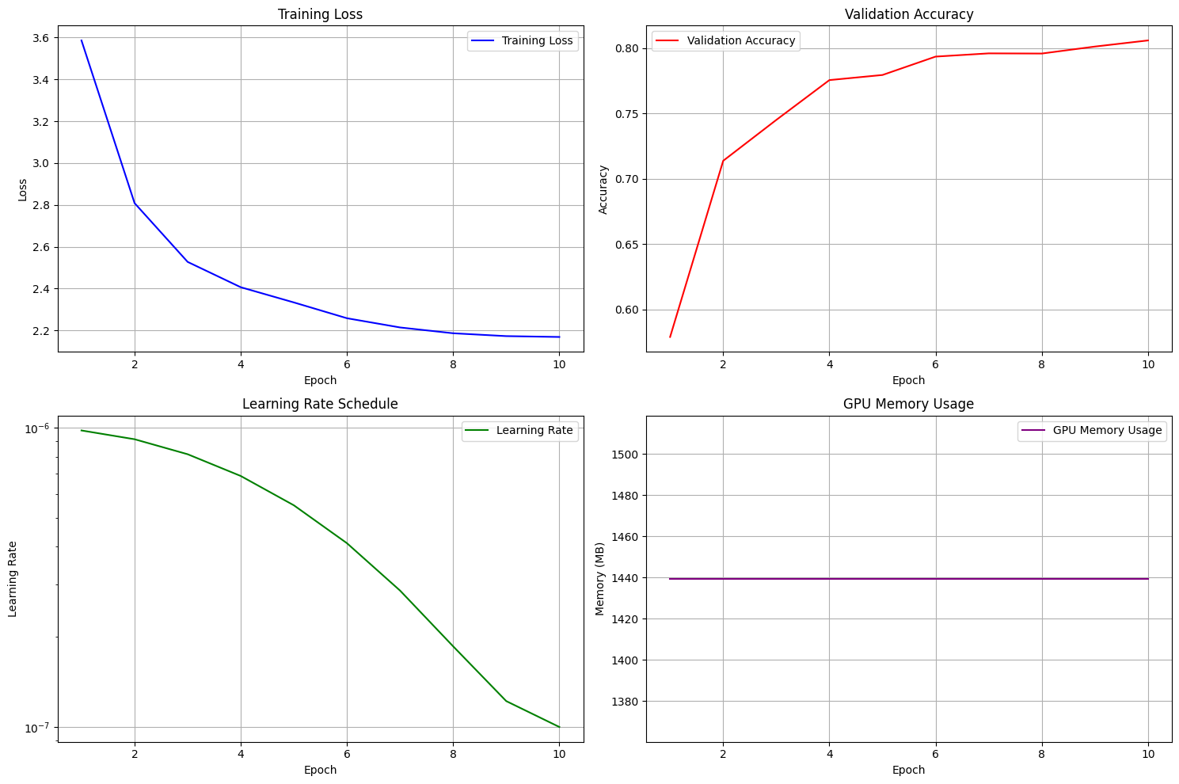Figure 1: CLIP Training Stats

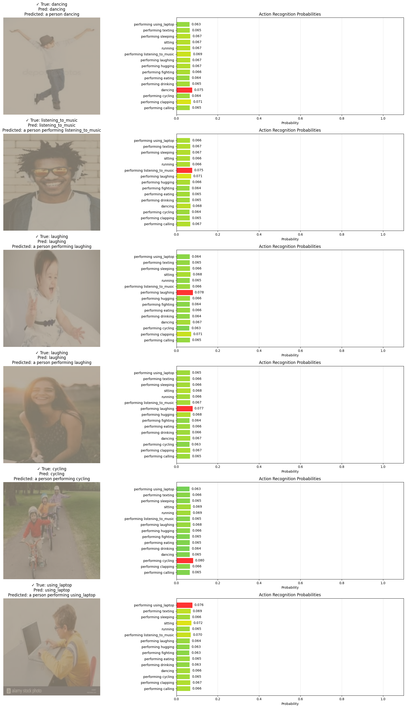Figure 2: Fine-Tuned CLIP Sample Images

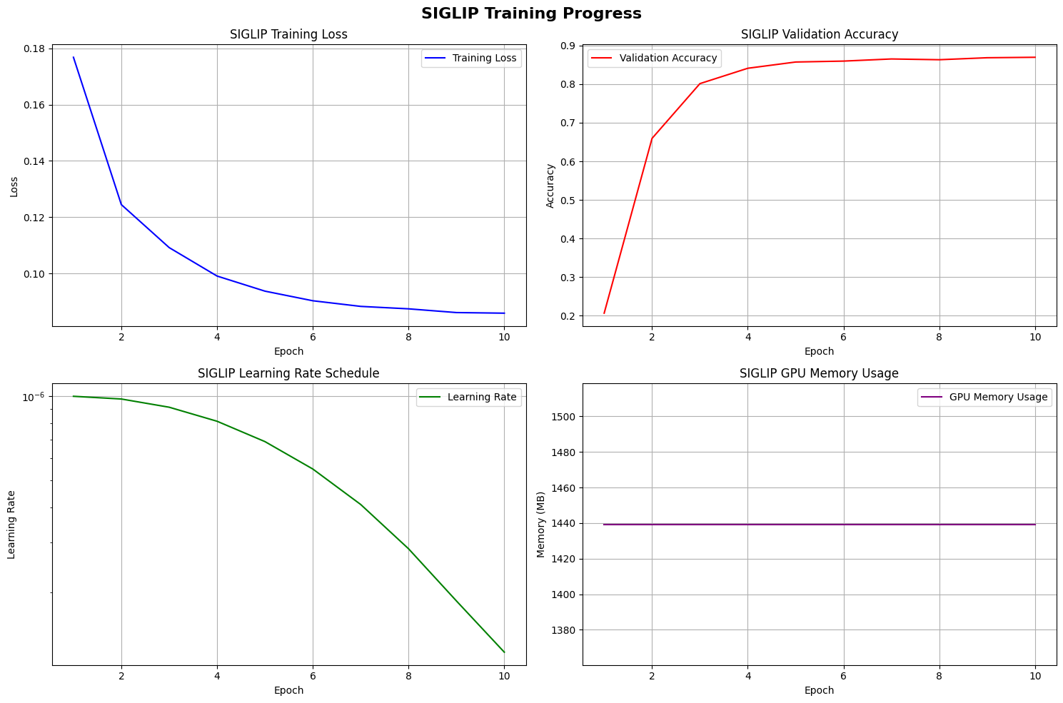Figure 3: Figure 3: SIGLIP Training Progress

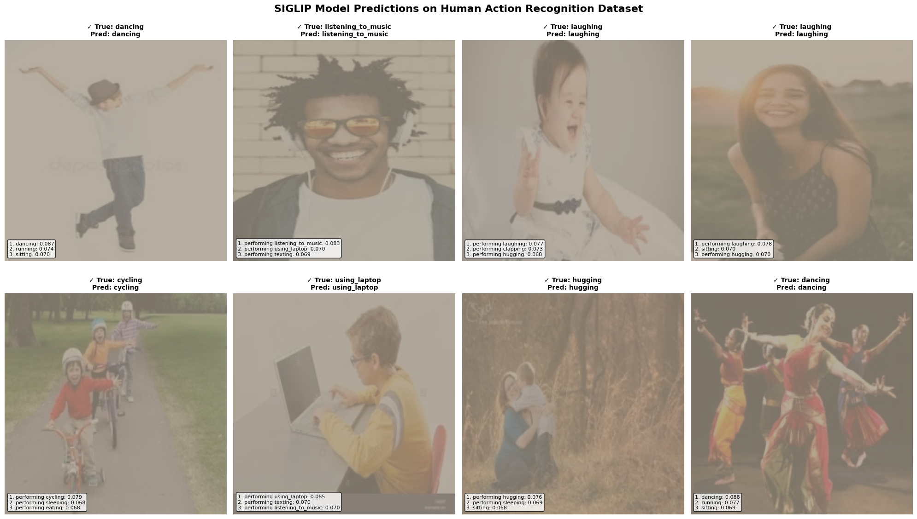Figure 4: SIGLIP Sample Image Identification after Finetune
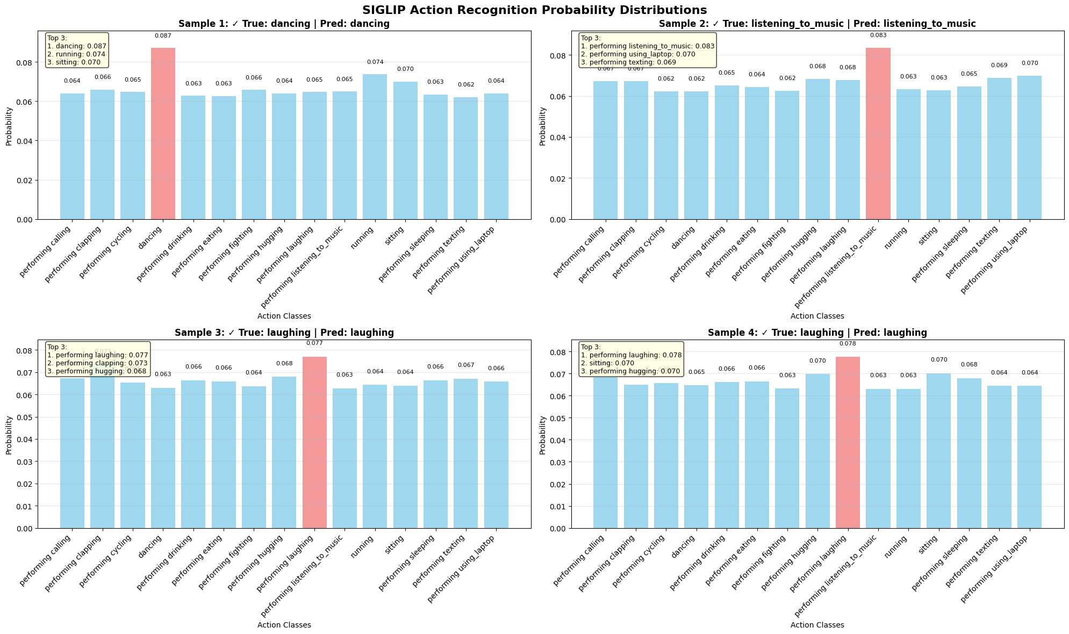Figure 5: SIGLIP Probability Distributions for Sample Images

Insights

I did not have the time to complete A-CLIP finetuning, however between CLIP and SIGLIP, SIGLIP took one third as much VRAM and got a 6% higher accuracy on the validation data. So I would use SIGLIP for image tasks since it can be run on a decent laptop and actually works better. Using the Sigmoid function really did help to reduce resource usage.

