**PubHub 100**

**Project Objective:**

For this project, you will be extending the Book Publishing System of PubHub, a self-publishing platform that allows anyone to write, publish, and sell their own books. You will be provided with an application that comprises the basic functionality for uploading and downloading files from the PubHub database.

It will be your responsibility to add a tagging system. Users should be able to add descriptive tags to books, and then search the application for books based on those tags. You will have to modify the database to support this new data, and write the code that not only stores and retrieves this information to and from the database, but also displays it for a user and allows them to manipulate it through an online interface.

The table **BOOK_TAGS** should have the following columns:

* Isbn_13
* Tag_name

Together, BOOK_TAGS.isbn_13 and BOOKTAGS.tag_name will operate as a composite key.

The table **BOOKS** should have a one-to-many relationship with BOOK_TAGS.

BOOK_TAGS.isbn_13 will be a foreign key to BOOKS.isbn_13.

**Technologies Used:**

1. Java
2. HMTL
3. CSS
4. JDBC
5. Servlets
6. JSPs

**Entity Relational Diagram:**

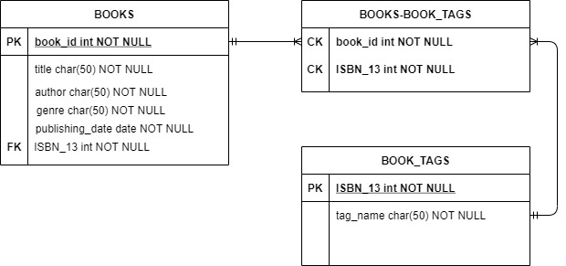

**Subobjective 01**

In this objective, you will create an interface for the book tags functionality of this application. Just put down the different type of CRUD(create, read, update, delete) functions to apply to the book tags. Name this interface file tagDAO.java.

**Subobjective 02**

Your next task is to create a Tag POJO that can store and map the data you're saving in your database tables, and relate it to the Book class if necessary. In this objective you will implement those interfaces and code your complete DAO (Data Access Layer) that forms a link between the Java Code and the SQL database backend.

As usual, feel free to use the existing BookDAOImpl class as a guideline for this process.