3.3 Usecase Diagram
Figure 3.4.1
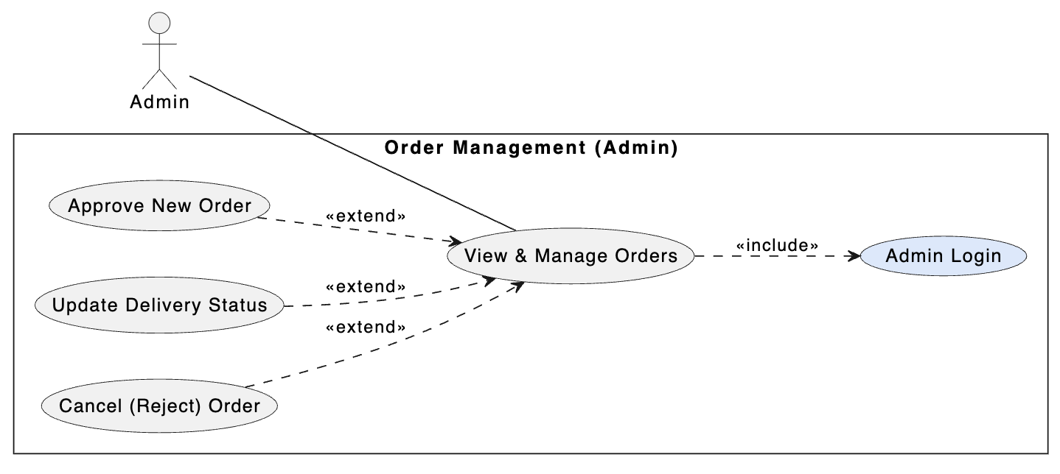
Field | Description
Use Case Name | User Login
Description | Allows staff or admin to authenticate and access the Dashboard module.
Actor | Agent, Admin
Pre-condition | User account has been created and exists in the database.
Post-condition | Session/JWT is successfully created on both browser and server.
Main Flow | 1. User opens Login page.  2. User enters Email and Password.  3. Browser sends POST /auth/login.  4. Server validates database and password hash.  5. If valid, server returns token; client stores token and redirects to /admin/dashboard.

Figure 3.4.2
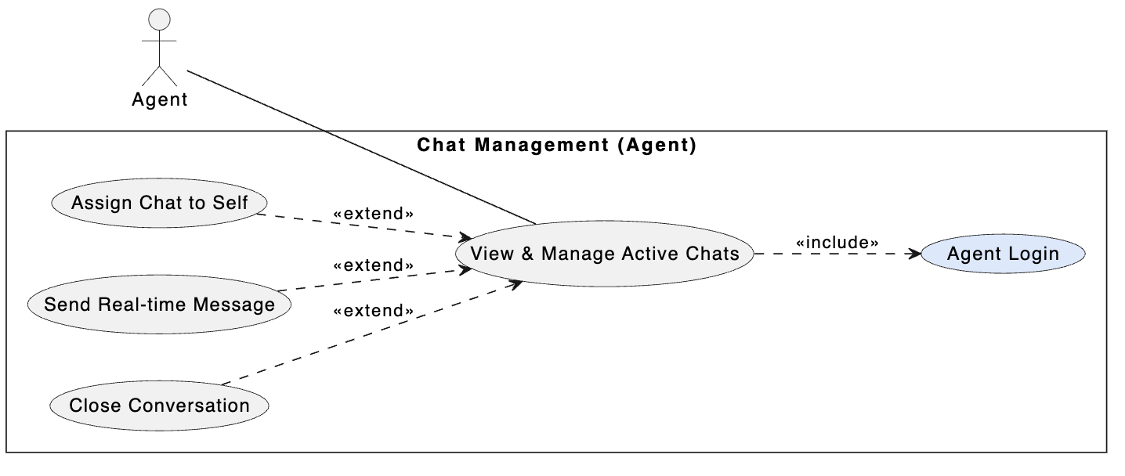
Field | Description
Use Case Name | Chat Initialization
Description | Allows customers to start a chat session for consultation.
Actor | Customer
Pre-condition | Network connection is available and chat server is running.
Post-condition | A Conversation record is created with status open.
Main Flow | 1. Customer opens chat widget.  2. Customer enters information (Name/Phone) and clicks Start.  3. System creates Conversation record in DB.  4. SessionID returned for WebSocket connection.  5. Chat window opens ready for messaging.

Figure 3.4.3
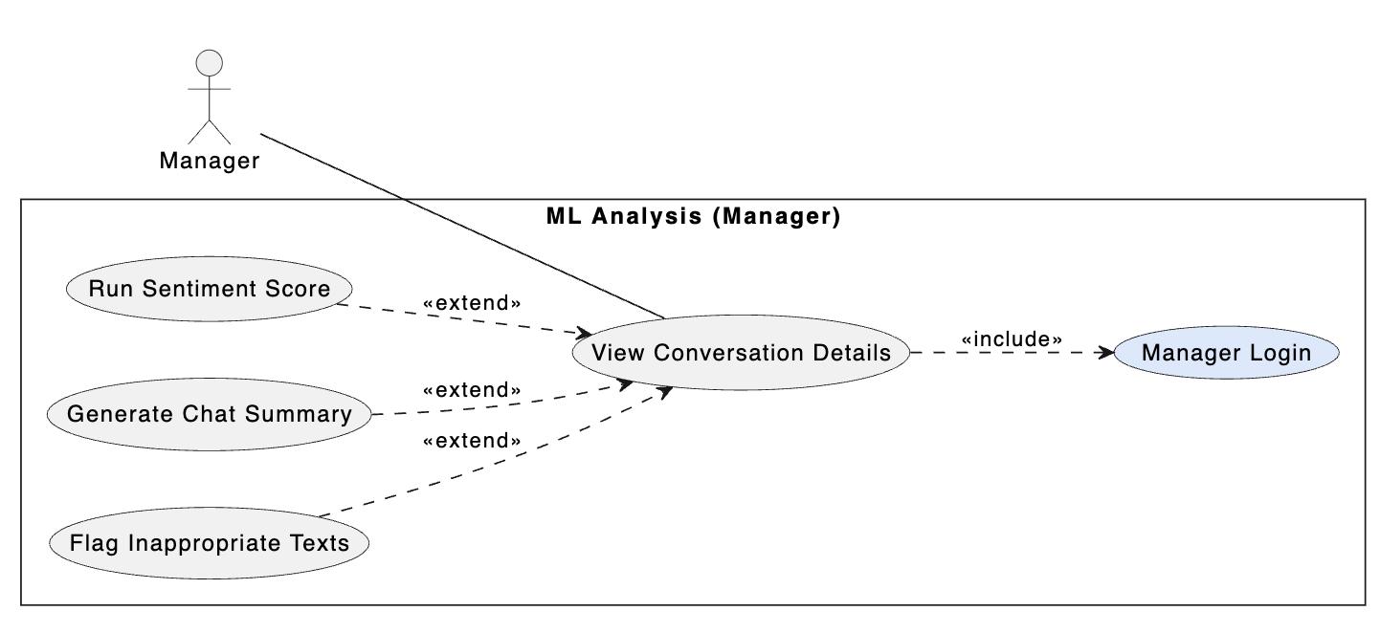
Field | Description
Use Case Name | Agent Chat Assignment
Description | Allows an agent to take an unassigned conversation and handle it.
Actor | Agent
Pre-condition | Agent logged in and viewing Active Chats. Customers waiting.
Post-condition | Chat status becomes inprogress and Agent ID stored.
Main Flow | 1. Agent views unassigned chats.  2. Agent clicks Assign to Me.  3. Server updates DB with agent ID.  4. WebSocket notifies customer that agent joined.  5. Agent starts messaging.

Figure 3.4.4
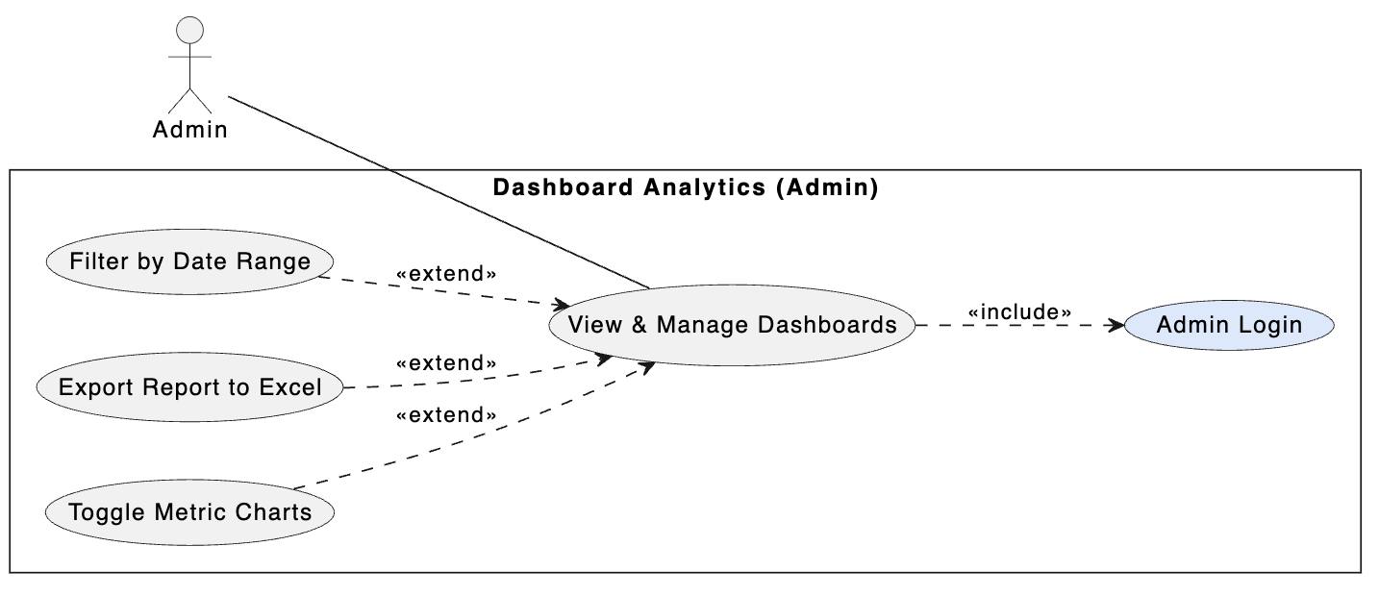

Field | Description
Use Case Name | Message Analysis
Description | Runs ML model to evaluate sentiment and summarize conversation.
Actor | Admin, Agent
Pre-condition | Conversation finished and ML service running.
Post-condition | Conversation updated with Sentiment Score and Summary.
Main Flow | 1. User clicks Analyze Conversation.  2. Backend queries all messages from DB.  3. Server sends JSON to FastAPI ML service.  4. Python runs sentiment and summarization model.  5. Results saved and charts displayed.

Figure 3.4.5
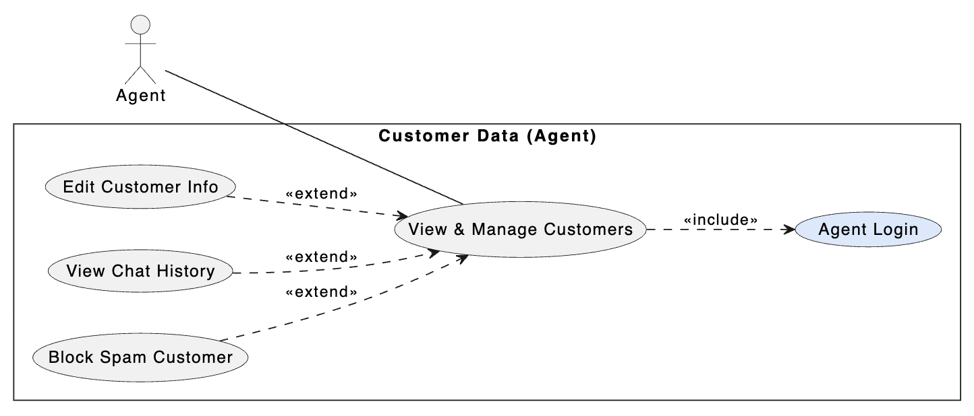
Field | Description
Use Case Name | Batch Analysis
Description | Automatically analyzes all conversations missing ML metrics.
Actor | Admin
Pre-condition | Admin permission and chats without sentiment tags exist.
Post-condition | All chats updated with ML metrics.
Main Flow | 1. Admin clicks Run Batch Analysis.  2. System selects top 20/50 unanalyzed chats.  3. Loop processes each chat via ML server.  4. Database updated.  5. Completion notification shown.

Figure 3.4.6
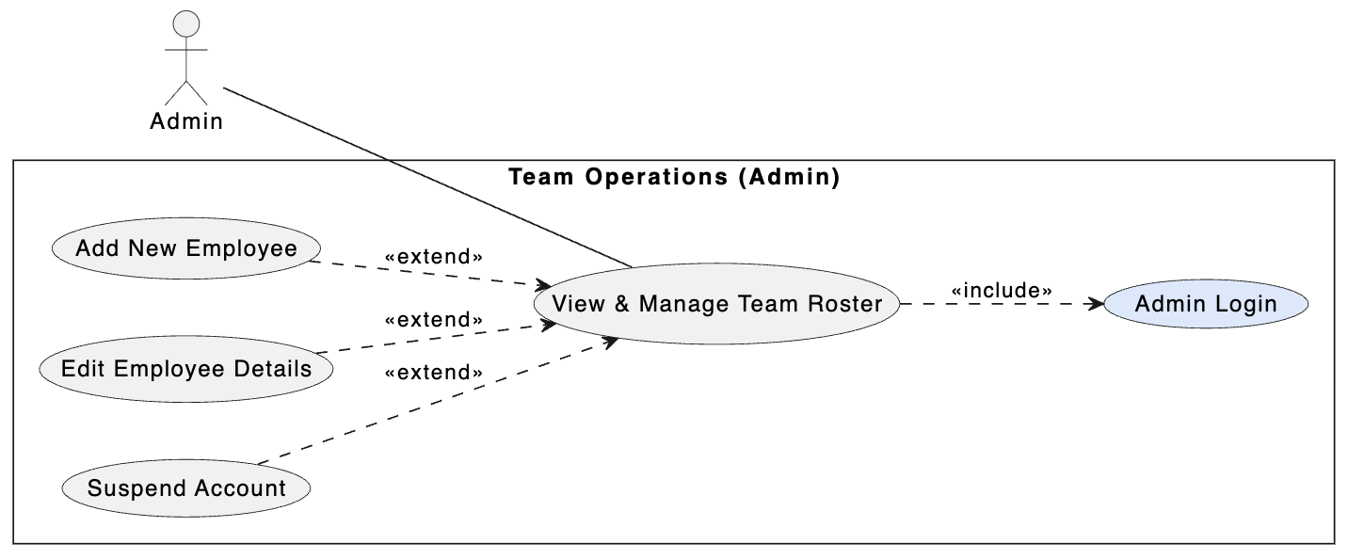
Field | Description
Use Case Name | Dashboard Analytics Retrieval
Description | Aggregates and displays team KPI metrics.
Actor | Admin, Manager
Pre-condition | Admin account and database contains conversation logs.
Post-condition | Read-only aggregated metrics returned.
Main Flow | 1. Manager selects report page and date filter.  2. Request GET /evaluation/report sent.  3. Server performs GROUP BY / SUM queries.  4. Server calculates averages.  5. JSON returned and charts rendered.

Figure 3.4.7
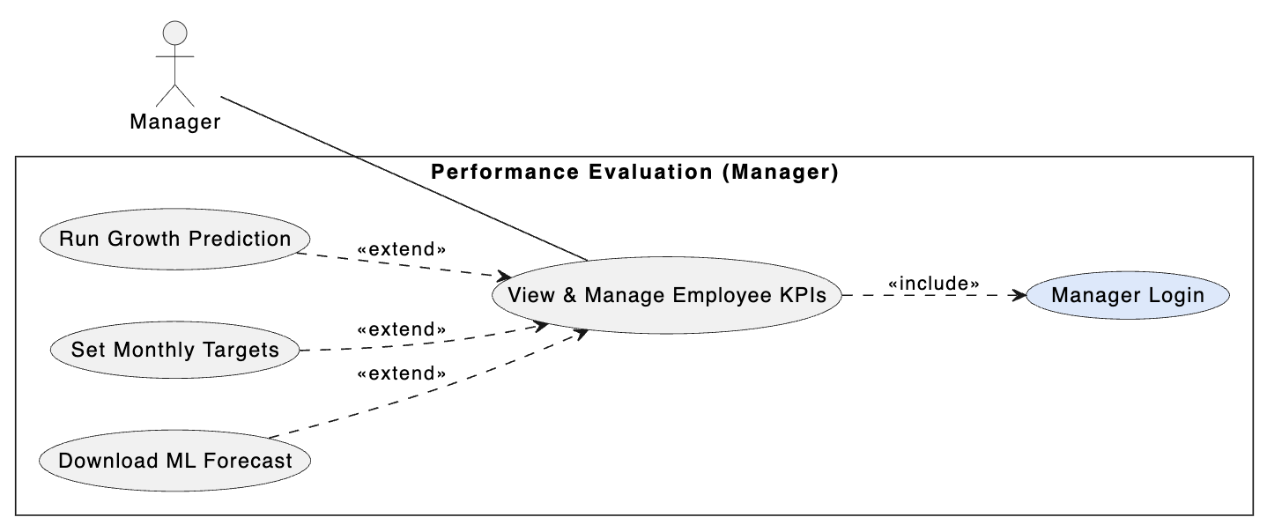
Field | Description
Use Case Name | Team Management
Description | Create, update, or delete employee profiles.
Actor | Admin
Pre-condition | Admin logged in with HR permission.
Post-condition | Employee table updated.
Main Flow | 1. Admin opens Team Management.  2. Click Create or Edit.  3. Enter name, department, role.  4. Frontend validation.  5. Server creates/updates DB record.

Figure 3.4.8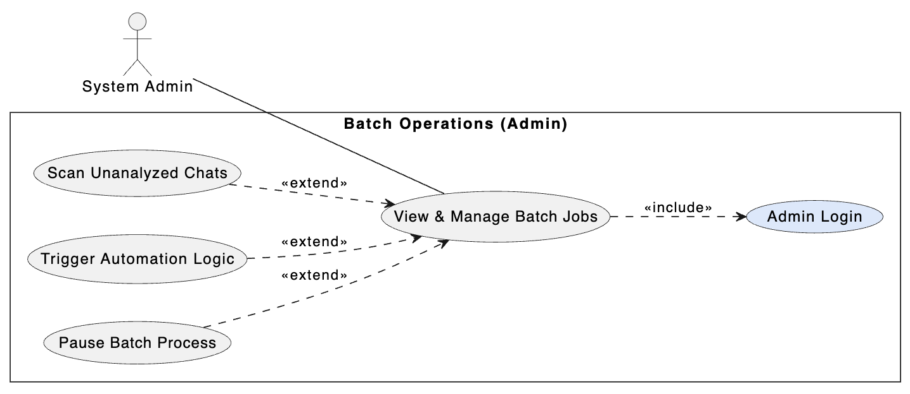

Field | Description
Use Case Name | Employee Performance Prediction
Description | Predicts future performance trend using historical logs.
Actor | Admin, Manager
Pre-condition | Employee has sufficient historical data.
Post-condition | Future trend chart displayed.
Main Flow | 1. Manager opens employee profile.  2. Click Run Prediction.  3. Backend retrieves historical scores.  4. Data sent to FastAPI ML model.  5. Prediction returned and displayed.

Figure 3.4.9
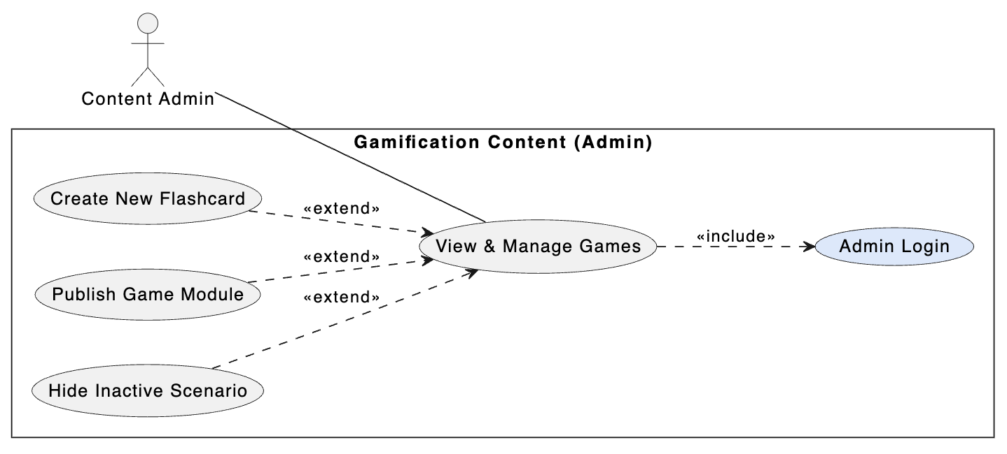
Field | Description
Use Case Name | Global Settings Configuration
Description | Modify global system parameters such as timeout and greeting message.
Actor | Admin
Pre-condition | SuperAdmin login.
Post-condition | New configuration values saved.
Main Flow | 1. Open Global Settings tab.  2. Modify parameters.  3. Browser sends PUT /api/settings.  4. Server upserts configuration.  5. Success message displayed.

Figure 3.4.10
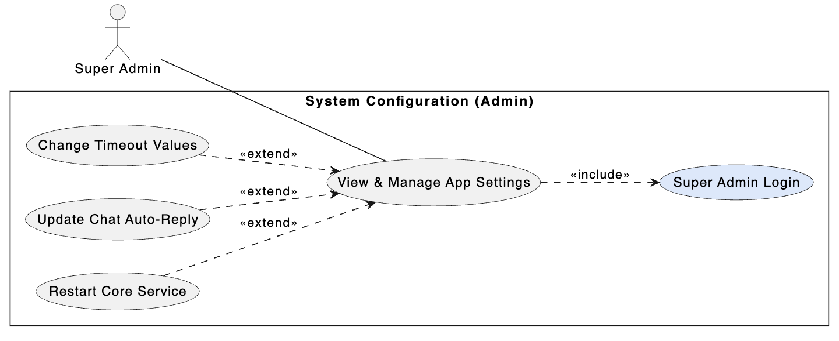
Field | Description
Use Case Name | Gamification Content Management
Description | Create and manage game content integrated in the system.
Actor | Admin, Agent
Pre-condition | User has game publishing permission.
Post-condition | New game content available for users.
Main Flow | 1. Open Game CMS.  2. Configure game rules and rewards.  3. Click Publish.  4. Backend validates and creates GameID.  5. Database updated and UI refreshed.

3.4. Activity Diagram
Figure 3.4.1 user login
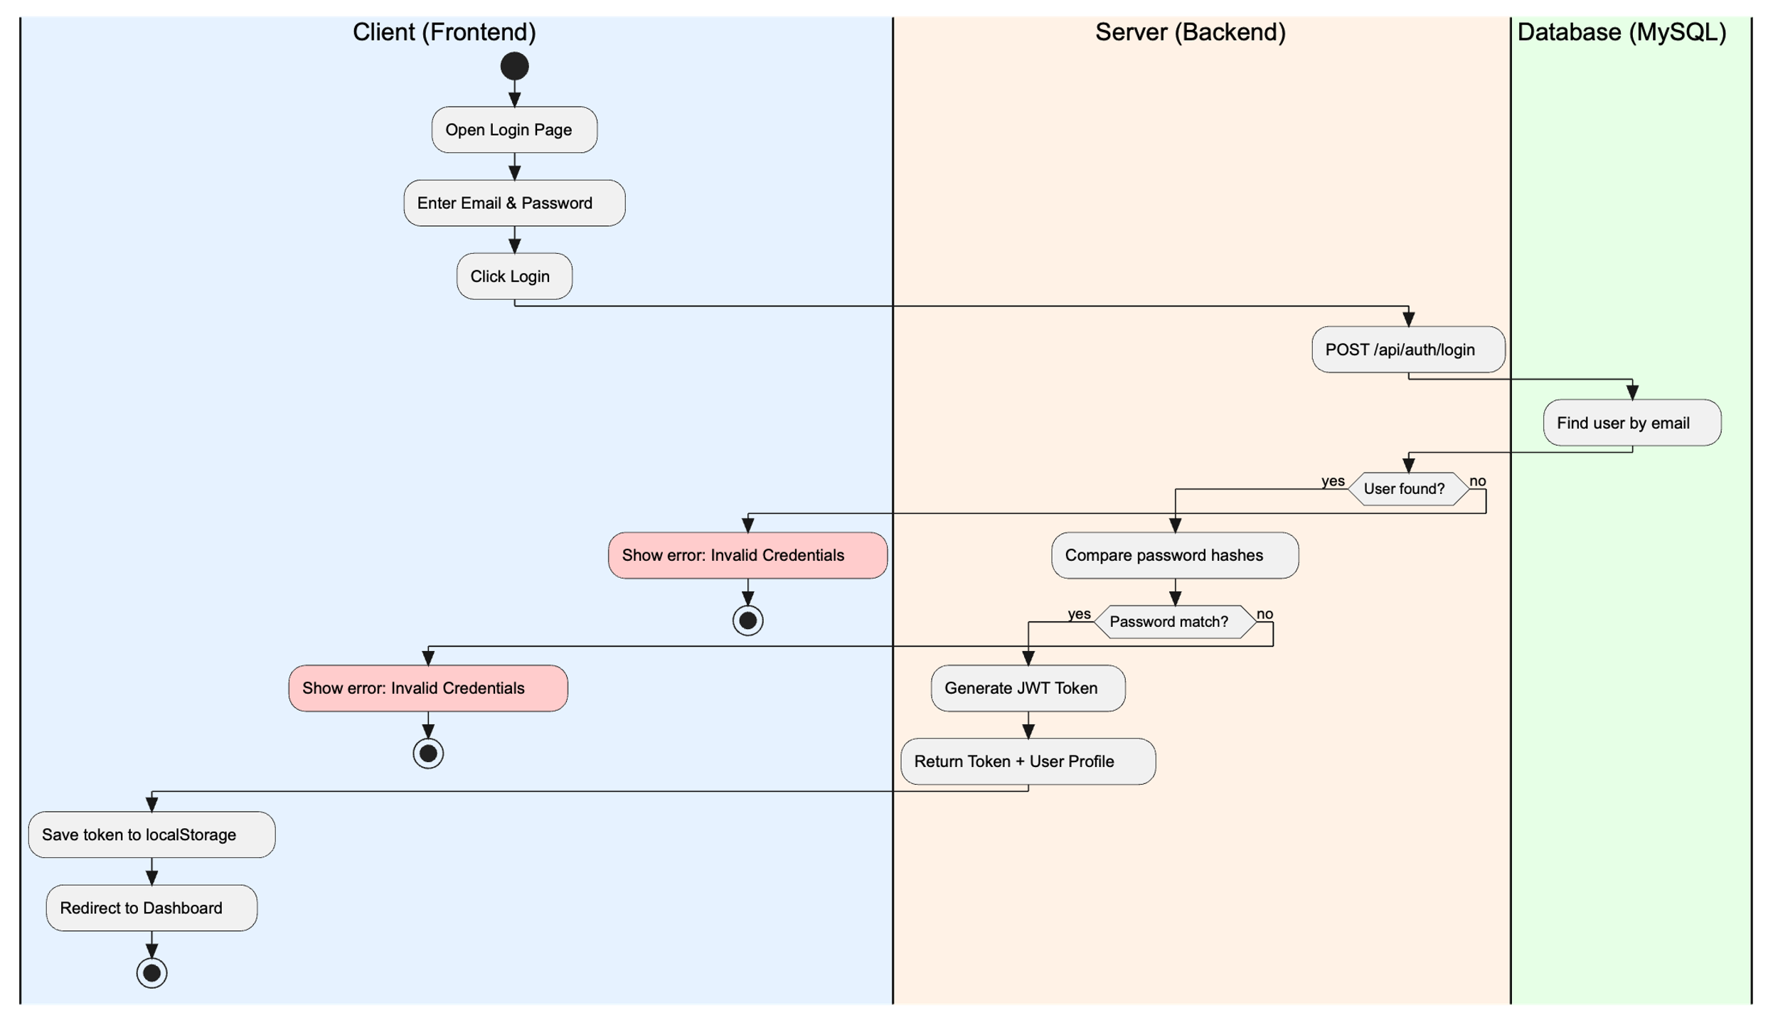

Figure 3.4.2 chat initialization
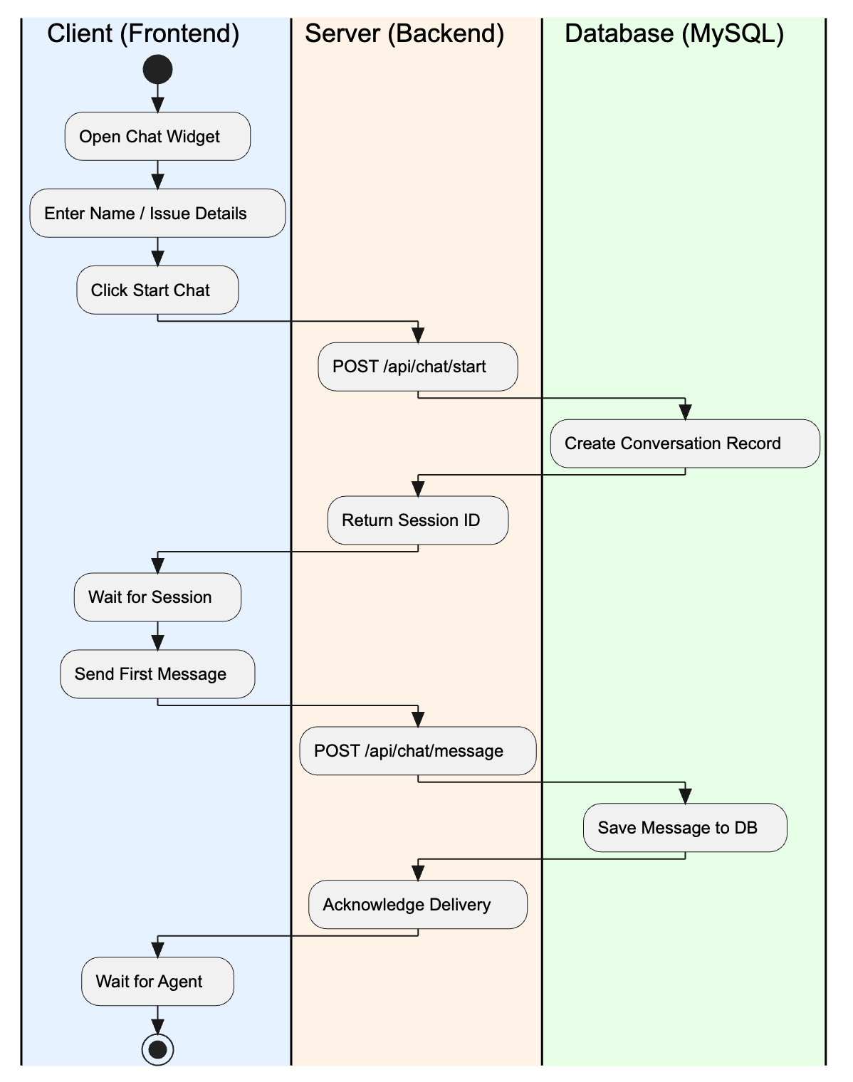

Figure 3.4.3 chat assignment
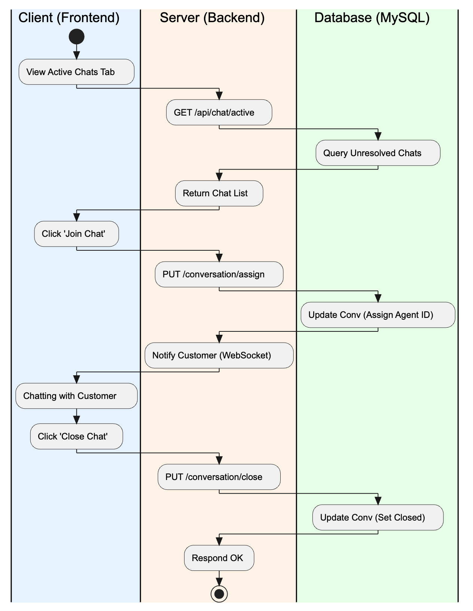
Figure 3.4.4 message analysis
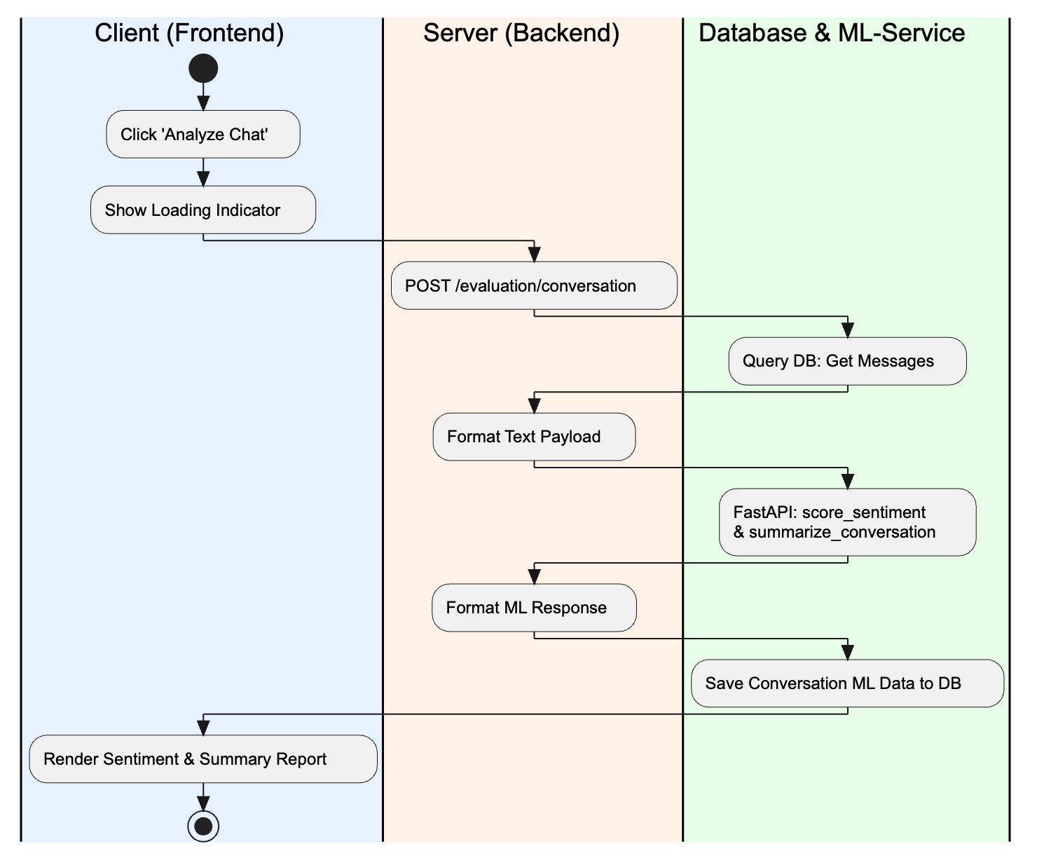

Figure 3.4.5 batch analysis
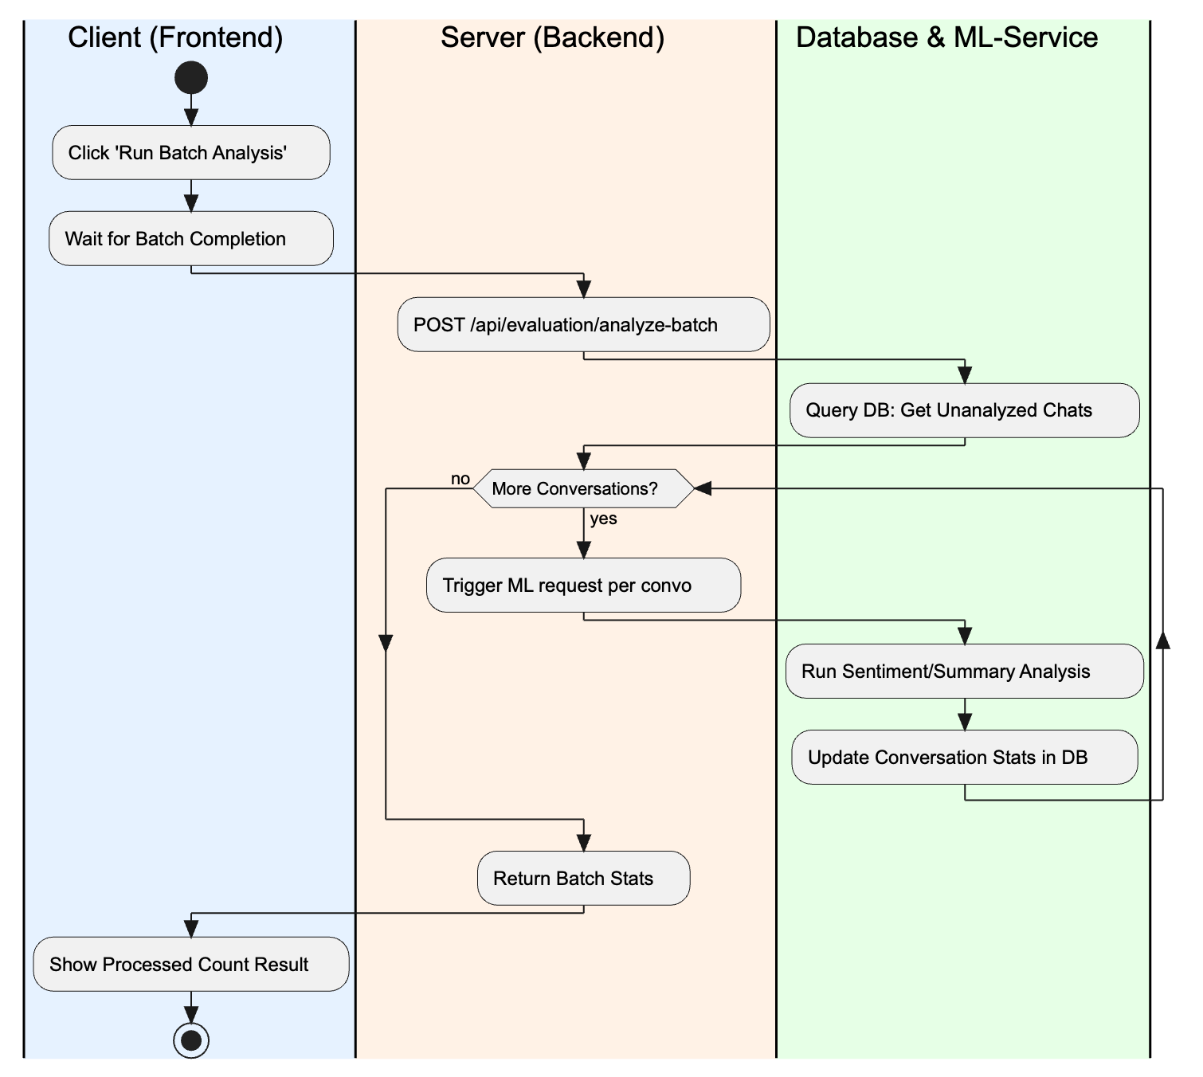

Figure 3.4.6 dashboard analytics
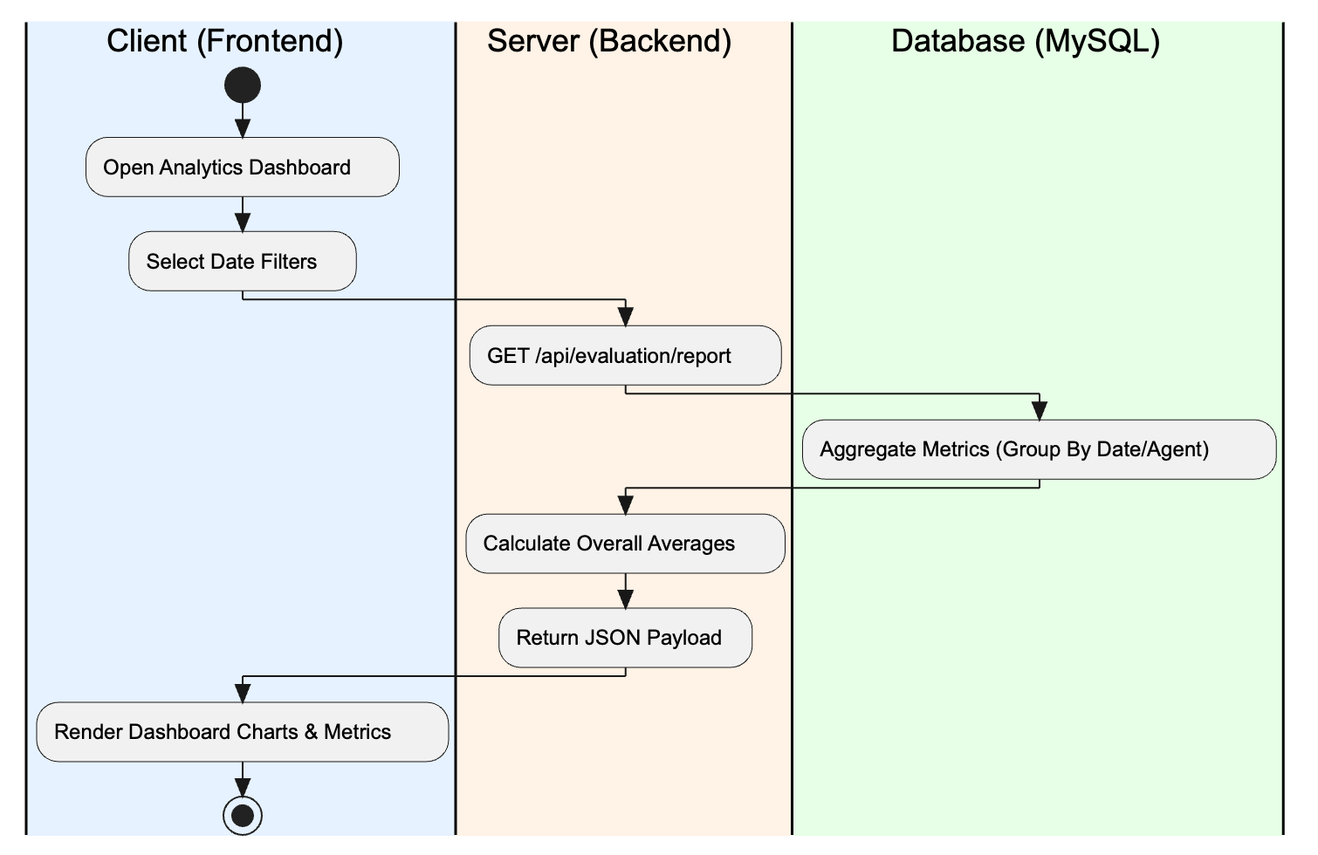
Figure 3.4.7 team management
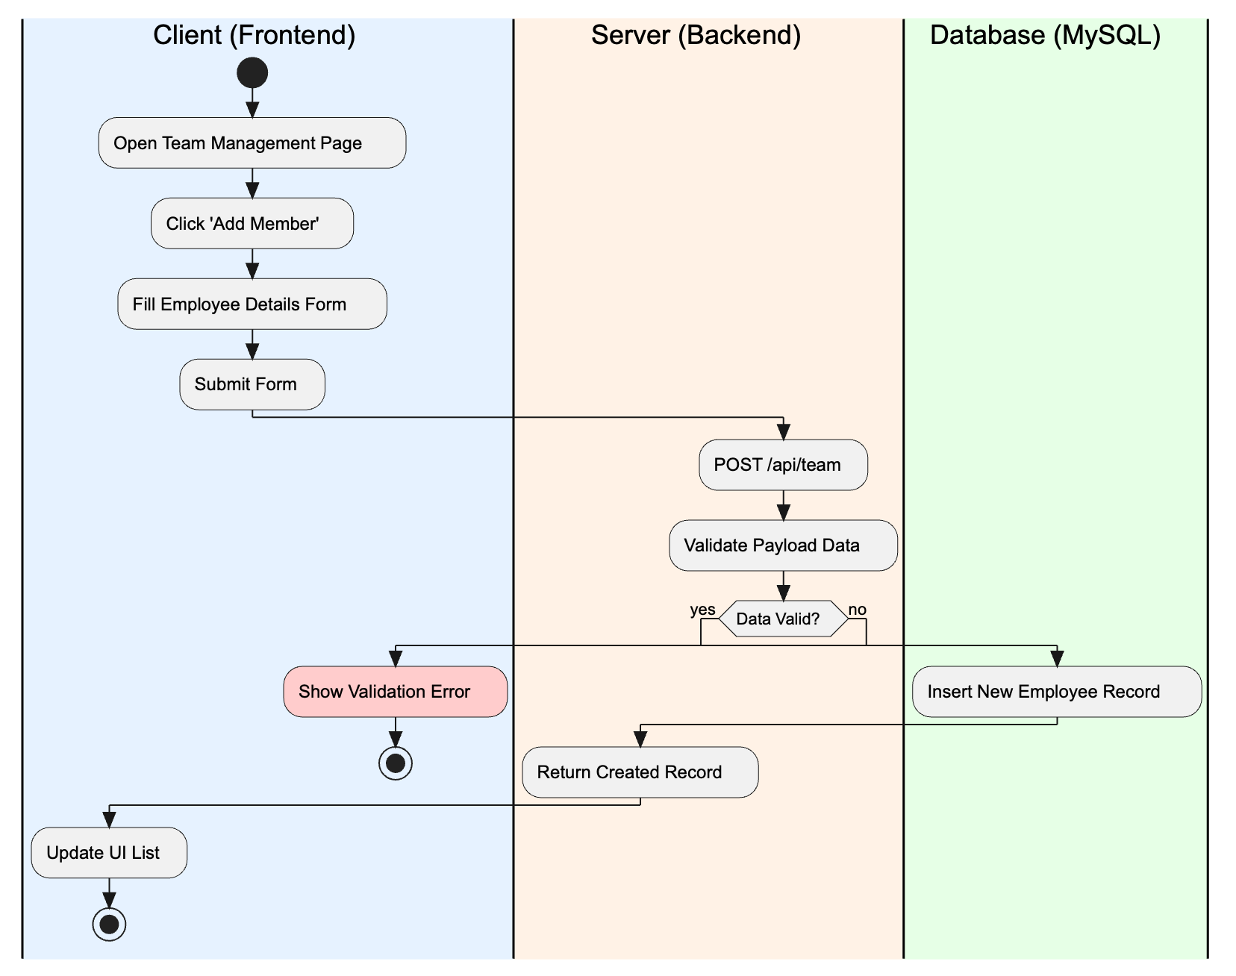

Figure 3.4.8 employee prediction
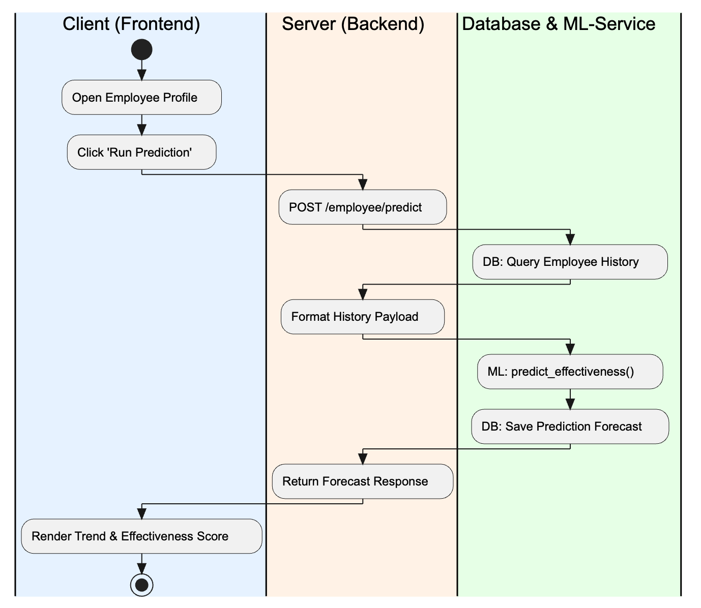
Figure 3.4.9 global settings
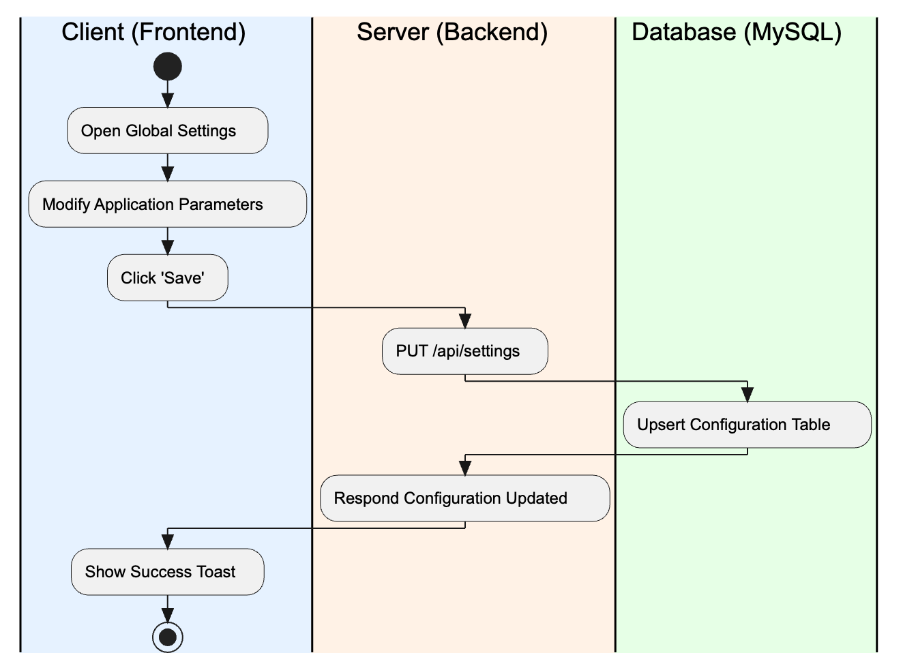
Figure 3.4.10 gamification
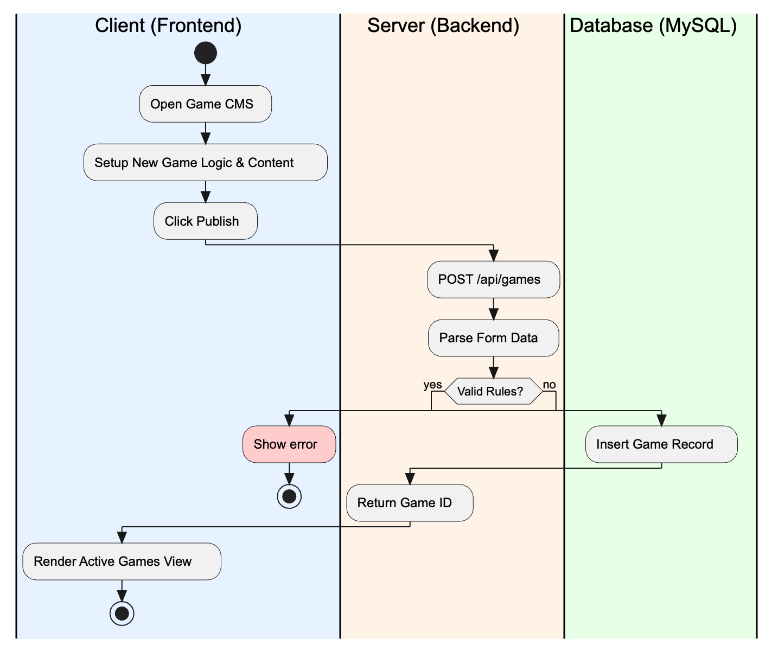

3.5 Sequence Diagrams
Figure 3.5.1 User Login Flow
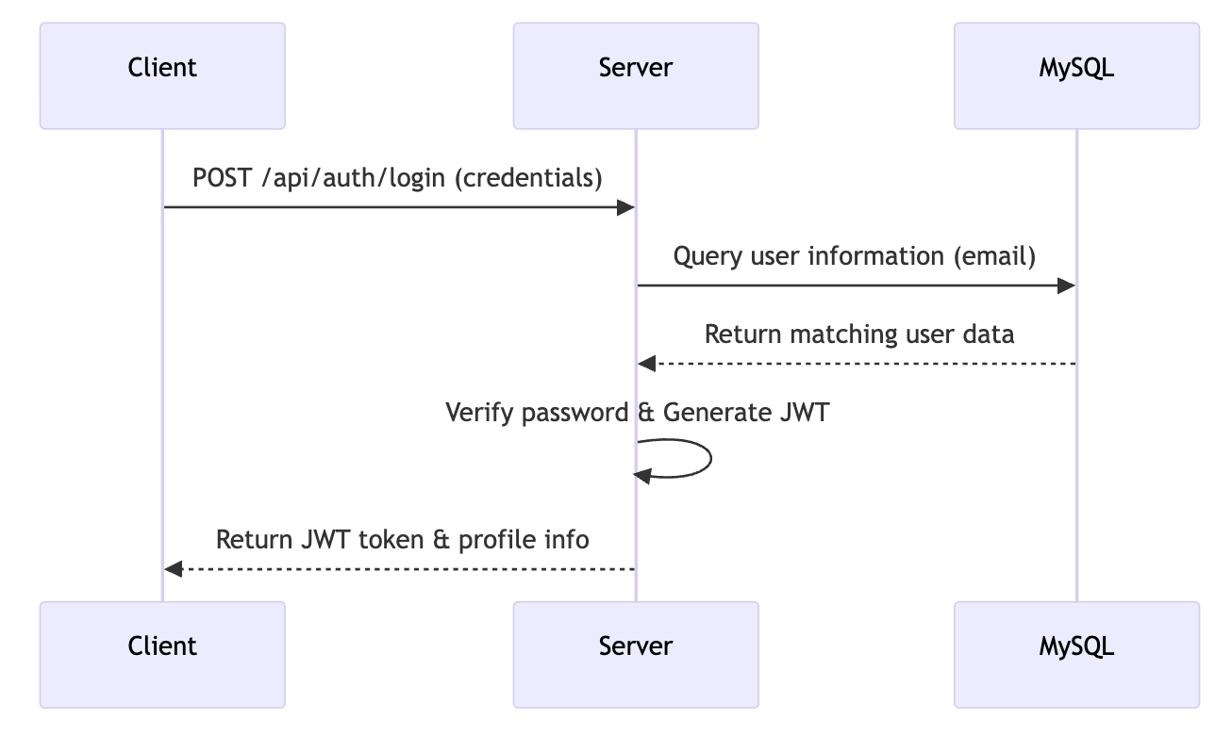
Figure 3.5.2 Customer Chat Initialization Flow
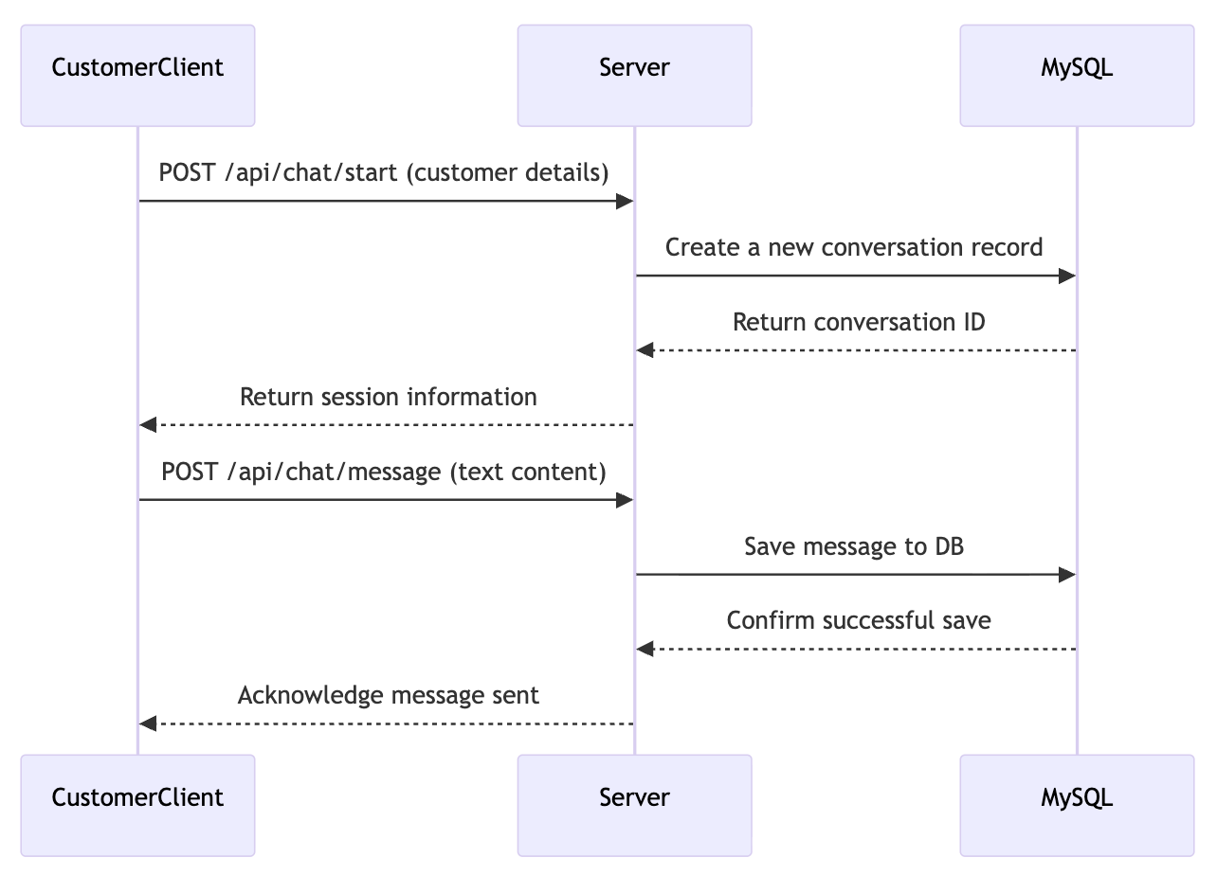
Figure 3.5.3 Agent Chat Assignment & Management Flow
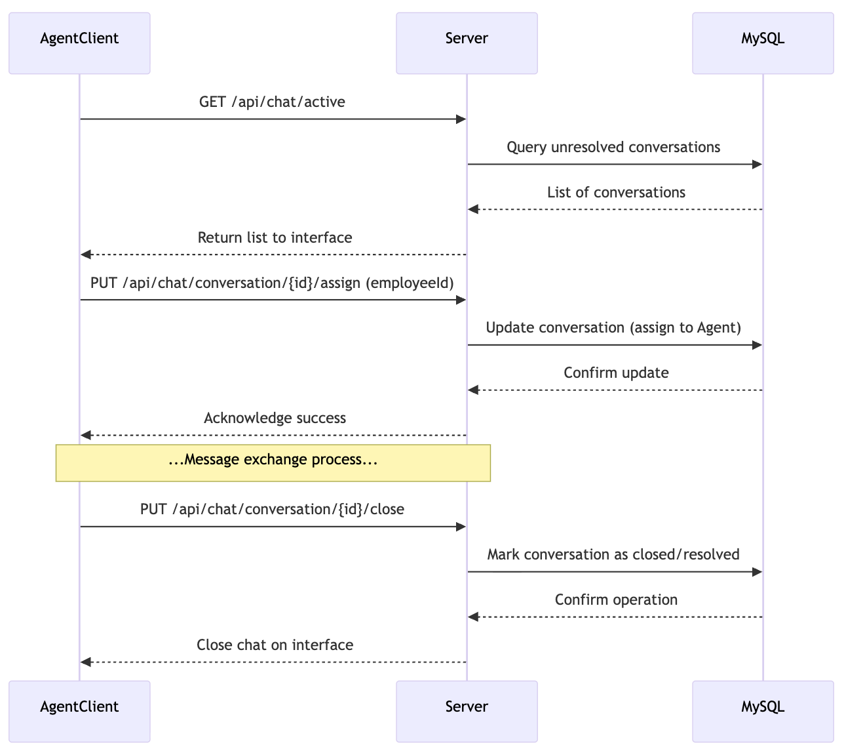
Figure 3.5.4 Message Analysis Flow

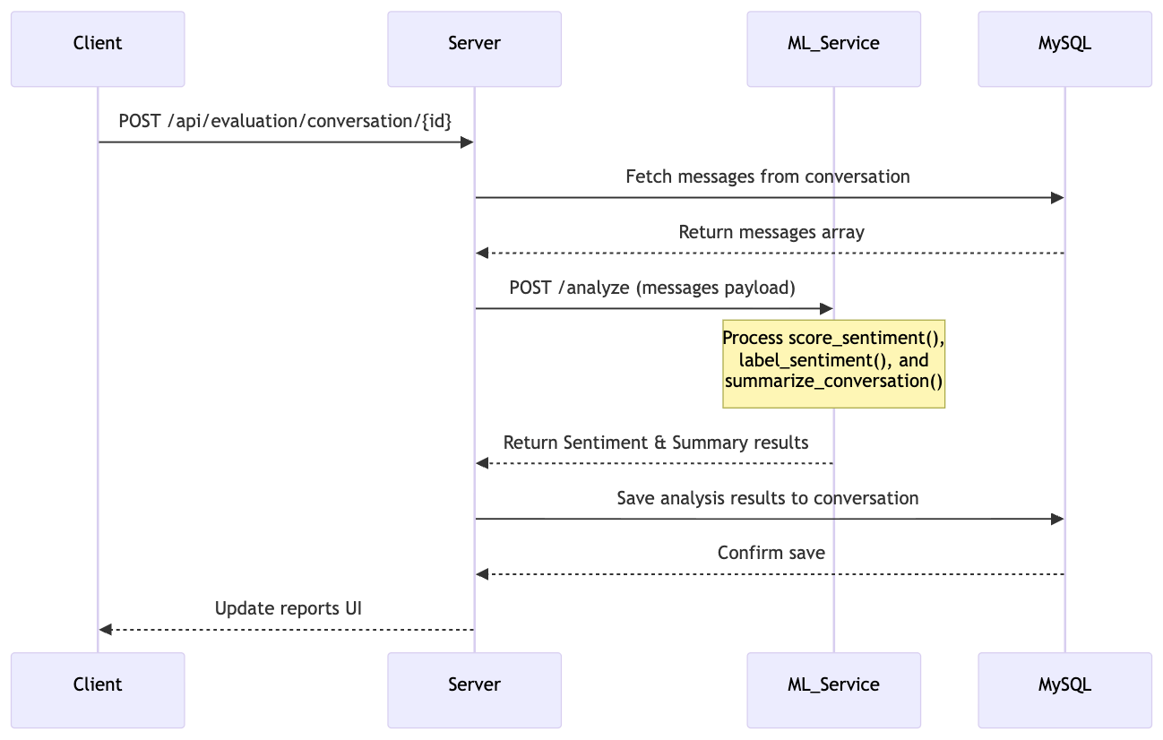
Figure 3.5.5 Batch Analysis Processing Flow
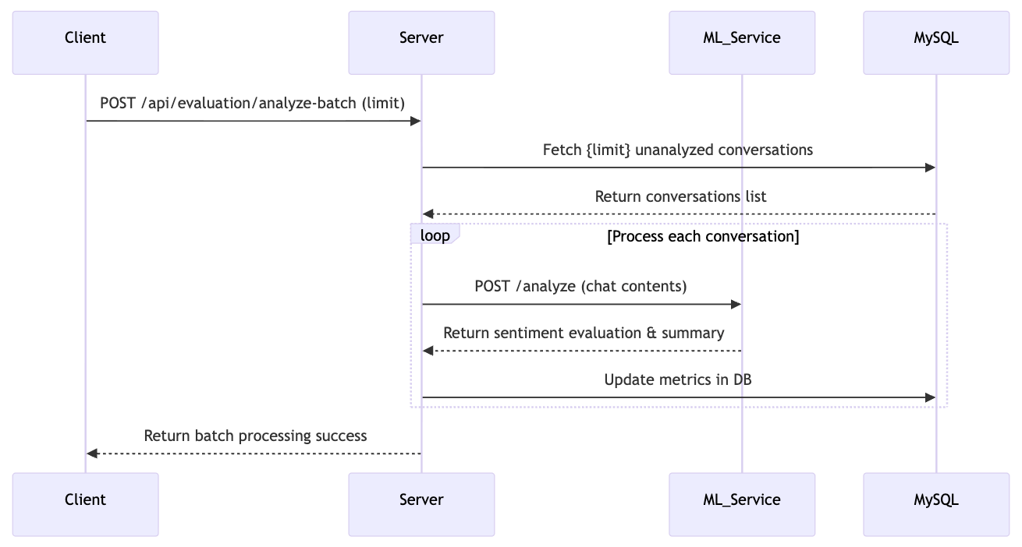
Figure 3.5.6 Dashboard Analytics Data Retrieval Flow
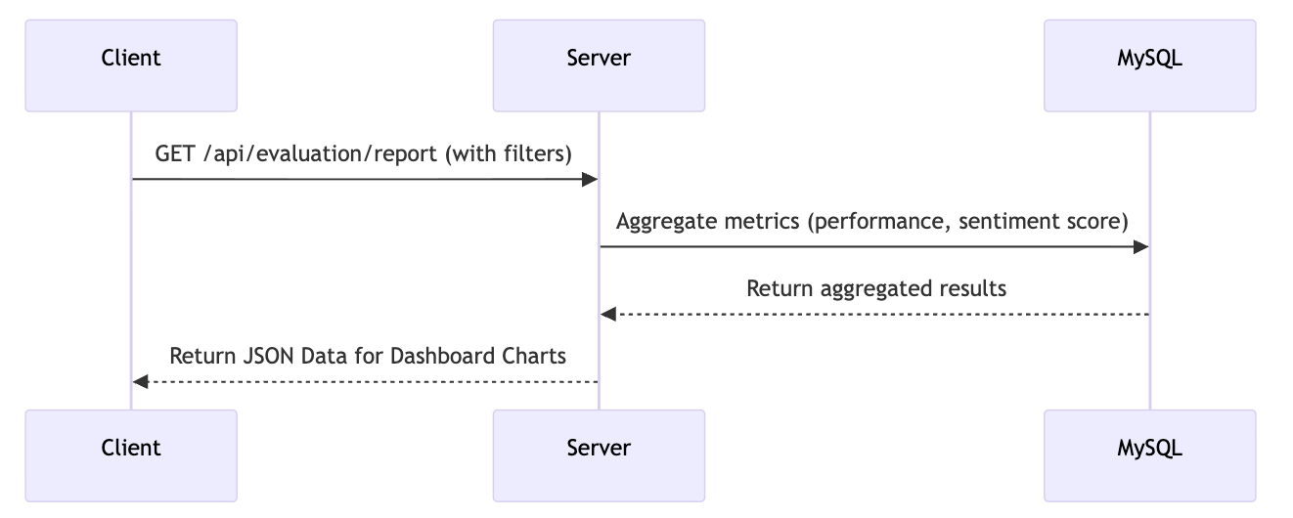

Figure 3.5.7 Team Management Flow
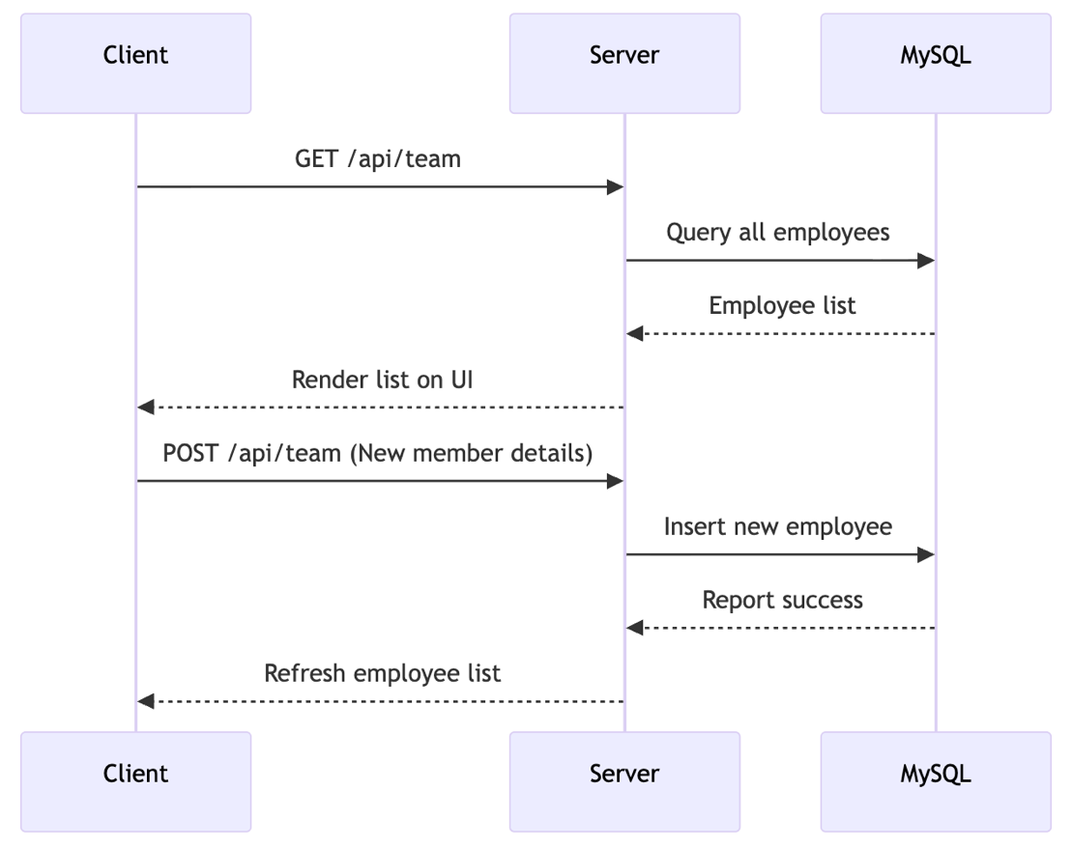
Figure 3.5.8 Employee Performance Prediction Flow
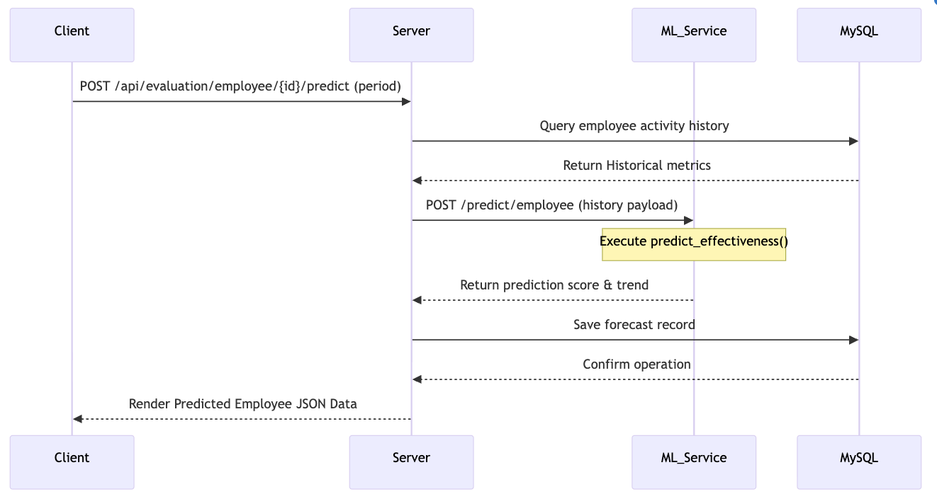

Figure 3.5.9 Global Settings Management Flow
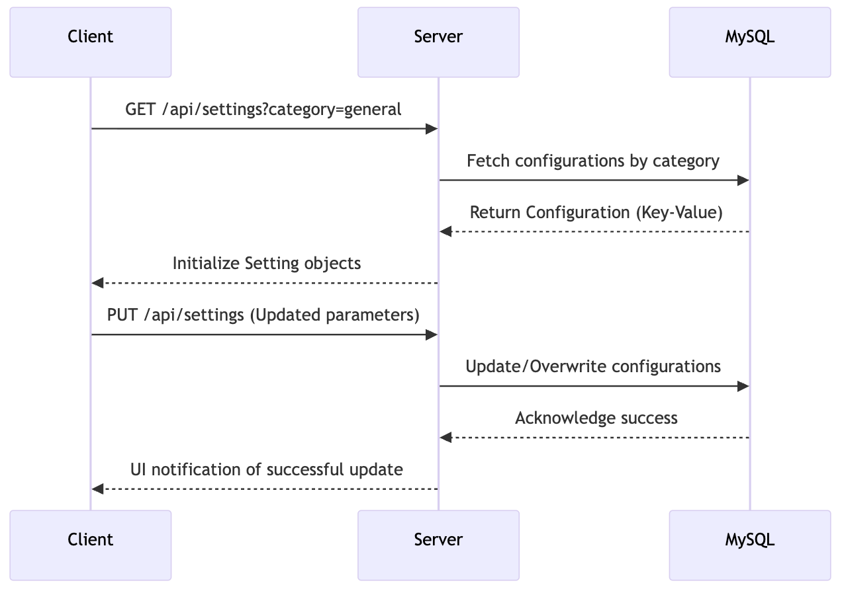
Figure 3.5.10 Gamification Management Flow
