Question 1
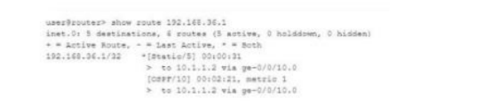
Referring to the exhibit, which route(s) will be selected by Junos for packet forwarding?
A. The OSPF route will be selected.
B. The static route will be selected.
C. The Junos OS randomly selects one route.
D. The Junos OS selects both routes.
Correct Answer: B
* Explanation/Reference:

Question 2
You want to find out the chassis serial number of a Junos device.
Which command would display this information?
A. show chassis environment
B. show chassis hardware
C. show chassis routing-engine
D. show chassis location
Correct Answer: B
* Explanation/Reference:

Question 3
Which two components are included in a transport header? (Choose two.)
A. destination MAC address
B. destination port number
C. source MAC address
D. source port number
Correct Answer: BD
* Explanation/Reference:

Question 4
What is a benefit of using J-Web?
A. It simultaneously manages multiple devices.
B. It provides a customizable dashboard.
C. It provides more advanced features than the CLI.
D. It provides console-based management.
Correct Answer: B
* Explanation/Reference:

Question 5
Which Junos OS component is responsible for maintaining the forwarding table?
A. Packet Forwarding Engine
B. chassis control daemon
C. Routing Engine
D. management daemon
Correct Answer: A
*Explanation/Reference:

Question 6
What are two examples of exception traffic? (Choose two.)
A. transit packets
B. routing updates
C. log messages
D. ping to the local device
Correct Answer: BD
*Explanation/Reference:

Question 7
You are trying to diagnose packet loss at interface ge-0/0/3.
In this scenario, which command would help you view error statistics in real
time?
A. monitor interface ge-0/0/3
B. show interface ge-0/0/3
C. show interface terse
D. monitor interface traffic
Correct Answer: A
* Explanation/Reference:

Question 8
What are two methods for navigating to configuration mode from an operational mode prompt? (Choose two.)
A. Use the quit command.
B. Use the configure command.
C. Use the exit command.
D. Use the edit command.
Correct Answer: BD
*Explanation/Reference:

Question 9
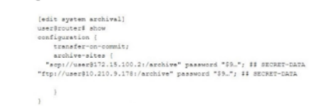Click the Exhibit button.
Referring to the exhibit, where are the configuration backup files stored?
A. Files are stored to any site as selected by Junos internally.
B. Files are stored to the SCP site but if the transfer fails, then to the FTP site.
C. Files are stored to the SCP site and the FTP site in a round-robin manner.
D. Files are stored to the SCP site and the FTP site simultaneously. Cùng 1 lúc
Correct Answer: D
* Explanation/Reference:

Question 10
You issue the telnet 10.10.10.1 source 192.168.100.1 command.
Which two statements are correct in this scenario? (Choose two.)
A. The telnet session will have a source address of 192.168.100.1.
B. The telnet session will have a destination address of 192.168.100.1.
C. The telnet session will have a source address of 10.10.10.1.
D. The telnet session will have a destination address of 10.10.10.1
Correct Answer: AD
* Explanation/Reference:

Question 11
You are logged in to a Junos OS device with SSH and issued the show protocols I compare command in the configuration, but no output is shown.
Which statement is correct in this scenario?
A. The command only works for interface configuration differences.
B. There are no changes to the candidate configuration.
C. Someone accidentally deleted the active configuration.
D. You must commit the configuration before any output will be shown.
Correct Answer: B
* Explanation/Reference:

Question 12
What are two physical interface properties? (Choose two.) giao diện vật lý
A. MTU
B. routing protocols
C. IP address
D. MAC address
Correct Answer: AD
* Explanation/Reference:

Question 13
Which prompt indicates that you are using configuration mode?
A. >
B. $
C. #
D. %
Correct Answer: C
* Explanation/Reference:

Question 14
Which process in the Junos OS is responsible for maintaining routing protocols and tables?
A. rpd
B. mgd
C. chassisd
D. dcd
Correct Answer: A

* Explanation/Reference:

Question 15
How many rescue configuration files are supported on a Junos device?
A. 49
B. 3
C. 50
D. 1
Correct Answer: D
* Explanation/Reference:

Question 16
What are two functions of the Routing Engine? (Choose two.)
A. It runs the Junos operating system.
B. It processes all management traffic.
C. It processes transit traffic.
D. It evaluates firewall filters for transit traffic.
Correct Answer: AB
* Explanation/Reference:

Question 17
You need to recover the root password on a Junos router without losing the current configuration settings.
Which three statements describe what you should perform in this scenario? (Choose three.)
A. Enter and commit the new root password.
B. Load the factory-default configuration.
C. Upgrade the Junos OS to the latest version.
D. Hit the space bar and enter recovery when prompted.
E. Use a console connection to reboot the device.
Correct Answer: ADE
* Explanation/Reference:

Question 18
You are configuring a firewall filter on a Juniper device.
In this scenario, what are two valid terminating actions? (Choose two.)
A. count
B. discard
C. next term
D. accept
Correct Answer: BD
* Explanation/Reference:

Question 19
Which two statements are true about the Junos OS? (Choose two.)
A. Routing tables are stored in the control plane.
B. Exception traffic is never sent to the control plane.
C. Exception traffic is sent to the control plane.
D. Routing tables are stored in the forwarding plane.
Correct Answer: AC
* Explanation/Reference:

Question 20
You are asked to view the real-time usage statistics for the busiest interfaces on a device running Junos OS.
Which command will achieve this task?
A. monitor traffic absolute-sequence
B. monitor interface traffic
C. monitor traffic
D. show interfaces extensive
Correct Answer: B
* Explanation/Reference:

Question 21
When considering routing policies, which two statements are correct? (Choose two.)
A. Routing policies are applied to interfaces as input or export filters.
B. An import routing policy for BGP determines which received prefix advertisements are placed in the routing information base.
C. Policy terms are evaluated from top to bottom with action taken on the first match found.
D. Policy terms are evaluated from top to bottom with the most restrictive action taken of all the matching terms.
Correct Answer: BC
* Explanation/Reference:

Question 22
Which service does RADIUS provide?
A. routing
B. authentication
C. DNS resolution
D. time synchronization
Correct Answer: B
* Explanation/Reference:

Question 23
Which two common routing policy actions affect the flow of policy evaluation? (Choose two.)
A. next policy
B. community
C. next term
D. next hop
Correct Answer: AC
* Explanation/Reference:

Question 24
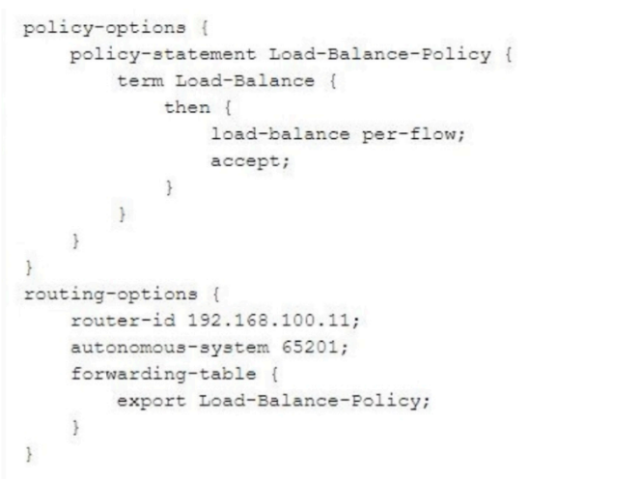

Referring to the exhibit, which two statements are correct? (Choose two.)
A. The policy enables equal cost load balancing in the forwarding table.
B. The policy must be applied under the protocols hierarchy.
C. The policy enables per-packet load balancing.
D. The policy enables flow-based load balancing.
Correct Answer: AD
* Explanation/Reference:

Question 25
What are two attributes of the UDP protocol? (Choose two.)
A. UDP is best effort.
B. UDP is always slower than TCP.
C. UDP is connectionless.
D. UDP is more reliable than TCP.
Correct Answer: AC
* Explanation/Reference:

Question 26
What will the request system configuration rescue save command do?
A. It saves the most recently committed configuration as the rescue configuration.
B. It saves the candidate configuration as the rescue configuration.
C. It saves a configuration version prior to the configuration most recently committed as the rescue configuration.
D. It activates the rescue configuration.
Correct Answer: A
* Explanation/Reference:

Question 27
What are two advantages of using the Junos OS? (Choose two.)
A. It supports up to a maximum of two previous configurations.
B. It enables you to roll back to a previous configuration.
C. It pushes your configuration changes "live" immediately.
D. It is modular.
Correct Answer: BD
* Explanation/Reference:

Question 28
What are two types of transit traffic that traverse the forwarding plane of a Layer 3 router? (Choose two.)
A. unicast traffic
B. multicast traffic
C. exception traffic
D. broadcast traffic
Correct Answer: AB
* Explanation/Reference:

Question 29
What are two benefits when implementing class of service? (Choose two.)
A. The network will be faster.
B. Traffic congestion can be managed.
C. Traffic congestion will be eliminated.
D. Latency-sensitive traffic can be prioritized
Correct Answer: BD
* Explanation/Reference:

Question 30
Which command displays all IPv6 routes in the default routing instance?
A. show route table inet.0
B. show route table inet6.1
C. show route table inet.l
D. show route table inet6.0
Correct Answer: D
* Explanation/Reference:

Question 31
You have just increased the MTU size of interface ge-0/0/0 and committed the configuration.
Which command would help you identify the applied MTU change?
A. monitor interface ge-0/0/0
B. monitor traffic interface ge-0/0/0
C. show interfaces ge-0/0/0 terse
D. show interfaces ge-0/0/0
Correct Answer: D
* Explanation/Reference:

Question 32
Which two external authentication methods does Junos support for administrative access? (Choose two.)
A. ACE
B. ONIS
C. RADIUS
D. TACACS+
Correct Answer: CD
* Explanation/Reference:

Question 33
What information does the forwarding table require so that the device forwards traffic? (Choose three.)
A. next hop MAC address
B. OSPF metric value
C. next hop IP address
D. BGP local preference value
E. outgoing interface name
Correct Answer: ACE
* Explanation/Reference:

Question 34
Which Junos feature limits the amount of exception traffic that is sent from the PFE to the RE?
A. scheduler
B. policer
C. CoS markings
D. routing policy
Correct Answer: B
* Explanation/Reference:

Question 35
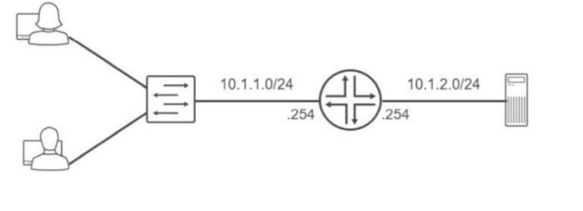
Referring to the exhibit, which routing configuration is required for these two users to access the remote server?
A. Users must connect directly to the router.
B. Users and the server require a default gateway.
C. Trunk ports must be enabled on the switch.
D. A routing protocol must be enabled on the router.
Correct Answer: B
* Explanation/Reference:

Question 36
Which criteria does the Junos OS use to select an active route when two entries exist in the routing table?
A. the route with the lowest preference number
B. the route with the highest preference number
C. the most recently learned dynamic route
D. the route with the highest metric
Correct Answer: A
* Explanation/Reference:

Question 37
You have configured some interfaces on a Junos device; however, you have not
yet committed the configuration.
What happens if you issue the rollback 0 command in this scenario?
A. The factory default configuration is loaded.
B. The Junos device is rebooted.
C. The interface changes you made are discarded.
D. The messages.log file is deleted.
Correct Answer: C
* Explanation/Reference:

Question 38
When considering routing tables and forwarding tables, which two statements are correct? (Choose two.)
A. The forwarding table stores all routes and prefixes from all protocols.
B. The forwarding table is used by the RE to select the best route.
C. The routing table is used by the RE to select the best route.
D. The routing table stores all routes and prefixes from all protocols.
Correct Answer: CD
* Explanation/Reference:

Question 39
Which type of device uses the destination IP address to forward packets?
A. Layer 2 switch
B. repeater
C. hub
D. Layer 3 router
Correct Answer: D
*Explanation/Reference:

Question 40
What are two ways that the carrier-sense multiple access with collision detection (CSMA/CD) MAC protocol help devices "talk" with each other in an Ethernet network? (Choose two.)
A. It allows an Ethernet device to check to see if anything else is transmitting before trying to send.
B. It allows a network device to either transmit data or receive data.
C. It operates in half-duplex or full-duplex mode.
D. It allows a network device to transmit and receive data simultaneously.
Correct Answer: AB
* Explanation/Reference:

Question 41
An administrator configures a router's interface with an IPv4 address and subnet mask. The administrator also confirms that this interface is in an up state.
In this scenario, which two route types are created on the local router? (Choose two.)
A. a local route
B. a dynamic route
C. a static route
D. a direct route
Correct Answer: AD
* Explanation/Reference:

Question 42
What information would you find using the CLI help command?
A. message of the day
B. a URL for accessing the technical documentation
C. an explanation for specific system log error messages
D. hyperlinks for remediation actions
Correct Answer: C
* Explanation/Reference:

Question 43
Which protocol is responsible for learning an IPv4 neighbor's MAC address?
A. Neighbor Discovery Protocol (NDP)
B. Address Resolution Protocol (ARP)
C. Media Access Control Security (MACsec)
D. Network Address Translation (NAT)
Correct Answer: B
* Explanation/Reference:

Question 44
What is the primary system log file that is present in the default configuration of a Junos device?
A. vrrp
B. kmd
C. messages
D. jsrpd
Correct Answer: C
* Explanation/Reference:

Question 45
Which two statements about firewall filters are correct? (Choose two.)
A. Firewall filters are stateless.
B. Firewall filters can match Layer 7 parameters.
C. Firewall filters are stateful.
D. Firewall filters can match parameters.
Correct Answer: AD
* Explanation/Reference:

Question 46
Which two fields are you required to enter when you create a new user account? (Choose two.)
A. username
B. full name
C. user ID
D. login class
Correct Answer: AD
* Explanation/Reference:

Question 47
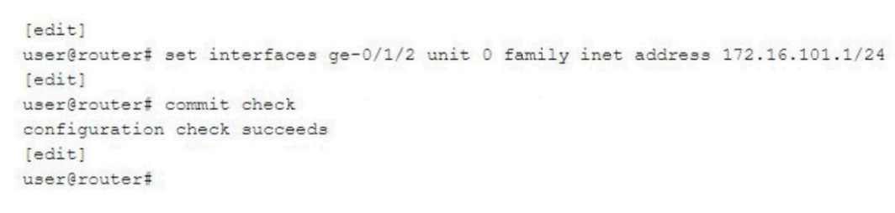Click the Exhibit button.
You need to configure interface ge-0/1/2 with an IP address of 172.16.100.1/24.
You have accidentally entered 172.16.101.1/24 as shown in the exhibit.
Which command should you issue to solve the problem?
- [edit]
user@route# rollback rescue
- [edit]
- user@route# rollback 2
- [edit]
user@route# rollback 0
- [edit]
user@route# rollback 1
Correct Answer: AD
* Explanation/Reference:

Question 48
You configured your system authentication order using the set authentication-order tacplus radius password command.
Which statement is correct in this scenario?
- A rejection by TACACS+ will prevent a login and bypass the other two authentication methods.
- The password authentication will only be used if the TACACS+ and RADIUS servers fail to respond.
- All authentication methods are used with the most restrictive permission set used.
- The password authentication method is evaluated if the TACACS+ and RADIUS servers respond with a reject message.

Correct Answer: B
* Explanation/Reference:

Question 49
You are asked to convert the number 7 from decimal to binary.
Which number is correct in this scenario?
A. 00001000
B. 00010000
C. 00000111
D. 11100000
Correct Answer: C
* Explanation/Reference:

Question 50
How many login classes are assignable to a user account?
A. 3
B. 2
C. 4
D. 1
Correct Answer: D
* Explanation/Reference:

Question 51
Which two functions are performed by the PFE? (Choose two.)
A. It implements firewall filters.
B. It selects active routes.
C. It forwards transit traffic.
D. It maintains the routing table.
Correct Answer: AC
* Explanation/Reference:

Question 52
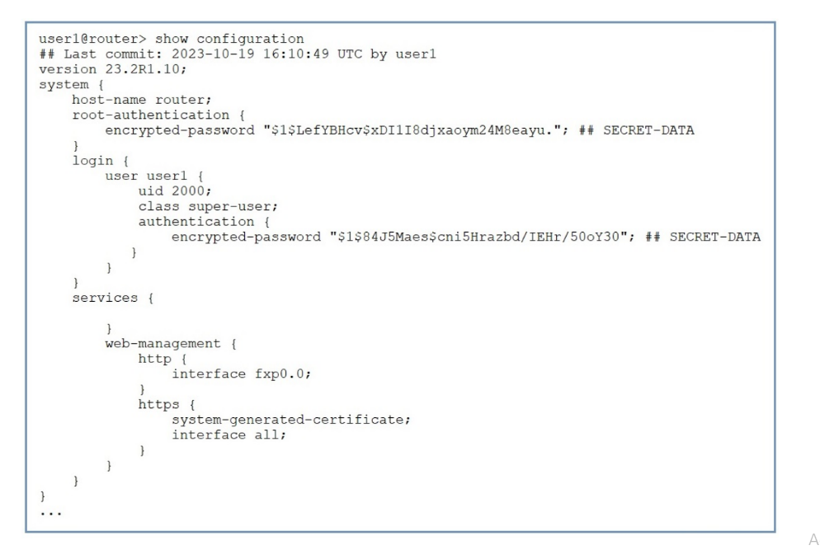Click the Exhibit button.
You are unable to remotely access your Juniper device using the CLI.
Referring to the exhibit, which command would you add to the existing configuration to enable remote CLI access?
A. set system login idle-timeout 20
B. load factory-default
C. set system services ssh
D. set system root-authentication plain-text-password
Correct Answer: C
* Explanation/Reference:

Question 53
What is the maximum number of rollback configuration files that the Junos OS
will store?
A. 65
B. 50
C. 25
D. 19
Correct Answer: B
* Explanation/Reference:

Question 54
You are creating a new policy to accept and redistribute routes into your IGP.
In this scenario, which match criteria would you use to identify the route prefixes to select?
A. instance
B. route-type
C. neighbor
D. route-filter
Correct Answer: D
* Explanation/Reference:

Question 55
Which three benefits occur when operating an interior gateway protocol (IGP) in an autonomous system (AS)? (Choose three.)
A. IGPs automatically distribute static routing information.
B. IGPs determine the optimal paths for data transmission.
C. IGPs learn prefixes in the global Internet's routing table.
D. IGPs react very fast to network change.
E. IGPs learn everything about the subnets and best paths within your network.
Correct Answer: BDE
* Explanation/Reference:

Question 56
By default, how does the PFE manage unicast traffic destined for an existing forwarding table entry?
A. It sends the traffic through multiple ports toward its destination.
B. It sends the traffic through one port toward its destination.
C. It sends the traffic through the f xpl interface to the RE.
D. It sends all traffic to the control plane for further processing.
Correct Answer: B
* Explanation/Reference:

Question 57
Which two actions happen when multiple users issue the configure exclusive command to enter configuration mode on a Junos device? (Choose two.)
A. The candidate configuration is locked.
B. Other users can enter configuration mode.
C. The candidate configuration is unlocked.
D. Other users cannot enter configuration mode.
Correct Answer: AD
* Explanation/Reference:

Question 58
Which statement is correct when multiple users are configuring a Junos device using the configure private command?
A. A commit by any user will commit changes made by all active users.
B. A commit will not succeed until there is only a single user in configuration mode.
C. Each user gets their own candidate configuration.
D. Each user shares the same candidate configuration.
Correct Answer: C
* Explanation/Reference:

Question 59
Which two statements about route preference in Junos are correct? (Choose two.)
A. Both direct and static routes have the same preference.
B. Both direct and local routes have the same preference.
C. Both OSPF internal and OSPF AS external routes have the same preference.
D. Both EBGP and IBGP routes have the same preference.
Correct Answer: BD
*Explanation/Reference:

Question 60
Which two addresses are included in an Ethernet frame header? (Choose two.)
A. destination MAC address
B. destination IP address
C. source MAC address
D. source IP address
Correct Answer: AC
* Explanation/Reference:

Question 61
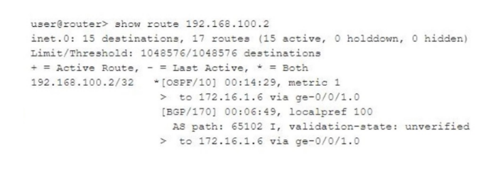Click the Exhibit button.
Referring to the exhibit, which statement is correct?
A. The OSPF path is the only active route.
B. The BGP route is preferred over the OSPF route.
C. The BGP path is the only active route.
D. Traffic is load-balanced across two routes.
Correct Answer: A
* Explanation/Reference:

Question 62
What is the protocol data unit (PDU) of the Data Link Layer?
A. byte
B. bit
C. segment
D. frame
Correct Answer: D
* Explanation/Reference:

Question 63
Which process in the Junos OS is responsible for device management tasks including the CLI and commit operations?
A. chassisd
B. mgd
C. rpd
D. dcd
Correct Answer: B
* Explanation/Reference:

Question 64
Which advantage is provided by multiple software processes running in the Junos OS?
A. Each process allocates a fixed amount of CPU resources.
B. Each process dependency can be mapped independently.
C. Each process is started manually to ensure system stability.
D. Each process runs in a protected memory space.
Correct Answer: D
* Explanation/Reference:

Question 65
You issue the monitor traffic interface ge-0/0/0 command.
What will this command accomplish?
A. It displays real-time statistics for interface ge-0/0/0.
B. It displays an operational summary of ge-0/0/0.
C. It displays the MTU and MAC address for ge-0/0/0.
D. It displays a packet capture on interface ge-0/0/0.
Correct Answer: D
* Explanation/Reference:

Question 66
Which statement is correct concerning exception traffic processing?
A. Exception traffic is discarded by the PFE.
B. Exception traffic is rate-limited to protect the RE.
C. Exception traffic is always dropped during congestion.
D. Exception traffic is never forwarded.
Correct Answer: B
* Explanation/Reference:

Question 67
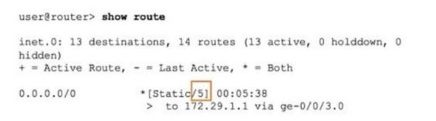
Referring the exhibit, what does the highlighted number indicate?
A. route preference is 5
B. hop count is 5
C. cost is 5
D. metric is 5
Correct Answer: A
* Explanation/Reference:

Question 68
Which component is considered part of the data plane?
A. the power supply
B. the Packet Forwarding Engine
C. the fan tray
D. the Routing Engine
Correct Answer: B
* Explanation/Reference:

Question 69
Which two statements apply to the Routing Engine functions? (Choose two.)
A. It processes the transit traffic.
B. It does not process routing updates.
C. It responds to ping and traceroute commands.
D. It maintains the routing tables.
Correct Answer: CD
* Explanation/Reference:

Question 70
Which two statements are correct about a Routing Engine? (Choose two.)
A. It processes CoS marked traffic.
B. It processes management traffic.
C. It maintains routing tables.
D. It forwards transit traffic.
Correct Answer: BC
* Explanation/Reference:

Question 71
When considering routing tables and forwarding tables, which two statements are correct? (Choose two.)
A. The routing table is used by the RE to select the best route.
B. The forwarding table is used by the RE to select the best route.
C. The routing table stores all routes and prefixes from all protocols.
D.The forwarding table stores all routes and prefixes from all protocols.
Correct Answer: AC
* Explanation/Reference:

Question 72
You have completed the initial configuration of your new Junos device. You want to be able to load this configuration at a later time.
Which action enables you to perform this task?
A. Enter the load factory-default command.
B. Enter the request system reboot command.
C. Enter the request system zeroize command.
D. Enter the request system configuration rescue save command.
Correct Answer: D
* Explanation/Reference:

Question 73
Which two statements are correct about the employee@Ri> prompt? (Choose two.)
A. R1 is the hostname of your device.
B. You are in operational mode.
C. You are in configuration mode.
D. You are at a shell prompt.
Correct Answer: AB
* Explanation/Reference:

Question 74
You have logged on to a Junos device and are at the operational mode prompt.
Which two commands are used at this prompt? (Choose two.)
A. show interface ge-0/0/0
B. request system shutdown
C. set interface ge-0/0/0 unit 0 family inet
D. run show interface terse
Correct Answer: AB
* Explanation/Reference:

Question 75
Which two statements describe the result when you enter ? at the command- line prompt? (Choose two.)
A. It displays help about a text string contained in a statement.
B. It lists the available commands and options.
C. It displays summary information about the commands and options.
D. It lists tips for the help menu.
Correct Answer: BC
*Explanation/Reference:

Question 76
Which two protocols use UDP at the transport layer? (Choose two.)
A. NTP
B. FTP
C. SNMP
D. HTTP
Correct Answer: AC
* Explanation/Reference:

Question 77
You received a new Junos device and are configuring the system-related settings. You must configure this device for the current date and time on the US West coast. You have set the time zone to America/Los_Angeles, however the time and date did not change.
In this scenario, which two additional actions would satisfy this requirement? (Choose two.)
A. Configure a DNS server.
B. Reboot the device.
C. Set the date and time setting manually.
D. Configure an NTP server.
Correct Answer: CD
* Explanation/Reference:

Question 78
After the factory default configuration is loaded, which configuration object must be created prior to the first commit?
A. out-of-band connectivity
B. loopback IP address
C. root authentication
D. host name
Correct Answer: C
* Explanation/Reference:

Question 79
In the Junos OS, which keyboard shortcut allows you to move to the start of the line?
A. Ctrl+e
B. Ctrl+a
C. Ctrl+k
D. Ctrl+w
Correct Answer: B
* Explanation/Reference:

Question 80
Your router has a route to the 10.1.1.0/24 network with a next hop of rict.
In this scenario, which action will your router perform when traffic destined to the 10.1.1.0/24 network is received?
A. The traffic will be discarded and an ICMP unreachable message will be sent to the destination of the traffic.
B. The traffic will be discarded and an ICMP unreachable message will be sent to the source of the traffic.
C. The traffic will be redirected using a default route.
D. The traffic will be silently discarded.
Correct Answer: B
* Explanation/Reference:

Question 81
Which two statements are correct about Junos traceoptions? (Choose two.)
A. Traceoptions cannot be enabled in a production environment.
B. Traceoptions are enabled through configuration.
C. Traceoptions are enabled by default.
D. Traceoption output, by default, is stored in /var/log/<file-name>
Correct Answer: BD
*Explanation/Reference:

Question 82
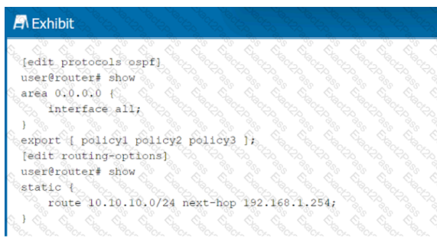
Referring to the exhibit, OSPF has three export policies that match different static route prefixes. The 10.10.10.0/24 static route does not match any terms in the policyl routing policy.
What happens next in this scenario?
A. The static route is evaluated evaluated by the policy3 routing policy.
B. The static route is evaluated by the policy2 routing policy.
C. The static route is rejected by the default routing policy.
D. The static route is rejected by the policyl routing policy.
Correct Answer: B
* Explanation/Reference:

Question 83
Which two statements are correct about MAC addresses? (Choose two.)
A. Switches use the Address Resolution Protocol table to assign MAC addresses to network interface cards in the forwarding frame.
B. The source and destination MAC addresses always remains static to the final destination.
C. The MAC address identifies the physical hardware.
D. Switches use the destination MAC address to identify the next-hop destination and to change the destination MAC address in the frame.
Correct Answer: CD
* Explanation/Reference:

Question 84
Your network infrastructure transports data, voice, and video traffic. Users are complaining that voice and video calls are not performing to their expectations.
In this scenario, which technology would you implement to improve voice and video performance on your network?
A. NAT
B. IPv6
C. STP
D. COS
Correct Answer: D
* Explanation/Reference:

Question 85
Which two statements are correct regarding Layer 2 network switches? (Choose two.)
A. Switches create a single collision domain.
B. Switches do not learn MAC addresses.
C. Switches flood broadcast traffic.
D. Switches are susceptible to traffic loops.
Correct Answer: CD
*Explanation/Reference:

Question 86
Which two statements are correct about firewall filters? (Choose two.)
A. "Discard" is the default action of packets that are not explicitly allowed.
B. There can be only one firewall filter.
C. There can be multiple firewall filters.
D. "Accept" is the default action of packets that are not explicitly allowed.
Correct Answer: AC
* Explanation/Reference:

Question 87
Which two statements are true about the candidate configuration? (Choose two.)
A. Candidate configuration changes are automatically applied.
B. You can deploy multiple changes at the same time.
C. Multiple users cannot modify the same candidate configuration.
D. You can discard changes before committing them.
Correct Answer: BD
* Explanation/Reference:

Question 88
Which two statements are true about the PFE? (Choose two.)
A. The PFE implements various services such as policing, stateless firewall filtering, and class of service.
B. The PFE uses Layer 2 and Layer 3 forwarding tables to forward traffic toward its destination.
C. The PFE handles all processes that control the chassis components.
D. The PFE is responsible for performing protocol updates and system management.
Correct Answer: AB
* Explanation/Reference:

Question 89
What are two link-state routing protocols? (Choose two.)
A. RIP
B. BGP
C. OSPF
D. IS-IS
Correct Answer: CD
* Explanation/Reference:

Question 90
Which process in the Junos OS is responsible for maintaining routing protocols and tables?
A. rpd
B. dcd
C. mgd
D. chassisd
Correct Answer: A
* Explanation/Reference:

Question 91
Which layer of the OSI model contains the IP address information?
A. Layer 4
B. Layer 2
C. Layer 3
D. Layer 1
Correct Answer: C
*Explanation/Reference:

Question 92
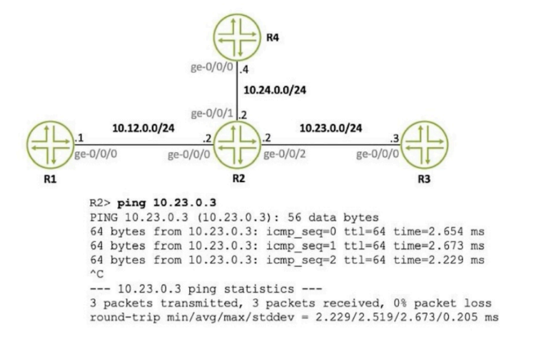
Referring to the exhibit, what is the source IP address of the ping that was executed?
A. 10.12.0.2
B. 10.23.0.2
C. 10.23.0.3
D. 10.24.0.4
Correct Answer: B
*Explanation/Reference:

Question 93
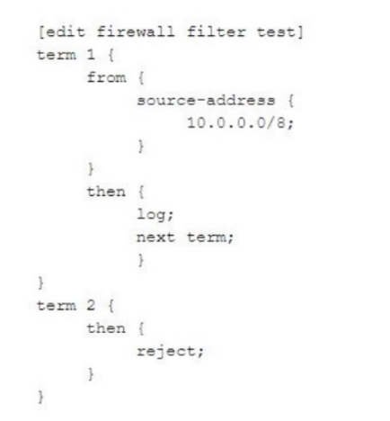
Click the Exhibit button.
How is traffic, sourced from 10.0.0.0/8, treated by the firewall filter shown in the exhibit?
A. logged with no further action
B. logged and rejected
C. logged and discarded
D. logged and accepted
Correct Answer: B
* Explanation/Reference:

Question 94
What does the user@router> clear log ospf-trace command accomplish?
A. Logging data into ospf-trace is stopped.
B. Trace parameters are removed from the OSPF protocol configuration.
C. Data in the ospf-trace file is removed and logging continues.
D. The ospf-trace file is deleted.
Correct Answer: C
* Explanation/Reference:

Question 95
Which character is used to filter the command output in the Junos CLI?
A. I
B. >
C. <
D.?
Correct Answer: A
* Explanation/Reference:

Question 96
A network administrator is attempting to route traffic on a Juniper switch to one of three different VLANs: Prod, Test, and Dev. Each VLAN has been assigned a numerical value. In this scenario, what are these numerical values called?
A. defaults
B. interfaces
C. names
D. tags
Correct Answer: D
* Explanation/Reference:

Question 97
What are two functions of the routing protocol daemon (rpd)? (Choose two.)
A. It maintains routing tables.
B. It generates chassis alarms.
C. It creates forwarding tables.
D. It provides access to the CLI.
Correct Answer: AC
* Explanation/Reference:

Question 98
Which two statements are correct regarding Layer 2 network switches? (Choose two.)
A. Switches flood broadcast traffic.
B. Switches are susceptible to traffic loops.
C. Switches do not learn MAC addresses.
D. Switches create a single collision domain.
Correct Answer: AB
* Explanation/Reference:

Question 99
Which two statements apply to the Routing Engine functions? (Choose two.)
A. It does not process routing updates.
B. It responds to ping and traceroute commands.
C. It maintains the routing tables.
D. It processes the transit traffic.
Correct Answer: BC
*Explanation/Reference:

Question 100
You have configured some interfaces on a Junos device; however, you have not yet committed the configuration.
What happens if you issue the rollback 0 command in this scenario?
A. The messages.log file is deleted.
B. The factory default configuration is loaded.
C. The Junos device is rebooted.
D. The interface changes you made are discarded.
Correct Answer: D
* Explanation/Reference:

Question 101
You want to redeploy a Junos device by clearing the existing configuration and resetting it to factory defaults.
In this scenario, which command would help to accomplish this task?
A. show system storage
B. request system storage cleanup
C. request system storage cleanup dry-run
D. request system zeroize media
Correct Answer: D
* Explanation/Reference:

Question 102
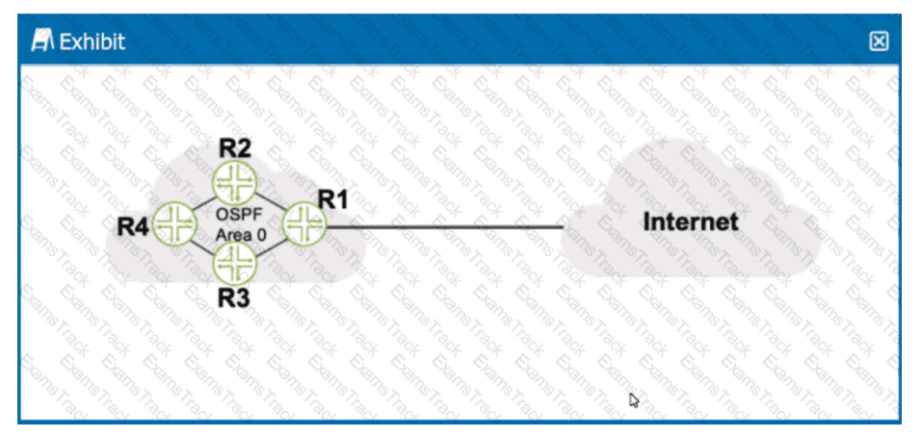
Referring to the exhibit, what should be configured on R1 to advertise a default static route into OSPF?
A. a firewall filter
B. a routing policy
C. a loopback interface
D. a management interface
Correct Answer: B
* Explanation/Reference:

Question 103
Exhibit
term limit-icmp
{
from {
source-address {
172.25.11.0/24;
}
protocol icmp;
}
then {
}
count count-icmp;
discard;
}
Referring to the exhibit, which two actions will occur when a packet matches the firewall filter? (Choose two.)
A. An ICMP destination unreachable message will be returned.
B. The packet will be forwarded.
C. The packet will be discarded.
D. A counter will be incremented.
Correct Answer: CD
* Explanation/Reference:

Question 104
Which two actions happen when multiple users issue the configure exclusive command to enter configuration mode on a Junos device? (Choose two.)
A. Other users can enter configuration mode.
B. The candidate configuration is unlocked.
C. The candidate configuration is locked.
D. Other users cannot enter configuration mode.
Correct Answer: CD
* Explanation/Reference:

Question 105
Which two statements are true about the Junos OS (Choose two)
- Routing table are stored in the control plane.
- Exception traffic is never sent to the control plane.
- Exception traffic is sent to the control plane.
- Routing table are stored in the forwarding plane.
Correct Answer: AC
* Explanation/Reference:

Question 106
You are manually adding a route to a Junos device.
In this scenario, which type of route would this be called?
- A directly connected route
- A static route
- A dynamic route
- A local route
Correct Answer: B
* Explanation/Reference:

