
College of Artificial Intelligence Engineering

University Project Management System
A senior 2 project report - submitted to complete the requirements for obtaining a Bachelor’s Degree in informatics engineering

Prepared by
Maii tlass
Lamees oufan
Abdalkreem Alnajjar

Supervised by
D.Mouhib Alnoukari
D.Anas Abdulaziz
Eng.amer khorsheed

Academic Year
2026

كلية هندسة الذكاء الاصطناعي

نظام إدارة المشاريع الجامعية

مشروع تخرج 2 - مُقدَّم لاستكمال متطلبات الحصول على درجة البكالوريوس في هندسة المعلوماتية
هندسة البرمجيات ونظم المعلومات
إعداد
لميس فيصل عوفان
مي خالد طلاس
عبد الكريم أيمن النجار
إشراف
د.مهيب النقري
د.أنس عبد العزيز
م.عامر خورشيد
العام الدراسي
2026

SUPERVISION CERTIFICATION

Supervisor Certification I Certify that the preparation of this project entitled
[ university project management system]
Prepared by
[lamees oufan
Maii tlass
Abdalkreem Alnajjar]
was completed under our supervision and submitted to the [College of Artificial Intelligence Engineering ] in partial fulfillment of the requirements for the Bachelor’s Degree in Software Engineering

Name: …………………………………………. Name: ………………………………………….

Signature: ……………………………………. Signature: …………………………………….

Abstract
Managing graduation projects in universities involves coordinating multiple stakeholders, including students, supervisors, and academic administrators. Traditional management approaches often rely on manual procedures or fragmented digital tools, which may lead to inefficiencies, limited transparency, and difficulties in monitoring the progress of student projects.
This project proposes the development of a Graduation Project Management System designed to streamline and automate the processes associated with managing student graduation projects. The system provides a centralized platform where students can propose project ideas, apply for available projects, and manage their project activities. Supervisors can review student submissions, evaluate project progress, and monitor development activities, while administrators oversee the overall workflow and decision-making processes.
To enhance the monitoring of technical development activities, the system integrates with GitLab, enabling automated tracking of repository updates and code contributions throughout the project lifecycle. This integration improves transparency and allows supervisors to follow the evolution of student projects more effectively.
The proposed system aims to improve project organization, support academic supervision, and provide a more structured environment for managing graduation projects. By combining administrative management with development activity monitoring, the system contributes to more efficient coordination and better visibility of student progress.

ملخص

يهدف هذا المشروع إلى تصميم وتطوير نظام لإدارة مشاريع التخرج بهدف تنظيم وتحسين عملية اقتراح المشاريع، واختيارها، والإشراف عليها ضمن البيئة الأكاديمية. يوفر النظام منصة رقمية متكاملة تدعم مختلف الأطراف المعنية، بما في ذلك الطلاب، وأعضاء الهيئة التدريسية المشرفين، ورؤساء الأقسام، وعمادة الكلية.
يتيح النظام لأعضاء الهيئة التدريسية اقتراح أفكار مشاريع، كما يسمح للطلاب بتصفح المشاريع المعتمدة والتقديم عليها. بعد ذلك، يقوم المشرفون بمراجعة طلبات الطلاب والموافقة عليها أو رفضها. إضافةً إلى ذلك، يوفر النظام أدوات لإدارة سير العمل المرتبط بمراحل المشروع المختلفة، بما يساعد على تنظيم عملية متابعة المشاريع منذ مرحلة الاقتراح وحتى التنفيذ.
كما يدعم النظام متابعة تقدم المشاريع من خلال ربطه بمنصات إدارة الشيفرة المصدرية، مما يسمح بتوثيق الأنشطة التطويرية ومراقبة تطور العمل البرمجي للطلاب. ويساهم ذلك في تعزيز الشفافية وإتاحة إمكانية تتبع مراحل تطوير المشروع.
يساعد هذا النظام في تحسين تنظيم عملية إدارة مشاريع التخرج، ويقلل من الإجراءات اليدوية، ويعزز التواصل بين الطلاب والمشرفين والإدارة الأكاديمية، مما يؤدي إلى بيئة أكثر كفاءة ووضوحًا في إدارة المشاريع الأكاديمية

Contents
Abstract 4
1.1 Project Overview and Background 17
1.2 Problem Statement 18
1.2.1 The Research Problem 18
1.3 Project Goals 19
1.4 Project Scope, Constraints, and Assumptions 19
1.4.1 System Scope 19
1.4.2 Constraints 20
1.4.3 Assumptions 20
1.5 Contribution of the Project to Knowledge and the Field 20
1.6 Research Methodology 21
1.7Document Organization 22
1.8 Key Definitions 23
Chapter Objective 25
2.1 Selected Development Methodology and Justification 25
2.2 Project Timeline and Work Plan 25
2.3 Risk Management 26
2.4 Team Structure and Role Distribution 31
2.5 Quality Management 32
2.6 Project Management Tools 32
2.7 Monitoring and Continuous Evaluation 33
2.8 Software Configuration Management 33
Chapter Summary 34
Chapter Objective 36
3.1 Previous Studies in Academic Project Management 36
3.1.1 UMIT Project Management System — Morey et al., 2024 36
3.1.2 Student Project Management System — University of Ibadan, 2024 36
3.1.3 Final Year Project Management System — UPTM, 2024 36
3.1.4 University Graduation Project Management System — Li et al., 2021 37
Summary of Previous Studies 37
3.2 Modern Technologies and Frameworks 37
3.2.1 Django and Django REST Framework 37
3.2.2 React 38
3.2.3 PostgreSQL 38
3.2.4 Celery and Redis 38
3.2.5 GitLab REST API 38
3.2.6 Google OR-Tools 38
3.3 Comparative Analysis of Existing Academic Project Management Systems 38
3.4 Research Gap and Proposed Contribution 39
3.5 Theoretical Framework 39
3.6 Recent and Future Trends 40
Chapter Summary 40
Chapter Introduction 42
4.1 Feasibility Study 42
4.2 Requirements Gathering 42
4.3 Stakeholders and Analysis of Their Needs 43
4.4 Functional Requirements 43
4.4.1 User and Permission Management 43
4.4.2 Academic Semester and Project Stage Management 44
4.4.3 Project Ideas, Teams, and Approvals 44
4.4.4 Project and Workflow Management 44
4.4.5 Committee and Discussion Scheduling Management 44
4.4.6 Grade and Report Management 45
4.5 Non-Functional Requirements 45
4.6 Requirements Prioritization Using MoSCoW 46
4.7 UML Requirements Diagrams 46
4.7.1 Use Case Diagrams 46
4.7.2 Use Case Descriptions 49
4.7.3 Activity Diagrams 53
4.7.4 Sequence Diagrams 58
4.8 Requirements Modeling According to the Adopted Methodology 62
4.8.1 Agile Modeling 62
4.9 Requirements Traceability and Verification 63
4.9.1 Requirements Traceability Matrix 63
4.9.2 Initial Test Cases 65
5.1 High-Level Design 74
5.1.1 System Block Diagram 74
5.1.2 Architectural Pattern 75
5.1.3 System Architecture Design 76
5.2 Database Design 77
5.2.1 Entity Relationship Diagram 78
5.2.2 Main Relational Schema 78
5.2.3 Constraints and Keys 79
5.3 External Interface and API Design 80
5.4 Security and Authorization Design 82
5.4.1 Authentication and Account Security 82
5.4.2 User Roles and Access Control 82
5.4.3 Role-Based and Object-Level Authorization 83
5.4.4 API, File, and Data Security 83
5.4.5 Database and Integration Security 83
5.5 Chapter Summary 84
6.1 Development Environment 86
6.2 Programming Languages 86
6.3 Frameworks 86
6.4 Database 86
6.5 Package Management 86
6.6 Version Control 87
6.7 Deployment 87
6.8 Testing Environment 87
Chapter Introduction 89
7.1 Project Structure 89
7.2 Main Modules Implementation 90
7.2.1 Authentication and JWT 90
7.2.2 Authorization 90
7.2.3 Project Management Module 90
7.2.4 Workflow Module 91
7.2.5 Dynamic Forms Module 92
7.2.6 Committee and Scheduling Module 92
7.2.7 Grading Module 93
7.2.8 Notification Module 93
7.2.9 GitLab Integration Module 94
7.3 API Implementation 94
7.3.1 Example: Workflow Submission API 95
7.4 Data Access Layer 95
Reresentative ORM Query 96
7.5 Business Logic Layer 96
7.6 User Interface Implementation 98
7.7 Project Distribution Using Round Robin 101
7.8 Intelligent Scheduling Algorithm Implementation 101
7.8.1 Why CP-SAT Was Used 101
7.8.2 Scheduling Inputs 102
7.8.3 Decision Variables 102
7.8.4 Hard Constraints 103
7.8.5 Objective Function and Multiple Feasible Solutions 104
7.8.6 Solver Execution and Result Status 106
7.8.7 Schedule Preview and Application 107
7.9 Error Handling and Logging 107
7.10 Security Implementation 108
7.11 Implementation Summary 109
8.1 Test Plan 111
8.2 Types of Testing 111
8.2.1 Unit Testing 111
8.2.2 Integration Testing 111
8.2.3 System Testing 112
8.2.4 Acceptance Testing 112
8.2.5 Performance and Load Testing 112
8.2.6 Security Testing 112
8.3 Test Diagrams 113
8.3.1 Test Case Diagrams 113
8.3.2 Test Result Diagrams 113
8.4 Test Results and Analysis 114
Chapter Summary 115
9.1 System Implementation Results 116
9.2 Comparative Analysis with Existing Approaches 117
9.3 Achievement of Project Objectives 118
9.4 Strengths and Weaknesses Analysis 119
9.5 Key Performance Indicators (KPIs) 120
Chapter Summary 120
10.1 Project Summary and Main Achievements 121
10.2 Difficulties and Challenges Faced During the Project 122
10.3 Suggestions for Future Development 122
10.4 Recommendations 122
1 - Class Diagrams 124
2- Component Diagrams 125
4-modules design 127
5-api design 127
6- Description of Algorithms Using Pseudocode 129
Algorithm 1: Round Robin Project Distribution 129
Algorithm 2: Conflict-Free Committee Scheduling Using CP-SAT 130
Algorithm Description 131

List of figures
Figure 1 Gantt chart 23
Figure 2 main use case 44
Figure 3 project management use case 44
Figure 4 committee management use case 45
Figure 5 project workflow use case 45
Figure 6 activity diagram Project Proposal and Approval 51
Figure 7 Project Workflow and Submission activity diagram 52
Figure 8 Committee Scheduling activity diagram 53
Figure 9 Project Evaluation and Grading activity diagram 54
Figure 10 fist login sequence diagram 55
Figure 11 Submit Workflow Stage sequence diagram 56
Figure 12 submit idea sequence diagram 56
Figure 13 Create GitLab Repository sequence diagram 57
Figure 14 schedule committee sequence diagram 59
Figure 15 story mapping 60
Figure 16 System Block Diagram 71
Figure 17 system architecture 73
Figure 18 ERD diagram 75
Figure 19 student dashboard 95
Figure 20 doctor Dashboard 96
Figure 21 Committee Scheduling Interface 96
Figure 22 Dynamic workflow 97
Figure 23 Test Case Diagram 110
Figure 24 GPMS Test Results Diagram 111
Figure 25 class diagram 122
Figure 26 component diagram 123
Figure 28 module design 124
Figure 29 api design 125

List of tables

Table 1Document Organization 19
Table 2. Risk Management Register 24
Table 3. Project Team Roles and Responsibilities 28
Table 4 Project Management and Development Tools 29
Table 5. Comparative Analysis of Academic Project Management Systems 35
Table 6 Stakeholders and Their Needs 40
Table 7 functional requirement 41
Table 8 non-functional requieremnt 42
Table 9 Requirements Prioritization Using MoSCoW 43
Table 10 use case description 46
Table 12 Functional Requirements Traceability Matrix (RTM) 60
Table 13 initial test cases 62
Table 14 Main Architectural Layers 72
Table 15 Main Backend Modules 74
Table 16 Main Relational Schema 76
Table 17 HTTP Methods 78
Table 18 Representative APIs 78
Table 19 Main User Roles 79
Table 20 Main Business Rules 93
Table 21 Security Controls 105
Table 22 Comparative Analysis with Existing Approaches 115

Chapter One
General introduction

1.1 Project Overview and Background
Electronic systems have become essential for managing academic processes within universities, especially processes that involve multiple stakeholders, such as students, supervisors, department heads, academic committees, and university administration. Graduation project management is one of the most complex academic processes because it begins with proposing or applying for a project idea, forming a team, selecting supervisors, and obtaining approvals. It then continues through follow-up stages, evaluations, committee reviews, and discussions until grades are approved and the project is formally completed.
In many cases, graduation projects are managed through separate files, spreadsheets, emails, and manual procedures. This makes it difficult to track the current status of each project, causes delays in approvals, creates duplicated or inconsistent data, and increases the possibility of errors in project distribution, committee formation, scheduling, and grading.
This project presents an integrated electronic system for managing graduation projects at the Syrian Private University. The system combines the academic and administrative processes associated with graduation projects within a single portal. It allows students to propose project ideas or apply for ideas published by faculty members, form project teams, select one or two supervisors, and follow approval requests and project stages.
The system also enables faculty members to supervise projects, review requests, apply workflow stages, and enter grades. Department heads and the dean can manage academic semesters, project stages, committee formations, project distribution, discussion schedules, rooms, grades, and academic reports.

1.2 Problem Statement

1.2.1 The Research Problem

The main problem is the absence of a centralized system that covers the full lifecycle of a graduation project. Dependence on manual procedures or disconnected systems leads to several difficulties, including:
- Difficulty identifying the current status of a project and the party whose approval is still required.
- Delays in communication between students, supervisors, and department heads.
- Repetition and inconsistency of data across student, project, and committee files.
- Difficulty organizing committees and distributing projects according to department, project type, and academic semester.
- The possibility of errors in grade entry or average calculation.
- The absence of a unified record that preserves project stages, approvals, rejections, and modifications.
- Difficulty tracking the transition of a project from a semester project to Graduation Project 1 and then Graduation Project 2.
The practical importance of the project lies in reducing manual work, simplifying project follow-up, improving procedural accuracy, and accelerating administrative and academic processes. The system also provides greater transparency because each user can view the requests, stages, and actions currently required from them.
From an academic perspective, the system contributes to organizing graduation project data and preserving its history. It also helps university administration evaluate the progress of projects and committees and generate reports that support academic decision-making.

1.3 Project Goals

Main Objective
To design and implement an integrated web-based system for managing the complete lifecycle of graduation projects, beginning with project idea submission and team formation, continuing through approvals, supervision, workflows, and committees, and ending with discussion, grade approval, and project closure.

Secondary Objectives
- Enable students to propose project ideas, apply for faculty ideas, form teams, manage invitations, and select one or two supervisors.
- Manage the approval sequence among team members, supervisors, and the department head.
- Provide flexible workflows that support multiple project stages and allow supervisors to monitor progress and review submissions.
- Manage committee formation, project distribution, discussion scheduling, rooms, and faculty availability.
- Support secure grade entry, committee-member verification, and automatic calculation of evaluation averages.
- Support transitions between Semester Project, Graduation Project 1, and Graduation Project 2 while preserving project history.
- Provide in-system and email notifications for important academic and workflow events.

1.4 Project Scope, Constraints, and Assumptions

1.4.1 System Scope
- User accounts, roles, permissions, and data import.
- Student proposals, faculty project ideas, team formation, invitations, supervisor selection, and approvals.
- Academic semesters, project stages, workflows, file uploads, and project monitoring.
- GitLab integration.
- Committee formation, project distribution, discussion scheduling, room management, and faculty availability.
- Grade entry, average calculation, grade documents, and academic reports.
- In-system and email notifications.

1.4.2 Constraints
- Limited time available for system development and testing.
- Dependence on the accuracy of imported data.
- The need for a valid email server to send verification codes and notifications.
- Dependence on external services such as GitLab when repository-related features are used.
- The need for Redis and Celery to run scheduled tasks and automatic notifications.
- Differences in academic procedures between departments or semesters.
- Difficulty testing the system with a large number of real users during the project period.

1.4.3 Assumptions
• Every user has a valid account and email address.
• Users have internet access and basic experience using web applications.
• User roles and permissions are defined by university administration.
• Semester dates, rooms, and committee formations are entered correctly by authorized administrators.
• Decisions related to passing and transition between project stages are approved by authorized academic staff.

• Imported and entered data represent the official academic records.

1.5 Contribution of the Project to Knowledge and the Field
The main contribution of this project is the development of an integrated engineering solution that combines graduation project management processes within a single system instead of distributing them across multiple files and tools.
The value of the project does not lie in one isolated function. Rather, it lies in linking the academic and administrative stages of the project within a unified and traceable workflow.
The main contributions include:
- Supporting a flexible approval process that includes team members and either one or two supervisors.
- Preserving previous approvals when a team member or supervisor is replaced, provided that the project content has not been significantly changed.
- Supporting multiple customizable workflows for the same project.
- Connecting committees, schedules, and grades to the academic semester and project type.
- Protecting grades from unauthorized modification or loss during committee redistribution.
- Recording the project’s transition history between Semester Project, Graduation Project 1, and Graduation Project 2.
- Combining academic project management with software development monitoring through GitLab.
- Designing the system according to the actual academic procedures followed at the Syrian Private University.
The contribution of the project is mainly practical and engineering-oriented, as it transforms complex academic procedures into electronic processes that can be managed, measured, and tracked

1.6 Research Methodology
The project relies on several complementary scientific approaches.

Descriptive and Analytical Method
This method is used to study the current procedures related to graduation projects, identify the participating stakeholders, analyze the problems resulting from manual work, and determine the functional needs of each type of user.

Engineering Method
This method is used to design and build a software system that provides a practical solution to the identified problem. Academic and administrative requirements are transformed into data models, interfaces, permissions, and interconnected processes.

Case Study Method
Graduation project management at the Syrian Private University is treated as an applied case study. The system is designed according to the university’s roles, departments, project stages, and academic procedures.

Experimental and Evaluation Method
The system is evaluated through functional testing of the main scenarios, such as proposal submission, approval processes, committee distribution, scheduling, and grade entry..
These approaches describe the scientific method used to understand the problem, design the solution, and evaluate the final system. They do not describe the software development methodology itself, which will be discussed in the next chapter.

1.7Document Organization
Table 1Document Organization
Chapter | Title
Chapter One | General Introduction
Chapter Two | Project Development and Management Methodology
Chapter Three | Review of Literature and Previous Studies
Chapter Four | Requirements Modeling and Analysis
Chapter Five | Architectural Design of the System
Chapter Six | Tools and Technologies Used
Chapter Seven | Programming Implementation
Chapter Eight | Testing and Evaluation
Chapter Nine | Results and Analysis
Chapter Ten | Conclusion and Recommendations

1.8 Key Definitions
- GitLab Integration: The connection between the GPMS and GitLab to retrieve and track project repository activities.
- Dynamic Forms: Configurable forms that can be created and modified for different project workflow stages without changing the source code.
- Workflow: A sequence of project stages with defined requirements, transitions, and approval rules.
- Kanban Board: A visual interface that organizes project tasks according to their current status, such as To Do, In Progress, and Done.
- Webhook: An HTTP mechanism that sends real-time event notifications from GitLab to the GPMS.
- Fernet Encryption: A symmetric encryption method used to protect sensitive data such as GitLab access tokens.
- Rate Limiting: A mechanism that limits the number of API requests allowed within a specific time period.
- Race Condition Protection: A mechanism that prevents inconsistent data when multiple users modify the same resource simultaneously.

project development and management methodology

Chapter Objective
This chapter aims to demonstrate that the Graduation Project Management System (GPMS) was developed and managed using a structured and systematic approach rather than an ad hoc process. It presents the selected software development methodology, project timeline, risk management plan, team structure and responsibilities, quality management practices, project management tools, monitoring and evaluation mechanisms, and software configuration management strategy.

2.1 Selected Development Methodology and Justification
The project adopts an Agile development approach based on the Scrum framework. This methodology was selected because the system requirements may evolve during development and require continuous feedback from academic supervisors.
Agile supports the project through:
- Flexible requirements: Requirements and priorities can be refined as the system develops.
- Continuous feedback: Supervisor feedback can be incorporated into subsequent development iterations.
- Incremental development: The system is developed in manageable functional groups, allowing features to be reviewed and validated progressively.
- Early problem detection: Iterative development helps identify technical, integration, and usability issues at an early stage.
- Progress tracking: Development is organized into Sprints to monitor completed tasks and upcoming priorities.
Initial planning was also performed to define the project scope, requirements, and main system components. This provided an overall direction while maintaining the flexibility of the Agile approach.

2.2 Project Timeline and Work Plan
The project timeline was divided into two main academic phases corresponding to Graduation Project 1 and Graduation Project 2. The work covered requirements analysis, system design, implementation, integration, testing, and documentation.
Graduation Project 1 focused mainly on problem analysis, requirements, system design, and implementation of the core modules. Graduation Project 2 focused on completing the remaining functionality, integrating the system components, implementing advanced features such as committees and grade management, testing, and final documentation.
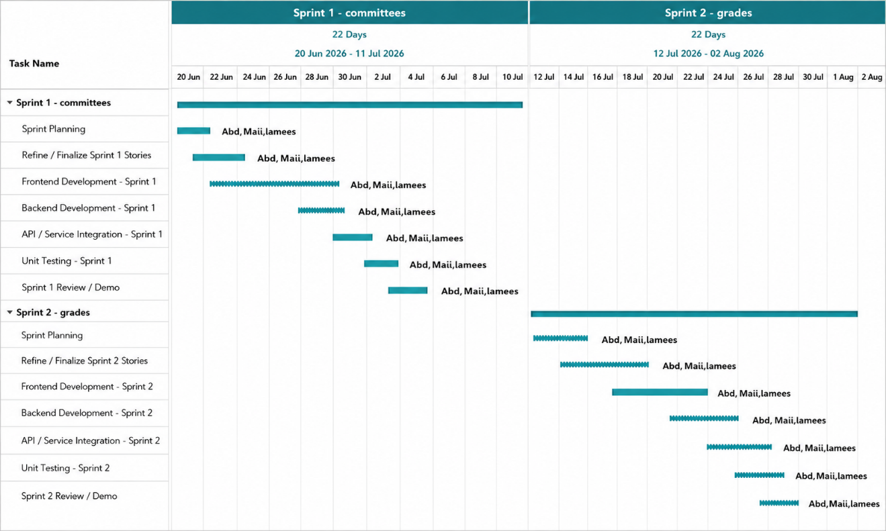
Figure 1 Gantt chart
The main activities were:
- Initial Planning: Project definition, scope identification, and task planning.
- Requirements Analysis: Stakeholder identification and requirements definition.
- System Analysis and Design: Architecture, database, workflows, and UML design.
- Implementation: Development of core and advanced system modules.
- Integration: Integration of frontend, backend, database, and external services.
- Testing and Quality Assurance: System validation and defect correction.
- Finalization: Documentation, final review, and deployment preparation.
The timeline was reviewed throughout development to adjust priorities when requirements or technical issues affected the original plan.

2.3 Risk Management
Risk management was used to identify technical, organizational, and operational risks that could affect the successful completion of the project. A risk register was maintained to document the identified risks, their estimated probability and impact, their current status, and the mitigation strategies used to reduce their effects.
The probability ratings below represent qualitative assessments made according to the nature of each risk and its expected likelihood during development.

Table 2. Risk Management Register
Risk ID | Risk Title | Description | Probability | Impact | Status | Tracking Frequency | Mitigation Plan
R-01 | GitLab Webhook  .ailure | Changes in GitLab, such as commits, merges, or issue updates, may fail to trigger updates in the system because of network or server problems. | Medium | High | Active | Daily | Provide a manual synchronization mechanism and detailed error logging to identify and recover from failed webhook events.
R-02 | Learning New Technologies | Limited previous experience with Django REST Framework or React may slow down development during the initial implementation stages. | Medium | Medium | Resolved | Weekly | Use structured learning, reusable templates, documentation, and practical experimentation to reduce the learning curve.
R-03 | RBAC Complexity | Managing permissions for the four system roles—Dean, Head of Department, Doctor, and Student—may lead to unauthorized access or incorrect data visibility if permissions are incorrectly implemented. | Medium | High | Active | Weekly | Implement role-based permission classes and apply role checks at the API level. Perform unit and integration testing for different role-access scenarios.
R-04 | Data Validation in Excel | Importing student or project data from Excel may fail if the file contains invalid formats, missing values, or duplicate identifiers. | Medium | Medium | Active | Daily | Validate imported files before modifying the database, detect duplicate identifiers, verify field formats, and provide clear validation errors.
R-05 | GitLab Token Expiration | Personal Access Tokens used to connect student accounts with GitLab may expire, causing the integration to stop functioning until a new token is provided. | Medium | Medium | Active | Monthly | Display clear token-validation errors and provide instructions for updating expired tokens. OAuth2 can be considered for future production deployment where appropriate.
R-06 | Frontend and Backend Integration | Coordination problems between the React frontend and Django backend may cause delays or inconsistencies during API integration. | Medium | High | Active | Daily | Maintain clear API documentation, agree on API contracts, and perform regular frontend-backend integration reviews.
R-07 | API Rate Limits | A large number of requests to external APIs, particularly GitLab APIs, may trigger rate limiting and reduce system responsiveness. | Medium | Medium | Active | Weekly | Apply request throttling, optimize external API calls, batch requests where appropriate, and use application-level caching when feasible.
R-08 | Requirement Changes | Late feedback from academic supervisors or changes in academic procedures may require modifications to existing workflow or system functionality. | High | High | Active | Monthly | Maintain a version-controlled requirements document, prioritize changes through the Agile process, and reserve time in the schedule for requirement adjustments.
R-09 | Database Integrity | Concurrent operations, such as a webhook update and a manual modification occurring at the same time, may cause conflicting database changes. | Medium | High | Active | Weekly | Use database-level row locking and atomic transactions for operations where concurrent modifications may occur, particularly invitation and approval workflows.
R-10 | Deployment Complexity | Configuring the production environment for the Django and React application may introduce deployment-related problems. | Medium | Medium | Active | Weekly | Perform deployment preparation and testing before the final stage and identify environment-specific configuration problems early.
R-11 | Reference API Downtime | Student self-registration depends on an external reference service for identity verification. If the service becomes unavailable, new students may be unable to complete registration. | Medium | High | Active | Weekly | Implement graceful error handling and user-friendly error messages. A controlled manual registration procedure can be considered for authorized university staff during external-service outages.
R-12 | Encryption Key Compromise | Exposure of the encryption key used to protect GitLab Personal Access Tokens could compromise the confidentiality of stored credentials. | Low | High | Active | Monthly | Restrict access to environment configuration files, exclude sensitive files from version control, and consider a dedicated secret-management service for production deployment.
Risk management was treated as a continuous activity rather than a one-time planning task. Risks were reviewed according to their tracking frequency, and mitigation strategies were adjusted when the project environment or implementation requirements changed.

2.4 Team Structure and Role Distribution
The project was developed by a three-member team. Each member was assigned a primary area of responsibility, while coordination and collaboration were maintained throughout the development process.

Table 3. Project Team Roles and Responsibilities

Team Member | Project Role | Main Responsibilities
Lamees | Frontend Developer | User interface design and implementation using React, frontend integration with backend APIs, responsive interface improvements, and frontend validation.
Abdalkareem | Backend Developer | Backend architecture, business logic, database-related functionality, REST API development, authentication, permissions, and backend integration.
Mai | Tester | Functional testing, validation of system behavior, test-case execution, identification and reporting of defects, and verification of corrections.

System Roles
The roles listed above describe the project development team and should not be confused with the user roles implemented within the system.
The system itself defines four main user roles:
- Student: manages project participation, project proposals, team activities, submissions, and related academic tasks.
- Doctor: represents a faculty member who may supervise projects, participate in committees, review project activities, and perform other academic functions assigned to faculty members.
- Head of Department: manages department-level academic processes, project approvals, workflows, committees, and related activities.
- Dean: performs university-level academic management and approval activities supported by the system.

2.5 Quality Management
Quality management was integrated throughout the development process to ensure that the system remained reliable, maintainable, secure, and consistent with the defined requirements.
The main quality practices included:
- Requirements Validation: Requirements were reviewed continuously and refined based on supervisor feedback.
- Code Review and Refactoring: Code was reviewed to improve readability, consistency, maintainability, and reduce duplication.
- Input and Data Validation: User inputs and imported data were validated before being processed or stored.
- Security and Permission Review: Role-based access controls were reviewed to ensure that each user could only access authorized operations and data.
- Acceptance Criteria: Major features were considered complete only after their required functionality was implemented, validated, and integrated successfully.
Detailed testing procedures and results are presented in Chapter Eight: System Testing.

2.6 Project Management Tools
Several tools were used to support different aspects of project development and management.
Table 4 Project Management and Development Tools
Tool | Purpose
Google Sheets / Excel | Data organization, planning, scheduling, and preparation of structured project information.
diagrams.net (draw.io) | Creation of UML diagrams, architecture diagrams, database-related diagrams, workflows, and other system design diagrams.
Git | Source-code version control and management of development branches.
GitHub | Source-code hosting, collaboration, pull requests, branch management, and version history for the project codebase.
GitLab | Repository-related functionality and integration with the University Project Management System for monitoring software-development activities of student projects.
Each tool was selected according to the specific project activity it supported. This separation helped maintain organized project artifacts and facilitated collaboration between team members.

2.7 Monitoring and Continuous Evaluation
Continuous monitoring was carried out throughout the project to ensure alignment with the objectives, requirements, and academic schedule.
The main monitoring activities included regular meetings with supervisors, periodic progress and sprint reviews, intermediate system demonstrations, issue tracking and correction, and continuous review of requirements based on feedback.
Technical guidance was provided by Eng. Amer Khorsheed, while Dr. Mouhib Alnoukari and Dr. Anas Abdulaziz provided academic supervision and reviewed project progress and milestones.
These activities helped provide continuous feedback and identify problems early during development.

2.8 Software Configuration Management
Software Configuration Management (SCM) was used to control changes to the project's source code, documentation, configuration files, and software versions. Git was used for version control, with GitHub used for source-code hosting and collaboration.

2.8.1 Branching Strategy
The project followed a structured branch strategy:
- main: stable and deliverable version.
- develop: integration branch for completed development work.
- feature/...: development of new features or modules.
- fix/...: correction of identified defects.
- hotfix/...: urgent fixes affecting the stable version.
- docs/...: documentation-related changes.
This structure allowed features and fixes to be developed independently while protecting the stable version.

2.8.2 Feature Development Process
New features were developed in dedicated branches, tested locally, committed with descriptive messages, and pushed to GitHub. Changes were reviewed through pull requests when applicable and then merged into the appropriate development or stable branch.
This process provided a clear history of changes and reduced the risk of introducing untested changes into the stable version.

2.8.3 Configuration and Sensitive Files
Sensitive information such as .env files, passwords, access tokens, secret keys, and database backups was excluded from source-code repositories using .gitignore. An .env.example file was provided to document the required environment variables without exposing actual credentials.

Chapter Summary
This chapter presented the methodology used to develop and manage the University Project Management System. An Agile development approach based on Scrum principles was selected because the project requirements could evolve throughout development and required continuous feedback and incremental implementation.
The chapter also presented the project timeline, risk management register, team structure, quality management practices, project management and development tools, monitoring mechanisms, and software configuration management strategy.
Graduation Project 1 focused primarily on project analysis, requirements, system design, and implementation of the core system modules. Graduation Project 2 focused on completing the remaining functionality, committee scheduling, grade management, system integration, testing, interface improvements, defect correction, and final documentation.
The use of an iterative development approach, continuous supervision, structured risk management, systematic testing, and Git-based configuration management provided an organized framework for developing the system and maintaining control over changes throughout the project lifecycle.

Chapter3
Review of literature and previous studies

Chapter Objective
This chapter reviews previous studies and existing systems related to university graduation project management. It presents the main technologies used in the proposed system, compares related academic project-management systems, identifies the research gap addressed by the proposed system, and discusses the theoretical concepts and future trends relevant to the project.

3.1 Previous Studies in Academic Project Management
Several studies have developed web-based systems to improve the management, supervision, monitoring, and evaluation of university graduation projects.

3.1.1 UMIT Project Management System — Morey et al., 2024
Morey et al. (2024) developed the UMIT Project Management System to automate the management and evaluation of student projects across multiple academic stages. The system supports project submission, group formation, guide allocation, evaluation schedules, rubrics, and mark calculation.
The study demonstrates the effectiveness of automating project evaluation and management. However, its focus is mainly on project phases and evaluation, while the proposed system provides a broader integration of academic workflows, committee management, scheduling, academic-stage transitions, and GitLab integration.

3.1.2 Student Project Management System — University of Ibadan, 2024
Arowolo, Saheed, and Akinola (2024) developed a web-based Student Project Management System for the Computer Science Department at the University of Ibadan. The system supports project proposal submission, supervisor assignment, project tracking, feedback management, document organization, communication, and reporting. It was developed using PHP, MySQL, HTML, CSS, and Bootstrap.
Compared with the proposed system, the study focuses mainly on managing and monitoring student projects, while the proposed system extends the lifecycle to include configurable academic workflows, committee management and scheduling, academic-stage transitions, grading, and GitLab integration.

3.1.3 Final Year Project Management System — UPTM, 2024
Isa et al. (2024) developed a web-based Final Year Project Management System (FYPMS) at University Poly-Tech Malaysia to improve the monitoring and supervision of final-year students. The system provides a centralized dashboard through which students can track their progress, while lecturers can monitor projects, review proposals, recommend project titles, and assess student work.
The study focuses primarily on improving project monitoring and supervision, whereas the proposed system extends project management to include academic workflows, committee management and scheduling, grading, academic-stage transitions, and GitLab integration.

3.1.4 University Graduation Project Management System — Li et al., 2021
Li, Liu, and Wu (2021) developed a graduation project management system based on a microservice architecture. The system uses Spring Boot, MyBatis, Ajax, and MySQL and supports multiple stages of the graduation-project lifecycle, including topic selection, assignment, opening reports, mid-term inspection, submission, review, defense, and archiving. The system demonstrates how a complete graduation-project process can be digitized through a centralized platform.
Compared with this system, the proposed GPMS focuses on integrating university-specific academic workflows with constraint-based committee scheduling, GitLab integration, grading, and transitions between project stages.

Summary of Previous Studies
The reviewed studies demonstrate that academic project-management systems can effectively support proposals, supervision, monitoring, evaluation, and document management. However, most systems focus on specific parts of the project lifecycle. The proposed system seeks to integrate these activities with academic workflows, committee management, automated scheduling, grading, notifications, academic-stage transitions, and GitLab integration.

3.2 Modern Technologies and Frameworks

3.2.1 Django and Django REST Framework
Django is used for backend development, while Django REST Framework provides the APIs connecting the backend with the frontend.

3.2.2 React
React is used to build the frontend through reusable components and dynamic role-based interfaces.

3.2.3 PostgreSQL
PostgreSQL is used as the main relational database for storing and maintaining system data.

3.2.4 Celery and Redis
Celery is used for background and scheduled tasks, while Redis supports Celery as a message broker for asynchronous processing

3.2.5 GitLab REST API
The GitLab REST API connects academic projects with their software-development repositories and related activities.

3.2.6 Google OR-Tools
Google OR-Tools is used for automated committee scheduling. The scheduling process considers constraints such as doctor availability, room availability, time conflicts, and discussion duration.

3.3 Comparative Analysis of Existing Academic Project Management Systems
The following table compares the reviewed systems with the proposed University Project Management System.

Table 5. Comparative Analysis of Academic Project Management Systems
Feature | UMIT PMS | Ibadan SPMS | UPTM FYPMS | Li et al. | Proposed GPMS
Project Proposal | ✓ | ✓ | ✓ | ✓ | ✓
Project/Topic Management | ✓ | ✓ | ✓ | ✓ | ✓
Student–Supervisor Management | ✓ | ✓ | ✓ | ✓ | ✓
Project Monitoring | ✓ | ✓ | ✓ | ✓ | ✓
Evaluation / Grading | ✓ | Partial | ✓ | ✓ | ✓
Multi-Stage Lifecycle | ✓ | Partial | Partial | ✓ | ✓
Approval Workflow | Partial | Partial | Partial | ✓ | ✓
Committee Management | Partial | ✗ | ✗ | Partial | ✓
Automated Committee Scheduling | ✗ | ✗ | ✗ | ✗ | ✓
Room Availability Constraints | ✗ | ✗ | ✗ | ✗ | ✓
Notifications | ✓ | Not specified | Not specified | Not specified | ✓
GitLab Integration | ✗ | ✗ | ✗ | ✗ | ✓
Academic-Stage Transition | Partial | ✗ | ✗ | Partial | ✓

The comparison shows that the proposed system combines project management, academic workflows, committee scheduling, grading, academic-stage transitions, and GitLab integration within a single platform.

3.4 Research Gap and Proposed Contribution
The reviewed systems provide useful functions for project proposal, supervision, monitoring, and evaluation, but they differ in the extent to which they integrate the complete academic project lifecycle.
The proposed system addresses this gap by combining academic workflows, committee management, constraint-based scheduling, grading, notifications, academic-stage transitions, and GitLab integration within a single university-oriented platform.
The contribution is therefore primarily an integrated software-engineering solution designed around the academic procedures of the Syrian Private University, rather than a new machine-learning algorithm.

3.5 Theoretical Framework
The proposed system is based on the following software-engineering and computational concepts:
- REST Architecture: Used for communication between the React frontend and Django backend through HTTP-based APIs.
- Role-Based Access Control (RBAC): Restricts system operations according to user roles, including Student, Doctor, Head of Department, and Dean.
- Workflow Management: Represents project stages and controls transitions according to defined conditions and approvals.
- Constraint-Based Scheduling: Models committee scheduling while considering doctor availability, rooms, time conflicts, and discussion duration.
- Database Transactions: Ensure that related database operations are completed consistently or rolled back when an error occurs.
- Asynchronous Processing: Supports background operations such as notifications and scheduled tasks.
- Version Control: Git maintains source-code history through commits, branches, and controlled changes.

3.6 Recent and Future Trends
Future versions of the system could benefit from Generative AI and LLMs for document assistance, predictive analytics for identifying delayed projects, intelligent scheduling for improved committee assignment, and integration with other university systems. Privacy and human oversight should remain essential when introducing intelligent features.

Chapter Summary
This chapter reviewed related systems, identified the main research gap, and presented the technologies and theoretical concepts underlying the proposed system. It also highlighted future directions, including AI, predictive analytics, intelligent scheduling, and university-system integration.

Requirements modeling and analysis

Chapter Introduction
This chapter presents the requirements that the Graduation Project Management System must satisfy, together with the methods used to collect, analyze, prioritize, and validate them. It identifies the project stakeholders, functional and non-functional requirements, main use cases, user stories, product backlog, and the relationship between requirements, system components, and testing.
Most requirements were identified and analyzed during Graduation Project 1. During Graduation Project 2, the requirements were updated to include discussion committee scheduling, grade entry, project transitions between academic stages, and improvements to several rules and permissions based on implementation feedback and testing results.

4.1 Feasibility Study

4.1.1 Technical Feasibility
The system is technically feasible using open-source technologies including Django, Django REST Framework, React, PostgreSQL, Redis, and Celery. The client-server architecture can run on a standard development computer or university server, while GitLab and email services can be integrated through APIs. The implemented system demonstrates the feasibility of the main project, workflow, committee, scheduling, grading, notification, and GitLab functions.

4.1.2 Financial Feasibility
The project has low development costs because its main technologies are open source. Potential operational costs include hosting, domain and SSL certificates, email services, backups, and maintenance. These costs can be reduced by using university infrastructure or available educational services.

4.1.3 Schedule and Operational Feasibility
The project was developed across Graduation Project 1 and Graduation Project 2, covering analysis, core implementation, advanced features, integration, and testing. The web-based interface uses familiar interaction patterns, so users require only basic training related to their roles.

4.2 Requirements Gathering

4.2.1 Discussions with Academic Supervisors
Discussions with the academic supervisors were used to understand graduation-project procedures and the responsibilities of students, faculty members, department heads, and the dean.

4.2.2 Analysis of the Existing Workflow
The existing graduation-project workflow was analyzed to identify problems such as duplicated data, delayed approvals, difficulty tracking project status, and scheduling conflicts.

4.2.3 Iterative Review
Requirements and initial models were reviewed periodically, and updates were made based on supervisor feedback and issues identified during implementation and testing.
A large-scale questionnaire was not used because the project required a detailed understanding of academic procedures, roles, and permissions. Therefore, direct discussions, document review, and workflow analysis were considered more appropriate.

4.2.4 Summary of Requirements-Gathering Results
The requirements-gathering process identified the need for a centralized project-management platform, role-based permissions, a clear approval sequence, semester and academic-stage management, conflict-free committee scheduling, secure grade management, preservation of evaluation history, and notifications for important actions.

4.3 Stakeholders and Analysis of Their Needs
The main stakeholders directly involved in the academic project lifecycle are students, supervisors, committee members, department heads, and the dean.
Table 6 Stakeholders and Their Needs
Stakeholder | Needs and Expectations
Student | Propose an idea, form a team, select a supervisor, track approvals, upload files, and view the current stage and results.
Supervisor | Review requests, monitor projects, open or review workflow stages, and access student submissions.
Committee Member | View assigned discussions and enter authorized grades.
Department Head | Review proposals, manage projects, form committees, distribute projects, and monitor the department.
Dean | Manage semesters, monitor all departments, approve operations, and access reports.

4.4 Functional Requirements
Functional requirements define the functions and services that the system shall provide. They are grouped according to the major functional modules of the Graduation Project Management System.

4.4.1 User and Permission Management
Table 7 functional requirement
ID | Functional Requirement
FR1 | The system shall allow students, doctors, department heads, and the dean to log in and access the functions assigned to their roles.
FR2 | The system shall allow authorized academic and administrative users to create and import student and faculty user accounts.
FR3 | The system shall apply role-based permissions for students, doctors, department heads, the dean, and system administrators according to their assigned roles.

4.4.2 Academic Semester and Project Stage Management
ID | Functional Requirement
FR4 | The system shall allow authorized department heads and the dean to create and configure academic semesters, including their names, dates, and status.
FR5 | The system shall allow users to select and filter projects, committees, and related academic records by semester.
FR6 | The system shall support the academic stages Seasonal Project, Graduation Project 1, and Graduation Project 2.
FR7 | The system shall preserve changes in project participation status, including active, failed, and withdrawn states, together with the related status information.

4.4.3 Project Ideas, Teams, and Approvals
ID | Functional Requirement
FR8 | The system shall allow students to propose project ideas or apply for ideas published by faculty members.
FR9 | The system shall allow students to form project teams and send invitations to other students.
FR10 | The system shall allow a project proposal to have a primary supervisor and, where applicable, a co-supervisor.
FR11 | The system shall manage the approval sequence involving team members, supervisors, and the department head.
FR12 | The system shall handle acceptance, rejection, and replacement cases while preserving the relevant proposal and decision records.

4.4.4 Project and Workflow Management
ID | Functional Requirement
FR13 | The system shall create and maintain project participation and related project records after the required proposal or application approval process is completed.
FR14 | The system shall allow authorized users to create workflow templates and assign workflows and stages to projects.
FR15 | The system shall allow students to submit required responses and upload files during workflow stages.
FR16 | The system shall allow supervisors to review workflow submissions and record feedback and decisions.
FR17 | The system shall generate in-system notifications for important events and support email notifications for configured events.
FR18 | The system shall allow students and supervisors to link a project to a GitLab repository and retrieve relevant repository information.

4.4.5 Committee and Discussion Scheduling Management
ID | Functional Requirement
FR19 | The system shall allow authorized department heads and the dean to create committee templates and define committee members and roles.
FR20 | The system shall allow authorized department heads and the dean to distribute projects among committees according to department, project stage, and semester.
FR21 | The system shall allow authorized department heads and the dean to define faculty availability, date exceptions, rooms, working days, and available scheduling periods.
FR22 | The system shall generate discussion schedules while preventing conflicts involving faculty members, rooms, and time periods.
FR23 | The system shall allow authorized department heads and the dean to preview, review, modify, and apply generated committee schedules.

4.4.6 Grade and Report Management
ID | Functional Requirement
FR24 | The system shall allow authorized committee members to enter project grades.
FR25 | The system shall support individual or collective evaluation according to the configured committee grading mode.
FR26 | The system shall calculate and finalize evaluation results only after all required evaluations have been completed.
FR27 | The system shall restrict grade operations according to user permissions and protect stored grade information from unauthorized modification.
FR28 | The system shall allow authorized academic users to export grade information and academic reports in supported document formats.
FR29 | The system shall track project and student participation statuses, including active, failed, and withdrawn states, and prevent unauthorized status changes.
FR30 | The system shall allow authorized department heads and the dean to manage project participation decisions, including marking participation as failed, withdrawn, or active again, with the decision recorded in the system.

4.5 Non-Functional Requirements
Table 8 non-functional requieremnt
ID | Category | Non-Functional Requirement
NFR1 | Performance | The system shall use pagination or incremental loading when displaying large lists.
NFR2 | Security | Passwords shall be stored securely and shall never be saved or displayed as plain text.
NFR3 | Security | User roles, permissions, and data ownership shall be verified by the backend.
NFR4 | Security | The deployed system shall use HTTPS to protect transmitted data.
NFR5 | Security | The system shall restrict uploaded file types and sizes.
NFR6 | Usability | The interfaces shall be clear and support Arabic and right-to-left layout.
NFR7 | Usability | Main operations shall require a limited number of clear steps.
NFR8 | Compatibility | The system shall operate correctly on modern web browsers and different screen sizes.
NFR9 | Reliability | Database transactions shall be used for operations that include multiple related updates.
NFR10 | Data Integrity | The system shall validate input data and apply database constraints before saving records.
NFR11 | Maintainability | The system shall be divided into independent and reusable backend applications and frontend components.
NFR12 | Maintainability | Core APIs, business rules, and system modules shall be documented.
NFR13 | Backup | Periodic backups shall be provided for the database and important uploaded files.
NFR14 | Auditability | Sensitive operations, such as grade approval and project-stage transitions, shall be recorded.
NFR15 | Privacy | Users shall not be able to access data unrelated to their roles or assigned projects.
NFR16 | Availability | Essential system functions shall remain usable when non-essential services, such as email delivery, temporarily fail.
NFR17 | Scalability | The database design and application structure shall support an increasing number of users, projects, and semesters.

4.6 Requirements Prioritization Using MoSCoW
Table 9 Requirements Prioritization Using MoSCoW
Priority | Requirements
Must Have | User accounts and permissions, project ideas and teams, supervisors and approvals, academic semesters and stages, workflows, committees, scheduling, and grade management.
Should Have | Email notifications, GitLab integration, report export, audit records, and support for two supervisors.
Could Have | Advanced analytical dashboards, project-delay indicators, intelligent scheduling suggestions, and a mobile application.
Won't Have Currently | Full university registration and financial management, automatic academic decision-making, machine-learning model training, and replacement of the university's entire information system.

4.7 UML Requirements Diagrams

4.7.1 Use Case Diagrams
To limit the size of the thesis, four main use cases were selected to represent the core system functions
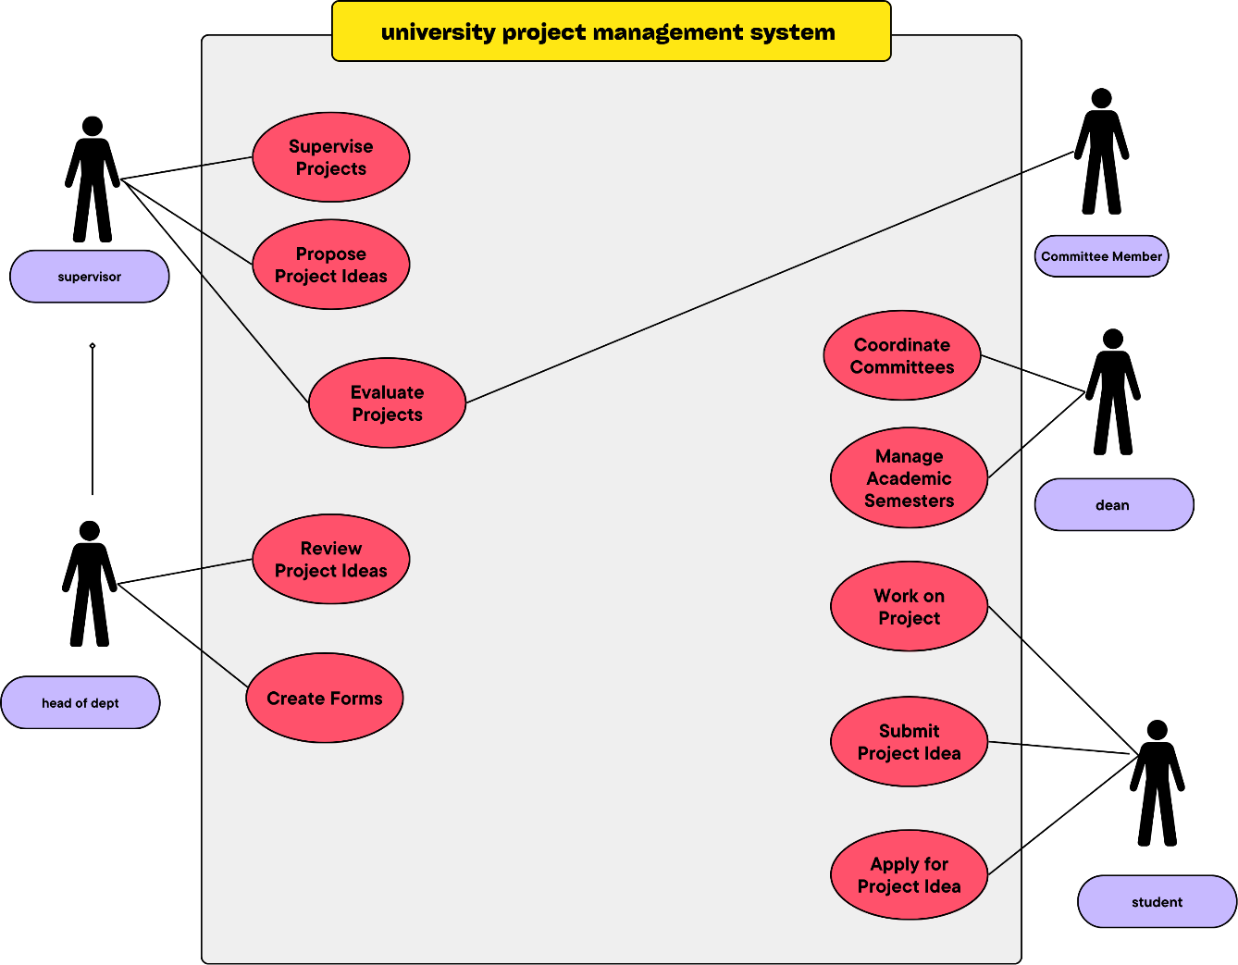
Figure 2 main use case
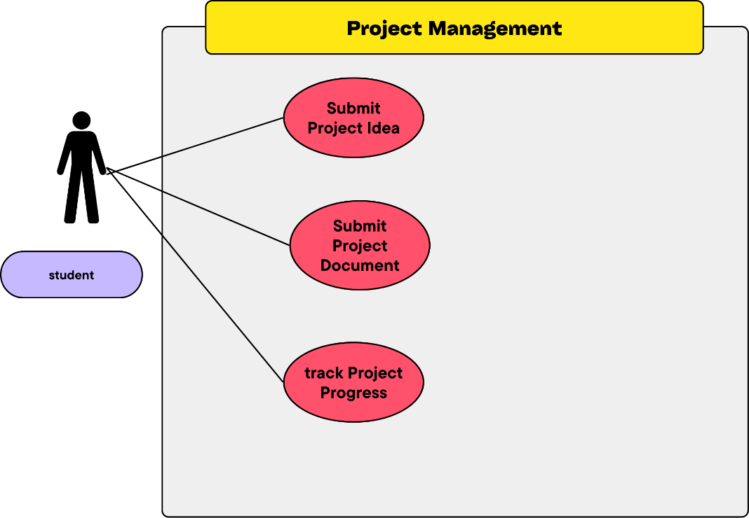
Figure 3 project management use case
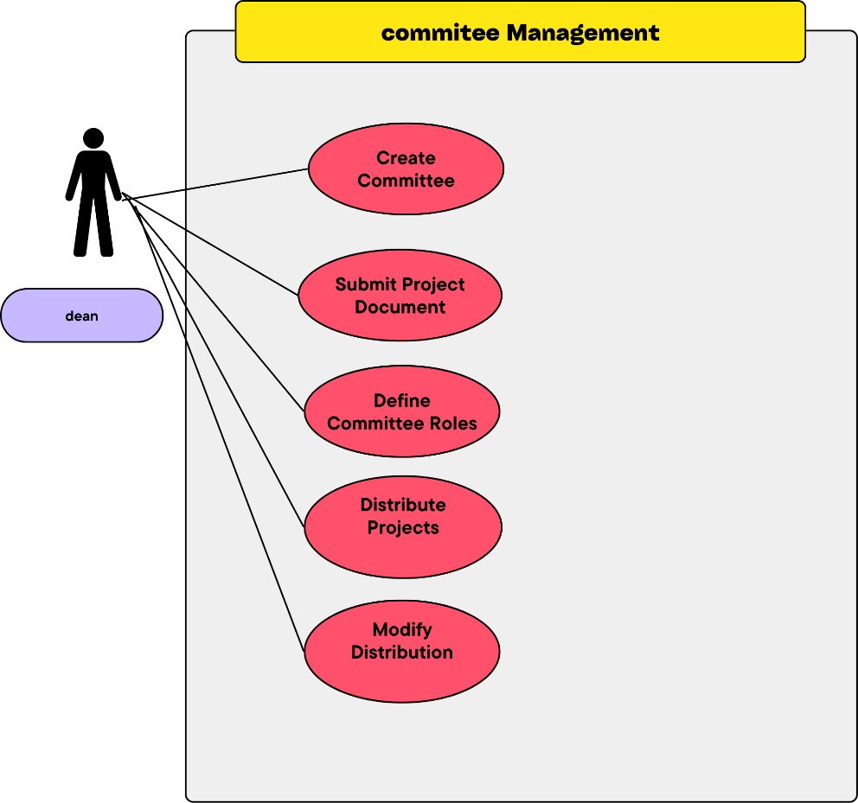
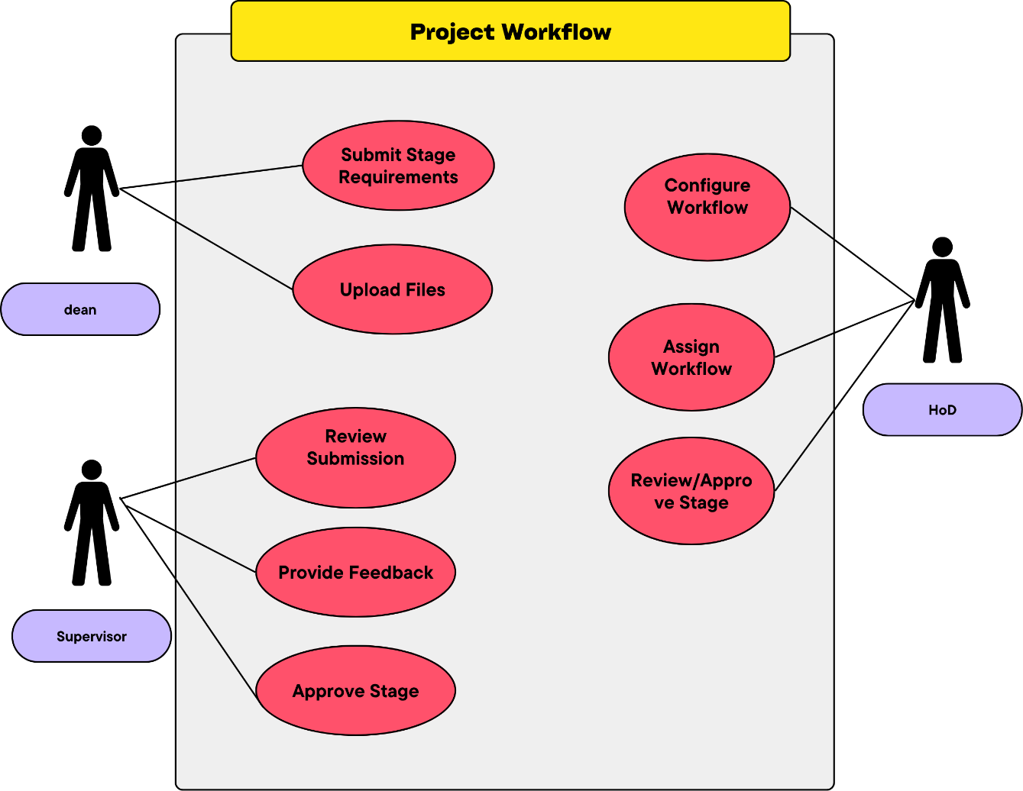

Figure 4 committee management use case
Figure 5 project workflow use case

4.7.2 Use Case Descriptions

UC-01: Manage Project Proposals

Table 10 use case description
Item | Description
Use Case Name | Manage Project Proposals
Actors | Student, Doctor/Supervisor, HoD
Related FRs | FR8, FR9, FR10, FR11, FR12, FR13
Precondition | The user is authenticated and has the required academic role.
Basic Flow | 1. Student creates a proposal or applies for a published idea. 2. Student forms a team and sends invitations. 3. Supervisor information is assigned. 4. Proposal is submitted for review. 5. Supervisor reviews the proposal. 6. HoD completes the required approval process. 7. Project participation/management records are created.
Alternative Flow | A proposal may be rejected, require revision, or involve replacement of a team member/supervisor.
Postcondition | The proposal is stored with its current decision and related project records.

UC-02: Manage Project Workflow
Item | Description
Use Case Name | Manage Project Workflow
Actors | Student, Doctor/Supervisor, HoD
Related FRs | FR14, FR15, FR16, FR17
Precondition | A valid project exists and a workflow is assigned.
Basic Flow | 1. Authorized user creates or selects a workflow template. 2. Workflow stages are configured. 3. Workflow is assigned to a project. 4. Student submits required responses/files. 5. Supervisor reviews the submission. 6. Feedback or decision is recorded. 7. The system generates relevant notifications.
Alternative Flow | Missing or invalid data prevents submission; the reviewer may request revision or reject the submission.
Postcondition | The workflow stage and submitted information are stored with the appropriate status.

UC-03: Manage Committees and Scheduling
Item | Description
Use Case Name | Manage Committees and Scheduling
Actors | Dean, HoD, Doctor/Supervisor
Related FRs | FR19, FR20, FR21, FR22, FR23
Precondition | Projects and committee information are available.
Basic Flow | 1. Authorized user creates a committee template. 2. Members are assigned. 3. Projects are distributed among committees. 4. Faculty availability, rooms, dates and working periods are configured. 5. The scheduling solver generates a schedule. 6. The generated schedule is reviewed. 7. Authorized user modifies or applies the schedule.
Alternative Flow | If constraints cannot be satisfied, the system reports that a valid schedule cannot be generated.
Postcondition | A valid committee schedule is stored and associated with the assigned projects.

UC-04: Manage Project Evaluation and Grades
Item | Description
Use Case Name | Manage Project Evaluation and Grades
Actors | Doctor/Supervisor, HoD, Dean
Related FRs | FR24, FR25, FR26, FR27, FR28
Precondition | The project has reached an evaluation stage and the user has grading permission.
Basic Flow | 1. Authorized evaluator opens the evaluation. 2. Required grades are entered. 3. The configured individual or collective grading mode is applied. 4. Required evaluations are checked. 5. Results are calculated/finalized when requirements are satisfied. 6. Authorized users may export reports.
Alternative Flow | Incomplete evaluations prevent finalization. Unauthorized users are prevented from modifying grades.
Postcondition | Valid evaluation results are stored and protected according to the user's permissions.

UC-05: Manage Project Repository
Item | Description
Use Case Name | Manage Project Repository
Actors | Student, Doctor/Supervisor
Related FRs | FR18
Precondition | A valid project exists and the user has permission to manage its repository.
Basic Flow | 1. User enters the GitLab repository URL. 2. System validates the repository. 3. Repository is linked to the project. 4. Repository information is retrieved and displayed.
Alternative Flow | Invalid or inaccessible repository information produces an error message.
Postcondition | The GitLab repository is linked to the project and its available information can be retrieved.

UC-06: Manage Project Participation
Item | Description
Use Case Name | Manage Project Participation
Actors | Student, HoD, Dean
Related FRs | FR6, FR7, FR29, FR30
Precondition | A project participation record exists and the user has the required permission.
Basic Flow | 1. Authorized user views participation information. 2. The current participation status is displayed. 3. Authorized user updates the status when required. 4. The new status is stored. 5. The previous information remains available as part of the participation record/history where supported.
Alternative Flow | Unauthorized users cannot modify participation status.
Postcondition | The participation record contains the updated valid status.

UC-07: Manage User Accounts
Item | Description
Use Case Name | Manage User Accounts
Actors | Dean, HoD, System Administrator
Related FRs | FR1, FR2, FR3
Precondition | The user is authenticated and has the required administrative permissions.
Basic Flow | 1. Authorized user opens user management. 2. The system displays available user accounts. 3. Authorized user creates, updates, imports, or manages user information. 4. The system validates the submitted data. 5. The account information is stored. 6. Appropriate permissions are assigned according to the user's academic role.
Alternative Flow | Invalid or duplicate user information is rejected and an appropriate error message is displayed. Unauthorized users cannot access account management functions.
Postcondition | The user account is created or updated with the appropriate role and permissions.

UC-08: Manage Academic Semester
Item | Description
Use Case Name | Manage Academic Semester
Actors | Dean, HoD
Related FRs | FR4, FR5, FR6, FR7
Precondition | The authorized user is authenticated and has permission to manage academic semester information.
Basic Flow | 1. Authorized user creates or updates an academic semester. 2. Semester name, start date, end date, and status are defined. 3. The system identifies the current semester. 4. Projects are associated with the appropriate academic stage and semester. 5. Previous project transitions and semester information are preserved.
Alternative Flow | Invalid dates or conflicting semester information prevent saving the semester.
Postcondition | The academic semester and related project-stage information are stored correctly.

UC-09: Manage Workflow Submissions
Item | Description
Use Case Name | Manage Workflow Submissions
Actors | Student, Doctor/Supervisor, HoD
Related FRs | FR14, FR15, FR16, FR17
Precondition | A valid project has an assigned workflow and the user has the required permission.
Basic Flow | 1. Student opens the current workflow stage. 2. Required fields and files are displayed. 3. Student submits the required information. 4. The system validates the submission. 5. Supervisor reviews the submission. 6. The supervisor records comments or a decision. 7. The system updates the workflow status and sends relevant notifications.
Alternative Flow | Missing or invalid information prevents submission. The reviewer may request revision or reject the submission.
Postcondition | The workflow submission and its current status are stored.

UC-10: Manage Committee Distribution
Item | Description
Use Case Name | Manage Committee Distribution
Actors | Dean, HoD
Related FRs | FR19, FR20
Precondition | Approved projects and committee information are available.
Basic Flow | 1. Authorized user creates or selects committee configurations. 2. Available committee members are identified. 3. Projects are distributed among committees according to the required criteria. 4. The system validates the distribution. 5. The distribution is stored.
Alternative Flow | If a project cannot be assigned according to the configured rules, the system reports the issue and allows the authorized user to modify the distribution.
Postcondition | Projects are assigned to the appropriate committees.

UC-11: Manage Grade Reports and Export
Item | Description
Use Case Name | Manage Grade Reports and Export
Actors | Dean, HoD, Doctor/Supervisor
Related FRs | FR24, FR25, FR26, FR27, FR28
Precondition | Evaluation data exists and the user has the required grading or reporting permission.
Basic Flow | 1. Authorized user opens the grading/reporting section. 2. The system retrieves available evaluation results. 3. The system verifies that required evaluations are completed. 4. Authorized user views the results. 5. The system generates the requested academic report. 6. The report is exported in the supported format.
Alternative Flow | Incomplete evaluations prevent finalization or report generation. Unauthorized users cannot access protected grade information.
Postcondition | The requested grade report is generated and exported without exposing unauthorized information.

UC-12: Manage Project Stage Transition
Item | Description
Use Case Name | Manage Project Stage Transition
Actors | Dean, HoD, Doctor/Supervisor
Related FRs | FR6, FR7, FR29, FR30
Precondition | A valid project participation record exists and the user has permission to manage its academic status.
Basic Flow | 1. Authorized user reviews the project's current stage and status. 2. The system checks required conditions and grades. 3. Authorized user approves the appropriate decision. 4. The system updates the project stage or participation status. 5. The previous status is preserved in the project history.
Alternative Flow | If required grades or conditions are incomplete, the system prevents the transition. The project may be marked for repetition, postponement, or another supported decision.
Postcondition | The project has a valid updated academic stage/status and the transition history is preserved.

4.7.3 Activity Diagrams
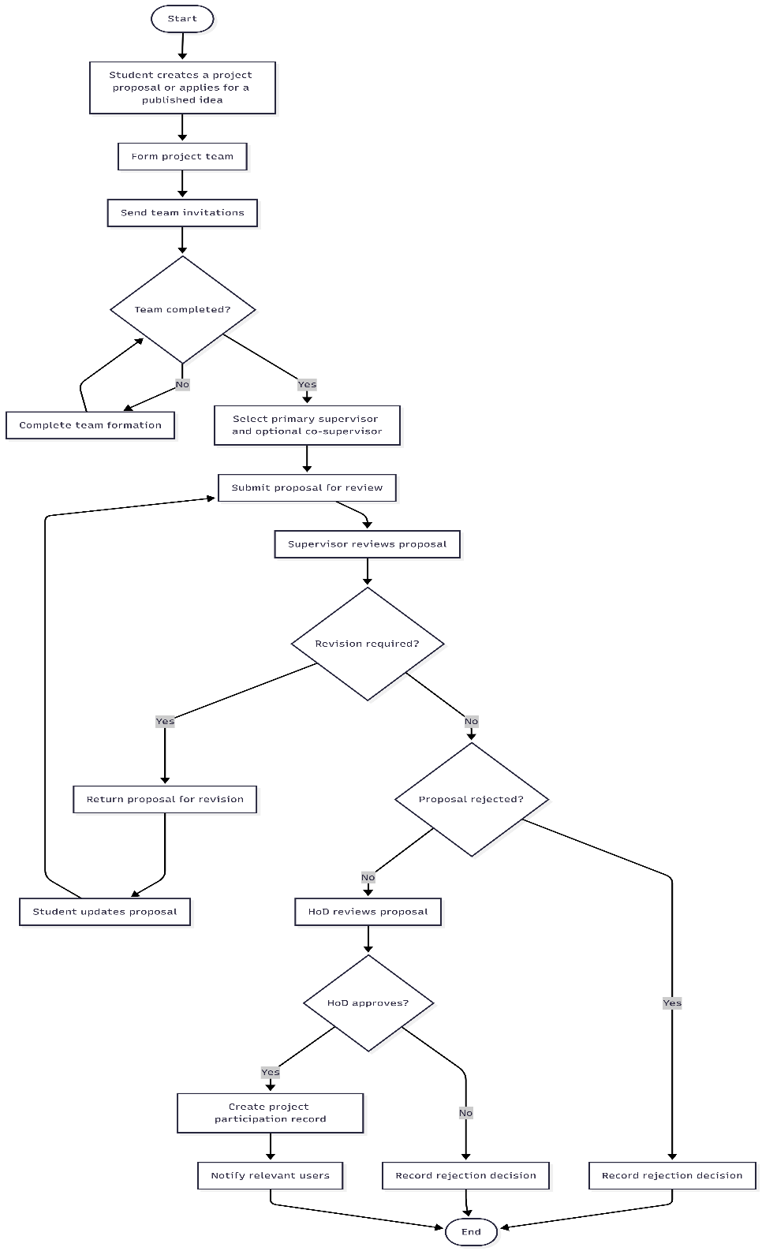
Figure 6 activity diagram Project Proposal and Approval

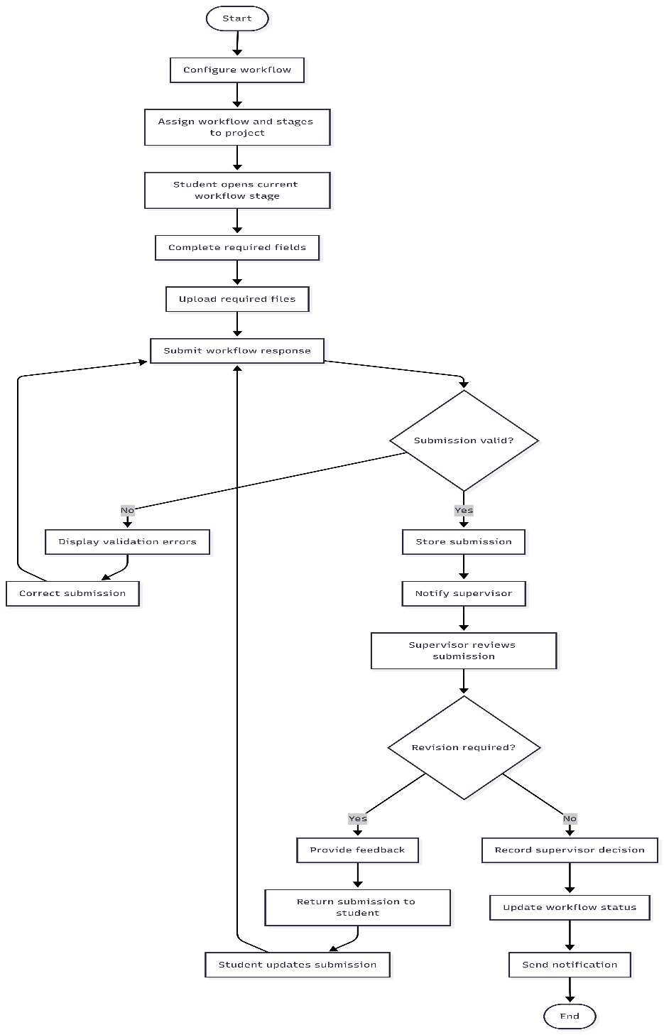
Figure 7 Project Workflow and Submission activity diagram

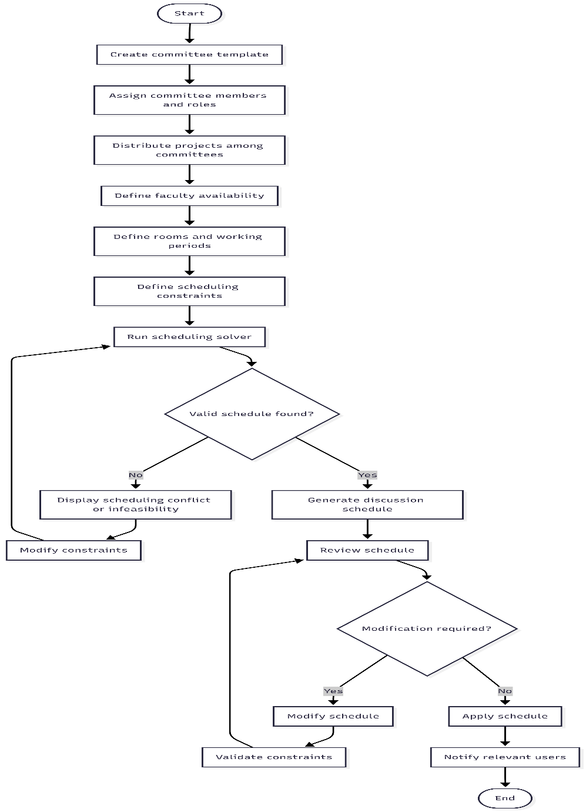
Figure 8 Committee Scheduling activity diagram
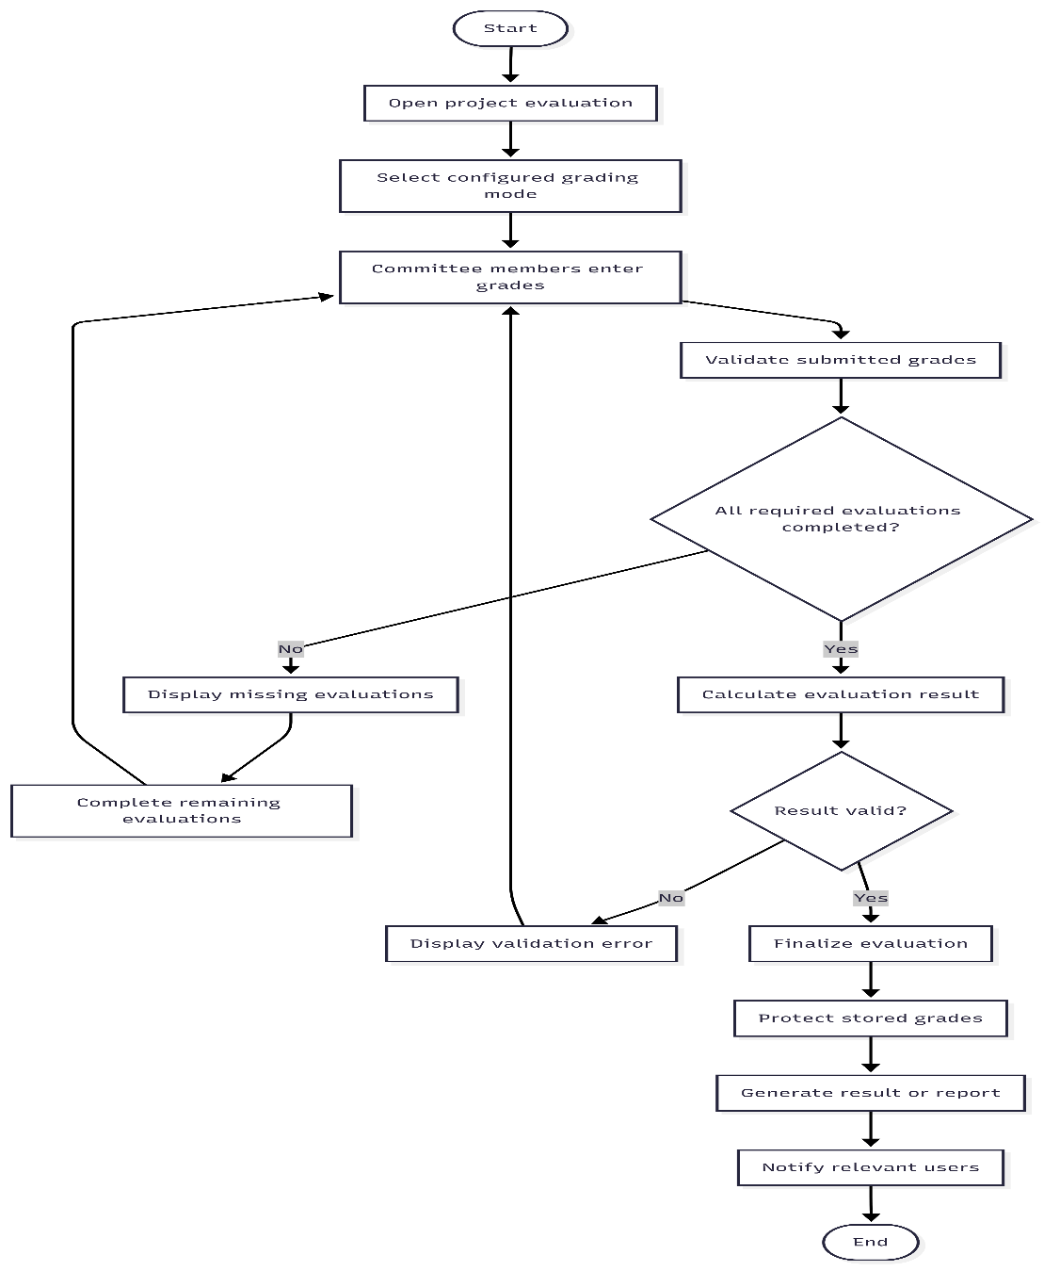
Figure 9 Project Evaluation and Grading activity diagram

4.7.4 Sequence Diagrams
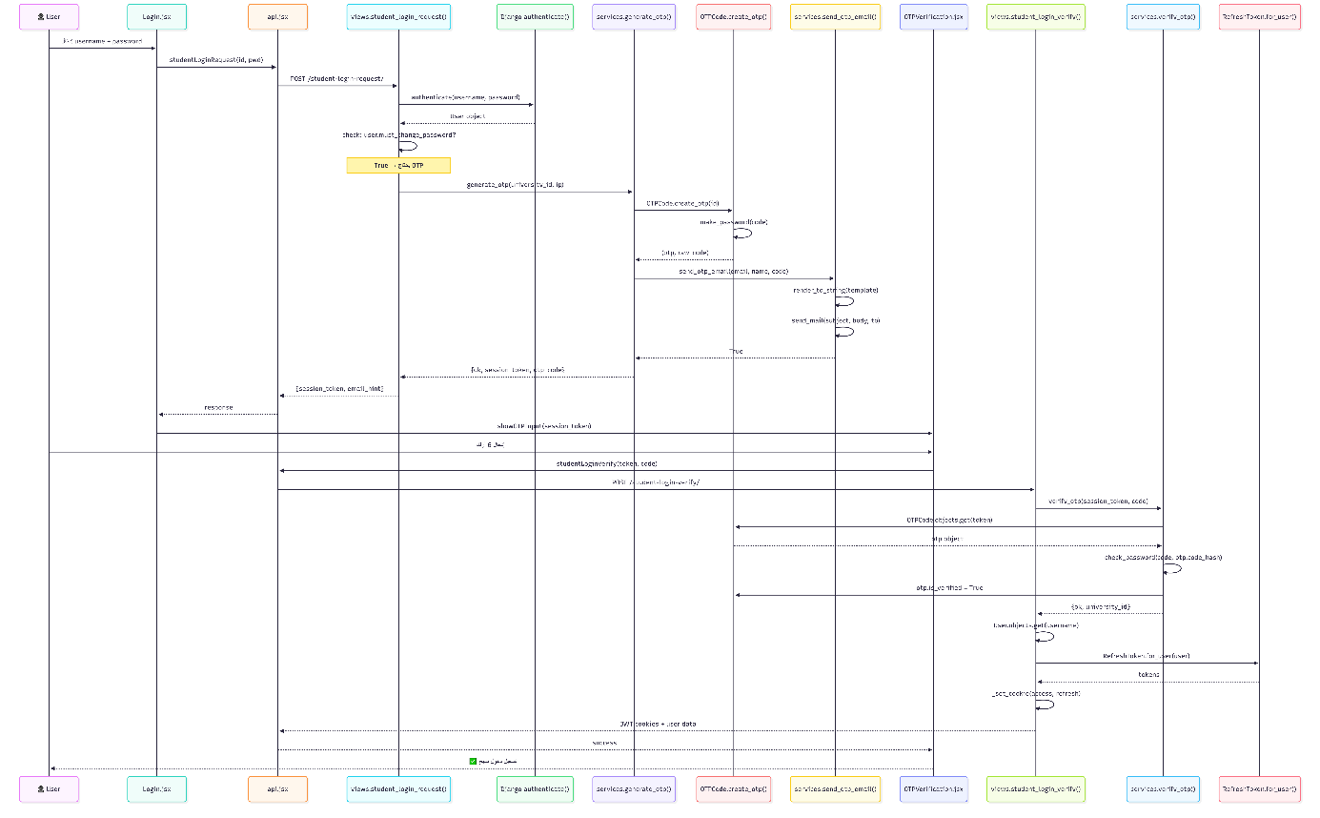
Figure 10 fist login sequence diagram

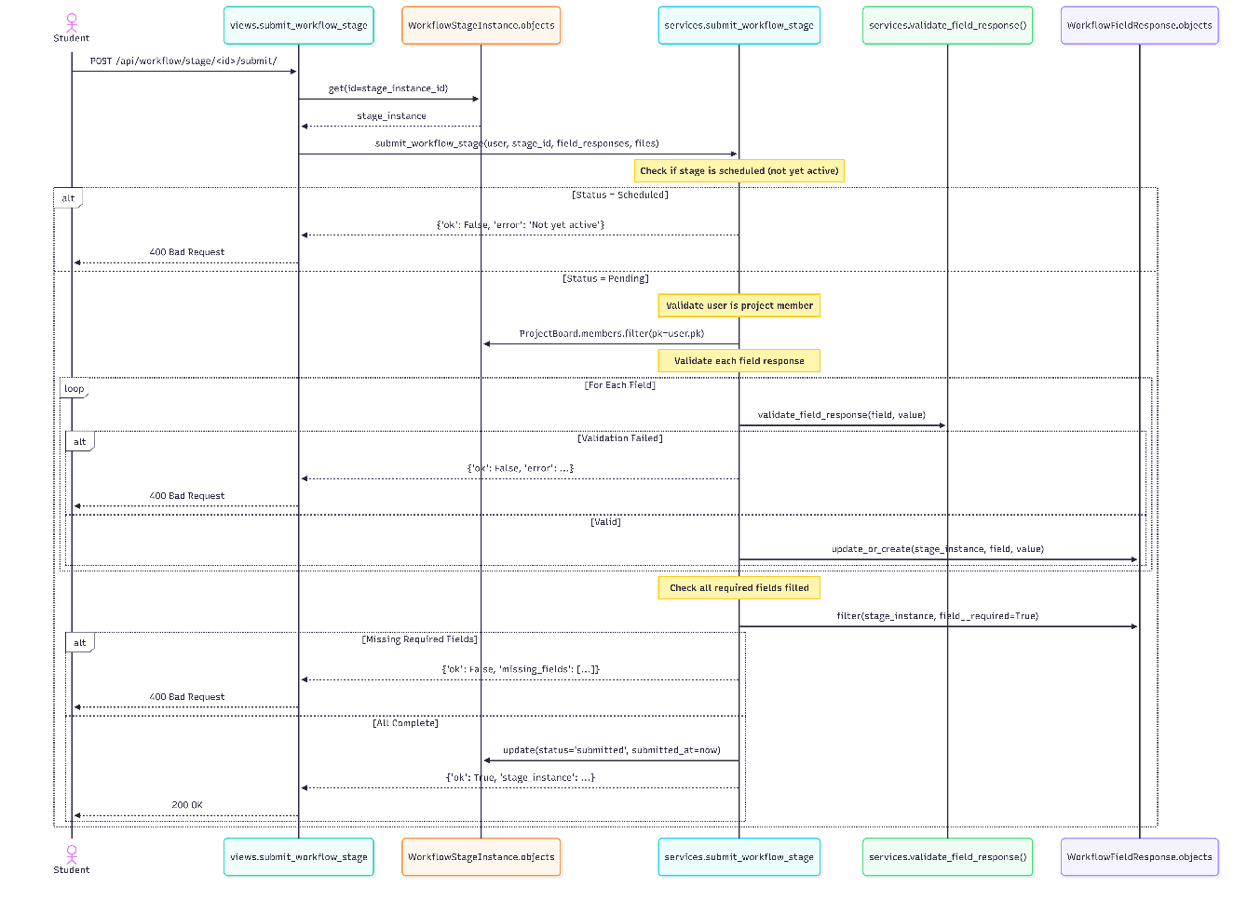
Figure 11 Submit Workflow Stage sequence diagram

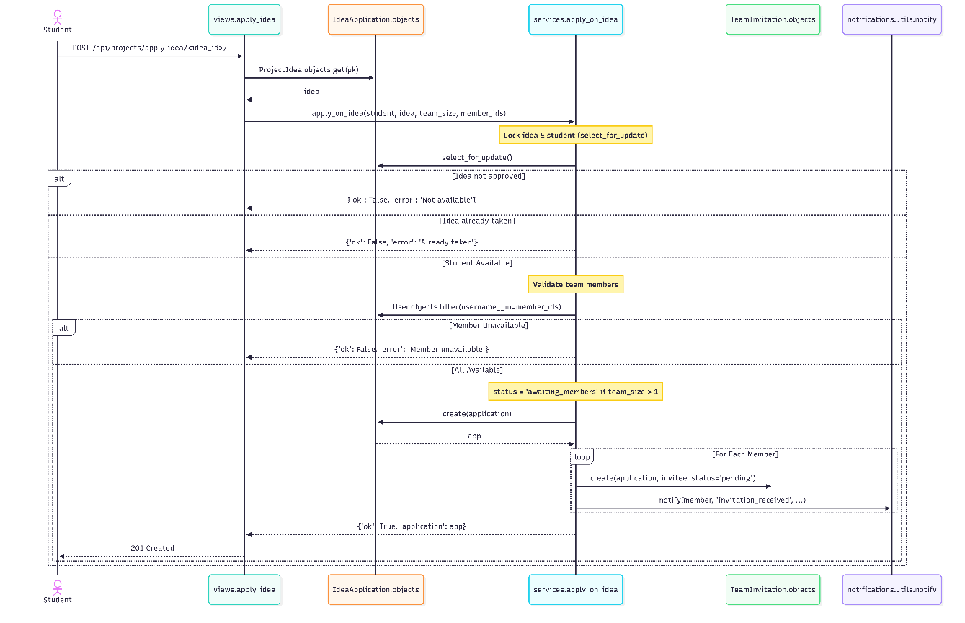
Figure 12 submit idea sequence diagram
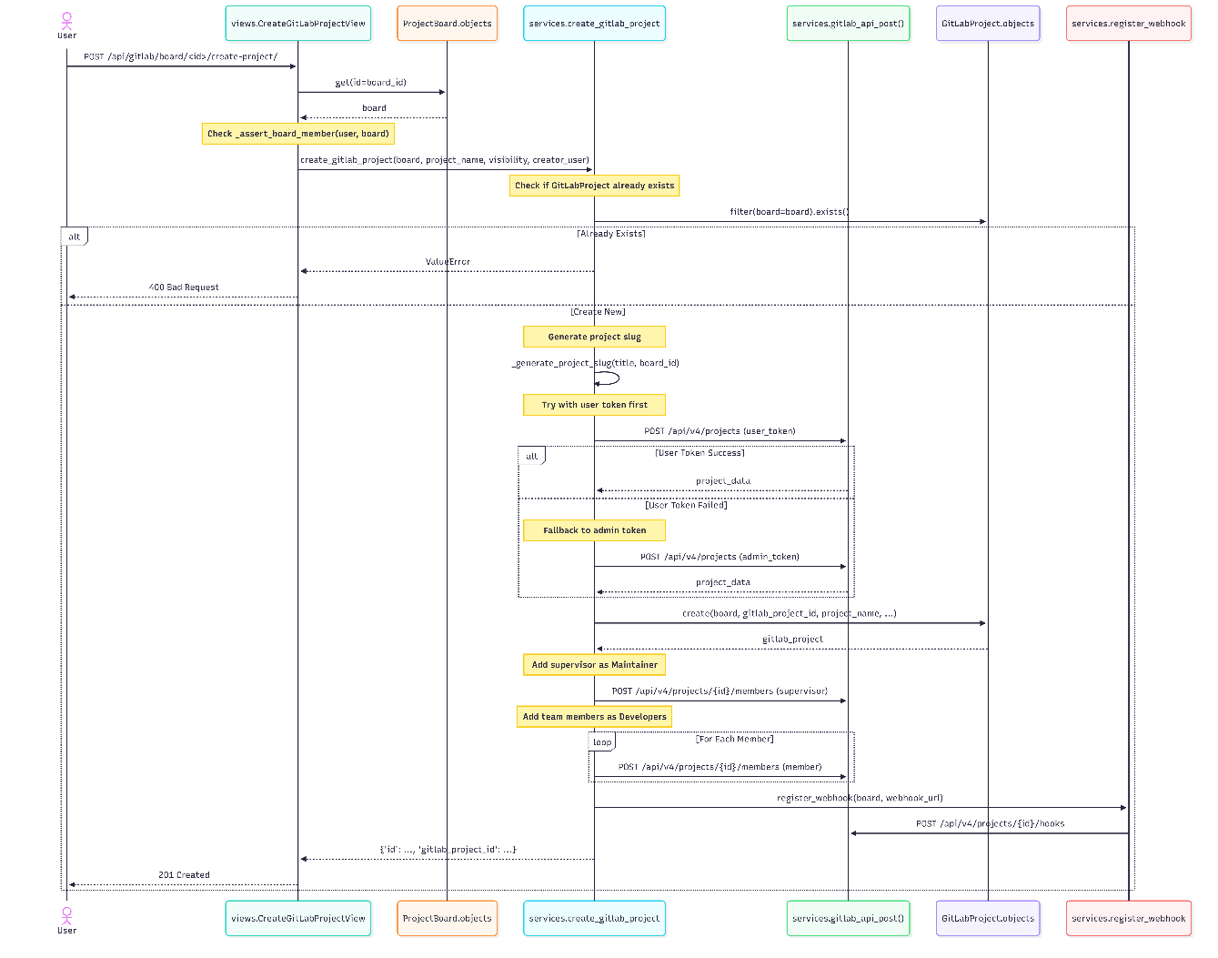
Figure 13 Create GitLab Repository sequence diagram

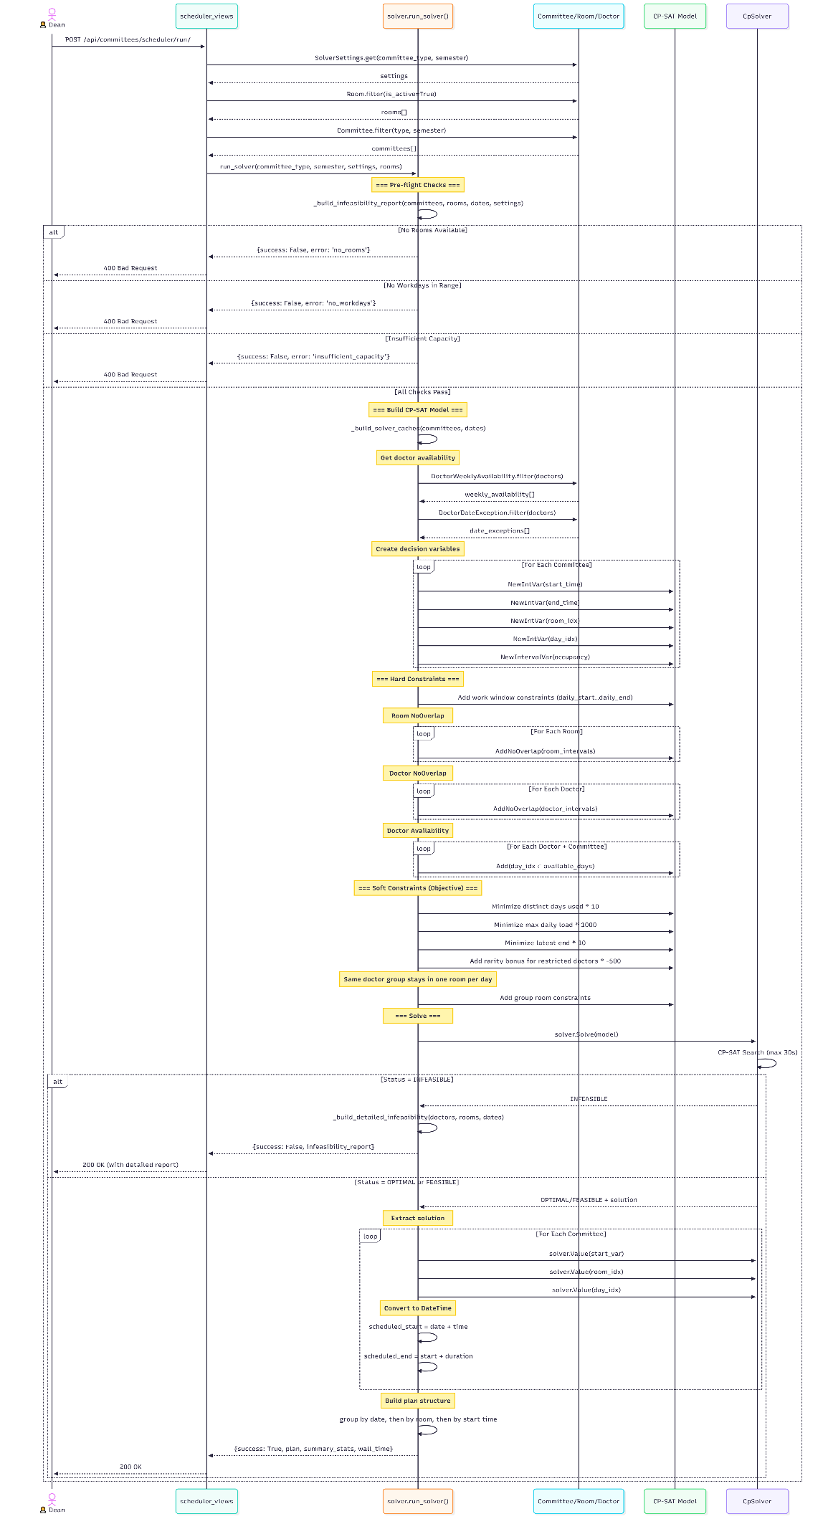
Figure 14 schedule committee sequence diagram

4.8 Requirements Modeling According to the Adopted Methodology

4.8.1 Agile Modeling
As the project follows an Agile approach, requirements were organized using User Stories, a Product Backlog, and Story Mapping to support incremental development and prioritization.
Examples of User Stories:
- Student: As a student, I want to propose a project and track its approvals so that I can know the status of my request.
- Supervisor: As a supervisor, I want to review project files so that I can monitor the team's progress.
- Department Head: As a department head, I want to distribute projects among committees so that the evaluation process is organized.
- Committee Member: As a committee member, I want to enter my grade independently so that all members can participate in the evaluation.
- Dean: As a dean, I want to define the current semester so that projects and committees are linked to the correct academic period.
The Product Backlog prioritized system modules as Must, Should, and Could Have items across Graduation Project 1, Graduation Project 2, and future development.
The Story Mapping diagram organizes the system functions according to the project lifecycle and shows the relationship between user activities and system functionality.
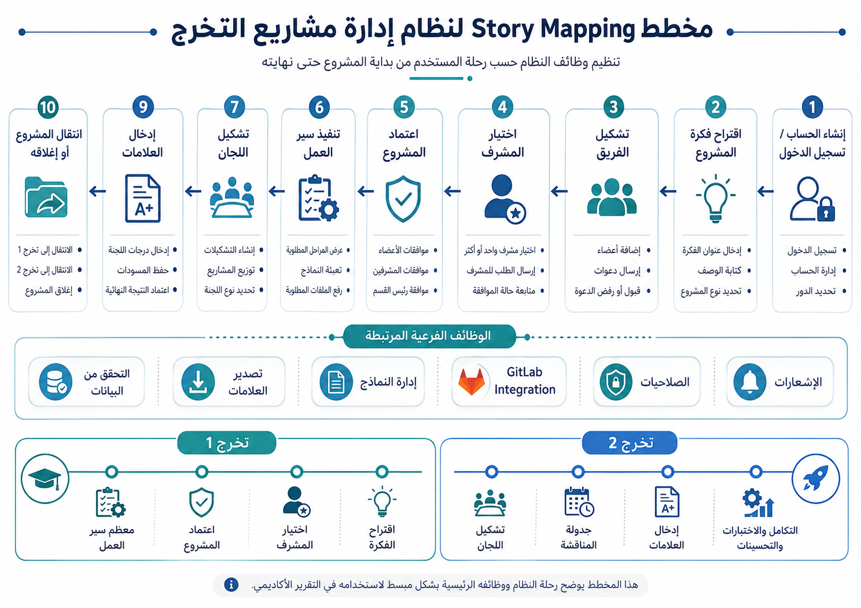
Figure 15 story mapping

4.9 Requirements Traceability and Verification
Requirements traceability establishes a relationship between each requirement, the system component responsible for implementing it, and the method used to verify it.

4.9.1 Requirements Traceability Matrix
Table 12 Functional Requirements Traceability Matrix (RTM)
FR | Use Case | Implementation | Test Case
FR1 | UC-07 Manage User Accounts | accounts / JWT | TC-01, TC-02
FR2 | UC-07 Manage User Accounts | accounts / import | TC-31
FR3 | UC-07 Manage User Accounts | accounts / permissions | TC-03, TC-32
FR4 | UC-08 Manage Academic Semester | Semester configuration | TC-33
FR5 | UC-08 Manage Academic Semester | Semester-related operations | TC-47
FR6 | UC-12 Manage Project Stage Transition | Project stage management | TC-35
FR7 | UC-06 Manage Project Participation | Participation services / history | TC-54
FR8 | UC-01 Manage Project Proposals | projects services | TC-06, TC-48
FR9 | UC-01 Manage Project Proposals | Team invitation module | TC-48
FR10 | UC-01 Manage Project Proposals | Project proposal module | TC-37
FR11 | UC-01 Manage Project Proposals | Approval services | TC-07, TC-10, TC-48
FR12 | UC-01 Manage Project Proposals | projects services | TC-08, TC-09, TC-38
FR13 | UC-01 Manage Project Proposals | Project participation | TC-10
FR14 | UC-02 Manage Project Workflow | workflow services | TC-49
FR15 | UC-09 Manage Workflow Submissions | Workflow / dynamic fields | TC-39
FR16 | UC-09 Manage Workflow Submissions | workflow services | TC-40
FR17 | UC-09 Manage Workflow Submissions | Notification service | TC-23, TC-24, TC-25, TC-41
FR18 | UC-05 Manage Project Repository | gitlab_integration | TC-17, TC-18, TC-19
FR19 | UC-03 Manage Committees and Scheduling | committees | TC-46
FR20 | UC-10 Manage Committee Distribution | committees/services.py | TC-50
FR21 | UC-03 Manage Committees and Scheduling | Scheduling configuration | TC-42
FR22 | UC-03 Manage Committees and Scheduling | committees/solver.py / OR-Tools | TC-51
FR23 | UC-03 Manage Committees and Scheduling | scheduler_views.py | TC-43
FR24 | UC-04 Manage Project Evaluation and Grades | grades/services.py | TC-52
FR25 | UC-04 Manage Project Evaluation and Grades | grades | TC-44
FR26 | UC-04 Manage Project Evaluation and Grades | grades/services.py | TC-22, TC-52
FR27 | UC-04 Manage Project Evaluation and Grades | grades/permissions.py | TC-03, TC-32, TC-52
FR28 | UC-11 Manage Grade Reports and Export | grades/views.py | TC-53
FR29 | UC-06 Manage Project Participation | Participation services | , TC-54
FR30 | UC-06 Manage Project Participation | Participation services | , TC-54

4.9.2 Initial Test Cases
Table 13 initial test cases
ID | Test Case Title | Test Type | Description & Steps | Expected Result
TC-01 | Login with valid credentials | Functional | The user enters a previously registered valid email and password, then clicks the login button. | The login succeeds and the user is redirected to the dashboard corresponding to their role with a valid JWT token created.
TC-02 | Login with invalid credentials | Functional | The user enters a valid email but an incorrect password, then clicks the login button. | The system rejects the login and displays a clear error message without revealing specific authentication details.
TC-03 | Deny unauthorized access | Security | A Student attempts to access an endpoint reserved for the Head of Department. | The system returns HTTP 403 Forbidden and prevents access to the protected resource.
TC-04 | Token expiration and refresh | Functional | The access token expires and the user attempts to perform an authenticated action. | The system automatically refreshes the token using the refresh token without requiring the user to log in again.
TC-05 | Logout and token revocation | Security | The user clicks the logout button during an active session. | The authentication session is terminated and the user is redirected to the login page.
TC-06 | Create a new project proposal | Functional | The student fills in the proposal title, description, objectives, and proposed technologies, then submits the form. | The proposal is saved with the appropriate initial status and displayed on the student's dashboard.
TC-07 | Submit a proposal for review | Functional | The student completes all required fields and submits a proposal for review. | The proposal status changes to Under Review and the assigned supervisor receives a notification.
TC-08 | Reject a proposal with comments | Functional | The supervisor reviews a proposal, selects rejection, and enters comments explaining the reasons. | The proposal status changes to Rejected and the student receives the rejection comments.
TC-09 | Request revision on a proposal | Functional | The supervisor selects Revision Required and enters observations describing the required changes. | The proposal status changes to Revision Required and the student can edit and resubmit it.
TC-10 | Final approval of a proposal | Functional | The Head of Department approves a proposal that has completed the required review. | The proposal becomes Approved, the corresponding project and project participation records are created or updated, and relevant users are notified.
TC-11 | Project state transition per defined flow | Functional | A sequence of valid project transitions is executed according to the defined workflow rules. | Each valid transition succeeds and is recorded with the relevant user, timestamp, and reason where applicable.
TC-12 | Reject disallowed transition | Functional | A Student attempts to move a proposal directly from Under Review to Approved, bypassing the required approval step. | The operation is rejected because the transition is not permitted for the current role or state.
TC-13 | Concurrent modification on the same proposal | Performance | Two authorized users attempt to modify or review the same proposal simultaneously. | The system prevents inconsistent data from being stored.
TC-14 | Create a new task in the project | Functional | A student creates a task by entering its title, description, priority, and responsible team member. | The task is created successfully and appears in the appropriate Kanban column.
TC-15 | Move a task between Kanban columns | Functional | The user moves a task from In Progress to Done using the Kanban interface. | The task status is updated and completion information is recorded where applicable.
TC-16 | View tasks with filtering and search | Functional | The user filters tasks by priority and searches for a specific task by name. | Only tasks matching the selected filter and search criteria are displayed.
TC-17 | Link a GitLab repository to the project | Functional | The student enters a valid GitLab repository URL and confirms the linking operation. | An authorized Student or Supervisor enters a valid GitLab repository URL for the relevant project and confirms the linking operation.
TC-18 | Synchronize commit data | Integration | A new commit is created in the linked GitLab repository and the project information is refreshed. | The system retrieves and displays the updated repository information and latest commit data.
TC-19 | Link project to an invalid repository | Functional | The user enters an invalid or inaccessible GitLab repository URL. | The system rejects the operation and displays a clear error message.
TC-20 | Create a new evaluation form | Functional | The Head of Department creates an evaluation form containing different field types and configured weights. | The form is saved successfully and becomes available to authorized evaluators.
TC-21 | Fill and save an evaluation form as draft | Functional | The doctor partially completes an evaluation form and selects Save as Draft. | The entered information is saved and can be continued later without data loss.
TC-22 | Submit a final evaluation | Functional | The evaluator's submission is finalized successfully. The overall project evaluation result is calculated and finalized only after all required evaluations have been completed. | Scores are calculated according to the configured rules and the evaluation is finalized.
TC-23 | Notification on proposal status change | Functional | The supervisor changes a proposal status to Revision Required. | The student receives an in-system notification containing the new status.
TC-24 | Notification on approaching deadline | Functional | A project deadline approaches while the project remains delayed. | The system sends the configured alert notification to the relevant users.
TC-25 | View notification history | Functional | The user opens the notifications page after several system events. | Notifications are displayed chronologically and unread notifications can be identified and marked as read.
TC-26 | API response time | Performance | A main API endpoint is tested under concurrent user load. | The response time remains within the defined performance threshold.
TC-27 | Sustain 200 concurrent virtual users | Performance | A Locust load test is executed with up to 200 concurrent virtual users performing simulated system operations. | The system remains stable with no failed requests and response-time percentiles remain within the acceptance criteria.
TC-28 | Prevent SQL injection | Security | Malicious SQL-like input is entered into an input field such as a proposal title. | The input is safely handled and does not modify the database or expose sensitive information.
TC-29 | Prevent Cross-Site Scripting (XSS) | Security | Malicious JavaScript content is entered into a comment or project description field. | The content is safely handled and no unauthorized script is executed.
TC-30 | Rate limiting on API endpoints | Security | More than the permitted number of requests is sent to a protected endpoint within a short period. | The system applies rate limiting and returns HTTP 429 Too Many Requests when the threshold is exceeded.
TC-31 | Create and Import User Accounts | Functional | An authorized user creates student or faculty accounts and imports valid user data. | The accounts are created or imported successfully with the correct academic information and roles.
TC-32 | Enforce Role-Based Permissions | Security | Users with different academic roles attempt to access functions assigned to other roles. | Each user can access only the functions permitted for their role.
TC-33 | Create Academic Semester | Functional | An authorized user creates a semester by entering its name, start date, end date, and status. | The semester is created successfully and its information is stored correctly.
TC-34 | Display Current Academic Semester | Functional | The user opens a system page that depends on the active academic semester. | The system correctly identifies and displays the current academic semester.
TC-35 | Manage Project Academic Stages | Functional | A project is moved through the supported academic stages according to the defined rules. | The project moves to the correct academic stage and the transition is recorded.
TC-36 | Preserve Project Stage History | Functional | A user views a project after several academic-stage or semester transitions. | The system displays previous stages, semesters, and relevant transition information.
TC-37 | Select One or Two Supervisors | Functional | An authorized user assigns a primary supervisor and, where applicable, an optional co-supervisor to the project proposal. | The selected supervisors are linked successfully and invalid assignments are prevented.
TC-38 | Preserve Approval Decision History | Functional | A project passes through acceptance, rejection, or replacement decisions. | Previous decisions remain stored and can be reviewed without being overwritten or lost.
TC-39 | Upload Workflow Submission | Functional | A student uploads a required file and submits the required response during a workflow stage. | The submission is stored and correctly linked to the project and workflow stage.
TC-40 | Supervisor Review and Decision | Functional | A supervisor opens a submitted workflow item, enters comments, and records a decision. | The comments and decision are stored and the workflow status is updated accordingly.
TC-41 | Send Email Notification | Integration | A system event requiring an email notification is triggered. | The system generates the required notification and sends the email to the intended recipient.
TC-42 | Configure Faculty and Room Availability | Functional | An authorized HoD or Dean configures faculty availability, date exceptions, rooms, working days, and available scheduling periods.. | The availability information is stored and made available to the scheduling process.
TC-43 | Review and Modify Generated Schedule | Functional | n authorized HoD or Dean generates a schedule preview, reviews the proposed assignments, performs an allowed modification when required, validates the resulting schedule, and applies the final schedule. | The schedule is presented as a preview before application. Valid modifications do not introduce conflicts, and the final schedule is stored only after it is successfully applied.
TC-44 | Support Individual and Collective Evaluation | Functional | An authorized evaluator performs an individual or collective evaluation according to the configured grading mode. | The system applies the configured evaluation method correctly and stores the resulting data.
TC-45 | Approve Project Outcome or Stage Transition | Functional | Authorized academic staff select an outcome such as success, repetition, postponement, or transition to the next stage. | The selected outcome is recorded and the project status or academic stage is updated according to the defined rules.
TC-46 | Create Committee Template and Assign Members | Functional | An authorized user creates a committee template, defines committee members and their roles, and saves the configuration. | The template and selected members are stored correctly and become available for project distribution and scheduling.
TC-47 | Filter Records by Academic Semester | Functional | The user selects an academic semester while viewing semester-dependent projects, committees, or related academic records. | The system displays only the records associated with the selected semester.
TC-48 | Apply for Faculty Idea, Form Team, and Complete Approval Sequence | Functional | A student applies for an available faculty project idea, adds required team members through invitations, and completes the required submission and approval steps. | Team membership, invitation decisions, supervisor information, and approval decisions are stored correctly, and the project proceeds only after the required approval sequence is completed.
TC-49 | Create and Assign Workflow Template | Functional | A student applies for an available faculty project idea, invites the required team members, records their invitation decisions, selects the required supervisor information, and completes the required approval sequence involving team members, supervisor(s), and the Head of Department. | The workflow is successfully assigned and its configured stages become available for the project.
TC-50 | Distribute Projects Among Committees | Functional | An authorized user selects the required semester, department, and project type/stage and starts project distribution among available committees. | Eligible projects are distributed among the appropriate committees according to the configured distribution rules.
TC-51 | Generate a Conflict-Free Committee Schedule | Functional | After project distribution has been completed, an authorized user runs the CP-SAT scheduling solver for the existing committees using the configured dates, rooms, working periods, and doctor availability.  . | The system generates a valid schedule in which doctor, room, availability, and time constraints are respected, or reports that no feasible schedule exists.
TC-52 | Enter and Finalize Committee Grades with Permission Validation | Functional / Security | An authorized committee member enters the required grades. The system verifies committee membership and completion of required evaluations before finalization. | Authorized grades are stored correctly, required results are calculated only after all evaluations are complete, and unauthorized grade operations are rejected.
TC-53 | Export Grade Report | Functional | An authorized academic user selects available evaluation results and requests a grade or academic report in a supported format. | The system generates and exports the requested report containing the authorized grading information.
TC-54 | Manage Project Participation Status, Authorization, and History | Functional | An authorized HoD or Dean updates a project participation status. An unauthorized user also attempts the same action. | Authorized changes are saved with history preserved, while unauthorized changes are rejected.

Architectural design of the system

5.1 High-Level Design
This chapter presents the architectural design of the Graduation Project Management System (GPMS) and explains how the requirements identified in Chapter 4 are implemented through the system architecture, database, APIs, and security mechanisms.

5.1.1 System Block Diagram
The system consists of a React frontend, Django REST Framework backend, PostgreSQL database, background-processing services, and external GitLab integration.
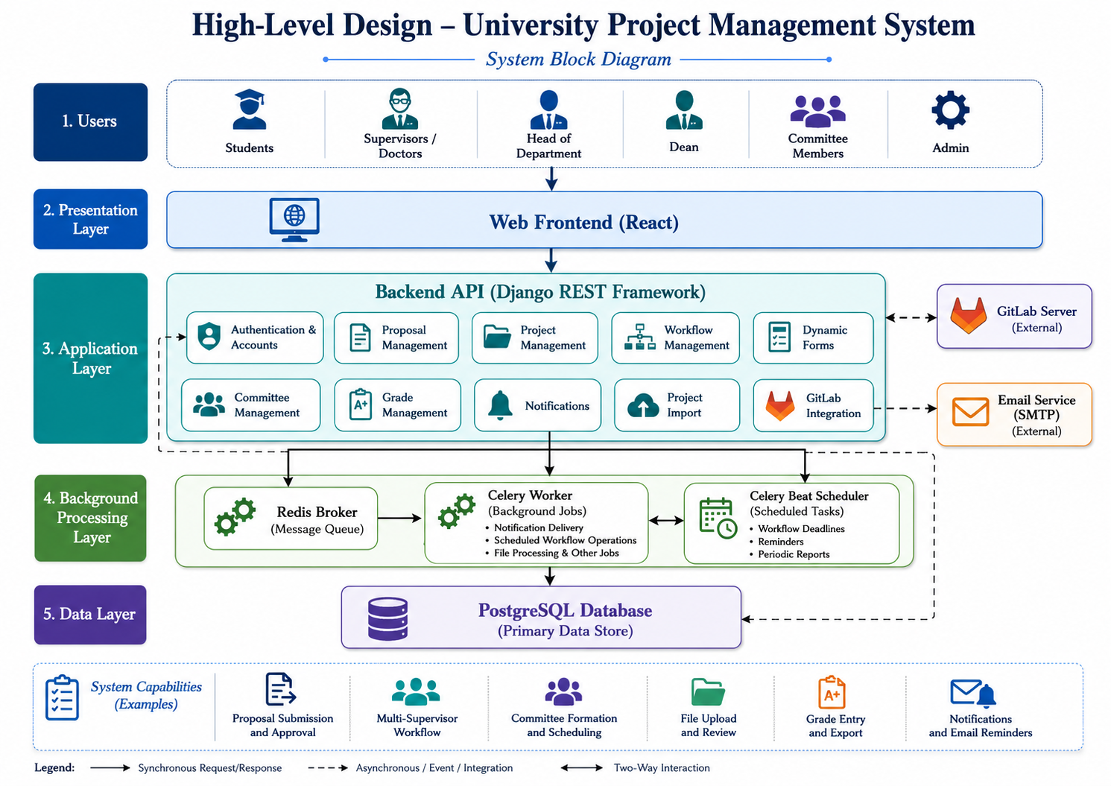
Figure 16 System Block Diagram
The main communication flow is:
Users
(Student / Doctor / HoD / Dean)
↓
React Frontend
↓
REST API
↓
Authentication & Authorization
↓
Validation / API Views
↓
Business Logic / Services
↓
Django ORM
↓
PostgreSQL
The backend also communicates with Redis and Celery for asynchronous and scheduled tasks, GitLab REST API for repository integration, and the notification subsystem for system and email notifications.

5.1.2 Architectural Pattern
GPMS follows a Client–Server Architecture with a Modular Layered Design.
The system is not implemented as Microservices. Instead, several Django applications operate within the same backend while separating the main functional domains.
The main architectural flow is:
React Frontend
↓
REST API
↓
Authentication / Authorization
↓
Serializers / Validation
↓
API Views
↓
Business Services
↓
Django ORM
↓
PostgreSQL

Table 14 Main Architectural Layers
Layer | Responsibility
Presentation Layer | React components, dashboards, forms, and user interaction.
API Layer | Receives HTTP requests and returns REST/JSON responses.
Authentication and Authorization Layer | Verifies JWT authentication and user permissions.
Validation Layer | Validates incoming data using serializers and business rules.
Business Logic Layer | Implements project, workflow, grading, committee, and other business rules.
Data Access Layer | Uses Django ORM to access relational data.
Database Layer | PostgreSQL stores persistent application data.
Background Processing Layer | Redis and Celery execute asynchronous and scheduled tasks.
External Integration Layer | GitLab REST APIs provide repository integration.

This architecture provides separation of concerns and supports maintainability, testing, and future extension.

5.1.3 System Architecture Design
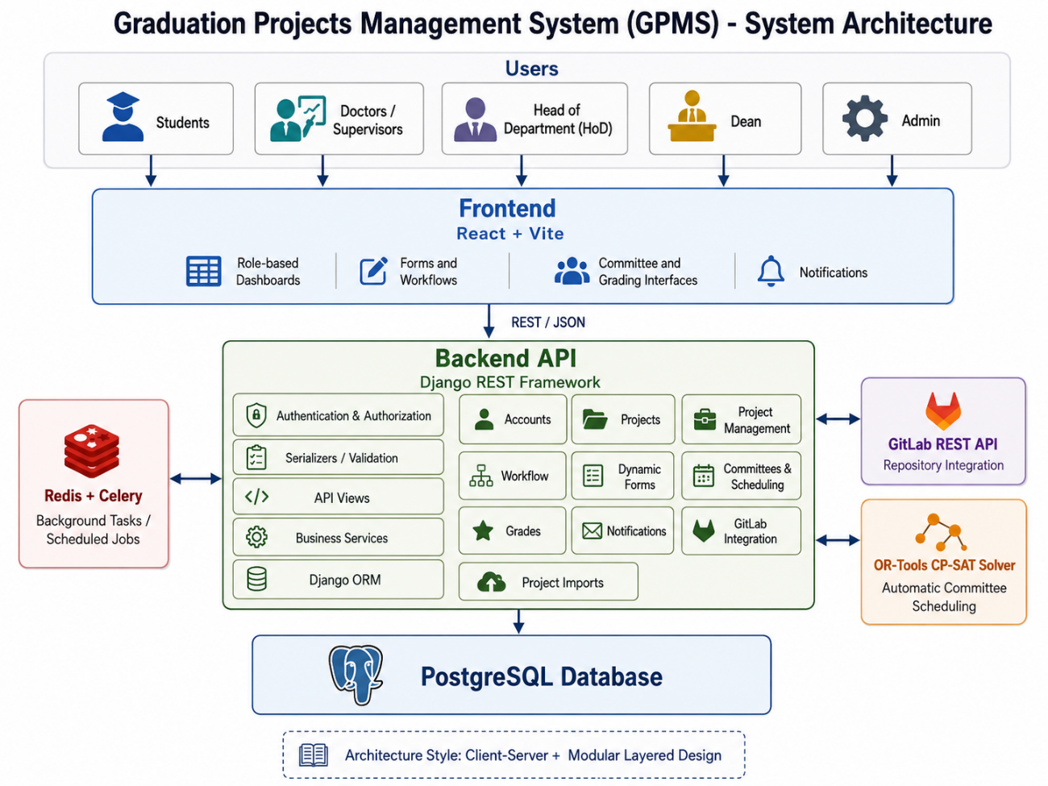
The React frontend and Django REST Framework backend are separated and communicate through REST APIs.The frontend provides role-specific interfaces, while the backend handles authentication, validation, business rules, database access, background d processing, and external integrations.
Figure 17 system architecture

Table 15 Main Backend Modules
Module | Main Responsibility
accounts | Authentication, users, roles, OTP, passwords, and account management.
projects | Project ideas, proposals, applications, teams, and participation.
project_management | Project boards, Kanban tasks, comments, attachments, and activity logs.
workflow | Workflow templates, stages, project workflows, and recurring stages.
dy_forms | Dynamic forms, configurable fields, and student responses.
committees | Committee templates, project distribution, scheduling, rooms, and availability.
grades | Reports, grades, grading modes, drafts, and audit records.
notifications | In-system notifications for project and workflow events.
gitlab_integration | GitLab repository linking and repository-related operations.
project_imports | Import and validation of academic project data.

5.2 Database Design
The system uses PostgreSQL as its primary relational database, accessed through the Django ORM.

5.2.1 Entity Relationship Diagram
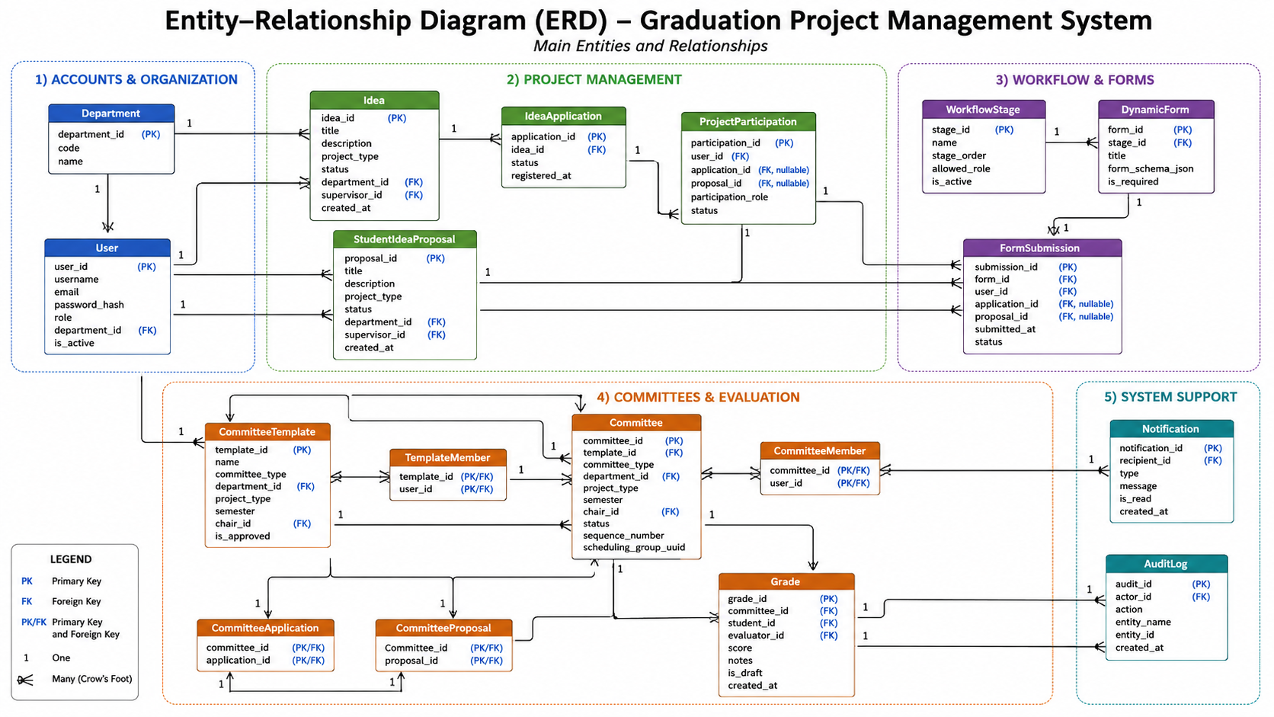
Figure 18 ERD diagram

The main project structure supports two project sources:
- IdeaApplication — when a student applies to a doctor-proposed project idea.
- StudentIdeaProposal — when a student submits their own proposal.
Other major entities include ProjectParticipation, ProjectBoard, WorkflowTemplate, WorkflowStage, DynamicForm, FormField, CommitteeTemplate, Committee, ProjectGrade, GitLabProject, and Notification.
The ER diagram shows the relationships between these entities, including user-project relationships, workflow-stage relationships, committee membership, grade records, and project-GitLab integration.

5.2.2 Main Relational Schema
The following table presents the main representative entities and fields. It does not list every database field, but focuses on the fields needed to understand the system design.

Table 16 Main Relational Schema
Table / Model | Main Fields | Main Relations
User | id, username, password, role, department, email | Primary entity for system users
ProjectIdea | id, doctor_id, title, description, department, project_type, status | doctor_id → User
IdeaApplication | id, idea_id, student_id, project_type, status | idea_id → ProjectIdea; student_id → User
StudentIdeaProposal | id, student_id, supervisor_id, title, description, department, project_type, status | student_id/supervisor_id → User
ProjectParticipation | id, student_id, idea_application_id, student_proposal_id, role, status | Links students to project sources
ProjectBoard | id, proposal_id, application_id, title | Connects project source to project-management functions
WorkflowTemplate | id, name, department, status | Parent of WorkflowStage
WorkflowStage | id, template_id, name, order, trigger_type, is_required | template_id → WorkflowTemplate
DynamicForm | id, hod_id, department, context, title | hod_id → User
FormField | id, form_id, label, field_type, required | form_id → DynamicForm
CommitteeTemplate | id, committee_type, department, project_type, semester, chair_id | chair_id → User
Committee | id, template_id, committee_type, semester, chair_id, members, room_id, scheduled_start, scheduled_end | Template, users, and room relationships
ProjectGrade | id, project_source, project_id, student_id, committee_type, semester | Linked to project and student
GitLabProject | id, project_board_id, repository information | project_board_id → ProjectBoard
Notification | id, recipient_id, notif_type, title, message | recipient_id → User

5.2.3 Constraints and Keys
The database and application use several mechanisms to preserve consistency.

Primary Keys
Each major entity has a unique primary key, normally represented by id.

Foreign Keys
Foreign keys represent relationships such as:
ProjectIdea.doctor_id → User.id
IdeaApplication.idea_id → ProjectIdea.id
StudentIdeaProposal.supervisor_id → User.id
WorkflowStage.template_id → WorkflowTemplate.id
Committee.template_id → CommitteeTemplate.id
Committee.chair_id → User.id

Many-to-Many Relationships
Committee membership is represented as a many-to-many relationship between Committee and User.

Unique and Validation Constraints
Unique constraints and application-level validation are used to prevent invalid duplicate or inconsistent records.
Examples include:
- Unique usernames.
- Valid project ownership and participation.
- Valid department access.
- Committee membership before authorized grading.
- Validation of uploaded file types and sizes.

Transactions and Concurrency
Critical operations use Django transactions such as:
transaction.atomic()
and, where required:
select_for_update()
These mechanisms help prevent partial updates and race conditions during operations such as approvals, committee redistribution, and grade updates.

5.3 External Interface and API Design
The React frontend communicates with the Django REST Framework backend through REST APIs.

Table 17 HTTP Methods
Method | Purpose
GET | Retrieve information.
POST | Create a resource or execute an operation.
PATCH | Partially update a resource.
PUT | Replace or update a resource.
DELETE | Remove a resource.
The following table provides representative APIs from the implemented system.

Table 18 Representative APIs
Module | Method | Endpoint | Main Parameters | Response | Common Errors
Authentication | POST | /api/token/ | Username, password | Authentication response | 400, 401
Authentication | GET | /api/auth/me/ | — | Current user information | 401
Projects | GET | /api/projects/ideas/browse/ | Optional filters | Project ideas | 401
Projects | GET | /api/projects/proposals/mine/ | — | User's proposal | 401, 403
Workflow | POST | /api/workflow/apply/ | Project, template | ProjectWorkflow | 400, 403
Workflow | POST | /api/workflow/stage/{id}/submit/ | Stage responses | Updated stage | 400, 403
Dynamic Forms | POST | /api/dy-forms/responses/submit/ | Form, responses | Form response | 400, 403
Committees | POST | /api/committees/distribute/ | Department, project type, semester | Distribution result | 400, 403
Scheduling | POST | /api/committees/schedule/preview/ | Semester, scheduling settings | Schedule preview | 400, 403
Grading | POST | /api/grades/enter/ | Committee, project, student, score | Grade | 400, 403
GitLab | GET | /api/gitlab/health/ | — | GitLab status | 401
Import | POST | /api/import/projects/ | Import file, options | Import/validation result | 400, 403
The complete implementation contains additional endpoints for the individual modules; the table presents the main interfaces relevant to understanding the system architecture.

5.4 Security and Authorization Design
The system protects academic data through authentication, role-based authorization, object-level permissions, input validation, rate limiting, password protection, transactions, and file validation.

5.4.1 Authentication and Account Security
GPMS uses JWT authentication with access and refresh tokens.
The implementation can store authentication information using HttpOnly cookies with settings such as:
HttpOnly = True
SameSite = Lax
Secure = environment-dependent
OTP verification is used for sensitive account-related operations such as password recovery.
Passwords are protected using Django's password-hashing framework and are not stored as plain text

5.4.2 User Roles and Access Control
The primary system roles are:

Table 19 Main User Roles
Role | Main Access
Student | Submit proposals and applications, participate in projects, manage tasks, complete workflow stages, and access authorized results.
Doctor | Propose ideas, supervise projects, review applications, participate in committees, and enter authorized grades.
Head of Department (HoD) | Manage department projects, workflows, dynamic forms, and department-level evaluation settings.
Dean | Monitor departments, manage committees, distribute projects, manage scheduling, and export committee information.
Supervisor is treated as a project relationship performed by a Doctor, while Committee Member is a committee relationship rather than a separate system role.

5.4.3 Role-Based and Object-Level Authorization
The backend uses Role-Based Access Control (RBAC) through permission classes.
Access is also checked at the object level. Examples include:
- A student must belong to the relevant project.
- A doctor must be authorized for the relevant project or committee.
- A HoD must operate within the permitted department.
- A committee member must belong to the relevant committee before entering grades.
This prevents unauthorized access even when a user knows the identifier of another resource.

5.4.4 API, File, and Data Security
API requests are validated using serializers, service-level validation, model constraints, and permission checks.
The main HTTP status codes include:
Code | Meaning
400 | Invalid request or business-rule violation
401 | Missing or invalid authentication
403 | Insufficient permission
404 | Resource not found or inaccessible
409 | Conflict with current system state
429 | Rate limit exceeded
500 | Unexpected server error
Rate limiting is applied to sensitive or high-frequency operations.
Uploaded files are validated according to file type, size, ownership, and permissions.

5.4.5 Database and Integration Security
Critical multi-step operations use database transactions and locking mechanisms to prevent partial updates and concurrency problems.
GitLab communication is handled through backend-controlled integration rather than direct frontend access. This allows repository operations and sensitive credentials, where applicable, to remain controlled by the backend.
Background tasks are executed using Celery and Redis while using the same application models and database as the main backend

5.5 Chapter Summary
This chapter presented the system architecture, database design, API interfaces, and security mechanisms of the Graduation Project Management System. The design uses a modular layered architecture with React, Django REST Framework, PostgreSQL, Redis, Celery, and GitLab integration, supported by database constraints, REST APIs, JWT authentication, RBAC, and data-protection mechanisms.

Chapter 6: Tools and Technologies Used

This chapter presents the main tools, technologies, and development environments used to build the GPMS system. The selected technologies supported the development of a reliable, maintainable, and scalable web application.

6.1 Development Environment
Visual Studio Code (VS Code) was used as the main development environment for both the backend and frontend. It provided useful extensions, debugging support, an integrated terminal, and Git integration, which facilitated the development process.

6.2 Programming Languages
Python 3 was used to develop the backend because of its readability and extensive web-development ecosystem. JavaScript (ES6+) was used for the frontend with React, supporting component-based development and asynchronous communication with the backend APIs.

6.3 Frameworks
The backend was developed using Django 5 and Django REST Framework (DRF). Django provided the ORM, authentication, administration, and security features, while DRF was used to build RESTful APIs.
The frontend was developed using React 19, with React Router for navigation and Axios for API communication.

6.4 Database
PostgreSQL 16 was used as the primary database. It provided reliable transaction management, data integrity, advanced data types, and database constraints required by the system.

6.5 Package Management
Backend dependencies were managed using pip and stored in requirements.txt. Frontend dependencies were managed using npm and documented in package.json.
6.6 Version Control
Git was used for source-code version control, while GitHub was used for source-code hosting, collaboration, branch management, and version history during the development of GPMS. GitLab was used only as an external integration platform for linking academic projects with their software-development repositories and retrieving related repository activities.

6.7 Deployment
The application was deployed using Gunicorn as the WSGI server and Nginx as the reverse proxy. The system can be deployed on a university server to provide centralized access for authorized users. A formal CI/CD pipeline was not implemented because of the academic scope of the project.

6.8 Testing Environment
Backend automated testing was performed using Pytest and pytest-django, while frontend testing was performed using Vitest and React Testing Library. The final backend test suite included 2,505 passing tests with approximately 71.2% code coverage. The frontend test suites included 1,591 passing tests. Locust was used for performance and load testing with up to 200 virtual users.

Chapter 7: Programming Implementation

Chapter Introduction
This chapter presents the implementation of the Graduation Project Management System (GPMS). It demonstrates how the architectural design and requirements defined in the previous chapters were translated into a working software system.
The chapter focuses on the project structure, implementation of the main modules, representative API implementation, data access, business logic, user-interface implementation, error handling, security mechanisms, and the intelligent scheduling algorithm.
Representative code snippets are included to demonstrate important implementation decisions without reproducing the complete source code.

7.1 Project Structure
The system is divided into a Django REST Framework backend and a React + Vite frontend.
The current project structure contains dedicated Django applications for the main functional domains.
GPMS/
│
├── backend/
│ ├── backend/
│ ├── accounts/
│ ├── projects/
│ ├── project_management/
│ ├── workflow/
│ ├── dy_forms/
│ ├── committees/
│ ├── grades/
│ ├── notifications/
│ ├── gitlab_integration/
│ ├── project_imports/
│ ├── load-tests/
│ ├── requirements.txt
│ └── manage.py
│
├── frontend/
│ ├── src/
│ │ ├── components/
│ │ ├── hooks/
│ │ ├── lib/
│ │ ├── api.js
│ │ ├── gitlabApi.js
│ │ └── assets/
│ └── package.json
│
└── README.md
The modular structure separates authentication, project management, workflows, dynamic forms, committees, grading, notifications, imports, and GitLab integration. This separation supports maintainability and allows the main functional domains to be developed and tested independently.

7.2 Main Modules Implementation

7.2.1 Authentication and JWT
Authentication is implemented using Django and JWT. A custom user model stores the user's academic role and department, allowing the backend to distinguish between Student, Doctor, HoD, and Dean.
JWT tokens include relevant user information such as role, department, and username. Authentication values can also be stored using HttpOnly cookies, reducing direct access to sensitive tokens from frontend JavaScript.

7.2.2 Authorization
Authorization is implemented using Django REST Framework permission classes. Protected endpoints verify both the authenticated user's role and, where required, the user's relationship with the requested resource.
For example, a student must belong to the relevant project, while a committee member must belong to the corresponding committee before accessing protected grading operations.
class IsHod(BasePermission):
def has_permission(self, request, view):
return request.user.is_authenticated and request.user.role == "hod"

7.2.3 Project Management Module
The Project Management module handles the main project lifecycle, including:
- Project idea creation.
- Student project proposals.
- Applications to approved ideas.
- Team formation.
- Supervisor decisions.
- Project approval.
- Project participation.
The main business rules are implemented in service functions rather than being placed entirely inside API views.
Representative service operations include:
create_project_idea()
create_student_proposal()
student_can_propose()
_student_is_active()
A typical operation first validates the data and business rules and then returns a structured result to the API view.
result = create_project_idea(
doctor=request.user,
title=data['title'],
description=data['description'],
department=data['department'],
required_skills=data.get('required_skills', ''),
max_team_size=data.get('max_team_size', 2),
)

if not result.get('ok'):
return Response(
{'error': result.get('error')},
status=409
)
This approach keeps business rules separate from HTTP response handling.

7.2.4 Workflow Module
The Workflow module implements reusable workflow templates, stages, stage fields, project workflow instances, submissions, and project progression.
It supports operations such as:
- Creating workflow templates.
- Defining workflow stages.
- Applying a workflow to a project.
- Submitting stage responses.
- Calculating stage status and deadlines.
- Controlling valid project transitions.

7.2.5 Dynamic Forms Module
The Dynamic Forms module allows academic forms to be created and configured without modifying application source code for every new form.
The module supports field types such as:
- Text.
- Numbers.
- Dates.
- Checkboxes.
- Selection fields.
- File uploads.
Submitted values are validated according to the configured field type.
The Dynamic Forms module supports text, numeric, date, checkbox, selection, and file fields. Submitted values are validated and represented according to their configured field types.

7.2.6 Committee and Scheduling Module
The Committees module manages:
- Committee templates.
- Committee creation.
- Committee members.
- Project distribution.
- Committee warnings and workload.
- Committee exports.
- Discussion scheduling.
Project distribution and automatic scheduling are separate responsibilities.
The Committee Service handles committee creation and project distribution, while a dedicated scheduling service uses Google OR-Tools CP-SAT to generate valid dates, times, and rooms.
The scheduler considers:
- Doctor availability.
- Room availability.
- Working days.
- Working hours.
- Doctor conflicts
- Room conflicts.

7.2.7 Grading Module
The Grading module implements:
- Project grade entry.
- Individual or collective evaluation.
- Draft grades.
- Evaluation forms.
- Final-result calculation.
- Grade authorization.
- Grade-related reports.
Grade operations validate the user's relationship with the relevant project or committee before storing results.
Final results are calculated only when the required evaluations have been completed according to the configured grading rules.

7.2.8 Notification Module
The Notification Service records and delivers system notifications generated by important events.
Notifications may be triggered by:
- Project proposals.
- Approval decisions.
- Workflow actions.
- Committee scheduling.
- Grade operations.
- Project-management activities.
- GitLab-related events.
Each notification stores information such as recipient, notification type, message, related object, and read status.
The notification service is used by multiple system modules to keep users informed of required actions and important changes.

7.2.9 GitLab Integration Module
The GitLab integration module connects academic project records with their corresponding GitLab repositories.
The implementation supports repository-related operations through the GitLab REST API, including repository linking and retrieval of relevant repository information.
GitLab operations are handled through the backend integration layer rather than being executed directly from the frontend

7.3 API Implementation
The frontend communicates with the Django REST Framework backend through REST APIs.
The API implementation follows the layered design presented in Chapter 5, where views handle HTTP requests, serializers validate data, permission classes authorize access, and service functions implement business rules.

7.3.1 Example: Workflow Submission API
A workflow submission follows a similar path:
React Form
↓
POST /api/workflow/stage/{id}/submit/
↓
Authentication and Permission Check
↓
Serializer Validation
↓
Workflow Service
↓
Workflow Stage / Response Data
↓
PostgreSQL
The backend validates the submitted values and verifies that the student is authorized to submit the selected workflow stage.

7.4 Data Access Layer
The Data Access Layer is implemented using the Django ORM.
Django models represent the database entities and QuerySets provide access to PostgreSQL without requiring raw SQL for normal operations.
The main models include:
Model | Purpose
User | Stores users, roles, departments, and authentication information.
ProjectIdea | Stores project ideas proposed by academic staff.
IdeaApplication | Stores student applications to project ideas.
StudentIdeaProposal | Stores proposals submitted by students.
ProjectParticipation | Stores student participation in projects.
ProjectBoard | Represents the project-management board.
WorkflowTemplate | Defines reusable workflows.
WorkflowStage | Represents workflow stages.
DynamicForm | Stores configurable forms.
FormField | Defines dynamic-form fields.
CommitteeTemplate | Stores committee configuration.
Committee | Stores committees, members, rooms, and schedules.
ProjectGrade | Stores evaluation and grade records.
Notification | Stores system notifications.
GitLabProject | Links a project board with a GitLab repository.

Representative ORM Query
ProjectParticipation.objects.filter(
student=user,
status='active'
).select_related(
'idea_application__idea',
'student_proposal'
)
The query retrieves active project participation while loading related project information efficiently.

7.5 Business Logic Layer
The Business Logic Layer contains the rules that determine whether operations are allowed and how system state changes..
Table 20 Main Business Rules
Business Rule | Implementation
Doctors can submit project ideas subject to role and permission checks. | projects services and permissions
Students cannot participate in conflicting active projects. | Project participation services
Proposals and applications pass through defined approval states. | Project services
Workflow stages follow the configured workflow rules. | Workflow services
Dynamic forms validate values according to their field types. | Dynamic-form serializers and validation
Committee schedules cannot contain room or doctor conflicts. | Committee scheduling service
Committee templates are synchronized with generated committees. | Committee services
Grades are validated according to permissions and evaluation rules. | Grade services
Notifications are generated after important events. | Notification service
GitLab operations are restricted to authorized project users. | GitLab services

Example: HoD Assignment
A critical administrative operation uses a database transaction and row-level locking:
with transaction.atomic():
doctor = User.objects.select_for_update().get(
id=doctor_id,
role__in=['doctor', 'hod']
)

current_hod = (
User.objects.select_for_update()
.filter(
role='hod',
department=department
)
.first()
)

if current_hod and current_hod.id != doctor.id:
current_hod.role = 'doctor'
current_hod.department = None
current_hod.save(
update_fields=['role', 'department']
)

doctor.role = 'hod'
doctor.department = department
doctor.save(
update_fields=['role', 'department']
)
This implementation ensures that only one HoD is assigned to a department while protecting the operation against concurrent database updates.

7.6 User Interface Implementation
The frontend was implemented using React and Vite and follows a component-based architecture.
The interface displays different dashboards and functionality according to the authenticated user's role.
Figure 19 student dashboard 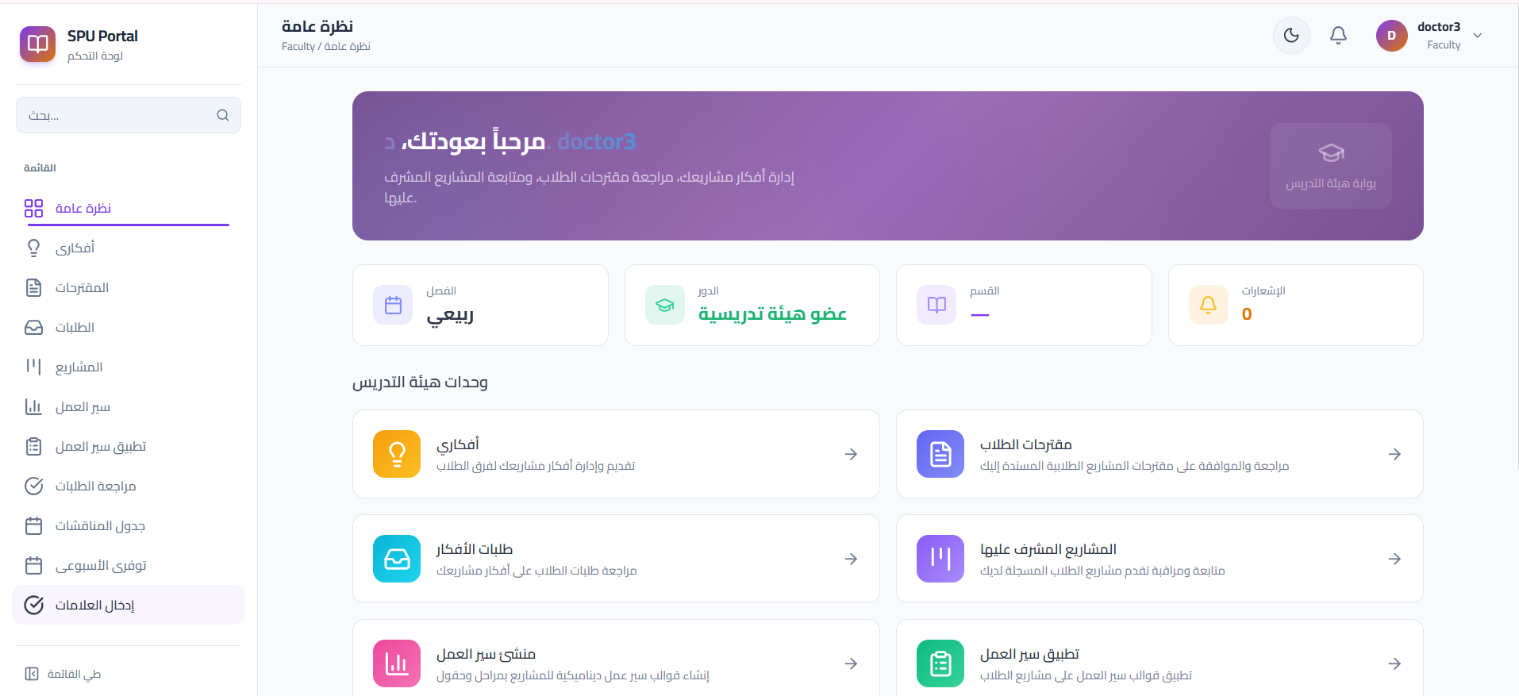


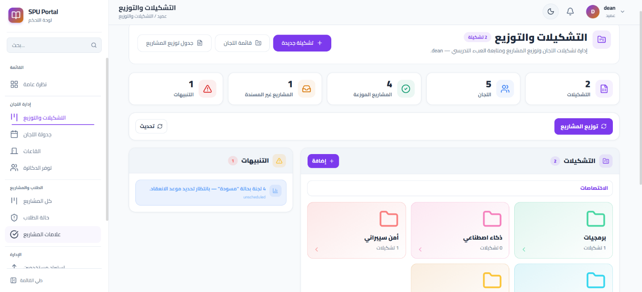
Figure 20 doctor Dashboard
Figure 21 Committee Scheduling Interface
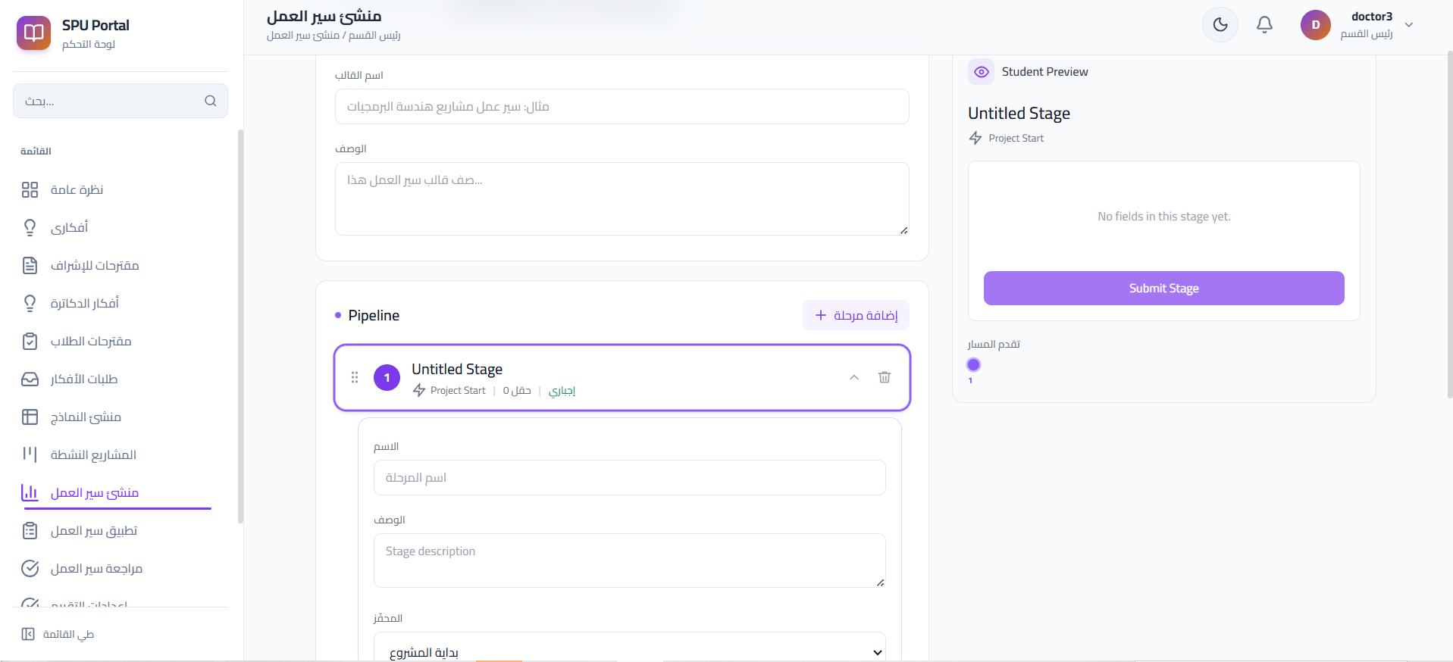
Figure 22 Dynamic workflow
The frontend communicates with the backend through a centralized Axios configuration.
const api = axios.create({
baseURL: API_BASE,
withCredentials: true,
});

let accessToken = null;

export function setAccessToken(token) {
accessToken = token;

if (token) {
api.defaults.headers.common[
'Authorization'
] = `Bearer ${token}`;
} else {
delete api.defaults.headers.common[
'Authorization'
];
}
}
The frontend can automatically refresh authentication when an API request returns HTTP 401.

7.7 Project Distribution Using Round Robin
GPMS uses Round Robin to distribute projects sequentially among available committee formations. The modulo operation allows the distribution to return to the first committee after reaching the last one.
A simplified example is:
Projects: P1 P2 P3 P4 P5 P6
Committees: C1 C2 C3

P1 → C1
P2 → C2
P3 → C3
P4 → C1
P5 → C2
P6 → C3
The implementation uses the modulo operator to perform the wrap-around:
committee = committees[idx % len(committees)]
This ensures that after reaching the last committee, the next project is assigned again to the first committee.
In Multi mode, projects are distributed across the available committees of each committee type using Round Robin. In Single mode, projects are distributed across the selected committee templates in the same way, and the four committee sessions of the same project keep the same committee formation.
The main purpose of Round Robin in GPMS is therefore to achieve a simple and balanced distribution of projects among the available committee formations.

7.8 Intelligent Scheduling Algorithm Implementation
The intelligent component of GPMS is the automated committee scheduling mechanism. The project does not use a trained Machine Learning model because committee scheduling is not a prediction or classification problem. Instead, it is a Constraint Scheduling Problem in which several academic, time, and resource constraints must be satisfied simultaneously.
For this purpose, GPMS uses Google OR-Tools CP-SAT (Constraint Programming – Satisfiability) to generate valid committee schedules. The scheduler is responsible for determining an appropriate date, time, and room for existing committees while respecting the configured constraints.

7.8.1 Why CP-SAT Was Used
Committee scheduling involves many possible combinations of dates, times, rooms, and committee members. A schedule may appear valid for one committee but create a conflict with another committee.
Therefore, manually checking all possible combinations becomes difficult as the number of committees increases.
CP-SAT was selected because the problem can be represented using:
Input Data
↓
Decision Variables
↓
Hard Constraints
↓
Objective Function
↓
CP-SAT Solver
↓
Feasible / Optimal Schedule
It is important to distinguish project distribution from committee scheduling. Project distribution determines which projects are assigned to each committee, while the scheduling algorithm determines when and where the already-created committees will take place.

7.8.2 Scheduling Inputs
Before executing the solver, the system collects the information required to construct the scheduling model.
The main inputs include:
- Existing committees and their members.
- Doctor availability.
- Available rooms.
- Available working dates.
- Working hours..
- Committee duration

7.8.3 Decision Variables
For each committee, the scheduler creates variables representing the decisions that must be made.
Conceptually, the main decisions are:
start
→ Starting time of the committee

end
→ Ending time

day_idx
→ Selected scheduling day

room_idx
→ Selected room

interval
→ Time interval occupied by the committee
The solver assigns values to these variables while respecting all scheduling constraints.
Therefore, the main scheduling result for each committee can be represented as:
Committee
↓
Date + Start Time + End Time + Room
The generated assignments contain the selected date, start and end times, room, doctors, project information, and committee duration.

7.8.4 Hard Constraints
Hard Constraints represent rules that must always be satisfied. Any schedule that violates one of these constraints is rejected.

Doctor Conflict
A Doctor cannot participate in two overlapping committees.
The implementation uses the CP-SAT AddNoOverlap() constraint:
if len(doc_intervals) > 1:
model.AddNoOverlap(doc_intervals)
The solver therefore prevents overlapping committee intervals for the same Doctor.

Room Conflict
Two committees cannot occupy the same room at overlapping times.
The system applies non-overlapping time intervals to rooms in the same way that it protects Doctor schedules.

Doctor Availability
A committee can only be assigned to a date on which all required Doctors are available.
The solver determines the available dates for each Doctor and restricts the corresponding committee's day_idx to those allowed dates.

Working Days and Hours
Each committee must be scheduled within the configured workdays and daily working window.
A committee cannot start outside the allowed period or extend beyond the permitted working time.

Single-Day Scheduling
A committee must start and finish within the same workday rather than crossing between two days.
Room Consistency:
Committees with the same doctor formation are assigned to the same room according to the scheduling rules.
These rules ensure that every solution returned by the solver is administratively valid before optimization is considered.

7.8.5 Objective Function and Multiple Feasible Solutions
Satisfying the Hard Constraints may produce more than one valid schedule..
Therefore, GPMS uses an Objective Function to compare feasible solutions and guide CP-SAT toward a better schedule.

Daily Load Balancing
The most important optimization objective is to distribute committees more evenly across the available days.
The solver calculates the number of committees scheduled on every day and creates:
max_daily_load
which represents the highest number of committees assigned to any single day.
The model then attempts to minimize this value. The implementation gives this objective a relatively strong weight:
penalties.append(max_daily_load * 1000)
Therefore, instead of producing an unnecessarily uneven schedule such as:
45 + 17 + 14
the solver is encouraged to generate a more balanced distribution when the constraints allow it.

Reducing the Number of Used Days
The solver also considers the number of different scheduling days used.
A smaller penalty is added for each used day:
penalties.append(
cp_model.LinearExpr.Sum(used_days) * 10
)
This encourages the solver to avoid unnecessary additional scheduling days when another valid and appropriately balanced solution exists.

Earlier Overall Completion
The system also calculates the latest ending point of the generated schedule:
latest_end
and adds a smaller penalty for later completion:
penalties.append(latest_end * 10)
Therefore, when solutions are otherwise comparable, the solver has a preference for schedules that finish earlier.
The overall idea is:
Satisfy all Hard Constraints
↓
Find Feasible Solutions
↓
Compare using Objective Function
↓
Prefer:
Better daily balance
+
Avoid unnecessary days
+
Earlier overall completion
↓
Return best solution found
The weights are important because not all optimization goals have the same priority. For example, daily load balancing has a much stronger influence than the earlier-finishing preference.

7.8.6 Solver Execution and Result Status
After constructing the decision variables, Hard Constraints, and Objective Function, the system executes the CP-SAT solver.
Input Data
↓
Create Variables
↓
Add Hard Constraints
↓
Add Objective Function
↓
Run CP-SAT Solver
↓
Result
The solver may return different statuses.

OPTIMAL
OPTIMAL means that the solver found a feasible solution and was able to prove that no better solution exists according to the defined Objective Function.

FEASIBLE
FEASIBLE means that a schedule satisfying all Hard Constraints was found, but the solver did not prove within the configured search time that it is the best possible solution.
The current implementation explicitly distinguishes between these two successful statuses.
Therefore, it is more accurate to say:
CP-SAT searches for the best feasible schedule according to the defined objective function. If optimality is proven, the result is OPTIMAL; otherwise, a valid FEASIBLE solution may be returned.
If the constraints cannot all be satisfied, the solver may return INFEASIBLE. If the configured solver time expires before a complete solution is obtained, it may return UNKNOWN. The system also generates information that can help explain scheduling failures, such as insufficient rooms, limited dates, or Doctor availability problems.

7.8.7 Schedule Preview and Application
A successful solver result is not immediately applied as the final university schedule.
Instead, the generated assignments are converted into a scheduling plan that contains information such as:
- Committee.
- Doctors.
- Projects.
- Date.
- Start time.
- End time.
- Room.
The proposed plan can then be displayed as a Preview for the authorized user.
The scheduling process is therefore:
CP-SAT
↓
Feasible / Optimal Solution
↓
Schedule Plan
↓
Preview
/ \
Apply Reject
↓
Final Schedule
This design combines automatic optimization with administrative control: the algorithm generates the proposed schedule, while the authorized user decides whether the generated plan should be applied.

7.9 Error Handling and Logging
Error handling is implemented across the application layers, including serializers, permission checks, business services, database transactions, scheduling validation, and external API integration.
Common errors such as invalid authentication, unauthorized access, invalid workflow transitions, scheduling conflicts, invalid grades, file-validation errors, and GitLab failures are handled with appropriate responses. Database transactions are rolled back when critical operations fail, while unexpected errors are logged for debugging and maintenance.
The main HTTP responses include 400 for invalid requests, 401 for authentication errors, 403 for unauthorized access, 404 for unavailable resources, 409 for state conflicts, 429 for rate limiting, and 500 for unexpected server errors.

7.10 Security Implementation
Security is implemented at multiple application layers.
Table 21 Security Controls
Security Control | Implementation
Authentication | JWT-based authentication with access and refresh tokens.
Role-Based Access Control | Permission classes for Student, Doctor, HoD, and Dean.
Password Security | Django password hashing and password validation.
API Authorization | Role and object-level permission checks.
Rate Limiting | DRF throttling for sensitive and high-frequency endpoints.
Input Validation | DRF serializers and service-level validation.
File Security | File type, size, and permission validation.
Database Integrity | Transactions, constraints, and row-level locking.
HoD Uniqueness | Database/business rule ensuring one HoD per department.
GitLab Security | Backend-controlled GitLab operations and protected credentials.
Authentication values may be stored using HttpOnly cookies:
response.set_cookie(
name,
value,
max_age=max_age,
httponly=True,
secure=secure,
samesite='Lax',
path='/',
)
This prevents normal frontend JavaScript from directly reading the authentication cookies.
The implementation details above provide the code-level realization of the security design discussed in Chapter 5.

7.11 Implementation Summary
GPMS was implemented using Django REST Framework for the backend and React with Vite for the frontend.
The implementation includes modules for authentication, project ideas, student proposals and applications, project participation, project management, workflows, dynamic forms, committees, scheduling, grading, notifications, imports, and GitLab integration.
The implementation follows the architectural separation established in Chapter 5:
- REST APIs handle communication between frontend and backend.
- Serializers validate incoming data.
- Permission classes enforce authorization.
- Service modules implement business rules.
- Django ORM provides database access.
- React provides role-specific user interfaces.
- Celery and Redis support background processing.
- Google OR-Tools provides automated committee scheduling.
The resulting implementation translates the requirements and architectural design into a working university-oriented graduation project management system.

Chapter 8: Testing and Evaluation

The purpose of this chapter is to verify that the Graduation Project Management System (GPMS) operates as required and achieves an acceptable level of software quality in terms of functionality, reliability, security, and performance.

8.1 Test Plan
Testing was performed during development, after module integration, after bug fixing, and before the final system evaluation.
The main tested areas included authentication, project management, workflows, dynamic forms, committees, scheduling, grading, GitLab integration, notifications, and system permissions.

Testing Tools
Tool | Purpose
Pytest / pytest-django | Backend automated testing
DRF APIClient | REST API testing
Coverage.py | Backend code coverage
Vitest | Frontend testing
React Testing Library | UI component testing
jsdom | Browser simulation
Locust | Performance and load testing
The normal system database is PostgreSQL, while backend automated tests were executed using an isolated test database.

8.2 Types of Testing

8.2.1 Unit Testing
Unit testing was used to verify individual functions, services, models, validation rules, and business logic independently.
Examples include authentication services, grade validation, committee distribution, and workflow rules.

8.2.2 Integration Testing
Integration testing verified that different modules, APIs, and database operations work correctly together.
For example:
Project
↓
Workflow
↓
Committee
↓
Scheduling
↓
Grading

8.2.3 System Testing
System testing evaluated GPMS as a complete integrated application.
The main roles tested were:
- Student
- Doctor
- Head of Department
- Dean
Complete role-based workflows and interactions between system modules were verified.

8.2.4 Acceptance Testing
Acceptance testing verified that the implemented system satisfies the defined project requirements.

8.2.5 Performance and Load Testing
Performance testing was conducted using Locust to simulate concurrent users and evaluate system behavior under load.
The tests measured:
- Response time
- Failure rate
- Throughput
- Performance under concurrent access
The final stress test reached 200 virtual users.

8.2.6 Security Testing
Security tests verified that protected system operations and academic information cannot be accessed by unauthorized users.
The tests covered:
- JWT Authentication
- Access and Refresh Tokens
- HttpOnly Cookies
- OTP verification
- Password reset
- Password hashing
- Role-Based Access Control (RBAC)
- Object-Level Permissions
- API Throttling
- Protected file access
- Sensitive data protection
- GitLab Webhook verification

8.3 Test Diagrams

8.3.1 Test Case Diagrams

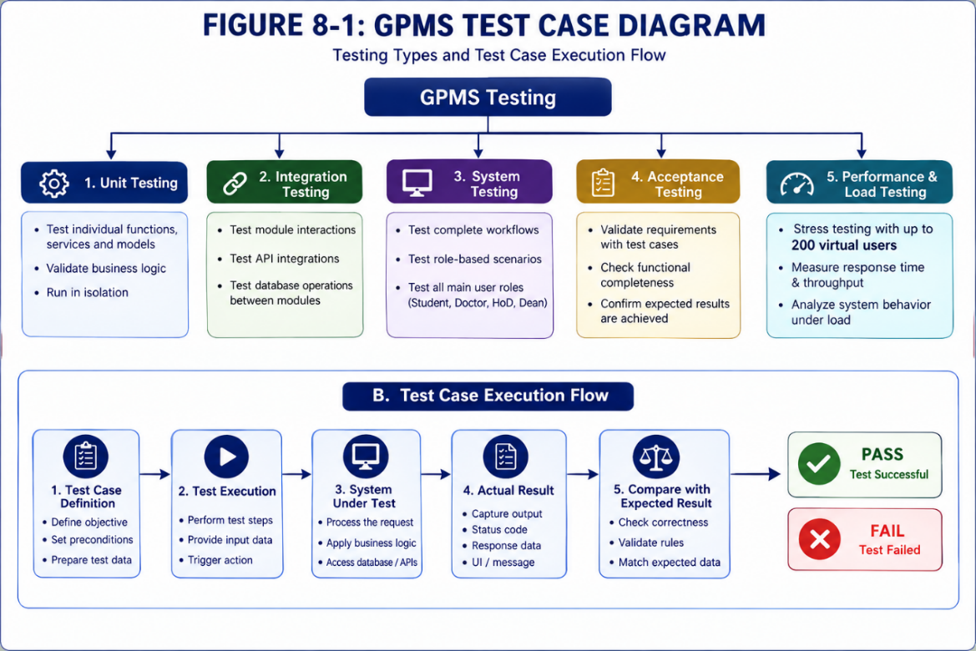

Figure 23 Test Case Diagram

8.3.2 Test Result Diagrams

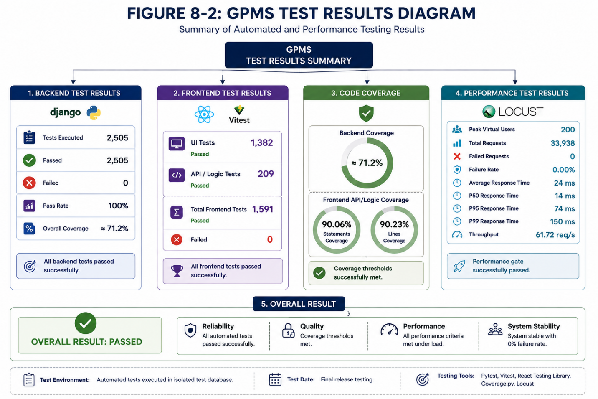
Figure 24 Test Results Diagram

8.4 Test Results and Analysis
The final automated testing results demonstrated that GPMS achieved stable functional and performance behavior. Backend testing was performed using Pytest and pytest-django, while frontend testing used Vitest and React Testing Library. Performance testing was conducted using Locust.
Metric | Final Result
Backend Tests | 2,505 passed, 0 failed
Backend Coverage | ≈71.2%
Frontend UI Tests | 1,382 passed
Frontend API/Logic Tests | 209 passed
Total Frontend Tests | 1,591 passed, 0 failed
Frontend Statement Coverage | 90.06%
Peak Virtual Users | 200
Total Requests | 33,938
Failed Requests | 0
Average Response Time | 24 ms
P50 | 14 ms
P95 | 74 ms
P99 | 150 ms
Throughput | 61.72 req/s

Chapter Summary
Testing verified the functionality, integration, security, and performance of GPMS. The final system passed 2,505 backend tests and 1,591 frontend tests. The Locust stress test reached 200 virtual users and completed 33,938 requests with zero failures. Overall, the results indicate that GPMS satisfies its main functional and quality requirements within the tested environment.

Chapter 9: Results and Analysis

9.1 System Implementation Results
The final GPMS implementation provides role-based interfaces and integrated functionality for project management, workflows, committees, scheduling, grading, notifications, and GitLab integration. Representative screenshots and generated reports demonstrate the main system outputs.
The main implemented results are summarized below:
Area | Final Result
Authentication and Authorization | Secure login and role-based access control were implemented.
Project Management | Project ideas, student proposals, applications, teams, and project participation are managed electronically.
Workflow Management | Academic project stages can be defined and applied using configurable workflows.
Dynamic Forms | HoDs can create configurable forms that students complete during different project stages.
Project Boards | Students and supervisors can follow project tasks and progress through project boards.
Committee Management | Committee templates can be created and projects can be distributed among committees.
Automatic Scheduling | Committee dates, times, and rooms can be generated automatically while avoiding conflicts.
Grading | Authorized committee members can enter and manage student grades.
Notifications | Users receive notifications about important project and workflow events.
GitLab Integration | Projects can be connected with GitLab repositories for development activity monitoring and tracking
Project Import | Academic project information can be imported into the system in bulk.
The system also produces several practical outputs that can be demonstrated through screenshots in the thesis, such as:
- Student, Doctor, HoD, and Dean dashboards.
- Project registration and management screens.
- Workflow and Dynamic Forms screens.
- Committee Distribution Dashboard.
- Automatic Committee Scheduling Preview.
- Grading screens.
- Project reports and exported committee schedules.
- Notifications and GitLab integration screens.
Final Performance Result
The final performance evaluation confirmed that GPMS remained stable under the tested workload. The Locust stress test reached 200 concurrent virtual users, processed 33,938 requests with zero failures, and satisfied all predefined performance acceptance criteria. Detailed testing results are presented in Chapter 8.

9.2 Comparative Analysis with Existing Approaches
The proposed GPMS was compared with traditional graduation-project management and general-purpose academic or development platforms.
Table 22 Comparative Analysis with Existing Approaches
Criterion | Traditional / Manual Approach | General Academic or Git-Based Tools | GPMS
Project Management | Mainly documents and manual records | Partial support | Fully integrated
Academic Workflow | Manual follow-up | Limited customization | Configurable workflows
Committee Management | Manual | Usually not supported | Integrated
Committee Scheduling | Manual and time-consuming | Not graduation-project specific | Automatic CP-SAT scheduling
Conflict Detection | Manual | Limited | Automatic doctor and room conflict prevention
Grading | Separate sheets or documents | Usually external | Integrated grading module
Notifications | Email or manual communication | Partially supported | Integrated notifications
Git Repository Integration | Separate from academic processes | Strong Git support | Integrated with academic project management
Improved through automation | Low to medium | Medium | High through automation
Improved through validation and business rules | Depends heavily on manual work | Medium to high | High through validation and business rules
Cost | Administrative time and manual effort | May require additional platforms or configuration | Mainly based on open-source technologies
Centralization | Low | Partial | High
The main advantage of GPMS is that it combines academic project management, workflows, committees, scheduling, grading, and software-development tracking within one system instead of requiring multiple independent tools.

9.3 Achievement of Project Objectives
The implemented system was evaluated against the main objectives defined for the project.
Objective | Evidence | Status
Integrated graduation project management | Complete web platform and core modules | Achieved
Project ideas, teams, supervisors, and approvals | Projects and approval modules | Achieved
Workflows, committees, and scheduling | Workflow, committee, and OR-Tools scheduling modules | Achieved
Grading and reports | Grading, validation, and reporting modules | Achieved
Notifications and GitLab integration | Notification and GitLab modules | Achieved
Academic stages, permissions, and project history | Stage transitions, RBAC, and participation history | Achieved
Responsive interface and performance | Responsive UI and final stress-test results | Achieved
The results therefore indicate that the main functional objectives of the project were achieved.
In particular, one of the most important improvements was the automation of committee scheduling. Instead of manually selecting dates, times, and rooms, the system uses the Google OR-Tools CP-SAT Solver to generate a valid schedule while respecting doctor availability, room availability, working hours, and conflict constraints.

9.4 Strengths and Weaknesses Analysis
The final implementation demonstrated several strengths, while some limitations remain and can be addressed in future development.
Strengths | Weaknesses / Limitations
Integrated management of the graduation project lifecycle. | Evaluation was mainly performed in a local/development environment rather than a full university production deployment.
Clear role-based access for Student, Doctor, HoD, and Dean. | Long-term real-world usage with a large university population has not yet been evaluated.
Modular Django and React architecture. | Some UI areas have lower automated test coverage than API and business-logic layers.
Automated workflow and Dynamic Forms. | External GitLab availability can affect some integration operations.
Automatic committee scheduling using CP-SAT. | Scheduling quality depends on the correctness of entered room and doctor-availability data.
Automatic detection of doctor and room scheduling conflicts. | Advanced analytics and AI-based recommendations are outside the current project scope.
Integrated grading, reports, notifications, and project tracking. | Native mobile applications are not currently provided.
Strong final stress-test performance with 0% failed requests. | Additional production-scale load testing would further validate scalability.
A major strength of the project is that the system is not limited to basic CRUD operations. It includes business rules, workflow automation, project lifecycle management, access control, and an optimization algorithm for committee scheduling.
At the same time, the current results should not be interpreted as proof of unlimited scalability. The performance tests demonstrate strong behavior under the tested configuration, while deployment under larger real-world workloads should be evaluated separately.

9.5 Key Performance Indicators (KPIs)
The following KPIs summarize the main testing and performance results of the final system
KPI | Result
Backend Automated Tests | 2,505 passed
Frontend Automated Tests | 1,591 passed
Backend Coverage | 71.2%
Frontend Statement Coverage | 90.06%
Stress Test Failure Rate | 0.00%
P95 Response Time | 74 ms
P99 Response Time | 150 ms
Throughput | 61.72 req/s
Peak Virtual Users | 200

Chapter Summary
This chapter presented the main results of the GPMS implementation and evaluated the system against its objectives. The final stress test processed 33,938 requests with a 0.00% failure rate, while the automated test suites demonstrated extensive functional verification and reliability.
The results show that the system successfully integrates project management, workflows, committee scheduling, grading, notifications, and GitLab integration. Despite limitations in large-scale production and long-term user evaluation, the system achieved its main objectives and provides a practical platform for graduation-project management.

Chapter 10: Conclusion and Recommendations

10.1 Project Summary and Main Achievements
This project resulted in the development of an integrated Graduation Project Management System (GPMS) using Django REST Framework and React. The system supports the management of project ideas and proposals, teams, workflows, dynamic forms, committees and scheduling, grading, notifications, and project imports, in addition to GitLab integration. Google OR-Tools CP-SAT was also used to automate committee scheduling and prevent conflicts between doctors and rooms. The final tests demonstrated good system stability and suitable performance under load.

10.2 Difficulties and Challenges Faced During the Project
The project faced several challenges during development. One of the main challenges was the complexity of permissions due to the different user roles, including Student, Doctor, HoD, and Dean, in addition to managing the project lifecycle and its different approval states. Committee scheduling was also one of the most complex parts because it required considering doctor availability, room availability, and conflict prevention.
Other challenges included improving the performance of some database queries, ensuring correct integration between the Frontend and Backend, and completing system testing and bug fixing within the available project timeframe.

10.3 Suggestions for Future Development
The system can be further developed by adding a dedicated mobile application, more advanced analytics and statistical reports, and Artificial Intelligence features such as recommending suitable supervisors or projects for students and analyzing team progress.
The scheduling algorithm can also be enhanced to consider additional doctor and room preferences, while integration with other university systems and improved tools for analyzing student activity on GitLab can be added.
Another important area for future development is expanding the system to support multiple colleges within the university instead of being limited to the College of Informatics only. The system could support different colleges and academic departments, with customizable workflows, forms, project types, committees, and evaluation rules according to the requirements of each college.

10.4 Recommendations
For students developing similar systems in the future, it is recommended to adopt a Modular Architecture from the beginning, separate Business Logic from the Views, and write automated tests continuously throughout development rather than postponing testing until the end of the project.
For institutions that may adopt the system, it is recommended to deploy it first in a pilot environment and verify the accuracy of user data, room information, and doctor availability before applying automatic scheduling. Regular backups, continuous performance and security monitoring, and further system improvements based on feedback from real users are also recommended.

References
- Morey, A., Chile, T., Jadhav, S., & Shah, S. (2024). UMIT Project Management System. International Journal of Innovative Technology and Exploring Engineering, 13(8), 29–35. https://doi.org/10.35940/ijitee.H9935.13080724
- Arowolo, A. O., Saheed, O. O., & Akinola, S. O. (2024). Student Project Management System for Monitoring Undergraduate Projects. Journal of Behavioural Informatics, Digital Humanities and Development Research, 10(3), 47–56. https://doi.org/10.22624/AIMS/BHI/V10N3P3
- Isa, R., Othman, S., Ali, A. S., Azizan, N., & Ferguson, J. (2024). Prototype Development of Final Year Project Management System to Monitor Student’s Performance. Journal of Advanced Research in Applied Sciences and Engineering Technology, 40(1), 164–173. https://doi.org/10.37934/araset.40.1.164173
- Li, Q., Liu, Y., & Wu, W. (2021). Design of University Graduation Project Management System Based on Micro Service Architecture. Proceedings of ICSSBDA 2021, 21–27. Atlantis Press. https://doi.org/10.2991/assehr.k.211216.005
- Django Software Foundation. Django Documentation. https://docs.djangoproject.com/
- Django REST Framework. Django REST Framework Documentation. https://www.django-rest-framework.org/
- React Team. React Documentation. https://react.dev/
- PostgreSQL Global Development Group. PostgreSQL Documentation. https://www.postgresql.org/docs/
- Celery Project. Celery Documentation. https://docs.celeryq.dev/
- Redis. Redis Documentation. https://redis.io/docs/
- GitLab Inc. GitLab Documentation. https://docs.gitlab.com/
- Google. Google OR-Tools Documentation. https://developers.google.com/optimization
- Locust. Locust Documentation. https://docs.locust.io/

The appendix

1 - Class Diagrams
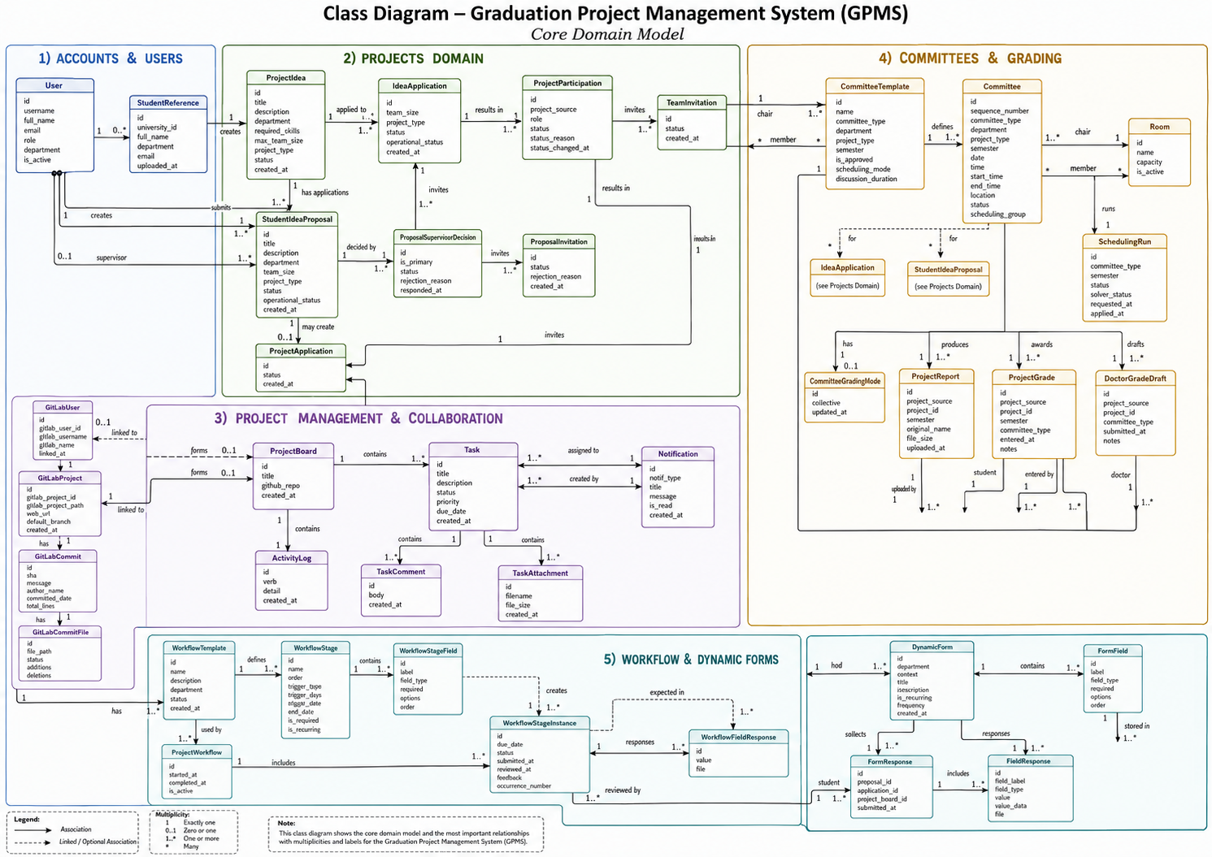
Figure 25 class diagram

2- Component Diagrams

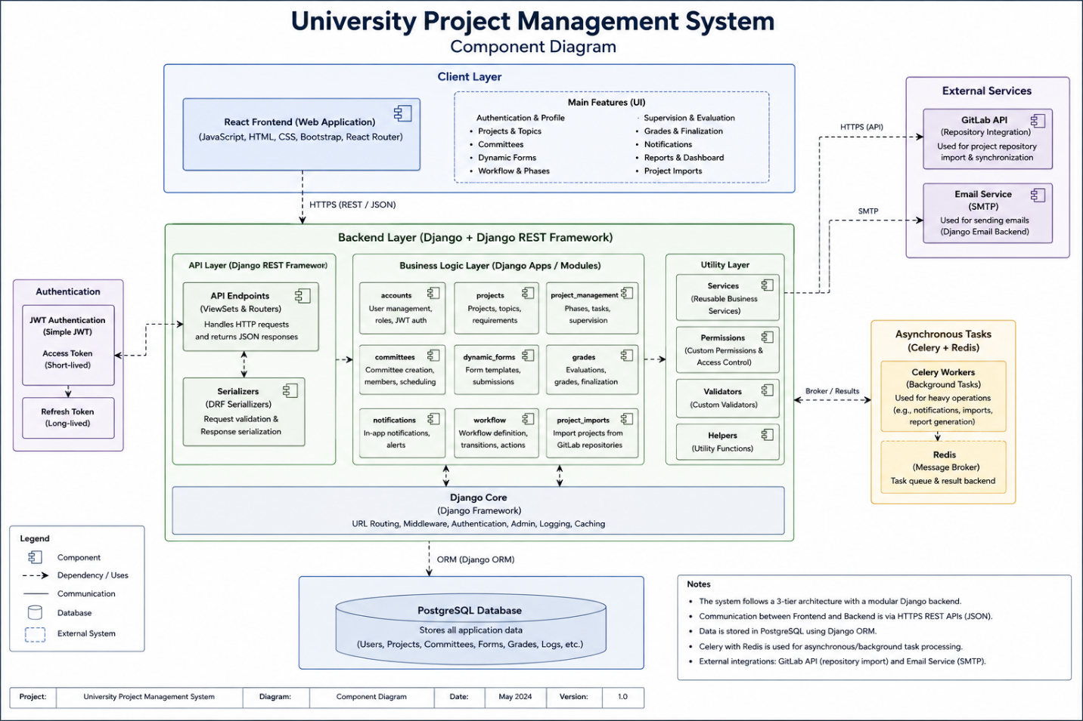
Figure 26 component diagram

4-modules design
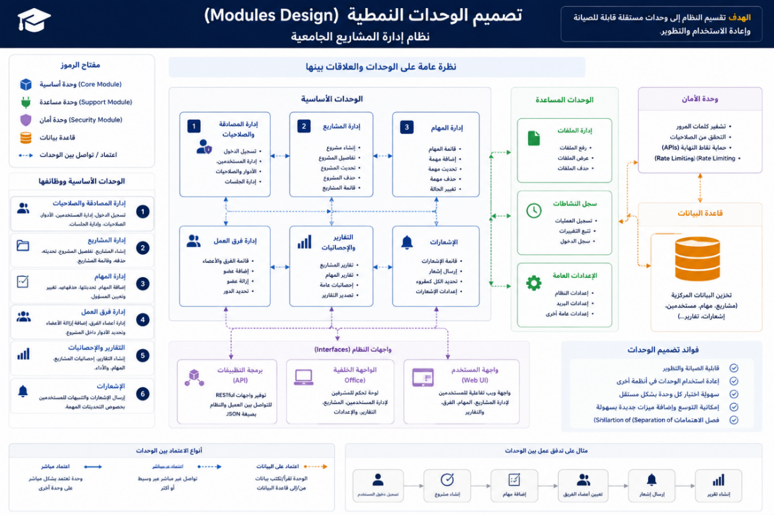
Figure 28 module design

5-api design

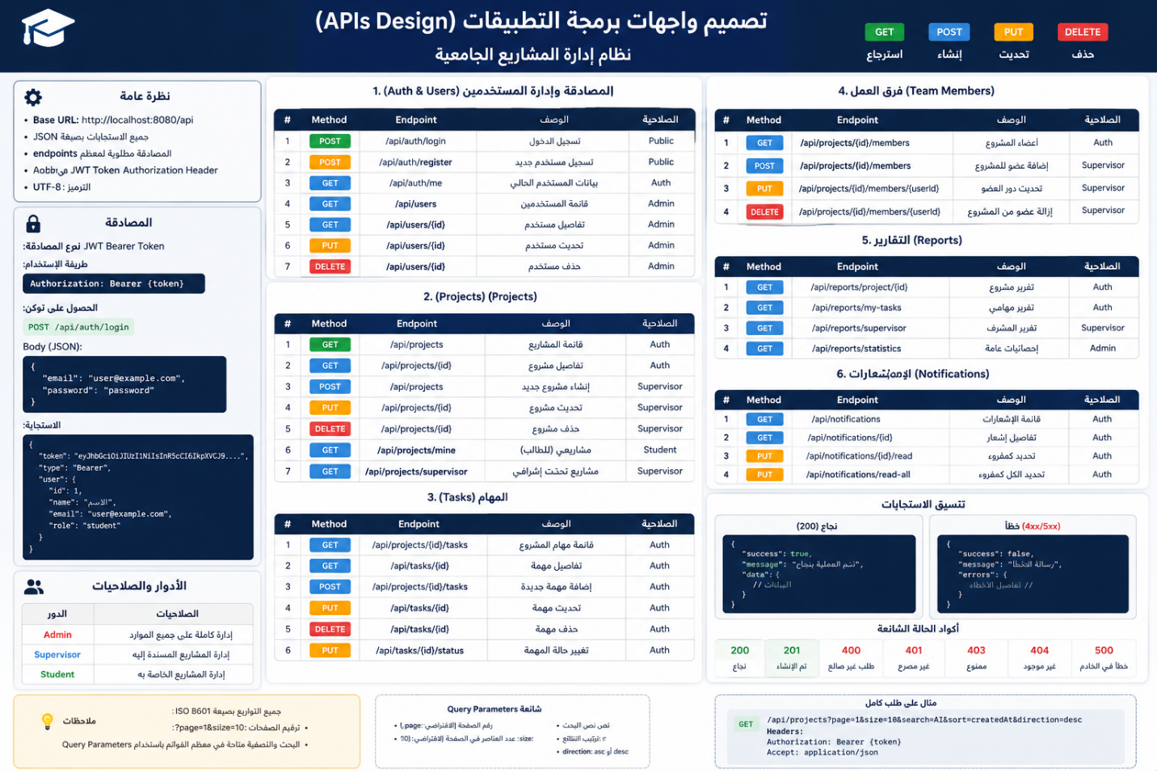
Figure 29 api design

6- Description of Algorithms Using Pseudocode
GPMS uses two main algorithms for committee management. Round Robin is used to distribute projects among available committee formations, while Google OR-Tools CP-SAT is used afterward to schedule the already-created committees by assigning suitable dates, times, and rooms.

Algorithm 1: Round Robin Project Distribution
The Round Robin algorithm distributes projects sequentially among the available committees. After reaching the last committee, the algorithm returns to the first committee and continues until all projects are assigned.
Pseudocode: Round Robin Project Distribution
Algorithm DistributeProjectsRoundRobin

Input:
Projects
AvailableCommittees

Output:
ProjectAssignments

1. If AvailableCommittees is empty:
Return an error indicating that no committees are available.

2. Initialize ProjectAssignments.

3. For each project with index i:

committee_index =
i mod NumberOfAvailableCommittees

selected_committee =
AvailableCommittees[committee_index]

Assign project to selected_committee.

Add the assignment to ProjectAssignments.

4. Return ProjectAssignments.

End Algorithm
The modulo operation allows the distribution to return automatically to the first committee after reaching the last one. In Multi mode, the process is applied separately for each committee type. The purpose of this algorithm is to provide a simple and balanced distribution of projects among available committees.

Algorithm 2: Conflict-Free Committee Scheduling Using CP-SAT
After project distribution is completed, GPMS uses Google OR-Tools CP-SAT to schedule the existing committees. The scheduling algorithm determines an appropriate date, start time, end time, and room for each committee while respecting the configured academic and resource constraints.
Pseudocode: Generate Conflict-Free Committee Schedule
Algorithm GenerateCommitteeSchedule

Input:
ExistingCommittees
DoctorAvailability
AvailableRooms
AvailableDates
WorkingHours
CommitteeDurations

Output:
SchedulePlan

1. Initialize the CP-SAT scheduling model.

2. For each existing committee:

Create decision variables for:
Day
StartTime
EndTime
Room

Set:
EndTime = StartTime + CommitteeDuration

3. Add Hard Constraints:

a. Each committee must be scheduled
on one valid working date.

b. Each committee must start and finish
within the configured working hours.

c. A committee must not cross
from one working day to another.

d. A doctor cannot participate in
two overlapping committees.

e. A room cannot host two
overlapping committees.

f. A committee can only be scheduled
on dates when its required doctors
are available.

4. Define the Objective Function:

Minimize:
Maximum daily committee load
+
Unnecessary scheduling days
+
Latest schedule completion time

5. Run the Google OR-Tools CP-SAT solver.

6. If SolverStatus is OPTIMAL or FEASIBLE:

For each committee:
Retrieve assigned date.
Retrieve start and end time.
Retrieve assigned room.

Create SchedulePlan.

Display SchedulePlan as Preview.

If authorized user selects Apply:
Store the generated schedule.

Else if authorized user selects Reject:
Do not apply the generated schedule.

Return SchedulePlan.

7. Else if SolverStatus is INFEASIBLE:

Report that no valid schedule satisfies
the current constraints.

8. Else:

Report that a valid solution
was not obtained within the solver limits.

End Algorithm

Algorithm Description
The scheduling process starts after committee formation and project distribution have already been completed. The solver therefore does not decide which project belongs to which committee. Instead, it schedules existing committees.
The algorithm first creates scheduling variables for each committee and applies the required Hard Constraints, including doctor availability, room conflicts, doctor conflicts, working dates, working hours, and committee duration.
When multiple valid schedules are possible, the Objective Function guides the solver toward a better arrangement by prioritizing balanced daily committee load, avoiding unnecessary scheduling days, and preferring earlier overall completion.
If the solver returns OPTIMAL or FEASIBLE, the generated schedule is presented as a Preview before being applied. The authorized user can then Apply or Reject the proposed schedule, preserving administrative control over the final result.

