Lương Hoàng Lâm 20183780

Môn: Project I

Lớp 706144

1. **giải :**

package com.company;  
  
import java.util.Scanner;  
  
public class bai1 {  
 public static int denominator(int n){  
 int sum = 0;  
 for(int i=1;i<=n;i++){  
 sum += i;  
 }  
 return sum;  
 }  
  
 public static void main(String[] args) {  
 System.*out*.println("Nhap n :");  
 Scanner scanner = new Scanner(System.*in*);  
 int n = scanner.nextInt();  
 double res =0;  
 for(int i =1 ;i<=n;i++){  
 res += (double)1/*denominator*(i);  
 }  
 System.*out*.println("Ket qua :"+res);  
 System.*out*.println("Luong Hoang Lam 20183780");  
 }  
}

Kết quả :

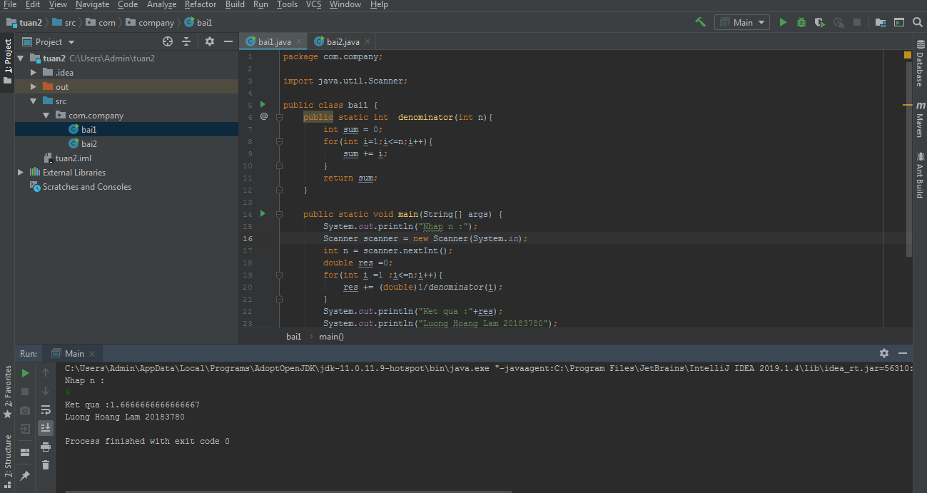

1. Giải:

package com.company;  
  
import java.util.Scanner;  
  
public class bai2 {  
 public static int factorial(int n){  
 if(n == 0 ){  
 return 1;  
 }  
 return n\**factorial*(n-1);  
 }  
 public static void main(String[] args) {  
 System.*out*.println("Nhap so n :");  
 Scanner scanner = new Scanner(System.*in*);  
 int n = scanner.nextInt();  
 double res =0;  
  
 for(int i =1;i<=n;i++){  
 res +=(double) 1/*factorial*(i);  
 }  
 System.*out*.println("Ket qua : "+res);  
 System.*out*.println("Luong Hoang Lam 20183780");  
 }  
}

Kêt quả:

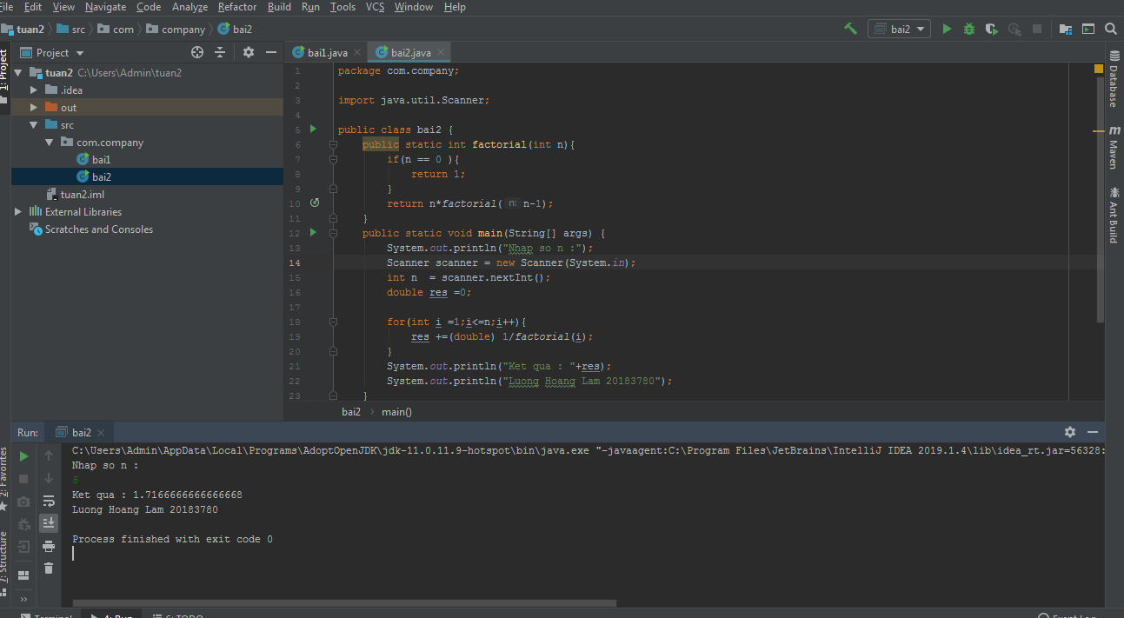

1. Giải:

package com.company;  
  
import java.util.Scanner;  
  
public class bai3 {  
 public static int factorial(int n){  
 if(n == 0 ){  
 return 1;  
 }  
 return n\**factorial*(n-1);  
 }  
 public static int denominator(int n){  
 int sum = 0;  
 for(int i=1;i<=n;i++){  
 sum += *factorial*(i);  
 }  
 return sum;  
 }  
 public static void main(String[] args) {  
 System.*out*.println("Nhap so n:");  
 Scanner scanner = new Scanner(System.*in*);  
 int n = scanner.nextInt();  
 double res =0;  
 for(int i =1;i<=n;i++){  
 res += (double)1/*denominator*(i);  
 }  
 System.*out*.println("Ket qua "+res);  
 System.*out*.println("Luong Hoang Lam 20183780");  
 }  
}

Kết quả:

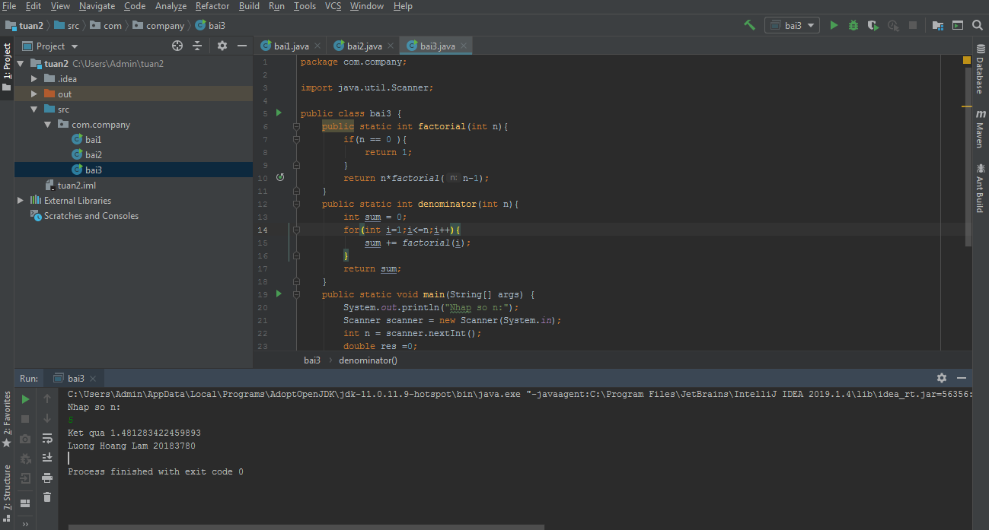

1. Giải:

package com.company;  
  
import java.util.Scanner;  
  
public class bai4 {  
 public static int fibonaci(int n){  
 if(n ==0 || n==1){  
 return 1;  
 }  
 return *fibonaci*(n-2)+*fibonaci*(n-1);  
 }  
 public static void main(String[] args) {  
 System.*out*.println("Nhap so n ");  
 Scanner scanner = new Scanner(System.*in*);  
 int n = scanner.nextInt();  
 int res = *fibonaci*(n);  
 System.*out*.println("Ket qua la : "+res);  
 System.*out*.println("Luong Hoang Lam 20183780");  
 }  
}

Kết quả:

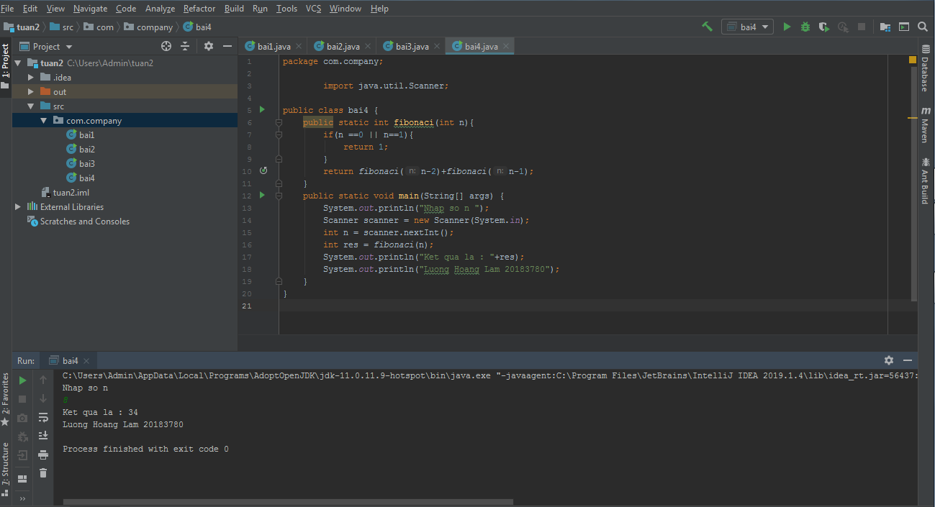

1. Giải:

package com.company;  
  
import java.util.Scanner;  
  
public class bai5 {  
 public static void sort(int[] arr){  
 int tmp ;  
 for(int i =0;i<arr.length-1;i++){  
 for(int j = i+1;j<arr.length;j++){  
 if(arr[i]<arr[j]){  
 tmp = arr[i];  
 arr[i]=arr[j];  
 arr[j]=tmp;  
 }  
 }  
 }  
 }  
 public static void main(String[] args) {  
 System.*out*.println("Nhap so phan tu :");  
 Scanner scanner = new Scanner(System.*in*);  
 int n = scanner.nextInt();  
 int[] arr = new int[n];  
 for(int i =1 ;i<=n;i++){  
 System.*out*.println("Nhap phan tu thu "+i+":");  
 arr[i-1] = scanner.nextInt();  
 }  
 *sort*(arr);  
 System.*out*.print("Day sau khi sap xep la :");  
 for (int i = 0;i<n;i++){  
 System.*out*.print(arr[i]+" ");  
 }  
 System.*out*.println();  
 System.*out*.println("Luong Hoang Lam 20183780");  
 }  
}

Kết quả :

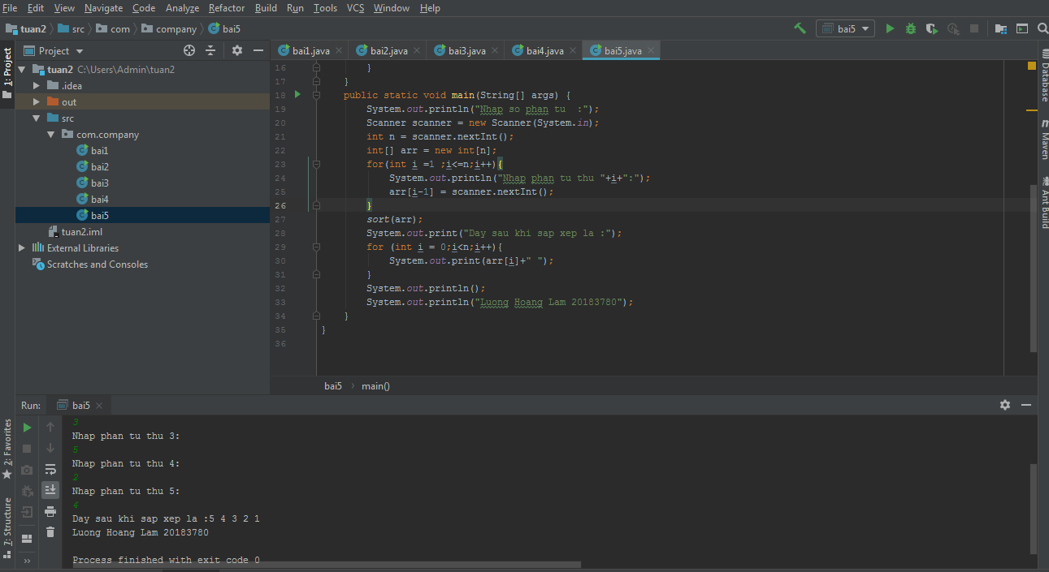

1. Giải:

package com.company;  
  
import java.util.Scanner;  
  
public class bai6 {  
 public static boolean isPrimeNumber(int n){  
 if(n == 1)  
 return false;  
 for(int i =2 ;i<=n/2;i++){  
 if(n%i==0){  
 return false;  
 }  
 }  
 return true;  
 }  
  
 public static void main(String[] args) {  
 System.*out*.println("Nhap so phan tu :");  
 Scanner scanner = new Scanner(System.*in*);  
 int n = scanner.nextInt();  
 int[] arr = new int[n];  
 for(int i =1 ;i<=n;i++){  
 System.*out*.println("Nhap phan tu thu "+i+":");  
 arr[i-1] = scanner.nextInt();  
 }  
 for(int i = 0 ;i<arr.length;i++){  
 if(*isPrimeNumber*(arr[i])){  
 System.*out*.print(arr[i]+" ");  
 }  
 }  
 System.*out*.println();  
 System.*out*.println("Luong Hoang Lam 20183780");  
 }  
}

Kết quả :

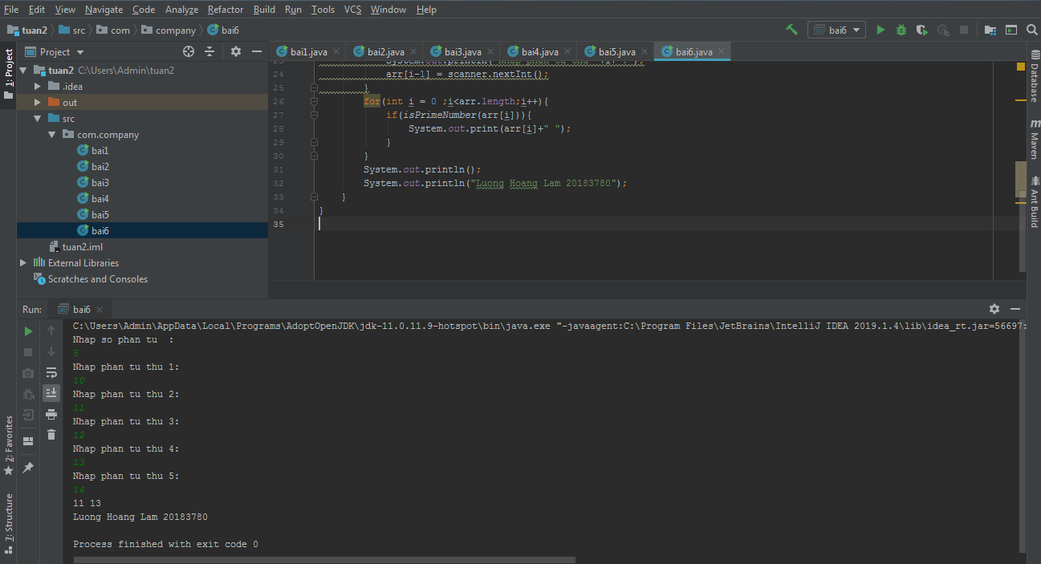

1. Giải

package com.company;  
  
import java.util.Scanner;  
  
public class bai7 {  
 public static final int *MAX_INT* = 999999999;  
 public static int findMin(int[] arr){  
 int min = *MAX_INT*;  
 for(int i =0;i<arr.length;i++){  
 if(arr[i]< min){  
 min = arr[i];  
 }  
 }  
 return min;  
 }  
 public static void main(String[] args) {  
 System.*out*.println("Nhap so phan tu :");  
 Scanner scanner = new Scanner(System.*in*);  
 int n = scanner.nextInt();  
 int[] arr = new int[n];  
 for(int i =1 ;i<=n;i++){  
 System.*out*.println("Nhap phan tu thu "+i+":");  
 arr[i-1] = scanner.nextInt();  
 }  
 int min_arr = *findMin*(arr);  
 System.*out*.print("Min cua day la :"+ min_arr+" va co chi so:");  
 for(int i = 0 ;i<n;i++){  
 if(arr[i]==min_arr){  
 System.*out*.print(i+" ");  
 }  
 }  
 System.*out*.println();  
 System.*out*.println("Luong Hoang Lam 20183780");  
 }  
}

Kết quả

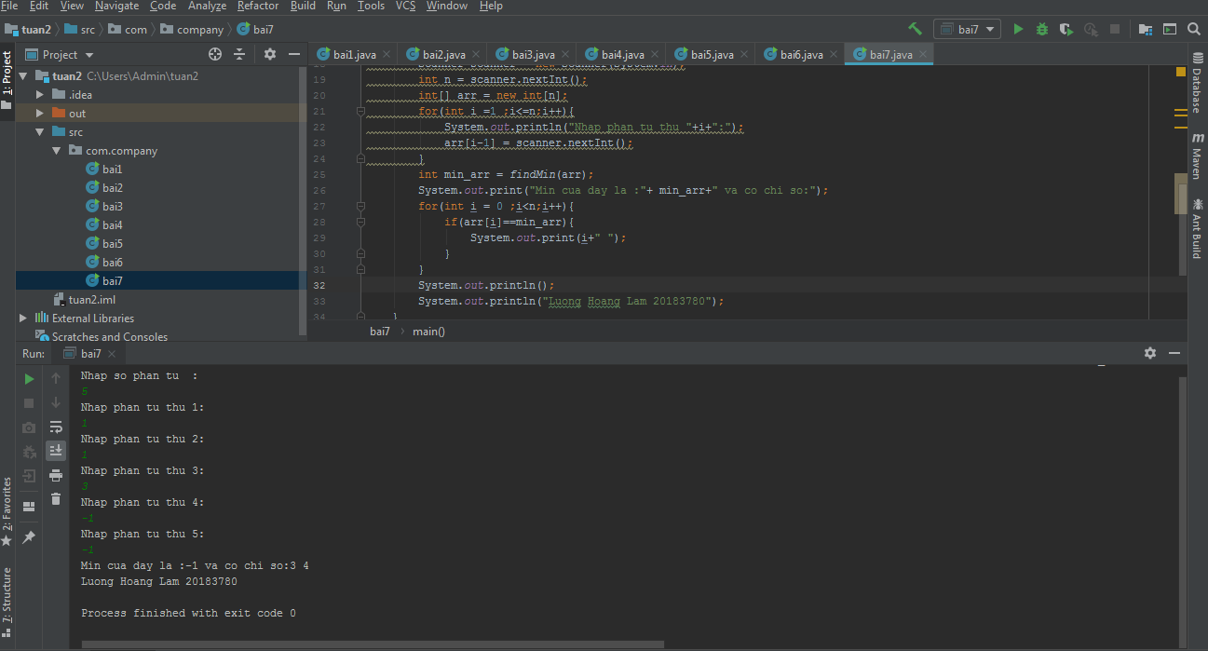

1. Giải:

package com.company;  
  
import java.util.Scanner;  
  
public class bai8 {  
 public static final int *MIN_INT* = -999999999;  
 public static int findMax(int[] arr){  
 int max = *MIN_INT*;  
 for(int i =0;i<arr.length;i++){  
 if(arr[i] > max){  
 max = arr[i];  
 }  
 }  
 return max;  
 }  
 public static void main(String[] args) {  
 System.*out*.println("Nhap so phan tu :");  
 Scanner scanner = new Scanner(System.*in*);  
 int n = scanner.nextInt();  
 int[] arr = new int[n];  
 for(int i =1 ;i<=n;i++){  
 System.*out*.println("Nhap phan tu thu "+i+":");  
 arr[i-1] = scanner.nextInt();  
 }  
 int max_arr = *findMax*(arr);  
 System.*out*.print("Max cua day la :"+ max_arr+" va co chi so:");  
 for(int i = 0 ;i<n;i++){  
 if(arr[i]==max_arr){  
 System.*out*.print(i+" ");  
 }  
 }  
 System.*out*.println();  
 System.*out*.println("Luong Hoang Lam 20183780");  
 }  
}

Kết quả :

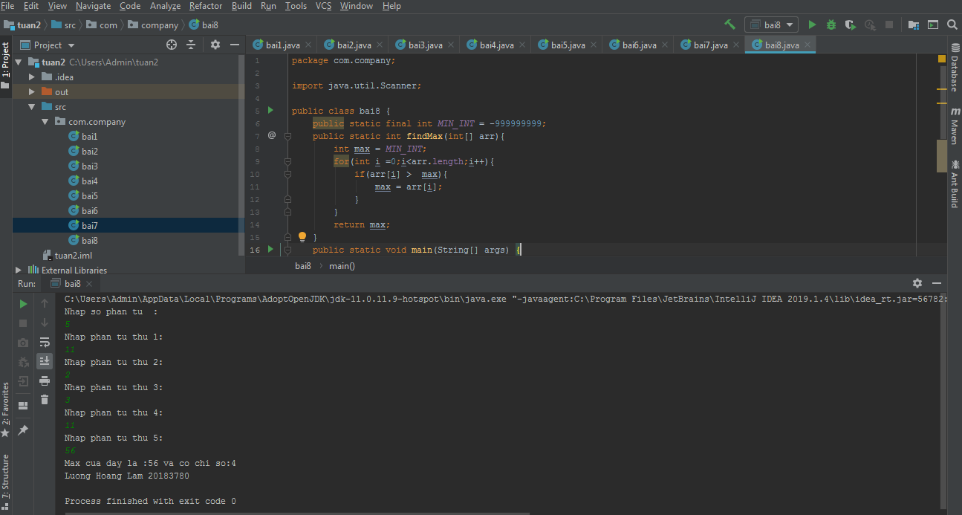

1. Giải:

package com.company;  
  
import java.util.Scanner;  
  
public class bai9 {  
 public static boolean isPrimeNumber(int n){  
 if(n == 1)  
 return false;  
 for(int i =2 ;i<=n/2;i++){  
 if(n%i==0){  
 return false;  
 }  
 }  
 return true;  
 }  
  
 public static void main(String[] args) {  
 System.*out*.println("Nhap so phan tu :");  
 Scanner scanner = new Scanner(System.*in*);  
 int n = scanner.nextInt();  
 int[] arr = new int[n];  
 for(int i =1 ;i<=n;i++){  
 System.*out*.println("Nhap phan tu thu "+i+":");  
 arr[i-1] = scanner.nextInt();  
 }  
 int count_Prime = 0;  
 int count_nonPrime =0;  
 for(int i = 0 ;i<arr.length;i++){  
 if(*isPrimeNumber*(arr[i])){  
 count_Prime++;  
 }  
 else if(arr[i]!=1){  
 count_nonPrime++ ;  
 }  
 }  
 System.*out*.println("So cac so nguyen to : "+ count_Prime+" so cac hop so "+count_nonPrime);  
 System.*out*.println();  
 System.*out*.println("Luong Hoang Lam 20183780");  
 }  
}

Kết quả:

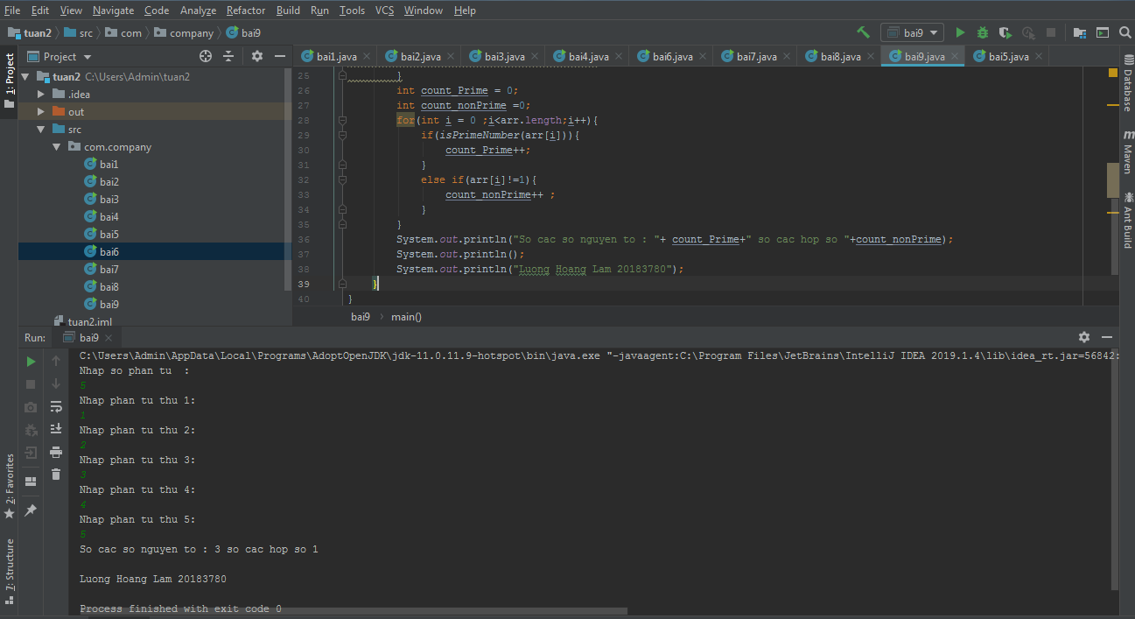

1. Giải:

package com.company;  
  
import java.util.ArrayList;  
import java.util.List;  
import java.util.Scanner;  
  
public class bai10 {  
 public static void main(String[] args) {  
 System.*out*.println("Nhap so phan tu :");  
 Scanner scanner = new Scanner(System.*in*);  
 int n = scanner.nextInt();  
 int[] arr = new int[n];  
 for(int i =1 ;i<=n;i++){  
 System.*out*.println("Nhap phan tu thu "+i+":");  
 arr[i-1] = scanner.nextInt();  
 }  
 List<Integer> list = new ArrayList<>();  
 for(int i =0;i<n;i++){  
 for(int j = 0;j<n;j++){  
 if(arr[j]%arr[i] == 0 && i!=j && !list.contains(arr[i])){  
 list.add(arr[i]);  
 }  
 }  
 }  
 System.*out*.println("Ket qua "+list);  
 System.*out*.println("Luong Hoang Lam 20183780");  
 }  
}

Kết quả :

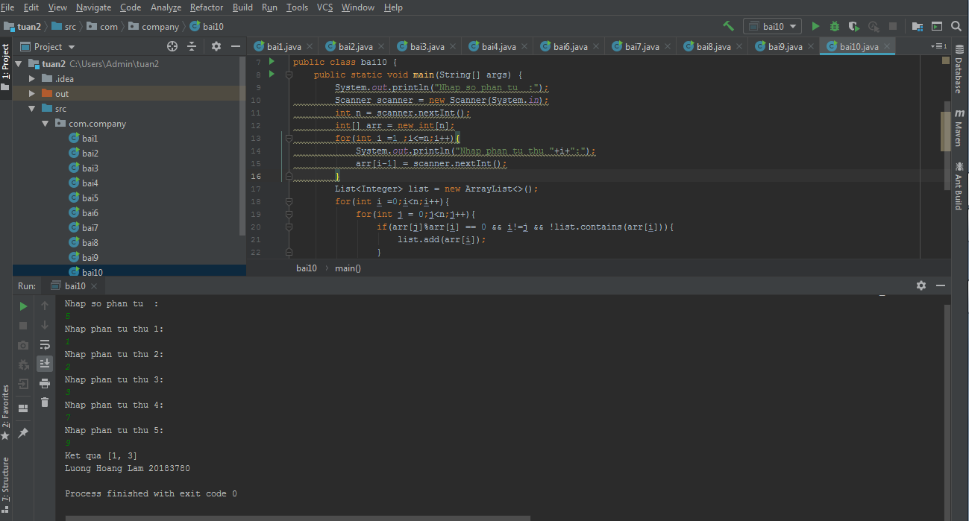

1. Giải:

package com.company;  
  
import java.util.*;  
  
public class bai11 {  
 public static final int *MAX_INT* = 999999999;  
 public static int findMin(List<Integer> arr) {  
 int min = *MAX_INT*;  
 for (int i = 0; i < arr.size(); i++) {  
 if (arr.get(i).compareTo(min)<0) {  
 min = arr.get(i);  
 }  
 }  
 return min;  
 }  
 public static void main(String[] args) {  
 System.*out*.println("Nhap so phan tu :");  
 Scanner scanner = new Scanner(System.*in*);  
 int n = scanner.nextInt();  
 int[] arr = new int[n];  
 for (int i = 1; i <= n; i++) {  
 System.*out*.println("Nhap phan tu thu " + i + ":");  
 arr[i - 1] = scanner.nextInt();  
 }  
 List<Integer> list = new ArrayList<>();  
 for(int i =0 ;i<n-1;i++){  
 for(int j =0;j<n;j++){  
 if(arr[i]==arr[j]&& i!=j){  
 break;  
 }  
 else if(j == n-1){  
 list.add(arr[i]);  
 }  
 }  
 }  
 System.*out*.println("ket qua la : "+*findMin*(list));  
 System.*out*.println("Luong Hoang Lam 20183780");  
 }  
}

Kết quả :

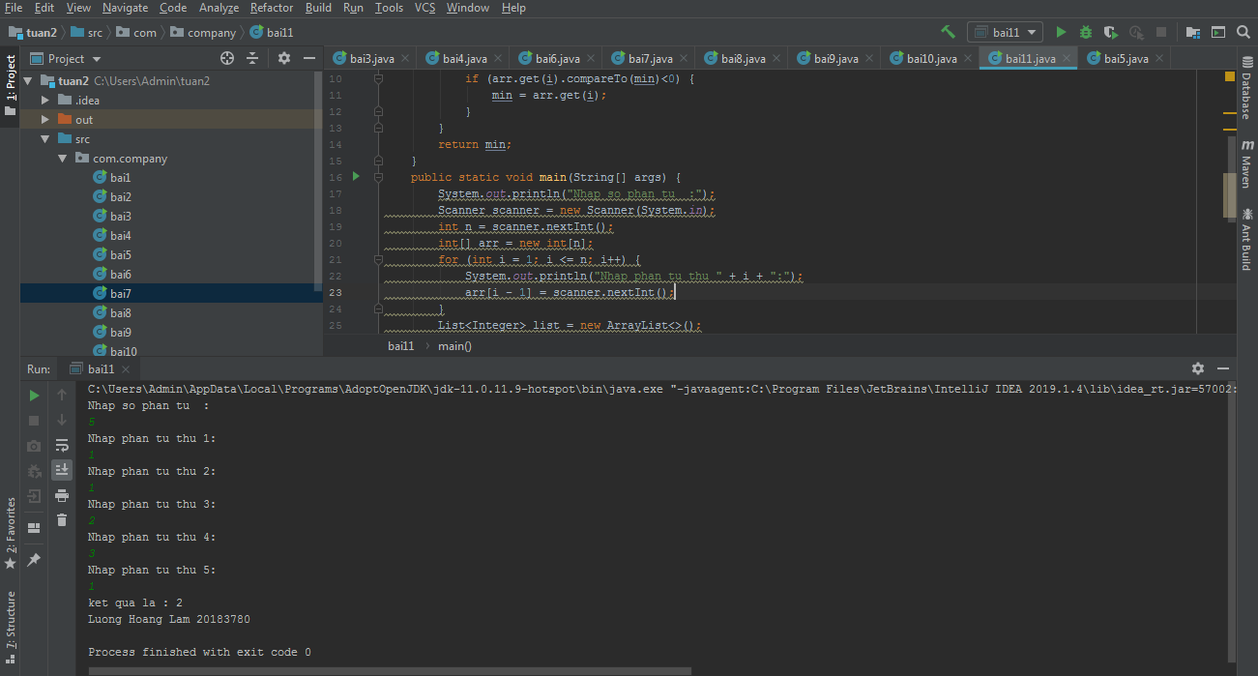

1. Giải:

package com.company;  
  
import javax.sound.midi.Soundbank;  
import java.util.ArrayList;  
import java.util.List;  
import java.util.Scanner;  
  
public class bai12 {  
 public static void main(String[] args) {  
 System.*out*.println("Nhap so phan tu :");  
 Scanner scanner = new Scanner(System.*in*);  
 int n = scanner.nextInt();  
 int[] arr = new int[n];  
 for (int i = 1; i <= n; i++) {  
 System.*out*.println("Nhap phan tu thu " + i + ":");  
 arr[i - 1] = scanner.nextInt();  
 }  
 List<Integer> list = new ArrayList<>();  
 for (int i =0;i<n;i++){  
 if(arr[i]!=0){  
 list.add(arr[i]);  
 }  
 }  
 System.*out*.println("Day sau khi luoc bo cac so 0 la :"+ list);  
 System.*out*.println("Luong Hoang Lam 20183780");  
 }  
}

Kết quả :

