**Guided Capstone Project Report – Big Mountain Resort Recommendation**

Big Mountain resort currently charges $81 dollars per Adult Weekend ticket which is above the $63 average price across the U.S. This is consistent with the pricing strategy, which is to add a premium above the average price of resorts in the market segment. Our analysis confirms management’s suspicions that Big Mountain Resort may be leaving money on the table by under charging customers based on facilities that Big Mountain Resort offers.

We created a pricing model using ski resort data and State level population and geographic data to get an understanding of the underlying relationship between ski resort facilities and pricing.

We find that Big Mountain Resort contains an above average amount of chair lifts, fast quads and number of runs and also has the 29th highest vertical drop in the country.

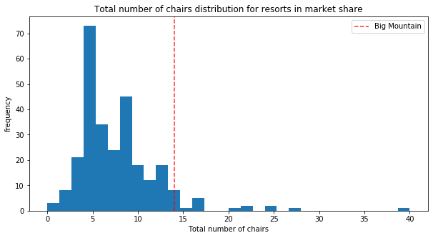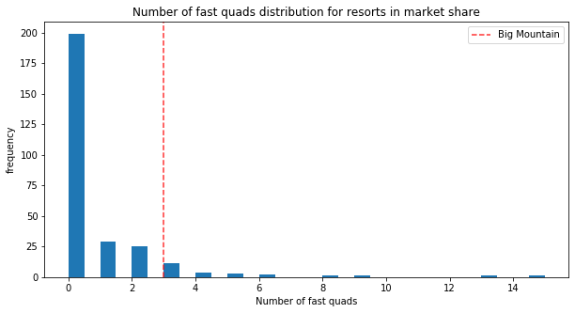

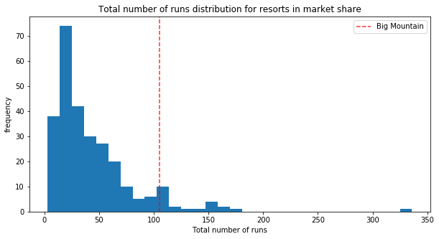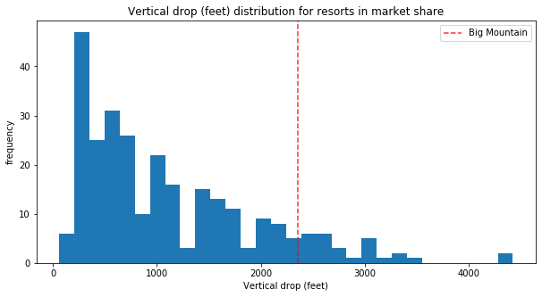

Based on ski mountain characteristics such as vertical drop, longest run, number of runs and amount of skiable terrain, and facilities such number of chair lifts, fast quads and snowmaking ability, our model suggests that a resort with similar facilities and mountain characteristics to Big Mountain Resort could potentially charge $94 per Adult weekend ticket which is a 16% increase over the current price.

However, given that we do not have data around the operating costs of ski resorts across the U.S, or data around other revenue sources such as chalet reservations, restaurant and spa spend, we do not suggest such a aggressive price hike. Furthermore, a one off 16% price increase may generate a negative reaction in our customer base which would end up hurting demand and offset any increase in revenues.

Instead, we would recommend for the immediate short term, an increase in ticket prices to $83 which amounts to a 2.4% price increase. This modest increase would generate an additional 3.5MM in revenues based on a customer base of 35000 per season with an average stay of 5 days.

This would cover the increased operational cost of the additional chair lift that was recently installed. At this moment, we would not recommend closing any additional runs or reducing facilities services as these are key drivers for ticket prices based on our model.

If we do not see a drop in demand during this upcoming season from the price increase, in the medium term, we would recommend that management explore adding an additional chair lift to add a run that would increase the vertical drop of Big Mountain Resort by a minimum of 150 ft. This could justify an additional price increase of $2 per Adult Weekend Ticket for next season.