Title: Assault injuries among older Multiracial adults in California, 2005-2022

Authors: Tracy Lam-Hine, DrPH, MBA¹; Emily F. Liu, MPH²; Caitlin Chan, SM²; Jennifer Ahern, PhD, MPH²

¹ Stanford University School of Medicine, Department of Epidemiology and Population Health
² University of California, Berkeley, Division of Epidemiology, School of Public Health

Corresponding author:
Tracy Lam-Hine, DrPH, MBA
Stanford University School of Medicine, Department of Epidemiology and Population Health
1701 Page Mill Road, Palo Alto, CA 94304
lamhine@stanford.edu

Article type: Research Letter

Short running title: Assault injuries among older Multiracial adults

Word count (main text): 744

Tables: 1

Figures: 1

Financial support: This research received funding from the Eunice Kennedy Shriver National Institute of Child Health and Human Development and the National Institutes of Health Office of the Director (DP2HD080350). JA is a Chan Zuckerberg Biohub-San Francisco Investigator. TLH did not receive direct funding for this paper.

Prior presentation: Accepted for poster presentation at the Society for Epidemiologic Research Annual Meeting, 2026.

Introduction
Violence against older adults is a growing public health concern. Between 2015 and 2022, U.S. emergency department visit rates for nonfatal assault among adults aged 60 years and older rose 31%, and homicide rates rose 26%, with an estimated annual economic cost of $32.7 billion in 2022.¹ Nationally, racial and ethnic disparities in nonfatal assault injury among older adults have been poorly characterized due to high levels of missing race and ethnicity data in the National Electronic Injury Surveillance System.² A recent analysis of assault injuries among women in California found that Multiracial women aged 65 years and older had the highest age-specific assault injury rates of any racial and ethnic group, exceeding Black women in this age range.³ Whether this pattern extends to Multiracial men or varies across the older age range is unknown. We estimated rates of fatal and non-fatal assault among California adults aged 50 years and older from 2005 to 2022 – stratifying by age group, sex, and race and ethnicity – to characterize patterns among Multiracial older adults across the older age range and in both sexes.

Methods
We combined 2005-2022 statewide hospital discharge data from the California Department of Health Care Access and Information with death records from the California Department of Public Health for residents aged 50 years and older. Using the data infrastructure and case definition described in Liu et al.,³ we identified fatal assault injuries from death records using ICD-10 external cause codes and non-fatal assault injuries from hospital records using ICD-9-CM external cause codes for events before October 2015 and ICD-10-CM external cause and diagnostic codes for events from October 2015 onward. To avoid double counting, we linked ED visits resulting in admission to their inpatient records and removed in-hospital deaths from the hospital data. We excluded records with missing age or race and ethnicity (<5%). We classified race and ethnicity into six mutually exclusive groups: Hispanic (any race), and non-Hispanic American Indian or Alaska Native (AIAN), Asian or Pacific Islander (API), Black, Multiracial, and White. We categorized age into 5-year intervals from 50-54 through 85+. We calculated sex- and age-specific assault injury rates per 100,000 person-years using intercensal (2005-2009) and postcensal (2010-2022) California population estimates as denominators. Exact 95% Poisson confidence intervals were estimated using the epitools package in R.⁴ Use of these data was approved by the California Health and Human Services Agency and the University of California, Berkeley Committee for the Protection of Human Subjects.

Results
Between 2005 and 2022, we identified 341,997 assault injury events among California adults aged 50 years and older (115,195 among females and 226,802 among males). Assault injury rates declined with age for females and males across all racial and ethnic groups (Figure 1). Across ages 50 to 64 years, Black adults had the highest assault injury rates. At ages 65 and older, Multiracial adults had the highest and most persistently elevated rates across groups.
Among adults aged 85 years and older, assault injury rates among Multiracial adults were 145.1 per 100,000 person-years among females and 253.6 per 100,000 person-years among males, compared with 77.1 and 135.6 among Black females and males, and 42.9 and 53.2 among White females and males, respectively (Table 1).

Discussion
Assault injury rates among older Multiracial adults in California were elevated relative to other racial and ethnic groups and showed less age-related decline. These findings extend a recent analysis among California women by showing the same pattern in both sexes and across the older age range.³ Multiracial older adults are routinely excluded from or aggregated within aging research, obscuring patterns of late-life risk that may differ from those of other groups.⁵
Several mechanisms may contribute to this pattern. Multiracial adults experience elevated rates of social isolation,⁶ which is an established risk factor for elder mistreatment and late-life interpersonal violence.⁷ Multiracial individuals also frequently report identity invalidation and marginalization across multiple racial communities,⁸ which may further weaken protective family and community ties as they age. These mechanisms warrant direct investigation in older Multiracial populations.
This analysis had limitations. Hospital and death records capture only assault injuries severe enough to result in medical attention or death and do not capture non-medically-attended events. These data also do not include information on perpetrator identity or relational context, and findings should not be interpreted as estimates of elder abuse incidence.
As the older adult population grows and diversifies, research disaggregating Multiracial older adults is needed to understand the conditions shaping late-life assault injury risk and to inform prevention efforts.

Acknowledgments

Conflict of Interest Statement: The authors declare no conflicts of interest.

Role of Funder: Funders had no involvement in the study’s conceptualization, design, analysis, or interpretation of results.

Access to Data: EFL had full access to the underlying individual-level data used to generate the aggregated rates analyzed in this manuscript. TLH had full access to the aggregated data analyzed in this manuscript and takes responsibility for the integrity of the analysis and figures presented.

Data Sharing Statement: Hospital discharge data used for this analysis are available upon request from the California Department of Health Care Access and Information. Death record data are available upon request from the California Department of Public Health.

References

1. Peterson C, Haileyesus T, Herbst JH, Gerald MS, Florence C. Economic Cost of US Older Adult Assault Injuries. JAMA Network Open. 2024;7(10):e2437644. doi:10.1001/jamanetworkopen.2024.37644

2. Logan JE, Haileyesus T, Ertl A, Rostad WL, Herbst JH. Nonfatal Assaults and Homicides Among Adults Aged ≥60 Years United States, 20022016. MMWR Morbidity and Mortality Weekly Report. 2019;68(13):297-302. doi:10.15585/mmwr.mm6813a1

3. Liu EF, Jung S, Mujahid MS, Morello-Frosch R, Ahern J. Trends and Disparities in Assault Injuries among Women in California 2005-2022. American Journal of Preventive Medicine. Published online March 2026:108350. doi:10.1016/j.amepre.2026.108350

4. Aragon TJ. Epitools: Epidemiology Tools. 2004. doi:10.32614/CRAN.package.epitools

5. Lam-Hine T, Odden MC, James BD, Rehkopf DH. Prevalence of Subjective Cognitive Decline Among Older Multiracial Adults, 20192023. Journal of Aging and Health. 2025;0(0):1-9. doi:10.1177/08982643251377230

6. Town M, Eke P, Zhao G, et al. Racial and ethnic differences in social determinants of health and health-related social needs among adults behavioral risk factor surveillance system, united states, 2022. MMWR Morbidity and Mortality Weekly Report. 2024;73(9):204-208. doi:10.15585/mmwr.mm7309a3

7. Rosen T, Makaroun LK, Conwell Y, Betz M. Violence In Older Adults: Scope, Impact, Challenges, And Strategies For Prevention. Health Affairs. 2019;38(10):1630-1637. doi:10.1377/hlthaff.2019.00577

8. Franco M, Durkee M, McElroy-Heltzel S. Discrimination comes in layers: Dimensions of discrimination and mental health for multiracial people. Cultural Diversity and Ethnic Minority Psychology. 2021;27(3):343. doi:10.1037/cdp0000441

Table 1. Age-specific assault injury rates per 100,000 person-years (95% CI) by race and ethnicity and sex, California, 2005-2022.
Age group | AIAN | API | Black | Hispanic | Multiracial | White
Female
50-54 | 315.5  (283.4, 347.7) | 61.7  (59.1, 64.2) | 668.2  (655.0, 681.5) | 150.4  (147.5, 153.3) | 396.8  (376.9, 416.7) | 193.8  (191.2, 196.5)
55-59 | 204.8  (178.4, 231.2) | 54.5  (52.0, 57.0) | 473.8  (462.2, 485.4) | 109.5  (106.8, 112.2) | 306.8  (288.0, 325.6) | 127.9  (125.7, 130.1)
60-64 | 123.0  (100.8, 145.2) | 49.6  (47.1, 52.2) | 290.6  (280.6, 300.6) | 84.4  (81.6, 87.1) | 245.7  (226.8, 264.6) | 80.3  (78.5, 82.1)
65-69 | 64.3  (46.0, 82.7) | 44.8  (42.1, 47.5) | 171.0  (162.3, 179.7) | 65.0  (62.2, 67.7) | 192.8  (173.2, 212.3) | 53.7  (52.1, 55.3)
70-74 | 66.8  (44.7, 89.0) | 42.0  (39.1, 45.0) | 107.0  (99.1, 115.0) | 49.3  (46.5, 52.2) | 158.1  (137.2, 178.9) | 41.4  (39.8, 42.9)
75-79 | 66.1  (39.1, 93.0) | 42.4  (38.9, 45.9) | 81.9  (73.7, 90.0) | 46.2  (43.0, 49.5) | 144.7  (120.8, 168.5) | 40.0  (38.2, 41.7)
80-84 | 43.4  (16.5, 70.4) | 39.5  (35.5, 43.5) | 66.9  (58.2, 75.7) | 44.5  (40.7, 48.3) | 148.4  (119.3, 177.4) | 38.7  (36.8, 40.6)
85+ | 31.4  (8.2, 54.7) | 28.9  (25.6, 32.2) | 77.1  (67.8, 86.4) | 40.5  (36.8, 44.2) | 145.1  (116.9, 173.2) | 42.9  (41.1, 44.8)
Male
50-54 | 466.9  (426.7, 507.0) | 97.5  (94.1, 101.0) | 1322.6  (1303.8, 1341.4) | 359.9  (355.5, 364.4) | 1000.6  (967.8, 1033.4) | 363.9  (360.3, 367.6)
55-59 | 366.4  (329.3, 403.5) | 90.4  (86.9, 93.9) | 1091.8  (1073.8, 1109.9) | 294.4  (289.9, 299.0) | 858.4  (825.7, 891.1) | 264.9  (261.8, 268.0)
60-64 | 261.4  (227.2, 295.5) | 78.9  (75.3, 82.4) | 761.6  (744.5, 778.6) | 224.3  (219.6, 229.0) | 657.8  (625.5, 690.1) | 178.4  (175.7, 181.1)
65-69 | 138.4  (109.8, 167.0) | 67.9  (64.2, 71.6) | 474.2  (458.3, 490.2) | 158.5  (153.8, 163.2) | 508.3  (474.5, 542.2) | 111.0  (108.7, 113.4)
70-74 | 94.1  (66.0, 122.2) | 52.5  (48.8, 56.3) | 243.6  (230.1, 257.1) | 116.5  (111.6, 121.5) | 357.2  (322.9, 391.6) | 72.4  (70.2, 74.6)
75-79 | 50.8  (25.1, 76.6) | 52.0  (47.5, 56.4) | 153.7  (140.6, 166.9) | 97.0  (91.5, 102.5) | 327.7  (287.0, 368.3) | 54.6  (52.4, 56.8)
80-84 | 60.9  (24.9, 96.8) | 52.8  (47.4, 58.3) | 120.6  (105.8, 135.3) | 77.9  (71.8, 84.0) | 241.7  (198.1, 285.2) | 48.3  (45.8, 50.8)
85+ | 45.1  (9.0, 81.1) | 42.5  (37.3, 47.7) | 135.6  (117.7, 153.5) | 90.2  (82.8, 97.5) | 253.6  (206.7, 300.5) | 53.2  (50.4, 55.9)
Abbreviations: AIAN = American Indian or Alaska Native; API = Asian or Pacific Islander.

Figure 1. Assault injury rates per 100,000 person-years by age group, race and ethnicity, and sex, California, 2005-2022.
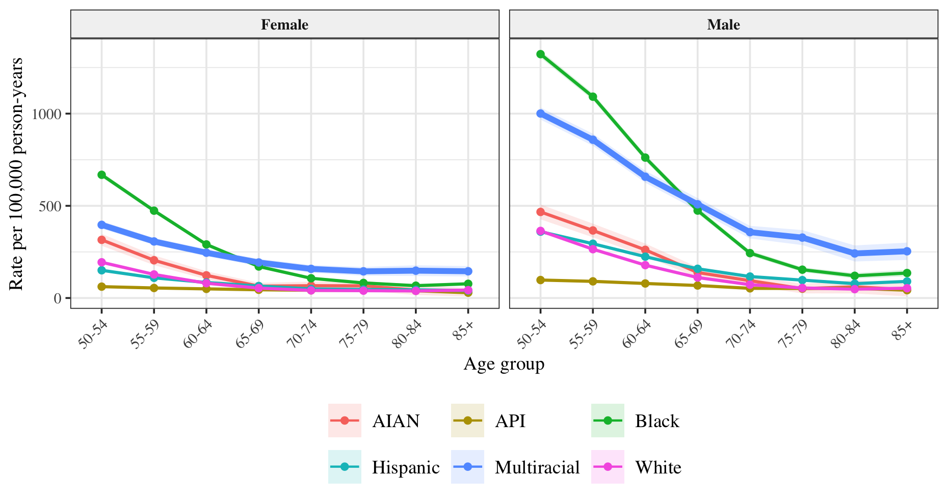
Shaded bands represent 95% confidence intervals. Abbreviations: AIAN = American Indian or Alaska Native; API = Asian or Pacific Islander.

