STAT6016 Assignment 2
Name: LAM Hin Tai
UID: 2004062587

Q1
This code sets up a color ramp scale from red to blue and returns a function rbPal.
The rbPal function in turn takes an interger argument, 10, and returns a character vector of length 10.
The character vector from rbPal stores RGB character codes of 10 colors that are created by interpolating between the 2 poles, red and blue.
The rainfall data from swissRain@data$rain is then taken and its whole range divided into 10 intervals. Each data point in swissRain@data$rain is then converted into an index number corresponding to which interval the data point is in. These index number then gets assigned to the corresponding RGB code and stored into Col.
Afterwards, the swissAltitude data is plotted as a graph, with title "Swiss Rainfall with background elevation", and bullet points added onto the graph according to swissRain@coords and the corresponding colors according to Col.
Locations with the lowest rainfall are plotted as red bullet points while those with the highest rainfall as blue bullet points.
Finally, the swiss border is also plotted onto the same graph from swissBorder.
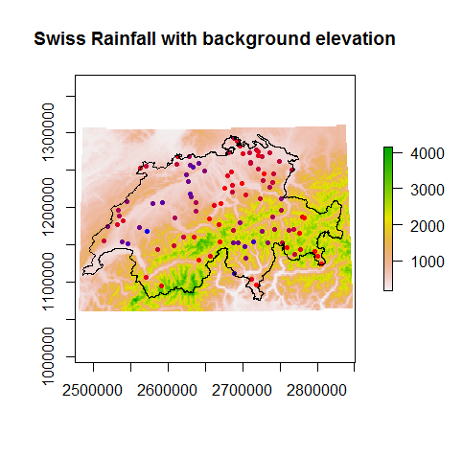

Q2
The log rainfall is stored in the variable swissRain@data$logRain in the code.

Variogram
Q3
The empirical variogram is fitted using a bin width of 13000, which gives all np > 30 and fairly even np values across the bins. The distance at the largest lag 12 is still quite large (144529.128) among various other bin widths.
> vempRain
np dist gamma dir.hor dir.ver id
1 58 9071.221 0.1666015 0 0 res
2 166 19842.758 0.2789560 0 0 res
3 240 32526.757 0.3279183 0 0 res
4 307 45365.302 0.4761482 0 0 res
5 348 58833.547 0.5710989 0 0 res
6 375 71701.618 0.6099448 0 0 res
7 372 84524.286 0.6644798 0 0 res
8 417 97332.463 0.5782368 0 0 res
9 458 110337.024 0.4922929 0 0 res
10 396 123543.659 0.5175687 0 0 res
11 346 136675.996 0.4544202 0 0 res
12 80 144529.128 0.5197167 0 0 res

Q4
Fit a variogram model to the empirical variogram as below:
> vfitRain <- fit.variogram(object=vempRain, model=vgm(c("Exp", "Sph", "Mat", "Gau")))
> vfitRain
model psill range
1 Nug 0.08047038 0.00
2 Sph 0.49930707 78530.49
This is a spherical model with nugget effect:
model | psill | range | kappa | ang1 | ang2 | ang3 | anis1 | anis2
Nug | 0.08047038 | 0.00 | 0.0 | 0 | 0 | 0 | 1 | 1
Sph | 0.49930707 | 78530.49 | 0.5 | 0 | 0 | 0 | 1 | 1

Fit some other models. First, exponential model:
> vfitRain_Exp <- fit.variogram(object=vempRain, model=vgm(model="Exp"))
> vfitRain_Exp
model psill range
1 Exp 0.6034925 31177.39
Spherical model:
> vfitRain_Sph <- fit.variogram(object=vempRain, model=vgm(model="Sph"))
> vfitRain_Sph
model psill range
1 Sph 0.5665393 63582.16
Matern model:
> vfitRain_Mat <- fit.variogram(object=vempRain, model=vgm(model="Mat"))
> vfitRain_Mat
model psill range kappa
1 Mat 0.6034925 31177.39 0.5
Gaussian model:
> vfitRain_Gau <- fit.variogram(object=vempRain, model=vgm(model="Gau"))
> vfitRain_Gau
model psill range
1 Gau 0.4471702 15120.87
(In all 4 cases, the kappa=0.5, ang1 to 3 = 0, anis1 = anis2 = 1)

Specifically include the nugget effect and fit the above 4 types of models again.
Exponential model with nugget effect:
> vfitRain_ExpNug <- fit.variogram(object=vempRain, model=vgm("Exp"))
> vfitRain_ExpNug
model psill range
1 Nug 0.02379037 0.00
2 Exp 0.59174967 34483.72
Spherical model with nugget effect (same model as our chosen model):
> vfitRain_SphNug <- fit.variogram(object=vempRain, model=vgm("Sph"))
> vfitRain_SphNug
model psill range
1 Nug 0.08047038 0.00
2 Sph 0.49930707 78530.49
Matern model with nugget effect:
vfitRain_MatNug <- fit.variogram(object=vempRain, model=vgm("Mat"))
> vfitRain_MatNug
model psill range kappa
1 Nug 0.0237904 0.00 0.0
2 Mat 0.5917497 34483.73 0.5
Gaussian model with nugget effect:
> vfitRain_GauNug <- fit.variogram(object=vempRain, model=vgm("Gau"))
> vfitRain_GauNug
model psill range
1 Nug 0.1489801 0.00
2 Gau 0.4307265 37974.21
(Again, in all 4 cases, the kappa=0.5, ang1 to 3 = 0, anis1 = anis2 = 1)

Comparing their SSEs, the smallest value indicates the best model in term of least squares.
> attributes(vfitRain)$SSErr
[1] 1.832005e-09
> attributes(vfitRain_Exp)$SSErr
[1] 3.15918e-09
> attributes(vfitRain_Sph)$SSErr
[1] 4.064118e-09
> attributes(vfitRain_Mat)$SSErr
[1] 3.15918e-09
> attributes(vfitRain_Gau)$SSErr
[1] 1.402204e-08
> attributes(vfitRain_ExpNug)$SSErr
[1] 3.07699e-09
> attributes(vfitRain_SphNug)$SSErr
[1] 1.832005e-09
> attributes(vfitRain_MatNug)$SSErr
[1] 3.07699e-09
> attributes(vfitRain_GauNug)$SSErr
[1] 2.112887e-09
So, the best model is our first one in vfitRain, which is a spherical model with nugget effect, with SSE = 1.832005*10⁻⁹. (The model vfitRain_SphNug is identical to vfitRain)

Q5
A plot of the variogram and the fitted variogram:
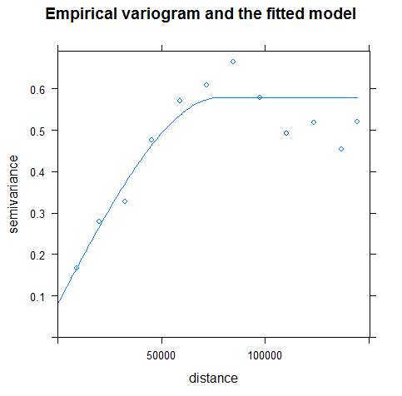

Kriging for the mean
Q6
Using R according to the spherical variogram model, we get the mean log rainfall = 2.544976

Q7
We divide the data into two as 75% training set and 25% testing set. Please refer to the code.

Simple Kriging
Q8
Using bin width 14000 to fit an empirical variogram on the training data set gives more even distribution of values in np with all np > 30.
> vempRain_train <- variogram(object=rainGsObj_train, cutoff=max(distMatS_train)/2, width=14000)
> vempRain_train
np dist gamma dir.hor dir.ver id
1 35 9384.497 0.2048459 0 0 res
2 105 21511.518 0.3354124 0 0 res
3 158 35332.658 0.3962593 0 0 res
4 178 48772.725 0.5252353 0 0 res
5 213 63117.285 0.4958140 0 0 res
6 207 77248.270 0.6994257 0 0 res
7 222 91240.739 0.6096664 0 0 res
8 255 104969.486 0.5750000 0 0 res
9 250 118656.673 0.6436661 0 0 res
10 201 132583.925 0.4604601 0 0 res
11 82 142651.471 0.5432289 0 0 res

