The line graph shows the production levels of main fuels in a European country from 1981 to 2000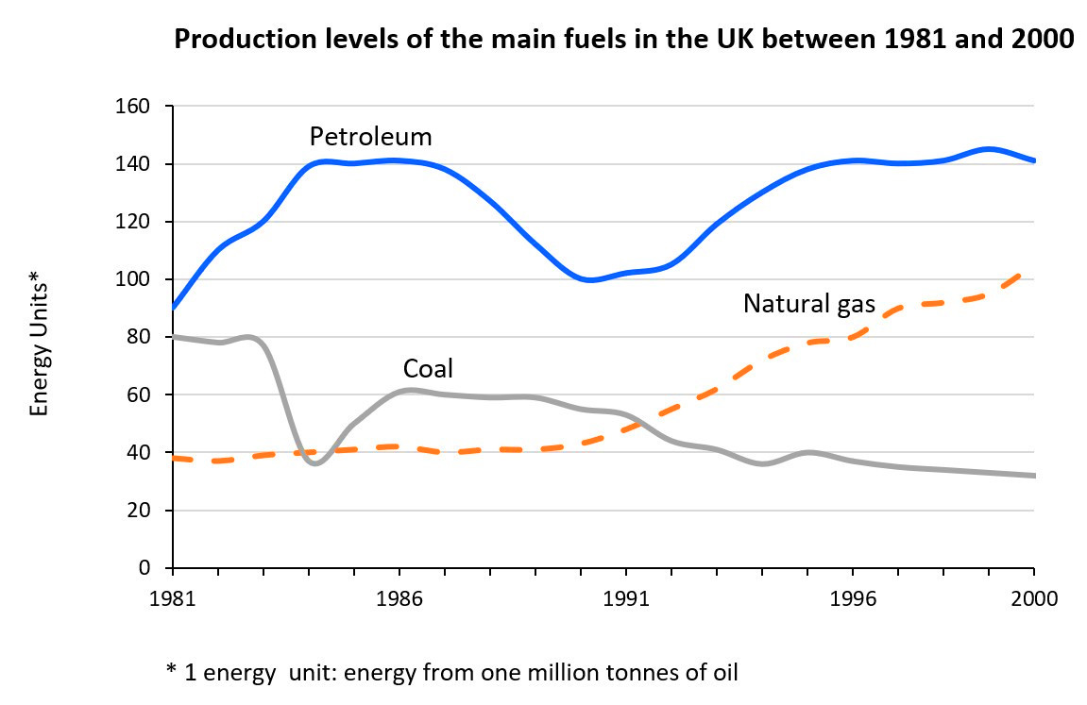
The chart with lines analyzes the amount of energy generated in the UK from 1981 to 2000 using three different fuels. Overall, it is apparent that petroleum output was far greater than coal and natural gas for the whole period. Furthermore, while petroleum and natural gas output surged during this time, coal production plummeted.
In 1981, the UK created roughly 90 tonnes of petroleum, which climbed dramatically to 140 tonnes in 1984 before staying steady for the next three years. By 1991, this statistic had decreased to its second lowest point of 100 tons before recovering strongly at the end of the examined course. Meanwhile, natural gas had risen considerably more continuously. Natural gas production climbed from less than 40 tonnes in the first year to around 42 tonnes in 1991. From this moment, it consistently rocketed, eventually reaching 100 tonnes.
Over the last two decades, the United Kingdom has produced increasingly less coal power. Starting at 80 tons, the quantity of coal produced declined to less than 40 tons in 1984 before rebounding to 60 tons by 1986. Coal manufacturing capacity fell gradually over the subsequent years, reaching 38 tons at the end of the surveyed period.
Throughout history, people have dreamed of living in a perfect society, but they have not agreed on what an ideal society would be like. What do you think is the most important element of a perfect society in the modern world ? How can people work towards achieving an ideal society ?

Throughout history, the idea of a perfect society has captivated human imagination, yet definitions vary widely. In the modern world, I believe there are multiple essential criteria needed to create an ideal society, and they will be examined thoroughly along with potential approaches that should be accompanied with them for our civilization to thrive as we have always been waiting.
On one hand, social equality and justice provide the foundation for a cohesive and prosperous society. A perfect society must ensure that resources, opportunities, and rights are distributed fairly among its citizens. For example, some western countries—Sweden, Norway, and Finland—are often cited as models of social justice due to their robust welfare systems, low levels of income inequality, and high overall life satisfaction. These countries invest heavily in education, healthcare, and social services, ensuring that every citizen, regardless of their background, has the opportunity to succeed. Furthermore, by fostering a sense of fairness and mutual respect, such societies promote social stability and reduce conflicts that often arise from economic and social disparities.
On the other hand, achieving an ideal society requires proactive measures that address both systemic inequalities and individual responsibilities. Governments can enact policies that promote universal healthcare and free or affordable education to reduce disparities. For instance, the introduction of fair tax systems in countries like Denmark has helped finance public services that benefit all citizens, thereby narrowing the wealth gap. Additionally, public initiatives and civic engagement play a critical role in driving change. Movements such as Black Lives Matter and environmental campaigns have demonstrated how collective action can put pressure on governments to implement more equitable and sustainable policies.
In conclusion, while multiple factors contribute to a perfect society, social equality and justice are fundamental. By implementing comprehensive reforms and encouraging active civic engagement, societies can create an environment where all citizens have the opportunity to flourish. Ultimately, fairness not only enhances individual well-being but also fosters a harmonious community for future generations.
The charts below show the number of working hours per week in the industrial sector in four European countries in 2002
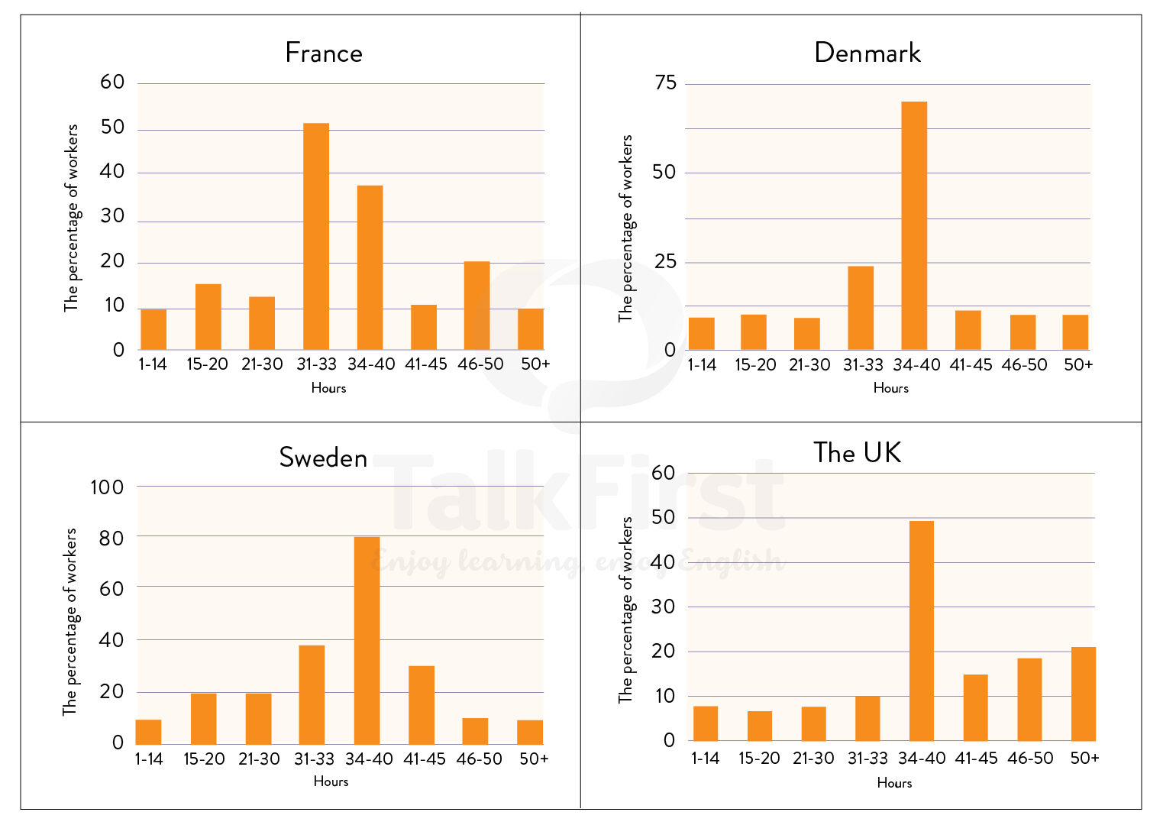
Paraphrase cụm “number of working hours per week”
- Weekly working time
- The weekly allocation of working time
- The total number of hours worked on a weekly basis
- The weekly time commitment to work
- How many hours people work on a weekly basis

TỪ VỰNG HỌC THUẬT + NGHĨA + TỪ ĐỒNG NGHĨA
- In terms of – xét về
  - Synonyms: regarding, with respect to, concerning
- Weekly working hours – số giờ làm việc mỗi tuần
  - Synonyms: hours worked per week, weekly work hours
- Correspond to – tương ứng với
  - Synonyms: relate to, match, align with
- The proportion of workers – tỷ lệ người lao động
  - Synonyms: the percentage of employees, the share of workers
- Industrial sector – lĩnh vực công nghiệp
  - Synonyms: manufacturing sector, industrial field
- Reflect that – phản ánh rằng
  - Synonyms: show that, indicate that, reveal that
- Worked between … and … hours – làm việc trong khoảng … giờ
  - Synonyms: worked within the range of…, spent … hours working
- By contrast – trái lại
  - Synonyms: in contrast, on the other hand
- Maximum working duration – thời gian làm việc tối đa
  - Synonyms: longest working hours, peak working time
- Varying levels – các mức độ khác nhau
  - Synonyms: different levels, varying degrees
- Timeframes in the workplace – khoảng thời gian làm việc
  - Synonyms: working hours ranges, work duration brackets
- Peaks of working hours – mức cao nhất của giờ làm
  - Synonyms: highest levels, peak values
- Indicated a similar tendency – cho thấy xu hướng tương tự
  - Synonyms: showed a similar trend, revealed a comparable pattern
Restoration of old buildings in many cities involves enormous government expenditure. It would be more beneficial to spend this money to build new houses and roads. To what extent do you agree or disagree?
TỪ VỰNG + NGHĨA + TỪ ĐỒNG NGHĨA
- Restoration of old buildings — việc trùng tu các công trình cũ
Synonyms: renovation of historic buildings, preservation of heritage structures
- Government expenditure — chi tiêu của chính phủ
Synonyms: public spending, state budget
- Infrastructure development — phát triển cơ sở hạ tầng
Synonyms: urban development, public infrastructure expansion
- Housing shortage — thiếu hụt nhà ở
Synonyms: housing crisis, lack of accommodation
- Urban areas — khu đô thị
Synonyms: cities, metropolitan areas
- Historical landmarks — di tích lịch sử
Synonyms: heritage sites, cultural monuments
- Cultural heritage — di sản văn hóa
Synonyms: historical legacy, cultural identity
- Costly renovations — việc cải tạo tốn kém
Synonyms: expensive restoration, high-cost upgrades
- Public funds — quỹ công
Synonyms: government budget, taxpayer money
- Economic inequality — bất bình đẳng kinh tế
Synonyms: wealth gap, income disparity
- Affordable housing — nhà ở giá phải chăng
Synonyms: low-cost housing, social housing
- Urban congestion — tắc nghẽn đô thị
Synonyms: traffic congestion, overcrowding
- Transport networks — hệ thống giao thông
Synonyms: transportation systems, transit infrastructure
- Economic productivity — năng suất kinh tế
Synonyms: economic output, efficiency
- Modern standards — tiêu chuẩn hiện đại
Synonyms: current regulations, updated requirements
- Structural upgrades — nâng cấp kết cấu
Synonyms: building improvements, infrastructure upgrades
- Tourism value — giá trị du lịch
Synonyms: tourist appeal, travel attraction
- Long-term benefits — lợi ích lâu dài
Synonyms: lasting advantages, sustainable benefits
- Practical needs — nhu cầu thực tế
Synonyms: essential needs, immediate demands
- Urban planning — quy hoạch đô thị
Synonyms: city planning, urban design
IDIOMS
- A waste of money — lãng phí tiền bạc
- Kill two birds with one stone — đạt hai mục tiêu cùng lúc
- In the long run — về lâu dài
- A pressing issue — vấn đề cấp bách
- Strike a balance — đạt được sự cân bằng
COLLOCATIONS
- Allocate public funds — phân bổ ngân sách công
- Invest in infrastructure — đầu tư vào cơ sở hạ tầng
- Preserve cultural heritage — bảo tồn di sản văn hóa
- Address housing shortages — giải quyết tình trạng thiếu nhà ở
- Improve living standards — cải thiện mức sống
- Enhance urban mobility — nâng cao khả năng di chuyển trong đô thị
- Reduce traffic congestion — giảm tắc nghẽn giao thông
- Meet modern safety standards — đáp ứng tiêu chuẩn an toàn hiện đại
- Support economic growth — hỗ trợ tăng trưởng kinh tế
- Provide affordable housing — cung cấp nhà ở giá rẻ
- Boost tourism industry — thúc đẩy ngành du lịch
- Upgrade public infrastructure — nâng cấp cơ sở hạ tầng công cộng
- Balance preservation and development — cân bằng giữa bảo tồn và phát triển

