**FINAL PROJECT REPORT**

**DevBasicSkills2018-TeamNumber13**

(Names of the writers)

Lam Pham

Minsi Jämsä

Oulu University of Applied Sciences

contents

1 Introduction 3

2 THE WORK ENVIRONMENT 3

3 Definition 4

4 Implementation 5

5 Testing 7

6 POSSIBILITIES OF FURTHER DEVELOPMENT 7

7 conclusion and user interface design material 8

user interface design material 8

8 REFERENCES 13

https://developer.mozilla.org/bm/docs/Web/JavaScript 13

https://developer.mozilla.org/en-US/docs/Web/CSS/Reference 13

https://developer.mozilla.org/en-US/docs/Web/HTML/Element 13

https://en.wikipedia.org/wiki/Truth_table 13

https://www.w3schools.com/css/ 13

https://www.w3schools.com/html/ 13

https://www.w3schools.com/js/ 13

https://www.w3schools.com/jsref/jsref_parseint.asp 13

# 1 Introduction

**Introduction** the course ID00BO85-3002 Developer Basic Skills DIN18SP, will be finally evaluate by the two person project work. The purpose of the project is to evaluate can students bringing up all the topics which under the course ID00BO85-3002 all together into one finally working project work. The final product of the project work is to present a web based mathematics tools. Such as Number system conversions, number system outputs, combinatorics, truth tables, random values, design your own- optional (Lotto for our team). The main reason for doing the work is to give student some close real life work scenario which help students to think and learn during the project.

**2 THE WORK ENVIRONMENT**

The web based mathematics tools has been widely used in the real life situation, nowadays people tend to use internet to learn and explore knowledges. It is very useful skills to be able to implement tools which presenting different tools for learning. Our team used visual studio code to generate the code. VS code is one of the most popular IDE (Integrated development environment) which can help developer to generate the first to last version of the code. Google Chrome browser has been used for test our code with inspect view, and other function buttons. In addition w3c and mozilla.org documentations was used when thinking how to write certain function for the code. Most of the solution are based on HTML5 with Css method.

**3 Definition**

**Definition**, our web based mathematics tools has 6 feature provided to the user, there are number system conversions, number system outputs, combinatorics, truth tables, random values and design your own- optional tool (Lotto for our team).

To be able to use the web tools, user needs to have suitable operating environment, like web browser in the computer or smartphone which can brow the web pages. Either computer or smartphone must support javascript, HTML5. The display resolution in the user’s device should be HD resolution.

**Random values,** there are 100 numbers provided to the user, by pressing the button each time there are 100 random number has been generated by system. After system has 100 random number it will show the bar chart as the distribution to the user. User can move the mouse between the bar level to check how many time each number has been created.

**Number system outputs** is utility tool which generates table showing decimals values from 0 to 50 converted to binary, octal and hexadecimal numbers. User can press clear button to clear number table, or press fill button to fill empty number table.

**Random number generator test tool** is tool for testing random generator. To generate input user can choose random number range from 1 to 100. User also need to select how many random numbers will be generated from range 1 to 1000. After generating random numbers tool will show random number distribution as bar chart. If random generator is good bar chart should be quite flat. User can see more number details by hovering mouse cursor on top of bar.

**Lotto simulator** is a tool where user can random generate lotto numbers and then choose how many lotto rounds simulation should run. After simulation has been run, it will show possible winning rounds. Main idea with Lotto simulator is to demonstrate how difficult it is to win from Lotto.

**Conbinatorics** is a function which calculate the combination, permutation of a sampling by the user. There are three part: combination, permutation with replacement and permutation without replacement. Combination is the calculation which show how many subsets can be created from one set. Permutation counts subsets which also consider the order of the element in each subset. User types in the math the they want to calculate and the program will show the result.

**Truth table** print the table which represents the math logic. It uses functions of logical expressions to decide on their combinations of different functional whether it is true or false.

**4 Implementation**

**Number system outputs** user interface is implemented with html5 using div elements with table display CSS style. Number conversion from decimals to binary, octal and hexadecimal is done by using Javascript .toString() function which takes radix value as argument. Number table rows are created and added dynamically by using createElement() and appendChild() functions.

**Random number generator test tool** user interface is implemented with html5. Input fields are set to accept only specific range of numbers, but it is still possible that user manually enters invalid numbers so user input for random number range and amount is validated also with if-conditions. Test material is generated by using Javascript Math.random() function. Random number distribution bar chart is implemented by using div elements with suitable CSS styles. Bar chart bars are created and added dynamically by using createElement() and appendChild() functions.

**Lotto simulator** user interface is implemented with html5. Lotto numbers (user and round numbers) are generated by using Javascript Math.random(). Lotto number checking algorithm is implemented with if-conditions. Lotto winning results are show in li-elements which are dynamically created and appended to ul-element.

**Number Converter.** In the process of doing this program is the first thing is to get the main idea how to convert the number which is typed in by the user into other types of number. In order to help the users to get the result they want easier and quicker, our team has separated the program into 4 sections: each sections required user to type in different sorts of number. The first method is to take out the number which user types in and put it to the script. Then the program will have to define which certain sort of number it and then the number will be converted. And before the number is checked if the input number is in the right way or not; If not the program will give a notice to the user.

**Combinatorics program**, it calculates the combination, permutation with or without replacement. The first thing we do in this program is learning the formula of this calculation and then we use script to calculate the result and show to the screen. The formula is based on the factorial math so in the script we use the loop to calculate the factorial.

**The truth table,** we use the java script to create a table in which the Boolean expression is combined and the program will give out the result. The boolean variables in this program are 1 and 0 which stand for true and false.

**5 Testing**

First, while we implementing the project we do some functional test to checked if the math task worked. Some functions work but others don’t so we have to fix our code again. Then we can make further improvement, some functions that helps user to get the result in the fastest way and easy to use and also make our code clear. When we have completed all the script, we start to test the user interface, how to make an attractive webpage that could please the user. We have tried different designs and themes and decide which is the best for our page.

**6 POSSIBILITIES OF FURTHER DEVELOPMENT**

Some features in our program are still not entirely completed and still need to be improved. For example, the user interface need to be nicer, and the program should process more quickly .

**7 conclusion and** **user interface design material**

The most significant results of the doing the project is to have the basic understanding of how developer works by using some basic programming tool such as HTML5, CSS and JavaScript. The most essential issues of the work was how to implement the function into the programming system so that it would present the suitable output. As group work, both team member make their own contribution to the project. In the end the out come of the final result was satisfied.

**user interface design material**

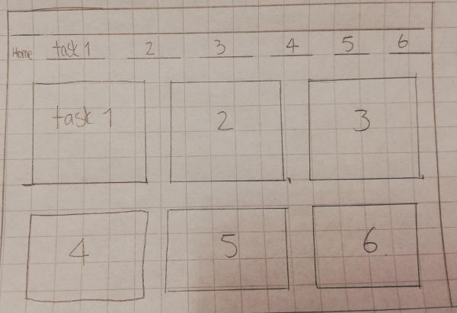

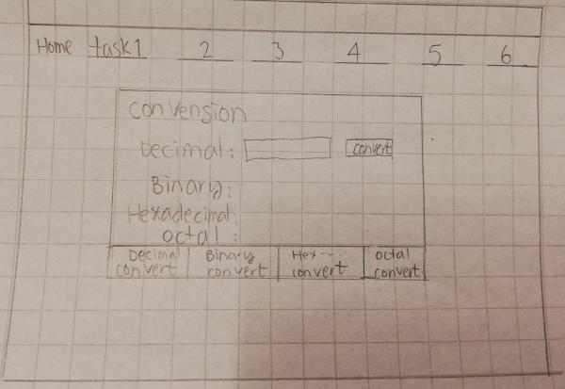

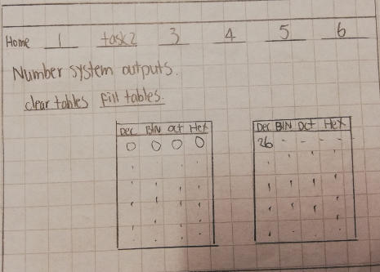

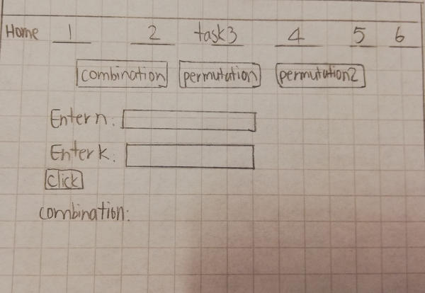

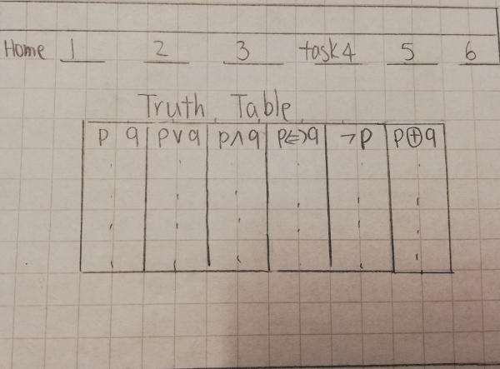

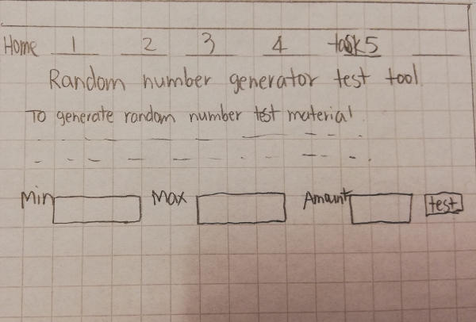

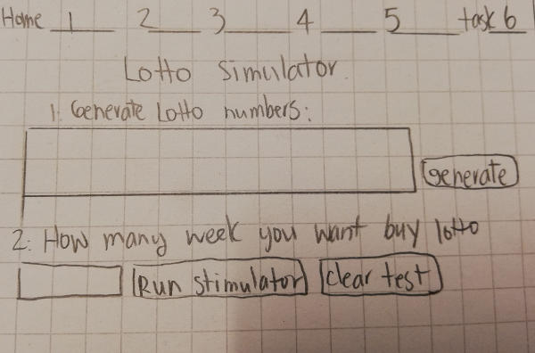

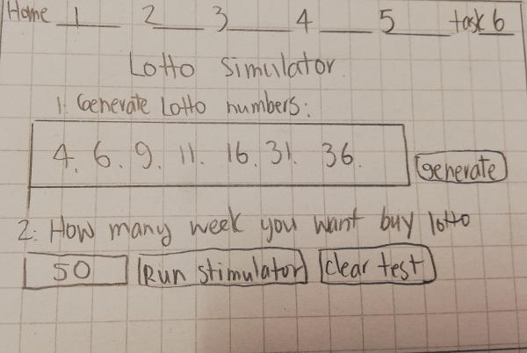

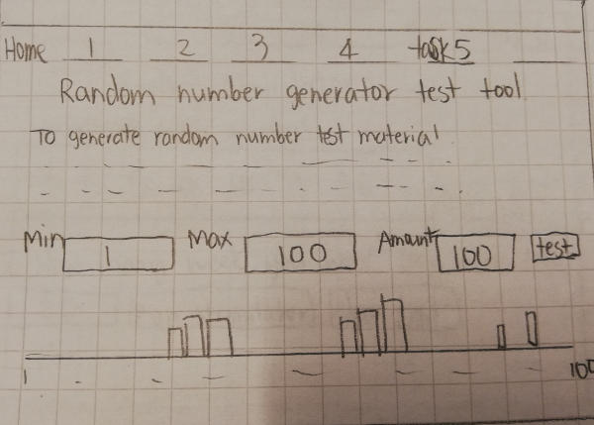

**8 REFERENCES**

https://developer.mozilla.org/bm/docs/Web/JavaScript

https://developer.mozilla.org/en-US/docs/Web/CSS/Reference

https://developer.mozilla.org/en-US/docs/Web/HTML/Element

https://en.wikipedia.org/wiki/Truth_table

https://www.w3schools.com/css/

https://www.w3schools.com/html/

https://www.w3schools.com/js/

https://www.w3schools.com/jsref/jsref_parseint.asp