**MINISTRY OF EDUCATION AND TRAINING**

**Star Security**

**Software Requirement Specification**

Project Code: SWR302

Document Code: SRS – v1.0

|  |  |
| --- | --- |
| **Group 5** | |
| **Group members** | Nông Quốc Lĩnh - SE141095 - Team leader  Hoàng Anh Dũng - SE141025 - Team member  Vũ Lâm Huy - SE140164 - Team member  Lâm Tân Hải - SE141056 - Team member  Nguyễn Ngọc Tiến - SE141023 - Team member |
| **Supervisor** | Lại Đức Hùng |

-Ho Chi Minh city, 16/03/2021-

**Record of change**

*A - Added M - Modified D - Deleted

|  |  |  |  |  |
| --- | --- | --- | --- | --- |
| **Effective Date** | **Changed Items** | **A* M, D** | **Change Description** | **New Version** |
| 02/12/2020 | Initial | a | Add project over view |  |
| 03/1702021 | SRS | M | Finish SRS |  |
|  |  |  |  |  |
|  |  |  |  |  |
|  |  |  |  |  |
|  |  |  |  |  |
|  |  |  |  |  |
|  |  |  |  |  |
|  |  |  |  |  |
|  |  |  |  |  |
|  |  |  |  |  |
|  |  |  |  |  |
|  |  |  |  |  |
|  |  |  |  |  |
|  |  |  |  |  |
|  |  |  |  |  |
|  |  |  |  |  |
|  |  |  |  |  |
|  |  |  |  |  |
|  |  |  |  |  |
|  |  |  |  |  |

**TABLE OF CONTENTS**

1 Introduction 6

1.1 Purpose 6

1.2 Scope 6

1.3 Definitions, Acronyms, and Abbreviations 6

1.4 References 6

2 Overall Description 7

2.1 Current situation 7

2.2 The proposed system 7

2.3 Web Application 7

3 FUNCTIONAL Requirements 8

3.1 Star Security Use Cases Diagram 8

3.2 < Guest> Login 9

3.3 < Guest> Register 11

3.4 < Authenticated user> View profile 14

3.5 < Authenticated user> Log out 17

3.6 < Authenticated user> Edit profile 18

3.7 < Celebrity> Send a request 21

3.8 < Celebrity> View list result 24

3.9 < Celebrity> View list request 26

3.10 < Celebrity> View detail request 28

3.11 < Celebrity> View detail result 30

3.12 < Celebrity> Cancel send request 33

3.13 < Celebrity> Edit request 35

3.14 <Super-moderator> View process of moderator 37

3.15 < Super-moderator> Create team 39

3.16 < Super-moderator> Assign jobs to team 41

3.17 < Super-moderator> Add moderator to team 44

3.18 < Super-moderator> Remove moderator 46

3.19 < Super-Moderator> Assign jobs to moderator 48

3.20 < Super-moderator> Remove team 50

3.21 < Admin> Accept new account 53

3.22 < Admin> Block account 55

3.23 < Admin> Unblock account 57

3.24 < Admin> Set moderator 59

3.25 < Admin> Set super-moderator 63

3.26 < Moderator> View list article 66

3.27 < Moderator> View specific article 68

3.28 < Moderator> View list Anti-Fanpages 71

3.29 < Moderator> View an Anti-Fanpage 73

3.30 < Moderator> View list Anti-group 76

3.31 < Moderator> View an Anti-group 78

3.32 < Moderator> Get a jobs from super-moderator 80

3.33 < Moderator> Handler article 82

3.34 < Moderator> Handler comment 85

3.35 < Moderator> Find message 87

3.36 < Moderator> Remove message 89

3.37 < Moderator> View list message 91

3.38 < Moderator> View specific message 93

3.39 < Moderator> Remove fanpage* 95

3.40 < Moderator> Remove a group* 96

3.41 <Moderator > Add a group* 98

3.42 <Moderator > Add a fanpage* 101

3.43 < Moderator > Add an account of celebrity* 103

3.44 < Moderator> Remove account of celebrity* 106

3.45 <Guest > Reset password* 108

4 NON-FUNCTIONAL Requirements 111

4.1 Usability 111

4.2 Reliability 111

4.3 Performance 111

4.4 Supportability 112

4.5 Design Constraints 112

4.6 On-line User Documentation and Help System Requirements 112

4.7 Purchased Components 112

4.8 Interfaces 112

- The current database systems for data from crawl bot 112

- The current data inventory system 112

- The search tool 112

4.9 Licensing Requirements 113

4.10 Legal, Copyright, and Other Notices 113

4.11 Applicable Standards 113

5 Supporting Information 113

# Introduction

Nowadays, celebrities have begun to have some influence on social media. Their articles are of interest to thousands of people. The articles about them were interesting and spread widely. Some articles may be true or false about themselves. Their information is used in an unauthorized manner causes them to encounter many different work-related problems such as brand representation, the image in front of people, etc. To limit the appearance of fake articles on social networks takes a lot of time and effort and has not found a thorough solution.

In our project, we want to create a Web Application that allows a celebrity to know and send a request to us to handle it, see how the result of the request has been processed. Besides, we allow our staff to receive a request and provide a solution for celebrities. This work will be held regularly and daily. Moreover, we also allow us to manage data and staff.

## Purpose

According to a survey of some celebrities and famous people, we find that most of them do not accept their images being used for defamatory or offensive purposes on the social network. So, our solution now is to create an application specifically for famous people to avoid attacks from social networks and protect them from insulting articles on the social network.

## Scope

Celebrities who need to protect themselves on the social network.

## Definitions, Acronyms, and Abbreviations

UC: Use case

URL: A Uniform Resource Locator

API: Application Programming Interface

## References

Book: Software requirements Third Edition

Software Requirements template: [SWR302_ HungLD](http://lms-undergrad.fpt.edu.vn/course/view.php?id=1257)

https://developers.facebook.com/docs/

# Overall Description

## Current situation

Social media celebrities are highly visible media figures whose fame is native to social media platforms. However, Vietnam has not any applications for protecting celebrities.

## The proposed system

Star Security is a new software system that protects celebrities against malicious information. This application allows celebrities to send requests, manage groups, fanpage, …

## Web Application

Web application consists of three main parts:

* Administrator:
* Manage User
* Super-Moderator:
* Manage team moderator
* Receive a request
* Manage jobs
* Moderator:
* Get a jobs from super-moderator
* Manage Fanpage of celebrity
* Manage Group of celebrity
* Manage Account of celebrity
* View list Anti-groups of celebrity
* View list Anti-fan pages of celebrity

- Celebrity:

* Send a request
* View list requests
* View list results

# FUNCTIONAL Requirements

## Star Security Use Cases Diagram

Figure 3.1.1 Star Security Overview Use Case

## < Guest> Login

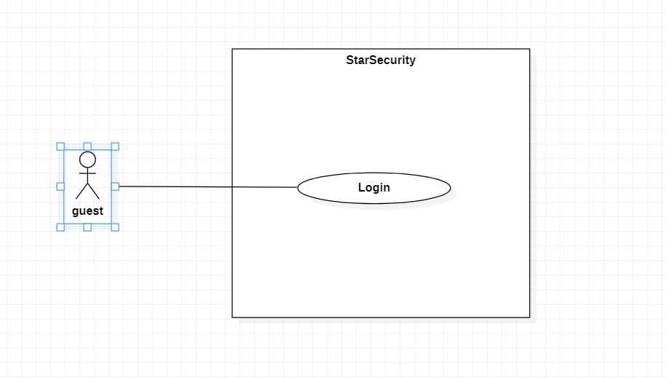

Figure 3.2.1 < Guest > Login

|  |  |  |  |  |
| --- | --- | --- | --- | --- |
| USE CASE – UC1 | | | | |
| Use-case No. | UC1 | Use-case Version | | 1.0 |
| Use-case Name | Login | | | |
| Author | Lam Tan Hai | | | |
| Date | 19/01/2021 | Priority | Normal | |
| Actor:   * Guest   Summary:   * This use case allows guest to login into the system.   Goal:   * Guest become an authenticated user and use their own features   Triggers   * Guest click “Login” button   Preconditions:   * Guest must have an account in system and status is Active   Main Success Scenario:   |  |  |  | | --- | --- | --- | | Step | Actor Action | System Response | | 1 | Guest input Username, Password | System show:  - “UserName”: textbox.  - “Password”: password.  - “Login”: button. | | 2 | Guest clicks “Login” button | * System check role of account and navigate to right dashboard   Alternative[1,2,3,4,5,6]  Exceptions[1,2] |   Alternative Scenario:   |  |  |  | | --- | --- | --- | | No | Actor Action | System Response | | 1 | Guest’s account is a Celebrity | * Navigate to celebrity dashboard. | | 2 | Guest’s account is a Moderator | * Navigate to Moderator dashboard | | 3 | Guest’s account is a Admin | * Navigate to Admin dashboard | | 4 | Guest’s account is a Super-Moderator | * Navigate to Super-Moderator dashboard | | 5 | Guest’s account is not in system | * System show message: “Invalid username or password”. | | 6 | Account is In-Activate | * System shows message: ”Your account is deactivated! Please contact with admin.” |   Exceptions:   |  |  |  | | --- | --- | --- | | No | Actor action | System Response | | 1 | Internet is not available | System shows message “Internet connection was interrupted! Please try again!” | | 2 | Connect database failure | System shows message: ”Error reading from database. Please try again!” |   Relationships:   * None   Business Rules:   * Logged in accounts expire duration is 30 minutes. * Only active account can login into the system. | | | | |

## < Guest> Register

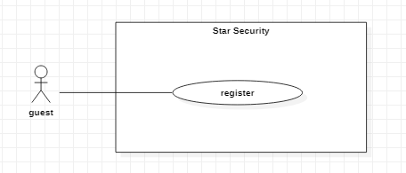

Figure 3.3.1 <Guest> Register

|  |  |  |  |  |
| --- | --- | --- | --- | --- |
| USE CASE – UC2 | | | | |
| Use-case No. | UC2 | Use-case Version | | 1.0 |
| Use-case Name | Register | | | |
| Author | Nong Quoc Linh | | | |
| Date | 14/03/2021 | Priority | Normal | |
| Actor:   * Guest   Summary:   * This use case allows guest to register new account   Goal:   * Guest is able to log in to the system and use the functions of the system   Triggers   * Guest click “Register” button   Preconditions:   * None   Post Conditions:   * Success: Guest’s account is register successfully and status is de-active. * Fail: Show error message   Main Success Scenario:   |  |  |  | | --- | --- | --- | | Step | Actor Action | System Response | | 1 | Guest click “Register” button | System shows form in table:   * Username: textbox, required * Password: password, required * Confirm password: password, required * Full name: textbox, required * Phone number: textbox, required * Email: textbox, required   “Create” button  “Cancel” button  Alternative[1]  Exception[1,2,3,4,5,6,7,8,9,10,11] | | 2 | Guest click “Create” button. | * System create account with status is de-active and send request create account to admin.   Exception[2] |   Alternative Scenario:   |  |  |  | | --- | --- | --- | | No. | Actor action | System response | | 1 | Guest click “Cancel” button | System back to login page. |   Exceptions:   |  |  |  | | --- | --- | --- | | No. | Actor action | System response | | 1 | Input field is empty | System show error message “This field is not allow empty” | | 2 | Internet is not available | System show error message “Internet was interrupted. Please try again!” | | 3 | Phone number is wrong format | System show error message “Phone number format is +84XXXXXXXXXX or 0XXXXXXXXX” | | 4 | Length of UserName is under 6 characters | System show error message “Length of UserName must be 6 – 50 characters” | | 5 | Length of UserName is over 50 characters | System show error message “Length of UserName must be 6 – 50 characters” | | 6 | Length of Password is under 8 characters | System show error message “Length of Password must be 8 – 30 characters” | | 7 | Length of Password is over 30 characters | System show error message “Length of Password must be 8 – 30 characters” | | 8 | Password is included special character | System show error message “Password is included special characters” | | 9 | UserName is included special character (except space) | System show error message “UserName is included special characters (except space)” | | 10 | Value of “Confirm password” is different to “Password” | System show error message “Confirm password is different to Password”. | | 11 | Email is wrong format | System show error message “Email format is abc@def.hkt(.xyz) ”. |   Relationships:   * None   Business Rules:   * UserName is unique * Password is encrypted by SHA-256. * After registered, email must be verified. | | | | |

## < Authenticated user> View profile

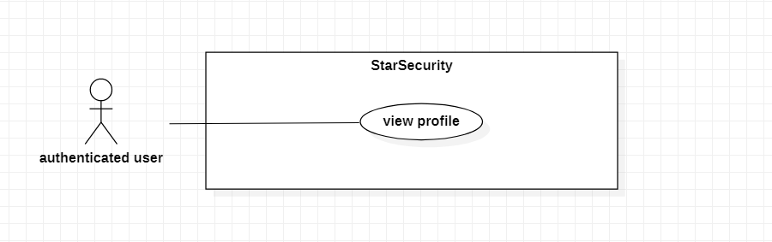

Figure 3.4.1 <Authenticated user> View profile

|  |  |  |  |  |
| --- | --- | --- | --- | --- |
| USE CASE – UC3 | | | | |
| Use-case No. | UC3 | Use-case Version | | 1.0 |
| Use-case Name | View profile | | | |
| Author | Hoang Anh Dung | | | |
| Date | 03/03/2021 | Priority | Normal | |
| Actor:   * Authenticated user.   Summary:   * This use case allows authenticated user to view profile.   Goal:   * User views their profile.   Triggers   * Authenticated user clicks “View profile” button.   Preconditions:   * Guest logged in as Authenticated user   Post Conditions:   * Success: All information about account will display on screen. * Fail: Show error message.   Main Success Scenario:   |  |  |  | | --- | --- | --- | | Step | Actor Action | System Response | | 1 | Authenticated user click “View profile” button | System will display all information about this account on screen as table:  - Avatar  - Username  - Password  - Full name  - Date of birth  - Phone number  - Email  “Back to dashboard” button  Alternative[1,2]  Exception[1,2] |   Alternative Scenario:   |  |  |  | | --- | --- | --- | | Step | Actor Action | System Response | | 1 | Authenticated user as celebrity click “View profile” button | System response:   * List fan page of celebrity is managing * List group of celebrity is managing | | 2 | Authenticated user clicks “Back to dashboard” button | System back to their dashboard |   Exceptions:   |  |  |  | | --- | --- | --- | | No | Actor action | System Response | | 1 | Internet is not available | System shows message “Internet connection was interrupted! Please try again!” | | 2 | Connect database failure | System shows message: ”Error reading from database. Please try again!” |   Relationships:   * None   Business Rules:   * The account must have status is Active * All information from account gets from database | | | | |

## < Authenticated user> Log out

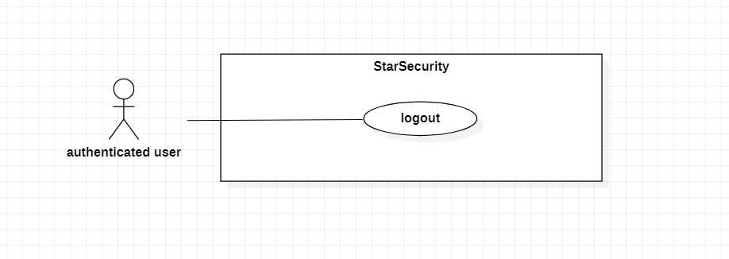

Figure 3.5.1 <Authenticated user> Logout

|  |  |  |  |  |
| --- | --- | --- | --- | --- |
| USE CASE – UC4 | | | | |
| Use-case No. | UC4 | Use-case Version | | 1.0 |
| Use-case Name | Logout | | | |
| Author | Hoang Anh Dung | | | |
| Date | 03/03/2021 | Priority | Normal | |
| Actor:   * Authenticated user   Summary:   * This use case allows authenticated user to log out of the system   Goal:   * User logout the system.   Triggers   * An authenticated click “Logout” button   Preconditions:   * Guest logged in as Authenticated user   Post Conditions:   * Success: User cannot use any features of the authenticated user system * Fail: Show error message   Main Success Scenario:   |  |  |  | | --- | --- | --- | | Step | Actor Action | System Response | | 1 | Authenticated user click “Logout” button | The system redirects users to the login screen |   Alternative Scenario:  - None  Exceptions:   |  |  |  | | --- | --- | --- | | No | Actor action | System Response | | 1 | Internet is not available | System shows message “Internet connection was interrupted! Please try again!” |   Relationships:   * None   Business Rules:   * The account must be login. * All sessions of account are invalid. | | | | |

## < Authenticated user> Edit profile

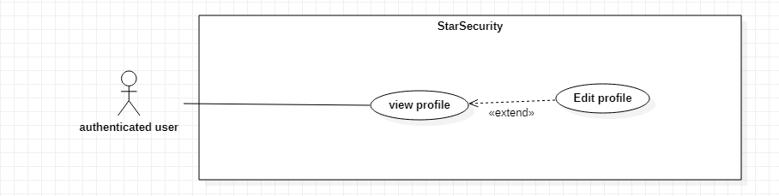

Figure 3.6.1 <Authenticated user> Edit profile

|  |  |  |  |  |
| --- | --- | --- | --- | --- |
| USE CASE – UC5 | | | | |
| Use-case No. | UC5 | Use-case Version | | 1.0 |
| Use-case Name | Edit profile | | | |
| Author | Nguyen Ngoc Tien | | | |
| Date | 19/01/2021 | Priority | Normal | |
| Actor:   * Authenticated user   Summary:   * This use case allows authenticated user to edit their profile.   Goal:   * Authenticated user edits their profile.   Triggers   * Authenticated user clicks “Edit profile” button. * Authenticated user clicks “Save” button.   Preconditions:   * Authenticated user must login to system.   Post Conditions:   * Success: Save change of profile. * Fail: Show error message.   Main Success Scenario:   |  |  |  | | --- | --- | --- | | Step | Actor action | System response | | 1 | Authenticated user clicks on “Edit profile” button. | System shows form in table:   * Password: password, required * Confirm password: password, required * Full name: textbox, required * Phone number: textbox, required * Email: textbox, required   “Cancel” button  “Save” button  Exception[1,2,3,4,5,6,7,8] | | 2 | Authenticated user clicks on “Save” | Show dialog message “Do you want to change your profile?” which contains:   * “Accept”: button * “Cancel”: button   Exception[1,2]  Alternative[1] | | 3 | Authenticated user clicks on “Accept” button | Show message “Saved successfully”.  Exception[2]  Alternative[1] |   Alternative Scenario:   |  |  |  | | --- | --- | --- | | No. | Actor action | System response | | 1 | Guest click “Cancel” button | System back to profile dashboard. |   Exceptions:   |  |  |  | | --- | --- | --- | | No. | Actor action | System response | | 1 | Input field is empty | System show message “This field is not allow empty” | | 2 | Internet is not available | System show message “Internet was interrupted. Please try again!” |  |  |  |  | | --- | --- | --- | | 3 | Phone number is wrong format | System show error message “Phone number format is +84XXXXXXXXXX or 0XXXXXXXXX” | | 4 | Length of Password is under 8 characters | System show error message “Length of Password must be 8 – 30 characters” | | 5 | Length of Password is over 30 characters | System show error message “Length of Password must be 8 – 30 characters” | | 6 | Password is included special character | System show error message “Password is included special characters” | | 7 | Value of “Confirm password” is different to “Password” | System show error message “Confirm password is different to Password”. | | 8 | Email is wrong format | System show error message “Email format is abc@def.hkt(.xyz) ”. |   Relationships:   * Extend from View profile   Business Rules:   * The information of Authenticated user is sent to the server * The account’s status is Active. * After Edit profile success. The system return to the profile dashboard | | | | |

## < Celebrity> Send a request

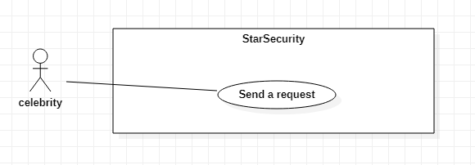

Figure 3.7.1 < Celebrity > Send a request

|  |  |  |  |  |
| --- | --- | --- | --- | --- |
| USE CASE – UC6 | | | | |
| Use-case No. | UC6 | Use-case Version | | 1.0 |
| Use-case Name | Send a request | | | |
| Author | Vu Lam Huy | | | |
| Date | 19/01/2021 | Priority | High | |
| Actor:   * Celebrity   Summary:   * This use case allows celebrity to send a request to super-moderator   Goal:   * Celebrity send a request with image, URL, issue, content to super- moderator   Triggers   * Celebrity click “Send a request” button   Preconditions:   * Guest logged in as celebrity   Post Conditions:   * Success: The request has been sent successfully. * Fail: Show error message.   Main Success Scenario:   |  |  |  | | --- | --- | --- | | Step | Actor Action | System Response | | 1 | Celebrity see their image or message on the internet | None | | 2 | Celebrity take a screenshot or take a URL | None | | 3 | Celebrity click “Send request” button | System show the form:  + URL: textbox, max length 500 characters  + Image: file  + RequestContent: textbox, max length 500 characters  + Issue: comboBox, required   * “Send a request” button * “Cancel” button   Exception[1,3]  Alternative[1] | | 4 | Celebrity click “Send” button. | * System show confirm dialog which contains:   + “OK” button  + “Cancel” button  Alternative[1] | | 5 | Celebrity click “OK” button in dialog | * System confirm and send to super-moderator * System show notification sending success or fail and back to celebrity’s dashboard.   Exception[2] |   Alternative Scenario:   |  |  |  | | --- | --- | --- | | No. | Actor action | System response | | 1 | Guest clicks “Cancel” button | System back to Page send request |   Exceptions:   |  |  |  | | --- | --- | --- | | No | Actor Action | System Response | | 1 | * URL or Image is empty | * System show message: “URL or Image must be fill” | | 2 | * System sending request fail | * System show message: ”Sending request fail. Please check again or try later!” | | 3 | * Length of RequestContent is over 500 characters | * System error message: “Length of RequestContent is over 500 characters” |   Relationships:   * None   Business Rules:   * The account of celebrity must have status is Active. * URL or Image has at least one. * RequestContent is not required. * Celebrity sends one request at once time. | | | | |

## < Celebrity> View list result

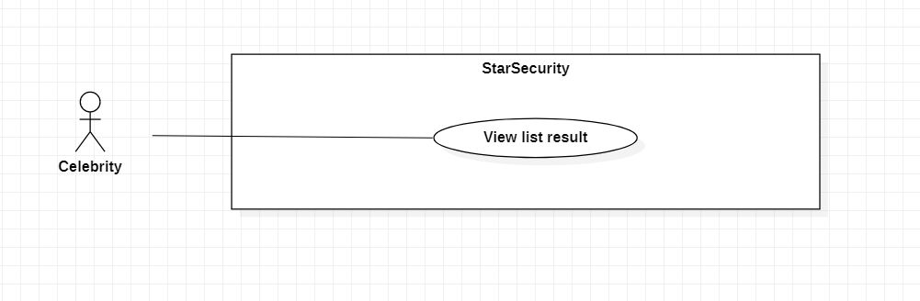

Figure 3.8.1 < Celebrity > View list result

|  |  |  |  |  |
| --- | --- | --- | --- | --- |
| USE CASE – UC7 | | | | |
| Use-case No. | UC7 | Use-case Version | | 1.0 |
| Use-case Name | View list result | | | |
| Author | Hoang Anh Dung | | | |
| Date | 14/03/2021 | Priority | Normal | |
| Actor:   * Celebrity   Summary:   * This use case allows celebrity to view list result of own request and daily protective action results.   Goal:   * List result of own request and daily protective action results display on screen   Triggers   * A celebrity clicks “View list results” button   Preconditions:   * Guest logged in as celebrity   Post Conditions:   * Success: Show list of result * Fail: Show error message   Main Success Scenario:   |  |  |  | | --- | --- | --- | | Step | Actor Action | System Response | | 1 | Celebrity click “View list results” button | The system show list of result with table:  + No  + Summary  + Date Create  + Type: request or daily protect  + Status: done/waiting/ cancel  + “View detail result” button  Exeption[1,2] |   Alternative Scenario:   * None   Exceptions:   |  |  |  | | --- | --- | --- | | No | Actor Action | System Response | | 1 | Connect to system fail | The system show dialog “Disconnect, please check internet connection.” | | 2 | Connect to database fail | The system show dialog “System is maintaining. Please, comeback later.” | | 3 | List of results is empty | The system show error message: “No record.” |   Relationships:   * None   Business Rules:   * The celebrity must have status is active. * List of results always get from database. | | | | |

## < Celebrity> View list request

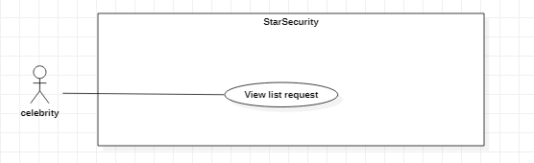

Figure 3.9.1 <Celebrity> View list request

|  |  |  |  |  |
| --- | --- | --- | --- | --- |
| USE CASE – UC8 | | | | |
| Use-case No. | UC8 | Use-case Version | | 1.0 |
| Use-case Name | View list request | | | |
| Author | Vu Lam Huy | | | |
| Date | 19/01/2021 | Priority | Normal | |
| Actor:   * Celebrity   Summary:   * This use case allows celebrity to view all list of request was sent to super-moderator.   Goal:   * Celebrity view all list of requests was sent to super-moderator   Triggers   * Celebrity click “View list request” button.   Preconditions:   * Guest logged in as celebrity   Post Conditions:   * Success: System show all request. * Fail: Show error message.   Main Success Scenario:   |  |  |  | | --- | --- | --- | | Step | Actor Action | System Response | | 1 | * Celebrity click “View list request” button | * System show list request in table:   + No  + Summary  + Time of upload request  + Status of request: Waiting/Cancel.  “Back” button  “View detail request” button  Exception[1,2,3]  Alternative[1] |   Alternative Scenario:   |  |  |  | | --- | --- | --- | | Step | Actor Action | System Response | | 1 | * Celebrity click “Back” button | System back to celebrity’s dashboard |   Exceptions:   |  |  |  | | --- | --- | --- | | Step | Actor Action | System Response | | 1 | * Celebrity click “View list request” button but no records of request was sent. | * System show message “No request was sent. Empty list request.” | | 2 | * Connect to system fail | * The system show dialog “Internet was interrupted. Please try later!” | | 3 | * Connect to database fail | * The system show dialog “System is maintaining. Please try later.” |   Relationships:   * None   Business Rules:   * The celebrity account must have status is Active * List of requests always get from database | | | | |

## < Celebrity> View detail request

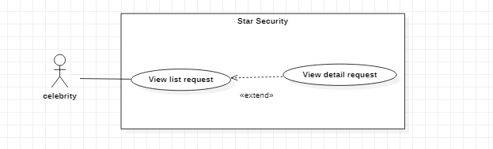

Figure 3.10.1 <Guest> View detail request

|  |  |  |  |  |
| --- | --- | --- | --- | --- |
| USE CASE – UC9 | | | | |
| Use-case No. | UC9 | Use-case Version | | 1.0 |
| Use-case Name | View detail request | | | |
| Author | Nong Quoc Linh | | | |
| Date | 14/03/2021 | Priority | Normal | |
| Actor:   * Celebrity   Summary:   * This use case allows celebrity to view detail of a request.   Goal:  - Celebrity view detail of a request.  Triggers   * Celebrity click “View detail” button in request list form   Preconditions:   * Guest login as Celebrity   Post Conditions:   * Success: All information about request is displayed on screen * Fail: Show error message   Main Success Scenario:   |  |  |  | | --- | --- | --- | | Step | Actor Action | System Response | | 1 | Celebrity click “View detail” button | System shows detail information of selected request in table:  + No  + Content  + Datetime request was sent  + Status: done/waiting/ cancel  “Edit request” button  “Cancel send request” button  “Back” button  Alternative[1]  Exception[1] |   Alternative Scenario:   |  |  |  | | --- | --- | --- | | No. | Cause | System response | | 1 | Celebrity click “Back” button | System back to list request |   Exceptions:   |  |  |  | | --- | --- | --- | | No. | Cause | System response | | 1 | Internet is not available | Show “No Internet connection found! Please try again” | | 2 | Connect to database fail | The system show dialog “System is maintaining. Please try later.” |   Relationships:   * Extend from View list request   Business Rules:   * The account’s status is Active * Requests is always get from database | | | | |

## < Celebrity> View detail result

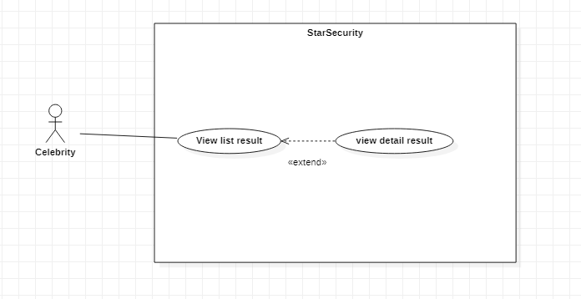

Figure 3.11.1 <Admin> Ban super-moderator

|  |  |  |  |  |
| --- | --- | --- | --- | --- |
| USE CASE – UC10 | | | | |
| Use-case No. | UC10 | Use-case Version | | <1.0> |
| Use-case Name | View detail result | | | |
| Author | Lam Tan Hai | | | |
| Date | 18/01/2021 | Priority | Normal | |
| Actor**:**   * Celebrity   Summary**:**   * This use case allows celebrity to view detail result   Goal**:**   * Celebrity see information of specific result from system   Triggers   * Celebrity click “View detail” button   Preconditions**:**   * Guest is logged in as Celebrity   Post Conditions**:**   * Success: Detail of result is shown * Fail: Show error message.   Main Success Scenario:     |  |  |  | | --- | --- | --- | | Step | Actor action | System Response | | 1 | Celebrity click “View detail” button | System shows detail of the result in table:  + No  + Content  + Datetime of result  + Status: done/waiting/cancel  + Type  + Get form: fanpage/group  + “Back” button  Alternative[1]  Exception[1,2] |   Alternative Scenario:   |  |  |  | | --- | --- | --- | | No | Actor action | System Response | | 1 | Celebrity click “Back” button | System back to list result |   Exceptions:   |  |  |  | | --- | --- | --- | | No | Actor action | System Response | | 1 | Internet is not available | System shows message “ No Internet connection found! Please try again” | | 2 | Celebrity click “View detail” button many time but not response | System show message: “System not responding. Please try later!” |   Relationships:   * Extend from View detail result   Business Rules:   * Only celebrity can use this feature. * Celebrity account must have status is Active. * Data is always get from database | | | | |

## < Celebrity> Cancel send request

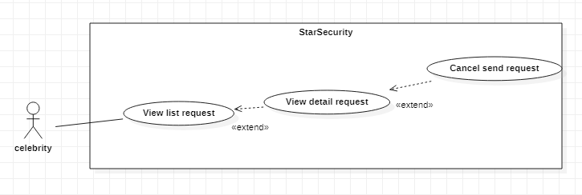

Figure 3.12.1 < Celebrity > Cancel send request

|  |  |  |  |  |
| --- | --- | --- | --- | --- |
| USE CASE - UC11 | | | | |
| Use-case No. | UC11 | Use-case Version | | 1.0 |
| Use-case Name | Cancel send request | | | |
| Author | Vu Lam Huy | | | |
| Date | 14/03/2021 | Priority | Normal | |
| Actor:   * Celebrity   Summary:   * This use case allows celebrity to cancel sending a request, request will not be handle   Goal:   * A request’ status updated to cancel   Triggers   * A celebrity click “Cancel send request” button   Preconditions:   * Guest logged in as celebrity   Post Conditions:   * Success: Request’s status changed to cancel. * Fail: Show error message   Main Success Scenario:   |  |  |  | | --- | --- | --- | | Step | Actor Action | System Response | | 1 | Celebrity click “Cancel send request” button  Alternative[1] | System show confirm dialog:   * “Ok” button * “Cancel” button | | 2 | Celebrity click “Ok” button  Alternative[2] | System update status request to “cancel” and update database  Exceptions[1, 2] |   Alternative Scenario:   |  |  |  | | --- | --- | --- | | No | Actor Action | System Response | | 1 | Celebrity click “Cancel” button | The system do nothing and navigate to page display list request |   Exceptions:   |  |  |  | | --- | --- | --- | | No | Actor Action | System Response | | 1 | Connect to system fail | The system show dialog “Internet was interrupted. Please check your internet connection!” | | 2 | Connect to database fail | The system show dialog “System is maintaining. Please, comeback later.” |   Relationships:   * Extend from view list request (select view list request), extend from view detail request (select view detail request)   Business Rules:   * The celebrity must have status is active * List of result always get from database | | | | |

## < Celebrity> Edit request

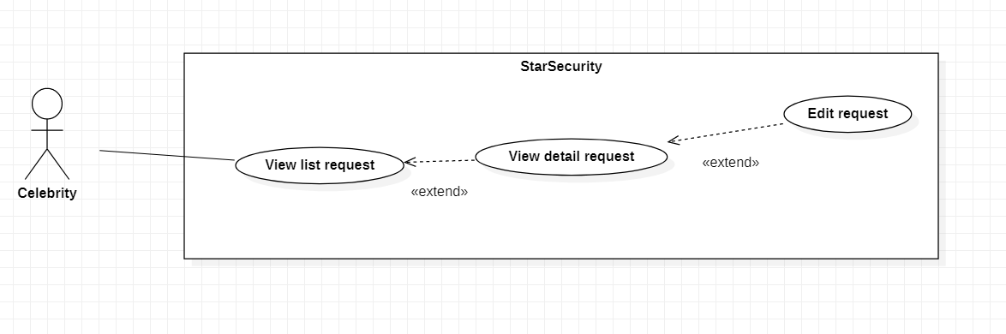

Figure 3.13.1 < Celebrity > Edit request

|  |  |  |  |  |
| --- | --- | --- | --- | --- |
| USE CASE – UC12 | | | | |
| Use-case No. | UC12 | Use-case Version | | 1.0 |
| Use-case Name | Edit request | | | |
| Author | Hoàng Anh Dũng | | | |
| Date | 14/03/2021 | Priority | Normal | |
| Actor:   * Celebrity   Summary:   * This use case allows celebrity edit a request sent to system   Goal:   * Information of specific request will be update   Triggers   * A celebrity clicks “Update request” button   Preconditions:   * Guest logged in as celebrity   Post Conditions:   * Success: Request will be update and sent to system * Fail: Show error message   Main Success Scenario:   |  |  |  | | --- | --- | --- | | Step | Actor Action | System Response | | 1 | Celebrity click “Edit” button of specific request in list request | The system display all information of specific request on a form:   * URL of article * Image * Issue * Request content * Create date * “Update request” button * “Cancel” button   Exceptions[1, 2] | | 2 | Celebrity change value in form:   * URL of article * Image * Issue * Request content | System check valid data input from celebrity:   * RequestContent: textbox, max length 500 characters * URL: textbox, max length 300 characters | | 3 | Celebrity click “Update request” button  Alternative[1] | System show confirm dialog:   * “Ok” button * “Cancel” button | | 4 | Celebrity click “Ok” button  Alternative[2] | System update request, save request update to database, show message: “Update successful”  Exceptions[1, 2] |   Alternative Scenario:   |  |  |  | | --- | --- | --- | | No | Actor Action | System Response | | 1 | Celebrity click “Cancel” button | The system do nothing and navigate to page display list request | | 2 | Celebrity click “Cancel” button | The system return to form update and allow celebrity continue edit request |   Exceptions:   |  |  |  | | --- | --- | --- | | No | Actor Action | System Response | | 1 | Connect to system fail | The system show dialog “Disconnect, please check internet connection.” | | 2 | Connect to database fail | The system show dialog “System is maintaining. Please, comeback later.” |   Relationships:   * Extend from view list request (select view list request), extend from view detail request (select view detail request)   Business Rules:   * The celebrity must have status is active * List of result always get from database * All information of the request get from database * The request has not been received by the super-moderator | | | | |

## <Super-moderator> View process of moderator

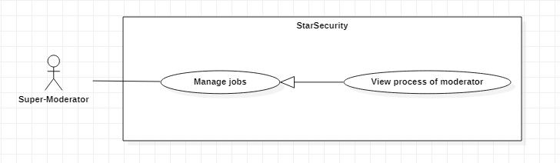

Figure 3.14.1 < Super-moderator > View process of moderator

|  |  |  |  |  |
| --- | --- | --- | --- | --- |
| USE CASE – UC13 | | | | |
| Use-case No. | UC13 | Use-case Version | | 1.0 |
| Use-case Name | View process of moderator | | | |
| Author | Nguyen Ngoc Tien | | | |
| Date | 19/1/2021 | Priority | Normal | |
| Actor:   * Super-Moderator   Summary:   * This use case allows Super-Moderator to view process of moderator   Goal:   * Super-Moderator view process working of moderator.   Triggers   * Super-Moderator clicks “View moderator process” button   Preconditions:   * Guest logged in as Super-Moderator.   Post Conditions:  - Success: List of moderator’s article  - Fail: Show error message  Main Success Scenario:   |  |  |  | | --- | --- | --- | | Step | Actor action | System response | | 1 | Super-Moderator clicks “View moderator process” button | System show list:  + No  + Moderator’s name  + Moderator job  + Status of jobs: Done/Waiting/Cancel  + Datetime moderator get a job  “Back” button  Alternative[1]  Exception[1] |   Alternative Scenario:   |  |  |  | | --- | --- | --- | | No | Actor Action | System response | | 1 | Super-Moderator clicks “Back” button | System will return to super-moderator dashboard |   Exceptions:   |  |  |  | | --- | --- | --- | | No | Actor Action | System response | | 1 | - Internet is not available | System shows message “No Internet connection found! Please try again” |   Relationships:   * Generalization from manage jobs   Business Rules:   * Guest must login to the system as Super-Moderator. * Data is always get from database | | | | |

## < Super-moderator> Create team

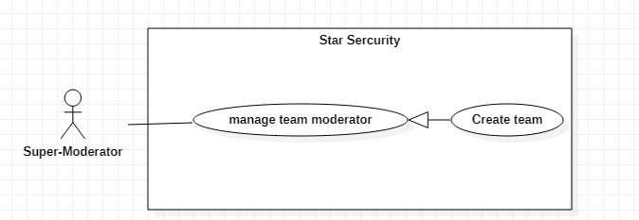

Figure 3.15.1< Super-moderator> Create team

|  |  |  |  |  |
| --- | --- | --- | --- | --- |
| USE CASE – UC14 | | | | |
| Use-case No. | UC14 | Use-case Version | | 1.0 |
| Use-case Name | Create team | | | |
| Author | Nong Quoc Linh | | | |
| Date | 19/01/2021 | Priority | Normal | |
| Actor:  - Super-moderator  Summary:   * This use case allows super-moderator to create a team of moderators.   Goal:   * Super-moderator creates a team of moderators.   Triggers   * Super-moderator clicks “Create team” button   Preconditions:   * Guest logged in as Super-moderator.   Post Conditions:   * Success: New team is created and system asks super-moderator to add moderators to the team. * Fail:Show error message.   Main Success Scenario:     |  |  |  | | --- | --- | --- | | Step | Actor Action | System response | | 1 | - Super-moderator click “Create team” button | - System ask super-moderator fill in the team's information in table:   * Name: text * Celebrity to support: comboBox * Add mod: listBox   “Create” button  “Cancel” button  Alternative[1]  Exception[1,2] | | 2 | - Super-moderator click “Create” | - System show confirm dialog  “OK” button  “Cancel” button  Exception[1,2] |   Alternative Scenario:   |  |  |  | | --- | --- | --- | | No | Actor Action | System response | | 1 | Passed step add moderator | System do nothing | | 2 | Super-moderator click “Cancel” | System back to dashboard |   Exceptions:   |  |  |  | | --- | --- | --- | | No | Actor Action | System response | | 1 | - Internet is not available | System shows message “No Internet connection found! Please try again” | | 2 | Connect to database fail | The system show dialog “System is maintaining. Please try later.” |   Relationships:  - Generation from manage team moderator  Business Rules:   * Only super-moderator can do this. * One Team support one celebrity. * Celebrity has no supporting team. | | | | |

## < Super-moderator> Assign jobs to team

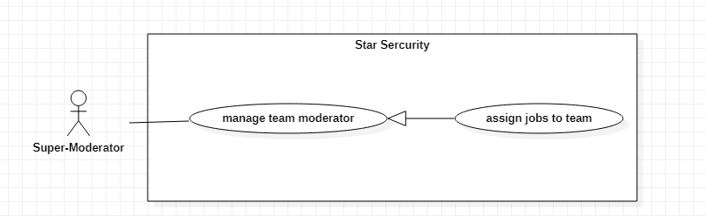

Figure 3.16.1 < Super-moderator > Assign jobs to team

|  |  |  |  |  |
| --- | --- | --- | --- | --- |
| USE CASE – UC15 | | | | |
| Use-case No. | UC15 | Use-case Version | | 1.0 |
| Use-case Name | Assign jobs to team | | | |
| Author | Nong Quoc Linh | | | |
| Date | 19/01/2021 | Priority | Normal | |
| Actor:  - Super-moderator  Summary:   * This use case allows super-moderator to assign job to team of moderators.   Goal:   * Super-moderator assign job to team of moderators.   Triggers   * Super-moderator clicks “Create job to team” button * Super-moderator clicks “Assign job to team” button   Preconditions:   * Guest logged in as Super-moderator.   Post Conditions:   * Success: Team of moderators is received new jobs from super-moderator. * Fail:Show error message.   Main Success Scenario:     |  |  |  | | --- | --- | --- | | Step | Actor Action | System response | | 1 | - Super-moderator click “Create job to team” button | - System will show list of jobs needed to solve.  Exception [1,2] | | 2 | Super-moderator click “Assign job to team” button | - System ask super-moderator choose team will receive jobs  Team: Combo box  “Assign” button  “Cancel” button  Exception [1,2,3] | | 3 | Super-moderator click “Assign” button | - System get jobs and assign to that team  Exception [1,2] |   Alternative Scenario:  - None  Exceptions:   |  |  |  | | --- | --- | --- | | No | Actor Action | System response | | 1 | - Internet is not available | System shows message “No Internet connection found! Please try again” | | 2 | Connect to database fail | The system show dialog “System is maintaining. Please try later.” | | 3 | Team has no member | System shows message “No one in team! Please add someone” |   Relationships:  - Generalization from manage team moderator  Business Rules:   * Only super-moderator can do this. * Team must be in processing * A team protect only one celebrity. | | | | |

## < Super-moderator> Add moderator to team

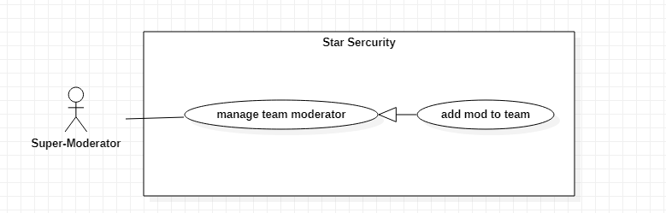

Figure 3.17.1 < Super-moderator > Add moderator to team

|  |  |  |  |  |
| --- | --- | --- | --- | --- |
| USE CASE – UC16 | | | | |
| Use-case No. | UC16 | Use-case Version | | 1.0 |
| Use-case Name | Add mod to team | | | |
| Author | Nong Quoc Linh | | | |
| Date | 03/03/2021 | Priority | Normal | |
| Actor:  - Super-moderator  Summary:   * This use case allows super-moderator to add mod to team.   Goal:   * Super-moderator can add moderator to team.   Triggers   * Super-moderator clicks “Add moderator to team” button   Preconditions:   * Guest logged in as Super-moderator.   Post Conditions:   * Success: Moderator added to team. * Fail*:* Show error message.   Main Success Scenario:   |  |  |  | | --- | --- | --- | | Step | Actor Action | System response | | 1 | - Super-moderator click “Add moderator to team” button | - System will show list of moderators who don’t have team or free. | | 2 | - Super-moderator choose moderators | - System show confirm dialog  “OK” button  “Cancel” button Exception [2,3]  Alternative[1] |   Alternative Scenario:   |  |  |  | | --- | --- | --- | | No | Actor Action | System response | | 1 | Super-Moderator click “Cancel” | System return to the list of moderators |   Exceptions:   |  |  |  | | --- | --- | --- | | No | Actor Action | System response | | 1 | - Internet is not available | System shows message “No Internet connection found! Please try again” | | 2 | Super-Moderator clicks “Accept” many times, but nothing happen | System shows message “Unexpected error! Please try again” | | 3 | Super-Moderator add member in other team | System shows message “This member is existed in the other team” |   Relationships:   * Generalization from manage team moderator.   Business Rules:   * Only super-moderator can do this. * Moderator in team can receive jobs. * List of member is always get from database | | | | |

## < Super-moderator> Remove moderator

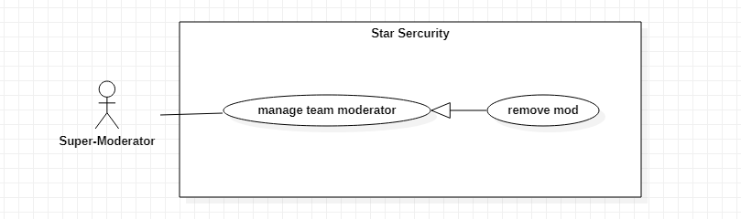

Figure 3.18.1 < Super-moderator > Remove moderator

|  |  |  |  |  |
| --- | --- | --- | --- | --- |
| USE CASE – UC17 | | | | |
| Use-case No. | UC17 | Use-case Version | | 1.0 |
| Use-case Name | Remove mod | | | |
| Author | Nong Quoc Linh | | | |
| Date | 03/03/2021 | Priority | Normal | |
| Actor:  - Super-moderator  Summary:   * This use case allows Super-moderator to remove moderator out of the team.   Goal:   * Super-moderator removes moderator out of team.   Triggers   * Super-moderator clicks “Remove moderator” button   Preconditions:   * Guest logged in as Super-moderator.   Post Conditions:   * Success: Moderator is removed from the team. * Fail: Show error message.   Main Success Scenario:   |  |  |  | | --- | --- | --- | | Step | Actor Action | System response | | 1 | - Super-moderator click “Remove moderator” button | - System will show a list of moderators in the team. | | 2 | - Super-moderator choose moderators passing in checkbox and click “Remove” button | - System remove moderators  Exception [2,3]  Alternative[1] |   Alternative Scenario:   |  |  |  | | --- | --- | --- | | No | Actor Action | System response | | 1 | Super-Moderator click “Cancel” button | System return to the list of moderators in the team |   Exceptions:   |  |  |  | | --- | --- | --- | | No | Actor Action | System response | | 1 | - Internet is not available | System shows message “No Internet connection found! Please try again” | | 2 | Super-Moderator click “Remove” many times, but nothing happen | System shows message “Unexpected error! Please try again” | | 3 | Connect to database fail | The system show dialog “System is maintaining. Please try later.” | | 4 | Moderator in working is removed | System show message :”Moderator is working! Cannot remove!” |   Relationships:  - Generalization from manage team moderator.  Business Rules:   * Only super-moderator can do this. * Super-moderator account’s status must be Active * Moderator doesn’t in any process | | | | |

## < Super-Moderator> Assign jobs to moderator

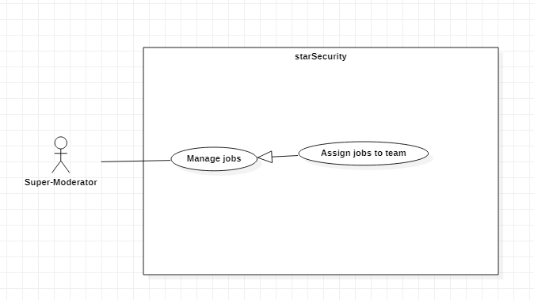

Figure 3.19.1 < Super-Moderator> Assign jobs to moderator

|  |  |  |  |  |
| --- | --- | --- | --- | --- |
| USE CASE – UC18 | | | | |
| Use-case No. | UC18 | Use-case Version | | 1.0 |
| Use-case Name | Assign jobs to moderator | | | |
| Author | Lam Tan Hai | | | |
| Date | 14/03/2021 | Priority | Normal | |
| Actor:  - Super-moderator  Summary:   * This use case allows super-moderator to assign job to moderator.   Goal:   * Super-moderator assign job moderator.   Triggers   * Super-moderator clicks “Create job to Moderator” button * Super-moderator clicks “Assign job to Moderator” button   Preconditions:   * Guest logged in as Super-moderator.   Post Conditions:   * Success: Super-Moderator send new jobs to moderator. * Fail:Show error message.   Main Success Scenario:   |  |  |  | | --- | --- | --- | | Step | Actor Action | System response | | 1 | - Super-moderator click “Create job to Moderator” button | - System will show list of jobs needed to solve.  Exception [1,2] | | 2 | Super-moderator click “Assign job to Moderator” button | - System ask super-moderator choose team will receive jobs  Moderator: Combo box  “Assign” button  “Cancel” button  Exception [1,2,3] | | 3 | Super-moderator click “Assign” button | - System get jobs and assign to that Moderator  Exception [1,2] |   Alternative Scenario:  - None  Exceptions:   |  |  |  | | --- | --- | --- | | No | Actor Action | System response | | 1 | - Internet is not available | System shows message “No Internet connection found! Please try again” | | 2 | Connect to database fail | The system show dialog “System is maintaining. Please try later.” |   Relationships:  - Generalization from manage team moderator  Business Rules:  - Only super-moderator can do this.  - Jobs is always saved to database | | | | |

## < Super-moderator> Remove team

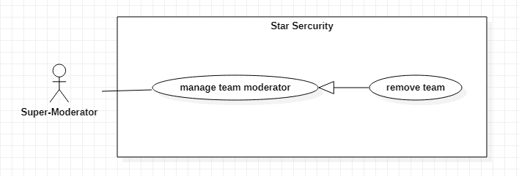

Figure 3.20.1 < Super-moderator > Remove team

|  |  |  |  |  |
| --- | --- | --- | --- | --- |
| USE CASE – UC19 | | | | |
| Use-case No. | UC19 | Use-case Version | | 1.0 |
| Use-case Name | Remove team | | | |
| Author | Nong Quoc Linh | | | |
| Date | 03/03/2021 | Priority | Normal | |
| Actor:  - Super-moderator  Summary:   * This use case allows super-moderator to remove a team.   Goal:   * Super-moderator remove team.   Triggers   * Super-moderator clicks “Remove team” button   Preconditions:   * Guest logged in as Super-moderator.   Post Conditions:   * Success: The team is removed. * *Fail:* Show error message.   Main Success Scenario:     |  |  |  | | --- | --- | --- | | Step | Actor Action | System response | | 1 | - Super-moderator click “Remove team” button | - System show confirm dialog  [Exception 1,2,3] |   Alternative Scenario:  - In case the team has at least 1 moderator remaining in the team.   |  |  |  | | --- | --- | --- | | Step | Actor Action | System response | | 1 | - Super-moderator click “Remove team” button but the team is in process | - System shows message “There are some moderator in the team. Do you want to disband this team?” and ask to confirm.  [Exception 1,2,3] | | 2 | Super-Moderator click “Cancel” | System return to the list of moderators in the team |   Exceptions:   |  |  |  | | --- | --- | --- | | No | Actor Action | System response | | 1 | - Internet is not available | System shows message “No Internet connection found! Please try again” | | 2 | Super-Moderator click “Accept” many times, but nothing happen | System shows message “Unexpected error! Please try again” | | 3 | Connect to database fail | The system show dialog “System is maintaining. Please try later.” |   Relationships:  - Generalization from manage team moderator.  Business Rules:   * Only super-moderator can do this. * The team in the process cannot remove * All member in removing team is available for pickup | | | | |

## < Admin> Accept new account

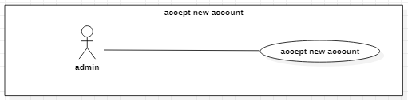

Figure 3.21.1 < Admin> Accept new account

|  |  |  |  |  |
| --- | --- | --- | --- | --- |
| USE CASE – UC20 | | | | |
| Use-case No. | UC20 | Use-case Version | | 1.0 |
| Use-case Name | Accept new account | | | |
| Author | Nguyen Ngoc Tien | | | |
| Date | 19/1/2021 | Priority | Normal | |
| Actor:  - Admin  Summary:  - This use case allows admin to create a new account, accept this account and use their features.  Goal:  - Admin accept a new account from customer who has register  Triggers  - Admin click “Accept account” button  Preconditions:  - Guest logged in as Admin  Post Conditions:  - Success: Create a new account and this account can login  - Fail: Show error message  Main Success Scenario:   |  |  |  | | --- | --- | --- | | Step | Actor action | System response | | 1 | Admin click “View list register” button | Show a table of account with 4 columns:  + Full Name  + Email  + Role  + Status  “Active” button  “Reject” button | | 2 | Admin click “Active” and set role for a account in table | Account will change status and role according Admin’s changes. |   Alternative Scenario:   |  |  |  | | --- | --- | --- | | No | Actor Action | System response | | 1 | Admin click “Reject” button | System sends notification to account’s Email |   Exceptions:   |  |  |  | | --- | --- | --- | | No | Actor Action | System response | | 1 | - Internet is not available | System shows message “No Internet connection found! Please try again” |   Relationships:  None  Business Rules:   * List of new registered partners sort by register date in ascending order. * The system is not in charge of verifying the registered information | | | | |
|  | | | | |

## < Admin> Block account

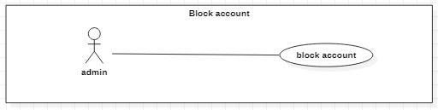

Figure 3.22.1 < Admin> Block account

|  |  |  |  |  |
| --- | --- | --- | --- | --- |
| USE CASE – UC21 | | | | |
| Use-case No. | UC21 | Use-case Version | | 1.0 |
| Use-case Name | Block account | | | |
| Author | Nguyen Ngoc Tien | | | |
| Date | 19/1/2021 | Priority | Normal | |
| Actor:  - Admin  Summary:  - This use case allows Admin to block account  Goal:  - Admin blocks an account  Triggers  - Admin click “Block” button  Preconditions:  - Guest logged in the system as Admin  Post Conditions:  - Success: An account is blocked.  - Fail: Show error message  Main Success Scenario:   |  |  |  | | --- | --- | --- | | Step | Actor action | System response | | 1 | Admin clicks menu item “Manage Account” | Navigate to “Manage Account” page which contains:   * A table of account with 4 columns:   + Full Name  + Email  + Role  + Status  Exception[1,2] | | 2 | Admin clicks on “Block” button | System shows confirm dialogs:  - “Accept” button  - “Cancel” button  Alternative [1]  Exception[1,2] | | 3 | Admin clicks “Accept” button | System changes account’s status is false  Exception[1,2] |   Alternative Scenario:   |  |  |  | | --- | --- | --- | | No | Actor Action | System response | | 1 | Admin clicks “Cancel” button | System returns to list of Account |   Exceptions:   |  |  |  | | --- | --- | --- | | No | Actor Action | System response | | 1 | - Internet is not available | System shows message “No Internet connection found! Please try again” | | 2 | Database connection error | System shows message “Database connection error! Please try again” | | 3 | Admin ban moderator’s account in the process | System shows error message: “this moderator’s account in working. Cannot block!” | | 4 | Admin ban Super-moderator’s account in the process | System shows error message: “this Super-moderator’s account in working. Cannot block!” |   Relationships:  None  Business Rules:  - Guest logged in the system as Admin.  - Active account: an account that can log in to the system and use account role’s functions.  - Deactivated account: an account that can’t log in to the system and can only use guest’s functions | | | | |

## < Admin> Unblock account

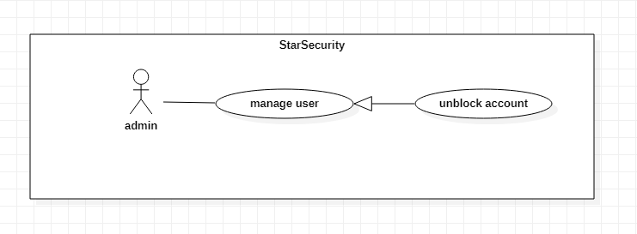

Figure 3.23.1 <Admin> unlock account

|  |  |  |  |  |
| --- | --- | --- | --- | --- |
| USE CASE – UC22 | | | | |
| Use-case No. | UC22 | Use-case Version | | 1.0 |
| Use-case Name | Unblock account | | | |
| Author | Vu Lam Huy | | | |
| Date | 03/03/2021 | Priority | Normal | |
| Actor:   * Admin   Summary:   * This use case allows admin to unblock account of a celebrity or super-moderator or moderator.   Goal:   * A super-moderator or celebrity or moderator is able to log-in to the system and reuse the feature for each account.   Triggers   * Admin clicks “Unlock” button.   Preconditions:   * Guest logged in as admin   Post Conditions:   * Success: Change status of the account is active. * Fail: show error message.   Main Success Scenario:   |  |  |  | | --- | --- | --- | | Step | Actor Action | System Response | | 1 | * Admin choose account and clicks “Unblock” button | * System show message “Are you want to unlock this account?” which contains:   + “OK”: button.  + “Cancel”: button. | | 2 | * Admin click “OK” button in dialog | * System change status of specified moderator to Active.   Exception[2] |   Alternative Scenario:   |  |  |  | | --- | --- | --- | | No | Actor Action | System Response | | 1 | * Admin clicks “Cancel” | - System do nothing |   Exceptions:   |  |  |  | | --- | --- | --- | | No | Actor Action | System Response | | 1 | * Admin clicks “Unlock” button many times, nothing happen. | - System show message: “Unlock fail. Please try again!”. | | 2 | * Internet is not available | - System shows message “Internet connection was interrupted! Please try again!” |   Relationships:   * Generalization from manage user.   Business Rules:   * The admin account must have status is Active. | | | | |

## < Admin> Set moderator

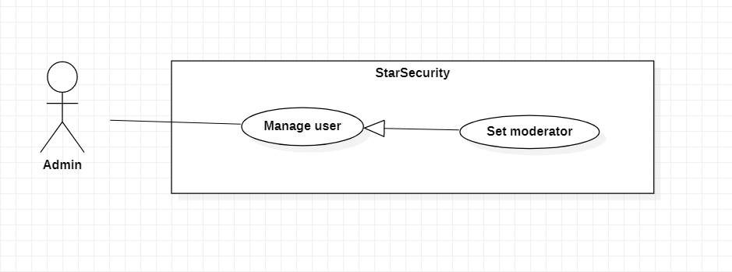

Figure 3.24.1 <Admin> Set moderator

|  |  |  |  |  |
| --- | --- | --- | --- | --- |
| USE CASE – UC23 | | | | |
| Use-case No. | UC23 | Use-case Version | | 1.0 |
| Use-case Name | Set moderator | | | |
| Author | Hoang Anh Dung | | | |
| Date | 19/01/2021 | Priority | Normal | |
| Actor:   * Admin   Summary:   * This use case allows admin to set up an account or a super-moderator to become a moderator   Goal:   * An account or a super-moderator will be moderator   Triggers  - Admin click “Manage User” button  - Admin click “View Specified User” button   * Admin click “Set moderator” button   Preconditions:   * Guest logged in as admin   Post Conditions:   * Success: Role of an account or a super-moderator change to moderator. * Fail: Show error message.   Main Success Scenario:   |  |  |  | | --- | --- | --- | | Step | Actor Action | System Response | | 1 | Admin click “Manage User” button. | System show table contains all accounts (except celebrity’s account) :  + UserName: textbox  + Role: combo box  + Status: checkbox  “View Specified User” button.  Exception [1,2] | | 2 | Admin click “View Specified User” button. | System shows detail information of specified account such as:  - Username  - Full name  - Phone number  - Email  - Date Of Birth  - Role  - Status  And contains:  - “Set moderator” button  - “Close” button  Exception [1,2]  Alternative[1] | | 3 | Admin click “Set moderator” button | System show confirm “Do you want to set this account role to become moderator?” and contain:  - “Ok” button.  - “Cancel” button  Exception [1,2]  Alternative[2] | | 4 | Admin click “Ok” button | System changes role of specified account to moderator.  Exception [1,2] |   Alternative Scenario:   |  |  |  | | --- | --- | --- | | No. | Actor action | System response | | 1 | Admin click “Close” button | System close the information table of the specified account. | | 2 | Admin click “Cancel” button | System close the confirm dialog and don’t set the role of account. |   Exceptions:   |  |  |  | | --- | --- | --- | | No. | Actor action | System response | | 1 | Internet is not available | System shows message “ Internet connection was interrupted! Please try again!” | | 2 | Connect to database fail | The system show dialog “System is maintaining. Please try later.” |   Relationships:   * Generalization from manage user   Business Rules:   * Normal user or Super-moderator become moderator and can work as moderator. * The super-moderator must not have process work or assigned jobs. | | | | |

## < Admin> Set super-moderator

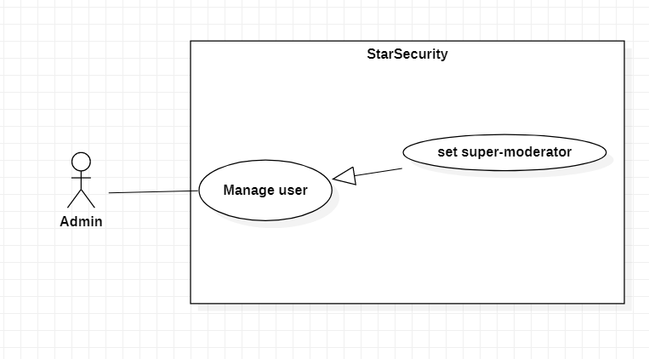

Figure 3.25.1 <Admin> Set super-moderator

|  |  |  |  |  |
| --- | --- | --- | --- | --- |
| USE CASE – UC24 | | | | |
| Use-case No. | UC24 | Use-case Version | | 1.0 |
| Use-case Name | Set super-moderator | | | |
| Author | Lam Tan Hai | | | |
| Date | 03/03/2021 | Priority | Normal | |
| Actor:   * Admin   Summary:   * This use case allows admin to set up an account to become a super-moderator   Goal:   * An account or moderator is became a super-moderator.   Triggers   * Admin click “Set super-moderator” button   Preconditions:  - Guest is logged in as admin  Post Conditions:   * Success: Role of account is set “Super-Moderator”. * Fail: Show error message.   Main Success Scenario:   |  |  |  | | --- | --- | --- | | Step | Actor Action | System Response | | 1 | Admin click “Manage User” button. | System show table contains all accounts (except celebrity’s account) :  + UserName: textbox  + Role: combo box  + Status: checkbox  “View Specified User” button.  Exception [1,2] | | 2 | Admin click “View Specified User” button. | System shows detail information of specified account such as:  - Username  - Full name  - Phone number  - Email  - Date Of Birth  - Role  - Status  And contains:  - “Set Super-moderator” button  - “Close” button  Exception [1,2]  Alternative[1] | | 3 | Admin click “Set Super-moderator” button | System show confirm “Do you want to set this account role to become Super-moderator?” and contain:  - “Ok” button.  - “Cancel” button  Exception [1]  Alternative[2] | | 4 | Admin click “Ok” button | System changes role of specified account to Super-moderator.  Exception [1,2] |   Alternative Scenario:   |  |  |  | | --- | --- | --- | | No. | Actor action | System response | | 1 | Admin click “Close” button | System close the information table of the specified account. | | 2 | Admin click “Cancel” button | System close the confirm dialog and don’t set the role of account. |   Exceptions:   |  |  |  | | --- | --- | --- | | No. | Actor action | System response | | 1 | Internet is not available | System shows message “ Internet connection was interrupted! Please try again!” | | 2 | Connect to database fail | The system show dialog “System is maintaining. Please try later.” |   Relationships:   * Generalization from manage user   Business Rules: | | | | |

## < Moderator> View list article

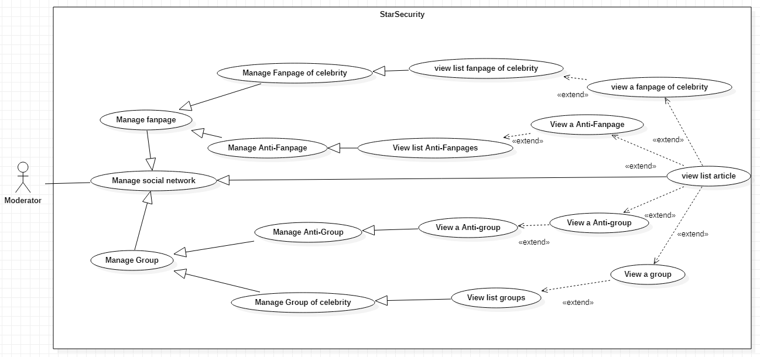

Figure 3.26.1 < Moderator> View list article

|  |  |  |  |  |
| --- | --- | --- | --- | --- |
| USE CASE – UC25 | | | | |
| Use-case No. | UC25 | Use-case Version | | 1.0 |
| Use-case Name | View list article | | | |
| Author | Lam Tan Hai | | | |
| Date | 14/03/2021 | Priority | Normal | |
| Actor:  - Moderator  Summary:   * This use case allows moderator to view list taking articles from the system (System automatically crawl data) from group, fanpage of celebrity or celebrity’s anti-fan.   Goal:   * Moderator view list article.   Triggers   * Moderator clicks “View list article” button   Preconditions:   * Guest logged in as Moderator. * Moderator is in a team. * Moderator must choose one option from combo box “From”   Post Conditions:   * Success: List article is shown. * Fail:Show error message.   Main Success Scenario:     |  |  |  | | --- | --- | --- | | Step | Actor Action | System response | | 1 | Moderator click combo box having “View list article” button | - List article show in table:  + Owner article  + URL  + Time  + Date collect  + “View detail article” button  [Exception 1,2] |   Alternative Scenario:   * None   Exceptions:   |  |  |  | | --- | --- | --- | | No. | Actor action | System response | | 1 | Internet is not available | System shows message “ Internet connection was interrupted! Please try again!” | | 2 | Connect to database fail | The system show dialog “System is maintaining. Please try later.” |   Relationships:  - Generalization from Manage social network  - Extend from View an Anti-Fanpage, View Anti-group, View a group, view a fanpage of celebrity  Business Rules:  - The moderator account’s status is Active  - Moderator is in team  - List articles are always get from database | | | | |

## < Moderator> View specific article

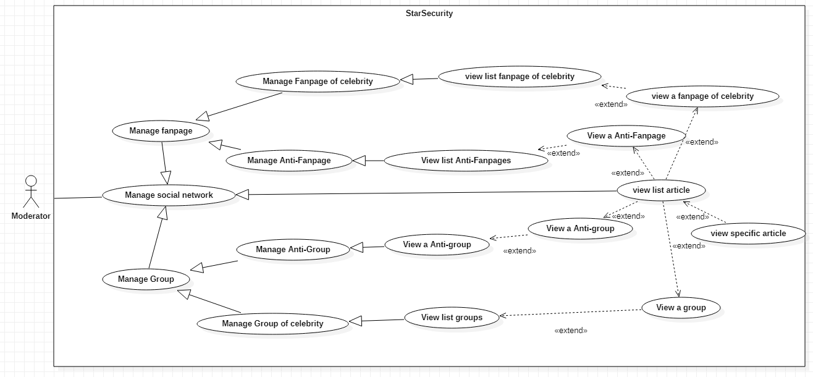

Figure 3.27.1 < Moderator> View specific article

|  |  |  |  |  |
| --- | --- | --- | --- | --- |
| USE CASE – UC26 | | | | |
| Use-case No. | UC26 | Use-case Version | | 1.0 |
| Use-case Name | View specific article | | | |
| Author | Lam Tan Hai | | | |
| Date | 14/03/2021 | Priority | Normal | |
| Actor:  - Moderator  Summary:   * This use case allows moderator to view specific articles from list articles.   Goal:   * Moderator views specific article.   Triggers   * Moderator clicks “View detail article” button   Preconditions:   * Guest logged in as Moderator. * List of articles has at least one record.   Post Conditions:   * Success: Detail of article is shown. * Fail:Show error message.   Main Success Scenario:     |  |  |  | | --- | --- | --- | | Step | Actor Action | System response | | 1 | Moderator click “View detail article” button | - System shows detail of that article include:  + Owner article  + URL  + Content  Alternative [1,2]  [Exception 1,2] |   Alternative Scenario:   |  |  |  | | --- | --- | --- | | No | Actor Action | System response | | 1 | If the article is in fan page or group of celebrity | System shows:  + “Delete” button  + “Hidden” button | | 2 | If the article is in fan page or group of anti | System shows:  + “Report” button |   Exceptions:   |  |  |  | | --- | --- | --- | | No | Actor Action | System response | | 1 | Internet is not available | System shows message “No Internet connection found! Please try again” | | 2 | Connect to database fail | The system show dialog “System is maintaining. Please try later.” |   Relationships:  - Extended from View list article  Business Rules:  - The moderator account’s status is Active  - Moderator is in team  - Specific article must be load from database | | | | |

## < Moderator> View list Anti-Fanpages

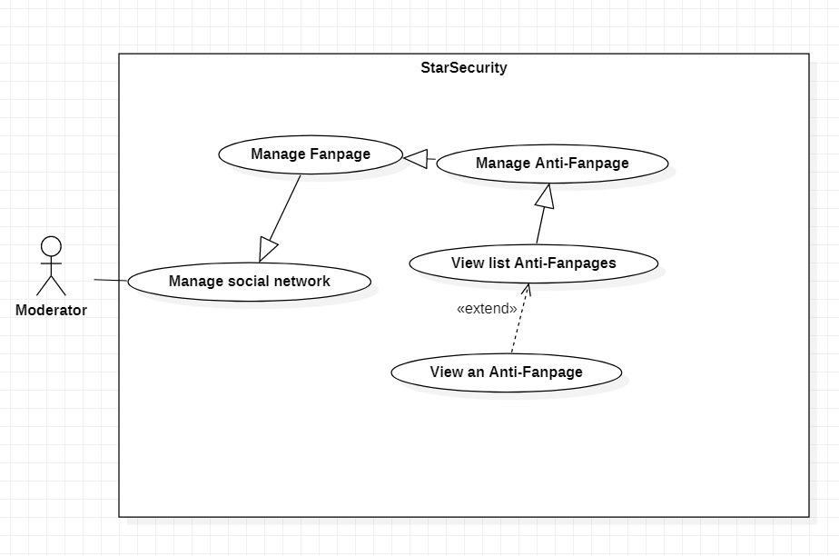

Figure 3.28.1 < Moderator > View list Anti-Fanpages

|  |  |  |  |  |
| --- | --- | --- | --- | --- |
| USE CASE – UC27 | | | | |
| Use-case No. | UC27 | Use-case Version | | 1.0 |
| Use-case Name | View list Anti-Fanpages | | | |
| Author | Nguyen Ngoc Tien | | | |
| Date | 19/01/2021 | Priority | Normal | |
| Actor:   * Moderator   Summary:   * This use case allows moderator to view list anti fanpages be crawl from bot or reporter.   Goal:   * Moderator view all list anti fanpages.   Triggers   * Moderator clicks “View Anti-Fanpages” button.   Preconditions:   * Guest logged in as Moderator.   Post Conditions:   * Success: All list anti fanpages has been shown on user interface. * Fail: Show error message.   Main Success Scenario:   |  |  |  | | --- | --- | --- | | Step | Actor Action | System response | | 1 | Moderator click “View Anti-Fanpages” button | System show list anti fanpages in table:  + URL  + Name  + “View Detail” button  + “Close” button  [Alternative 1]  [Exception 1,2,3,4] |   Alternative Scenario:   |  |  |  | | --- | --- | --- | | No | Actor Action | System response | | 1 | Moderator clicks “Close” button | System close table |   Exceptions:   |  |  |  | | --- | --- | --- | | No | Actor Action | System response | | 1 | Internet is not available | System shows message “No Internet connection found! Please try again” | | 2 | List anti page is empty | System shows message “Not detect anti fanpage.” | | 3 | Moderator click “View Anti-Fanpages” many times, but nothing happen | System shows message “Unexpected error! Please try again” | | 4 | Connect to database fail | The system show dialog “System is maintaining. Please try later.” |   Relationships:   * Generalization from Manage Anti-Fanpages * Extend to View an Anti-Fanpage   Business Rules:   * The Moderator account must have status is Active. * List of Anti-Fanpages load from database | | | | |

## < Moderator> View an Anti-Fanpage

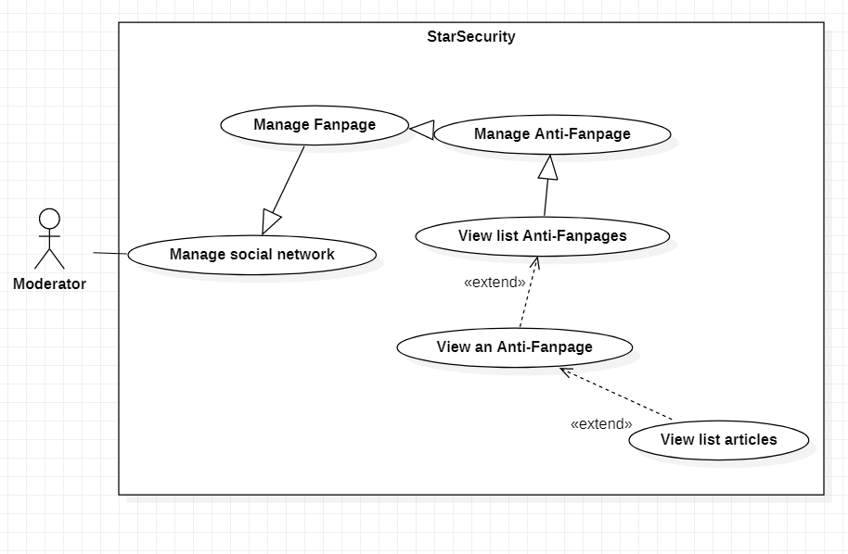

Figure 3.29.1 < Moderator > View an Anti-Fanpage

|  |  |  |  |  |
| --- | --- | --- | --- | --- |
| USE CASE – UC28 | | | | |
| Use-case No. | UC28 | Use-case Version | | 1.0 |
| Use-case Name | View an Anti-Fanpage | | | |
| Author | Nguyen Ngoc Tien | | | |
| Date | 19/01/2021 | Priority | Normal | |
| Actor:   * Moderator   Summary:   * This use case allows moderator to view an anti fanpages in list anti fanpages be crawl from bot or reporter.   Goal:   * Moderator view an anti fanpages.   Triggers   * Moderator clicks “View Detail” button.   Preconditions:   * Guest logged in as Moderator. * Moderator in View list Anti-Fanpages case   Post Conditions:   * Success: Detail of an anti fanpages has been shown on user interface. * Fail: Show error message.   Main Success Scenario:   |  |  |  | | --- | --- | --- | | Step | Actor Action | System response | | 1 | - Moderator click “View Detail” button | - System show detail of a anti fanpages  + URL  + Name  + Time  + Date collect  “View list Anti-Fanpages” button  [Exception 1,2,3] |   Alternative Scenario:   |  |  |  | | --- | --- | --- | | No. | Cause | System response | | 1 | Moderator clicks “View list Anti-Fanpages” button | System return to the list of Anti-Fanpages |   Exceptions:   |  |  |  | | --- | --- | --- | | No | Actor Action | System response | | 1 | Internet is not available | System shows message “No Internet connection found! Please try again” | | 2 | Moderator click “View Detail” many times, but nothing happen | System shows message “Unexpected error! Please try again” | | 3 | Connect to database fail | The system show dialog “System is maintaining. Please try later.” |   Relationships:   * Extend from View list Anti-Fanpages * Extend to View list articles   Business Rules:   * The Moderator account must have status is Active. | | | | |

## < Moderator> View list Anti-group

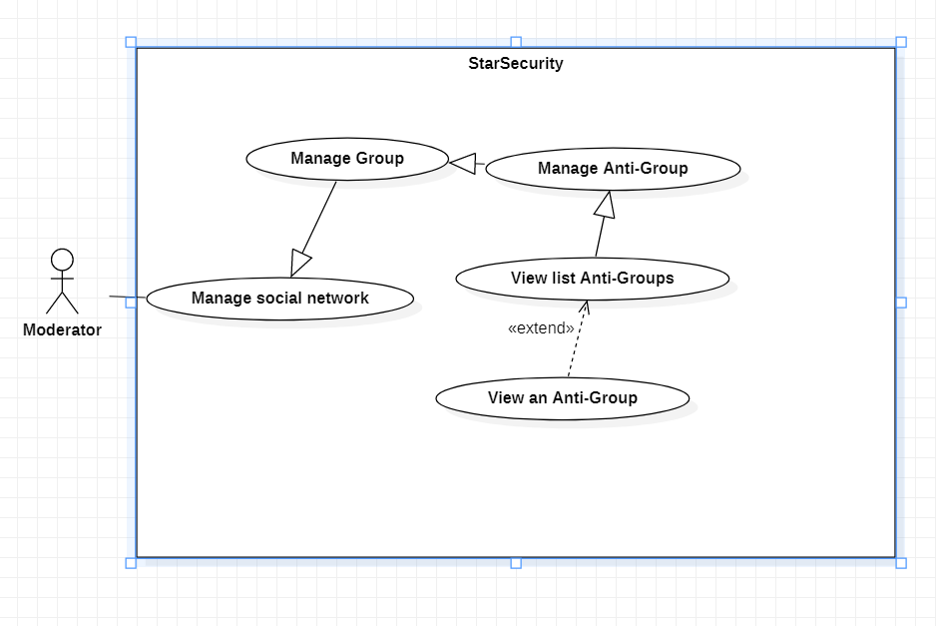

Figure 3.30.1 <Moderator> View list Anti-groups

|  |  |  |  |  |
| --- | --- | --- | --- | --- |
| USE CASE – UC29 | | | | |
| Use-case No. | UC29 | Use-case Version | | 1.0 |
| Use-case Name | View Anti-groups | | | |
| Author | Nong Quoc Linh | | | |
| Date | 14/03/2021 | Priority | Normal | |
| Actor:   * Moderator   Summary:   * This use case allows moderator to view list anti group   Goal:  - Moderator views list anti groups  Triggers   * Moderator clicks “View list anti-groups” button   Preconditions:   * Guest login as moderator   Post Conditions:   * Success: List anti-groups is displayed on screen * Fail: Show error message   Main Success Scenario:   |  |  |  | | --- | --- | --- | | Step | Actor Action | System Response | | 1 | Moderator click “View list anti-groups” button | System shows information about anti-groups  + URL  + Name  “View detail” button  “Close” button  [Alternative 1]  [Exception 1,2] |   Alternative Scenario:   |  |  |  | | --- | --- | --- | | No. | Cause | System response | | 1 | Moderator click “Close” button | System close that table |   Exceptions:   |  |  |  | | --- | --- | --- | | No. | Cause | System response | | 1 | Internet is not available | Show “No Internet connection found! Please try again” | | 2 | Connect to database fail | The system show dialog “System is maintaining. Please try later.” |   Relationships:   * Generalization from Manage Anti-Group (Select View list Anti-Groups) * Extend to View an Anti-Group (Select View an Anti-Group)   Business Rules:   * Guest login as moderator * Moderator is assigned to handle the anti-group. | | | | |

## < Moderator> View an Anti-group

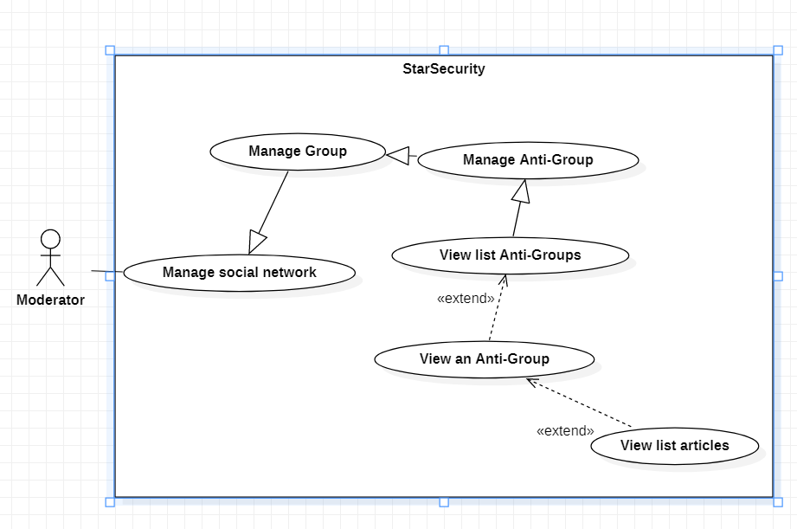

Figure 3.31.1 <Moderator> View an Anti-group

|  |  |  |  |  |
| --- | --- | --- | --- | --- |
| USE CASE – UC30 | | | | |
| Use-case No. | UC30 | Use-case Version | | 1.0 |
| Use-case Name | View an Anti-group | | | |
| Author | Nong Quoc Linh | | | |
| Date | 14/03/2021 | Priority | Normal | |
| Actor:   * Moderator   Summary:   * This use case allows moderator to view an anti group   Goal:  - Moderator can view anti group  Triggers   * Moderator click “View detail” button   Preconditions:   * Guest login as moderator   Post Conditions:   * Success: All information about an anti-group is displayed on screen * Fail: Show error message   Main Success Scenario:   |  |  |  | | --- | --- | --- | | Step | Actor Action | System Response | | 1 | Moderator clicks “View detail” button | System shows information about anti-group  + URL  + Name  + Time  + Date collect  “View list Anti-groups” button  [Exception 1,2] |   Alternative Scenario:   |  |  |  | | --- | --- | --- | | No. | Cause | System response | | 1 | Moderator clicks “View list Anti-groups” button | System return to the list of anti-groups |   Exceptions:   |  |  |  | | --- | --- | --- | | No. | Cause | System response | | 1 | Internet is not available | Show “No Internet connection found! Please try again” | | 2 | Connect to database fail | The system show dialog “System is maintaining. Please try later.” |   Relationships:   * Extend from View list Anti-groups * Extend to View list articles   Business Rules:   * Guest login as moderator * Moderator is assigned to handle the anti-group. | | | | |

## < Moderator> Get a jobs from super-moderator

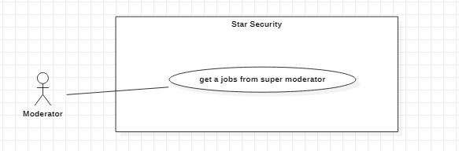

Figure 3.32.1 <Moderator> Get a jobs from super-moderator

|  |  |  |  |  |
| --- | --- | --- | --- | --- |
| USE CASE – UC31 | | | | |
| Use-case No. | UC31 | Use-case Version | | 1.0 |
| Use-case Name | Get jobs from super-moderator | | | |
| Author | Nong Quoc Linh | | | |
| Date | 14/03/2021 | Priority | Normal | |
| Actor:   * Moderator   Summary:   * This use case allows moderator to receive jobs from super-moderator   Goal:   * Moderator receives jobs from super-moderator   Triggers   * Moderator clicks “Receive” button.   Preconditions:   * Guest login as moderator   Post Conditions:   * Success: Moderator receive jobs   Main Success Scenario:   |  |  |  | | --- | --- | --- | | Step | Actor Action | System Response | | 1 | Moderator receives a notification | System shows notify about new jobs | | 2 | Moderator click “View job” button | System show all information about jobs:   * Time * Content * Description. * Celebrity   + “Cancel” button   * “Receive” button   [Exception 1] | | 3 | Moderator clicks “Receive” button | New job will be added in moderator jobs list.  [Exception 1] |   Alternative Scenario:   |  |  |  | | --- | --- | --- | | No. | Cause | System response | | 1 | Moderator clicks “Cancel” | System close the notification |   Exceptions:   |  |  |  | | --- | --- | --- | | No. | Cause | System response | | 1 | Internet is not available | Show “No Internet connection found! Please try again” | | 2 | Connect to database fail | The system show dialog “System is maintaining. Please try later.” |   Relationships:   * None   Business Rules:   * Only moderator can receive jobs from super-moderator. * One Moderator can receive many jobs. | | | | |

## < Moderator> Handler article

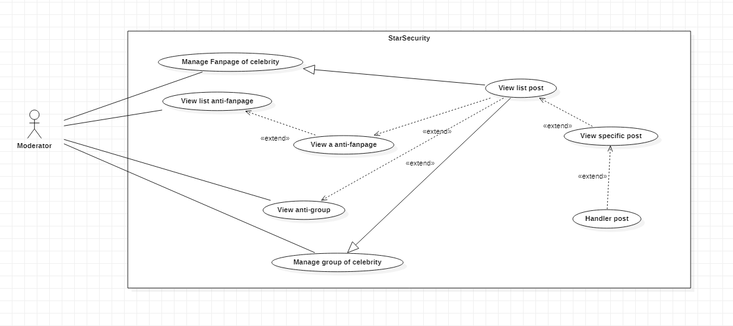

Figure 3.33.1 <Moderator> Handler article

|  |  |  |  |  |
| --- | --- | --- | --- | --- |
| USE CASE – UC32 | | | | |
| Use-case No. | UC32 | Use-case Version | | 1.0 |
| Use-case Name | Handler article | | | |
| Author | Hoang Anh Dung | | | |
| Date | 14/03/2021 | Priority | Normal | |
| Actor:   * Moderator   Summary:   * This use case allows moderator delete a article, report article   Goal:   * Specific article will be deleted if it is in fan page or group of celebrity, and will be reported if it is in fanpage-anti or group-anti about celebrity   Triggers   * A moderator clicks “Delete article” button * A moderator clicks “Report article” button   Preconditions:   * Guest logged in as moderator   Post Conditions:   * Success: specific article will be deleted or report * Fail: Show error message   Main Success Scenario:   |  |  |  | | --- | --- | --- | | Step | Actor Action | System Response | | 1 | Moderator click “Delete article” button if this article is in fanpage or group of celebrity  [Alternative 1] | System show dialog confirm:   * “Ok” button * “Cancel” button | | 2 | Moderator click “Ok” button | System call API to delete specific article in fanpage or group of celebrity  [Alternative 2]  [Exceptions 1] |   Alternative Scenario:   |  |  |  | | --- | --- | --- | | No | Actor Action | System Response | | 1 | Moderator click “Report” button if this article in fanpage-anti or group-anti about celebrity | System show dialog confirm:   * “Ok” button * “Cancel” button | | 2 | The article in anti-fanpage or group-anti about celebrity | System call API to report specific article in fanpage-anti or group-anti about celebrity  [Exceptions 1] |   Exceptions:   |  |  |  | | --- | --- | --- | | No | Actor Action | System Response | | 1 | The article is not exist | The system show dialog “This article is not exist, cannot delete” |   Relationships:   * Generalization by Manage Fanpage of celebrity, extend to View list anti-fanpage (select view list anti-fanpage), extend to View a anti-fanpage (select view an anti-fanpage), extend to View anti-group (select view anti-group), generalization by Manage group of celebrity, extend to View list article (select view list article), extend to View specific article (select view specific article)   Business Rules:   * List available article always get from database * Specific article must have enough information: owner article, content, id, time establish,… | | | | |

## < Moderator> Handler comment

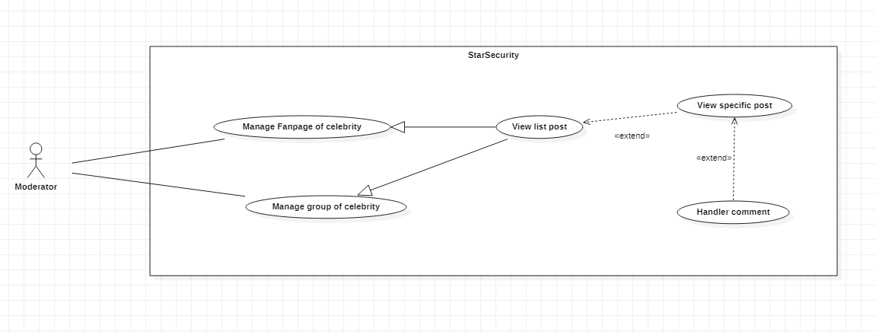

Figure 3.34.1 <Moderator> Handler comment

|  |  |  |  |  |
| --- | --- | --- | --- | --- |
| USE CASE – UC33 | | | | |
| Use-case No. | UC33 | Use-case Version | | 1.0 |
| Use-case Name | Handler comment | | | |
| Author | Hoang Anh Dung | | | |
| Date | 14/03/2021 | Priority | Normal | |
| Actor:   * Moderator   Summary:   * This use case allows moderator to delete a comment, hidden a comment   Goal:   * Specific comment will be deleted or hidden from specific article   Triggers   * A moderator clicks “Delete comment” button * A moderator clicks “Hidden comment” button   Preconditions:   * Guest logged in as moderator   Post Conditions:   * Success: specific comment in specific article will be deleted or hidden * Fail: Show error message   Main Success Scenario:   |  |  |  | | --- | --- | --- | | Step | Actor Action | System Response | | 1 | Moderator click “Delete comment” button  [Alternative 1] | System show dialog confirm:   * “Ok” button * “Cancel” button | | 2 | Moderator click “Ok” button | System call API to delete specific comment  [Alternative 2]  [Exceptions 1, 2] |   Alternative Scenario:   |  |  |  | | --- | --- | --- | | No | Actor Action | System Response | | 1 | Moderator click “Hidden comment” button | System show dialog confirm:   * “Ok” button * “Cancel” button | | 2 | If function is hidden comment | System call API to hidden specific comment  [Exceptions 1, 2] |   Exceptions:   |  |  |  | | --- | --- | --- | | No | Actor Action | System Response | | 1 | The article is not exist | The system show dialog “This article not exist, maybe already delete” | | 2 | The comment is not exist | The system show dialog “This comment not exist, maybe already delete” |   Relationships:   * Generalization by Manage Fanpage of celebrity, generalization by Manage group of celebrity, extend to View list article (select view list article), extend to View specific article (select view specific article)   Business Rules:   * All comment available in specific article will show * Specific article still exists in social media * Specific comment still exists in social media * Specific comment must have enough information: owner comment, content, id, time establish | | | | |

## < Moderator> Find message

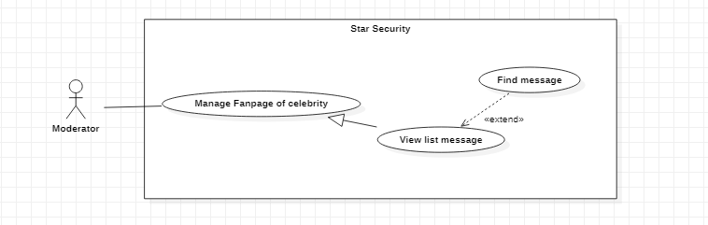

Figure 3.35.1 <Moderator> Find message

|  |
| --- |
| USE CASE – UC34 |

|  |  |  |  |  |
| --- | --- | --- | --- | --- |
| Use-case No. | UC34 | Use-case Version | | 1.0 |
| Use-case Name | Find message | | | |
| Author | Nong Quoc Linh | | | |
| Date | 16/03/2021 | Priority | Normal | |
| Actor:   * Moderator   Summary:   * This use case allows moderator to find message in list message   Goal:   * System shows all messages contain search value.   Triggers   * A moderator clicks “Find message” button   Preconditions:   * Guest logged in as moderator   Post Conditions:   * Success: all message contain search value will be shown. * Fail: Show error message   Main Success Scenario:   |  |  |  | | --- | --- | --- | | Step | Actor Action | System Response | | 1 | Moderator input the text in find message form then click “Find Message” button | System show list of messages in table:   * Sender * Time * Message content * Receiver   [Exception 1] |   Alternative Scenario:   * None   Exceptions:   |  |  |  | | --- | --- | --- | | No | Actor Action | System Response | | 1 | Search value is not existed in any messages. | The system shows dialog “Don’t have any message contains this search value”. |   Relationships:   * Generalization by Manage Fanpage of celebrity, extend to View list messages.   Business Rules:   * All message contains specific text will show * Specific message still exists in social media | | | | |

## < Moderator> Remove message

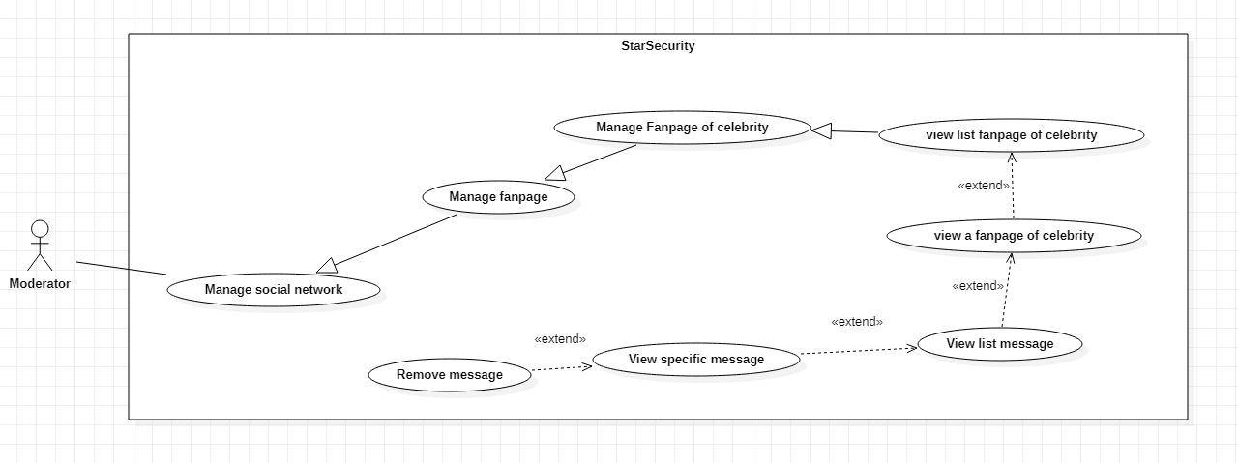

Figure 3.36.1 < Moderator > Remove message

|  |  |  |  |  |
| --- | --- | --- | --- | --- |
| USE CASE - UC35 | | | | |
| Use-case No. | UC35 | Use-case Version | | 1.0 |
| Use-case Name | Remove message | | | |
| Author | Nong Quoc Linh | | | |
| Date | 18/03/2021 | Priority | Normal | |
| Actor:   * Moderator   Summary:   * This use case allows moderator to remove message   Goal:   * A message has been removed   Triggers   * A moderator clicks “Remove message” button   Preconditions:   * Guest logged in as moderator   Post Conditions:   * Success: A message has been removed. * Fail: Show error message   Main Success Scenario:   |  |  |  | | --- | --- | --- | | Step | Actor Action | System Response | | 1 | Moderator click “Remove message” button  Alternative[1] | System show confirm dialog:   * “Remove” button * “Cancel” button | | 2 | Moderator click “Remove” button | System remove message from social networks of celebrity.  Exceptions[1] |   Alternative Scenario:   |  |  |  | | --- | --- | --- | | No | Actor Action | System Response | | 1 | Moderator click “Cancel” button | The system do nothing. |   Exceptions:   |  |  |  | | --- | --- | --- | | No | Actor Action | System Response | | 1 | Internet is not available | The system show dialog “Internet was interrupted. Please check your internet connection!” |   Relationships:   * Extend from view list message (select view list message), extend from view detail message (select view detail message)   Business Rules:   * The moderator must have status is active | | | | |

## < Moderator> View list message

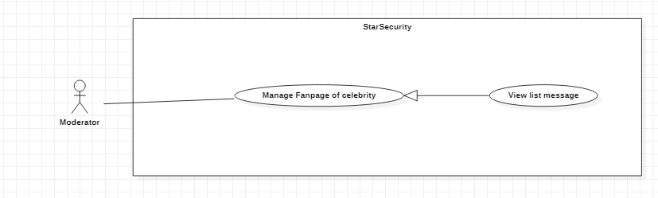

Figure 3.37.1 < Moderator > View list message

|  |  |  |  |  |
| --- | --- | --- | --- | --- |
| USE CASE – UC36 | | | | |
| Use-case No. | UC36 | Use-case Version | | 1.0 |
| Use-case Name | View list message | | | |
| Author | Nguyen Ngoc Tien | | | |
| Date | 15/03/2021 | Priority | Normal | |
| Actor:   * Moderator   Summary:   * This use case allows moderator view list message be send to fanpage of celebrity   Goal:   * Moderator view list message be send to fanpage of celebrity   Triggers   * A celebrity click “show list message ” button at page manage fanpage of celebrity   Preconditions:   * Guest logged in as Moderator   Post Conditions:   * Success: List message is show * Fail: Show error message   Main Success Scenario:   |  |  |  | | --- | --- | --- | | Step | Actor Action | System Response | | 1 | Moderator click combo box having “show list message” button | The system display all information of specific request on a form:   * Message content * Datetime send * “View Specific message” button each a message * “Cancel” button   Exceptions[1, 2] | | 2 | Celebrity click “View Specific message” button  Alternative[1] | System action case View Specific message |   Alternative Scenario:   |  |  |  | | --- | --- | --- | | No | Actor Action | System Response | | 1 | Celebrity click “Cancel” button | The system return screen to page manage fanpage of celebrity |   Exceptions:   |  |  |  | | --- | --- | --- | | No | Actor Action | System Response | | 1 | Connect to system fail | The system show dialog “Disconnect, please check internet connection.” | | 2 | Connect to database fail | The system show dialog “System is maintaining. Please, comeback later.” |   Relationships:  - Extends from View a fanpage of celebrity (Select View list message).  Business Rules:   * The moderator must have status is active * All information of the request get from database | | | | |

## < Moderator> View specific message

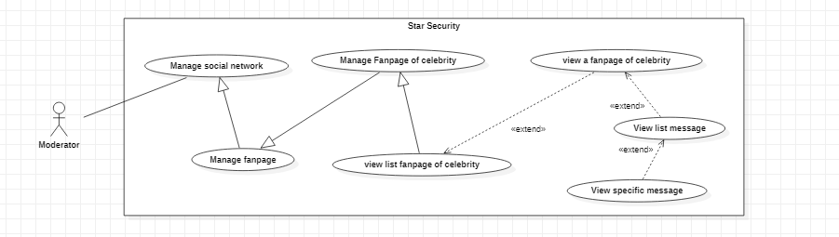

Figure 3.38.1 < Moderator > View specific message

|  |  |  |  |  |
| --- | --- | --- | --- | --- |
| USE CASE – UC37 | | | | |
| Use-case No. | UC37 | Use-case Version | | 1.0 |
| Use-case Name | View list message | | | |
| Author | Lam Tan Hai | | | |
| Date | 15/03/2021 | Priority | Normal | |
| Actor:   * Moderator   Summary:   * This use case allows moderator view specific message be sent to fanpage of celebrity   Goal:   * Moderator view specific message be sent to fanpage of celebrity   Triggers   * A celebrity clicks “View Specific message” button   Preconditions:   * Guest logged in as Moderator   Post Conditions:   * Success: Specific message is show * Fail: Show error message   Main Success Scenario:   |  |  |  | | --- | --- | --- | | Step | Actor Action | System Response | | 1 | Moderator click “View Specific message” button | The system display all information of specific request on a form:   * Message content * Datetime send * “Remove” button * “Back” button   Alternative[1]  Exceptions[1, 2] |   Alternative Scenario:   |  |  |  | | --- | --- | --- | | No | Actor Action | System Response | | 1 | Celebrity click “Back” button | The system return list of message |   Exceptions:   |  |  |  | | --- | --- | --- | | No | Actor Action | System Response | | 1 | Connect to system fail | The system show dialog “Disconnect, please check internet connection.” | | 2 | Connect to database fail | The system show dialog “System is maintaining. Please, comeback later.” |   Relationships:  - Extends from View list message (Select View specific message).  Business Rules:   * The moderator must have status is active * All information of the message get from database | | | | |

## < Moderator> Remove fanpage

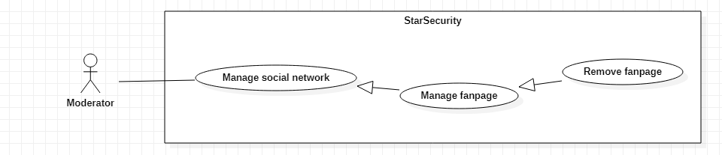

Figure 3.39.1 < Moderator > Remove fanpage

|  |  |  |  |  |
| --- | --- | --- | --- | --- |
| USE CASE - UC38 | | | | |
| Use-case No. | UC38 | Use-case Version | | 1.0 |
| Use-case Name | Remove fanpage | | | |
| Author | Nguyen Ngoc Tien | | | |
| Date | 18/03/2021 | Priority | Normal | |
| Actor:   * Moderator   Summary:   * This use case allows moderator to remove a fanpage   Goal:   * A fanpage’s status is updated into In-Active   Triggers   * A moderator clicks “Remove fanpage” button   Preconditions:   * Guest logged in as moderator   Post Conditions:   * Success: A group has been removed. * Fail: Show error message   Main Success Scenario:   |  |  |  | | --- | --- | --- | | Step | Actor Action | System Response | | 1 | Moderator click “Remove fanpage” button  Alternative[1] | System show confirm dialog:   * “Remove” button * “Cancel” button | | 2 | Moderator click “Remove” button | System updated status of fanpage in Database into In-Active.  Exceptions[1,2] |   Alternative Scenario:   |  |  |  | | --- | --- | --- | | No | Actor Action | System Response | | 1 | Moderator click “Cancel” button | The system do nothing. |   Exceptions:   |  |  |  | | --- | --- | --- | | No | Actor Action | System Response | | 1 | Internet is not available | The system show dialog “Internet was interrupted. Please check your internet connection!” | | 2 | Connect to database fail | The system show dialog “System is maintaining. Please try later.” |   Relationships:   * Generalization from Manage Fanpage   Business Rules:   * The moderator must have status is active * Not removed from database, update status in Database into In-Active | | | | |

## < Moderator> Remove a group

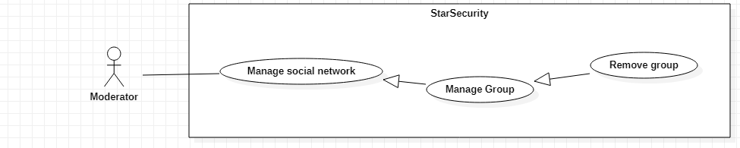

Figure 3.40.1 < Moderator > Remove group

|  |  |  |  |  |
| --- | --- | --- | --- | --- |
| USE CASE – UC3 | | | | |
| Use-case No. | UC39 | Use-case Version | | 1.0 |
| Use-case Name | Remove Group | | | |
| Author | Nguyen Ngoc Tien | | | |
| Date | 18/03/2021 | Priority | Normal | |
| Actor:   * Moderator   Summary:   * This use case allows moderator to remove a group   Goal:   * A group is updated status to In-Active   Triggers   * A moderator clicks “Remove group” button   Preconditions:   * Guest logged in as moderator   Post Conditions:   * Success: A group has been removed. * Fail: Show error message   Main Success Scenario:   |  |  |  | | --- | --- | --- | | Step | Actor Action | System Response | | 1 | Moderator click “Remove group” button  Alternative[1] | System show confirm dialog:   * “Remove” button * “Cancel” button | | 2 | Moderator click “Remove” button | System update status of group in Database into In-Active.  Exceptions[1,2] |   Alternative Scenario:   |  |  |  | | --- | --- | --- | | No | Actor Action | System Response | | 1 | Moderator click “Cancel” button | The system do nothing. |   Exceptions:   |  |  |  | | --- | --- | --- | | No | Actor Action | System Response | | 1 | Internet is not available | The system show dialog “Internet was interrupted. Please check your internet connection!” | | 2 | Connect to database fail | The system show dialog “System is maintaining. Please try later.” |   Relationships:   * Generalization from Manage Group   Business Rules:   * The moderator must have status is active * Not removed from database, update status in Database into In-Active | | | | |

## <Moderator > Add a group

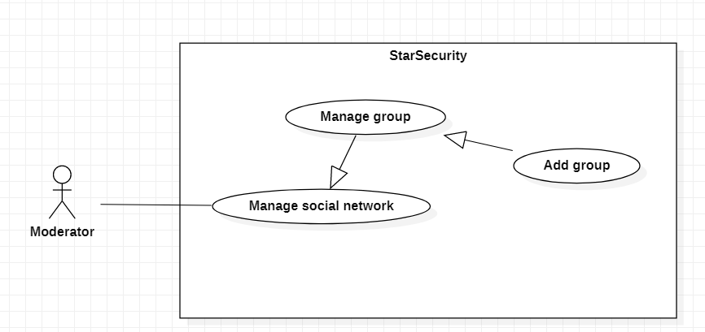

Figure 3.41.1 <Moderator> Add a group

|  |  |  |  |  |
| --- | --- | --- | --- | --- |
| USE CASE – UC40 | | | | |
| Use-case No. | UC40 | Use-case Version | | 1.0 |
| Use-case Name | Add a group | | | |
| Author | Nong Quoc Linh | | | |
| Date | 19/03/2021 | Priority | Normal | |
| Actor:  - Moderator  Summary:   * This use case allows moderator to add a group.   Goal:   * Moderator can add a group.   Triggers   * Moderator clicks “Add group” button   Preconditions:   * Guest logged in as Moderator.   Post Conditions:   * Success: Group added to list. * Fail*:* Show error message.   Main Success Scenario:   |  |  |  | | --- | --- | --- | | Step | Actor Action | System response | | 1 | - Moderator click “Add group” button | - System will show form:  + Group name: text  + Group URL: text  + Social network: comboBox  + Is Anti-group: checkbox  “Add” button  “Cancel” button  Alternative[1]  Exception [1, 2,4,5,6] | | 2 | - Moderator click “Add” button | - System show confirm dialog  “OK” button  “Cancel” button Exception [1, 2,3]  Alternative[2] |   Alternative Scenario:   |  |  |  | | --- | --- | --- | | No | Actor Action | System response | | 1 | Moderator click “Cancel” button | System return to dashboard | | 2 | Moderator click “Cancel” button | System return to form Add group |   Exceptions:   |  |  |  | | --- | --- | --- | | No | Actor Action | System response | | 1 | - Internet is not available | System shows message “No Internet connection found! Please try again” | | 2 | Moderator clicks “Add” many times, but nothing happen | System shows message “Unexpected error! Please try again” | | 3 | Moderator add duplicate group | System shows message “This group is existed in list” | | 4 | Field name and field group URL is empty | System show message: “This field is not allow to empty” | | 5 | Length of field name is over 100 characters | System show message: “Name is from 1-100 characters” | | 6 | Length of field group URL is over 300 characters | System show message: “URL is from 1-300 characters” |   Relationships:   * Generalization from manage group (Select Add group).   Business Rules:   * Moderator account must have Active status. * Data is always insert into database | | | | |

## <Moderator > Add a fanpage

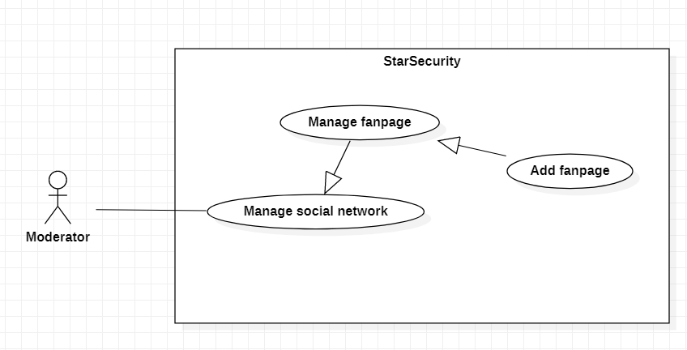

Figure 3.42.1 < Moderator > Add a fanpage

|  |  |  |  |  |
| --- | --- | --- | --- | --- |
| USE CASE – UC41 | | | | |
| Use-case No. | UC41 | Use-case Version | | 1.0 |
| Use-case Name | Add a Fanpage | | | |
| Author | Nong Quoc Linh | | | |
| Date | 19/03/2021 | Priority | Normal | |
| Actor:  - Moderator  Summary:   * This use case allows moderator to add a fanpage.   Goal:   * Moderator added a fanpage.   Triggers   * Moderator clicks “Add fanpage” button   Preconditions:   * Guest logged in as Moderator.   Post Conditions:   * Success: Fanpage added to list. * Fail*:* Show error message.   Main Success Scenario:   |  |  |  | | --- | --- | --- | | Step | Actor Action | System response | | 1 | - Moderator click “Add fanpage” button | - System will show form:  + Fanpage name  + Fanpage URL  + Social network  + Is Anti-Fanpage  “Add” button  “Cancel” button  Alternative[1]  Exception [1, 2,4,5,6] | | 2 | - Moderator click “Add” button | - System show confirm dialog  “OK” button  “Cancel” button Exception [1, 2,3]  Alternative[2] |   Alternative Scenario:   |  |  |  | | --- | --- | --- | | No | Actor Action | System response | | 1 | Moderator click “Cancel” | System return to dashboard | | 2 | Moderator click “Cancel” button | System return to form Add a fanpage |   Exceptions:   |  |  |  | | --- | --- | --- | | No | Actor Action | System response | | 1 | - Internet is not available | System shows message “No Internet connection found! Please try again” | | 2 | Moderator clicks “Add” many times, but nothing happen | System shows message “Unexpected error! Please try again” | | 3 | Moderator add duplicated fanpage | System shows message “This group is existed in list” | | 4 | Field name and field fanpage URL is empty | System show message: “This field is not allow to empty” | | 5 | Length of field name is over 100 characters | System show message: “Name is from 1-100 characters” | | 6 | Length of field group URL is over 300 characters | System show message: “URL is from 1-300 characters” |   Relationships:   * Generalization from manage fanpage (Select Add fanpage).   Business Rules:   * Moderator account must have Active status. * Data is always insert into database | | | | |

## < Moderator > Add an account of celebrity

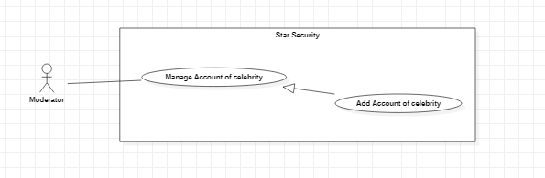

Figure 3.43.1 < Super-Moderator > Add an account of celebrity

|  |  |  |  |  |
| --- | --- | --- | --- | --- |
| USE CASE – UC42 | | | | |
| Use-case No. | UC42 | Use-case Version | | 1.0 |
| Use-case Name | Add an account of celebrity | | | |
| Author | Nong Quoc Linh | | | |
| Date | 19/03/2021 | Priority | Normal | |
| Actor:  - Moderator  Summary:   * This use case allows moderator to add an account of celebrity.   Goal:   * Moderator added an account of celebrity.   Triggers   * Moderator clicks “Add account” button   Preconditions:   * Guest logged in as Moderator.   Post Conditions:   * Success: Account added to list. * Fail*:* Show error message.   Main Success Scenario:   |  |  |  | | --- | --- | --- | | Step | Actor Action | System response | | 1 | - Moderator click “Add account” button | - System will show form:  + Account ID: textbox  + Social network: comboBox  “Add” button  “Cancel” button  Alternative[1]  Exception [1, 2,4] | | 2 | - Moderator click “Add” button | - System show confirm dialog  “OK” button  “Cancel” button Exception [1, 2,3]  Alternative[2] |   Alternative Scenario:   |  |  |  | | --- | --- | --- | | No | Actor Action | System response | | 1 | Moderator click “Cancel” | System return to dashboard | | 2 | Moderator click “Cancel” | System back to form add account |   Exceptions:   |  |  |  | | --- | --- | --- | | No | Actor Action | System response | | 1 | - Internet is not available | System shows message “No Internet connection found! Please try again” | | 2 | Moderator clicks “Add” many times, but nothing happen | System shows message “Unexpected error! Please try again” | | 3 | Moderator add duplicated accountID | System shows message “This account is existed in list” | | 4 | AccountID is empty | System shows message: “This field not allows empty” |   Relationships:   * Generalization from manage account of celebrity (Select Add group).   Business Rules:   * Super-moderator account must have Active status. * Data is always insert into database * Owner and username is name of celebrity who is support by their team | | | | |

## < Moderator> Remove account of celebrity

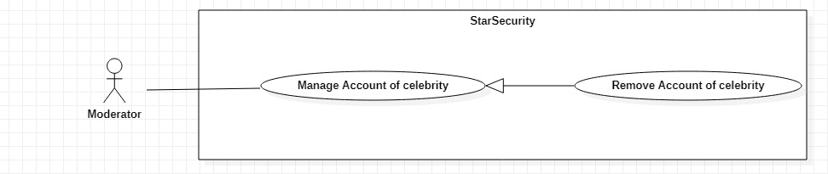 Figure 3.36.1 < Moderator > Remove account of celebrity

|  |  |  |  |  |
| --- | --- | --- | --- | --- |
| USE CASE – UC43 | | | | |
| Use-case No. | UC43 | Use-case Version | | 1.0 |
| Use-case Name | Remove account of celebrity | | | |
| Author | Nguyen Ngoc Tien | | | |
| Date | 18/03/2021 | Priority | Normal | |
| Actor:   * Moderator   Summary:   * This use case allows moderator to remove a account of celebrity   Goal:   * A account of celebrity has been removed   Triggers   * A moderator clicks “Remove account of celebrity” button   Preconditions:   * Guest logged in as moderator   Post Conditions:   * Success: A account of celebrity has been removed. * Fail: Show error message   Main Success Scenario:   |  |  |  | | --- | --- | --- | | Step | Actor Action | System Response | | 1 | Moderator click “Remove account” button | System show confirm dialog:   * “Remove” button * “Cancel” button | | 2 | Moderator click “Remove” button  Alternative[1] | System remove account of celebrity at social networks.  Exceptions[1] |   Alternative Scenario:   |  |  |  | | --- | --- | --- | | No | Actor Action | System Response | | 1 | Moderator click “Cancel” button | The system do nothing. |   Exceptions:   |  |  |  | | --- | --- | --- | | No | Actor Action | System Response | | 1 | Internet is not available | The system show dialog “Internet was interrupted. Please check your internet connection!” |   Relationships:   * Generalization from Manage account of celebrity   Business Rules:   * The moderator must have status is active * Remove account in the database | | | | |

## <Guest > Reset password

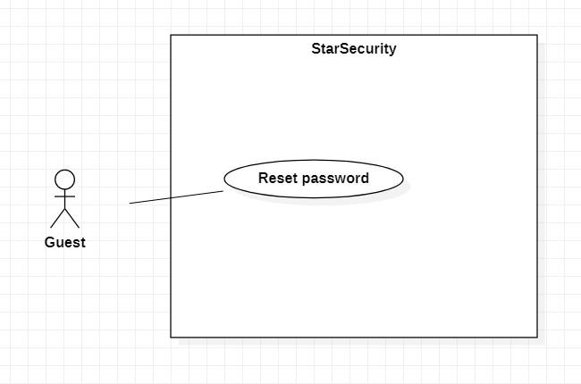

Figure 3.45.1 <Guest > Reset password

|  |  |  |  |  |
| --- | --- | --- | --- | --- |
| USE CASE – UC44 | | | | |
| Use-case No. | UC44 | Use-case Version | | 1.0 |
| Use-case Name | Reset password | | | |
| Author | Lam Tan Hai | | | |
| Date | 19/03/2021 | Priority | Normal | |
| Actor:   * Guest   Summary:   * This use case allows guest to reset password of their account   Goal:   * Account of user has been reset password.   Triggers   * A guest clicks “Reset password” button   Preconditions:   * None   Post Conditions:   * Success: A account of user has been reset password. * Fail: Show error message   Main Success Scenario:   |  |  |  | | --- | --- | --- | | Step | Actor Action | System Response | | 1 | Guest click “Reset password” button | System shows a form:   * Username: textbox   “Reset password” button  “Cancel” button  [Exception 1, 2, 3, 7] | | 2 | Guest click “Reset password” button  Alternative[1] | System send URL to reset password to email of account | | 3 | Guest clicks URL | System response to URL that allows guest to type new password  New password: text  “OK” button  “Cancel” button  Exception[1] | | 4 | Guest input new password and click “ok” button  Alternative[1] | System changes old password to new password and show messages “Change password successful”  Exception[1,2,3,4,5,6] |   Alternative Scenario:   |  |  |  | | --- | --- | --- | | No | Actor Action | System Response | | 1 | Guest clicks “Cancel” button | The system do nothing. |   Exceptions:   |  |  |  | | --- | --- | --- | | No | Actor Action | System Response | | 1 | Internet is not available | The system show dialog “Internet was interrupted. Please check your internet connection!” | | 2 | Connect to database fail | The system show dialog “System is maintaining. Please, comeback later.” | | 3 | Input field is empty | System show error message “This field is not allow empty” | | 4 | Length of Password is under 8 characters | System show error message “Length of Password must be 8 – 30 characters” | | 5 | Length of Password is over 30 characters | System show error message “Length of Password must be 8 – 30 characters” | | 6 | Password is included special character | System show error message “Password is included special characters” | | 7 | Username is not existed in database | System show message: “Invalid username” |   Relationships:   * None   Business Rules:   * After reset password, system redirect to login page. * Password is encrypted by SHA-256 * Update new password to database | | | | |

# NON-FUNCTIONAL Requirements

## Usability

* Normal user need less than one day to learn using features and familiarize with the interface.
* Admin, Super-moderator, Moderator need less than one week of training to be productive with the system.

## Reliability

* If the website goes down, the administrator has responsibility to restore the website in the shortest time.
* User accounts are not allowed to be transmitted over the network environment without being encrypted.
* The system immediately disconnects login after 3 incorrect entries.
* Compliance with safety according to the general standards of security of the world.
* Data is absolutely confidential.
* Data is updated daily

## Performance

* System working 24/24.
* Time responding of system should be less than 3 second.
* Limit the number of people accessing the website system 5000 Users.

## Supportability

- Support multiple browsers

## Design Constraints

* Back-end: C# .NET Core, restful API, Entity framework
* Front-end: Angular framework
* Database: SQL server

## On-line User Documentation and Help System Requirements

* The system shall provide a web page that explains how to navigate the site. This page should be customized based on what pages that user is allowed to access.
* This help page should be accessible from all other pages.

## Purchased Components

* Domain name registration.
* Purchase cloud hosting.
* Testing tools.
* IDE.

## Interfaces

### - The current database systems for data from crawl bot

### - The current data inventory system

### - The search tool

[Describe any communications interfaces to other systems or devices such as local area networks, remote serial devices, and so forth.]

## Licensing Requirements

- Business license.

## Legal, Copyright, and Other Notices

*(none)*

## Applicable Standards

* ISO/IEC 27001.
* ISO/IEC JTC 1.
* ISO 9126.

# Supporting Information

*[The supporting information makes the SRS easier to use. It includes:*

*Table of contents*

*Index*

*Appendices*

*These may include use-case storyboards or user-interface prototypes. When appendices are included, the SRS should explicitly state whether or not the appendices are to be considered part of the requirements.]*