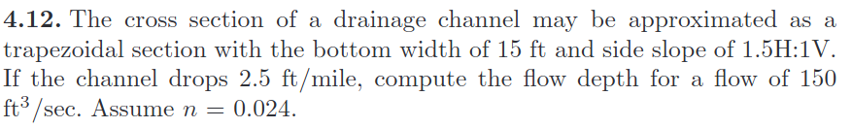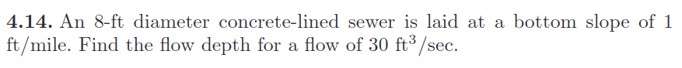**From: Open Channel Flow (H. Chaudhry)**

**F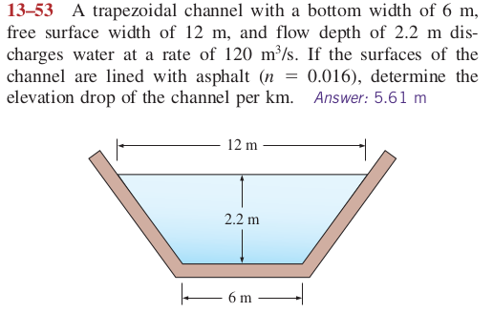rom: Fluids Mechanics (Cengel)**

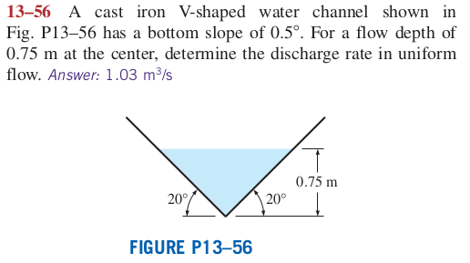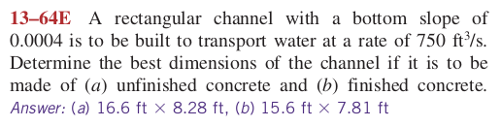

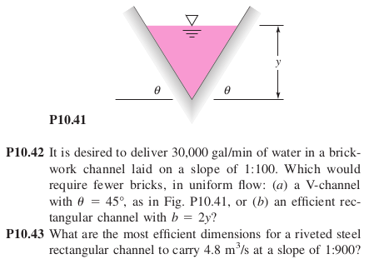**F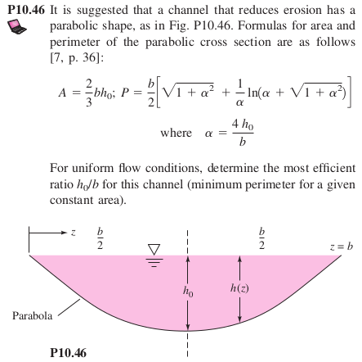rom: Fluids Mechanics (F. White)**