# **Assessment 2 – Investigation A Report (Histogram + Bars, with Terminal Conclusions)**

Dataset 1 path: D:\HIT140\HIT140_Assessment2_Submission\hit140_obj1_grp42\dataset1(1).csv

Date parsing: dayfirst=True (Australian format) applied after CSV read.

**Dataset 1 – key descriptives**

|  |  |  |  |  |  |  |  |  |
| --- | --- | --- | --- | --- | --- | --- | --- | --- |
|  | **count** | **mean** | **std** | **min** | **25%** | **50%** | **75%** | **max** |
| bat_landing_to_food | 907.0 | 11.713 | 27.644 | 0.01 | 1.0 | 4.0 | 11.5 | 443.0 |
| risk | 907.0 | 0.495 | 0.5 | 0.0 | 0.0 | 0.0 | 1.0 | 1.0 |
| reward | 907.0 | 0.534 | 0.499 | 0.0 | 0.0 | 1.0 | 1.0 | 1.0 |

Records: 907

## **Graph types used and why**

• Histogram (Figure 1) — lets me compare the full distribution of approach times (x: seconds; y: frequency) across risk groups.

• Bar charts (Figures 2 & 3) — show success-rate (proportion of reward=1) for each group; Figure 3 repeats the same data with the assignment-specific caption ‘Evidence of Predator Perception’.

Note: Figures 2 and 3 intentionally use the SAME values

## **Statistical results (formatted table)**

|  |  |  |  |  |  |  |
| --- | --- | --- | --- | --- | --- | --- |
| **Test** | **Variables** | **Statistic** | **p value** | **n** | **Interpretation** | **Graph** |
| Context (proportions) | success rate ~ risk group | avoid=84.3%, take=21.8% | Fisher=4.92e-85 | n0=458, n1=449 | Observed success proportions by group (same values in Fig 2 & Fig 3). | Bar chart |
| Mann–Whitney U | time-to-food ~ risk (0=avoid,1=take) | U=68002 | 8.43e-19 | n0=458, n1=449 | Non-parametric group difference in approach times. | Histogram (frequency) |

**Figure 1: Time to approach food by risk behaviour (histogram: frequency vs seconds)**

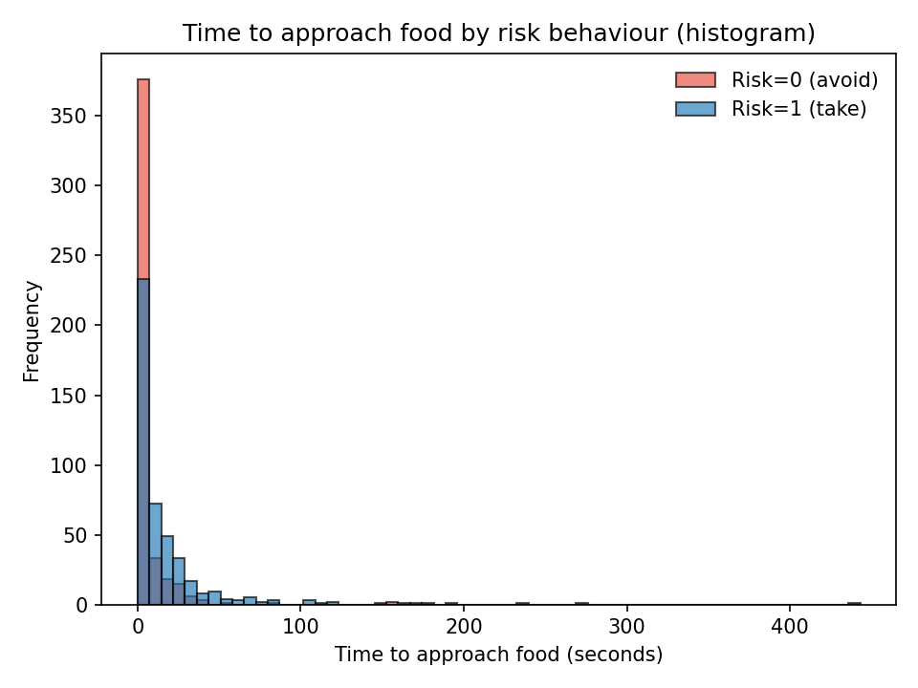

**Figure 2: Success rate by risk behaviour (bar graph)**

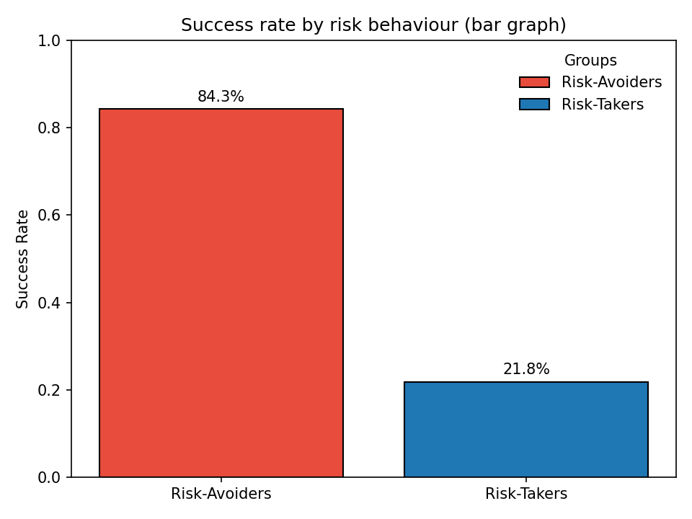

**Figure 3: Bat Success Rate – Evidence of Predator Perception (bar graph)**

