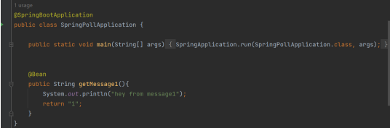

Qustion1:  
the output:  
hey from message1  
1  
  
Qustion2:  
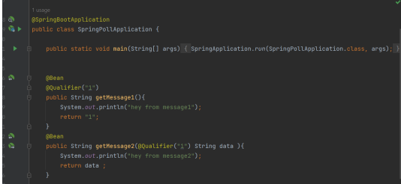  
  
the output:  
hay masseg1

hay masseg2  
reason: annotation @Qualifier(“1”) will give order to the method that have String ”1”,then it will go to the second method and print the message.

Qustion3:  
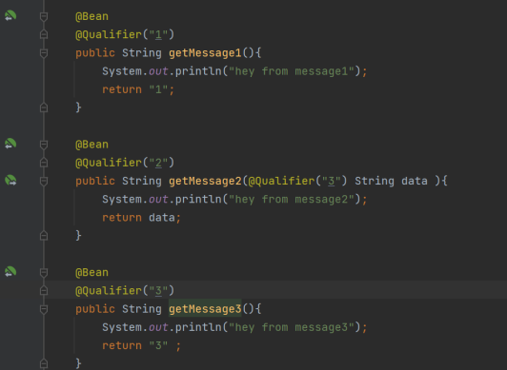  
  
  
 the output:  
hay masseg1

hey massege3

hay masseg2  
  
reason:@Qualifier will order the output based on @Qualifier notation , @Qualifier1 will go to the method1 that have @Qualifier “1”then will print the message then method2 that have String type parameter will print a message from method that have notation@Qualifier“3” and print the message , then the compiler will print the rest witch is message2.  
  
Qustion4:  
\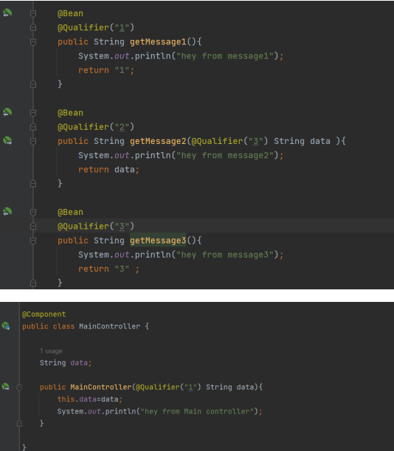

output:  
hay masseg1  
hey massege3

hay masseg2  
  
Qustion5:  
  
  
  
  
  
  
output:  
hay masseg1

hey massege3

hay masseg2