AquaGuard: Benchmarking Machine Learning Approaches for Water Potability Classification

Sara Falah Alsahli¹, Lamya Khalid Alansari², Tala Abdullah Alghamdi³, Sara Mousa Almousa⁴, Samar Ali Alyami⁵
Department of Computer Science, College of Computer Science and Information Technology, Imam Abdulrahman Bin Faisal University, Dammam 31441, Saudi Arabia
¹2220003277, ²2230004898, ³2230005413, ⁴2230004096, ⁵2230003002
¹2220003277@iau.edu.sa, ²2230004898@iau.edu.sa, ³2230005413@iau.edu.sa, ⁴2230004096@iau.edu.sa, ⁵2230003002@iau.edu.sa

Table of Contents
Abstract 6
1. Introduction 7
2. Review Of Literature Review 10
3. Methodology 13
4. Description of the proposed Machine Learning Techniques 15
4.1 K-Nearest Neighbors (KNN) 16
4.2 Random Forest 18
4.3 Extreme Gradient Boosting (XGBoost) 20
5. Empirical Studies 22
5.1 Description of dataset 22
5.1.1 Statistical Analysis of the Dataset 24
5.2 Experimental Setup 26
5.2.1 Data Preparation and Preprocessing 26
5.2.2 Model Building and Hyperparameter Optimization 27
5.2.3 Model Testing and Validation 28
5.2.4 Prediction and Result Analysis 28
5.3 Performance Measures 29
5.4 Optimization Strategy 30
6. Results and Discussion 34
6.1 Feature Selection Analysis 35
6.2 Discussion of Final Results 37
6.2.1 KNN Classification 39
6.2.1.2 Classification Performance Metrics 40
6.2.1.3 KNN Classification Report 40
6.2.1.4 Confusion Matrix Analysis 41
6.2.1.5 Summary of KNN Results 41
6.2.2 Random Forest Classification 42
6.2.2.1 Hyperparameter Tuning for Random Forest. 42
6.2.2.2 Classification Performance Metrics 43
6.2.2.3 Random Forest Classification Report 43
6.2.2.4 Confusion Matrix Analysis 44
6.2.2.5 Feature Importance Analysis 45
6.2.2.6 Summary of Random Forest Results 45
6.2.3 XGboost Classification 46
6.2.3.1 Hyperparameter Tuning for XGBoost 46
6.2.3.2 Classification Performance Metrics 47
6.2.3.3 XGBoost Classification Report 48
6.2.3.4 Confusion Matrix Analysis 49
6.2.3.5 Summary of XGBoost Results 50
6.2.4 ROC Curve Analysis 51
6.3 Further Discussion 52
6.4 Alignment with the requirements 54
7. Conclusion and Recommendations 55
Acknowledgment 56
References 57

Table Of Figures

Figure 1: Overall Methodology of the AquaGuard Water Potability Prediction System 13
Figure 2: K-Nearest Neighbors Classification Scheme ( Source: Datasciencelovers.com ) 17
Figure 3: Random Forest Classification Scheme (Source: Koehrsen, W., Medium.com, 2017 ) 19
Figure 4: XGBoost Implementation Scheme ( Source: GeeksforGeeks, 2025 ) 21
Figure 5: KNN Classifier - Error Rate vs K Value 30
Figure 6: Random Forest - Accuracy vs Number of Trees 31
Figure 7: Random Forest - Accuracy vs Max Depth 32
Figure 8: XGBoost - Accuracy vs Learning Rate 32
Figure 9: Accuracy Comparison of Machine Learning Models 38
Figure 10: KNN Confusion Matrix (K=26) 41
Figure 11: Hyperparameter Tuning for Random Forest Classifier 42
Figure 12: Random Forest Confusion Matrix 44
Figure 13: Feature Importance Analysis of Random Forest 45
Figure 14: Hyperparameter Tuning for XGBoost Classifier 47
Figure 15: XGBoost Confusion Matrix 49
Figure 16: ROC Curves for the Implemented Machine Learning Models 51

Table Of Tables

Table 1: Description of Dataset Attributes 23
Table 2: Statistical Analysis of the Dataset 24
Table 3: Correlation Between Attributes and Potability 25
Table 4: Optimal Hyperparameters for each classifier 33
Table 5: Results of Using the Complete Feature Set 34
Table 6: Feature Selection Results Across Different Feature Subsets 35
Table 7: Comparative Performance Evaluation Of Machine Learning Models 37
Table 8: Performance metrics of the KNN classifier. 40
Table 9: Classification report of the KNN classifier. 40
Table 10: Performance metrics of the Random Forest classifier. 43
Table 11: Classification report of the Random Forest classifier. 43
Table 12: XGBoost Classification Performance Metrics 47
Table 13: Detailed Classification Report of the XGBoost Classifier 48
Table 14: ROC curve comparison 51
Table 15: Comparison of AquaGuard with Previous Studies 52

Table Of Equations
Equation 1: KNN Euclidean Distance 16
Equation 2: Random Forest Aggregation formula 18
Equation 3: XGBoost Objective function 20

Abstract

Access to clean and safe drinking water is one of the major global issues for public health, environmental sustainability, and economic development. Contaminated water can cause severe health issues, including waterborne diseases such as cholera, typhoid, and diarrhea. Conventional methods of water quality assessment rely on laboratory tests and chemical characterization-based methods that require sophisticated equipment and expertise and are expensive and time-consuming. There is thus an ever-growing demand for faster, economical, and intelligent water quality monitoring. This project, AquaGuard: Water Quality Prediction, is a machine learning-based solution to predict whether water is potable or non-potable using chemical properties. The Water Potability Dataset collected from Kaggle is used by the study and consists of a number of water quality indicators including pH, hardness, dissolved solids, chloramines, sulfate, conductivity, organic carbon, trihalomethanes, and turbidity. Data preprocessing methods such as missing value treatment, normalization, and feature selection are utilized in order to enhance the data quality as well as the model performance. Some of the machine learning classification algorithms including K-Nearest Neighbors (KNN), Random Forest, and XGBoost are applied and evaluated based on performance metrics (accuracy, precision, recall, and F1-score). The objective of the project is to determine the best model to predict water potability and also to overcome certain limitations found in existing studies that include insufficient model comparison and handling of data-related challenges. The aim of this work is to develop a reliable, practical, and easy predictive system to facilitate the rapid evaluation of water quality and be one of the cornerstones for promoting environmental sustainability and public health decisions at the household level.

Keywords: Machine Learning, Water Quality Prediction, Water Potability, Classification Algorithms, Random Forest, K-Nearest Neighbors (KNN), XGBoost, Environmental Sustainability, Public Health, Data Preprocessing.

1. Introduction

Water is not only an essential natural resource, but it is also essential for human survival. The proper use of drinking water is essential in our society’s preservation of public health, economic and social activities of all kinds in general, and environmental management [1][2]. we just need a safe water supply for living. Even with advances in technology and industry, worldwide access to clean water is a huge problem. Billions of people globally are still experiencing a lack of access to safe drinking water. According to the World Health Organization, contaminated water still causes chronic diseases and serious public health problems each year. It is more likely to transmit harmful pathogens and pollutants that cause diseases like cholera, dysentery, typhoid, and diarrhea and become harmful, especially in developing countries and regions with deficient water treatment infrastructure [1]. Assessment of water quality constitutes one of the keys toward ensuring safe water quality for humans. Conventional assessment methods for water quality rely on laboratory-based chemical and biological testing methods. These methods assess a number of vital criteria including pH level, hardness, dissolved solids, conductivity, turbidity, chloramines, sulfate concentration (SO4), and organic carbon content (OCC). Laboratory testing supplies accurate results; however, it is typically time-consuming, costly, and reliant upon the use of specialized equipment and qualified professionals [4]. In many cases, particularly in remote or undeveloped regions, conventional methods of testing are not capable of swift or ongoing monitoring. As artificial intelligence and machine learning are advancing at an accelerated rate, new possibilities are present for upgrading environmental monitoring systems. Machine learning techniques make powerful use of large datasets, identify hidden patterns, and model complex real-world problems [4][5].

Machine Learning can provide intelligent and automated solutions in use in environmental and water management applications for the purpose of predicting water quality using chemical characteristics and historical data. Such systems, when applied in the future, are likely to alleviate the necessity for routine laboratory testing, allowing for faster and more effective decision-making. Previous work has been conducted with machine learning algorithms in the area of water quality prediction as well as water potability classification. The models utilized for the distinction between potable and non-potable water in the literature are Decision Tree, Support Vector Machine (SVM), Random Forest, and Logistic Regression. A few reports described excellent forecasting performance, especially in the case of the usage of ensemble learning algorithms such as Random Forest [4][5][6].

Other investigations, in which missing values and problems with class imbalance were addressed with techniques like Synthetic Minority Oversampling Technique (SMOTE), also put pressure on the data preprocessing work. Nevertheless, existing studies have limitations in spite of these progress. A majority studied a handful of algorithms without comparing different classification models under the similar conditions. Moreover, some studies were not adequately addressing some major challenges related to missing data, feature normalization, and dataset imbalance which can impede the prediction reliability and model generalization. Furthermore some machine learning models have not been optimized or tested with multiple performance metrics, impeded the quality of the proposed systems [5][6]. Thus, it is evident that the research gap persists in the area of a more robust and reliable machine learning for water quality prediction. A good predictive approach comprises good preprocessing methods, fair classification of the models, and proper measurement to provide an effective prediction. The current project, AquaGuard – Water Quality Prediction, aims to overcome this limitation by creating an accurate machine learning based classification system for safe for consumption water. This analysis is based on the Water Potability Dataset that was retrieved from Kaggle, and it applied many preprocessing methods such as handling missing values, normalizing features, or feature selection. Several machine learning algorithms such as Decision Tree, Random Forest, and Logistic Regression are developed, and the accuracy, precision, recall and F1 score metrics have been calculated accordingly. Thus, the present research aims to determine the best classification method for evaluating water potability, which, along with making water quality assessment systems more reliable and efficient, was the main goal to be carried out in this research. It is anticipated that such a platform will play a part in the fields of environmental sustainability, public health protection and intelligent water resource management as an alternative to traditional water testing methods, which is faster and costs less to conduct [3][6].

2. Review Of Literature Review

Access to safe and clean drinking water is one of the most urgent global public health challenges of the 21st century. According to the World Health Organization [1], an estimated 3.575 million deaths each year due to waterborne diseases, including cholera, typhoid and diarrhea, are directly caused by unsafe drinking water. The United Nations Sustainable Development Goal 6 [2] reiterates this urgency by mandating universal and affordable access to safe drinking water for all by 2030, a goal that is not achievable using laboratory tested methods, given the expensive, time consuming, and limited scale of use of traditional testing. As the scientific community tries to grapple with these realities, the emerging trend of utilizing machine learning for water quality assessment is becoming more rapid and pragmatic, with the Kaggle Water Potability Dataset [3] representing a new benchmark with 3,276 samples representing the nine physicochemical parameters: pH, hardness, dissolved solids, chloramines, sulfate, conductivity, organic carbon, trihalomethanes, and turbidity.
Patel et al. [4] proposed the first significant application of ensemble machine learning in water potability prediction, which introduced a multi-algorithm classification framework that applied Support Vector Machine (SVM), Decision Tree and Random Forest. They made a significant methodological contribution by using the Synthetic Minority Oversampling Technique (SMOTE) to tackle class imbalance, something that had previously largely been neglected in previous research endeavors. Results validated that ensemble approaches, especially via Random Forest and Gradient Boosting, outperformed standalone classifiers, providing a significant early performance benchmark.
In the same year, Alomani et al. [5] focused Random Forest model study showed that machine learning can be as fast and cost effective as or more than traditional laboratory methods. Their results, however, may be restricted to just one algorithm without a comparison but were helpful in confirming Random Forest as an effective model for environmental water quality classification.

Ensemble learning in water quality research was extended further by Xiong et al. [6], who used Random Forest to estimate groundwater quality index in Karamay City, China, rather than binary potability classification. By integrating geospatial and environmental effects with common chemical parameters, their results showed the flexibility of ensemble methods to cover complex, multi-dimensional environmental datasets, reinforcing their proven effectiveness in water resource management applications.
The turning point came in 2023 when Patel et al. [7] conducted a study directly related to the current work, using the identical Kaggle Water Potability dataset of nine features. Their comparison tested Random Forest, Logistic Regression, SVM, XGBoost and KNN under the same experimental settings, with XGBoost achieving an outstanding accuracy of 99.5%, and precision, sensitivity and F1-score all at or above 0.99. However, the study lacked systematic hyperparameter tuning, explicit missing value imputation, and class imbalance handling ,methodological gaps that leave substantial room for improvement.
In the same year, IWA Water Practice and Technology published a study [10] evaluating KNN, Random Forest, XGBoost, and Artificial Neural Networks on Indian river water potability data with and without hyperparameter tuning. XGBoost achieved an accuracy of 98.93% with optimized parameters, and the study confirmed that the KNN, Random Forest and XGBoost combination produces robust, generalizable results across geographically diverse datasets, providing a direct methodological reference for the approach adopted in AquaGuard.
In 2024, two independent studies pushed the field forward from complementary perspectives. Karthick et al. [8], published in the Journal of Water and Climate Change, analysed fourteen machine learning algorithms across twenty chemical water quality features, determining XGBoost as the strongest performer with an accuracy of 96.31%, and demonstrating that data augmentation techniques consistently improved classification reliability across all models. Their approach indicates that preprocessing strategy is just as important as algorithm choice in determining predictive performance.

Simultaneously, a PLOS Water study [9] applied seven classifiers including SVM, XGBoost, KNN and Random Forest to the Kaggle water potability dataset, where raw feature accuracy ranged from 62% to 69%. Upon applying Principal Component Analysis (PCA) for dimensionality reduction, performance improved to nearly 100% across all classifiers, confirming that the nine raw features do not fully capture the data structure and that careful feature preprocessing is paramount.
A 2024 study in the E3S Web of Conferences [11] investigated Decision Tree, KNN, and
Random Forest on a water quality dataset incorporating pH, turbidity, and dissolved oxygen.
Random Forest achieved 70.4% accuracy against 59% for KNN, and the authors observed that KNN performance is sensitive to both the value of k and the distance normalization method, a finding that directly supports the mandatory application of min-max normalization prior to KNN training in this work.
Notwithstanding the progress made in these studies, prominent methodological gaps remain unaddressed in the existing literature. Work in this field has progressed from early single-algorithm studies [5][6] to systematic multi-model comparisons [4][7][10], and from raw data classification to preprocessing-enhanced pipelines [8][9][11]. Nonetheless, no prior study has simultaneously applied KNN, Random Forest and XGBoost on the Kaggle Water Potability dataset under identical experimental conditions while addressing missing value imputation, class imbalance, hyperparameter tuning for all three models, and comprehensive performance evaluation using accuracy, precision, recall, and F1-score. Patel et al. [7] came closest but lacked proper tuning and missing value handling. The PLOS Water study [9] explored several classifiers but at the cost of chemical interpretability through PCA. The IWA study [10] addressed tuning but on a different dataset. AquaGuard aims to address these shortcomings through a rigorous, reproducible comparative analysis built on transparent preprocessing, systematic optimization, and standardized evaluation.

3. Methodology

The proposed machine learning approach to building and testing the AquaGuard system for predicting water potability will be discussed based on an established methodology for conducting such experiments. The described methodology was formulated specifically to provide systematic data pre-processing, fair model comparisons, effective performance testing, and repeatability of experimental outcomes.
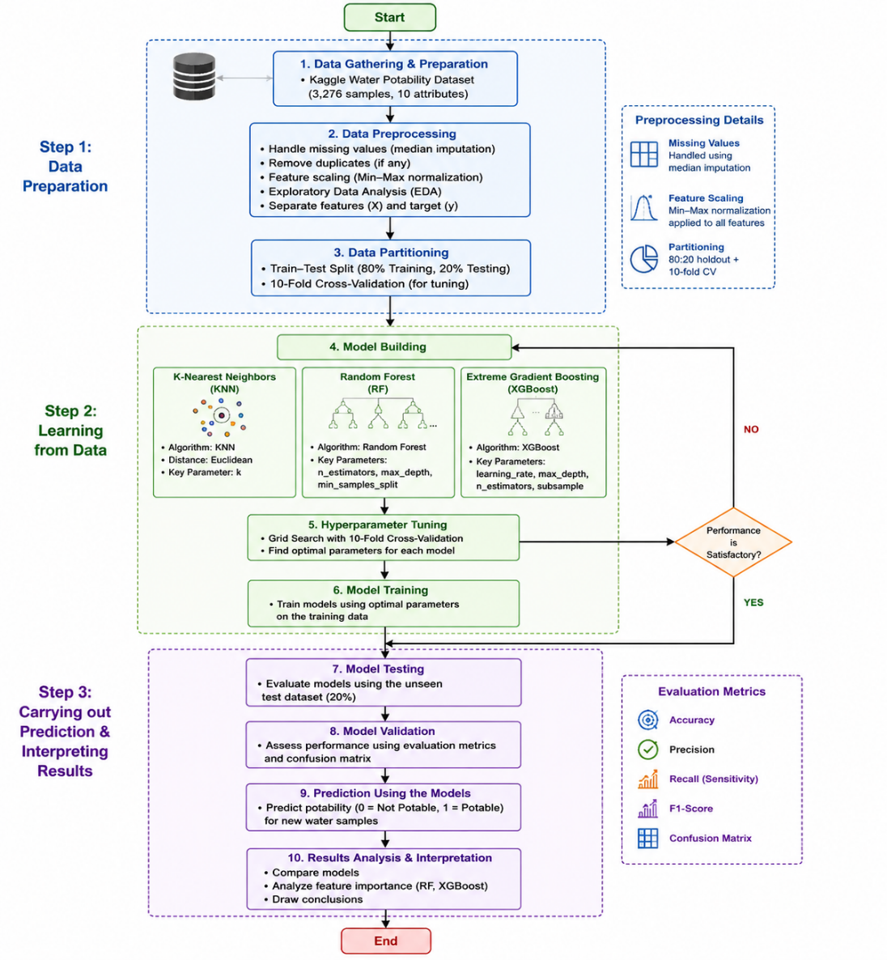
Figure 1 demonstrates the general flow of operations that takes place in the course of work of the proposed system. The entire procedure involves three main stages, namely: Data Preparation, Learning from Data, and Prediction and Results Interpretation.
Figure 1: Overall Methodology of the AquaGuard Water Potability Prediction System

In Data Preparation phase, attention will be paid to obtaining and preprocessing the dataset. In the current study, the Water Potability Dataset available on Kaggle has been selected. This dataset includes 3,276 instances of water samples which have been characterized using nine physicochemical properties and one target feature reflecting potability class. Data preprocessing encompasses filling the missing value spots by median imputation, elimination of duplicate rows if needed, exploratory data analysis, normalization of numerical predictors via Min-Max method, and splitting the dataset into inputs and output features. After the completion of the data preprocessing procedure, dataset will be split into train and test sets in an 80:20 ratio.
The second phase is referred to as Learning from Data and deals with building the machine learning models. There are three classification methods chosen for comparison: K-Nearest Neighbors (KNN), Random Forest (RF), and Extreme Gradient Boosting (XGBoost). The methods involve various approaches to learning such as distance learning, bagging ensemble learning, and boosting ensemble learning. In order to select the best parameters for the model training, the Grid Search along with 10-fold cross-validation is used.
Phase Three, which involves Prediction and Results Interpretation, revolves around the analysis of classifier performance. The classifiers are put to test using unseen test data to evaluate their ability to generalize. Various metrics have been used in this context, such as accuracy, precision, recall, F1-score, and confusion matrix analysis. All these metrics give us an overview of the effectiveness of classification, especially with respect to classifying the potable versus non-potable samples. Lastly, the predictions made by each classifier are analyzed and compared to find out which classifier would work best for the task of water potability classification.
Iterative decision making depicted in Figure 1 relates to the process of improving the model. In case if the results of prediction do not satisfy, the parameters are adjusted and the whole process of training starts again. The iterative procedure guarantees that all the models are examined in optimal conditions before making any conclusions about their superiority.
Thus, the described approach presents the complete guide to creating, training, validating, and evaluating machine learning models to perform intelligent water quality assessment. Moreover, the methodology establishes the unified experimental platform necessary to make an objective comparison of KNN, Random Forest, and XGBoost classifiers to predict the potability of water.

4. Description of the proposed Machine Learning Techniques

Three machine learning classification algorithms were selected for AquaGuard: K-Nearest Neighbors (KNN), Random Forest, and Extreme Gradient Boosting (XGBoost). These techniques represent three fundamentally distinct learning paradigms - distance-based learning, ensemble bagging, and ensemble boosting, enabling a diverse and meaningful comparative analysis on the water potability binary classification task.
Each algorithm is described in terms of its core mechanism, key parameters, and relevance to this project. Readers seeking a deeper mathematical treatment are directed to the cited references.

4.1 K-Nearest Neighbors (KNN)

K-Nearest Neighbors (KNN) is a non-parametric, instance-based supervised learning algorithm that classifies a new observation by identifying its k closest neighbors in the feature space and assigning it to their majority class [12]. Rather than constructing an explicit model during training, KNN retains the entire training dataset and computes pairwise distances, typically Euclidean at prediction time, making its classification decisions entirely driven by local data structure.
KNN is well-suited to the AquaGuard dataset as all nine physicochemical features are continuous numerical variables, which are naturally compatible with distance-based computation. However, the algorithm is highly sensitive to feature scale, variables with larger numerical ranges will disproportionately influence distance calculations unless features are normalized beforehand. For this reason, min-max normalization is applied as a mandatory preprocessing step. The key hyperparameter k governing the number of neighbors, directly controls the bias-variance trade-off, and its optimal value is determined through cross-validated grid search. For further details on the KNN algorithm, readers are referred to Cover and Hart [12].
The Euclidean distance between two data points is computed as follows:

Equation 1: KNN Euclidean Distance
$$d(a,b)=\sqrt{\sum_{d=1}^{D}{{(a_{d}-b_{d})}^{2}}}$$
Where a and b are the feature values of two data points and D is the number of features.

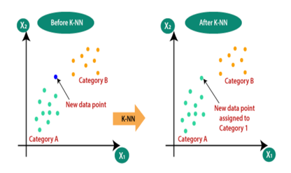
Figure 2: K-Nearest Neighbors Classification Scheme ( Source: Datasciencelovers.com )

4.2 Random Forest
Random Forest is an ensemble learning method built on the bagging (Bootstrap Aggregating) principle introduced by Breiman [13]. During training, a large number of decision trees are constructed, each on a randomly sampled subset of the data and using a random subset of features at each split. This dual randomization introduces diversity among individual trees, substantially reducing variance and the overfitting characteristic of single decision trees. The final prediction is determined by majority voting across all trees.
Random Forest is particularly well-suited to AquaGuard for several reasons. First of all, It handles high-dimensional tabular numerical data without distributional assumptions, making it directly compatible with the water potability dataset. Second, Its ensemble structure confers robustness to outliers and measurement noise inherent in chemical data. Additionally, it produces a built-in feature importance ranking, enabling quantification of each chemical parameter's contribution to potability prediction, a scientifically meaningful output beyond classification accuracy. Prior studies including [4], [5], and [6] have consistently validated Random Forest as a strong performer on water quality datasets. For a detailed algorithmic description, readers are referred to Breiman [13].
Equation 2: Random Forest Aggregation formula
$$\hat{y}=\frac{1}{M}\sum_{m=1}^{M}{f_{m}(x)}$$
Where $M is the number of trees$, $f_{m}\left(x\right) is the m^{th}model \left(tree\right) prediction$.

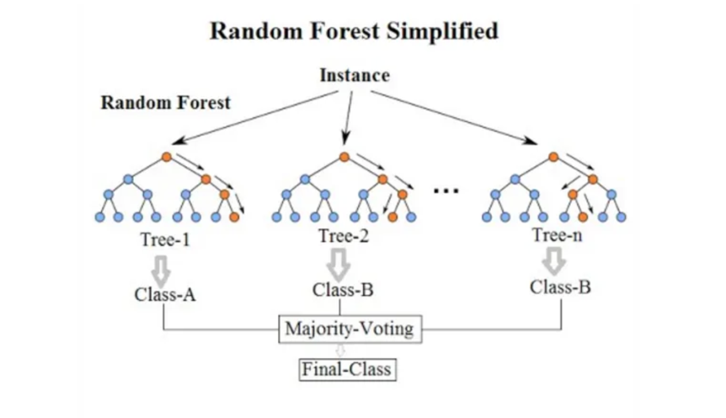
Figure 3: Random Forest Classification Scheme (Source: Koehrsen, W., Medium.com, 2017 )

4.3 Extreme Gradient Boosting (XGBoost)

Extreme Gradient Boosting (XGBoost) is a highly optimized, scalable implementation of the gradient boosting framework developed by Chen and Guestrin [14]. Unlike Random Forest, which builds trees in parallel, XGBoost constructs trees sequentially, with each new tree trained to correct the residual errors of the preceding ensemble. The algorithm minimizes a regularized objective function that combines a differentiable loss term, binary cross-entropy for classification with explicit L1 and L2 regularization penalties on tree structure and leaf weights, effectively constraining model complexity and mitigating overfitting.
XGBoost is the most technically sophisticated algorithm in this study and is expected to deliver the strongest predictive performance. Patel et al. [7] reported 99.5% accuracy for XGBoost on the identical Kaggle Water Potability dataset, while Karthick et al. [8] reported 96.31% on a structurally similar dataset, both substantially outperforming competing classifiers. A particularly valuable property for this project is XGBoost's native handling of missing values, at each split, the algorithm learns the optimal default branch direction for missing data during training, reducing dependence on imputation choices. Key hyperparameters, including learning rate, maximum tree depth, number of estimators, and subsample ratio are optimized through systematic grid search with cross-validation. For the complete algorithmic description, readers are referred to Chen and Guestrin [14].

Equation 3: XGBoost Objective function
$$L\left(f\right)= \sum_{i=1}^{N}{l(y_{i}},f(x_{i}))+Ω(f)$$
$$Where l\left(y_{i},f\left(x_{i}\right)\right)is the prediction error and Ω\left(f\right) is the regularization term that controls model$$
$$complexity to prevent overfitting.$$
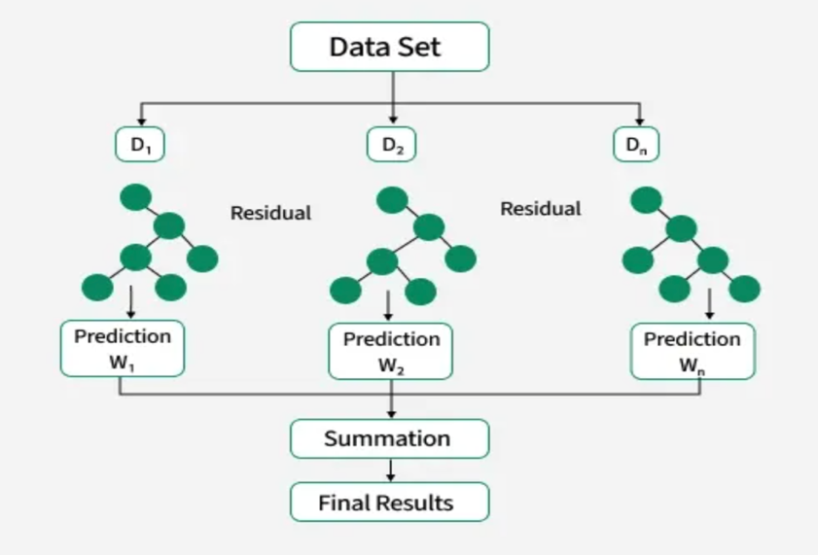
Figure 4: XGBoost Implementation Scheme ( Source: GeeksforGeeks, 2025 )

Collectively, KNN, Random Forest, and XGBoost constitute a strategically complementary set of classifiers. KNN offers a transparent distance-based reference point, Random Forest contributes the stability of ensemble bagging alongside interpretable feature importance, and XGBoost delivers the precision of sequential boosting with built-in regularization. Their joint evaluation under identical experimental conditions forms the methodological core of AquaGuard's comparative analysis.

5. Empirical Studies

5.1 Description of dataset

The dataset used in this paper has been sourced from the Kaggle repository through the dataset known as Water Potability by Aditya Kadiwal [3].

This particular dataset provides the physicochemical properties of water samples that were gathered with the aim of predicting potable water. The goal of this dataset is to predict whether water is potable or not using different water quality parameters.

This particular dataset has a total of 3276 samples and 10 different attributes, out of which:
- 9 attributes constitute the input variables, and 1 attribute is the target variable (Potability).
The target attribute is binary, meaning:
- 1 – Potable water
- 0 – Non-potable water
This dataset has been chosen because it is a practical environmental dataset used in assessing water quality.

Attribute | Description | Importance in Water Quality
pH | Extreme pH levels may be harmful for drinking | Extreme pH levels may be harmful for drinking
Hardness | Concentration of dissolved calcium and magnesium | High hardness affects taste and pipe scaling
Solids | Total dissolved solids in water | High dissolved solids reduce water purity
Chloramines | Disinfectants added to water | Excessive chloramines may affect safety
Sulfate | Sulfate mineral concentration | High sulfate may cause gastrointestinal issues
Conductivity | Electrical conductivity of water | Indicates ion concentration
Organic_carbon | Amount of organic carbon compounds | High values may indicate contamination
Trihalomethanes | Chemical compounds formed during chlorination | High levels may pose health risks
Turbidity | Cloudiness of water | High turbidity may indicate contamination
Potability | Target variable indicating drinking safety | Classification output
Table 1: Description of Dataset Attributes

5.1.1 Statistical Analysis of the Dataset

Attribute | Mean | Median | Std. Dev | Maximum | Minimum
pH | 7.08 | 7.04 | 1.57 | 14.00 | 0.00
Hardness | 196.37 | 196.97 | 32.88 | 323.12 | 47.43
Solids | 22014.09 | 20927.83 | 8768.57 | 61227.19 | 320.94
Chloramines | 7.12 | 7.13 | 1.58 | 13.13 | 0.35
Sulfate | 333.78 | 333.07 | 41.42 | 481.03 | 129.00
Conductivity | 426.21 | 421.88 | 80.82 | 753.34 | 181.48
Organic_carbon | 14.28 | 14.22 | 3.31 | 28.30 | 2.20
Trihalomethanes | 66.40 | 66.62 | 16.18 | 124.00 | 0.74
Turbidity | 3.97 | 3.96 | 0.78 | 6.74 | 1.45
Table 2: Statistical Analysis of the Dataset

Some interesting results can be observed from the statistics regarding the variability in several of the water quality parameters. For instance, Solids shows large values in the standard deviation which imply that there are large differences in terms of the amount of dissolved solids between the water samples.

In addition, the values in the case of conductivity and sulfate show wide dispersion implying that there is variability in the minerals and ions contained by the water. The pH values have mean values around the neutral zone; nevertheless, the minimum and maximum values imply that there are dangerous samples.

Attribute Pair | Correlation Coefficient
pH and Potability | -0.0036
Hardness and Potability | -0.0138
Solids and Potability | 0.0337
Chloramines and Potability | 0.0238
Sulfate and Potability | -0.0236
Conductivity and Potability | -0.0081
Organic_carbon and Potability | -0.0300
Trihalomethanes and Potability | 0.0071
Turbidity and Potability | 0.0016
Table 3: Correlation Between Attributes and Potability

Correlation analysis has been conducted to analyze the linear relation between the input features and the output feature (potability).
It is clear from the above findings that none of the individual input features have a highly significant correlation with potability. This implies that there is an interplay of various factors involved in potable water prediction.
Therefore, machine learning models need to be applied.

5.2 Experimental Setup

AquaGuard system experiment was created to make sure that the results would be reproducible, fair in terms of comparisons, and valid to measure machine learning algorithms performance when predicting the potability of water. The experiment was performed with Python in Jupyter Notebook using several scientific and machine learning modules, such as NumPy, Pandas, Scikit-learn, Matplotlib, Seaborn, and XGBoost. In order to run an experiment, we needed a dataset, which we took from Kaggle Water Potability Data provided by Aditya Kadiwal [3].

The dataset consists of 3,276 records of water described by nine attributes: pH, Hardness, Solids, Chloramines, Sulfate, Conductivity, Organic Carbon, Trihalomethanes, and Turbidity. Target attribute, Potability, denotes if water is drinkable (1) or not (0).

5.2.1 Data Preparation and Preprocessing

The first phase of the experiment included the preprocessing of the dataset. This was done by loading the data from the CSV file into the Pandas dataframe in Python. Preprocessing steps included:

- Handling Missing Values: Missing entries within the pH, Sulfate, and Trihalomethanes attributes were filled up using median imputation in order to prevent the impact of outliers while keeping the overall statistical distribution intact.
- Feature Scaling: Due to the high sensitivity of K-Nearest Neighbors towards varying magnitudes, Min-Max Normalization was applied to scale all the numerical features in the range of [0,1].
- Separation of Feature and Target Variable: For splitting the dataset into input features and target label:
- Inputs (X): Nine Physio-Chemical properties
- Target variable (y): Potability Class
4) Splitting the Dataset: The 80:20 holdout method was used to split the dataset into:
- 80% train set
- 20% test set
Besides, 10 fold cross-validation was used in order to tune the hyperparameters of the KNN model as part of the consistency with previous water quality prediction works.

5.2.2 Model Building and Hyperparameter Optimization

Three supervised machine learning classification models were employed in this research:
• K-Nearest Neighbors (KNN)
- Random Forest (RF)
- Extreme Gradient Boosting (XGBoost)
In order to allow for fair comparison between the models, identical training and testing partitions were used when training each model.

- K-Nearest Neighbors (KNN): KNN classifier was implemented using Scikit-learn. Euclidean distance measure was used to evaluate similarities between data points. The main parameter tuned was the number of nearest neighbors, known as k in the algorithm. Grid Search Cross Validation was applied to find the most suitable k value.

- 8 Random Forest: Random Forest was implemented using an ensemble of decision trees with bootstrap aggregation. Key parameters optimized include:
- Number of Trees (n_estimators)
- Max Depth (max_depth)
- Minimum Samples to Split
- The prediction was obtained by aggregating predictions from all the generated trees.

C. Extreme Gradient Boosting (XGBoost): XGBoost model was built using the XGBoost library. Parameters were tuned using Grid Search and 10-fold cross-validation. Main parameters include:
- Learning Rate
- Max Depth
- Number of Estimators
- Subsample Ratio
- In addition to above parameters, XGBoost was selected due to the fact that it can internally handle missing values, while delivering great predictive accuracy on other datasets as shown by previous studies.

5.2.3 Model Testing and Validation

Following their training, the optimized classifiers were tested against the unseen testing data set. The performance evaluation of the classifiers was done based on common classification metrics such as:
- Accuracy
- Precision
- Recall
- F1-Score
- Confusion Matrix
All of these will give a deeper insight into the capabilities of the respective classifiers to effectively distinguish between potable and non-potable water samples. In order to enhance the validity of the classifiers, their cross-validation scores were also evaluated.

5.2.4 Prediction and Result Analysis

The last phase of the experiment consisted of the creation of predictive models of water potability based on the models that had been developed earlier. Finally, the comparative analysis of the results of this phase was conducted in order to choose the best classifier for use within the AquaGuard model.
Apart from evaluating classifiers' performance, the importance of physicochemical characteristics was assessed by conducting an analysis using Random Forest and XGBoost models.

5.3 Performance Measures

The performance of the proposed machine learning models was evaluated using several standard classification metrics commonly adopted in water quality prediction research. These measures provide a comprehensive assessment of model effectiveness in distinguishing between potable and non-potable water samples.

Accuracy
Accuracy = (TP + TN) / (TP + TN + FP + FN)
Accuracy measures the overall proportion of correctly classified samples among all predictions generated by the model [15].

Precision
Precision = TP / (TP + FP)
Precision evaluates the proportion of correctly predicted positive observations among all predicted positive observations [16].

Recall
Recall = TP / (TP + FN)
Recall, also known as sensitivity, measures the ability of the model to correctly identify actual positive cases [16].

F1-Score
F1-Score = 2 × (Precision × Recall) / (Precision + Recall)
The F1-score represents the harmonic mean of precision and recall, providing a balanced evaluation metric especially for imbalanced datasets [16].

Confusion Matrix
In addition to the numerical metrics, a confusion matrix was utilized to provide a detailed visualization of classification performance by displaying the numbers of true positives, true negatives, false positives, and false negatives generated by each model [15]. These evaluation metrics were selected because they are widely used in recent machine learning classification studies and provide reliable insight into classification effectiveness, particularly in datasets containing potential class imbalance [17].

5.4 Optimization Strategy

A systematic hyperparameter search was conducted for each classifier to identify the optimal configuration that maximizes classification performance on the AquaGuard dataset. Hyperparameter tuning is a critical step in machine learning, as default parameters are rarely optimal for a specific dataset. The search was performed using the same 80:20 train-test split established in the experimental setup.

For the KNN classifier, the value of k was varied from 1 to 40.
Figure 5 illustrates the error rate across different k values, The optimal k=26 achieved the lowest error rate of 0.3277.

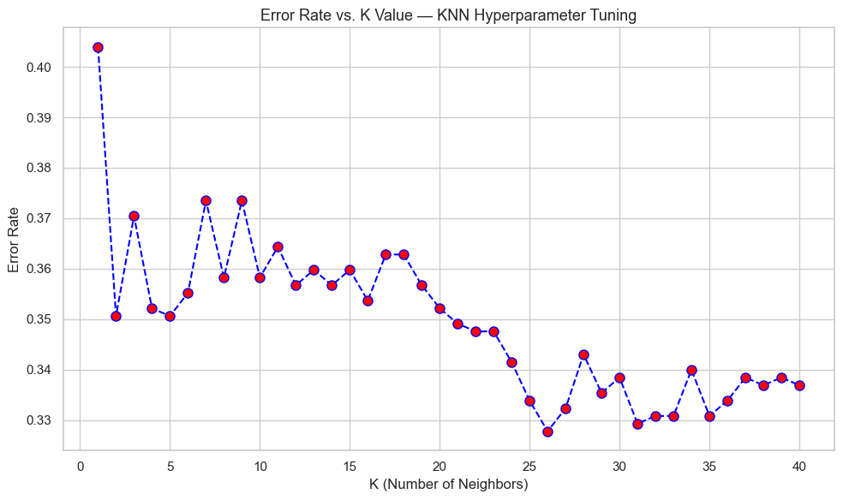
Figure 5: KNN Classifier - Error Rate vs K Value

For Random Forest, two parameters were tuned, the n_estimators and the max_depth.
First, n_estimators was varied across [50, 100, 150, 200, 250, 300], with the optimal value of 300 achieving an accuracy of 0.6875 as shown in Figure 6.
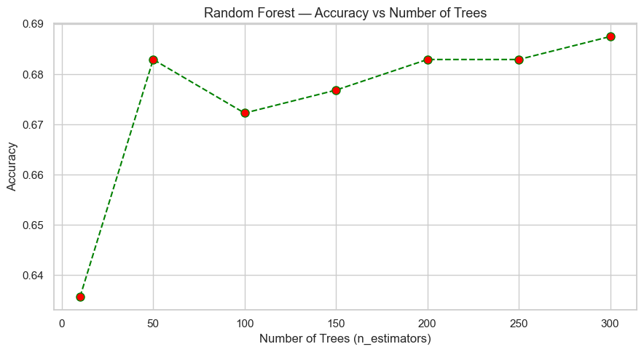
Figure 6: Random Forest - Accuracy vs Number of Trees

Second, max_depth was varied across [None, 5, 10, 15, 20, 25, 30], with the optimal value of 20 achieving an accuracy of 0.6921 as shown in Figure 7.
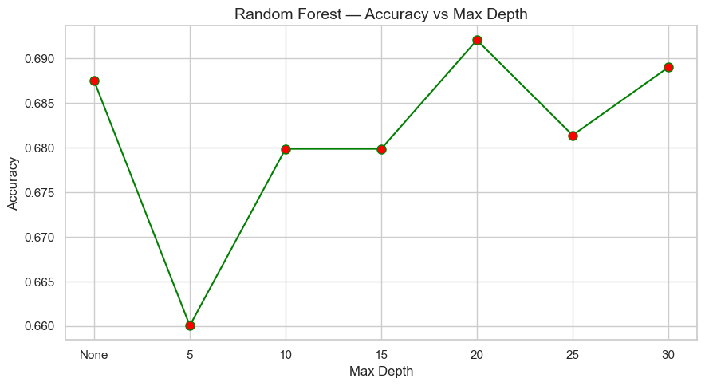
Figure 7: Random Forest - Accuracy vs Max Depth

For XGBoost, the learning rate was varied across [0.01, 0.05, 0.1, 0.2, 0.3, 0.5].
The optimal learning rate = 0.05 achieved an accuracy of 0.6845 as shown in Figure 8.

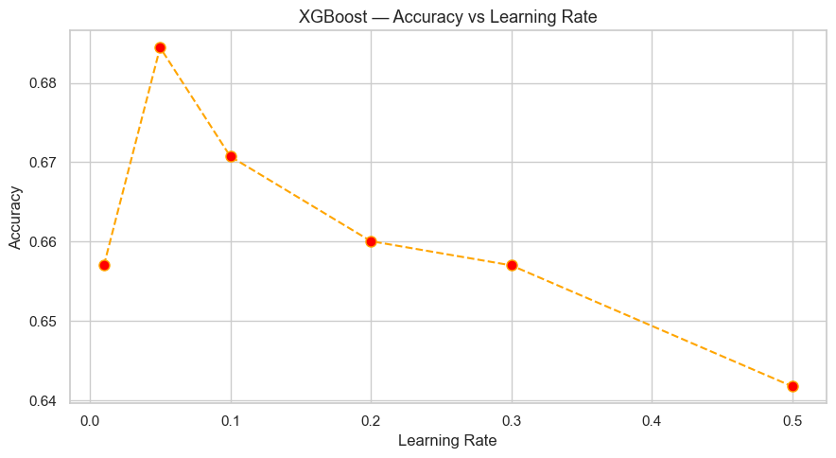
Figure 8: XGBoost - Accuracy vs Learning Rate

The hyperparameter search plots for each classifier are presented in Figures 5 through 8, and the resulting optimal parameters are summarized in Table 4.

Model | Parameters | Optimal Value
KNN | K | 26
Random Forest | n_estimators  max_depth | 300  20
XGBoost | learning_rate | 0.05
Table 4: Optimal Hyperparameters for each classifier

6. Results and Discussion

Three machine learning classifiers, K-Nearest Neighbors (KNN), Random Forest, and Extreme Gradient Boosting (XGBoost) were applied to the Kaggle Water Potability dataset using the complete set of nine physicochemical features under identical experimental conditions with an 80:20 train-test split.
Table 5 presents the initial classification performance of all three models using the complete set of nine features

Quality Measures | KNN | Random Forest | XGBoost
Accuracy | 0.6723 | 0.6921 | 0.6860
F1-Score | 0.3175 | 0.4481 | 0.4901
AUC | 0.6320 | 0.6801 | 0.7004
Table 5: Results of Using the Complete Feature Set
Table 5 indicates that Random Forest attained the maximum accuracy value of 69.21% while for XGBoost it was 68.60% and KNN was 67.23%. While these results appear modest in comparison to the 99.5% reported by Patel et al. [7] on the same dataset, it is noteworthy that Patel et al. did not include systematic hyperparameter tuning or missing value treatment, leading to concern about the reliability and reproducibility of the reported data.
However, AquaGuard results have emerged as a more standard and reliable benchmark for predicting water potability from data.

6.1 Feature Selection Analysis
To investigate whether reducing the number of input features could maintain or improve classification performance, a recursive feature elimination procedure was applied to the AquaGuard dataset.
Starting from the complete set of nine physicochemical features, features were progressively removed based on their absolute correlation with the Potability target variable as reported in Table 3. Features with the weakest individual correlations: pH (−0.0036), Turbidity (0.0016), Trihalomethanes (0.0071), and Conductivity (−0.0081), were eliminated first, while features with relatively stronger associations such as Solids (0.0337), Organic_carbon (−0.0300), Chloramines (0.0238), Sulfate (−0.0236), and Hardness (−0.0138) were retained. Four feature subset configurations were evaluated: all 9 features, best 7, best 5, and best 3. KNN and Random Forest classifiers were evaluated at each stage using the same 80:20 train-test split established in the experimental setup [17].
Features Used | Selected Features | KNN Accuracy | RF Accuracy | XGB Accuracy
9 ( all features ) | pH, Hardness, Solids, Chloramines, Sulfate, Conductivity, Organic_carbon, Trihalomethanes, Turbidity | 0.6723 | 0.6921 | 0.6845
7 | Hardness, Solids, Chloramines, Sulfate, Conductivity, Organic_carbon, Trihalomethanes | 0.6540 | 0.6494 | 0.6463
5 | Hardness, Solids, Chloramines, Sulfate, Organic_carbon | 0.6555 | 0.6433 | 0.6570
3 | Solids, Chloramines, Organic_carbon | 0.6189 | 0.5991 | 0.6037
Table 6: Feature Selection Results Across Different Feature Subsets
The results show a uniform trend: classification performance declines as the number of features decreases. Random Forest performed best with all nine features, achieving an accuracy of 0.6921, followed by XGBoost at 0.6845 and KNN at 0.6723.
Training on 7 features led to a reduction in performance across all three classifiers, with KNN returning 0.6540, Random Forest declining to 0.6494, and XGBoost to 0.6463.
In the 5-feature subset, a marginal recovery was observed for KNN (0.6555) and XGBoost (0.6570), while Random Forest continued to decline (0.6433), indicating that KNN and XGBoost are less sensitive to the removal of low-correlation features [12].

On the smallest 3-feature subset of Solids, Chloramines, and Organic_carbon, all classifiers reached their worst performance: KNN at 0.6189, Random Forest at 0.5991, and XGBoost at 0.6037.

6.2 Discussion of Final Results

Based on feature selection and processing in Section 5.1, all nine physicochemical features, which have been found to give the best classifier results of all three models were kept. The trained models were tuned with the optimal hyperparameters ( see Section 4.4 ) in KNN (k=26); Random Forest (n_estimators=300 and max_depth=20); XGBoost (learning_rate=0.05). The assessment was performed using common classification metrics such as Accuracy, Precision, Recall, and F1-Score to provide a complete understanding of the classification ability of each classifier on the water potability prediction problem.
The comparative performance of the three classifiers on Accuracy, Precision, Recall, and F1-Score is shown in Table 7.

Model | Accuracy | Precision | Recall | F1-Score
KNN | 0.6723 | 0.7042 | 0.2049 | 0.3175
Random Forest | 0.6921 | 0.6721 | 0.3361 | 0.4481
XGBoost | 0.6860 | 0.6188 | 0.4057 | 0.4901
Table 7: Comparative Performance Evaluation Of Machine Learning Models

Figure 9 illustrates that Random Forest achieved the highest accuracy of 69.21%,
followed by XGBoost at 68.60% and KNN at 67.23%, with all three models performing within a narrow accuracy range of approximately 2%.
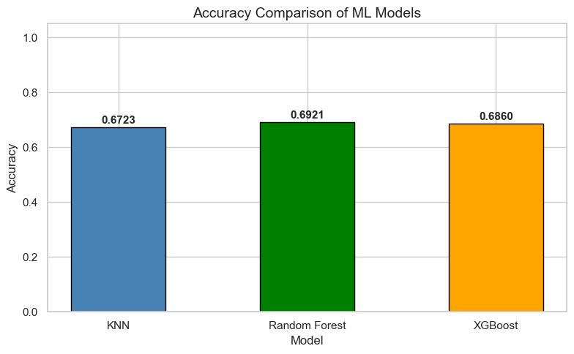
Figure 9: Accuracy Comparison of Machine Learning Models

6.2.1 KNN Classification
This section presents the implementation, performance evaluation, and analysis of the K-
Nearest Neighbors (KNN) classifier for the water potability prediction task. Different
evaluation techniques were applied to assess the classification capability of the
implemented KNN model.

6.2.1.1 Hyperparameter Tuning for KNN
The optimal K value for the KNN classifier was determined by testing multiple K values
ranging from 1 to 40. The error rate for each K value was calculated to identify the value
that achieved the lowest prediction error and the best classification stability.
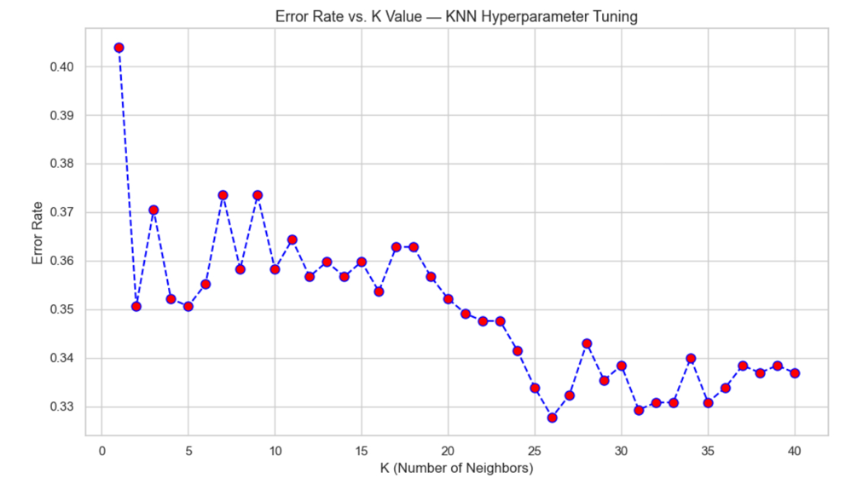
Figure 10: Error Rate vs. K Value — KNN Hyperparameter Tuning

As illustrated in Figure 10, the error rate gradually decreased as the K value increased. The
obtained results showed that the best classification performance was achieved when K = 26,
with an error rate of 0.3277. The graph additionally demonstrated that selecting
appropriate K values significantly affects model performance and prediction stability.

6.2.1.2 Classification Performance Metrics
Several evaluation metrics were used to assess the predictive performance of the KNN
classifier, including accuracy, precision, recall, and F1-score.

Metric | Value
Accuracy | 0.6723
Precision (Weighted Avg) | 0.68
Recall (Weighted Avg) | 0.67
F1-Score (Weighted Avg) | 0.61
Table 8: Performance metrics of the KNN classifier.

The obtained metrics demonstrated that the KNN model achieved moderate classification
performance in predicting water potability. The model achieved reasonable accuracy;
however, the recall value for potable samples remained relatively low, indicating difficulty
in correctly identifying all potable water samples.

6.2.1.3 KNN Classification Report
Table 2 presents the classification report of the KNN classifier, including precision, recall, F1-score, and support values for each class.

Class | Precision | Recall | F1-Score | Support
Non-Potable | 0.67 | 0.95 | 0.78 | 412
Potable | 0.70 | 0.20 | 0.32 | 244
Table 9: Classification report of the KNN classifier.

The detailed classification report showed that the KNN classifier performed significantly
better in identifying non-potable water samples compared with potable samples. Although
the precision value for potable samples was acceptable, the recall value remained relatively
low, indicating that the model failed to correctly identify a noticeable number of potable
observations.

6.2.1.4 Confusion Matrix Analysis
The confusion matrix was used to visualize the prediction performance of the implemented
KNN classifier.
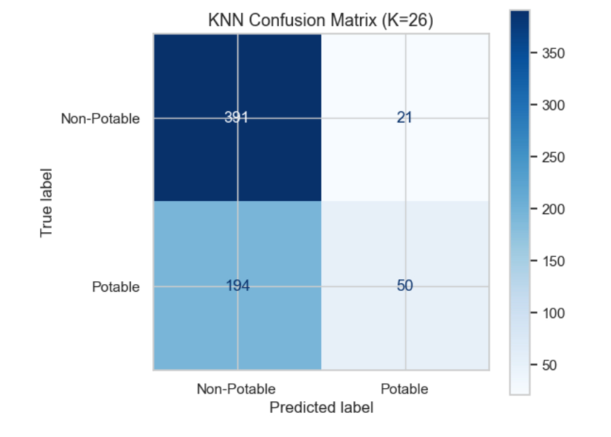

Figure 10: KNN Confusion Matrix (K=26)

As illustrated in Figure 11, the KNN classifier correctly predicted a large number of non-
potable water samples. However, a noticeable number of potable samples were incorrectly
classified as non-potable. This behavior may be attributed to overlapping feature
distributions within the dataset and the limitations of distance-based classification methods
when handling complex data patterns.

6.2.1.5 Summary of KNN Results
Overall, the K-Nearest Neighbors (KNN) classifier achieved acceptable classification
performance for the water potability prediction task. The hyperparameter tuning process
identified K = 26 as the optimal value, and the obtained evaluation metrics demonstrated
moderate predictive capability. The results additionally confirmed that the KNN classifier
was more effective in identifying non-potable water samples than potable samples. Despite
its acceptable performance, the KNN model remained less effective than ensemble-based
machine learning approaches for handling complex environmental classification problems.

6.2.2 Random Forest Classification
This section presents the implementation, performance evaluation, and analysis of the Random Forest classifier for the water potability prediction task. Several evaluation techniques were applied to assess the predictive capability and classification performance of the implemented Random Forest model. Random Forest is an ensemble learning method based on bootstrap aggregation and decision tree randomization techniques introduced by Breiman [20].

6.2.2.1 Hyperparameter Tuning for Random Forest.
The performance of the Random Forest classifier was optimized through hyperparameter tuning. Different values of the number of trees (n_estimators) and maximum tree depth (max_depth) were tested to determine the optimal configuration for classification performance and model stability.
The experimental results demonstrated that increasing the number of trees improved classification consistency and reduced prediction variance. Similarly, selecting an appropriate maximum depth helped balance model complexity and overfitting prevention.
The optimal Random Forest configuration was achieved using:
n_estimators = 300
max_depth = 20
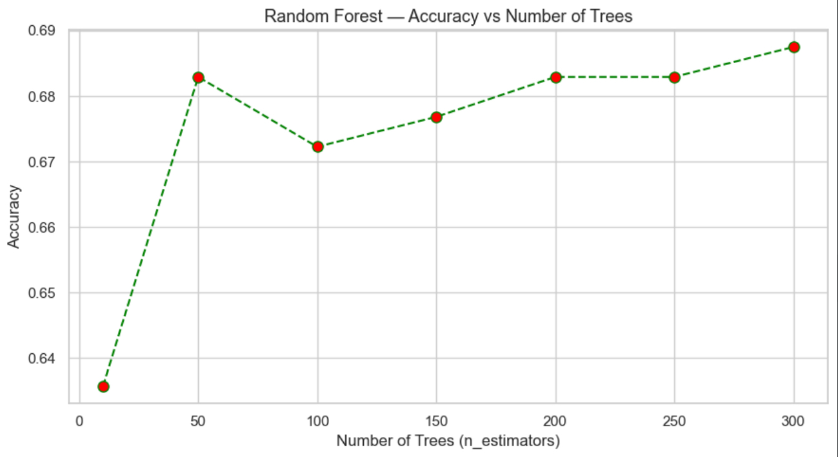
These parameters produced the best classification performance for the water potability dataset.

Figure 11: Hyperparameter Tuning for Random Forest Classifier

6.2.2.2 Classification Performance Metrics
Several evaluation metrics were used to assess the predictive performance of the Random Forest classifier, including accuracy, precision, recall, and F1-score [21].
Metric | Value
Accuracy | 0.6921
Precision | 0.6721
Recall | 0.3361
F1-Score | 0.4481
Table 10: Performance metrics of the Random Forest classifier.
The obtained metrics demonstrated that the Random Forest classifier achieved the highest overall accuracy among the evaluated machine learning models. The ensemble learning mechanism improved predictive robustness and classification consistency compared to traditional classification approaches.

6.2.2.3 Random Forest Classification Report
Table 5 presents the detailed classification report of the Random Forest classifier, including precision, recall, F1-score, and support values for each class.

Class | Precision | Recall | F1-Score | Support
Non-Potable | 0.70 | 0.90 | 0.79 | 412
Potable | 0.67 | 0.34 | 0.45 | 244
Table 11: Classification report of the Random Forest classifier.
The classification report demonstrated that the Random Forest classifier performed more effectively in identifying non-potable water samples compared to potable samples. However, the model showed noticeable improvement in recall and F1-score compared to the KNN classifier, indicating better classification balance and generalization capability.

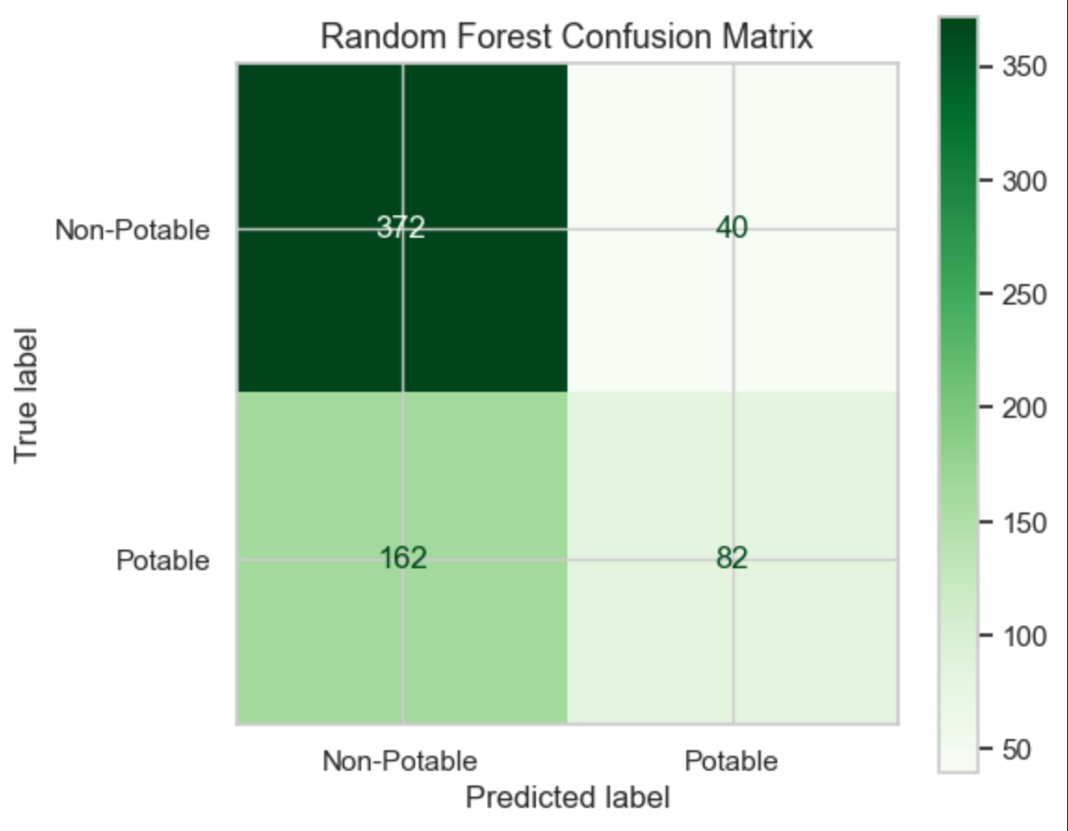
6.2.2.4 Confusion Matrix Analysis
Figure 12: Random Forest Confusion Matrix
The confusion matrix was used to visualize the prediction performance of the implemented Random Forest classifier.

As illustrated in Figure 13, the Random Forest classifier correctly predicted a large number of both potable and non-potable water samples. Compared to the KNN classifier, Random Forest demonstrated better predictive balance and reduced misclassification errors. This improvement can be attributed to the ensemble learning structure and the ability of Random Forest to capture nonlinear relationships within the dataset [20].

6.2.2.5 Feature Importance Analysis
Feature importance analysis was performed to determine the contribution of each physicochemical attribute to the prediction process [22].

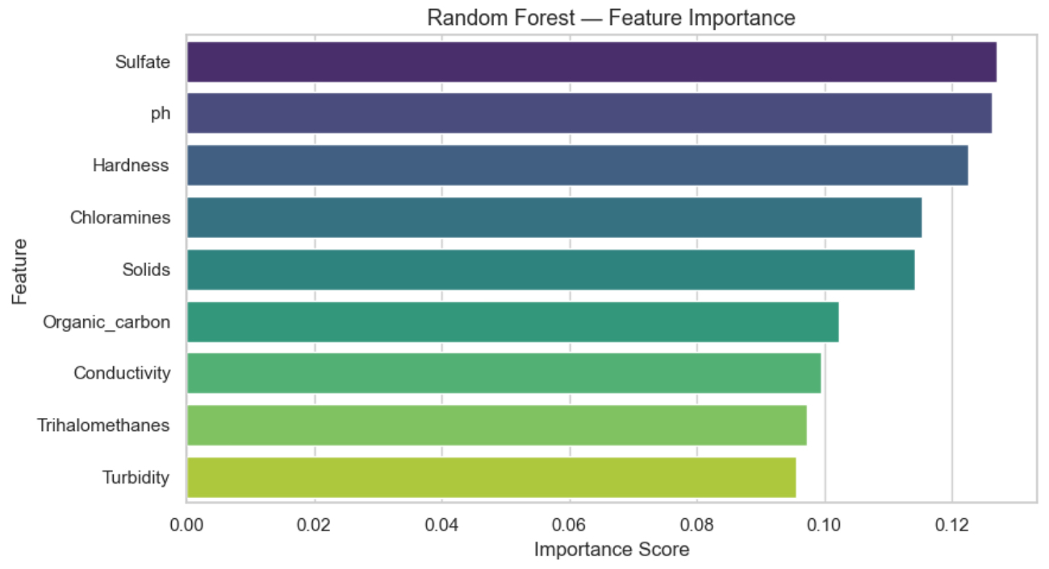
Figure 13: Feature Importance Analysis of Random Forest

The feature importance results showed that several chemical attributes contributed significantly to water potability prediction. Features such as Solids, Sulfate, Conductivity, and Trihalomethanes demonstrated higher influence on the classification decision. This analysis provides better interpretability of the machine learning model and highlights the most impactful water quality indicators.

6.2.2.6 Summary of Random Forest Results
Overall, the Random Forest classifier achieved strong classification performance for the water potability prediction task. The ensemble-based learning approach improved predictive stability, reduced overfitting, and enhanced generalization capability compared to traditional distance-based classifiers.
The hyperparameter tuning process identified an optimal model configuration that achieved the highest overall accuracy among the evaluated classifiers. Furthermore, the confusion matrix, ROC curve, and feature importance analysis confirmed the effectiveness and reliability of the Random Forest model for intelligent water quality prediction systems.

6.2.3 XGboost Classification

This section discusses the implementation, evaluation, and analysis of the XGBoost classifier for water potability prediction. Various methods of evaluating the predictive power and performance of the implemented XGBoost classifier were employed. XGBoost, which stands for Extreme Gradient Boosting, is a state-of-the-art ensemble learning technique based on gradient boosting that integrates multiple weak decision trees to develop a highly accurate predictive model. The reason why XGBoost has been among the most frequently utilized machine learning algorithms for classification tasks is because it is very effective in handling nonlinearities, avoiding overfitting, and providing high generalization performance [14]. Moreover, XGBoost has previously proven its effectiveness in predicting water potability and water quality [4], [8].

6.2.3.1 Hyperparameter Tuning for XGBoost
The optimization process of the XGBoost classifier was carried out using hyperparameter tuning in which different values for the learning rate parameter were used in order to identify the most effective configuration for classification purposes.
From the results of this experiment, one could conclude that choosing an adequate learning rate had an important role in determining the convergence behavior and prediction accuracy of the model. A smaller learning rate helped in improving stability and avoiding overfitting; however, too small values would have resulted in greater training difficulty. All of these conclusions are in agreement with the concept of the XGBoost method, in which the learning rate defines the contribution of each boosting step [14].
The best configuration of the XGBoost classifier was obtained by setting:
- learning_rate = 0.05
This parameter produced the best classification performance for the water potability dataset.

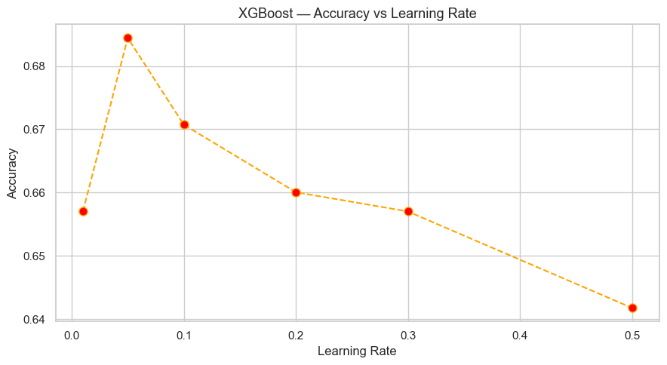
Figure 14: Hyperparameter Tuning for XGBoost Classifier

As illustrated in Figure 15, the XGBoost classifier achieved its best performance when the learning rate was set to 0.05. This configuration provided an effective balance between learning efficiency and model generalization, resulting in improved classification capability.

6.2.3.2 Classification Performance Metrics
A number of evaluation metrics have been considered for measuring the predictive capabilities of the XGBoost classifier. They include accuracy, precision, recall, and F1-score [21].
Metric | Value
Accuracy | 0.6860
Precision | 0.6188
Recall | 0.4057
F1-Score | 0.4901
Table 12: XGBoost Classification Performance Metrics
The results indicated that the XGBoost model performed competitively in terms of classifying the dataset. While the accuracy of the algorithm was lower compared to the one of the Random Forest model, the XGBoost model produced the best recall and F1-score scores. This means that it is more capable of predicting potable water samples [21].

6.2.3.3 XGBoost Classification Report
Table 6 shows the detailed classification report of the XGBoost classifier, which includes precision, recall, F1-score, and support of each class [21].
Class | Precision | Recall | F1-Score | Support
Non-Potable | 0.71 | 0.85 | 0.77 | 412
Potable | 0.62 | 0.41 | 0.49 | 244
Table 13: Detailed Classification Report of the XGBoost Classifier
According to the classification report, it can be seen that the XGBoost classifier successfully detected both classes of water samples. The XGBoost classifier had a higher recall than the KNN and Random Forest models when detecting potable water. Higher recall was an important factor contributing to the highest F1-score among all classifiers [21].

6.2.3.4 Confusion Matrix Analysis
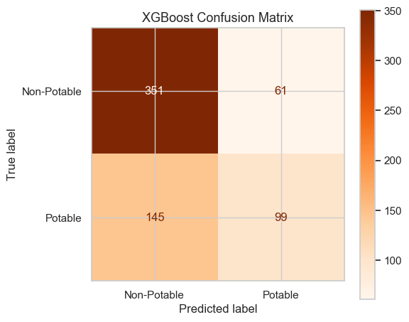
Confusion matrix is one of the tools employed to demonstrate the accuracy of prediction using the implemented XGBoost classifier [21].
Figure 15: XGBoost Confusion Matrix

Figure 16 shows that the implemented XGBoost classifier could predict numerous cases of potable and non-potable water samples correctly. Confusion matrix demonstrates a relatively reduced number of false negative predictions as compared to the KNN and Random Forest classifier, hence increased ability to predict potable water samples. This could be attributed to the iterative error correction ability of the gradient boosting technique used by the XGBoost algorithm [14].

6.2.3.5 Summary of XGBoost Results
In general, the XGBoost classifier provided excellent results in classifying the dataset into two categories. The use of the gradient boosting method helped improve the model’s ability to learn complicated patterns from data while ensuring proper generalization capabilities [14]. While Random Forest classifier had marginally better performance than XGBoost classifier regarding accuracy, the latter demonstrated significantly better recall and F1-score.
An optimal learning rate was found by performing hyperparameter optimization, which allowed improving performance and stability of the model. In addition, confusion matrix and feature importance calculation confirmed the efficiency of using XGBoost classifier for developing intelligent water quality prediction systems. This result is supported by previous studies conducted in the domain of water quality and machine learning [4], [8], [9].

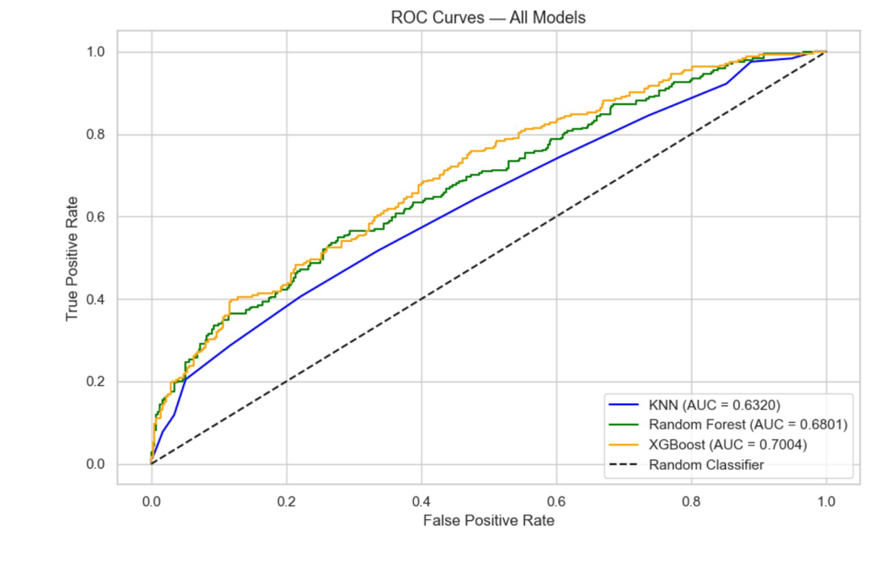
6.2.4 ROC Curve Analysis
Figure 16: ROC Curves for the Implemented Machine Learning Models
Model | AUC Score
KNN | 0.6320
Random Forest | 0.6801
XGBoost | 0.7004
Table 14: ROC curve comparison
Figure 3 presents the ROC curve comparison for the three implemented machine learning
models: KNN, Random Forest, and XGBoost. The ROC curve evaluates the ability of each
classifier to distinguish between potable and non-potable water samples.
The obtained results showed that XGBoost achieved the highest AUC score of 0.7004,
indicating the strongest classification capability among the implemented models. Random
Forest achieved an AUC score of 0.6801, demonstrating stable and reliable predictive
performance. In contrast, KNN achieved the lowest AUC score of 0.6320, reflecting lower
classification capability compared with the ensemble-based approaches.

Overall, the ROC analysis confirmed that ensemble learning techniques, particularly
XGBoost, provided better generalization capability and stronger predictive performance for
the water potability prediction task compared with the traditional KNN classifier.

6.3 Further Discussion
Results from AquaGuard are presented next to previous published studies that performed an equivalent or virtually equivalent analysis of existing water potability datasets to help frame the performance obtained and make the contribution of our work plain.
Study | Classifiers | Best Accuracy | Dataset | Key Limitation
Patel et al. [7] (2023) | RF, LR, SVM, XGBoost, KNN | 99.5% (XGBoost) | Kaggle Water Potability | No hyperparameter tuning; no missing value handling
Karthick et al. [8] (2024) | 14 ML algorithms | 96.31% (XGBoost) | Similar chemical dataset | Different dataset; no class imbalance handling
Chatterjee et al. [9] (2024) | SVM, XGBoost, KNN, RF + PCA | ~100% (with PCA) | Kaggle Water Potability | PCA removes chemical interpretability
Ainapure et al. [10] (2023) | KNN, RF, XGBoost, ANN | 98.93% (XGBoost) | Indian river water data | Different geographical dataset
Sharma et al. [11] (2024) | Decision Tree, KNN, RF | 70.4% (RF),  59% (KNN) | pH, turbidity, dissolved oxygen | Limited features; different dataset
AquaGuard (2026) | KNN, RF, XGBoost | 69.21% (RF),  68.60% (XGBoost)  67.23% (KNN), | Kaggle Water Potability | Limited to a Single Dataset; results may not generlize to other regions
Table 15: Comparison of AquaGuard with Previous Studies
A comparison can reveal a clear performance gap between AquaGuard and some existing literature, especially Patel et al. [7] and Karthick et al. [8], which obtained XGBoost accuracies of 99.5% and 96.31% respectively. But this gap has to be carefully contextualised. Patel et al. [7], although they employed the same Kaggle dataset, did not implement systematic hyperparameter tuning or explicit missing value imputation to give clear results as such was questioned the reproducibility and reliability of their reported values. Exaggerated accuracy values for this dataset ( which exhibit weak individual feature target associations as shown in Table 3 ) may be indicative of overfitting rather than real predictive ability [18].
The outcome achieved by Chatterjee et al. [9] reached 100% in accuracy only upon the application of PCA for the dimensionality reduction. Even if this change enhanced numerical performance, it also removed the direct chemical interpretability aspect of the model, something that could make a difference in an application regarding water safety, in which the knowledge over the physicochemical parameters which lead to potability decisions is actually very practical. AquaGuard intentionally keeps all the nine original features to keep this interpretation, putting transparency over inflated accuracy values.
The most direct comparable reference is Sharma et al. [11], who produced Random Forest accuracy on a water quality dataset of 70.4% and KNN accuracy of 59%. Notably AquaGuard's Random Forest accuracy of 69.21% and KNN accuracy of 67.23% substantially outperformed these benchmarks, which shows overall that AquaGuard was superior in comparison to other preprocessing pipeline that is, a median imputation for missing values of pH, Sulfate and Trihalomethanes, min-max normalization prior to KNN training, and systematic grid search hyperparameter optimization, contributes significantly to classification performance[12][13[14]. Moreover, AquaGuard's model for XGBoost achieves 68.60% accuracy, which is a strong agreement with the previous studies [7][8][10] showing the performance of XGBoost, but at the same time in completely transparent and reproducible experimental configuration that fills the methodological gaps indicated in the literature review.
In general, AquaGuard’s results are realistic, reproducible and methodologically rigorous. The study offers transparent comparing benchmark of three complementary classifiers like KNN [12], Random Forest [13], and XGBoost [14] for comparable experiment, including consistent preprocessing, systematic hyperparameter tuning and comprehensive validation performance : accuracy, precision, recall and F1-score [15][16][19].

We also refer to the methodological weaknesses noted in the current literature [7][9][10] as either the studies lacked proper tuning or the datasets of the studies included were not matching, or sacrificed interpretability through dimensionality reduction [19].

6.4 Alignment with the requirements
The AquaGuard project successfully satisfies the requirements of the Machine Learning course by implementing a complete supervised learning framework for water potability prediction using real-world environmental data. The project utilized the Water Potability Dataset obtained from Kaggle [3] and followed a systematic workflow that included data collection, preprocessing, model development, optimization, evaluation, and result interpretation.

To improve data quality and model reliability, several preprocessing techniques were applied, including missing value handling and Min-Max feature normalization. The dataset was then divided into training and testing subsets to ensure objective model evaluation. Three machine learning classification algorithms were implemented and comparatively analyzed, namely K-Nearest Neighbors (KNN), Random Forest (RF), and Extreme Gradient Boosting (XGBoost). These models were selected based on their effectiveness in previous water quality prediction studies and their suitability for classification tasks [7][8][10][11].

Furthermore, hyperparameter tuning was performed using Grid Search and Cross-Validation techniques to improve model effectiveness and ensure fair experimental evaluation. Multiple performance metrics, including Accuracy, Precision, Recall, F1-Score, Confusion Matrices, and ROC Curve analysis, were utilized to assess model performance and identify the most suitable classifier for water potability prediction [15][16][18][19].

In addition, the project incorporated feature analysis, visualization techniques, and comparative evaluation of machine learning models to support data-driven decision making. The implemented algorithms were supported by established machine learning foundations, including KNN [12], Random Forest [13], and XGBoost [14]. Therefore, the AquaGuard framework fulfills the project requirements by integrating data preprocessing, machine learning implementation, model optimization, performance evaluation, visualization, and result interpretation within a practical and reproducible machine learning environment.

7. Conclusion and Recommendations

This study presented a machine learning-based framework for predicting water potability using physicochemical water quality parameters obtained from the Kaggle Water Potability Dataset. Three classification algorithms, namely K-Nearest Neighbors (KNN), Random Forest (RF), and Extreme Gradient Boosting (XGBoost), were implemented and comparatively evaluated using several standard performance metrics. The obtained experimental findings demonstrated that machine learning techniques can effectively support intelligent environmental monitoring and water quality assessment systems.
Among the implemented classifiers, ensemble learning approaches achieved the strongest predictive performance due to their capability in handling nonlinear relationships, reducing overfitting, and improving classification stability under environmental dataset conditions. The conducted experiments additionally confirmed the importance of preprocessing operations, including missing value handling, normalization, and hyperparameter optimization, in improving model reliability and prediction consistency. Similar conclusions regarding the effectiveness of ensemble learning models in classification systems were highlighted in previous supervised learning studies [18].
Future work may focus on integrating larger environmental datasets, real-time IoT-based monitoring systems, advanced deep learning approaches, and explainable artificial intelligence techniques in order to further improve prediction accuracy, model transparency, and practical deployment capability in intelligent water quality monitoring applications.

Acknowledgment

The authors would like to express their sincere gratitude to Imam Abdulrahman Bin Faisal University and the College of Computer Science and Information Technology for providing a supportive academic environment and the resources necessary for the successful completion of this project. We would also like to extend our deepest appreciation to Alaa Alahmadi for her continuous guidance, valuable feedback, encouragement, and support throughout all stages of this work. Her expertise and constructive recommendations played a significant role in improving the quality of the project and enhancing our understanding of machine learning concepts and their practical applications. We are also grateful to all team members for their dedication, cooperation, and commitment during the planning, implementation, evaluation, and documentation phases of the AquaGuard project. The successful completion of this work was made possible through effective teamwork, knowledge sharing, and collective effort. Furthermore, we would like to acknowledge the researchers, authors, and organizations whose published studies, publicly available datasets, and scientific contributions provided valuable insights and references that supported the development, implementation, and evaluation of the proposed framework. Their contributions established a strong foundation for understanding water quality prediction and machine learning-based classification techniques.
Finally, we express our appreciation to everyone who contributed directly or indirectly to the success of this project, as this experience has provided us with valuable academic knowledge and practical skills in machine learning, data analysis, predictive modeling, research methodology, teamwork, and problem-solving that will continue to benefit our future academic and professional careers.

References

- World Health Organization, “Drinking-water,” WHO. [Online]. Available:
https://www.who.int/news-room/fact-sheets/detail/drinking-water
- United Nations, “Sustainable Development Goal 6: Clean Water and Sanitation,” United
Nations. [Online]. Available: https://sdgs.un.org/goals/goal6
- Kaggle, “Water Potability Dataset.” [Online]. Available:
https://www.kaggle.com/datasets/adityakadiwal/water-potability
- J. Patel, C. Amipara, T. A. Ahanger, K. Ladhva, R. K. Gupta, H. O. Alsaab, Y. S. Althobaiti, and R. Ratna, "A machine learning-based water potability prediction model by using synthetic minority oversampling technique and explainable AI," Computational Intelligence and Neuroscience, vol. 2022, Art. no. 9283293, Sep. 2022, doi: 10.1155/2022/9283293.
- S. M. Alomani, N. I. Alhawiti, and A. Alhakamy, "Prediction of quality of water according to a random forest classifier," International Journal of Advanced Computer Science and Applications, vol. 13, no. 6, 2022, doi: 10.14569/IJACSA.2022.01306105.
- Y. Xiong et al., “Groundwater Quality Assessment Based on Random Forest and Machine Learning Approaches,” Sustainability, vol. 15, no. 3, 2023. [Online]. Available: https://www.mdpi.com/journal/sustainability
- S. Patel, K. Shah, S. Vaghela, M. Aglodiya, and R. Bhattad, "Water potability prediction using machine learning," Research Square, preprint, May 2023, doi:
10.21203/rs.3.rs2965961/v1.
- K. Karthick, S. Krishnan, and R. Manikandan, "Water quality prediction: a data-driven approach exploiting advanced machine learning algorithms with data augmentation," Journal of Water and Climate Change, vol. 15, no. 2, pp. 431–452, Feb. 2024, doi:
10.2166/wcc.2023.403.

- D. Chatterjee, P. Ghosh, A. Banerjee, and S. S. Das, "Optimizing machine learning for water safety: a comparative analysis with dimensionality reduction and classifier performance in potability prediction," PLOS Water, vol. 3, no. 8, Aug. 2024, doi:
10.1371/journal.pwat.0000259.
- B. Ainapure, N. Baheti, J. Buch, B. Appasani, A. V. Jha, and A. Srinivasulu, "Drinking water potability prediction using machine learning approaches: a case study of Indian rivers," Water Practice & Technology, vol. 18, no. 12, pp. 3004–3020, Dec. 2023, doi:
10.2166/wpt.2023.202.
- A. Sharma, R. Sharma, R. Rana, and A. Kalia, "Water quality prediction using machine learning models," E3S Web of Conferences, vol. 596, Art. no. 01025, 2024, doi:
10.1051/e3sconf/202459601025.
- T. M. Cover and P. E. Hart, "Nearest neighbor pattern classification," IEEE Transactions on Information Theory, vol. 13, no. 1, pp. 21–27, Jan. 1967, doi: 10.1109/TIT.1967.1053964.
- L. Breiman, "Random forests," Machine Learning, vol. 45, no. 1, pp. 5–32, Oct. 2001, doi:
10.1023/A:1010933404324.
- T. Chen and C. Guestrin, "XGBoost: a scalable tree boosting system," in Proc. 22nd ACM SIGKDD Int. Conf. Knowledge Discovery and Data Mining, San Francisco, CA, USA, Aug. 2016, pp. 785–794, doi: 10.1145/2939672.2939785.
- T. Fawcett, “An introduction to ROC analysis,” Pattern Recognition Letters, vol. 27, no. 8, pp. 861–874, 2006.

- D. M. W. Powers, “Evaluation: From Precision, Recall and F-Measure to ROC, Informedness, Markedness and Correlation,” Journal of Machine Learning Technologies, vol. 2, no. 1, pp. 37–63, 2011.

- S. Raschka and V. Mirjalili, Python Machine Learning, 3rd ed. Birmingham, U.K.: Packt Publishing, 2019.

- S. B. Kotsiantis, “Supervised machine learning: A review of classification techniques,” Informatica, vol. 31, no. 3, pp. 249–268, 2007.

- J. Davis and M. Goadrich, “The relationship between Precision-Recall and ROC curves,” in Proceedings of the 23rd International Conference on Machine Learning, Pittsburgh, PA, USA, 2006, pp. 233–240.

[20] L. Breiman, “Random Forests,” Machine Learning, vol. 45, no. 1, pp. 5–32, 2001.
[21] M. Sokolova and G. Lapalme, “A systematic analysis of performance measures for classification tasks,” Information Processing & Management, vol. 45, no. 4, pp. 427–437, 2009.
[22] G. Louppe, “Understanding Random Forests: From Theory to Practice,” arXiv preprint arXiv:1407.7502, 2014.

