Biobank and Biospecimen Management System

Database Project
Database Management System: MySQL
Prepared by: Lamia Shady
ID:241002351
Contents
1. Problem Statement and Project Scope: 3
2. Database Entities: 3
1.Problem Statement and Project Scope: 3
1.2Major Business Rules: 3
2.Entities and Attributes: 5
3. ER Diagram: 7
4. Relational Schema: 9
4.1 Donors 10
4.2 Consent 10
4.3 SampleTypes 10
4.4 StorageLocations 10
4.5 CollectionEvents 10
4.6 Samples 10
4.7 Researchers 10
4.8 TestRequests 10
4.9 TestRequestSamples 10
4.10 SampleUsage 11
4.11 Constraints: 11
5. Normalization: 12
5.1 First Normal Form (1NF): 12
5.2 Second Normal Form (2NF): 12
5.3 Third Normal Form (3NF): 12
Normalization Conclusion: 13
Implementation Details and Selected SQL Code: 13
6. Implementation Details: 13
6.1 Database Creation: 13
6.2 Table Creation: 13
6.3 Data Loading: 14
6.4 SQL Operations: 15
6.5 Data Modification: 16
7. Sample Data and Successful Execution: 16
7.1 Donors Table: 17
7.2 Samples Table: 17
7.3 Researchers Table: 17
8. Views and Trigger: 18
8.1 First View — Donor Sample View: 18
8.2 Second View — Research Test View: 19
8.3 Trigger: 20
9. Testing and Validation: 21
9.1 Testing Summary: 21
9.3 Foreign Key Test: 22
9.4 UNIQUE Constraint Test: 22
9.5 Trigger Test: 22
9.6 View Testing: 23
10. Conclusion: 23
11. Bonus Feature: Connected User Interface: 24
12. References: 25
References 25

1. Problem Statement and Project Scope:
The Biobank and Biospecimen Management System is a relational database designed to manage information related to donors, consent records, biological samples, collection events, storage locations, researchers, test requests, and sample usage.
The main purpose of the system is to organize biospecimen information efficiently and maintain relationships between donors, samples, researchers, and laboratory activities.
The database provides data integrity through primary keys, foreign keys, unique constraints, and other validation rules. It also includes SQL queries, joins, aggregation, subqueries, views, and a trigger.

2. Database Entities:
- Donors — stores donor personal information.
- Consent — stores donor consent information.
- SampleTypes — stores different biological sample types.
- StorageLocations — stores information about sample storage locations.
- CollectionEvents — records sample collection events.
- Samples — stores information about collected samples.
- Researchers — stores researcher information.
- TestRequests — stores laboratory test requests.
- TestRequestSamples — connects test requests with samples.
- SampleUsage — records the usage of samples by researchers.

1.Problem Statement and Project Scope:
The system assumes that each donor is identified by a unique donor ID and may have associated consent records and collection events. Each collected sample is associated with one collection event, one sample type, and one storage location. Researchers are registered in the system with unique email addresses and may submit multiple test requests and use multiple samples. Test requests can be associated with samples through the TestRequestSamples associative table. The database uses anonymized sample and donor information for academic and demonstration purposes.

1.2Major Business Rules:
- Each donor must have a unique donor ID.
- Each donor email address must be unique when provided.
- A donor can have multiple collection events.
- Each collection event belongs to one donor.
- Each sample must be associated with a valid collection event, sample type, and storage location.
- Each sample must have a unique sample code.
- Each researcher must have a unique email address.
- A researcher can create multiple test requests.
- A test request can be associated with one or more samples through the TestRequestSamples table.
- A sample can be used by researchers for different research purposes.
- The quantity used for a sample must be greater than zero.
- Foreign key constraints prevent records from referencing donors, samples, researchers, or other entities that do not exist.

2.Entities and Attributes:
The database consists of ten main entities. Each entity represents a specific part of the biobank management system and contains attributes that describe its data. Primary keys are used to uniquely identify records, while foreign keys establish relationships between related entities.
Entity | Primary Key | Important Attributes | Foreign Key / Key Decision
Donors | donor_id | first_name, last_name, gender, date_of_birth, phone, email | email is UNIQUE
Consent | consent_id | consent_date, consent_type, status | donor_id → Donors
SampleTypes | sample_type_id | type_name, description | type_name is UNIQUE
StorageLocations | storage_location_id | location_name, freezer_number, temperature | Identifies sample storage location
CollectionEvents | collection_event_id | collection_date, collection_method, collector_name | donor_id → Donors
Samples | sample_id | sample_code, collection_date, status | collection_event  _id, sample_type_id, storage_location  _id
Researchers | researcher_id | first_name, last_name, email, department | email is UNIQUE
TestRequests | test_request_id | request_date, test_type, status | researcher_id → Researchers
TestRequestSamples | test_request_id + sample_id | test_result, result_date | Associative table for many-to-many relationship
SampleUsage | usage_id | usage_date, quantity_used, purpose | sample_id → Samples; researcher_id → Researchers

The primary keys provide unique identification for each entity. Foreign keys maintain referential integrity between related tables. Unique constraints are applied to attributes such as donor email, researcher email, sample type name, and sample code where duplicate values are not allowed.

3. ER Diagram:
The Entity-Relationship (ER) diagram represents the conceptual design of the Biobank and Biospecimen Management System. It shows the main entities, their attributes, primary and foreign keys, and the relationships between entities. The diagram also represents the cardinality ratios and participation constraints of the relationships.
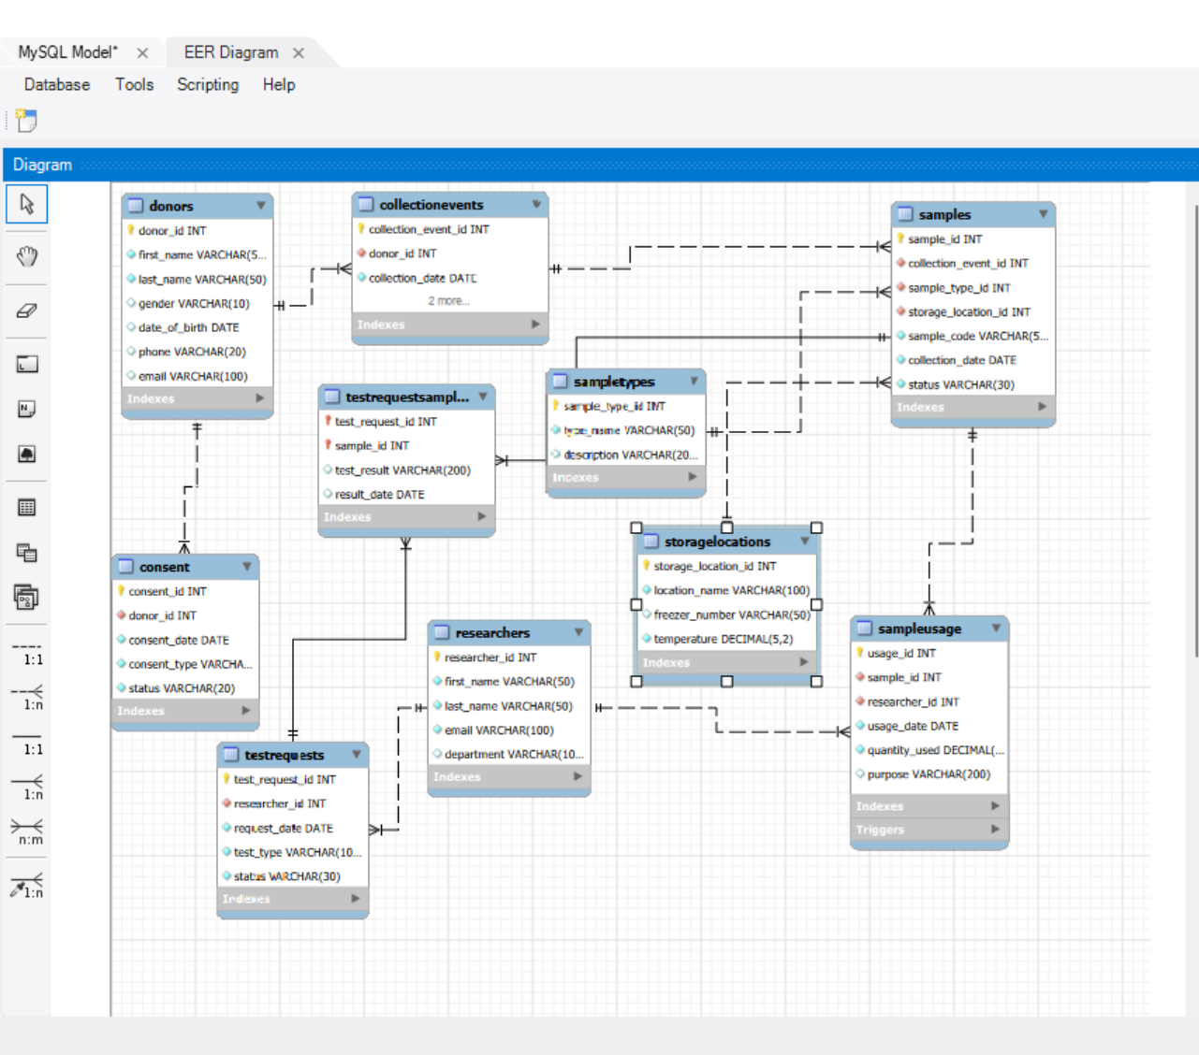

Relationship | Cardinality | Participation
Donor — Consent | 1 : Many | Consent has total participation; Donor has partial participation
Donor — CollectionEvent | 1 : Many | CollectionEvent has total participation; Donor has partial participation
CollectionEvent — Sample | 1 : Many | Sample has total participation
SampleType — Sample | 1 : Many | Sample has total participation; SampleType has partial participation
StorageLocation — Sample | 1 : Many | Sample has total participation; StorageLocation has partial participation
Researcher — TestRequest | 1 : Many | TestRequest has total participation; Researcher has partial participation
TestRequest — Sample | Many : Many | Resolved through TestRequestSamples
Researcher — Sample | Many : Many | Resolved through SampleUsage

The many-to-many relationship between TestRequests and Samples is resolved using the associative entity TestRequestSamples. This table uses a composite primary key consisting of test_request_id and sample_id. The SampleUsage entity also records the relationship between researchers and samples and stores additional information such as usage date, quantity used, and purpose.

4. Relational Schema:
The ER model was converted into a relational schema suitable for implementation using MySQL. Each strong entity was mapped to a separate relational table with a primary key. Foreign keys were used to represent relationships between related entities and to maintain referential integrity. The many-to-many relationship between TestRequests and Samples was resolved using the associative table TestRequestSamples.
4.1 Donors | Donors(donor_id, first_name, last_name, gender, date_of_birth, phone, email)  PK: donor_id; UNIQUE: email
4.2 Consent | Consent(consent_id, donor_id, consent_date, consent_type, status)  PK: consent_id; FK: donor_id → Donors(donor_id)
4.3 SampleTypes | SampleTypes(sample_type_id, type_name, description)  PK: sample_type_id; UNIQUE: type_name
4.4 StorageLocations | StorageLocations(storage_location_id, location_name, freezer_number, temperature)  PK: storage_location_id
4.5 CollectionEvents | CollectionEvents(collection_event_id, donor_id, collection_date, collection_method, collector_name)  PK: collection_event_id; FK: donor_id → Donors(donor_id)
4.6 Samples | Samples(sample_id, collection_event_id, sample_type_id, storage_location_id, sample_code, collection_date, status) . PK: sample_id  FK: collection_event_id → CollectionEvents(collection_event_id)  FK: sample_type_id → SampleTypes(sample_type_id)  FK: storage_location_id → StorageLocations(storage_location_id) ; UNIQUE: sample_code
4.7 Researchers | Researchers(researcher_id, first_name, last_name, email, department) ; PK: researcher_id; UNIQUE: email
4.8 TestRequests | TestRequests(test_request_id, researcher_id, request_date, test_type, status) ; PK: test_request_id  FK: researcher_id → Researchers(researcher_id)
4.9 TestRequestSamples | TestRequestSamples(test_request_id, sample_id, test_result, result_date) ;  PK: (test_request_id, sample_id);  FK: test_request_id → TestRequests(test_request_id)  FK: sample_id → Samples(sample_id)
4.10 SampleUsage | SampleUsage(usage_id, sample_id, researcher_id, usage_date, quantity_used, purpose) . PK: usage_id;  FK: sample_id → Samples(sample_id)  FK: researcher_id → Researchers(researcher_id)

4.11 Constraints:
Several integrity constraints were implemented in the database. Primary keys uniquely identify records in each table. Foreign keys maintain referential integrity between related tables. NOT NULL constraints are used for required attributes. UNIQUE constraints prevent duplicate values for important identifiers such as email addresses and sample codes. The SampleUsage table also uses a trigger to prevent a non-positive quantity from being recorded.

5. Normalization:
The database was normalized to at least Third Normal Form (3NF) to reduce data redundancy, avoid update anomalies, and improve data integrity. The normalization process was considered during the separation of entities, selection of primary keys, and definition of relationships.

5.1 First Normal Form (1NF):
The database satisfies First Normal Form because each table contains atomic attributes, and each field stores a single value. There are no repeating groups or multi-valued attributes within the tables. For example, donor information such as first name, last name, gender, phone, and email is stored in separate attributes in the Donors table.

5.2 Second Normal Form (2NF):
The database satisfies Second Normal Form because all non-key attributes depend on the complete primary key of their table. This is especially important in the TestRequestSamples table, which has a composite primary key consisting of test_request_id and sample_id. The attributes test_result and result_date depend on the combination of the test request and sample.

5.3 Third Normal Form (3NF):
The database satisfies Third Normal Form because non-key attributes depend on the primary key and not on other non-key attributes. Related information is separated into appropriate tables. For example, researcher information is stored in Researchers, test request information is stored in TestRequests, sample type information is stored in SampleTypes, and storage information is stored in StorageLocations.
Normal Form | How it is achieved
1NF | Atomic values and no repeating groups
2NF | Non-key attributes depend on the complete primary key
3NF | No non-key attribute depends on another non-key attribute

Normalization Conclusion:
The database design follows Third Normal Form (3NF), which helps minimize redundancy and maintain consistency while allowing the different components of the biobank system to be managed independently.

Implementation Details and Selected SQL Code:

6. Implementation Details:
The database was implemented using MySQL as the relational database management system. MySQL Workbench was used to create the database schema, define tables and constraints, insert test data, execute SQL queries, create views, and implement the database trigger.
The database contains ten main tables: Donors, Consent, SampleTypes, StorageLocations, CollectionEvents, Samples, Researchers, TestRequests, TestRequestSamples, and SampleUsage. Primary keys and foreign keys were implemented to maintain entity integrity and referential integrity.
The implementation was divided into separate SQL scripts for table creation, data loading, queries, views, and triggers. This organization makes the project easier to execute, test, maintain, and reproduce.

6.1 Database Creation:
The database was created using the following SQL statement:
CREATE DATABASE IF NOT EXISTS BiobankDB;
USE BiobankDB;

6.2 Table Creation:
The tables were created using SQL DDL statements with appropriate data types, primary keys, foreign keys, NOT NULL constraints, and UNIQUE constraints. For example, the Donors table was created as follows:
CREATE TABLE Donors (
donor_id INT AUTO_INCREMENT PRIMARY KEY,
first_name VARCHAR(50) NOT NULL,
last_name VARCHAR(50) NOT NULL,
gender VARCHAR(10),
date_of_birth DATE,
phone VARCHAR(20),
email VARCHAR(100) UNIQUE
);

6.3 Data Loading:
Test data was inserted into the database using INSERT statements.
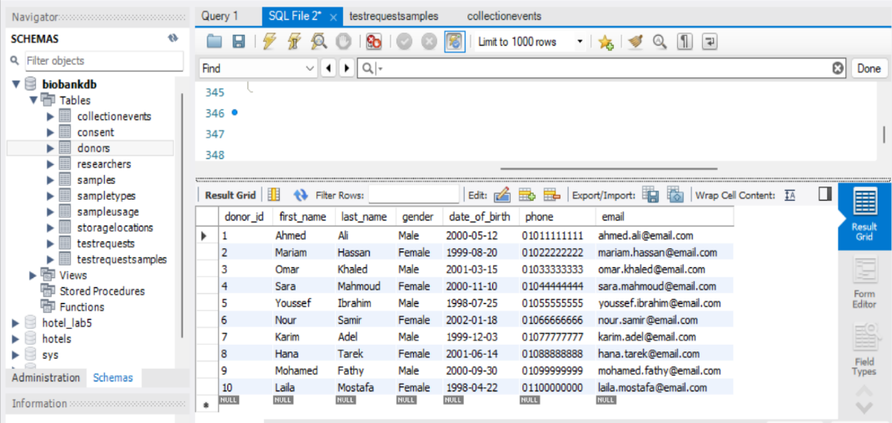

The database contains at least ten meaningful records for each main table, as required by the project guidelines.

INSERT INTO Donors
(first_name, last_name, gender, date_of_birth, phone, email)
VALUES
('Ahmed', 'Ali', 'Male', '2000-05-12',
'01011111111', 'ahmed.ali@email.com');

6.4 SQL Operations:
Several SQL operations were implemented to demonstrate data retrieval, filtering, sorting, joins, aggregation, subqueries, and data modification.
SELECT and WHERE:
SELECT *
FROM Donors
WHERE gender = 'Female';
JOIN:
SELECT
Donors.first_name,
Donors.last_name,
CollectionEvents.collection_date,
CollectionEvents.collection_method
FROM Donors
JOIN CollectionEvents
ON Donors.donor_id = CollectionEvents.donor_id;
Aggregation:
SELECT
SampleTypes.type_name,
COUNT(Samples.sample_id) AS number_of_samples
FROM SampleTypes
LEFT JOIN Samples
ON SampleTypes.sample_type_id = Samples.sample_type_id
GROUP BY SampleTypes.type_name;

Subquery:
SELECT first_name, last_name
FROM Donors
WHERE donor_id IN (
SELECT donor_id
FROM CollectionEvents
);

6.5 Data Modification:
Data modification operations were also tested using INSERT, UPDATE, and DELETE statements.
UPDATE Samples
SET status = 'Used'
WHERE sample_id = 1;
INSERT INTO Researchers
(first_name, last_name, email, department)
VALUES
('Test', 'Researcher',
'test.researcher@biobank.com', 'Testing');
DELETE FROM Researchers
WHERE email = 'test.researcher@biobank.com';

7. Sample Data and Successful Execution:
Sample data was inserted into the database to demonstrate the functionality of the Biobank and Biospecimen Management System. Each main table contains meaningful test records, allowing the database relationships, queries, views, and constraints to be tested.

7.1 Donors Table:
The Donors table contains 10 sample donor records. The following screenshot shows the successfully inserted records.
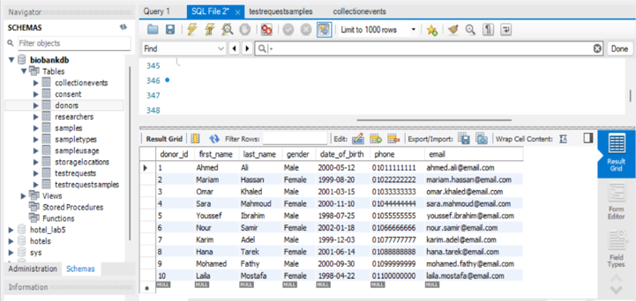
Figure 1. Donors table showing 10 successfully inserted records.

7.2 Samples Table:
The Samples table stores information about collected biological samples, including the sample code, collection event, sample type, storage location, collection date, and current status.
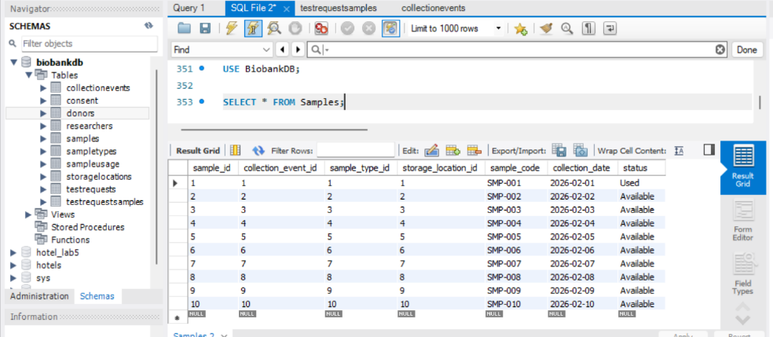
Figure 2. Samples table showing successfully inserted sample records.

7.3 Researchers Table:
The Researchers table contains researcher information, including names, email addresses, and departments. The screenshot demonstrates that the researcher records were successfully inserted.
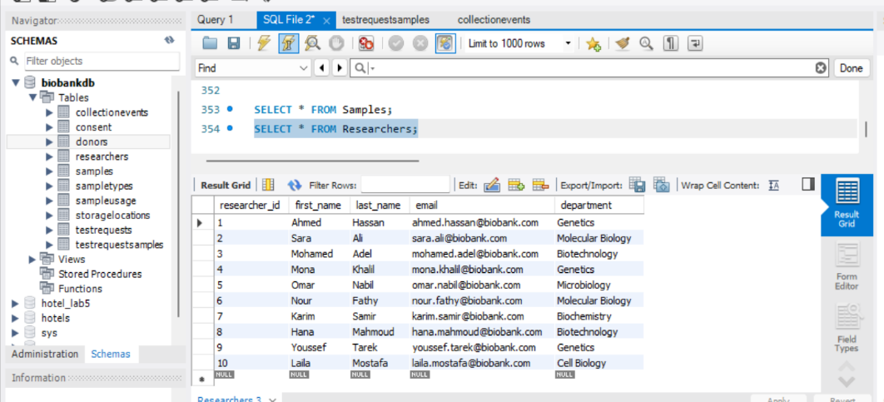
Figure 3. Researchers table showing successfully inserted researcher records.

8. Views and Trigger:
The database includes two views to simplify data retrieval from multiple related tables. A trigger was also implemented to enforce a business rule and maintain data integrity.

8.1 First View — Donor Sample View:
The DonorSampleView combines donor, collection event, sample, sample type, and storage information. It provides a convenient way to display information about donors and their collected samples without repeatedly writing multiple JOIN statements.
CREATE VIEW DonorSampleView AS
SELECT
d.donor_id,
CONCAT(d.first_name, ' ', d.last_name) AS donor_name,
s.sample_code,
st.type_name AS sample_type,
sl.location_name,
sl.temperature,
s.status
FROM Donors d
JOIN CollectionEvents ce
ON d.donor_id = ce.donor_id
JOIN Samples s
ON ce.collection_event_id = s.collection_event_id
JOIN SampleTypes st
ON s.sample_type_id = st.sample_type_id
JOIN StorageLocations sl
ON s.storage_location_id = sl.storage_location_id;
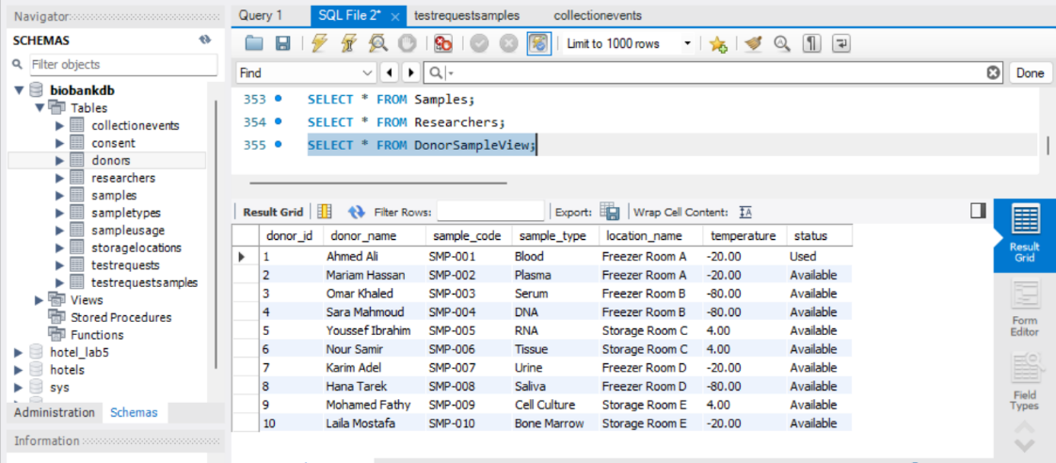
Figure 4. DonorSampleView successfully displaying donor and sample information.

8.2 Second View — Research Test View:
The Research Test View combines researcher and test request information. It displays the researcher responsible for a test request, department, request date, test type, and request status.
CREATE VIEW ResearchTestView AS
SELECT
tr.test_request_id,
CONCAT(r.first_name, ' ', r.last_name) AS researcher_name,
r.department,
tr.request_date,
tr.test_type,
tr.status
FROM TestRequests tr
JOIN Researchers r
ON tr.researcher_id = r.researcher_id;
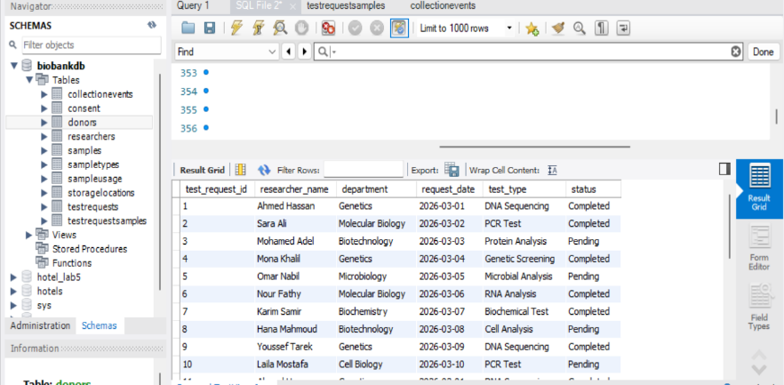
Figure 5. Research Test View successfully displaying researcher and test request information.

8.3 Trigger:
The Check Sample Usage Quantity trigger is executed before inserting a record into SampleUsage. It prevents the insertion of a record when the quantity_used value is less than or equal to zero. This ensures that sample usage quantities remain valid.
CREATE TRIGGER Check Sample Usage Quantity
BEFORE INSERT ON SampleUsage
FOR EACH ROW
BEGIN
IF NEW.quantity_used <= 0 THEN
SIGNAL SQLSTATE '45000'
SET MESSAGE_TEXT = 'Quantity used must be greater than zero';
END IF;
END;
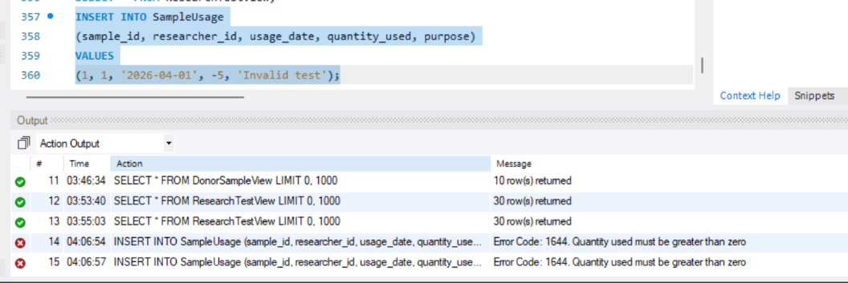
Figure 6. Trigger successfully rejecting an invalid negative sample usage quantity.
The test was successful because the trigger rejected the invalid record and prevented a non-positive quantity from being inserted into the SampleUsage table.

9. Testing and Validation:
The database was tested to verify that the implemented tables, relationships, constraints, views, and trigger work correctly. Different tests were performed to verify data integrity and the enforcement of the defined business rules.

9.1 Testing Summary:
Test | Expected Result | Result
Valid data insertion | Record is inserted successfully | Passed
Duplicate Primary Key | Duplicate record is rejected | Passed
Invalid Foreign Key | Record is rejected | Passed
Duplicate UNIQUE value | Duplicate value is rejected | Passed
Negative Sample Usage Quantity | Trigger rejects the record | Passed
View execution | View returns the expected data | Passed
JOIN query | Related records are displayed correctly | Passed

The testing results demonstrate that the database constraints and business rules are functioning correctly. Invalid records are prevented, while valid records can be inserted and retrieved successfully.
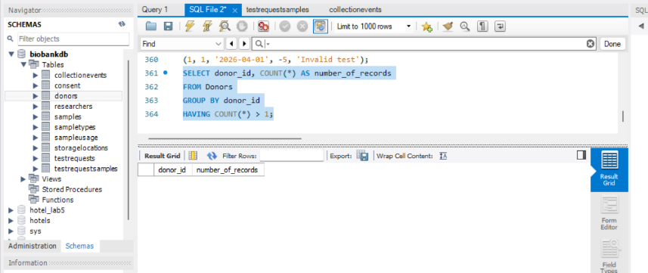
Figure 7. Primary key validation showing no duplicate donor IDs.

9.3 Foreign Key Test:
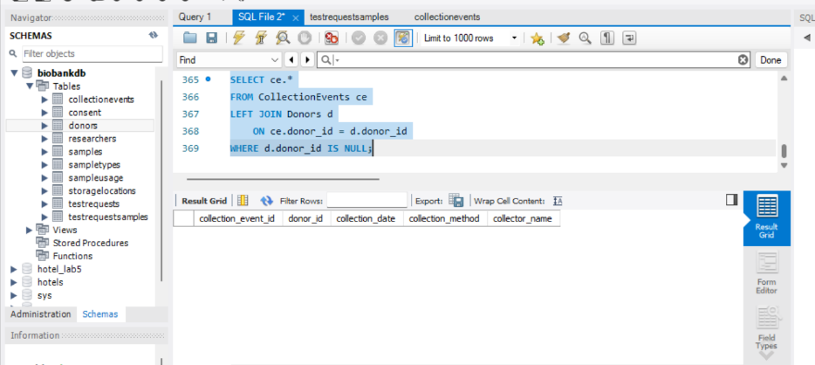
Figure 8. Foreign key validation showing that all collection events reference valid donors.

9.4 UNIQUE Constraint Test:
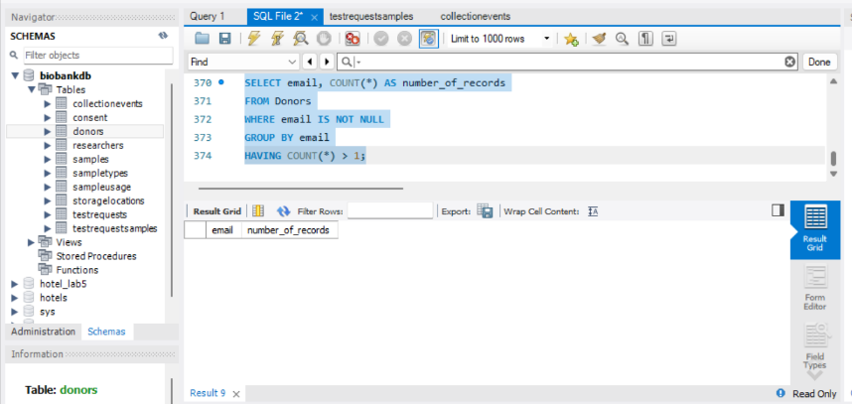
Figure 9. UNIQUE constraint validation showing no duplicate donor emails.

9.5 Trigger Test:
The trigger test was successfully completed in Section 8. The trigger rejected a negative quantity and displayed an error message, confirming that the business rule was enforced.
See Figure 6 in Section 8.

9.6 View Testing:
Both database views were executed successfully and returned the expected combined information from their related tables.
See Figures 4 and 5 in Section 8.

10. Conclusion:
The Biobank and Biospecimen Management System successfully provides a structured relational database for managing donors, consent records, biological samples, collection events, storage locations, researchers, test requests, and sample usage.
The database was designed using an ER model and transformed into a relational schema following Third Normal Form (3NF). Primary keys, foreign keys, UNIQUE constraints, and NOT NULL constraints were implemented to maintain data integrity and consistency.
The system also includes SQL queries, joins, aggregation, subqueries, two database views, and a trigger for enforcing a sample usage quantity rule. Testing confirmed that the implemented constraints and database features work as expected.
Overall, the project demonstrates how a relational database can be used to organize and manage biobank information efficiently while maintaining relationships and data integrity.

11. Bonus Feature: Connected User Interface:
A graphical user interface (GUI) was developed using Python Tkinter and connected directly to the MySQL Biobank DB database. The application allows users to display and search donor records through the database. It also supports validated CRUD operations, including adding, updating, and deleting donor records. The interface provides input validation and displays appropriate success or error messages. The application was tested successfully to verify database connectivity, data retrieval, searching, insertion, updating, and deletion operations.
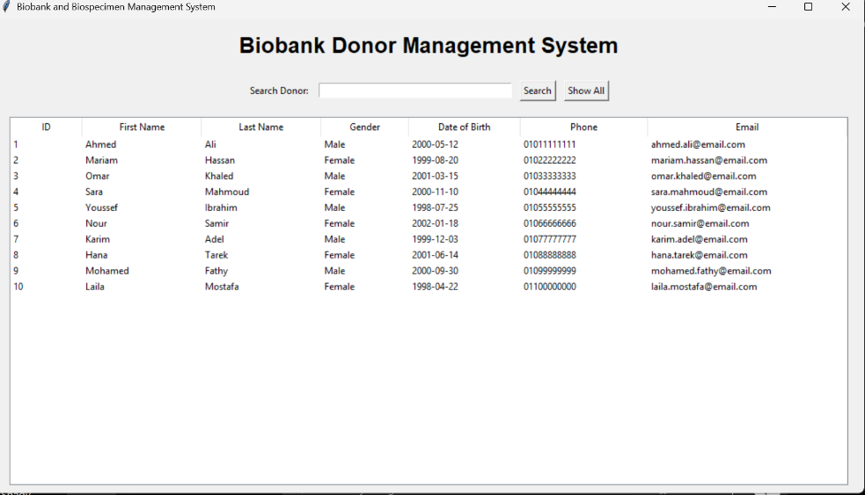
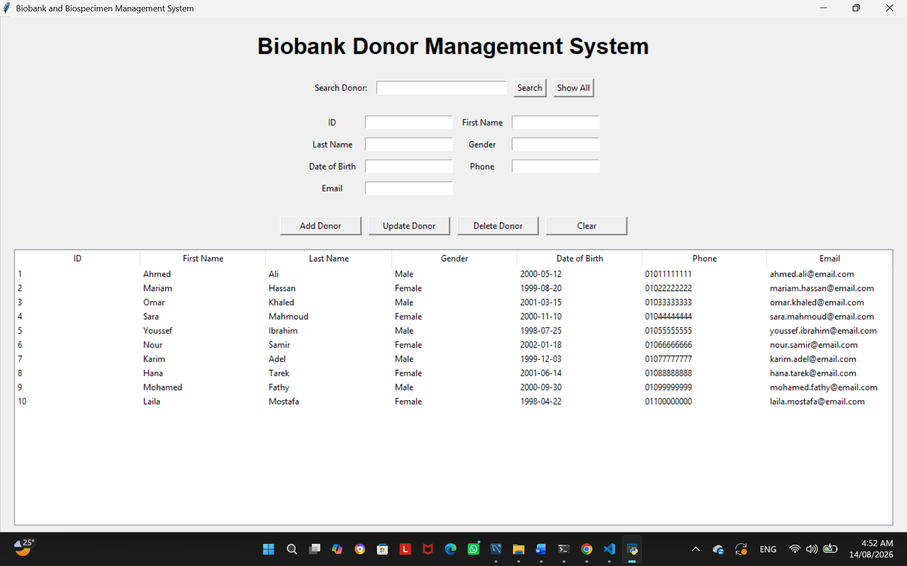

12. References:

References
(n.d.).
Oracle. (2026). MySQL 8.0 Reference Manual. MySQL Documentation. (n.d.).
Elmasri, R., & Navathe, S. B. (2016). Fundamentals of Database Systems (7th ed.). Pearson.
Coronel, C., & Morris, S. (2019). Database Systems: Design, Implementation, & Management (13th ed.). Cengage.

