Simulating OS Task Management
CPU scheduling, process synchronization, memory management and disk scheduling. Prepared by Papa Lamine SANE.
All results were computed by hand and cross-checked with a small JavaScript simulation (simulate.js).

Part 1: Process Scheduling
Process | Arrival time | Burst time
P1 | 0 | 5
P2 | 1 | 3
P3 | 2 | 1

Formulas: Turnaround = Completion − Arrival; Waiting = Turnaround − Burst; Response = first time on CPU − Arrival.

1.1 FCFS (First Come, First Served)
Processes run to completion in arrival order, with no preemption.
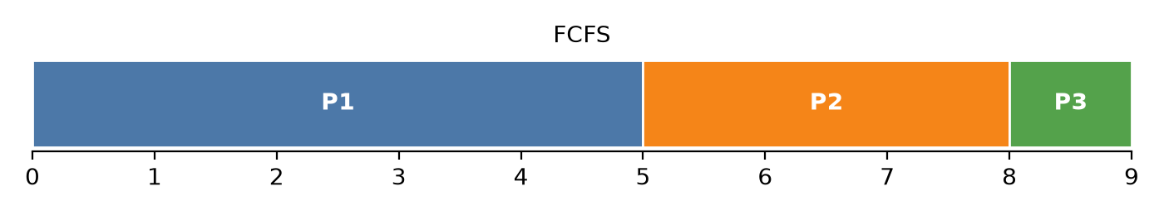
Process | Arrival | Burst | Completion | Turnaround | Waiting | Response
P1 | 0 | 5 | 5 | 5 − 0 = 5 | 5 − 5 = 0 | 0
P2 | 1 | 3 | 8 | 8 − 1 = 7 | 7 − 3 = 4 | 4
P3 | 2 | 1 | 9 | 9 − 2 = 7 | 7 − 1 = 6 | 6
Average |  |  |  | 19/3 = 6.33 | (0+4+6)/3 = 3.33 | 3.33

1.2 Round Robin (quantum = 2)
Each process runs at most 2 units, then goes to the back of the ready queue. When an arrival and a preemption happen at the same time, the new process is queued first.
Time | Running | Remaining after slice | Ready queue after slice
0–2 | P1 | P1 = 3 | P2, P3, P1
2–4 | P2 | P2 = 1 | P3, P1, P2
4–5 | P3 | P3 = 0 (done) | P1, P2
5–7 | P1 | P1 = 1 | P2, P1
7–8 | P2 | P2 = 0 (done) | P1
8–9 | P1 | P1 = 0 (done) | –

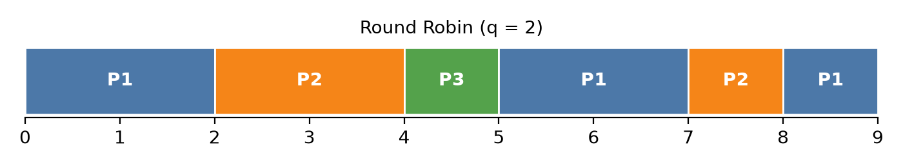
Process | Arrival | Burst | Completion | Turnaround | Waiting | Response
P1 | 0 | 5 | 9 | 9 − 0 = 9 | 9 − 5 = 4 | 0
P2 | 1 | 3 | 8 | 8 − 1 = 7 | 7 − 3 = 4 | 1
P3 | 2 | 1 | 5 | 5 − 2 = 3 | 3 − 1 = 2 | 2
Average |  |  |  | 19/3 = 6.33 | (4+4+2)/3 = 3.33 | 1.00

1.3 Comparison and responsiveness
Metric | FCFS | Round Robin (q = 2)
Average waiting time | 3.33 | 3.33
Average turnaround time | 6.33 | 6.33
Average response time | 3.33 | 1.00
Context switches | 2 | 5

Round Robin is more responsive. Both algorithms have the same average waiting time here (3.33), but under Round Robin every process gets the CPU within 2 time units of arriving (average response time 1 versus 3.33). With FCFS, the short process P3 (burst 1) waits 6 units behind the long P1, which is the convoy effect. Round Robin's time-sharing stops one long job from blocking the others, which matters for interactive systems. The cost is more context switches (5 versus 2), and a quantum that's too small would add overhead.

Part 2: Process Synchronization

2.1 What can go wrong without synchronization
counter++ is not atomic. The CPU executes it in three steps: read the value into a register, add 1, and write it back. If P1 and P2 interleave these steps, one update overwrites the other (a lost update):
Step | P1 | P2 | counter in memory
1 | reg1 = counter (0) |  | 0
2 |  | reg2 = counter (0) | 0
3 | reg1 = reg1 + 1 (1) |  | 0
4 |  | reg2 = reg2 + 1 (1) | 0
5 | counter = reg1 |  | 1
6 |  | counter = reg2 | 1 (should be 2)

This is a race condition: the result depends on the timing of the scheduler. The expected final value is 200, but any value between 2 and 200 is possible, so the program becomes non-deterministic and hard to debug.

2.2 Proposed mechanism: a mutex
A mutex (mutual-exclusion lock) is the simplest fit. Only one process can hold it at a time, so the read, add and write steps on counter form a critical section that cannot be interleaved. A binary semaphore initialized to 1 works the same way (wait/signal), and a monitor wraps the same lock inside an object.

2.3 Pseudocode
shared int counter = 0
shared mutex lock = UNLOCKED
procedure worker(name):
for i from 1 to 100:
acquire(lock) // entry section: blocks if the other process holds the lock
temp = counter // ---- critical section ----
temp = temp + 1
counter = temp // --------------------------
release(lock) // exit section: wakes up a waiting process
end for
start P1 = worker("P1")
start P2 = worker("P2")
join P1, P2
print counter // always 200

The same with a binary semaphore:
semaphore S = 1
P1, P2: repeat 100 times { wait(S); counter = counter + 1; signal(S); }

This satisfies the three requirements of a critical-section solution. Mutual exclusion: only one process is ever inside. Progress: the lock is released right after the update. Bounded waiting: a fair lock or semaphore queue serves waiting processes in turn. Keeping the critical section short limits the time the other process waits.

Part 3: Memory Management (3 frames)
Reference string: 1, 2, 3, 2, 4, 1, 5 (5 distinct pages, 3 frames). F means page fault, Hit means the page is already in memory.

3.1 FIFO
Replace the page that has been in memory the longest.
Reference | 1 | 2 | 3 | 2 | 4 | 1 | 5
Frame 1 | 1 | 1 | 1 | 1 | 2 | 3 | 4
Frame 2 |  | 2 | 2 | 2 | 3 | 4 | 1
Frame 3 |  |  | 3 | 3 | 4 | 1 | 5
Fault? | F | F | F | Hit | F | F | F
Evicted | – | – | – | – | 1 | 2 | 3

Page faults: 6 (1 hit, on page 2).

3.2 LRU (Least Recently Used)
Replace the page that has not been used for the longest time.
Reference | 1 | 2 | 3 | 2 | 4 | 1 | 5
Frame 1 | 1 | 1 | 1 | 1 | 4 | 4 | 4
Frame 2 |  | 2 | 2 | 2 | 2 | 2 | 5
Frame 3 |  |  | 3 | 3 | 3 | 1 | 1
Fault? | F | F | F | Hit | F | F | F
Evicted | – | – | – | – | 1 | 3 | 2

Page faults: 6 (1 hit, on page 2).

3.3 Comparison
Algorithm | Page faults | Hits | Fault rate | Final frames
FIFO | 6 | 1 | 6/7 ≈ 86% | 4, 1, 5
LRU | 6 | 1 | 6/7 ≈ 86% | 4, 5, 1

On this string, both give 6 faults. The first 3 faults are compulsory (empty frames), and the string is too short and has too little reuse to separate the two policies. They even evict different pages (when page 1 is referenced, FIFO evicts 2 but LRU evicts 3) and still reach the same count.

In general, LRU performs better. It uses the recent past to predict the near future (locality of reference), so frequently used pages stay in memory. FIFO ignores usage and can evict a page that is still in heavy use, and it suffers from Belady's anomaly (more frames can cause more faults), which LRU does not. LRU's drawback is the cost of tracking the time of last use, so real systems approximate it with the clock (second-chance) algorithm.

Part 4: Disk Scheduling
Head at track 53. Requests: 98, 183, 37, 122, 14, 124, 65, 67.

4.1 FCFS
Order: 53 → 98 → 183 → 37 → 122 → 14 → 124 → 65 → 67
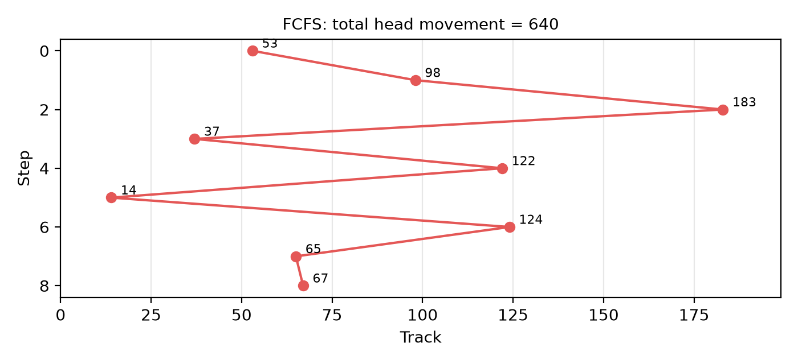
Step | From → To | Movement
1 | 53 → 98 | 45
2 | 98 → 183 | 85
3 | 183 → 37 | 146
4 | 37 → 122 | 85
5 | 122 → 14 | 108
6 | 14 → 124 | 110
7 | 124 → 65 | 59
8 | 65 → 67 | 2
Total |  | 640

4.2 SSTF (Shortest Seek Time First)
The head always goes to the closest pending request. Order: 53 → 65 → 67 → 37 → 14 → 98 → 122 → 124 → 183
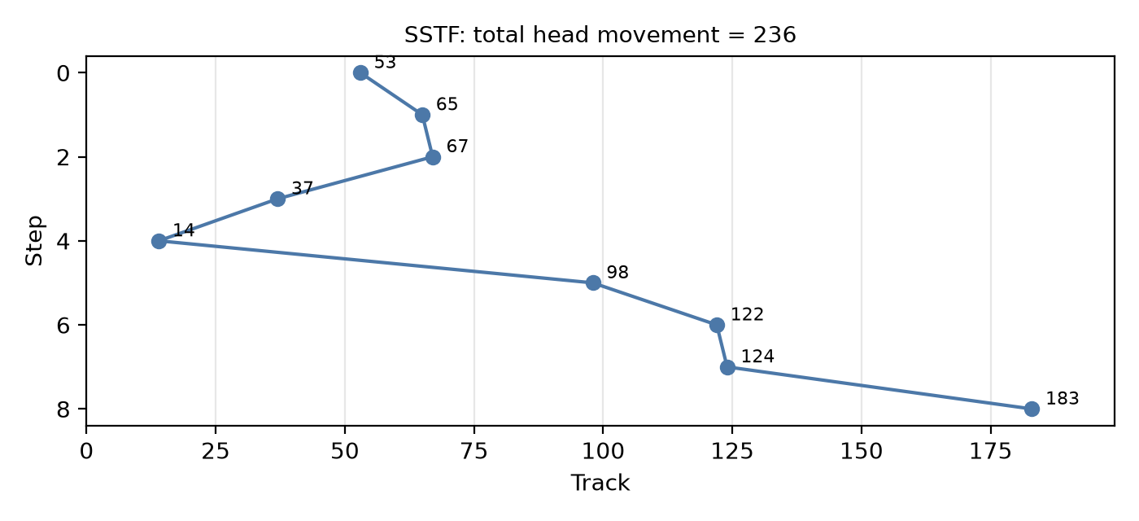
Step | From → To | Movement
1 | 53 → 65 | 12
2 | 65 → 67 | 2
3 | 67 → 37 | 30
4 | 37 → 14 | 23
5 | 14 → 98 | 84
6 | 98 → 122 | 24
7 | 122 → 124 | 2
8 | 124 → 183 | 59
Total |  | 236

4.3 Conclusion
Algorithm | Total head movement | Average per request
FCFS | 640 tracks | 80 tracks
SSTF | 236 tracks | 29.5 tracks

SSTF is more efficient: 236 tracks versus 640, a 63% reduction. FCFS zig-zags across the disk (183 → 37 → 122 → 14), while SSTF serves nearby requests together. Its weakness is possible starvation: far requests can wait indefinitely if new close requests keep arriving. SCAN or C-SCAN (the elevator algorithms) keep most of the gain while guaranteeing fairness.

Summary
Part | Compared | Result | Better choice
CPU scheduling | FCFS vs RR (q = 2) | Avg waiting 3.33 vs 3.33; avg response 3.33 vs 1 | RR (responsiveness)
Synchronization | No lock vs mutex | Lost updates (≤ 200) vs always 200 | Mutex
Memory | FIFO vs LRU | 6 vs 6 page faults | LRU in general (locality)
Disk | FCFS vs SSTF | 640 vs 236 tracks | SSTF (starvation risk)

