10-Day Challenge · Process map
From research to prototype, with AI in the loop
A working process for the emotion-aware music project. Not the classic double diamond: every step is a short loop where AI drafts, you judge, and a gate decides whether to move on.
For: Amin & AmiR
Scope: Research → interviews → survey → definition → prototype → test → case study
Rhythm: 10 working sessions. A session is a focused block, not necessarily a calendar day.

The map
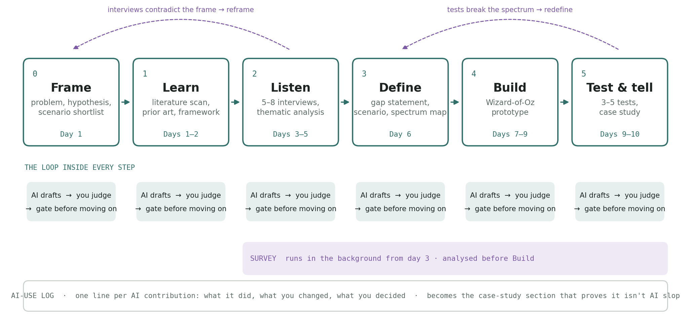
Six phases in a line, a loop inside each one, two places where the line is allowed to bend backwards, a survey running in the background, and a log underneath it all. That log is the piece that makes this an AI-native process rather than a classic one with AI bolted on.

Why this isn't the classic model
The classic design process (empathise → define → ideate → prototype → test) assumes the expensive part is producing things: interview guides, transcripts, syntheses, code. With AI in the room, producing is cheap and judging is the expensive part. So the process is rebuilt around three rules:
- AI drafts, you decide. Every artefact starts as an AI draft that you then cut, correct and own. Nothing AI produces goes into the case study unedited.
- Gates, not phases. You don't move on because the calendar says so. You move on when a specific, written condition is true. The gates are listed under each step.
- Log every AI contribution. One line each: what the AI did, what you changed, what you decided. This log is not admin, it is a deliverable. It becomes the section of the case study that shows a reader exactly how AI was used and where the human judgement sat. That is the answer to "is this AI slop?"
Two loops back are built in on purpose: interviews are allowed to break the framing (back to step 0), and tests are allowed to break the spectrum map (back to step 3). Plan for one of them to happen.

The steps

0 · Frame (Session 1, half a day)
Goal | Write down what you think the problem is before research tells you otherwise, so you can see later how much it moved.
You do | Write a one-paragraph problem statement and a one-line hypothesis ("people want music that moves them from X to Y, not music that matches X").  Shortlist three scenarios and pick a favourite. Candidates: the drive home after a bad day; calming down before a hard conversation; getting going on a low morning.  Decide the split with AmiR: who owns which steps, who edits.
AI does | Drafts the problem statement and hypothesis from the kickoff chat and the brief.  Generates ten scenario candidates so you're choosing, not inventing.
Gate | One scenario chosen, one hypothesis written in a sentence AmiR agrees with. If you can't state the hypothesis in one sentence, you're not done.
Output | frame.md: problem, hypothesis, chosen scenario, two runner-up scenarios.

1 · Learn (Sessions 1–2)
Goal | Borrow a validated model for the "spectrum" instead of inventing one, and know exactly what prior work has and hasn't done.
You do | Read five papers properly, not fifty summaries. Suggested five: the MoodDJ paper (emotion regulation in a music app), EmoHeal (iso-principle, match → guide → target), the on-car mood paper, the Melbourne group's ethics paper on emotion-sensing plugins, and one review of music and emotion regulation.  Pick the framework: the valence–arousal circumplex for the emotional map, and the iso-principle for the transition logic. Write down why in three lines.  Reuse the affective-computing sources from your thesis; you've already read them.
AI does | Rapid scan: finds and summarises 20–30 candidates so you can pick the five.  Extracts each paper's method, input signal, and what it did NOT do into a comparison table.  Drafts a prior-art section from the table (already started in the brief).
Gate | You can explain the iso-principle and the circumplex to AmiR without notes, and the comparison table has a column that is empty for every row except yours (facial input + phase model).
Output | literature.md with the five-paper summary, the framework choice, and the prior-art table.

2 · Listen (Sessions 3–5)
Goal | Find the real pain, which is probably not "the music doesn't match my mood" but something about control, trust, or the moment itself.
You do | Interview 5–8 people, 20–25 minutes each. Mix: some who drive, some who don't; some who use music deliberately for mood, some who don't think they do.  Ask for a specific recent moment, not habits in general. Then ask the two questions that target the gap: would you want this automated, and how would you feel about a camera reading your face to do it.  Do the thematic analysis yourself in the last pass. Name the themes in your own words.
AI does | Drafts the interview guide (semi-structured, 8–10 prompts, with follow-ups).  Transcribes recordings and does a first-pass open coding: every quote tagged, no themes yet.  Clusters the codes into candidate themes for you to accept, merge, split or reject.
Gate | At least one theme you did not expect. If every theme confirms the hypothesis, either the questions were leading or you didn't talk to enough people. This is the step allowed to send you back to Frame.
Output | interviews/ folder with guide, anonymised transcripts, codebook, and themes.md with 4–6 named themes and the best quote for each.

S · Survey (runs alongside 2–4) (Send in session 3, close before session 7)
Goal | Check whether what a handful of interviewees said holds across a wider group, especially on interaction preference and camera acceptance.
You do | Send the survey (separate document) to 40+ people. Friends, the café, AmiR's network, one or two design communities.  Read the open-text answers yourself; that's where the surprises are.
AI does | Drafts and formats the survey (done).  Cleans the export, produces the counts and cross-tabs (e.g. camera acceptance × car users), and drafts a findings summary you then edit.
Gate | 40 responses, or 25 if the pattern is already unambiguous.
Output | survey-findings.md with the five numbers that matter and three quotes.

3 · Define (Session 6)
Goal | Turn everything above into three things you can design from: a gap statement, a scenario, and the spectrum map.
You do | Write the gap statement in two sentences: what exists, what's missing, why people care (from themes and survey).  Lock the scenario. Narrow beats broad.  Sketch the spectrum map by hand: emotional phases on one axis (from the circumplex), musical parameters on the other (tempo, mode, timbre, register, density — EmoHeal's vocabulary is a fine starting point). Mark the path the system walks for your scenario: start state → intermediate → target.  Write 3–5 design principles. At least one should come from the privacy/trust theme, e.g. "the system explains what it noticed before it acts."
AI does | Drafts three alternative gap statements so you can pick the sharpest.  Turns your hand sketch into a clean diagram and a table (phase → parameter ranges → example tracks).  Stress-tests the principles against the interview quotes: which quote supports or contradicts each one.
Gate | AmiR can read the gap statement and the spectrum map and describe what the prototype will do without you explaining it.
Output | define.md and spectrum-map.png. This map is the centrepiece of the portfolio piece, more than the prototype.

4 · Build (Sessions 7–9)
Goal | A working demonstration of the journey, not a product. Wizard-of-Oz where it's cheaper.
You do | Design the interface. Remember the constraint from the kickoff: the mechanism can be nearly invisible, but the journey has to be visible in the UI. Show the person where they are on the spectrum and where the music is taking them.  Choose the tracks per phase by hand. Your ear is the model here, not a recommender.  Decide what is real and what is faked: real face detection is cheap (runs in the browser); the transition engine can be a small rule set; the music library can be a folder of files.
AI does | Writes the code: browser-based face-expression detection, the phase-transition engine, the player, the UI you designed.  Builds the fake parts convincingly (seeded states, a demo mode that walks the whole journey in two minutes).
Gate | You can run the demo on your laptop, in front of a person, from a cold start, twice in a row without touching the code.
Output | The app folder, a two-minute screen recording of the journey, and the AI-use log entries for the build (which will be many).

5 · Test & tell (Sessions 9–10)
Goal | See the demo through three to five people's eyes, then write it up as a case study that a hiring manager reads in four minutes.
You do | Test with 3–5 people in the scenario as far as possible (in a parked car if the scenario is the drive home). Watch faces, not the screen. Ask what they think the system noticed and whether it was right.  Write the case study in your voice. Structure: the question, what people told us, the spectrum map, the prototype, what testing changed, and how AI was used (from the log).  Edit the AI-use log into a readable section: a short table, not a diary.
AI does | Drafts the test script and the note-taking sheet.  Synthesises the test notes into what worked / what broke / what to change.  Drafts the case study from your outline and your logged decisions, then you rewrite it.
Gate | Someone who wasn't involved reads the case study and can say back the gap, the scenario, and one thing testing changed. This is the step allowed to send you back to Define.
Output | case-study.md (or the portfolio page), the recording, and the final AI-use log.

The AI-use log
Keep one file, ai-log.md, from session 1. One line per contribution, three columns:
What AI did | "Drafted 10 interview prompts"; "Open-coded transcript 3"; "Wrote the face-detection module"
What you changed | "Cut 4, rewrote 2 to be less leading"; "Merged 6 codes into 'control'"; "Changed the smoothing window from 1s to 3s after testing"
What you decided | "Kept the question about cameras even though it felt awkward"; "Named the theme 'being read'"; "Faked the voice-tone input for the demo"

By the end you'll have 40–80 lines. The case study shows a curated dozen. That dozen is the proof that the judgement was yours.

How to use this map
- Start each session by reading the gate for the step you're on. Work backwards from it.
- If a step is taking longer than its budget, it usually means the gate is wrong or the scope crept. Fix the gate before pushing through.
- Treat the two back-arrows as expected, not as failure. A case study where nothing moved is less convincing than one where the interviews broke the first framing.
- Everything here is a draft you own. Change the steps, rename them, add a seventh. The only parts worth protecting are the loop, the gates and the log.
10-Day Challenge · process map · prepared 18 September 2026. Companion documents: project brief, survey.

