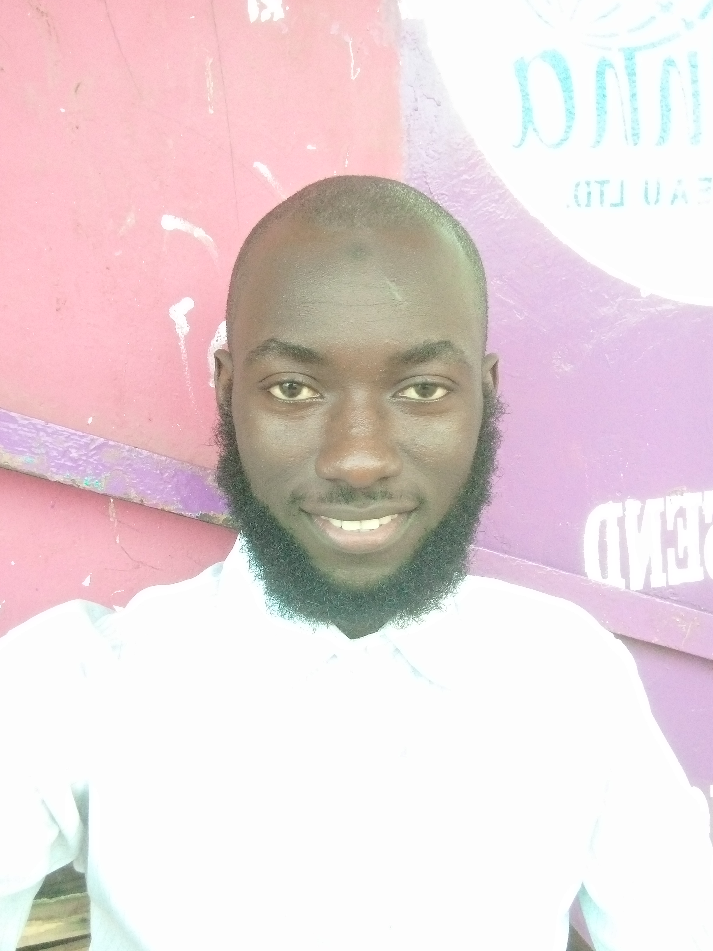

Lamin Jawla | +220-2933536 | laminjawla1001@gmail.com

# About me

I love coding and solving problems

# Work Experience

**Yonna Forex Bureau** *2022 - Present*It is amazing

**Saidou's Mobile Repairing** *2021 - 2022*It was intuitive

# SKILLS

* C Programmer
* Python
* Microsoft Office Applications
* Mathematics
* Writing and Reading
* Singing