pathX
Software Design Description

Author: Steven Herring
March, 2014
Version 1.0

Abstract: This document contains the software design layout for pathX, a casual results driven game being developed upon request by Richard McKennas CSE219 class at Stony Brook University.

Based on IEEE Std 1016TM-2009 document format

- Introduction

The Software Design Description for the pathX game is to act as a visual aid and schematic at a low-level. This will help introduce all parties in the development stages to understand the design and ensure we meet our customers needs. Since we assume there will be many teams working on this project, this document will hold as an introduction for all members. Thus, any member should have a solid understanding of the pathX game by the conclusion of this aid.

  - Purpose

PathX will be a game application, designed and built using the current version of Java to be run on up to date JVM enabled machines. Following you will find UML class diagrams detailing the overall structure and communications between classes, local and global variables, and methods including their signatures. Case interactions caused by user events or timing triggers will be detailed using the UML Sequence diagrams.

  - Scope

PathX will be a standalone game. Any future expansions now are not to be discussed but their possibility is inevitable. Therefore our design will be constructed as such to accommodate ease of expansion. The application will be built upon the MiniGame Framework authored by Richard McKenna of Stony Brook University. As such, this design document will focus primarily on the development of the pathX application and refer to the MiniGame Framework in a black box manner. We will programming using Java 7.4.

  - Definitions, acronyms, and abbreviations

Casual Game – A game that can be picked up and played quickly, where 15 minutes of entertainment may suffice, but typically where richer experiences are also possible. Easy to pick up, easy to put down.

Class Diagram – A UML document format that describes classes graphically. Specifically, it describes their instance variables, method headers and relationships to other classes.

IEEE – Institute of Electrical and Electronics Engineers, the “world's largest professional association for the advancement of technology”.

Framework – In an object-oriented language, a collection of classes and interfaces that collectively provide a service for building applications or additional frameworks all with a common need.

GUI – Graphical User Interface, visual controls like buttons inside a window in a software application that collectively allow the user to operate the program.

Java - A high-level programming language that uses a virtual machine layer between the Java application and the hardware to provide program portability.

Level – A game screen with its own particular set of components and features that fit within the broader rules of the game. Note that rules will be interdependent, so one must complete low levels to advance to higher ones.

Level Select Screen – A game screen that allows the player to progress through the game, selecting the level to play and showing all the levels as they are ordered according to dependencies.

Mini-Game – A standalone game that is a subset of a larger game application, typically sharing the primary game theme with that parent game application.

Mini-Game Framework – Created by Richard McKenna, this framework is the ground which pathX will be built upon. It contains necessary utilities that will be required to complete the project.

PathX - The title for the application in which this document describes.

Sequence Diagram - A UML document format that specifies how object methods interact with one another.

Sprite - A renderable, and sometimes movable or clickable image in the game. GUI controls, buttons and cars may all be their own sprites.

SpriteType – A type of Sprite, meaning all the artwork and states corresponding to a category of a sprite. We do this because many objects may hold many similarities but, they individually have their own positions, speeds, direction and effects.

UML – Unified Modeling Language, a standard set of document formats for designing software graphically.

Use Case Diagram – A UML document format that specifies how a user will interact with a system. Note that these diagrams do not include technical details. Instead, they are fed as input into the design stage (stage after this one) where the appropriate software designs are constructed based in part on the Use Cases specified in the SRS.

  - References

IEEE Std 830TM-1998 (R2009) – IEEE Standard for Information Technology – Systems Design – Software Design Descriptions

pathX SRS – Debugging Enterprises Software Requirements Specifications for the pathX game application.
Zombiequariam SDD – Sample SDD provided by Richard McKenna to aid production in our own SDD.

  - Overview

This Software Design Description document provides a working design layout for the pathX software application as described in the pathX Software Requirements Specification. Note that all parties in the implementation stage must agree upon all connections between components before proceeding with the implementation state.
This Software Design Description document provides our teams with a feasible design layout for the pathX game application using the details provided to us in the pathX SRS by Richard McKenna. Any design issues must be dealt with now and an updated SDD may be created to honor those resolutions before we move into implementation stages.

Sections
- Section 2 will provide Package-Level Viewpoint,specifying the packages to be designed.
- Section 3 will provide the Class-Level Viewpoint, using UML Class Diagrams to spcify how the classes should be constructed.
- Section 4 will provide the Method-Level System Viewpoint, describing how methods will interact with one another.
- Section 5 will provide deployment information like file structures and formats to use.
- Section 6 provides a Table of Contents, an Index and References. Note that all UML Diagrams in this document were created using the VioletUML editor.

- Package-Level Design Viewpoint

The pathX game design will only require a client side application. The game data will live within memory, our game has no need to control multiple users. It is understood that the game will have one owner, thus one user. We will use a Model-View-Controller. We will be using Java's API, the MiniGame Framework and application specific components we will build on our own.

  - pathX and Mini Game overview

Figure 2.1 shows necessary components to be developed and localizing them into seperate packages for ease of use.

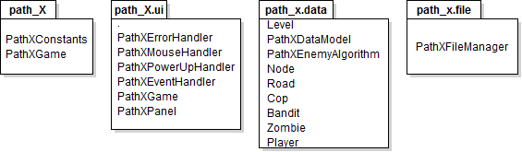

Figure 2.1: Design Packages Expansion

  - Java API Usage

PathX as said, will be developed using Java also keep in mind the MiniGame Framework which has already been developed, is also in Java. We will be using the classes laid out below in Figure 2.2.

Figure 2.2: Java API Expansion

  - Java API Usage Descriptions
Tables 2.3.1 – 2.3.8 summarize how the aforementioned classes will be used.

Class/Interface | Use
Color | For setting the rendering colors for text, cars, buttons etc.
Cursor | For loading a custom mouse cursor.
Font | For setting the fonts for rendered text.
Graphics | For rendering text, images, and shapes to the canvas.
Image | For storing image data.
Insets | For changing component margins.
MediaTracker | For ensuring synchronous image loading.
Toolkit | For loading images.

Table 2.3.1: Uses for classes in the Java API's java.awt package.

Class/Interface | Use
ActionEvent | For getting event information when a button is pressed.
ActionListener | For responding to an action event, like a button press. We will provide our own custom implementation of this interface.
KeyEvent | For getting information about a key event, like which key is pressed.
KeyListener | For responding to a key event, like a key press. We will provoide out own custom implementation of this interface.
MouseEvent | For getting information about a mouse event, like click location.
MouseListener | For responding to a mouse event, like a mouse click. We will provide our own custom implementation of this interface.

Table 2.3.2: Uses for classes in the Java API's java.awt.event package.

Class/Interface | Use
Buffered Image | For storing image data where pixel information can be accessed and changed.
WritableRaster | For changing pixel data in a BufferedImage. We'll use this to add transparency to pixels loaded with the color key.

Table 2.3.3: Uses for classes in the Java API's java.awt.image package.

Class/Interface | Use
BufferedInputStream | Second layer of input reading stream for loading game data.
BufferedOutputStream | Second layer of output writing stream for saving game data.
BufferedReader | For reading text files, we'll use this for loading game data during load.
ByteArrayOutputStream | For storing game data in a byte array.
DataInputStream | For reading primitive types in game save files during load.
DataOutputStream | For writing primitive types in game save files, during save/quit.
FileInputStream | For reading text files to load game data.
FileOutputStream | For writing to text files when saving game data.
FileReader | For reading files
IOException | For picking up exception errors and handling them properly.

Table 2.3.4: Uses for classes in the Java API's java.io package.

Class/Interface | Use
ArrayList | For storing algorithm paths, like the cop or bandits route.
Collection | For storing groups of data, Values in Maps are stored in collections, allowign iterating for rendering purposes
GregorianCalendar | For calculating time spent doing specific tasks, useful for statistics.
HashMap | For storing(name,value) key pairs, we'll use it for storing out Images, accessible using their ID names.
Iterator | For iterating through a data structure during operations like rendering or collision detection.
Timer | Will execute custom task at fixed intervals. i.e. Traffic lights
TimerTask | Our custom task to be executed at a fixed framerate. This will be extended and provide task implementation in the run method.
TreeMap | For storing (name, value) key pairs, we'll use it for storing SpriteTypes and GUI components, accessible using their ID names.
Vector | For storing data like the Strings for rendering debugging text.

Table 2.3.5: Uses for classes in the Java API's java.util package.

Class/Interfact | Use
ReentrantLock | For ensuring only one thread has access to program data.

Table 2.3.6: Uses for classes in the Java API's java.util.concurrent package.

Class/Interface | Use
JFrame | Provides the window for out GUI.
JOptionPane | Provides a popup dialog for error feedback, exit confirmations.
JPanel | Provides a canvas for the game to be rendered onto.

Table 2.3.7: Uses for classes in the Java API's javax.swing package.

Class/Interface | Use
NumberFormat | For formatting numerical data like game cash, points, time, wins etc.

Table 2.3.8: Uses for classes in the Java API's java.text package.'

      - Class-Level Design Viewpoint

Here we would like to display our application pathX using UML Class Diagrams. We will start with a birds eye view of the project, eventually zooming down to the intricacies of each class.

Figure 3.0.1: PathX Overview UML Class Diagram

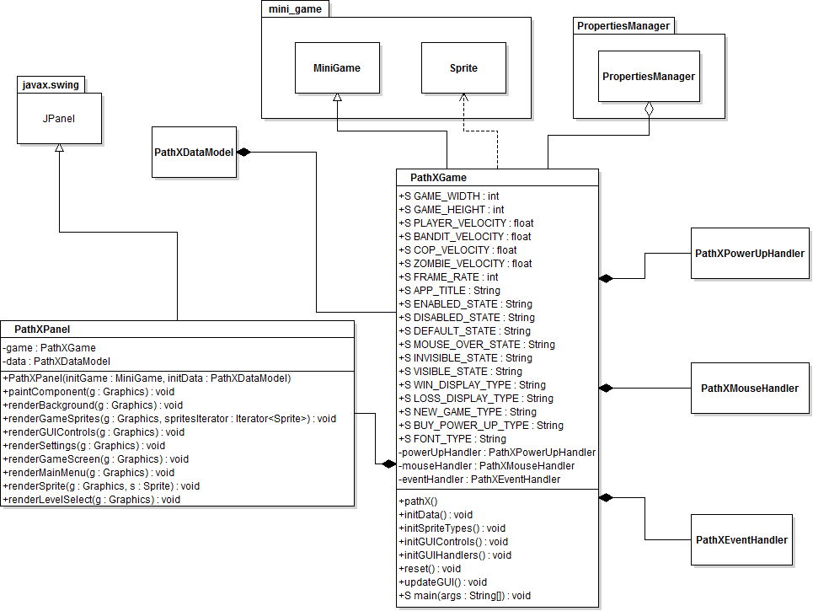

Figure 3.0.2: PathXPanel and PathXGame Detailed UML Class Diagram

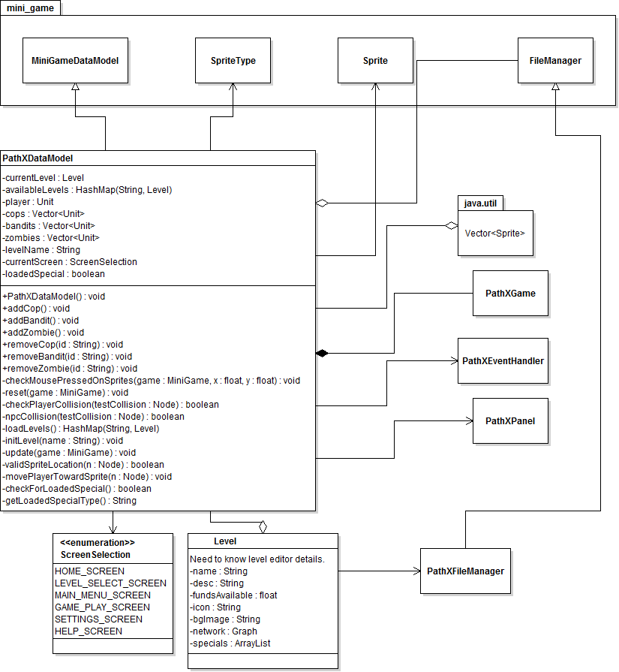

Figure 3.0.3 PathXDataModel, ScreenSelection, Level UML Class Diagrams

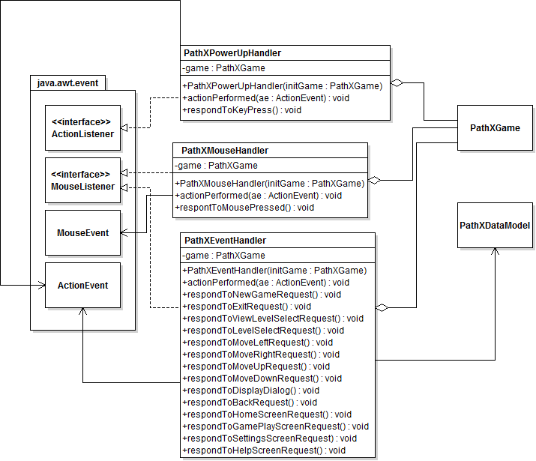

Figure 3.0.4 Detailed PowerUpHandler, MovementHandler, PathXEventHandler UML Class Diagrams.

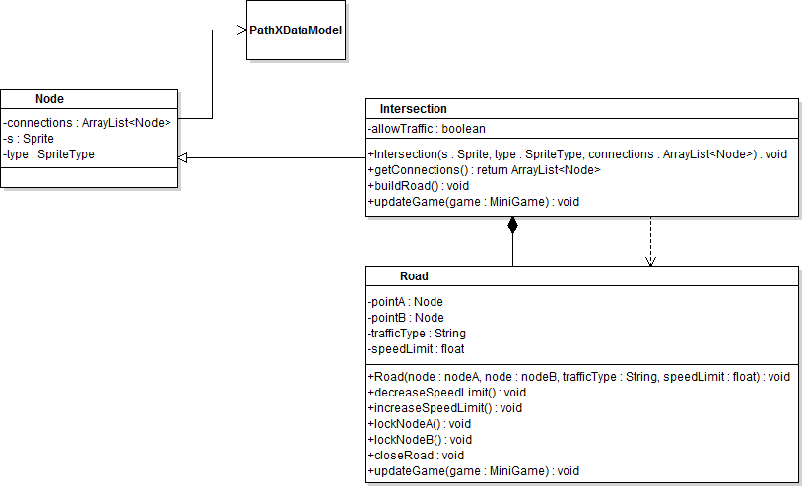

Figure 3.0.5 Nodes and Roads UML Class Diagram

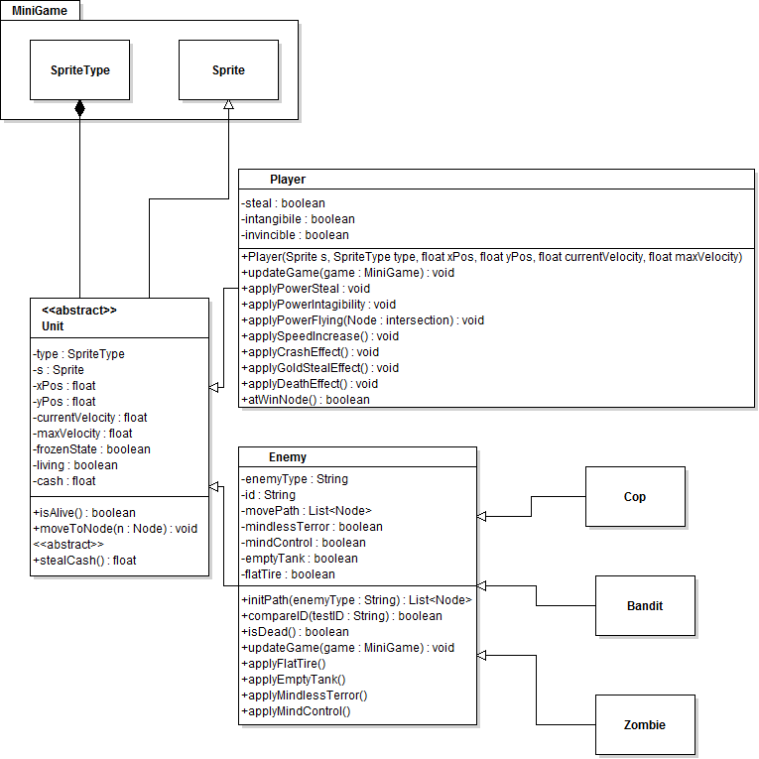
Figure 3.0.6 Game Unit, Player, Enemy UML Class Diagram

4. Method-Level Design Viewpoint

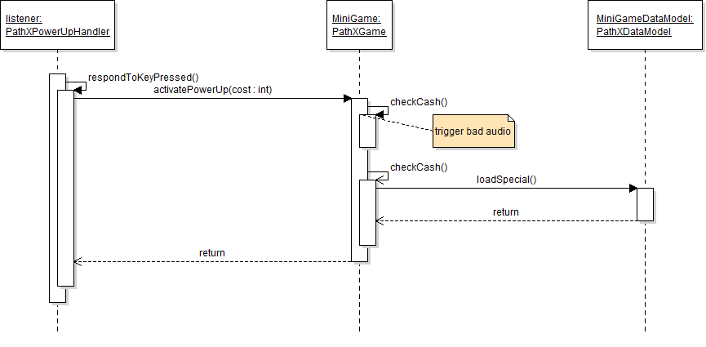
Figure 4.0.1 PowerUpHandler UML Sequence Diagram

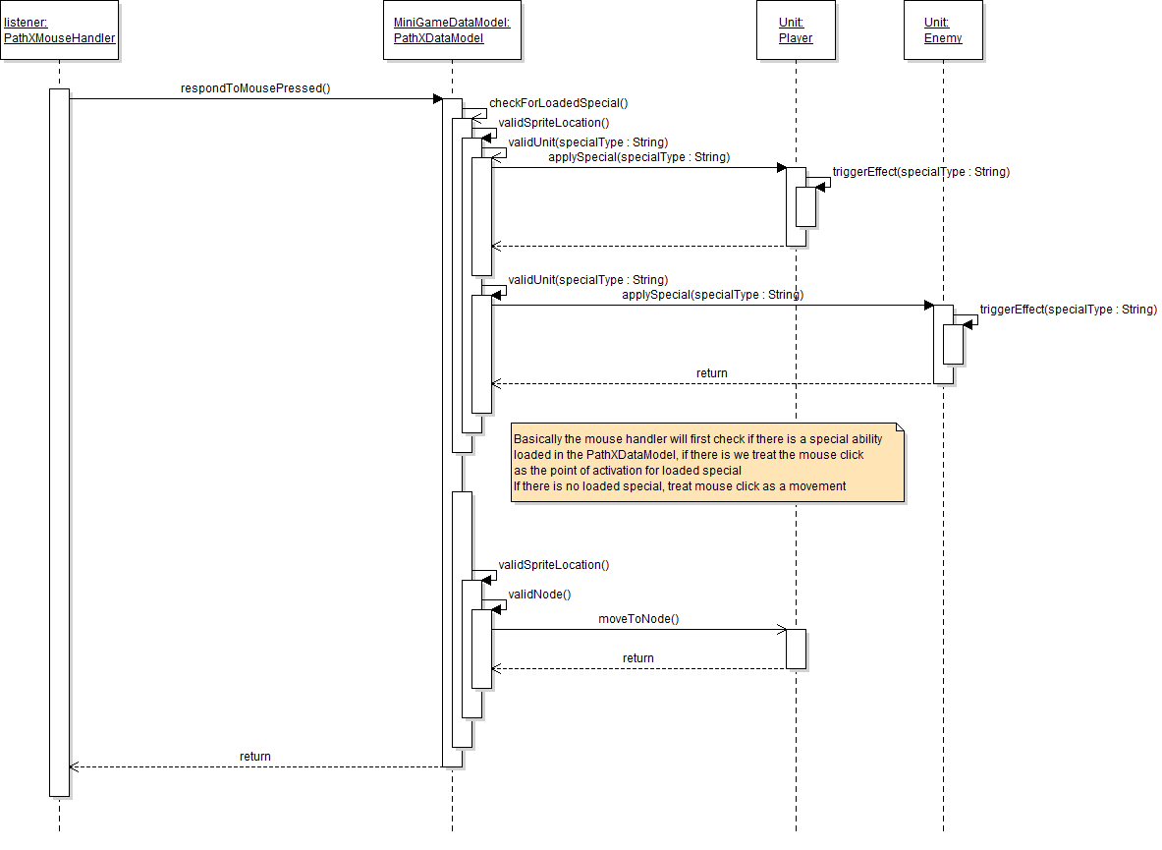

Figure 4.0.2 MouseHandler UML Sequence Diagram

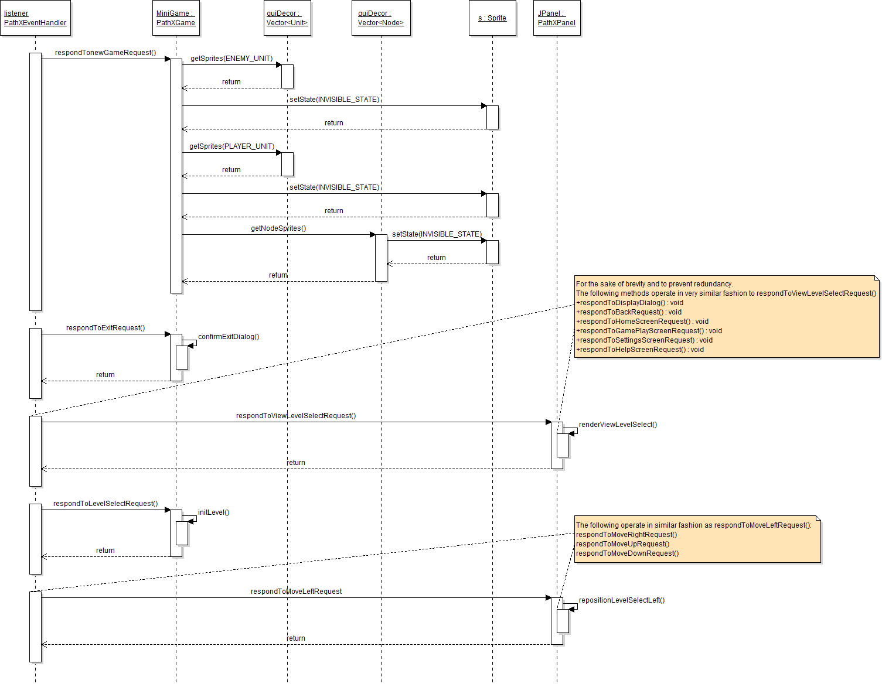
Figure 4.0.3 PathXEventHandler UML Sequence Diagram

      - File Structure and Formats

The Framework used, developed by Richard McKenna; MiniGameFrame work will be accessible via a Java Archive File (JAR). For our purposes we will need to import this JAR into the PathX project so we can make use of all the useful classes it contains.
Within the deployment folder will be a PathX.jar file in company of a setup folder. There we will have a data file named PathX.dat. Next an XML file named Properties, this will be paired with a PropertiesSchema.xsd. Finally two last folders one named Image, the other, Audio.

PathX.jar – will be our working executable application.
Setup[Folder] - will be a place to store important load data including the following files.
PathX.dat – will be a place for storing game save data.
Properties.xml -will be a place for defining all used Strings commonly used for the game properties, file locations, audio etc.
PropetiesSchema.xsd – will be a xml schematic to help confirm we're loading a properly built file.
Images[Folder] – will be a place to store every display image within the game.
Audio[Folder] – will be a place to store audio files for the game.

        - Supporting Information

Since this document is to aid in the development process, convenience is key. Therefore a table of contents will aid nicely.

  - Table of Contents

- Introduction 2
    - Purpose 2
    - Scope 2
    - Definitions, acronyms, and abbreviations 2
    - References 3
    - Overview 4
2. Package-Level Design Viewpoint 5
1. PathX and MiniGame overview 5
2. Java API Usage 6
3. Java API Usage Descriptions 6
3. Class-Level Design Viewpoint 9
4. Method-Level Design Viewpoint 15
5. File Structure and Formats 18
6. Supporting Information 18
1. Table of Contents 18

