Eyeglass Preview for E-commerce

By IIT, University of Dhaka.

# Background

From a recent rise in e-commerce growth, an expectation among buyers is to preview themselves in their choice of wearable before they buy it. For instance, one would want to see how his/her face looks like wearing an eyeglass he/she likes. The quickest approach is to take a photo of own self, pick the eyeglass of choice and leaving the rest to the application that automatically places the glass smoothly around the eyes. This cool feature is badly required but missing in e-commerce sites across the globe. Therefore, this project aims to build a prototype of this e-commerce application that will allow users to preview their face wearing a set of eyeglasses in virtual space.

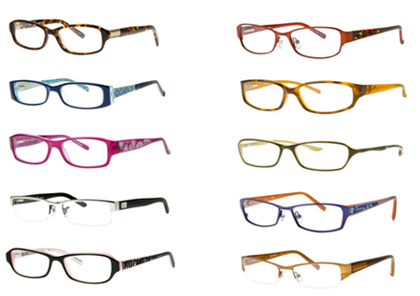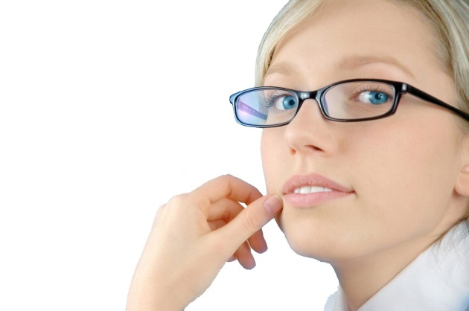

# Figure 1: Eyeglass preview

# Project Scope

Eyeglass preview for e-commerce application covers the following areas:

**Basis Requirements**

* The app window will contain a set of virtual eyeglasses and preview camera.
* User will able to click on eyeglasses and the glass will automatically set in face
* The eye must visible from the eyeglass lenses

**Exciting Requirements**

* The shadow of eyeglass will be shown

# Solution Direction

**Basic Deliverables**

* Detect face and eyes
  + Using open source
  + Features: Haar /LBP/HOG/SIFT
  + Classifier: Adaboost /SVM/Random Forest
* Detect the glass frame excluding the eyeglass
  + Using adaptive threshold based method
* Set the frame on eye
  + Using superposition theorem
* Make the lenses transparent enough to visualize the eyes

**Exciting Deliverables (if possible)**

* Reflect the shadow of eyeglass using laws of reflection

**Timeline**

|  |  |  |  |  |  |  |  |  |  |  |
| --- | --- | --- | --- | --- | --- | --- | --- | --- | --- | --- |
| **Features** | **Jan, 2015** | **Feb** | **Mar** | **Apr** | **May** | **Jun** | **Jul** | **Aug** | **Sep** | **Oct, 2015** |
| Face and eye pupil detection: R&D |  |  |  |  |  |  |  |  |  |  |
| Glass frame detection: R&D |  |  |  |  |  |  |  |  |  |  |
| Setting frame on eye: R&D |  |  |  |  |  |  |  |  |  |  |
| Making the lenses transparent: R&D |  |  |  |  |  |  |  |  |  |  |
| Reflection of eyeglass shadow: R&D |  |  |  |  |  |  |  |  |  |  |

**Cost Estimation**

Team Members: 5

Total Time required: 10 months

Total cost: 5 lacks