INDIVIDUAL REPORT
DATABASE DESIGN & SQL
Online Bookstore Database - MySQL
Full name: Lam Ngoc Kien
Student ID: 134010126001
Class: K26ISTG01
Database: MySQL 8.x
Assignment: Individual - 2 weeks

Submission package includes SQL scripts, ERD, query catalogue, result previews, README, CI workflow, and this report.

1. Objectives and Scope
The project designs a normalized relational database for a small online bookstore using MySQL 8.x. The goal is to demonstrate database design, integrity constraints, SQL querying, reusable database objects and practical optimization choices.

2. Requirement Analysis
The model contains eight tables. Books connect to one category, one author and one publisher. Customers place orders. Each order contains order items, and each order has at most one payment record. The order_items table resolves the business many-to-many relationship between orders and books.
Table | Purpose | PK | FK
categories | Classification | category_id | -
authors | Author master | author_id | -
publishers | Publisher master | publisher_id | -
books | Catalogue | book_id | author_id, publisher_id, category_id
customers | Customer master | customer_id | -
orders | Order header | order_id | customer_id
order_items | Order lines | order_item_id | order_id, book_id
payments | Payment | payment_id | order_id

Seed volume
10 categories | 10 authors | 10 publishers | 20 books | 10 customers | 10 orders | 20 order items | 10 payments

3. ERD and Relationships
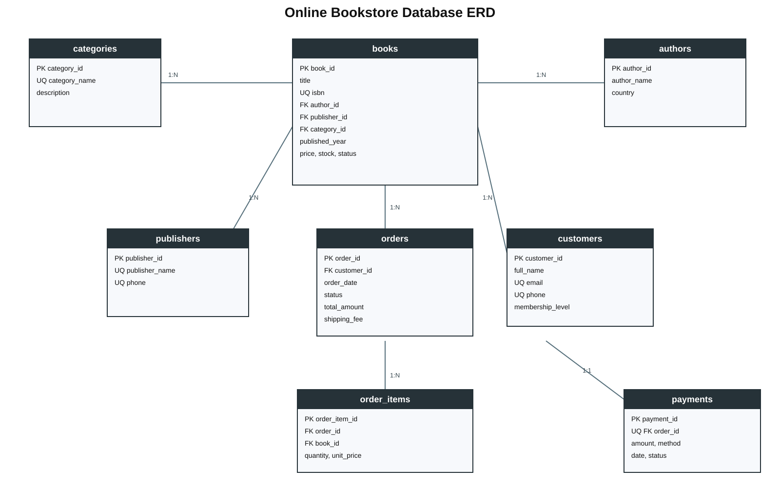
Figure 1. ERD of the eight-table online bookstore database.
Relationships: categories 1-N books; authors 1-N books; publishers 1-N books; customers 1-N orders; orders 1-N order_items; books 1-N order_items; orders 1-1 payments.

4. Normalization to 3NF

1NF
Columns contain atomic values and every table has a primary key.

2NF
Order header fields are separated from order-line fields; non-key attributes depend on the complete row identity.

3NF
Author, publisher and category descriptions are separated into master tables. Customer attributes remain in customers and order attributes remain in orders, removing transitive dependencies.

5. Database Implementation
Feature | Object | Purpose
Indexes | 4 indexes | Frequent title, category+price, customer+date, book joins
View | v_order_summary | Reusable customer/order summary
Stored procedure | sp_create_order | Transactionally create a pending order
Trigger | trg_order_items_before_insert | Validate stock, freeze price, decrement stock
Trigger | trg_payments_after_insert | Set order to PAID after success
Constraints include PK, FK, UNIQUE, NOT NULL, CHECK and DEFAULT. Monetary values use DECIMAL(12,2). Status columns use controlled ENUM values.

6. Query Coverage
Query | SQL feature | Purpose
Q01 | SELECT/WHERE/ORDER BY/LIMIT | Active books under price threshold
Q02 | INNER JOIN | Orders with customer names
Q03 | LEFT JOIN | All customers + order counts
Q04 | GROUP BY + aggregates | Revenue statistics
Q05 | Subquery WHERE | Books above average price
Q06 | Subquery FROM | Sales by category
Q07 | Window function | Book sales ranking
Q08 | Nested query | Customers above average spend
Q09 | CASE WHEN | Price segments
Q10 | Missing data | Customers without orders
Q11 | Pagination | Page 2 of books
Q12 | CTE | Monthly revenue ranking

7.1 Query Result Previews
These images are deterministic previews generated from the exact seeded dataset. They are not claimed as live MySQL Workbench screenshots. Replace with live screenshots before final submission when literal screenshots are required.
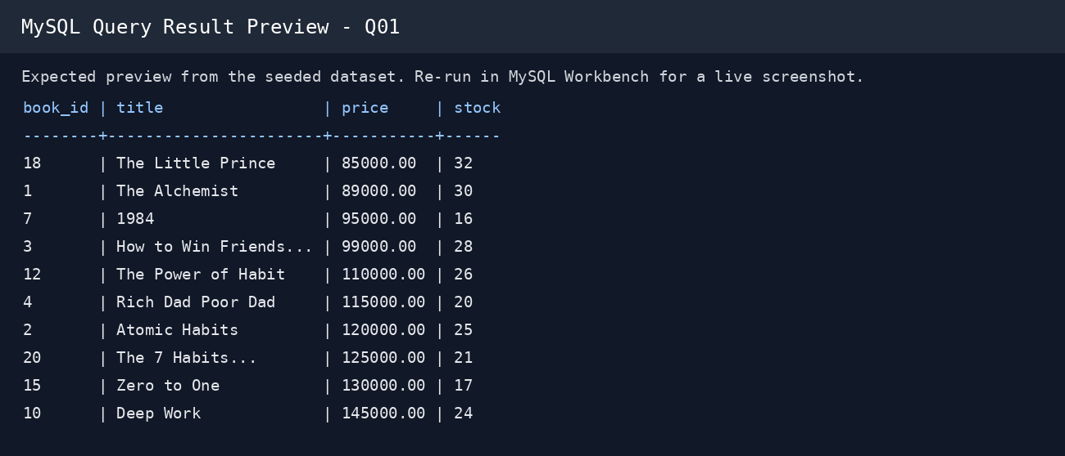  Q01 result preview | 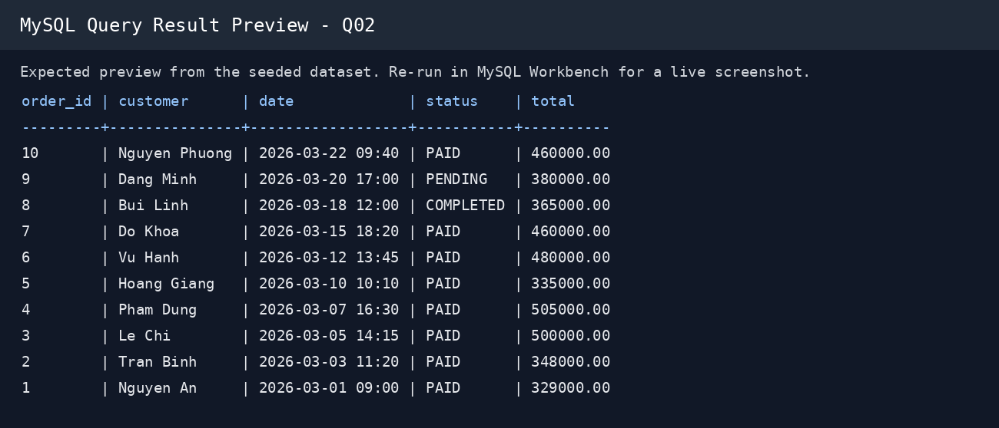  Q02 result preview
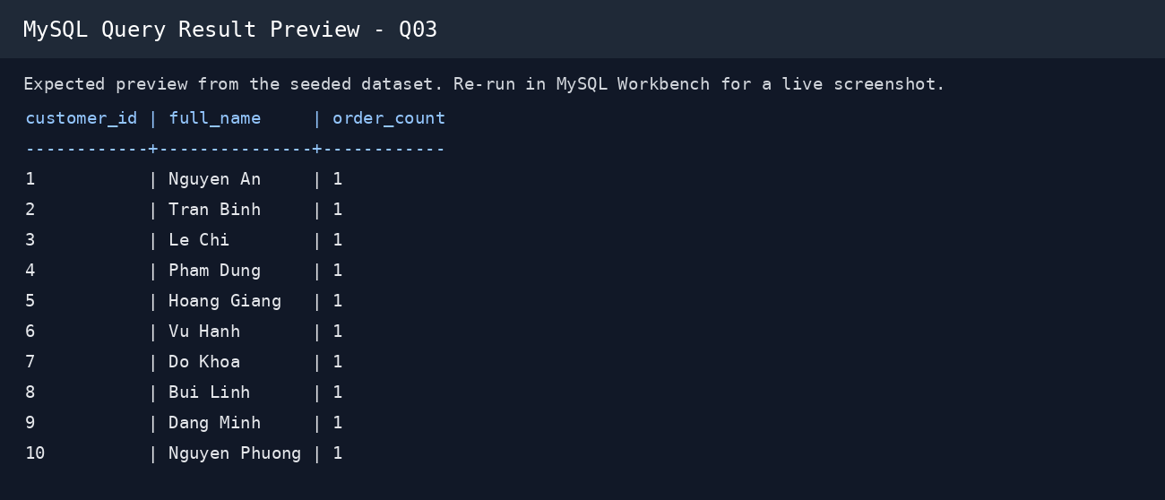  Q03 result preview | 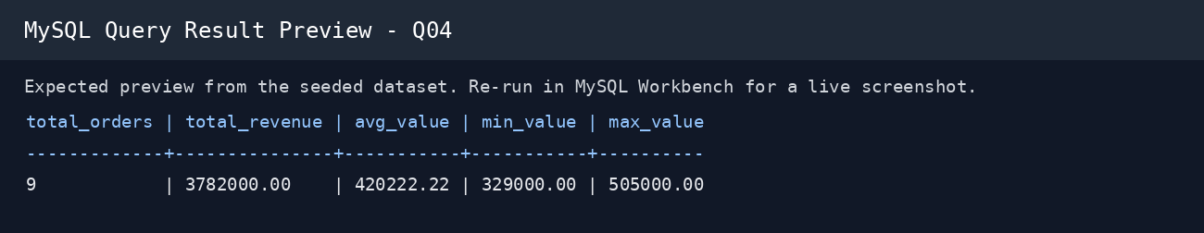  Q04 result preview

7.2 Query Result Previews
These images are deterministic previews generated from the exact seeded dataset. They are not claimed as live MySQL Workbench screenshots. Replace with live screenshots before final submission when literal screenshots are required.
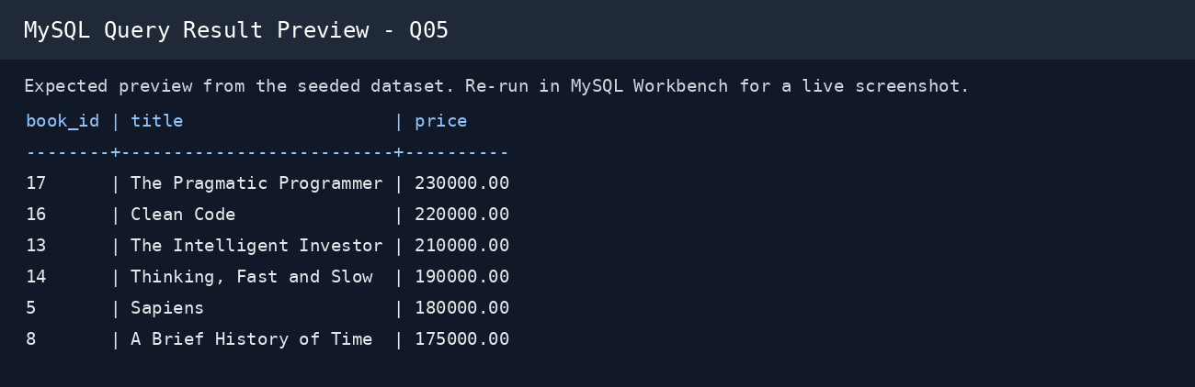  Q05 result preview | 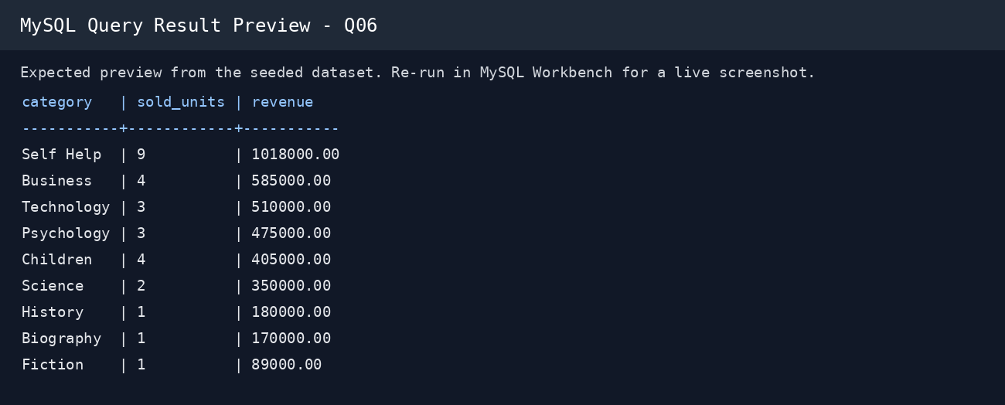  Q06 result preview
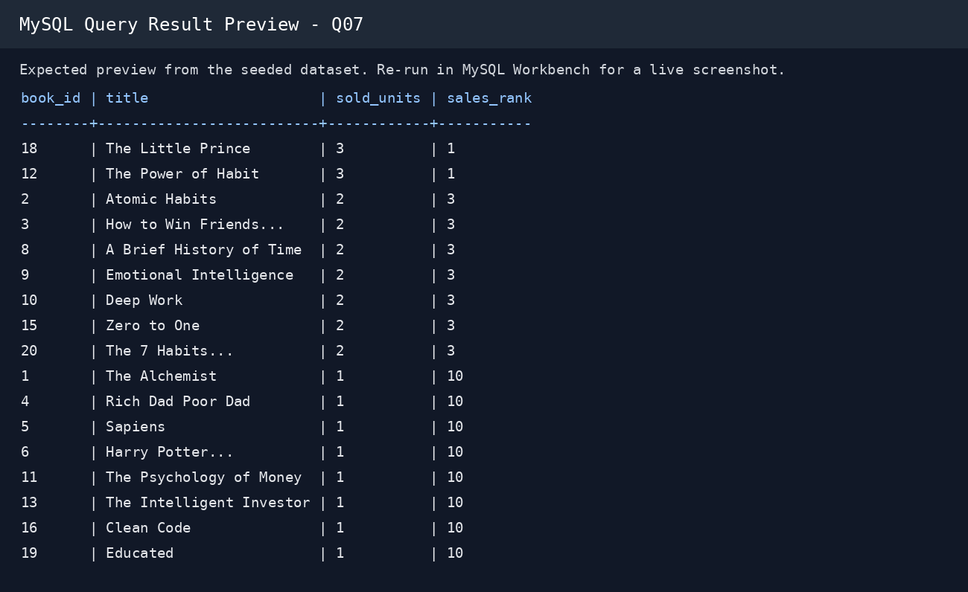  Q07 result preview | 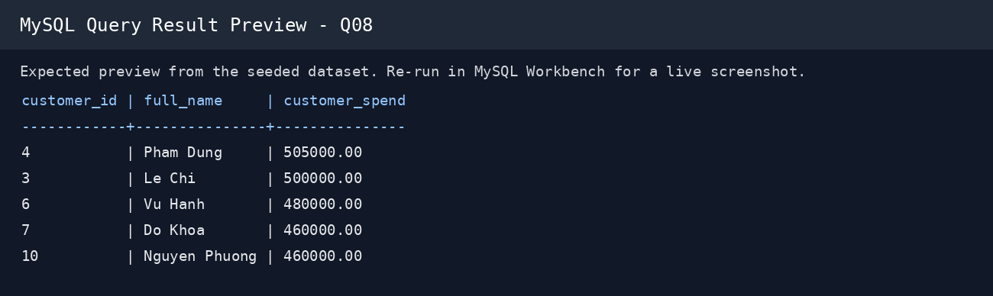  Q08 result preview

7.3 Query Result Previews
These images are deterministic previews generated from the exact seeded dataset. They are not claimed as live MySQL Workbench screenshots. Replace with live screenshots before final submission when literal screenshots are required.
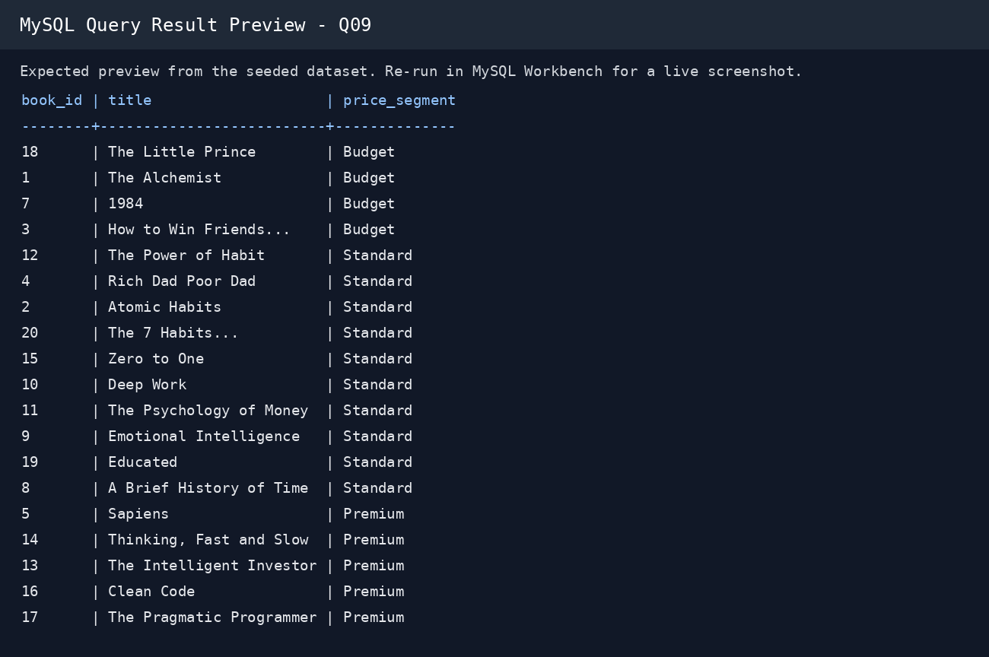  Q09 result preview | 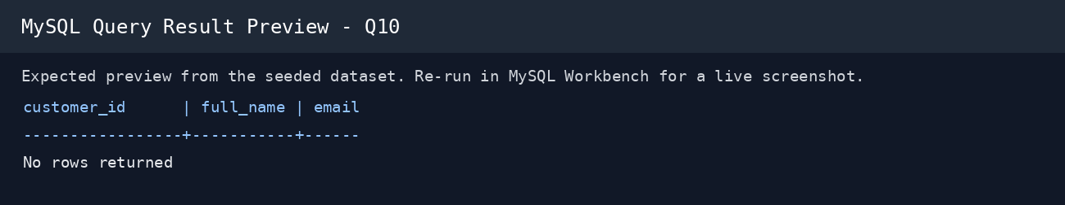  Q10 result preview
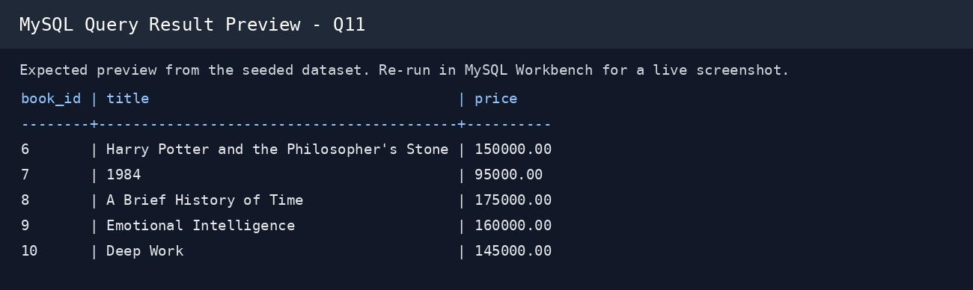  Q11 result preview | 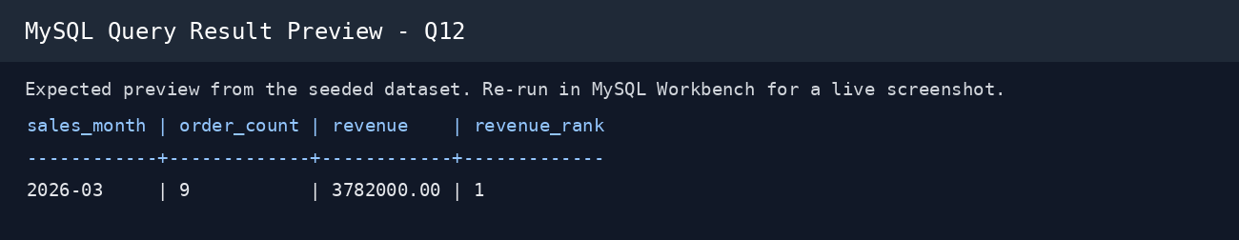  Q12 result preview

8. Optimization and Performance
The project includes indexes selected from common access patterns. Use EXPLAIN in MySQL Workbench to compare query plans before and after adding an index. The repository intentionally avoids fabricated timing numbers; actual timings should be captured on the submission machine.

9. Difficulties and Solutions

3NF design
Separated master data from transactional data and linked tables using foreign keys.

Stock consistency
A trigger validates stock and decrements it when an order line is inserted.

Reusable reporting
A view centralizes common order/customer columns.

10. Lessons Learned
The design process showed that constraints and data organization are as important as writing SELECT statements. Normalization reduces duplication, while indexes should be chosen from real query patterns. CTEs and window functions make analytical reporting clearer.

11. Future Improvements
Possible extensions include multiple authors per book, customer addresses, shipment tracking, discounts, audit logging and full-text search.

