CHAPTER 07 – STATIC MODELING
Assignment 07: Static Class Modeling for Orders

- Identify entity classes
• Order Food
• Payment
• Cancel Order
• View Order Status
• Feedback
• Search Food / Category
• Customer
• Owner / Staff
2. Draw a Class Diagram showing:
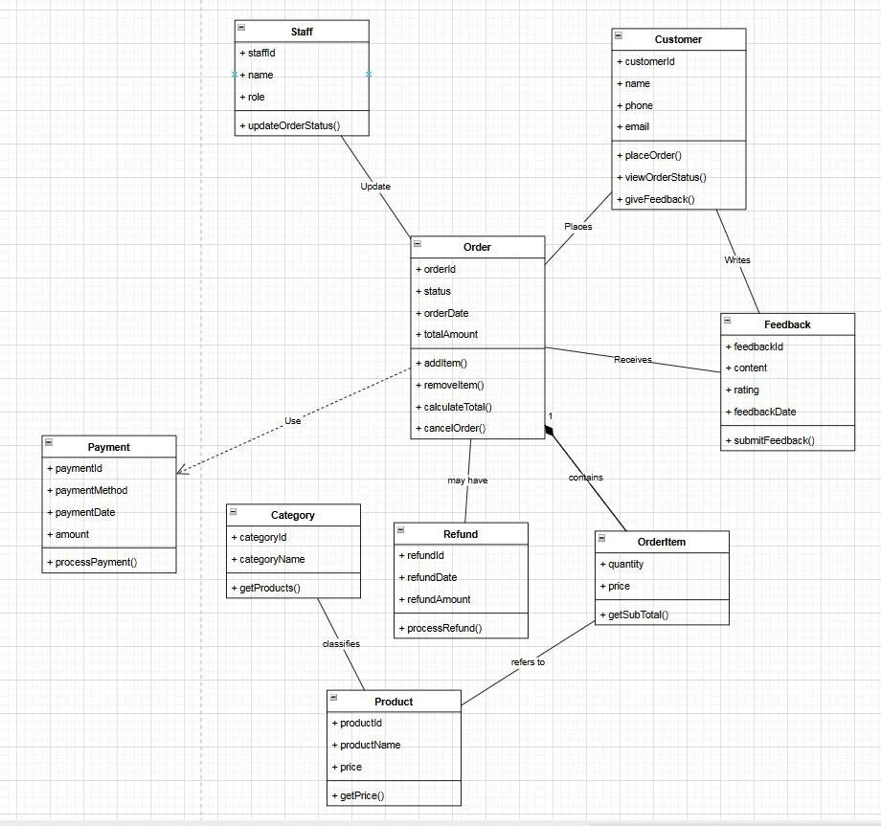
3. Explain design decisions
The static class model is designed based on the structure of the Order module.
Entity classes are chosen to represent persistent objects in the system.
Composition is applied between Order and OrderItem to reflect a strong whole-part relationship.
Association relationships are used to represent static links between independent entities such as Customer and Order.
Dependency relationships are used where a class temporarily uses another class without owning it structurally, such as Order using Payment and Refund.

