**Object-Oriented Programming**

**Report Lab 02: Problem Modeling and Encapsulation**

Student name: Lê Tùng Lâm

Student ID: 20235962

1. Use case diagram

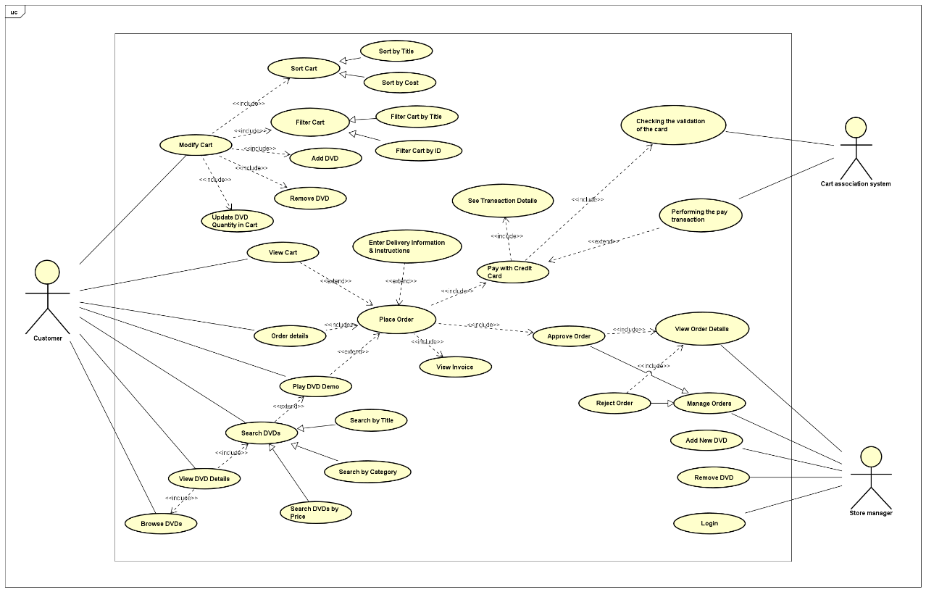

1. Class diagram

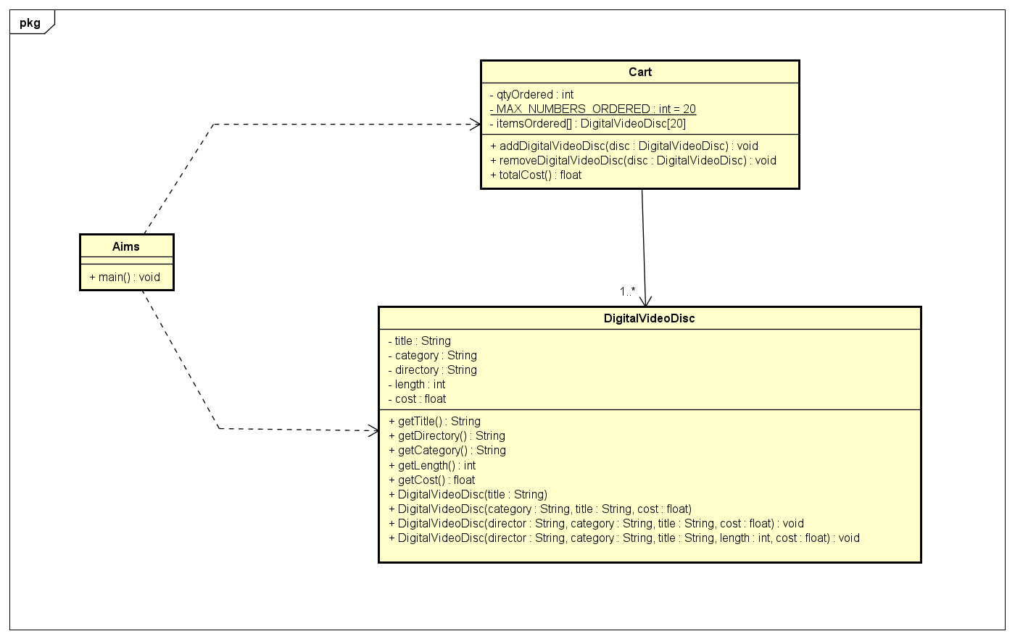

1. Reading assignment

When should accessor methods be used?

Answer: Accessor methods be used for returning objects through interfaces, when a method returns an object that implements a specific interface.

Reason:

* Interface Isolation: The interface defines the behavior or contract that code can interact with, rather than exposing the internal structure or implementation details of the object. This allows the calling code to interact with the object in a consistent way without being tied to a specific implementation.
* Encapsulation Protection: If the underlying implementation of the object changes but still conforms to the same interface, code using the object remains unaffected. This protects the integrity of the data and preserves encapsulation, reducing the risk of errors caused by implementation changes.

1. Answering questions

If you create a constructor method to build a DVD by title then create a constructor method to build a DVD by category. Does JAVA allow you to do this?

Answer: No, Java does not allow to build create a constructor method to build a DVD by category after creating a constructor method to build a DVD by title

Because: "category" and "title" have the same variable type String so Java can not distinguish two variables when user inputs. Java does allow you to have multiple constructors for a class (a concept called constructor overloading), but each constructor must have a different parameter list. When both constructors use a single String as their parameter, Java cannot distinguish between them. So, if you define two constructors, each with a single String parameter, the compiler will throw an error because it cannot tell if the String input should be treated as a title or a category.