**Report Object-Oriented Programming**

Lab 03: Basic Object-Oriented Techniques

# 2. Working with method overloading

2.1. Overloading by differing types of parameter

## 2.2. Overloading by differing the number of parameters

# 3. Passing parameter

Result:

4. Use debug run

## Debug run for the swap method of TestPassingParameter

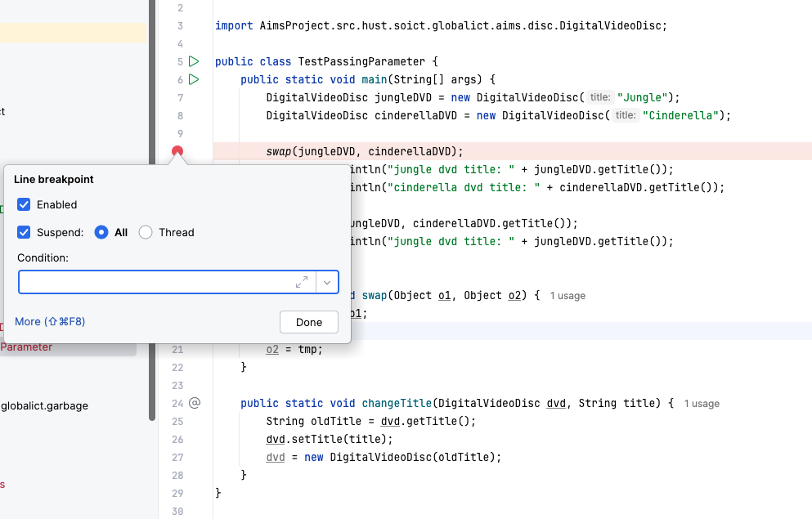

## Run in Debug mode:

1. Classifier Member and Instance Member

# Open the Cart class

CartTest:

Result:

# Implement the Store class

# Re-organize your projects

## String, StringBuilder and StringBuffer

GarbageCreator:

NoGarbage:

ConcatenationInLoops:

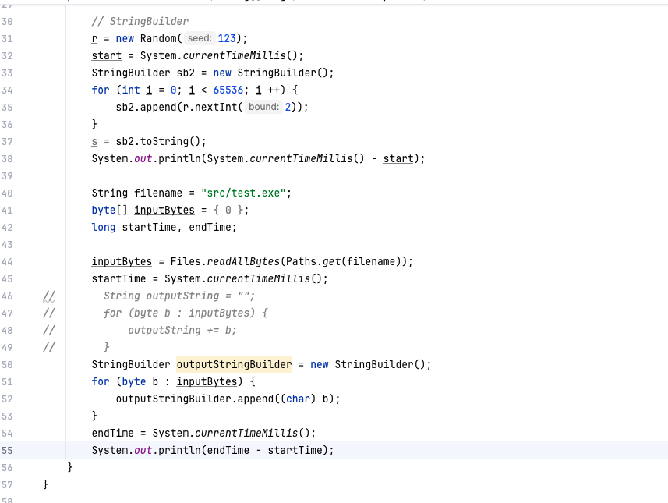

Result:

