**Install Jenkins on Azure**

**Deployment Architecture**

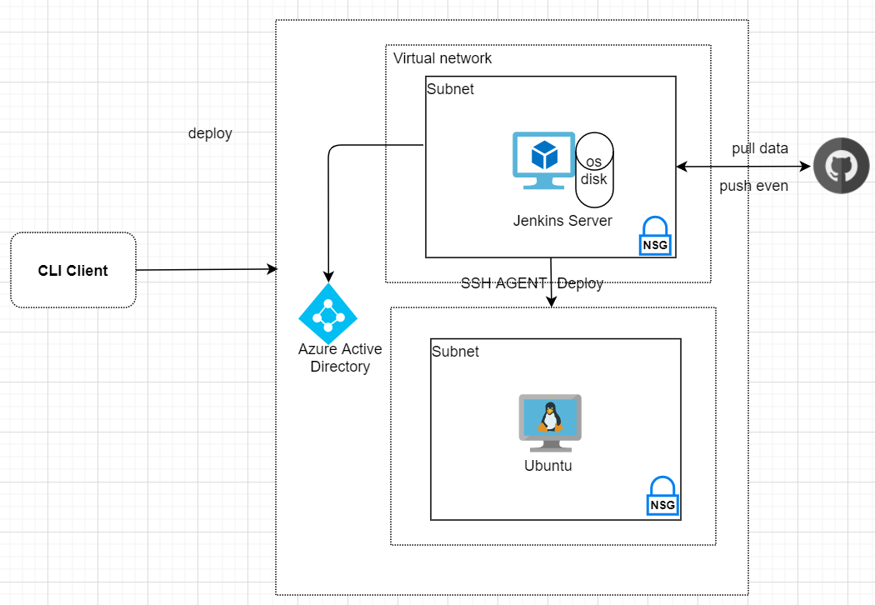  
  
In this exercise, we will deploy a Jenkins server on azure cloud using azure cli api.  
  
**Step 1**: Login into Azure

az login –username=youruser  
Password prompt next

**Step 2**: Create resource group to manage Jenkins server and all related resources which are created later.  
  
  
  
**Step 3**: Create ubuntu VM and Initialize the server with shell script which executes:  
- install open JDK 8  
- install Jenkins server  
  
**cloud-init-jenkins.txt:**

az vm create --resource-group jenkins-rg --name jenkins --image Canonical:UbuntuServer:16.04-LTS:latest --admin-username azureuser --generate-ssh-keys --custom-data cloud-init-jenkins.txt

az group create --name jenkins-rg --location eastus

#cloud-config

runcmd:

- sudo apt-get update

- sudo apt install openjdk-8-jre-headless -y

- sudo apt install openjdk-8-jdk-headless -y

- wget -qO - https://pkg.jenkins.io/debian-stable/jenkins.io.key | sudo apt-key add -

- sudo sh -c 'echo deb https://pkg.jenkins.io/debian-stable binary/ > /etc/apt/sources.list.d/jenkins.list'

- sudo apt-get update && sudo apt-get install jenkins -y

- sudo service jenkins restart

**Step 4**: Add inbound rules for port 8080 (http) and 8443 (https)  
  
  
  
  
  
**Step 5**: Check checking is working?  
- Get IP of Jenkins server:  
   
  
  
- Open browser and go to the http://ip_address:8080

az vm show --resource-group jenkins-rg --name jenkins -d --query [publicIps] --o tsv

az vm open-port --resource-group jenkins-rg --name jenkins --port 8080 --priority 1001

az vm open-port --resource-group jenkins-rg --name jenkins --port 8443 --priority 1002

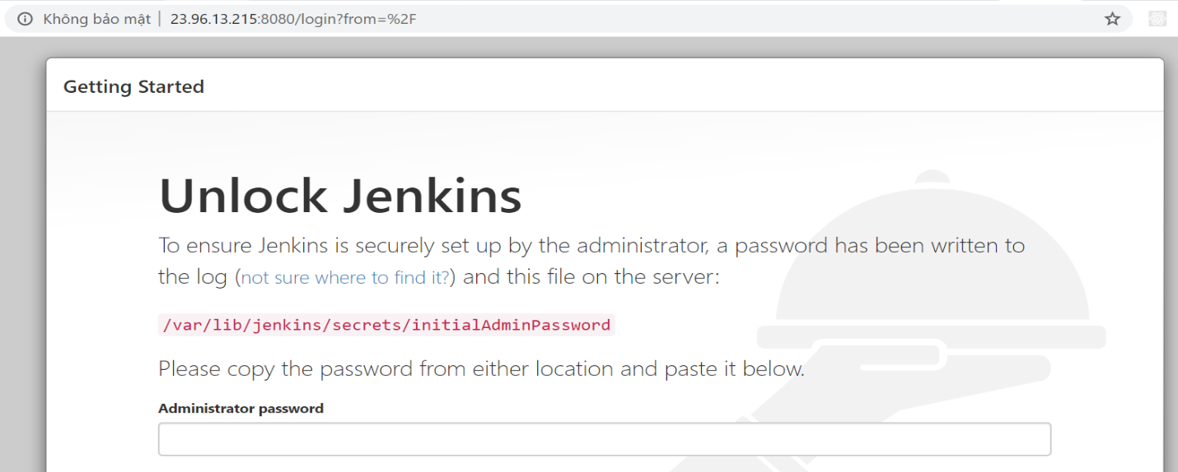

**Step 5:** Config HTTPS:  
- SSH to the Jenkins server and generate cerfiticate  
  
  
  
  
  
- Update Jenkins config   
  
  
  
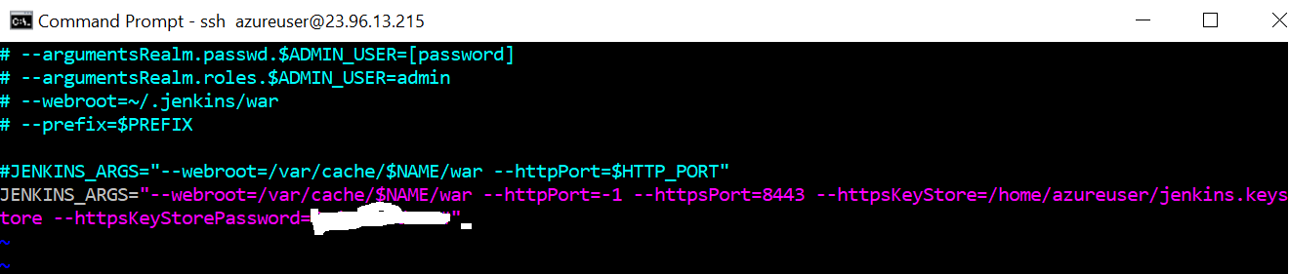  
  
- Restart Jenkins server  
  
  
  
- Open browser and check <https://ip_address:8443>  
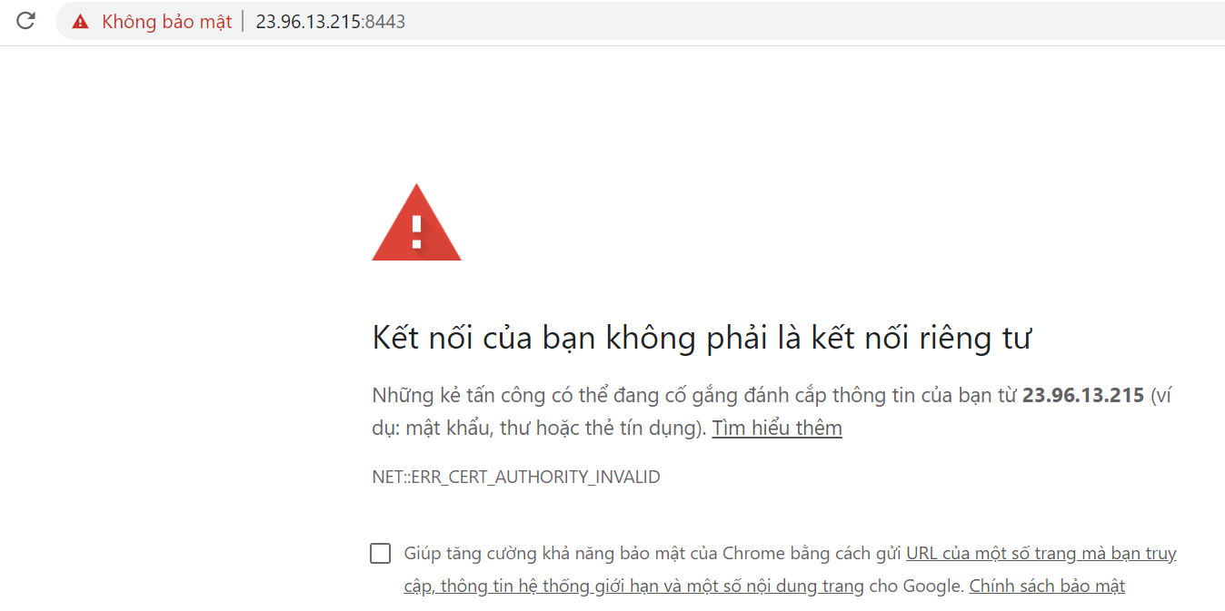  
  
**Step 7:** Config Jenkins server  
- Follow the Jenkins and add admin user  
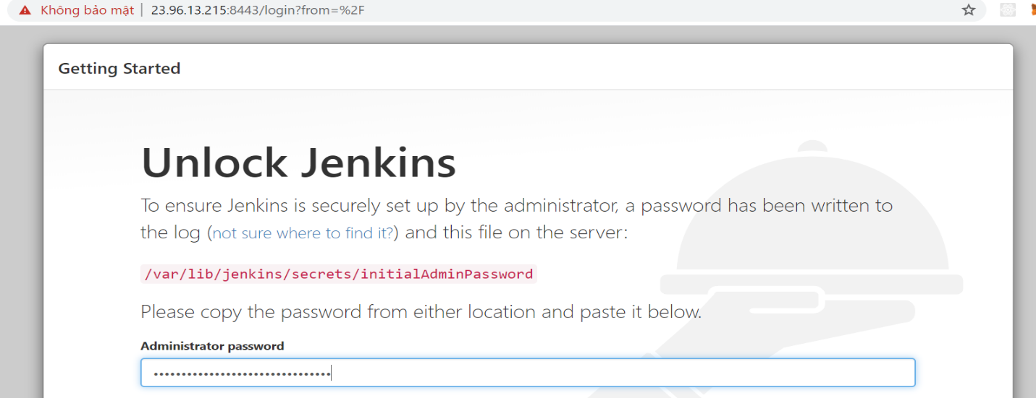  
- Install suggested plugins  
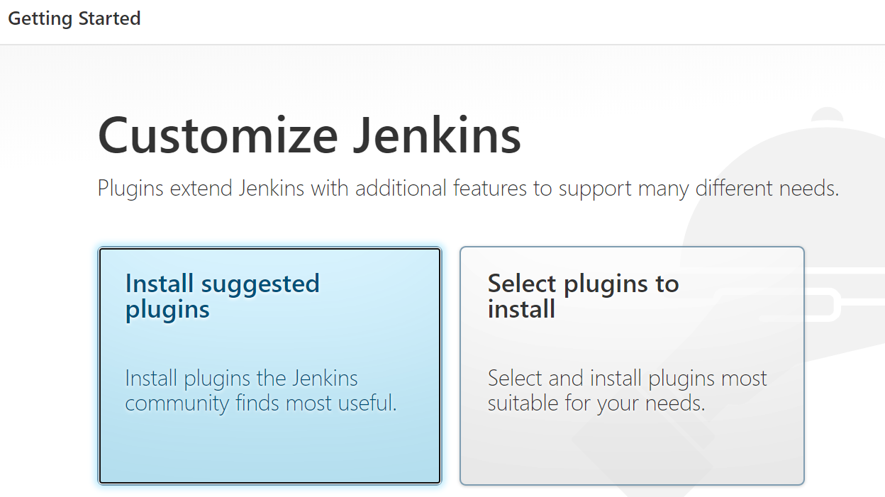  
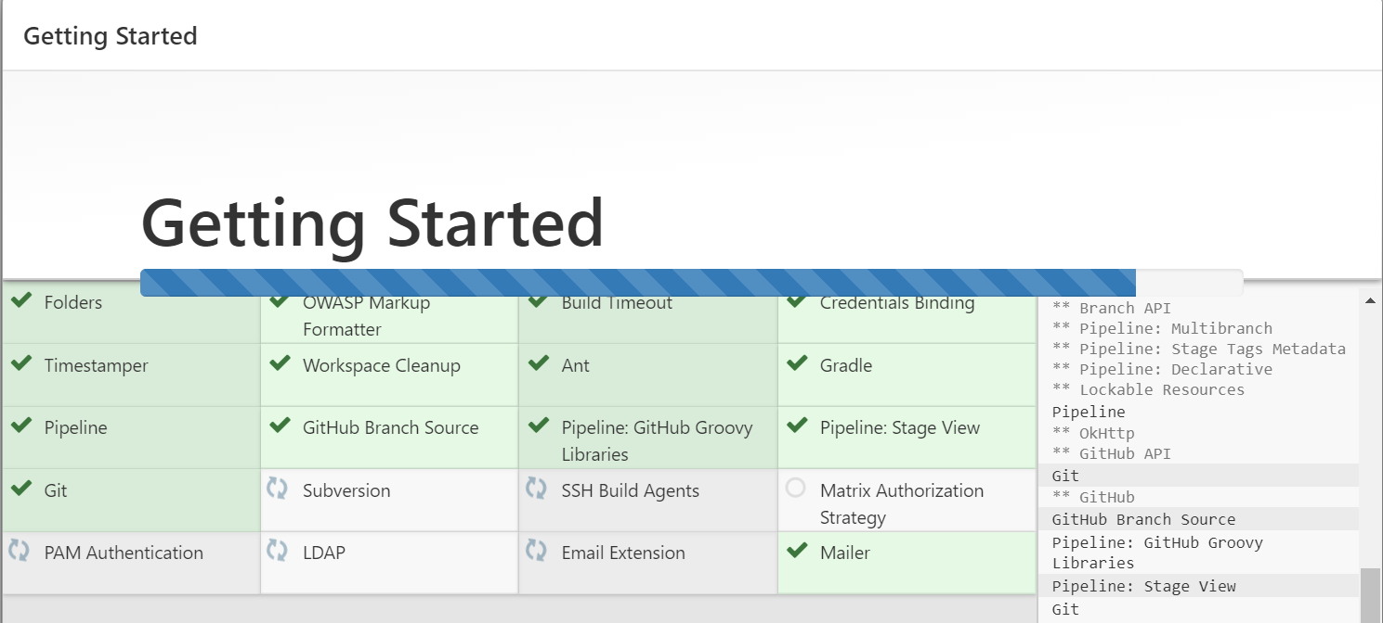  
  
- Add admin user  
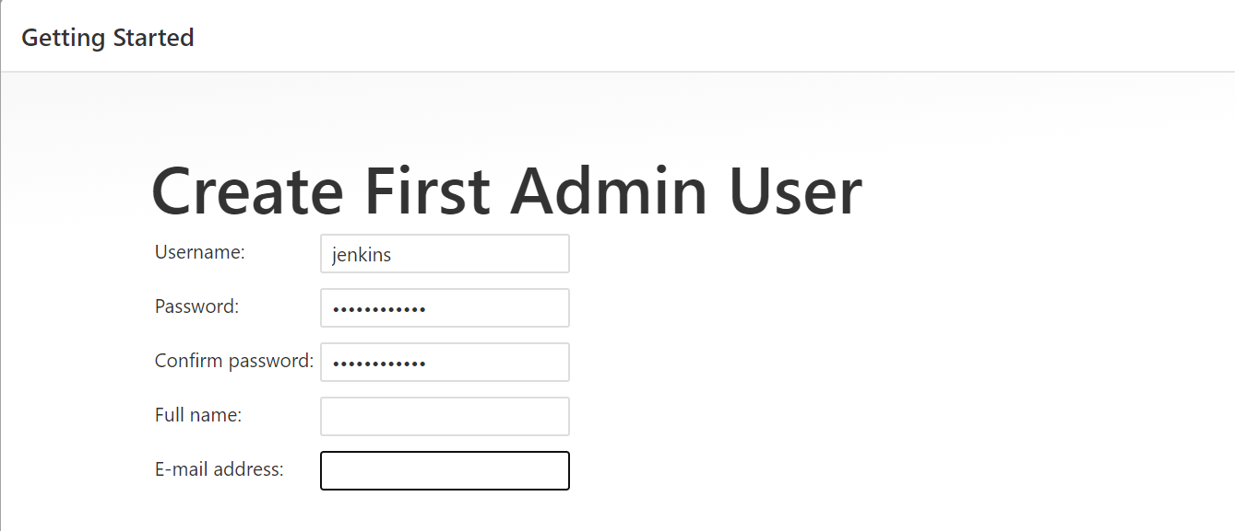

Sudo service Jenkins restart

sudo vi /etc/default/jenkins

ssh azueruser@ip_address  
keytool -genkey -v -keystore jenkins.keystore -alias alias_name -keyalg RSA -keysize 2048 -validity 10000

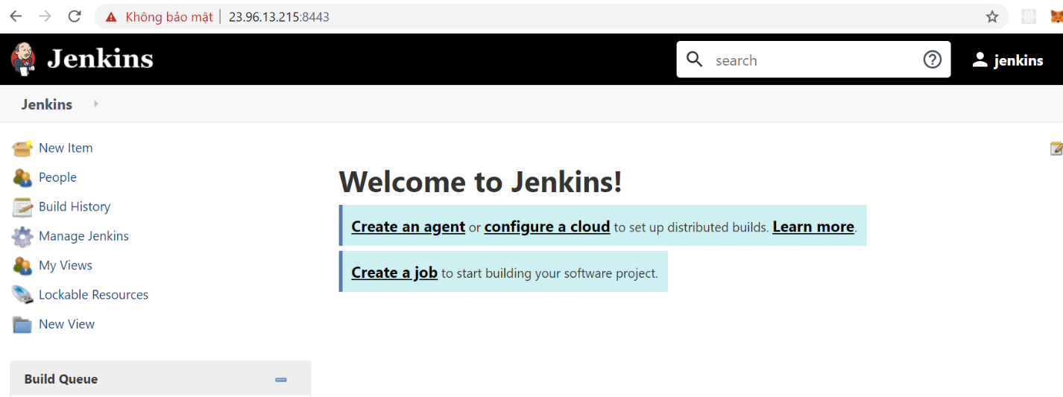  
  
- go to Manage Jenkins -> Global Tool Configuration: add git and maven  
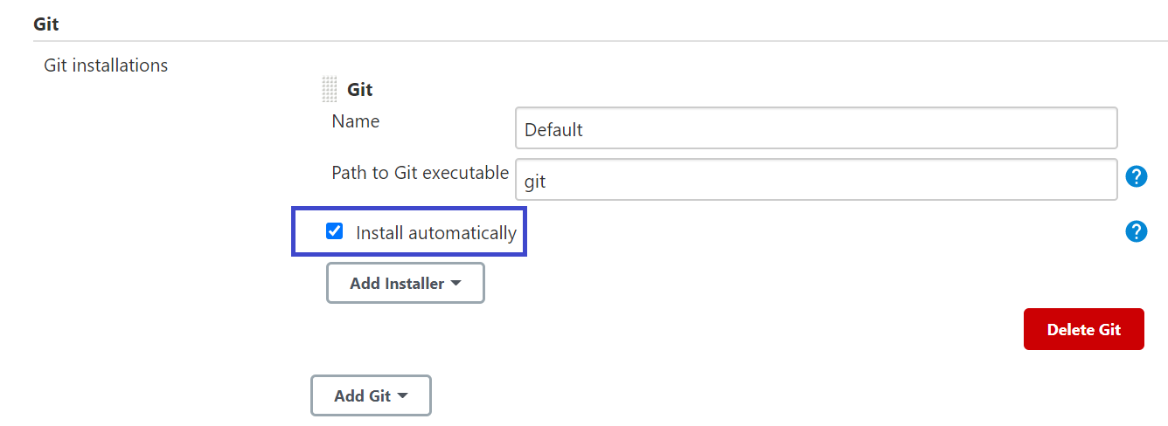  
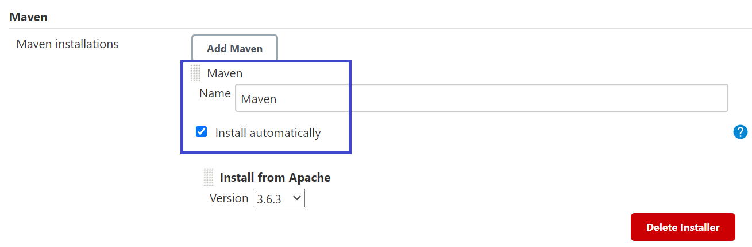  
  
- go to Manage Jenkins -> Manage Plugins : install maven integration  
  
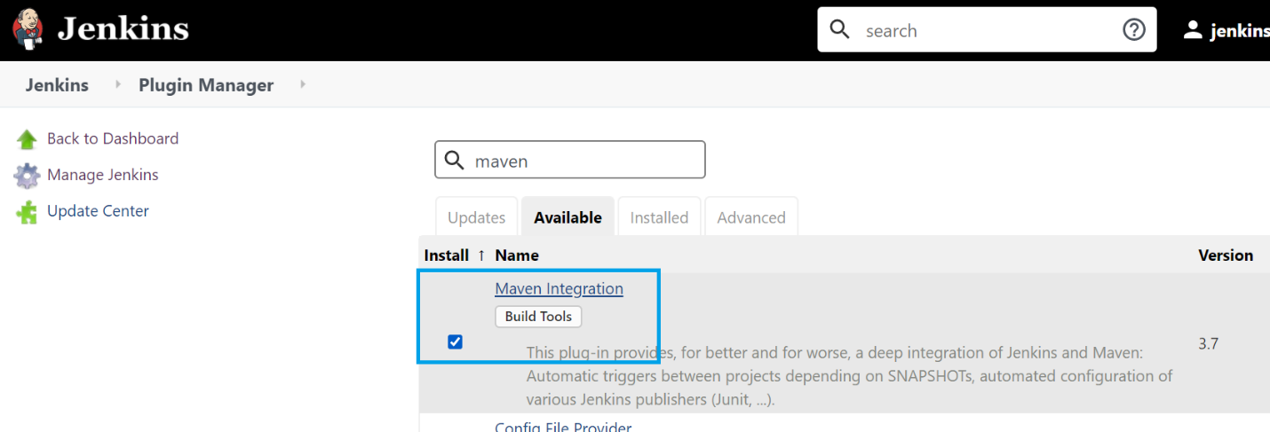

**Step 8**: Create Job: go to Jenkins   
- Create job  
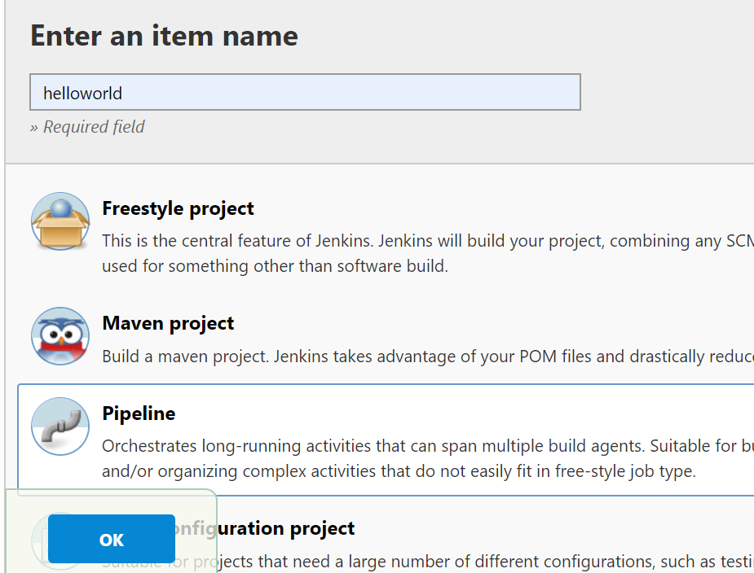  
  
- Config build and github project

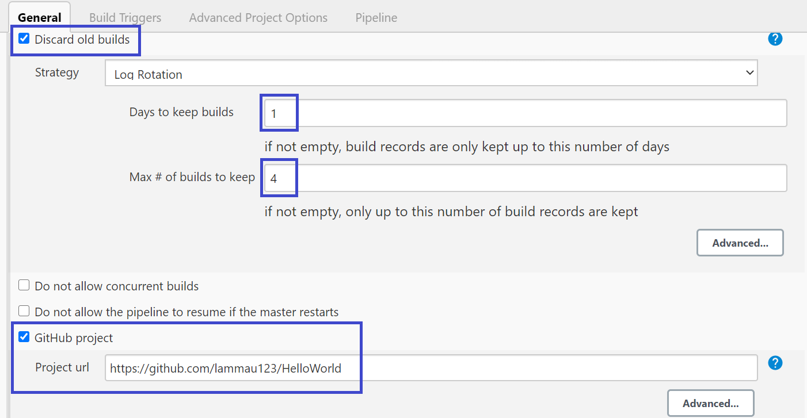

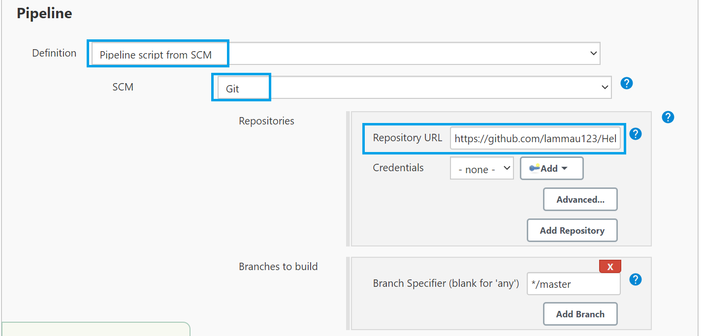  
  
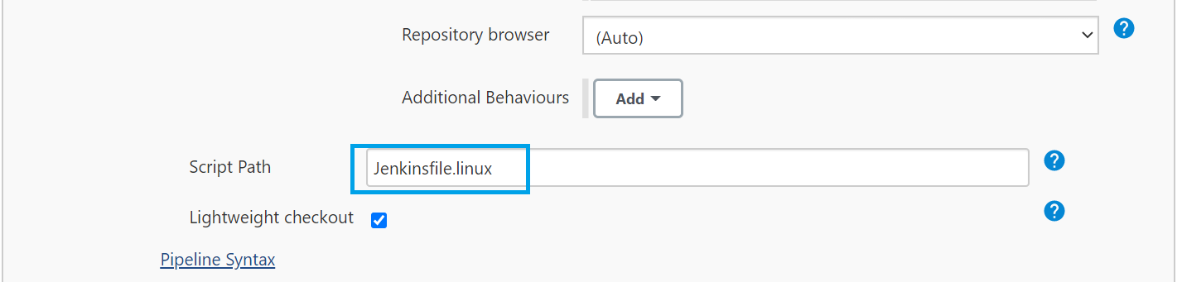  
  
- Source git structure:  
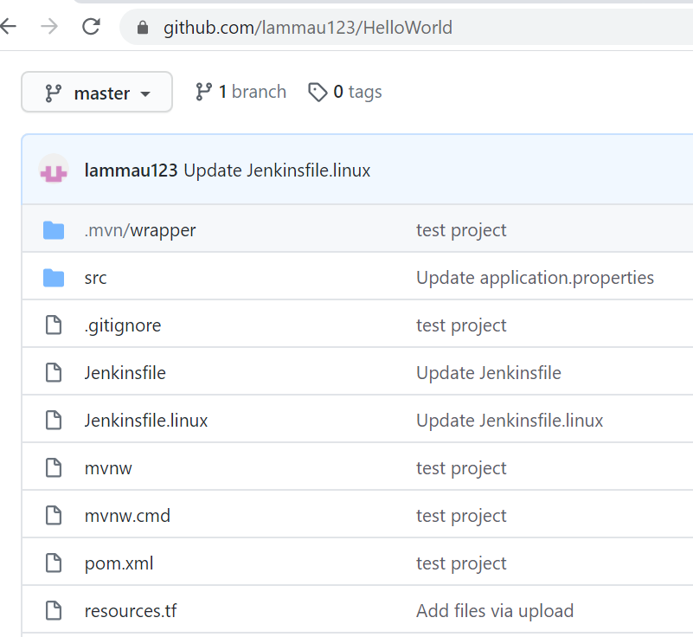  
  
**Step 9**: Creating ubuntu server to host the helloworld spring boot app.  
- Create ssh key pair

ssh-keygen -m PEM -t rsa -b 4096

- Create ubuntu server

az group create --name servers-rg --location eastus

az vm create --resource-group servers-rg --name rest_servers --image Canonical:UbuntuServer:16.04-LTS:latest --admin-username azureuser --ssh-key-value rest_server.pub --custom-data cloud-init-server.txt

az vm open-port --resource-group servers-rg --name rest_servers --port 8080 --priority 1001

**cloud-init-server.txt**  
  
  
  
  
  
  
  
  
- Create dev folder on ubuntu server to deploy the app  
  
  
  
  
  
**Step 10:** Create Jenkins file  
  
  
  
  
  
  
  
  
  
  
  
  
  
  
  
  
  
  
  
  
  
  
  
  
  
  
  
  
  
  
  
  
  
  
  
  
- start.sh  
  
  
  
  
  
**Step 11:** When Jenkins server build successfully and it will copy the jar file to ubuntu server and start the application server. Jenkins use ssh agent plugin to copy to ubuntu server.  
- Goto Jenkins -> Manage Jenkins -> Manage Plugins and install ssh agent  
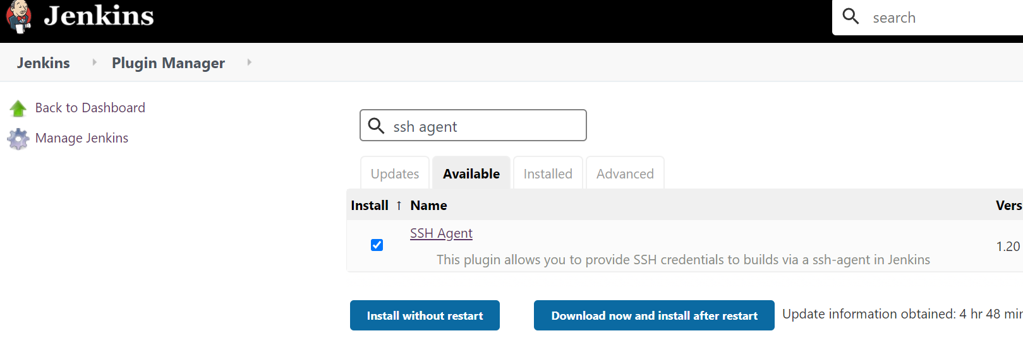  
- Go to Jenkins -> Manage Jenkins -> Manage Credential -> Add Credential and enter the private ssk key pair so Jenkins server can copy file to ubuntu server.  
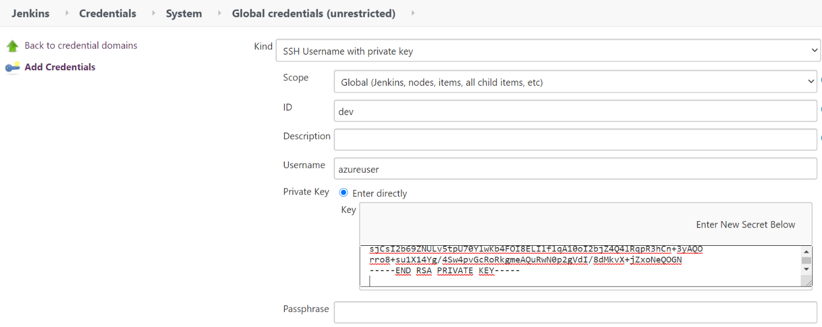  
  
**Step 12:** Click Build to check the result. After the build finishing, open browser and check <http://ip_address:8080/hello>  


#cloud-config

runcmd:

- sudo apt-get update

- sudo apt install openjdk-8-jre-headless -y

#cloud-config

runcmd:

- sudo apt-get update

- sudo apt install openjdk-8-jre-headless -y

az vm show --resource-group servers-rg --name rest_servers -d --query [publicIps] --o tsv  
ssh -i rest_server azureuser@ip_address  
mkdir dev

pipeline {

agent any

tools {

maven 'Maven'

}

stages {

stage('Initialize') {

steps {

sh 'echo Initialzie'

}

}

stage ('Build') {

steps {

sh 'mvn clean package'

}

}

stage ('Deploy to Dev') {

steps {

sshagent (['dev']) {

sh 'scp -o StrictHostkeyChecking=no target/*.jar azureuser@52.188.155.23:/home/azureuser/dev/'

sh 'ssh -tt azureuser@52.188.155.23 < start.sh'

}

}

} }}

sudo nohup java -jar ./dev/*.jar com.helloworld.test.HelloworldApplication > log.txt &

exit

Step 13: Config git webhook to push notification to Jenkins server when something change on git repo.  
- Login to git repos and add webhook point to Jenkins server:  
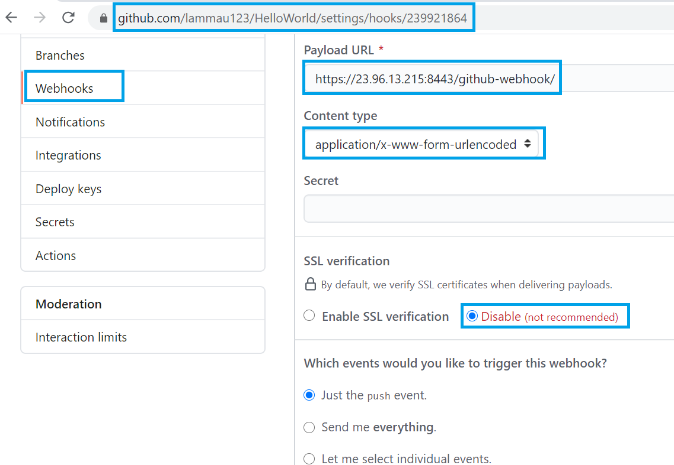  
  
  
- Goto Jenkins -> helloworld -> Configure to config Jenkins trigger the build when receiving event from git  
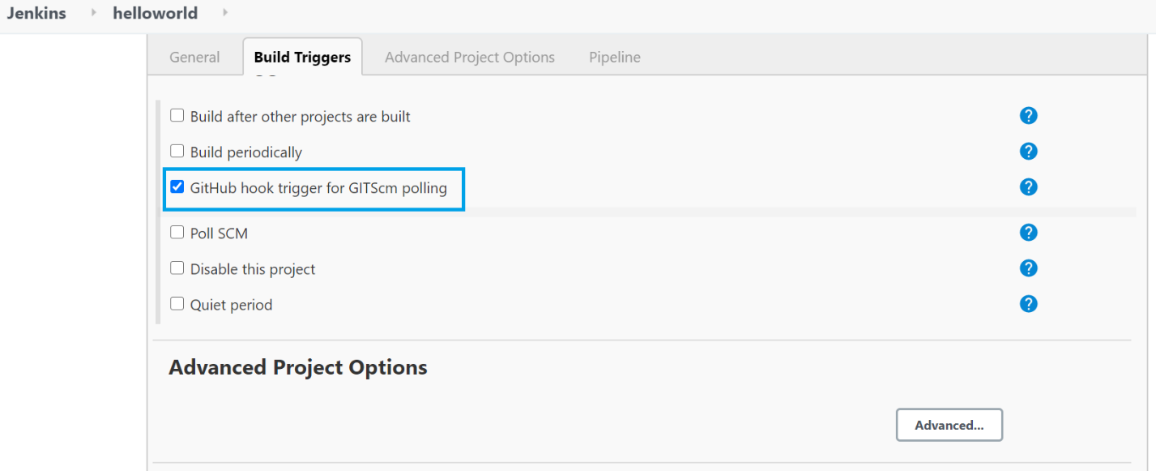  
  
 **Step 14:** Install Blue Ocean help manage Jenkins easier  
  
  
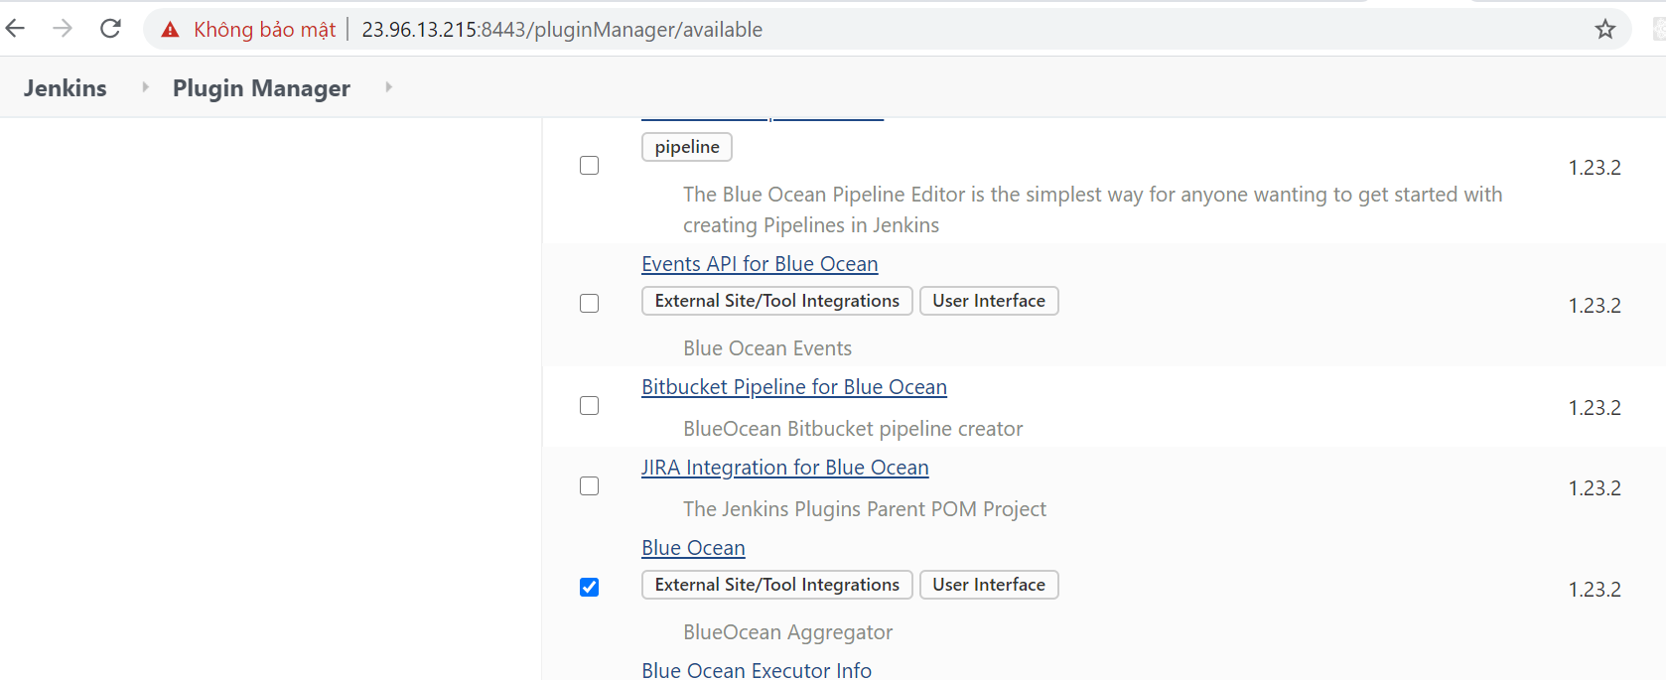  
  
**- Step 14:** Check git push event:  
- Commit a change to git and see Jenkins will kick a build automatically  
- After the build finishing click on the build and click on the Blue Ocean   
