Trang bia

# Contents

Contents 1

I. INTRODUCTION 2

1. About GO-JEK 2

2. About GO-VIET 2

II. EXISTING IT SERVICE SCOPE 3

1. Current service 3

• **GO-RIDE** 3

• **GO-SEND** 4

III. GO-CLEAN 5

1. About GO-CLEAN 5

3. Why GO-CLEAN 7

IV. KEY SERVICE ELEMENTS 10

1. Identify Market of New Services 10

2. Analyze 5 key elements of Go-Clean Services 10

V. DART MODELS 11

1. Dialogue 11

2. Access 11

VI. CO-CREATION PROCESSES 15

VII. DEMONSTRATE A CO-CREATIVES PRACTICE 16

VI. CO-CREATION Framework 17

1. Customer 17

2. Supplier Processes 17

3. Encounters processes 17

# INTRODUCTION

## About GO-JEK

GO-JEK has officially expanded its market to Southeast Asia including Vietnam with new technology investment in GO-VIET. One of the future promises that GO-VIET will be the provider of ride-hailing, logistics and digital payments services on the battle with Grab.

GO-JEK was founded in 2010 with its predecessor - the company providing motorbike taxi service on the mobile platform, also known as ride-hailing technology. GO-JEK not only offers ride-hailing services but instead dozens of other services can be deployed through this application. GO-JEK offers a wide range of services such as 2-wheel and 4-wheel mobile vehicles, shopping, housekeeping, health care and car repair services. This is what Grab and Uber in Vietnam does not have and may be a good point if GO-JEK start running in this country.

Reported on 2018: The application of GO-JEK company has been downloaded more than 60 million times in Indonesia, according to a press release last month. GO-JEK has over 900,000 registered drivers in the country and facilitates over 100 million transactions a month.

## About GO-VIET

GO-VIET is proud to be a strategic partner of GO-JEK, providing multi-service applications with four-wheel and two-wheel drive transportation solutions, ordering, delivery and many other services. Serving the daily needs of Vietnamese users.

With GO-JEK's advanced world technology platform, GO-VIET aims to improve the quality of life for our users and create value for our partners and communities.

Besides to the riding service, goods delivery, shopping, GO-VIET is the solution to help you handle daily needs easily, conveniently and quickly.

GO-VIET cooperates with thousands of driver partners, restaurant partners and other partners in Viet Nam to bring you a comfortable experience on every service. GO-VIET's products are aimed at facilitating users and solving social problems such as employment, income and business development of small and medium enterprises.

# EXISTING IT SERVICE SCOPE

GO-VIET is an application for ride-hailing, online shipping, food delivery, billing and daily services. At the moment, GO-JEK invests more than US $ 500 million in 4 markets in South East Asia including Vietnam, Singapore, Thailand, Philippines. With that amount of money, GO-VIET in Vietnam is the biggest competitor of Grab in Vietnam, when it owns more than 95% of the market ride-hailing technology.

## Current service

GO-VIET is currently providing a variety of mobile transporting and shipping services including:

* **GO-RIDE**

GO-BIKE is a motorcycle drive technology service of GO-VIET has just launched, application will connect motorbike drivers with customer using GO-VIET application to solve the traveling needs of customer as well as increase additional income for the driver.

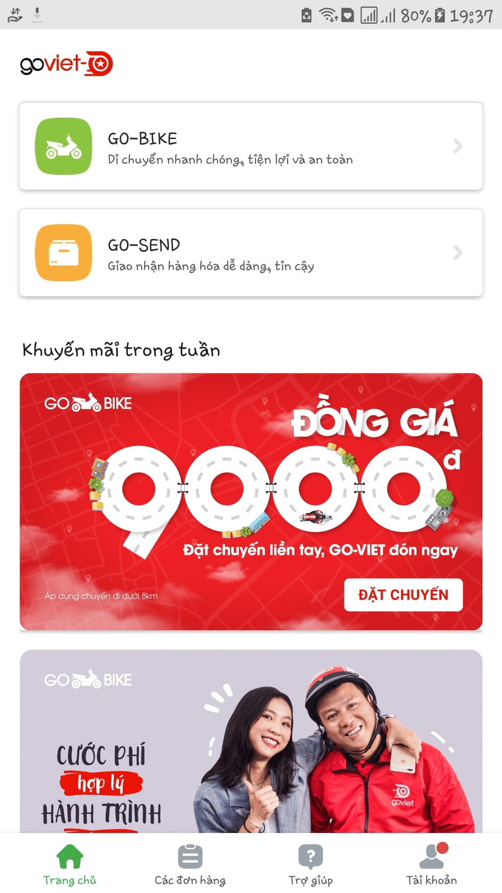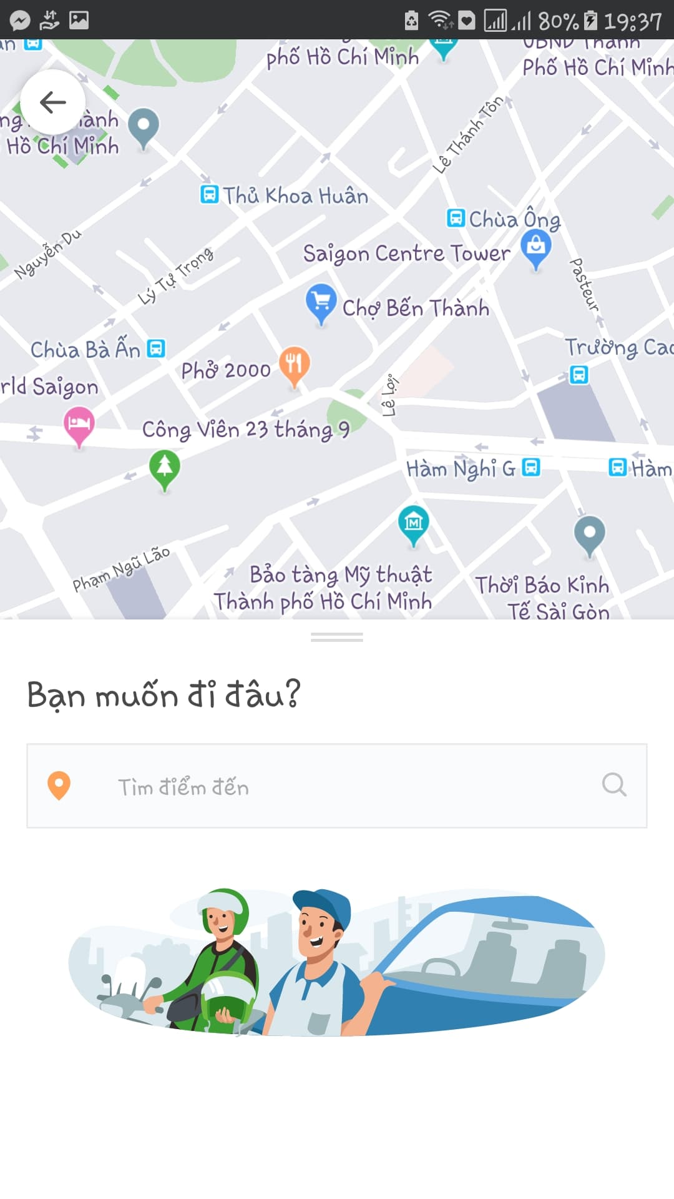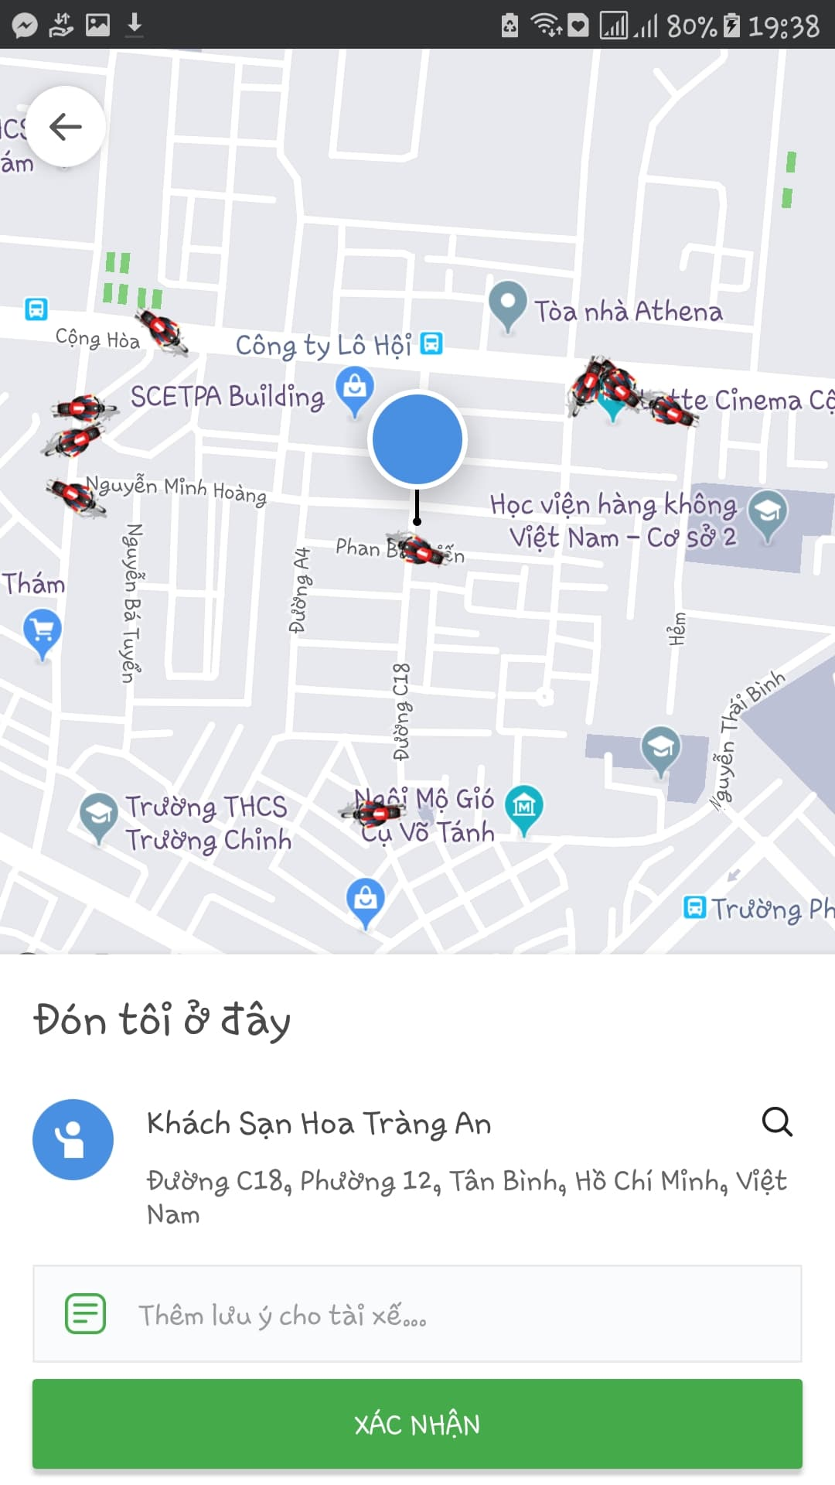

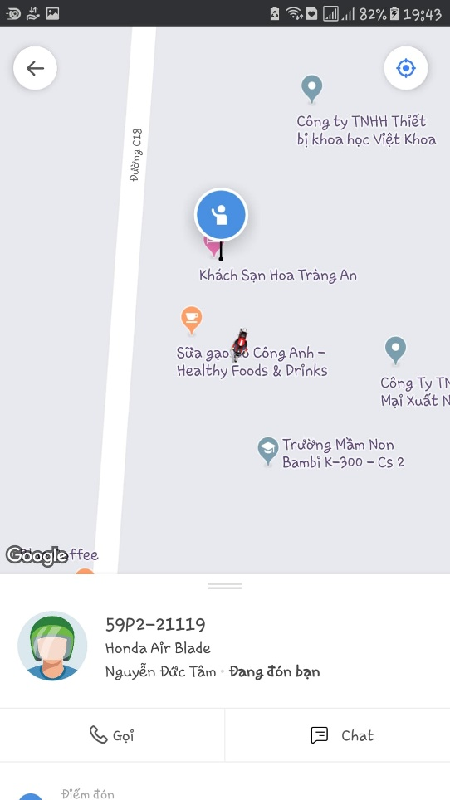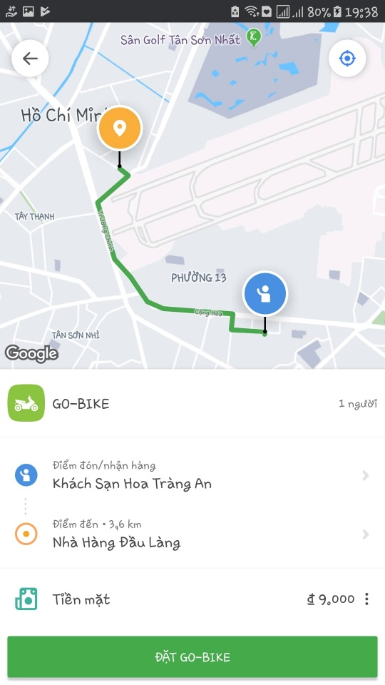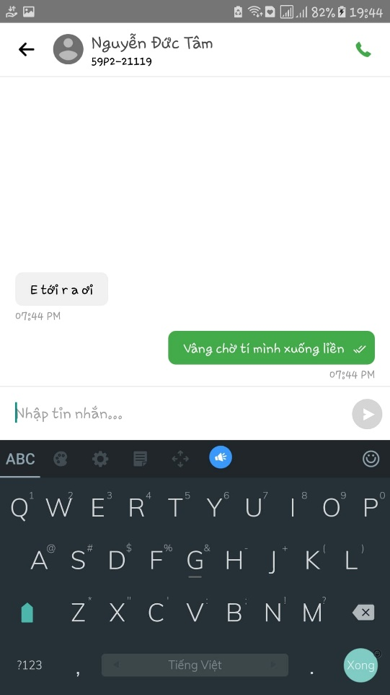

* **GO-SEND**

GO-SEND is a GO-VIET motorbike delivery service for customer who wish to book the delivery. You can easily deliver letters, goods, gifts, products safely, quickly and economically. Commodities will be delivered by GO-BIKE drivers of GO-VIET to increase driver's income as well as cost savings for customer.

When using GO-BIKE and GO-SEND, customers don’t have to worry about the distance, price or time because even it’s far or near, day or night, dry or wet, GO-Driver will happy to delivery their customer’s goods to the location. That’s the strong side of GO-VIET which made this company become the 1st competitor of Grab nowadays.

# GO-CLEAN

As GO-VIET expanding its business, GO-CLEAN will be the next service in Vietnam. GO-CLEAN, with the moto “***CLEANING YOUR HOME IS NO LONGER A CHORE***”, will give customers the most professional cleaning service at anytime and anywhere.

## About GO-CLEAN

GO-CLEAN is an app-based professional cleaning service which available in many large Indonesian cities.

GO-CLEAN’s customers will choose from the app with 4 main categories are **Building types**, **Main services**, **Amount of cleaners**, **Time/date** and **Address**. In addition to those main tasks, customers also can choose **additional services** too. This is the current list of each categories that this service provide.

Building types:

* Houses
* Lodging Rooms
* Apartments
* Shops

Main Services:

* Sweeping
* Mopping
* Dusting
* Bathroom cleaning \**Deep cleaning is not included(e.g. grout cleaning)*
* Room cleaning

Additional services:

* Ironing and Folding
* Cabinet cleaning
* Refrigerator cleaning
* Washing up
* Kitchen cleaning
* Stove cleaning

Here is the sample of ordering service.

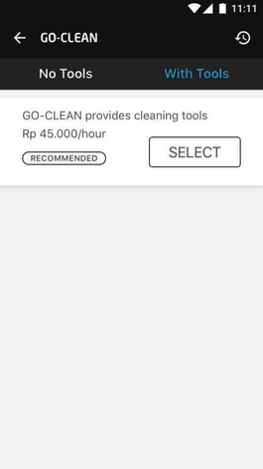 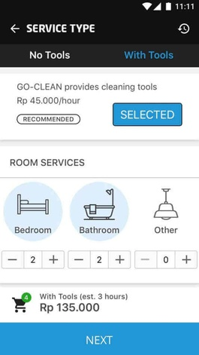 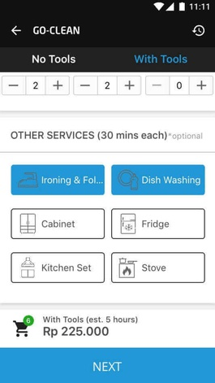

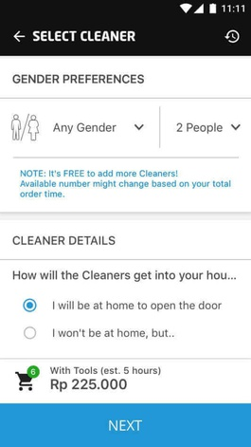 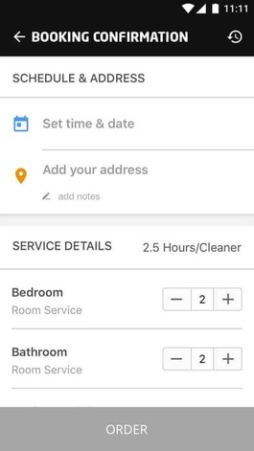 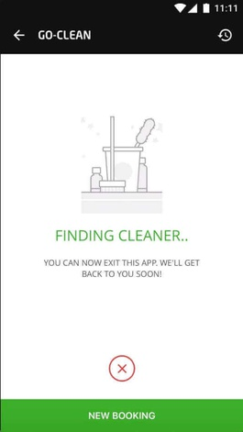

In the side of cleaners, GO-VIET will provide them with necessary tools and uniform to operate services and proper training to perform cleaning like conversation with customers or standards of cleaning. In additional to that, GO-VIET also provide a ranking system to promote cleaners with high rating.

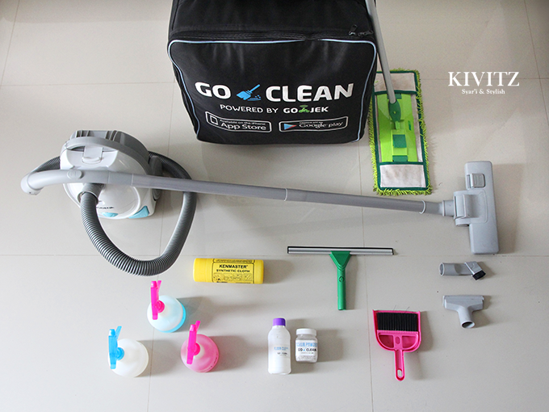

GO-CLEAN tools box

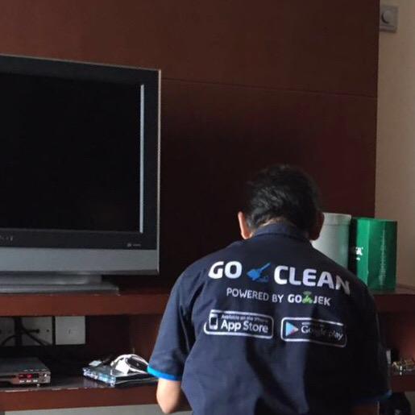

GO-CLEAN uniforms

## Why GO-CLEAN

* We have more than 700 skillful and friendly employees in cleaning field. Moreover, all of them are selected carefully and received a special training course before becoming our official staffs.
* We co-operate with the best provider in cleaning equipment in order to provide customers our professional service.
* GO-CLEAN is active 24/7. That is mean, you can call us any time you want. In addition, we work with many elite partners, so customers do not worry our service.
* We know there are many families have limit budget. However, they still want to use our service. That is why we create a list of option services which can help customers choose what they really need.

**Customer response:**

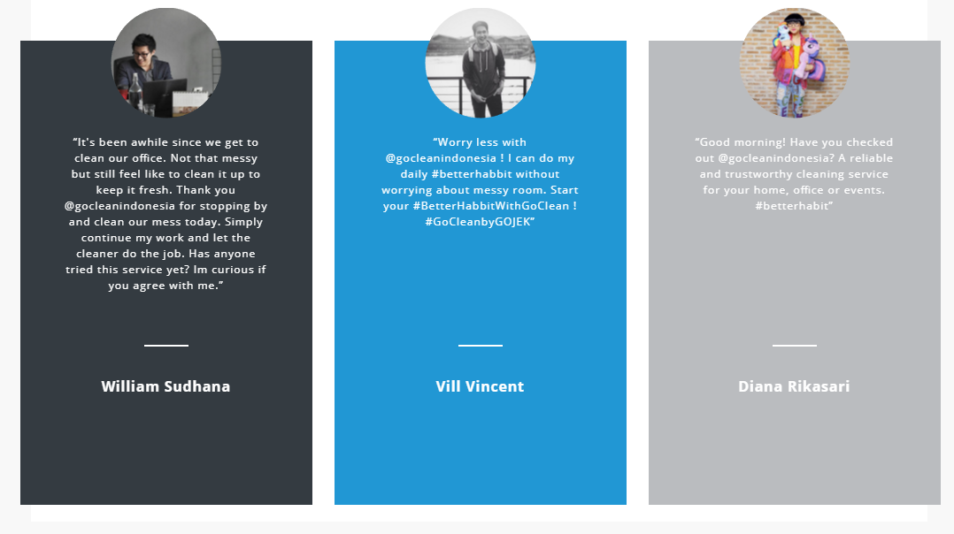

**Source :** [www.go-jek.com/go-clean](http://www.go-jek.com/go-clean)

**Our partners:**

**Pak Sugeng** :

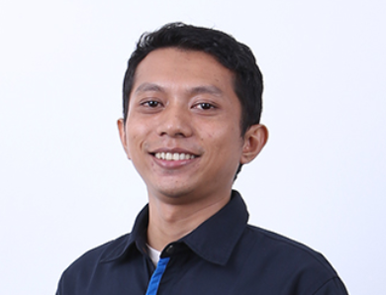

* An ex-supervisor of GO-LIFE.
* He wants to earn more money for his family. However, a full-time job will waste too much time.
* He retired from his previous job and focus on GO-CLEAN.
* He creates a connection between him and other people from various jobs.
* He can help his wife establish a food online base on his connection. From

**Nuridah** :

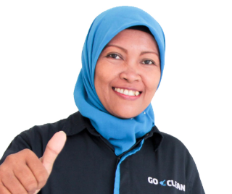

* She is a mother who truly inspire us.
* She works as a GO-JEK driver and GO-CLEAN cleaner.
* She can save enough money for her eldest child to study at the University of Indonesia.

# KEY SERVICE ELEMENTS

## Identify Market of New Services

According to the annual report and financial report in 2017, many statistics show that:

* Total numbers of household in HN and HCM city about: 3.5 million.
* About 15% household need to rent a domestic helper or housekeeper.
* Average salary of a housekeeper per hour: 40-50k VND.
* Average salary of a helper per month: 4.5 mil VND.
* In HCM city, nearly 10000 housekeepers only adapt to 30% of the market and the needs will continue increase in the future.

Those elements above contribute to create a market for building applications to hire a domestic helper that is estimated more than 1,400 billion VND-a huge mark. Thus, many suppliers housekeeper participate in this area and divide into 3 types:

* Traditional type: includes recruiting, training and providing workers.
* Half traditional type: add supporting of high technique (application) for transaction, resolve and estimate quality of services(Go-clean service)
* Only technique: link between provider and customer not provide worker directly.

## Analyze 5 key elements of Go-Clean Services

* **Resources:**
* Include all of manpower of Go-Clean service, experience knowledge and physical resource as tools for cleaning house, Go-clean tools box...
* Physical network, smartphone, the servers, SAN...
* **Provider:**
* As GO-JEK, GO-VIET will expand CLEAN service to provide better application and skillful housekeeper to their customer.
* **Consumer:**
* Employee: most of house helpers are older woman who have free time and want to become a house helper. Most of them lack experience in cleaning household and need money. Thus, they need a training course before provide workers to customer.
* Customer: who lack time to take care their house and do chores so they need a house chore worker.
* **Benefit:**
* Service provider: Go-Clean will gain benefit from 15-20% per contract between customer and employee. By satisfy the need of customer and improve service with skillful helpers»» ranking system»» increase revenue and prestige.
* Customer: Save their time from doing chores. Have more time and healthy to enjoy their life.
* Employee: Earn more money (5.5-6 mil/month) by using their free time more effective.
* **Time:**
* Typically, customer take 5-6 days to contact with employee in real life by intermediate organizations. But, with Go-Clean, customer only take a half day to meet employee directly at their home and have a week trial period before signing a contract.

# DART MODELS

In the knowledge intensive economy the capacity to serve individual customers is becoming a major source of competitive advantage. Therefore the operational instruments enabling the managers to understand and implement new business models enhancing the capacity of value co-creation are welcome. Despite its importance, research on co-creation with customers is still at an early stage. In particular, there is a dearth of quantitative evidence, obtained through research methods other than case studies and other qualitative approaches. The DART model is considered to be an important step forward and a valuable attempt to indicate the range of companies’ capabilities necessary to effectively work with customers. It specifies the four main building blocks or groups of competencies that companies should develop to effectively engage in value co-creation with customers. Those blocks include Dialogue, Access, Risk Assessment and Transparency, which taken together form the DART acronym. Here we will use DART model to explain what our service best fit.

## Dialogue

From the meaning of Dialogue is to shared learning and communication between two equal problem solvers. We propose to create communication platforms that are popular in Vietnam:

* Facebook –via Facebook fanpage and Facebook group.
* Youtube channel
* Feedback form
* Surveys
* Notifications of apps/sms/email
* Emergency call center

Hence Facebook is the most used social network in Vietnam, GO-VIET should take advantages two of its features: fanpage and group. Fanpage is used to give out exclusive news. Group is for collecting opinions from users to company and vice versa. We suggest that we should use a join group for both consumers and partners

Meanwhile Facebook video functions is still lackluster, Youtube channel is the main way for video solution.

Feedback and survey are still an available option for getting opinions from customers, although they serve different objectives.

Push notification through apps, sms and email is also a solution for give news or personal informs for users.

Emergency call center is a must in all service, it not only for helping customers with emergency problems but also give solutions from data collected from critical case.

## Access

Customers and talents can access to our service via website or application in both PCs and mobile devices.

In PCs:

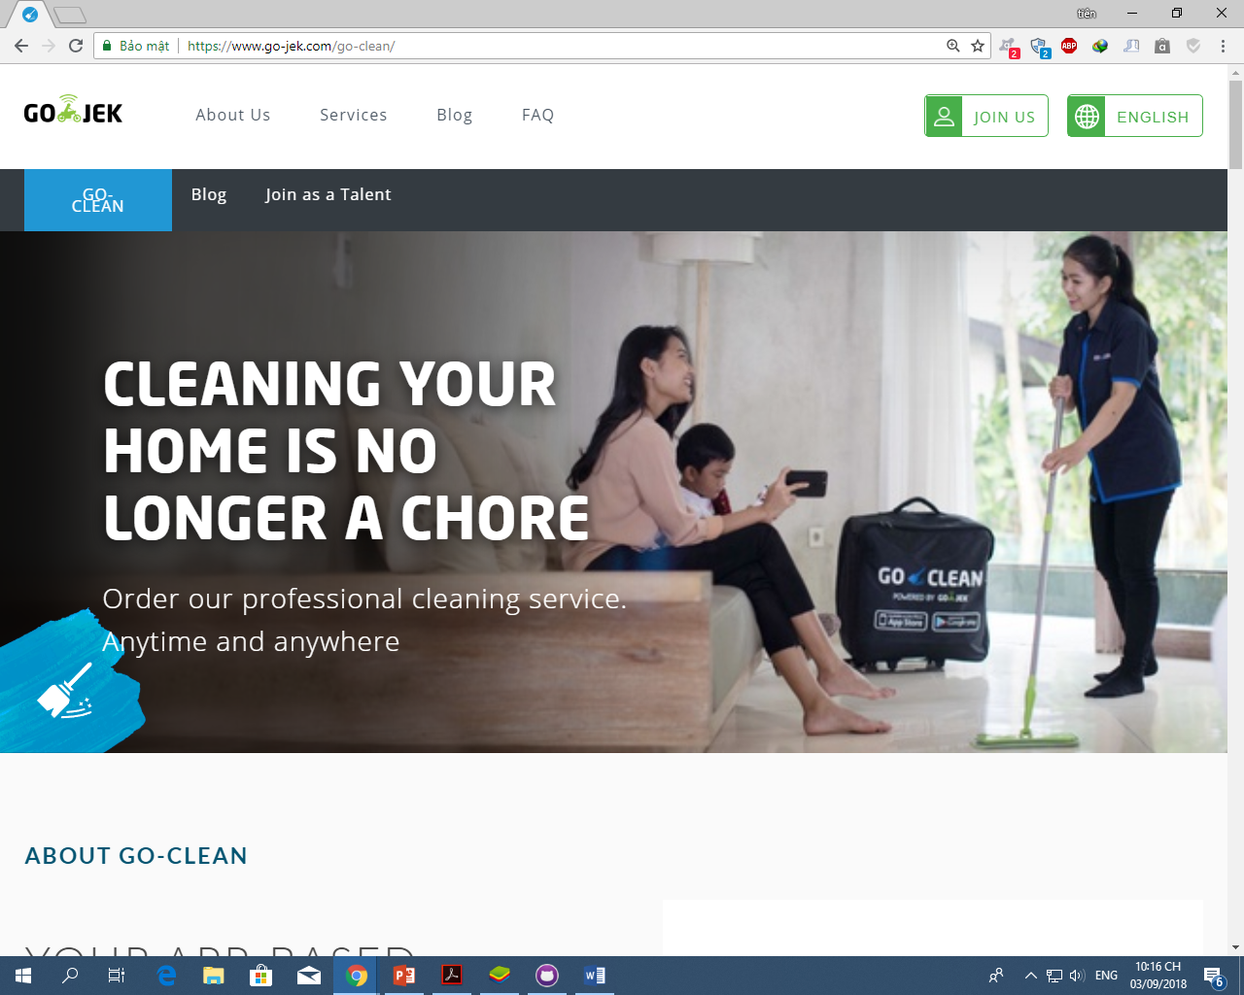

Register(talent):

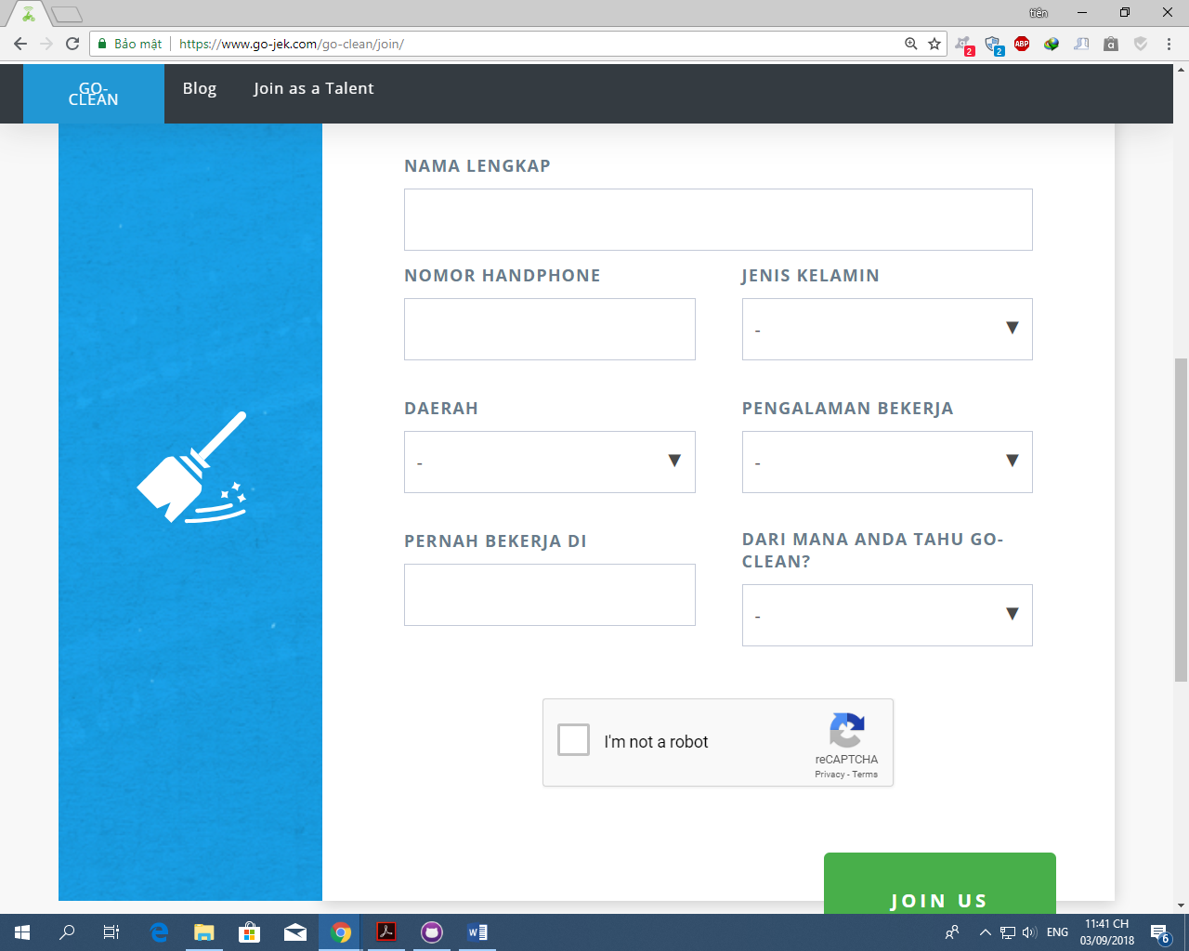

Blog:

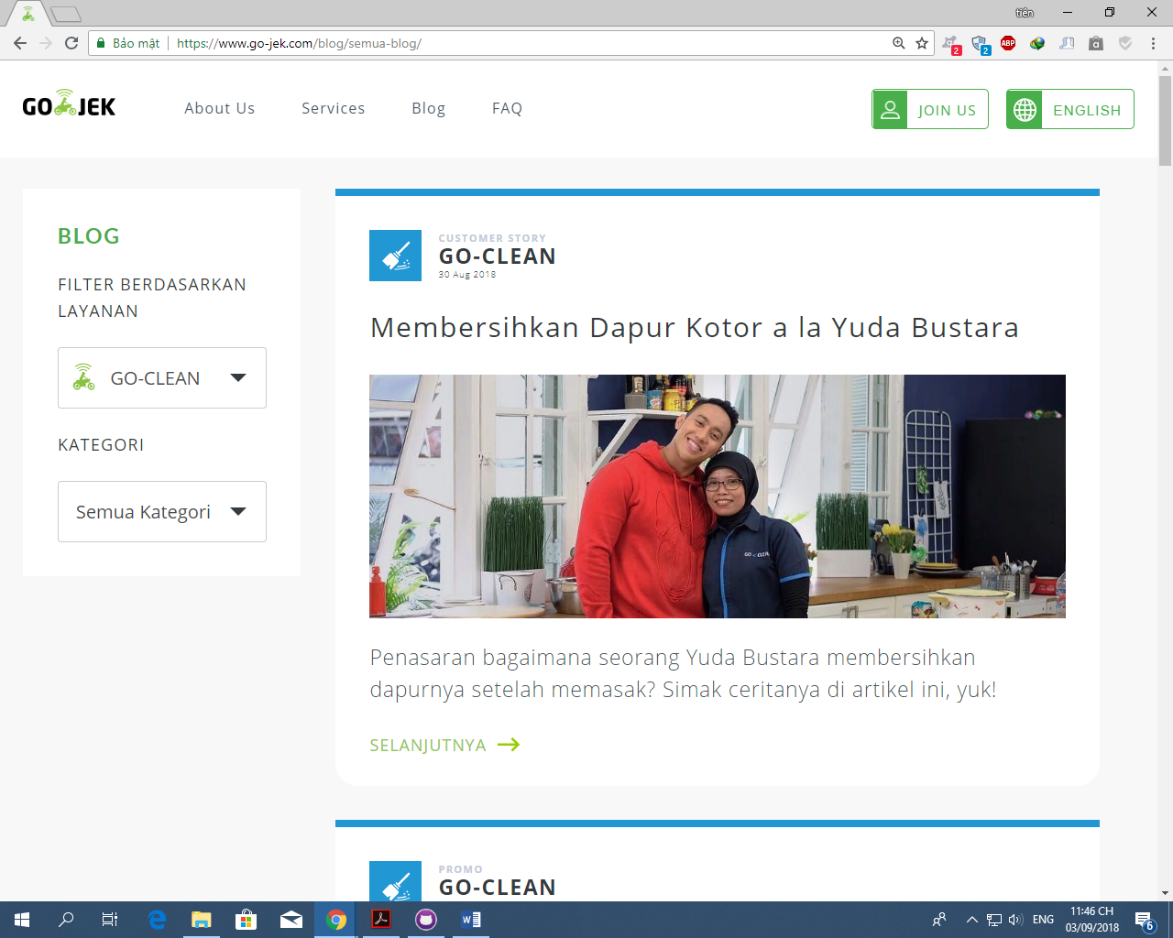

In mobile devices (it is a part of GO-LIFE in Indonesia):

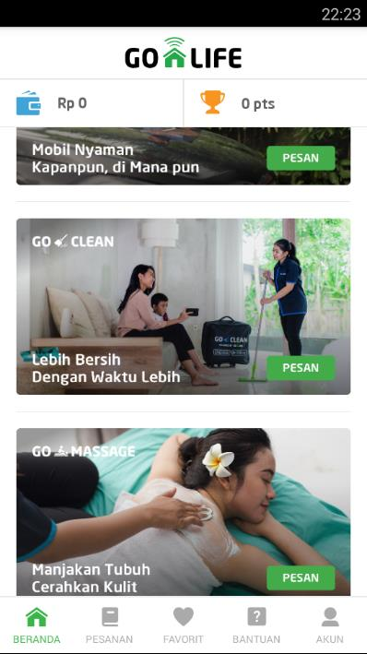

Consumers:

* + They can access in both application and website if they have account (using Facebook account or creating go-life account).
  + They can choose suitable service in option list area.
  + Consumers can judge Go-Clean cleaner
  + Consumers can see partner/talent information
  + Consumers can see all information of service include fee before deciding.

Partner:

* + Partner/talent can work with Go-Clean if they have talent accounts and verify by Go-Clean admin.
  + Partner/talent can use company equipment
  + They can see their information customers (limit)

# CO-CREATION PROCESSES

Different from manufacturing products, service is not end after its release even it is a completed products. It will need practices to improve even though RnD departments carefully did their parts. These works need the help of two side of the business, and called “*Co-creation*”. Below are two examples that:

* **Tinkering:**

Cleaning partners start to complain that the amount of request that they receive in some day is too much, some day is too few. Some even say they don’t even have any requests. Company take a look into the problems and realize that the matching algorithm is the course of the problem. So company and partners will join hand to do a co-creation which is “**Tinkering the matching algorithm**”.

* **Collaboration:**

From the above situation, the partners expects that the company have a public policy about the core of problems – which can be elaborate about time of works, expecting amount of a task, a proper amount for jobs per days, etc.. With this co-creation process that collaborate to create a good policy, both sides gain lots of benefits.

We would like to add into Go-clean service the feedback system for users to give us what they think about the service itself or just a simple rating. Why we should apply this into our new service? By doing this, we can:

• Improve products and services

• Measure customer satisfaction

• Create the best customer experience

• Creating reliable source for information to other consumers

• Collect data that helps taking business decisions

# DEMONSTRATE A CO-CREATIVES PRACTICE

First of all, the basic problem of our GO-CLEAN service is when a group of our partners complain that there’s just a few or even no users hired them for cleaning, while other partners in the same local area was hired more often and earned more profits for themselves. After considering all aspects of the problem, we end up with the best method that we can demonstrate: Improve the current algorithms of searching engine.

By using this method, we need to work and co-operate with 4 stakeholders:

* + - * Go-Viet company and Go-clean service team: understand and become skilled in using the new algorithms into current searching engine to perform effectively and professionally. We don’t need to understand the algorithms but must have abilities in manipulating it in the infrastructure that we have.
      * Algorithms supplier experts: Go-Viet company has to contact the suitable Algorithms supplier to co-operate and create new algorithms that can bring effective result in changing the old one to the new great one.
      * Cleaning Partners: this is the most important factor that express the result of new algorithms by collecting all the feedback from themselves using the feedback system. After that, they bring the result of feedback system report for the service team
      * Users: this stakeholder is the second-most important factor that continue to use Go-send application normally after the change, but keep rating during the service running for the company to collect the data.

# CO-CREATION Framework

As the business expand, the more co-creation processes will be created. The follow are predicted processes of both side of customers : partners and consumers.

Partners

|  |  |  |  |  |
| --- | --- | --- | --- | --- |
| **Customer processes** | **Goals in life**   * Full time jobs * Part time jobs * Social interaction * Works have Insurance | **Training plans**   * Learn about how to communicate with consumers * Learn about cleaning process * Learn about problem solving when servicing * Obtains tools for servicing | **Tinker matching systems**   * Balance the schedule for partners. * Give equality for all users * Improve distant between partners and work places * Full time/Part time option | **Co-create policy**   * Working contract * Working insurance * Keep partners benefits |
| **Encounters** | * Advertisement | * Face-to-face classrooms. * Training documents. * Direct mails * Tests * Feedback forms | * Feedback forms * Face-to-face meeting * Petition forms * Data collected from apps | * Feedback forms * Face-to-face meeting |
| **Supplier processes** | **Supports of GO_VIET**   * Support the missions of partners that want to earn livings through house works. * Improving brand recognition * Attractive marketing communication | **Training support**   * Trains partners about communication * Trains partners about Term of Service, policies * Trains about cleaning process and self-validate the result * Trains about using how to use tools * Trains about solving typical problems | **Improve matching systems**   * Analyze data collected * Tinker the matching system. | **Policy support**   * Follow the policy * Help to improve policy |

Consumers:

|  |  |  |  |  |
| --- | --- | --- | --- | --- |
| **Customer processes** | **Goals in life**   * Need some house works helpers that trustworthy at a reasonable price * Save time | **Features**   * Pay by cash or credit cards * Good feedbacks system * Good rating systems * Good range of options for selected * See details of payments * Specific schedule * Security * Services be done right | **Improvement**   * Expands more payments methods * Keep the quality of service stable * Payments plan * Loyal customers plan | **Co-create policy**   * Users contract * Service insurance * Term of services |
| **Encounters** | * Advertisement | * Face-to-face * Direct mails * Feedback forms * Market research | * Feedback forms * Face-to-face meeting * Petition forms * Data collected from apps | * Feedback forms * Face-to-face meeting |
| **Supplier processes** | **Supports of GO_VIET**   * Support the missions of consumers that want to solve house works problems. * Improving brand recognition * Attractive marketing communication | **Training support**   * Provide the consumer’s needs in the app * Track working process to ensure service delivery the right way * Solve the data collected | **Improve matching systems**   * Analyze data collected * Counteract with the requirements from customers | **Policy support**   * Follow the policy * Help to improve policy |