Chapter 3
Aggregate Production and Productivity

Chapter Outline, Overview, and Teaching Tips

Chapter Outline

Determinants of Aggregate Production

Factors of Production

Production Function

Cobb-Douglas Production Function

Application: Why Are Some Countries Rich and Others Poor?

Cobb-Douglas Production Function Characteristics

Changes in the Production Function: Supply Shocks

Determination of Factor Prices

Demand for Capital and Labor

Supply of Capital and Labor

Factor Market Equilibrium

Distribution of National Income

Application: Explaining Real Wage Growth

Application: Oil Shocks, Real Wages, and the Stock Market

Concluding Remarks

Chapter Overview and Teaching Tips
This chapter develops one of the basic building blocks for all the macroeconomic analysis throughout this book, the aggregate production function. Not only is the aggregate production function used in the study of economic growth, where it plays a central role, it also is a key element of business cycle analysis because it determines the level of potential output given the factor inputs.
The chapter starts by discussing the fundamental factors of production and develops the Cobb-Douglas production function. It then develops key concepts like the marginal product of capital and labor and shows how the production function shifts. Armed with these concepts, the chapter then conducts a supply-and-demand analysis to show how factor prices, like wages and the rental price of capital, are determined, which also shows how the share of national income going to capital and labor is determined.
One important feature of this chapter is that it lays out a supply and demand analysis that is at a similar level to that found in principles of economics textbooks. The derivation of the demand curves is quite detailed and the concept of equilibrium is carefully developed. The step-by-step treatment in this chapter is worthwhile because supply-and-demand analysis is a basic tool used not only in microeconomics, but also in the study of macroeconomics in this book.
This chapter has several applications to both stimulate students’ interest and to convince them that the analysis helps explain the real world. The first application, “Why Are Some Countries Rich and Others Poor?” shows how the aggregate production function can help us to understand the sources of huge income differences between countries. Why some countries are so poor and some so rich is an inherently interesting question that students love to think about, and so covering this application in class helps students see that studying the aggregate production function is worthwhile. The second, “Explaining Real Wage Growth,” shows how important productivity changes are to workers’ well-being. The final one, “Oil Shocks, Real Wages, and the Stock Market,” shows how the supply-and-demand model of factor inputs can be used to explain fluctuations in the data. The link between oil prices and the stock market is often discussed in the media and students find it particularly interesting to get an explanation of why there is a link between what they see happening at the fuel pump at their local gas station and what happens in the stock market. Also, students more interested in finance get excited about anything that helps explain fluctuations in the stock market.

Answers to End of Chapter Review Questions and Problems

Answers to Review Questions

Determinants of Aggregate Production

1. The aggregate production function represents the relationship between the quantities of inputs that go into the production process and the output that is produced with those inputs. In the production function Y = F(K,L), output (Y) is an endogenous variable whose value is explained by the production function while the capital (K) and labor (L) inputs used in production are the exogenous variables that determine or explain the level of output produced.

2. Total factor productivity measures the productivity of all inputs. It is the average output produced by one unit of capital together with one unit of labor. Labor productivity measures the average output produced by one unit of labor. Labor productivity increases if increases in capital lead to the production of more output with the same amount of labor, even though total factor productivity does not change in this case. Labor productivity is more easily measured, but total factor productivity is a better indicator of how productive capital and labor are together.

3. The Cobb-Douglas production function is Y = AK^{0.3}L^{0.7}, where Y = output, A = total factor productivity, K = capital, L = labor, and the exponents are the shares of national income received by capital (0.3 or 30 percent) and labor (0.7 or 70 percent). Total factor productivity cannot be measured directly but can be estimated as A = Y/(K ^{0.3}L ^{0.7}).

4. The Cobb-Douglas production function exhibits constant returns to scale and diminishing marginal products for each input. Constant returns to scale means that if all inputs increase by an identical proportion, output rises by that same proportion. For example, if the amounts of capital and labor used in production are doubled, output also doubles. Diminishing marginal product implies that if additional units of one input (capital, say) are added one after another to the production process, while the other input (labor) is held constant, then the additional increments of output that can be produced (the marginal product) become smaller and smaller. In other words, as more capital is used in production, the marginal product of capital diminishes, and the same holds true for labor if the amount of labor increases, while capital remains unchanged.

5. Supply shocks are events that either increase or decrease the amount of output that can be produced with given amounts of capital and labor. In other words, they cause output to change even though capital and labor have remained the same because they change the productivity of the inputs (the A parameter in the Cobb-Douglas production function). They can arise from changes in technology, weather, natural catastrophes, resource availability, or even government policies. With a positive supply shock, more output can be produced with a given amount of inputs; a negative supply shock reduces the amount of output produced with those same inputs.

Determination of Factor Prices

6. Factor prices are the prices firms pay for each unit of labor and capital they hire. They pay the wage rate for each unit of labor they hire and the rental price of capital for each unit of capital they hire. The explanation of how these factor prices are determined assumes that all firms operate under conditions of perfect competition. They are price takers and cannot control the prices at which they sell their output or buy the inputs they use in production. With no control over prices, they choose the quantity of output to produce and the quantities of inputs to employ to maximize their profits. The explanation also assumes the economy is in long-run equilibrium, meaning that the quantity of factors supplied is equal to the quantity of factors demanded.

7. The profit function is Π = P × F(K,L) − RK − WL. Π denotes economic profits, which are revenues earned from production minus the costs of production. Revenues are P × F(K,L), where P is the average price level and F(K,L) is the quantity of output; costs are RK for capital, the rental price of capital times the amount of capital hired, and WL for labor, the wage rate times the amount of labor hired.

8. Firms will hire additional units of capital and labor inputs as long as the additional revenue they can earn by doing so—the marginal product of capital or labor times the average price level—is greater than the cost (rental price of capital or wage rate of labor) of hiring an additional unit of input. As long as this condition holds, firms’ profits increase as they use more capital and labor. Because of diminishing marginal product, however, the additional revenue earned by hiring additional units of input diminishes. Therefore, firms will hire additional amounts of each input until the marginal product of each input equals its real factor price.

9. A factor demand curve for capital or labor shows how much of the factor firms will demand at various real factor prices—the real rental price of capital or the real wage rate of labor—when all other variables (including amounts of the other factor) are held constant. The negative slopes of the demand curves for capital and labor result from the production function’s characteristic of diminishing marginal products and firms’ profit-maximizing decisions to additional units of an input until its marginal product equals its real factor price. When the real factor price of an input decreases, firms will hire additional units of that input until its marginal product declines to the level of its now lower real factor price. Conversely, if an input’s real factor price increases, then firms hire less of that input so that its marginal product will rise to equal the now higher real factor price. Thus, the quantity of a factor demanded will vary inversely with its real factor price and the demand curve for the factor is the same as its marginal product curve. The supply curves for capital and labor are vertical because the quantities of each factor available are assumed to be fixed.

10. Equilibrium occurs in a factor market when the quantity of the factor demanded by firms equals the quantity of the factor its owners offer for sale. The factor price at which this condition is met is the equilibrium price of the factor. When there is an excess demand, firms want to hire more of the factor than owners of the factor offer for sale. This occurs when the factor’s price is below the equilibrium price. Firms’ competition for the factor drives up its price, which eliminates the excess demand. If the price of the factor is above the equilibrium price, the quantity of a factor demanded is less than the quantity offered for sale and there is an excess supply of the factor. In this case, factor owners compete against one another and drive the factor price down. So excess demand and excess supply in a factor market cause the factor’s price to move toward its equilibrium value.

Distribution of National Income

11. Based on the Cobb-Douglas production function and assuming that labor and capital inputs are hired in perfectly competitive factor markets, national income is divided between labor and capital with the payments to each input determined by the input’s marginal product. Support for the Cobb-Douglas production function comes from evidence that the shares of national income going to labor and capital remain constant over time, as it predicts, regardless of the level of national income.

Answers to Problems

Determinants of Aggregate Production

1. Replacing K and L by 2K and 2L respectively yields:

The equation above shows that this production function, although not a Cobb-Douglas, also exhibits constant returns to scale.

2. a.

b. According to the answer to part (a), this production function does not exhibit diminishing marginal product of labor. Increases in L will increase MPL. One might think that this is not a desirable characteristic of a production function. However, under some circumstances it is correct to assume that increases in the labor input will not decrease the marginal contribution of labor to total output (MPL). Educational improvements will increase labor’s productivity, and the law of diminishing marginal product will be offset by the fact that more highly educated workers can become more productive.

3. a. Mexico total factor productivity:

Spain total factor productivity:

b. Mexico’s per capita income:

Spain’s per capita income:

c. Spain’s per capita income is around four times Mexico’s per capita income. This difference is explained by the fact that total factor productivity is higher in Spain than in Mexico (twice as large). Spain has also a higher capital per worker ratio than Mexico:

With respect to factors of production, although Spain has more capital, Mexico has more labor, so it is not correct to explain differences in per capita income based on different levels of factors of production.

4. a. The unusually high crop yield is interpreted as a positive supply shock. This increases output for any given combination of capital and labor, shifting the production function upward.

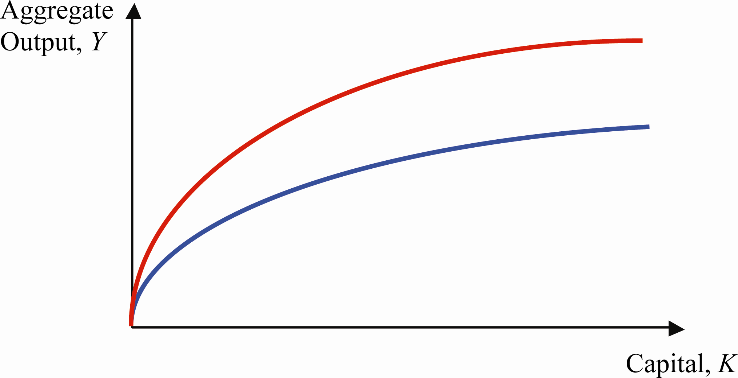

b. The marginal product of capital increases as a result of the positive supply shock. Graphically, this can be observed by a steeper slope at every capital level.

Determination of Factor Prices

5. a. This firm is not maximizing its profit because it is hiring too many employees and using less equipment (capital) than it should. At this current real wage, the marginal product of labor (worker’s contribution to total output) is lower than its cost (the real wage). Also, at this current real rental rate, the marginal product of capital is higher than its cost. Currently, the profit-maximization condition is not met for either factor of production.

b. This firm should change the amount of each factor of production it is currently employing. It should therefore lay off some workers until the marginal product of labor rises to $12 and should use more capital (equipment) until its marginal product falls to $20.

6. a. When L = 80 the marginal product of labor is As one can see from the formula for the marginal product of labor, MPL decreases as L increases.

b. To determine the equilibrium real wage, demand must equal supply in the labor market. Demand is represented by the marginal product of labor, while supply is considered to be fixed at 100 million workers. Equilibrium implies: The equilibrium real wage is $13 when labor supply is 100 million.

7. a. The intersection of supply and demand in the capital market indicates that the real rental rate of capital is:

Graphically:

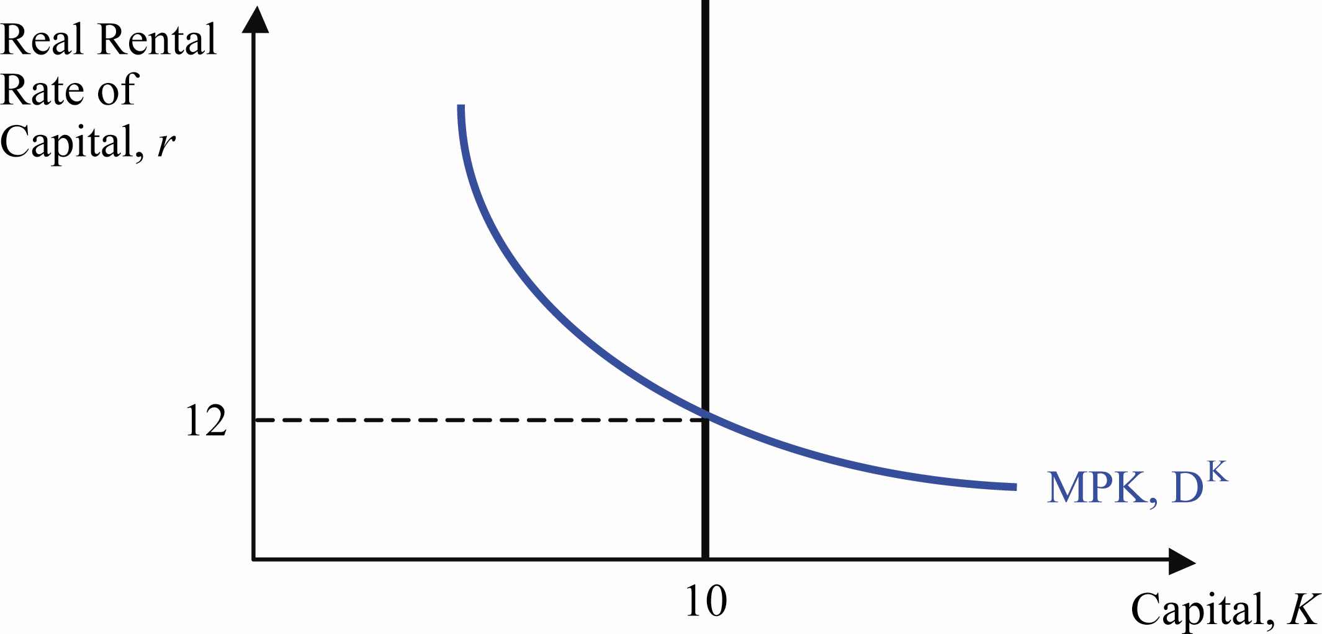

b. The new real rental rate of capital is given by:

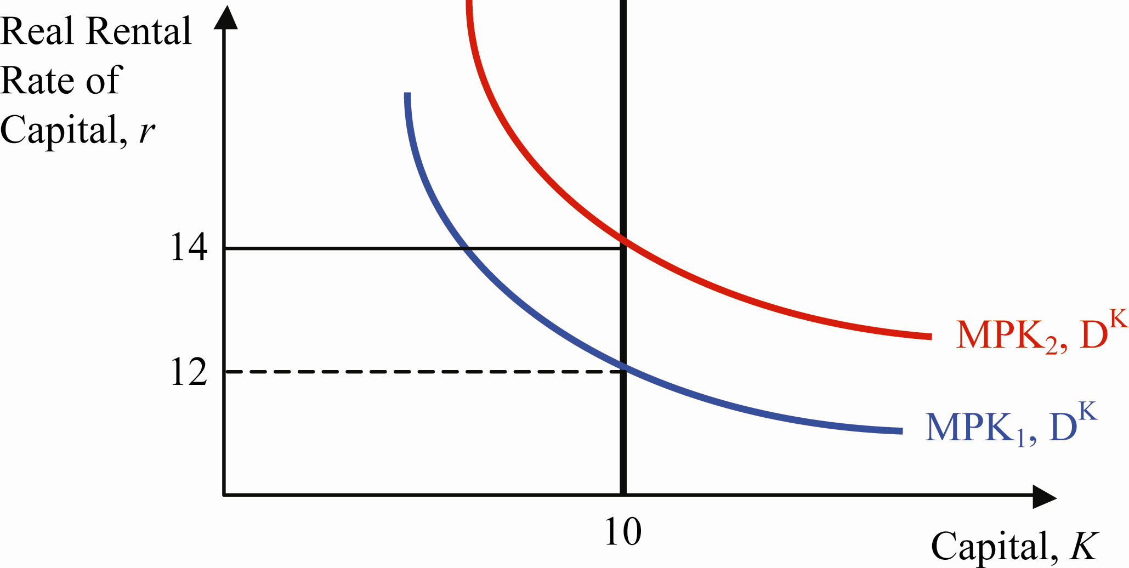

Distribution of National Income

8. A Cobb-Douglas production function uses the labor income and capital income shares of total income as the exponents on labor and capital respectively. In this case, the labor income share is 0.75, and the capital income share is 0.25. This economy could be represented by the following production function:

9. Your boss is not correct because an important characteristic of a Cobb-Douglass production function is that both the labor and capital income shares of total income are constant. Therefore, the Cobb-Douglas production function is a good representation only for countries whose labor and capital income shares remain relatively constant over time.

10. Chile’s real labor and real capital income are given by the parameters of the Cobb-Douglas production function and national income:
Real labor income: billion.
Real capital income: billion.

Answers to Data Analysis Problems

1. a. From 1980 to 2012, nominal wage growth has averaged 4.3 percent, and CPI inflation has averaged 3.6 percent per year. Thus, inflation has eroded away a substantial part of the purchasing power of the nominal increase in wages.

b. Real wage growth can be inferred from the difference between nominal wage growth and the CPI inflation rate, which is 0.7 percent average per year over that time.

c. Average labor productivity growth is 1.8 percent per year from 1980 to 2012; this is consistent with the result that labor productivity growth and real wage growth are positively correlated. These numbers are also remarkably similar to the period from 1973–1995 as shown in Table 3.2.

2. a. From 2000:Q1 through 2013:Q1, output per person has grown by 28.4 percent; from January 2000 to March 2013, the labor force participation rate fell from 67.3 percent to 63.3 percent, a decline of 4 percentage points.

b. The decline in the labor force participation rate means that for GDP per capita to grow, it will have to be driven by higher labor productivity; in other words, given the demographic factors pushing the labor force participation rate down since its peak around 2000, sustained growth in GDP per capita will have to come from higher labor productivity growth to offset the declining labor force participation rate.

3. a. Generally, labor productivity rises during expansions and declines or does not grow much during recessions, particularly near the beginning and middle of recessions. Generally, real compensation per hour rises during expansions and declines or grows slowly during recessions.

b. If output per worker and the MPL are closely linked, then declines in output per worker (MPL) that happen during recessions should reduce labor demand, and hence the equilibrium real wage, and vice versa. The labor productivity and real compensation measures seem to support this basic labor market result: when OPHNFB declines, COMPRNFB generally declines, and vice versa. The graph of the two data series are shown below.
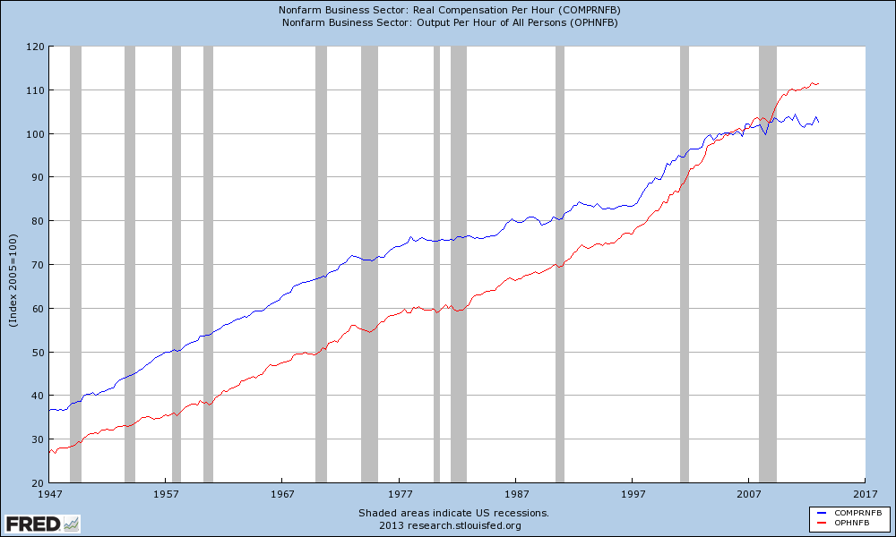

Data Sources, Related Articles, and Discussion Questions

A. For Information About Application: Why Are Some Countries Rich and Others Poor?

Data Source

1. Penn World Tables: http://pwt.econ.upenn.edu/php_site/pwt_index.php. This is a comprehensive database that allows cross country comparisons. You can chose from various versions of this table by scrolling down.

2. World Bank Classification (Atlas method): http://data.worldbank.org/indicator/NY.GNP.PCAP.CD/countries/latest?display=default. This alternative method is used by the World Bank to compare countries according to the Atlas method. For more information about the Atlas method: http://data.worldbank.org/about/data-overview/methodologies. The World Bank uses this method to classify countries into four categories.

Related Article

1. Lucas, Robert E. Jr., “On the Mechanics of Economic Development”: http://www.fordham.edu/economics/mcleod/LucasMechanicsEconomicGrowth.pdf. This is one of the most important papers about economic development.

2. Romer, Paul M., “Economic Growth”: http://www.econlib.org/library/Enc/EconomicGrowth.html. This article discusses various economic growth determinants.

Discussion Question
The “total factor productivity” term is usually conceived to be a “black box”: it could represent different technologies, production processes, or even the efficiency of the financial system. Propose different ways to fill that “black box”: factors that can increase a country’s income per worker (everything else given).
Answer: Even though there are no simple answers to this question, economists all over the world keep measuring the effect of several factors to test whether they are related to “total factor productivity.” By nature, though, this line of research is usually controversial, as one might argue that “ideas” or the quality of education can impact total factor productivity. The controversy arises because many of these factors are difficult to measure to begin with.

B. For Information About Application: Explaining Real Wage Growth

Data Source
The Bureau of Labor Statistics: http://data.bls.gov/PDQ/outside.jsp?survey=pr. To reproduce (and expand) Table 3.2: Select “nonfarm business” for sector, then “real hourly compensation” (real wages) and “Labor productivity (output per hour)” for measures, and finally “percentage change from same quarter a year ago” for duration. When done, click “get data.”

Related Article
Greenspan, Alan, “The Revolution in Information Technology”: http://www.federalreserve.gov/boarddocs/speeches/2000/20000306.htm. In this speech, Greenspan points out the implications of the revolution in information technology for the U.S. economy.

Discussion Questions
Why do you think that increases in total factor productivity are important for a country as a whole? What about for an individual in particular?
Answer: According to the previous “Application,” increases in total factor productivity will result in increases in income per capita, thereby increasing the standards of living of the whole society. If real wage growth is closely linked to productivity measures, then the case is even stronger to look for factors that can increase “total factor productivity.” Some of these new technologies sometimes affect only one industry (at least at the beginning), like the assembly line implemented by Henry Ford at the beginning of the twentieth century. Real wages for many workers in the automobile industry increased, and ultimately, other industries that copied the same production process also saw an increase in real wages.

C. For Information About Application: Oil Shocks, Real Wages, and the Stock Market

Data Sources
Federal Reserve Bank of Saint Louis database: http://research.stlouisfed.org/fred2/series/SP500?cid=32232. This link provides information about the S&P 500 Index. Note the decline in stock prices during 1973–1975, 1979–1980, and 2007–2008.

Related Article
Hamilton, James D., “Causes and Consequences of the Oil Shock of 2007–2008”: http://www.nber.org/papers/w15002.pdf. This paper compares the causes and consequences of the 2007–2008 supply shock with previous similar events (e.g., in 1973). Figure 1 (page 50) is a plot of oil prices since 1945.

Discussion Question
Fluctuations in the price of oil impact stock prices; real wages and can potentially create a recession. Can you think of a way for countries to avoid such dependence on the price of oil?
Answer: There is no easy answer to this question. Many political leaders have pointed out the need for alternative energy sources (i.e., not oil) precisely because of this problem. If a country does not need to buy oil in the world market, then increases in its price will not affect production (and thereby real wages or stock prices), minimizing the effect of such a price spike. The search for alternative (and renewable) sources of energy is under way also for other reasons: to take better care of our environment. Although many people agree that oil dependence is not a wise policy, apparently the costs of switching to another energy source are still quite high.

