Chapter 6
The Sources of Growth and the Solow Model

Chapter Outline, Overview, and Teaching Tips

Chapter Outline

Economic Growth Around the World

The Solow Growth Model

Building Blocks of the Solow Growth Model

Dynamics of the Solow Growth Model

Convergence in the Solow Model

Application: Evidence on Convergence, 1960–2012

Saving Rate Changes in the Solow Model

Population Growth in the Solow Model

Population Growth and the Steady State

Changes in Population Growth

Population Growth and Real GDP Per Capita

Policy and Practice: China’s One-Child Policy and Other Policies to Limit Population Growth

Productivity Growth in the Solow Model

Technology Growth and the Steady State

Summing Up the Solow Model

Solow Model: The Results

Solow Model: Limitations

Sources of Economic Growth: Growth Accounting

Growth Accounting Equation

Growth Accounting in Practice

Application: U.S. Growth Rates in the Postwar Period

Cross-Country Differences in Growth Accounting Rates

Chapter 6 Appendix: The Algebra of the Solow Growth Model

Chapter 6 Web Appendix: The Golden Rule Level of the Capitol-Labor Ratio

Chapter Overview and Teaching Tips
Part Three of the book introduces students to the fascinating study of economic growth. I like to start teaching this material by contrasting the situation in South Korea in 1960 with other poor countries at the time, and then fast forward to today, when South Korea is so rich, while many countries that it was comparable to in 1960 are still so poor. Another contrast that can be used is the condition of South versus North Korea in 1960 when their income per capita was comparable and today, when they are not. These comparisons make clear how important it is to understand what drives economic growth. Putting Lucas’s quote, “The consequences for human welfare involved in questions like these [about economic growth] are simply staggering” on the blackboard is a good way to motivate the material.
The chapter starts with a tour of economic growth around the world. This section provides students with facts about economic growth and motivates the questions that they will want answered in this part of the book: How can we explain why most countries experience economic growth over time? Why do some countries display convergence, while others do not? Why do some countries have growth miracles, while others have growth disasters?
The Solow growth model developed in the chapter is very standard in most macroeconomic textbooks. One innovation here is the bathtub model of the steady state, which provides a lot of intuition about how the Solow growth model works. One key implication of the Solow model is convergence of economic growth, and the application on the evidence on convergence illustrates when the Solow model helps explain convergence and when it does not. A particularly graphic example of when the Solow model helps explain convergence is in the box, “War, Destruction, and Growth Miracles,” which shows that economic devastation often does not have long-run effects on per capita income because of convergence.
The rest of the chapter puts the Solow growth model through its paces, explaining the effect of changes in the saving rate, population growth, and productivity growth on economic growth. The chapter ends by providing a recap of the Solow model, which not only helps solidify the student’s understanding, but demonstrates the model’s limitations, which helps motivate the remaining chapters in Part Three of the book.
Having students debate the Policy and Practice case, “China’s One-Child Policy and Other Policies to Limit Population Growth,” in class gets students to recognize that policies to increase growth may not always be beneficial because they may have disturbing moral consequences.
The chapter ends with growth accounting and develops the growth accounting Equation 11, which is derived from the aggregate production function in Chapter 3. Although accounting is usually a dry topic, this is not the case for growth accounting. Talking about the sources of economic growth is inherently fascinating, and growth accounting helps lay out the key issues that we have to think about to understand economic growth. Applications, such as the one in the chapter on U.S. growth rates since World War II, drive home that the growth accounting equation is a useful tool for understanding variations in economic growth. This can be driven home even further by discussing international comparisons along the lines in the chapter. The most important conclusion to get across to students from growth accounting is that productivity growth is a more important source of variations in economic growth across countries than is factor accumulation, and this naturally leads to the study of the role of technology and institutions in economic growth in Chapter 7.
The chapter has an appendix on the algebra of the Solow growth model that is worth presenting to more mathematically inclined students, who will see that the results of the Solow growth model can be derived very quickly algebraically, with some quantitative predictions that are quite useful. This chapter also has an online appendix found on the Companion Website at www.pearsonhighered.com/mishkin. It discusses the golden rule level of the capital–labor ratio and indicates that increasingly higher saving rates, which always raise income per capita, do not necessarily lead to higher economic welfare because at some point a higher saving rate leads to a decline in consumption. This analysis is somewhat more complex than in the chapter and is thus relegated to an online appendix, but the basic intuition for this point can be made without going through the full analysis.

Answers to End of Chapter Review Questions and Problems

Answers to Review Questions

The Solow Growth Model

1. According to the per-worker production function, derived from the aggregate production function, output per worker y_{t} depends on two things: total factor productivity A and the amount of capital per worker, the capital–labor ratio k_{t}. The Solow growth model considers total factor productivity to be an exogenous variable and provides no explanation for changes in its value.

2. The per-worker production function slopes upward because an increase in capital per worker increases output per worker. However, as capital per worker rises, the additional output per worker that can be produced with each unit addition to the capital–labor ratio declines because the per-worker production function, like the aggregate production function on which it is based, exhibits diminishing marginal product of capital. Thus the per-worker production function becomes flatter as the capital–labor ratio increases.

3. The amount of investment per worker is based on the equality of saving and investment in the long run. The Solow model assumes workers save a given proportion s of their output per worker y_{t} so sy_{t} is available to finance investment per worker i_{t}. To avoid capital dilution and a decline in the capital–labor ratio, a fraction of this investment must be used to replace old capital that has worn out (depreciated). This fraction is the depreciation rate δ . Capital accumulation—increases in capital per worker—occur only if the amount of investment is greater than δ k_{t}. The change in capital per worker, then, equals investment per worker minus depreciation per worker.

4. Given the per-worker production function and fixed productivity and population, the steady-state level of capital per worker depends on the proportion of income per worker that is saved and the depreciation rate. The steady state is achieved when the level of capital per worker does not change. For this to occur, the amount of investment per worker must equal depreciation per worker. If the capital–labor ratio is above the steady-state level, investment is less than the amount of new capital needed to replace that which wears out. With more capital wearing out than is being replaced, capital per worker declines toward the steady-state level. If the capital–labor ratio is below the steady-state level, investment more than adequate to replace the capital that wears out and capital per worker rises toward the steady-state level. Thus the capital–labor ratio moves to the steady-state level regardless of its initial value.

Saving Rate Changes in the Solow Model

5. If the saving rate increases, a larger portion of the present output per worker will be invested in new capital. Capital accumulation and capital per worker will rise, and capital per worker will continue growing until a new steady state is reached. As capital per worker rises, output per worker and investment per worker also grow. In the new steady state, the higher level of investment is needed to replace the greater amount of depreciation that results from the higher level of capital per worker. Once the new steady state is reached, however, there are no further increases in the levels of capital or output per worker. An increase in the saving rate, then, causes temporary growth in capital and output per worker that raises them to higher levels, but in the long run steady state the growth rates of those variables return to zero.

Population Growth in the Solow Model

6. Population growth results in capital dilution, as a given amount of capital must be used by a larger number of workers. The decline in capital per worker reduces output per worker. (This occurs despite growth in total output that results from having additional workers as population grows.) To achieve a steady state, the amount of investment per worker now must cover two sources of capital dilution, depreciation and increases in the number of workers, both of which will reduce the capital–labor ratio if investment is not sufficient. In the steady state, saving per worker equals depreciation per worker (δ k_{t}) plus the amount of capital needed to keep capital per worker constant in the face of population growth (nk_{t}.) Compared with a situation in which population is fixed, population growth reduces the steady-state levels of capital and output per worker, ceteris paribus.

7. The exogenous variables include total factor productivity, the saving rate, the depreciation rate, and the population growth rate. The endogenous variables are consumption per worker, investment per worker, capital per worker, and output per worker.

Productivity Growth in the Solow Model

8. An increase in total factor productivity works in two ways to increase output per worker. First, output per worker rises because the available capital and labor inputs are more productive and total output increases for given levels of capital and labor. Graphically, the per-worker production function rotates upward so that at the initial capital–labor ratio output per worker is higher. Second, with higher output per worker there is also more investment per worker, so the amount of capital per worker increases to a higher steady-state level, and output per worker rises along with it.

Summing Up the Solow Model

9. The Solow model provides these insights into economic growth: (1) if different economies have the same aggregate production function they will converge to similar levels of output per worker and per capita income; (2) a higher saving rate increases the levels of capital and output per worker but does not affect their long-run growth rates; (3) a higher rate of population growth reduces the level of output per person; and (4) increases in productivity directly increase output per person and also increase it indirectly by causing the capital–labor ratio to rise. The Solow model’s chief deficiency is that it does not explain sustained increases in output per worker and per capita income. This is so because productivity growth, which in the Solow model is the only source of continuous growth, is determined by factors outside the model.

Sources of Economic Growth: Growth Accounting

10. According to the growth accounting equation, which is derived from the aggregate production function, the three sources of economic growth are productivity growth, capital growth, and labor growth. The contribution to economic growth from productivity is ΔA/A. The contributions to growth from increases in capital and labor are 0.3ΔK/K and 0.7ΔL/L.

Answers to Problems

The Solow Growth Model

1. a. The steady-state condition is given by Solving for k_{t} yields:
.

b. Consumption is given by

2. a. Then new capital–labor ratio will be lower than the original one because this earthquake decreased Chile’s capital stock (including ports, roads, schools, etc.). The new capital–labor ratio is noted in the graph in red.

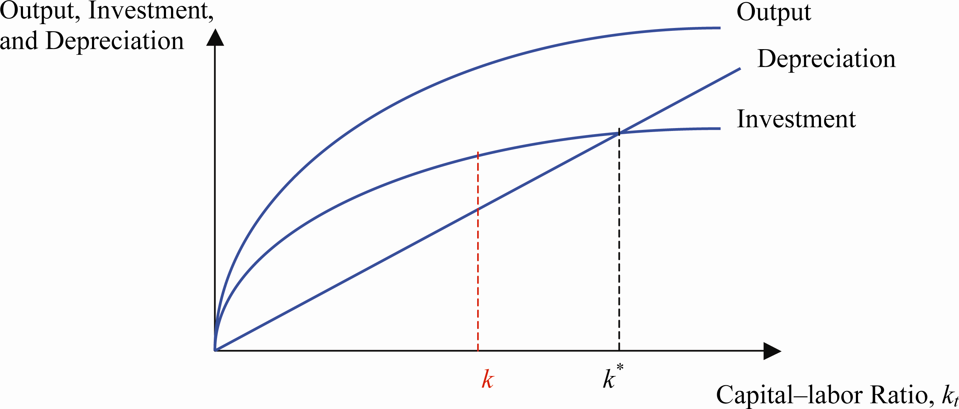

b. In the aftermath of the earthquake, Chile’s capital–labor ratio will be at a lower level than at its steady state. At this point, investment is higher than depreciation, and Chile will be adding to its capital stock for some time, until the capital–labor ratio reaches its steady state again. According to the model, Chile (or its most affected areas) should grow at a slightly higher rate than prior to the earthquake for some time, until it reaches its steady state again.

Saving Rate Changes in the Solow Model

3. a. According to the Solow model, an increase in the saving rate will increase the capital–labor ratio in the United States. There will be a transition during which the U.S. economy will move toward a new steady state. At the new steady state, U.S. residents will enjoy a higher capital–labor ratio level and, therefore, a higher output-per-worker ratio. These ratios, however, will not increase any further. The effect of a higher saving rate, according to the Solow model, is to increase the steady state level of output per worker. After this transition period is over, output per worker does not increase any further.

b. In light of the previous answer, one might ask: Why not keep increasing the saving rate forever? The answer is that increasing the saving rate means decreasing current consumption, a quite important trade-off. This reasoning demonstrates that there is a limit to this path to encourage economic growth.

Population Growth in the Solow Model

4. If low standards of living are the reason individuals decide to have many children, then encouraging couples to have fewer children will not have a significant effect on economic growth. Although the concept of capital dilution is very important, there are many arguments in favor of the hypothesis that low standards of living encourage individuals to have more children. Some population control policies were not very successful (e.g., distribution of contraceptives). As people saw no change in their well-being, even if they had contraceptive methods at hand, they still decided to have many children. Some other population control methods were more coercive (e.g., fines, sterilization, etc.) and, therefore, resulted in lower fertility rates. These often did not translate to an increase in the standard of living of these societies. Most societies that saw a decrease in their fertility rates also experienced an increase in their standards of living either prior to or during the decrease in fertility rates.

5. There are many consequences that arise from a coercive population control method as the one implemented by China. First, the drop in fertility rates has been so big that the Chinese labor force might be smaller in the future than what it is today. Second, it means that young workers in the future will have to work extra hard to support their parents. This is a phenomenon shared by many aging populations, even when there is not population control, but clearly the one-child policy makes this worse. Finally, and most importantly, Chinese families that are allowed to have only one child usually prefer to have a baby boy. This has resulted in ratios of baby boys to baby girls of around 120 to 100, when the usual ratio is around 103 to 105 baby boys per 100 baby girls. An interesting corollary is that in the future there will be more Chinese young boys trying to marry fewer Chinese girls than in previous years.

6. a. According to the Solow model, immigration will result in an increase in the aggregate output level. An increase in the labor input increases the economy’s ability to produce goods and services. This can be seen by increasing “L” in the original production function and holding the capital factor and productivity constant. As a result, “Y” will increase.

b. Even if aggregate output increases at a higher rate due to immigration, the steady-state capital–labor ratio will decline. Everything else the same (including the savings rate and the productivity factor), the Solow model predicts that higher population growth dilutes the capital stock per worker and therefore results in lower output per worker.

Productivity Growth in the Solow Model

7. a. Investment increases as productivity increases during the period. This results in an upward shift of the investment curve (holding the saving rate constant). At the same time, the immigration wave means higher population growth during that period, making the depreciation and capital dilution curve rotate counterclockwise.

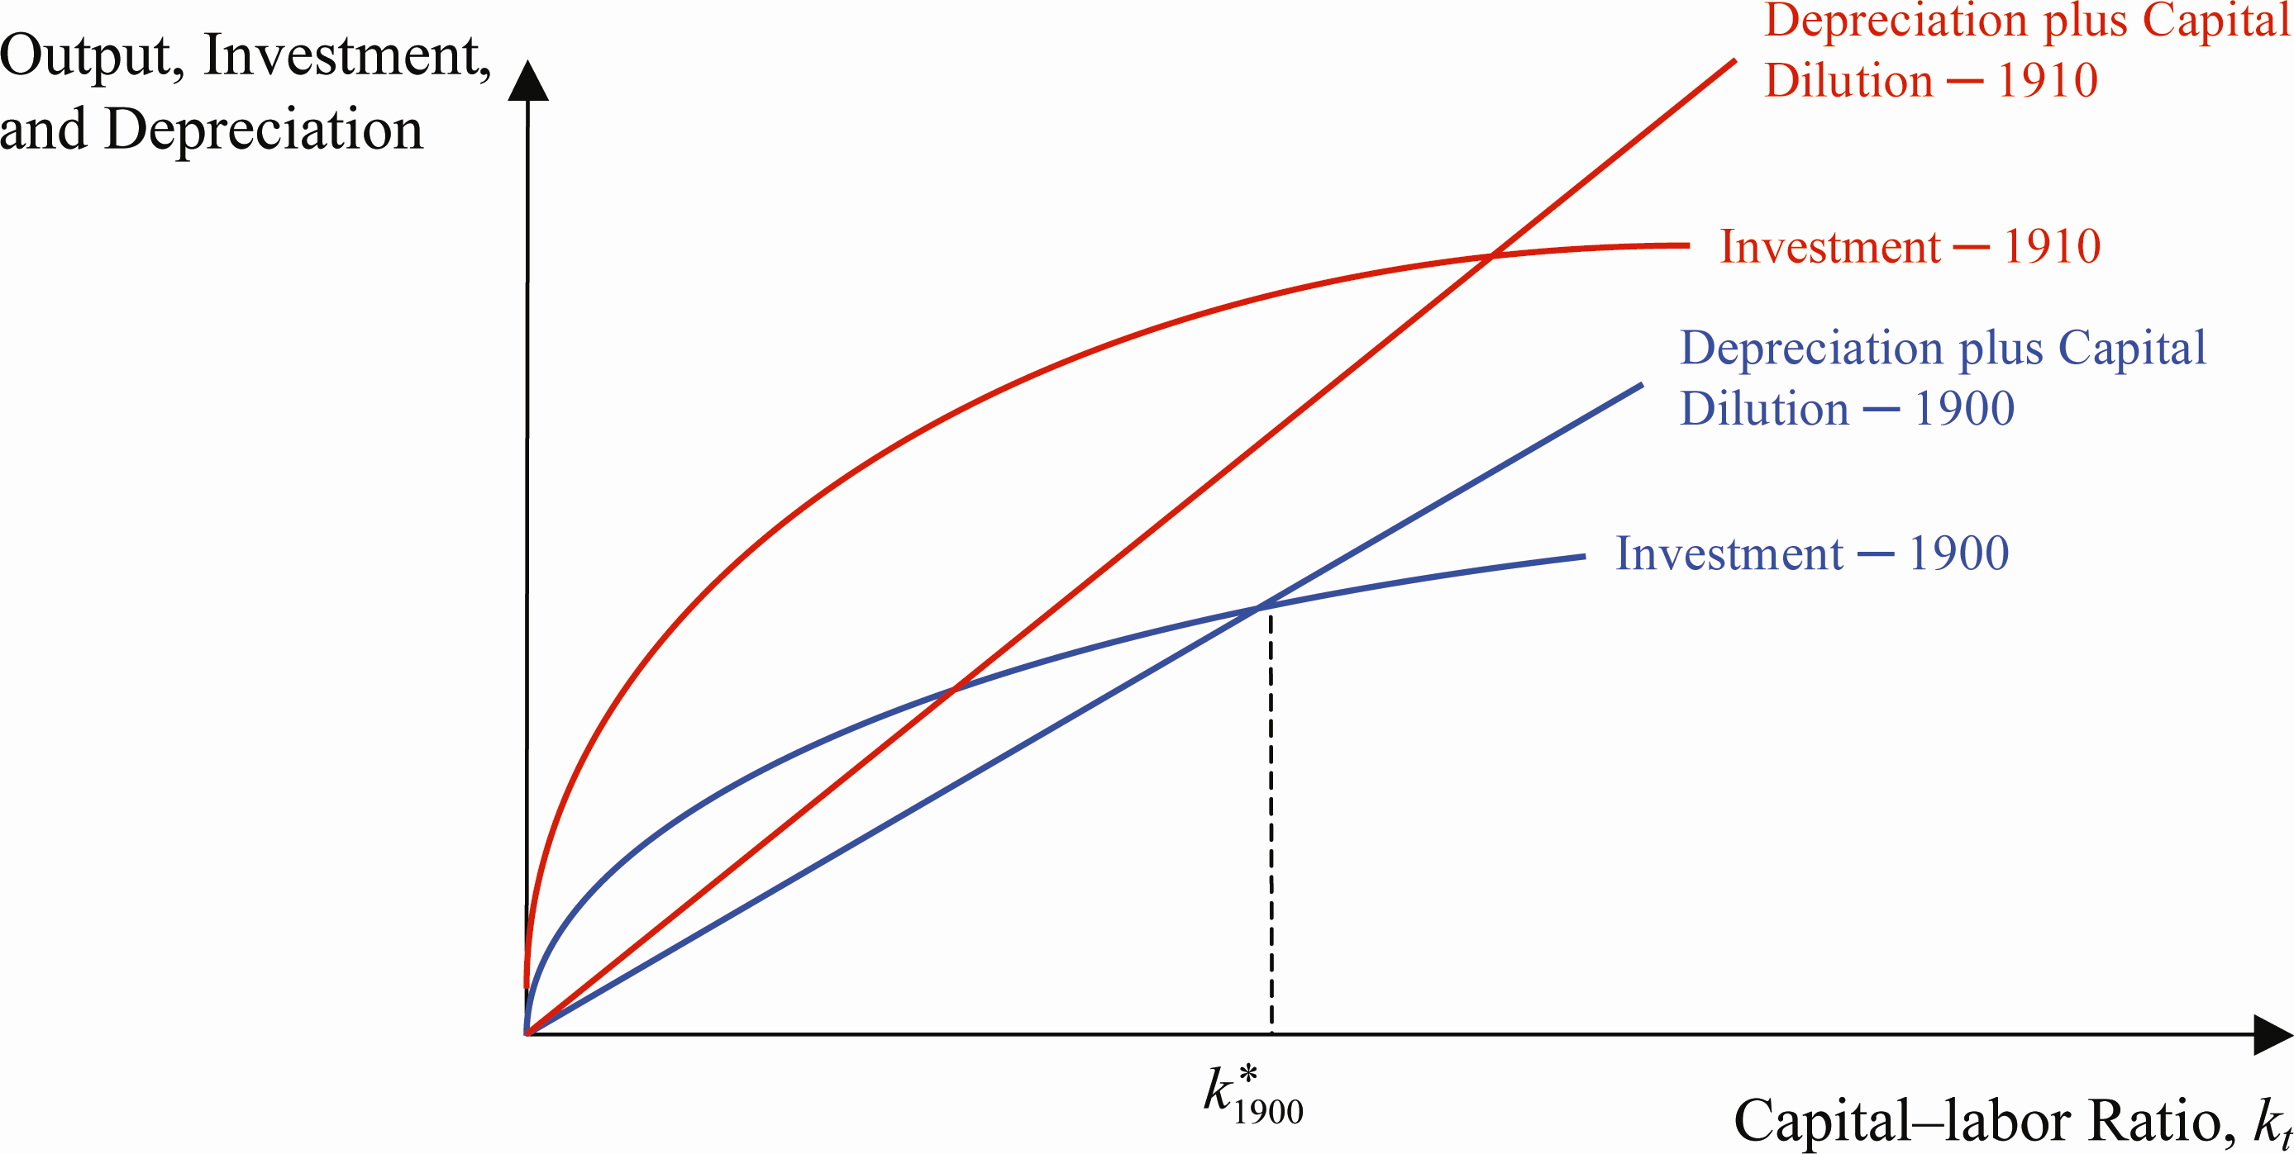

b. The result of these two opposing effects on the steady state capital–labor ratio depends on their relative magnitudes. If capital per worker was higher in 1910 than it was in 1900, then it is plausible to assume that the increased in productivity offset the increase in population growth, as shown in the graph.

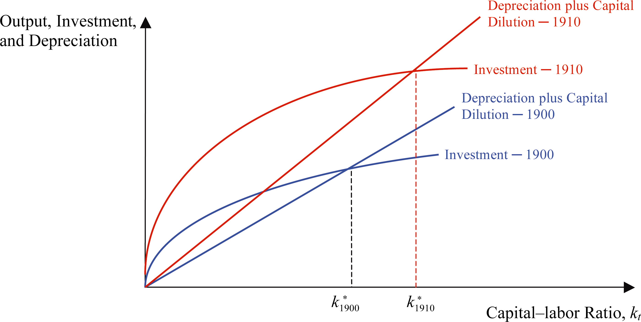

Summing Up the Solow Model

8.

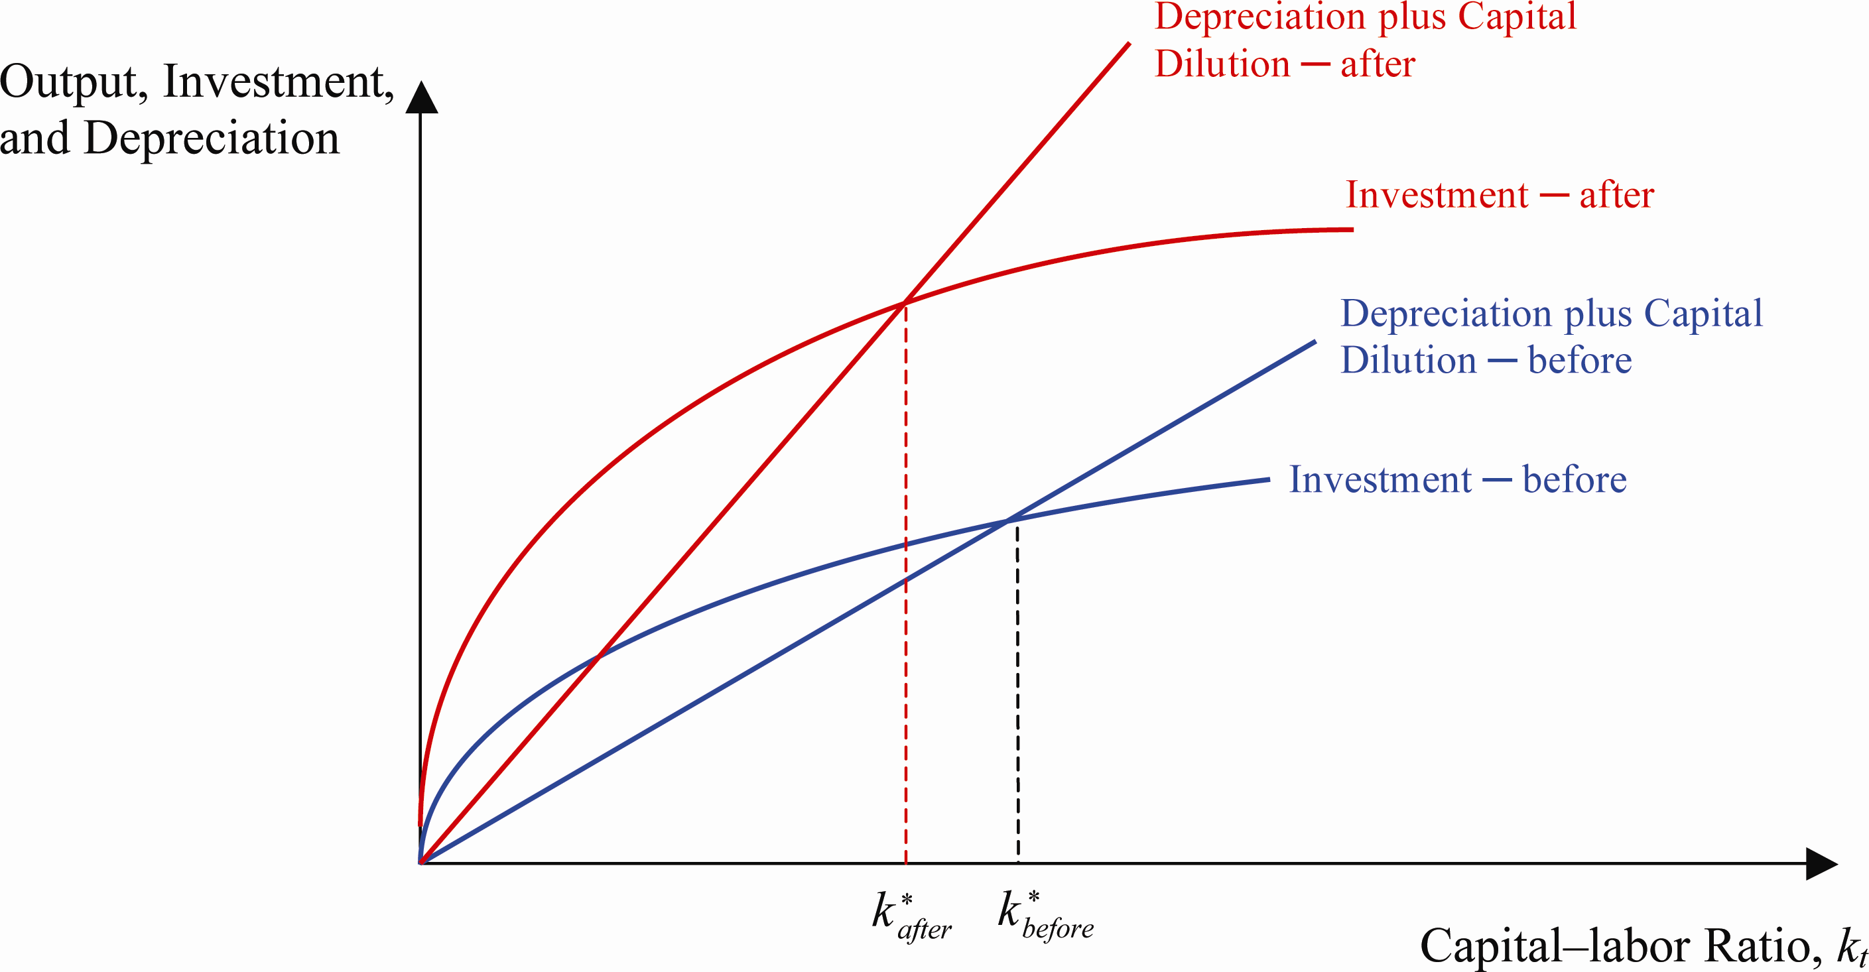

a. Immigrants’ higher saving rate means that the new saving rate of the whole country will be higher, shifting the investment curve upward. Also, a higher fertility rate means higher population growth, represented by a counterclockwise rotation in the depreciation and capital dilution curve.

b. Without having an estimate of the magnitude of these effects, we cannot determine if the new steady state level of the capital–labor ratio will be higher or lower than its previous level. The graph shows the case in which the population growth effect is larger than the increase in the saving rate, and therefore, the economy reaches a lower steady state level of the capital–labor ratio.

Sources of Economic Growth: Growth Accounting

9. a. India’s output growth can be calculated as:

b. The contribution of productivity growth to total output growth is Almost 60 percent of India’s growth came from productivity growth in this case.

10. a. The difference in output growth rates can be explained by differences in productivity growth rates. This is the factor that cannot be measured directly, as opposed to changes in the capital and labor input stocks.

b. Productivity growth rates can be calculated as the difference between output growth rates and the combined growth rates of the capital and labor input stock. Productivity growth in country 1 is a mere 0.5 percent, and it is 2.5 percent for country 2, which explains its higher output growth rate.

Answers to Data Analysis Problems

1. a. See table below.

b. See table below. The low population growth countries of Japan, United States, and Canada have an average population growth rate of 1.3 percent, and average GDP per capita of $48,119 for the sample period. The high population growth countries of Egypt, Mexico, and the Philippines have an average population growth rate of 4.2 percent, and average GDP per capita of $5,066 for the sample period. This is to be expected based on the Solow model. Among these 10 countries, Brazil and Mexico seem to be outliers to the pattern. Both have population growth in the 3 percent range; however, they have much higher GDP per capita than the other countries with approximately similar population growth.
Country | Average Population Growth Rate (1960–2011) | GDP Per Capita (2011)
Japan | 0.73% | $45,902.67
United States | 1.39% | $48,111.97
Canada | 1.78% | $50,343.69
China | 1.95% | $5,444.79
Indonesia | 3.15% | $3,494.60
Brazil | 3.27% | $12,593.89
India | 3.41% | $1,508.54
Egypt | 3.77% | $2,780.95
Mexico | 3.82% | $10,047.13
Philippines | 5.09% | $2,369.70

c. See scatterplot below. Clearly, among these countries there is a strong relationship between high population growth leading to low GDP per capita as predicted by the Solow model.
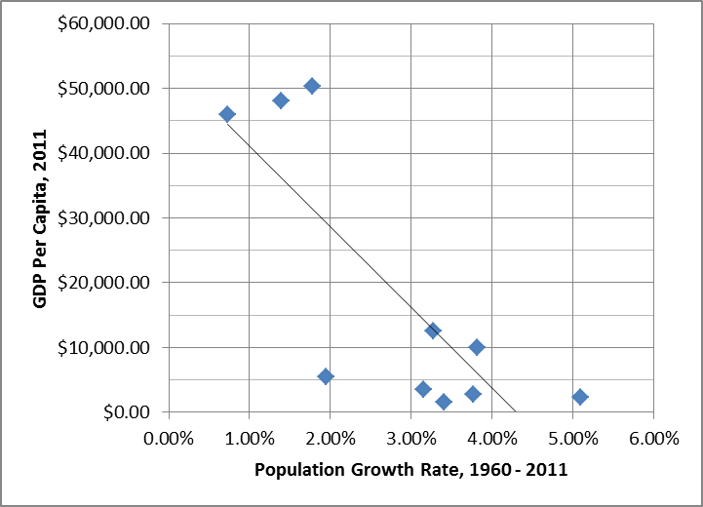

2. a. Calculations not shown here.

b. See table below.

c. See table below. In every decade except the 2000s, total factor productivity (A) contributes significantly more to growth in output per worker than does capital accumulation, represented by 0.3g_{k}. This can be seen more clearly in the averages across each decade: real output per worker has grown slightly more than 1 percent on average per year, and more than 80 percent of the growth (0.84/1.03) derives from improvements in total factor productivity, while only around 20 percent of that growth derives from growth in capital per worker.
Decade | g_{k} | g_{A} | 0.3g_{k} | g_{y} = 0.3g_{k} + g_{A}
1960–1969 | 0.77 | 2.07 | 0.23 | 2.30
1970–1979 | 0.39 | 0.41 | 0.12 | 0.53
1980–1989 | 0.73 | 0.87 | 0.22 | 1.09
1990–1999 | 0.97 | 1.05 | 0.29 | 1.34
2000–2009 | 0.70 | -0.17 | 0.21 | 0.04
2010–2012 | 0.29 | 0.81 | 0.09 | 0.90
Average | 0.64 | 0.84 | 0.19 | 1.03

3. a. From 1960 to 1980, the average net saving rate is 9.6 percent, and for 1980 to 2011, the average net saving rate is 4.0 percent.

b. The Solow model predicts that, holding all other factors constant, a decrease in the saving rate will reduce the steady-state level of capital per worker and, hence, reduce output per worker and output per capita.

c. The net saving rate went down from 9.6 percent to 4.0 percent, while real GDP per capita increased significantly from $29,041 in 1980 to $48,282 per person in 2011. This is inconsistent with the Solow model prediction from part (b); however, the predicted decline in real GDP per capita from the declining saving rate is likely offset by slower population growth and significant increases in total factor productivity during that time in the United States.

Answers to Review Questions and Problems in Appendix, “The Algebra of the Solow Growth Model”

1. According to the per worker production function, the steady-state value of the capital–labor ratio is given by:

The steady-state value of per-worker output is:
 | Steady-state capital–labor ratio | 21.6
 | Steady-state output | 5.02

2. According to the per-worker production function, the steady-state value of the capital–labor ratio is now:

The steady-state value of per-worker output is: The higher saving rate shifts the investment curve up, intersecting the depreciation plus capital dilution curve at a new (higher) steady state value of the capital–labor ratio. Intuitively, the increase in savings allows this economy to reach a higher capital-per-worker steady state by adding more capital to the existing capital stock until the economy reaches its steady state again. Once the new steady state is reached, the addition to the capital stock is just enough to replace worn out capital and match new workers with the same capital stock as the previous generation. The new capital–labor ratio and output per worker steady states are denoted in red in the graph:

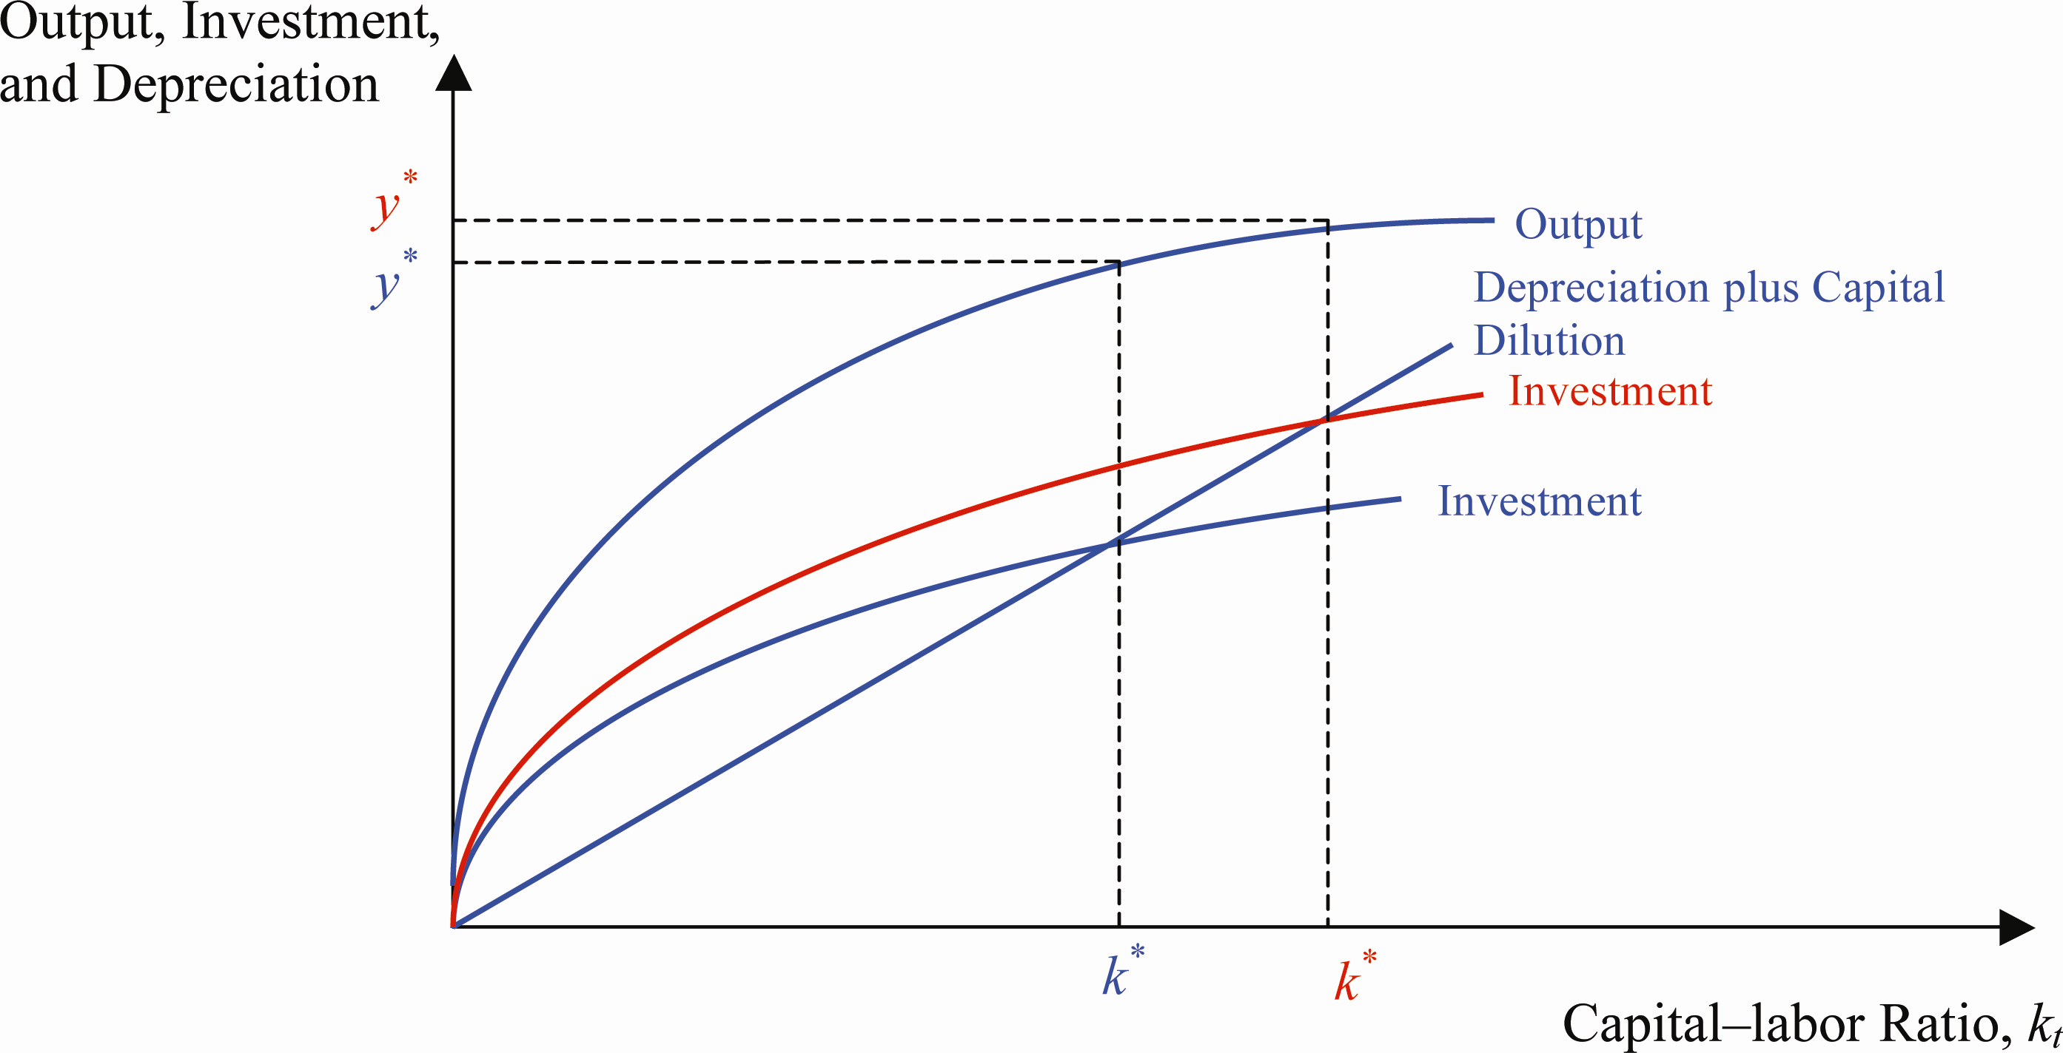

3. According to the per-worker production function, the steady-state value of the capital–labor ratio is given by:

The steady-state value of per-worker output is: The higher population growth rate rotates the depreciation plus capital dilution curve counterclockwise and determines a lower level of the steady-state values of the capital–labor ratio and output per worker. (The new values are denoted in red in the graph; the values from Problem 1 are in blue.)

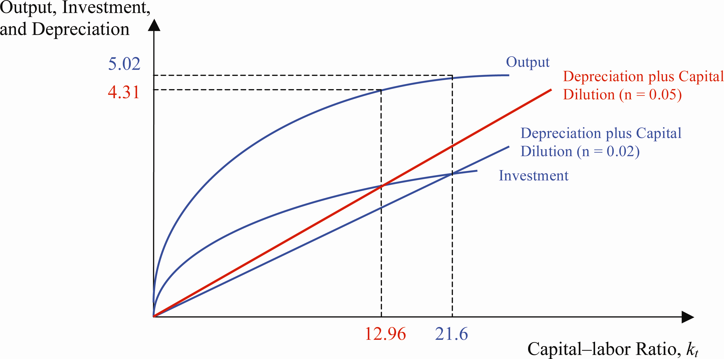

4. An increase in productivity (the technology factor) results in a rotation upward of both the output and investment curves. At the original capital–labor ratio, output per worker rises as the output curve rises. Output per worker will also rise because the intersection point of the new investment curve and the depreciation plus capital dilution curve occurs to the right of the original steady state value of the capital–labor ratio, so that output per worker will be higher because the capital–labor ratio is higher. Thus the original increase in output that results from an increase in technology is amplified. See graph:

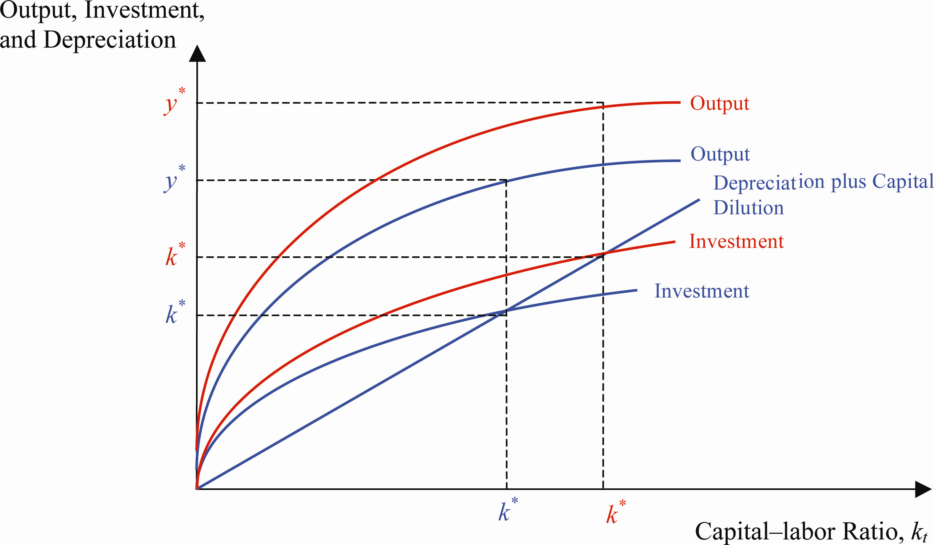

Answers to Review Questions and Problems in Web Appendix, “The Golden Rule Level of the Capital–Labor Ratio”

1. The Golden Rule capital–labor ratio is special because it is the value of the capital–labor ratio that maximizes consumption per worker; at the Golden Rule capital–labor ratio the marginal product of capital equals the depreciation rate. Whether or not the economy achieves the Golden Rule capital–labor ratio and maximizes consumption per worker depends on the saving rate. If the saving rate is too low, the capital–labor ratio will be below the Golden Rule value. The marginal product of capital exceeds the depreciation rate, and the economy passes up the opportunity to add units of capital that would increase consumption per worker because they would increase output per worker by more than the increase in investment per worker. If the saving rate is too high, the capital–labor ratio will be greater than the Golden Rule value. The marginal product of capital will be less than the depreciation rate, and consumption per worker will be lower than at the Golden Rule capital–labor ratio because the added units of capital add less to output per worker than they do to investment per worker, which lowers consumption per worker.

2. A saving rate that is lower than the Golden Rule saving rate results in a capital–labor ratio that is smaller than the Golden Rule ratio. This implies that consumption is not maximized. The choice of a lower saving rate means that current and future generations will not enjoy as much consumption as possible. One could interpret this as the current generation preventing future generations from achieving higher consumption levels.

3. An increase in the population growth rate will result in a decrease in the Golden Rule level of the capital–labor ratio (refer to Equation 5 and remember that the marginal product of capital increases as the capital–labor ratio decreases). Intuitively, if the capital–labor ratio does not change, then the marginal product of capital will be less than the sum of the depreciation and population growth rates. This means that the addition to output derived from increasing the capital–labor ratio is less than the increase in investment, thereby decreasing consumption. The increase in the population growth rate has the same effect on both the steady state capital–labor ratio and the golden rule capital–labor ratio.

4. A decrease in the depreciation rate means that fewer units of capital are needed to replace the wearing out of the current capital stock and maintain the Golden Rule capital–labor ratio. Using Equation 5, this means that the lefthand side of the equilibrium condition has decreased. This results in an increase in the Golden Rule capital–labor ratio, so that the marginal product of capital is set now at the new (lower) level consistent with the lower depreciation rate. The decrease in the depreciation rate has the same effect on both the steady state capital–labor ratio and the Golden Rule capital–labor ratio.

5. The Golden Rule capital–labor ratio is determined at $6,000 per worker, when the equilibrium condition in Equation 5 is met: marginal product of capital = depreciation rate + population growth rate.

6. An increase in the technological factor increases the marginal productivity of capital, thereby resulting in an increase in the Golden Rule capital–labor ratio. Graphically, the increase in A (technology) shifts up the production function and the saving function Everything else the same, including the depreciation and population growth rates, the Golden Rule capital–labor ratio increases.

Data Sources, Related Articles, and Discussion Questions

A. For Information About Application: Evidence on Convergence, 1960–2012

Data Source
Penn World Tables: http://pwt.econ.upenn.edu/php_site/pwt_index.php. Here you can find information about different countries’ growth rates.

Related Article
Grier, Kevin, “Empirics of Economic Growth”: http://www.econlib.org/library/Enc/EmpiricsofEconomicGrowth.html. This article refers to the “absolute” and “conditional” convergence concepts.

Discussion Question
What are some potential reasons different countries might be represented by different production functions (so that according to the Solow model they would not converge to the same steady state)?
Answer: Even if some countries have similar per capita stocks or human capital (i.e., education), they might be represented by different production functions. This is due mostly to different ways in which economic activity is organized across countries. A fundamental ingredient is “institutions,” meaning formal (e.g., judicial system) or informal (e.g., corruption prevalence and/or enforcement) arrangements that determine how efficiently inputs can be used in a society. This concept (and others) is captured by total factor productivity, so that different countries can potentially be represented by different production functions.

B. For Information About Policy and Practice: China’s One-Child Policy and Other Policies to Limit Population Growth

Data Source
OECD Statistics, China’s statistical profile: http://stats.oecd.org/index.aspx?queryid=32517. Check China’s current fertility rate (around 1.59) and China’s fertility rate in 1970 (around 5.5).

Related Article
Nie, Weiliang, “China’s One-Child Policy: Success or Failure?” http://www.bbc.co.uk/news/world-asia-pacific-11404623. This article evaluates the consequences of the one-child policy in China.

Discussion Questions
Do you agree with the one-child policy? Why or why not?
Answer: The principle of the one-child policy is highly controversial. Not only does it impose a restriction on the behavior of individuals, but it also creates some short- and long-term problems. Even if virtually any form of government enacts policies that affect our behavior, most of them are in the form of taxes or with the ultimate goal of protecting our human rights. This policy, however, does not allow individuals to make one of their lives’ most important decisions: how many children to have. In addition, due to the fact that most households prefer to have one boy, girls are not given the proper care or attention. This behavior has been reported many times in China. The long-term effect has been that entire generations of Chinese males are find it increasingly difficult to marry, which could potentially decrease the already low fertility rate even further.

C. For Information About Application: U.S. Growth Rates in the Postwar Period

Data Source
Bureau of Economic Analysis, NIPA Tables: http://www.bea.gov/iTable/iTable.cfm?ReqID=9&step=1#reqid=9&step=1&isuri=1. Here you can find information about nominal and real GDP for the United States.

Related Article
Bosworth, Barry P. and Jack E. Triplett, “What’s New About the New Economy? IT, Economic Growth and Productivity”: http://www.brookings.edu/research/papers/2000/10/20healthcare-bosworth . This article discusses the “new economy” concept and measures its effects on the U.S. economy.

Discussion Question
Suppose that during the next 10 years the growth rate of both labor and capital input remains constant in the U.S. economy. What would happen to the U.S. GDP growth rate?
Answer: If the growth rate of both the labor and capital inputs remain constant, GDP growth will be entirely determined by productivity growth. This scenario might be possible in the future if one thinks that a depressed savings rate will not allow for a significant increase in capital inputs. With respect to the labor input, future fertility and immigration rates will play important roles in determining the evolution of this input.

