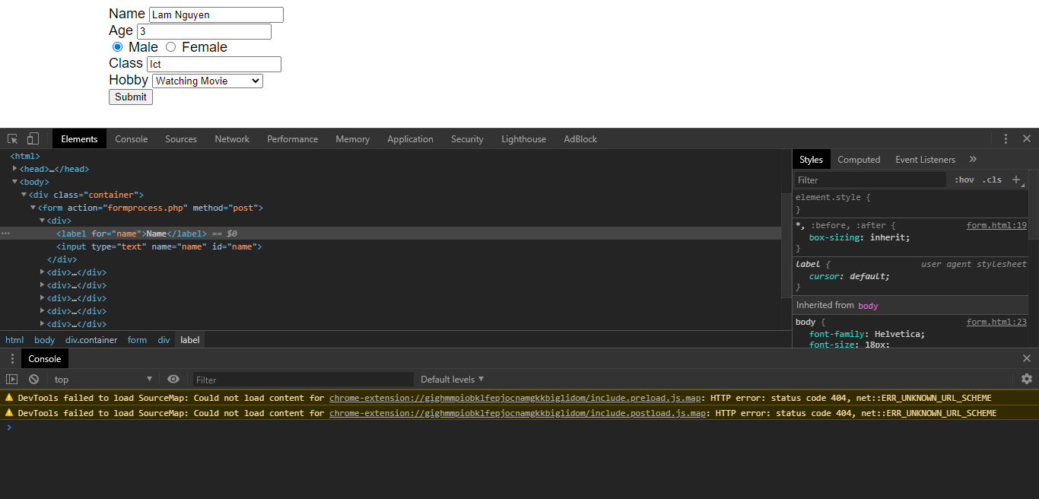

In this screen, I used inspector to check how html elements is aligned, and then adjusting as I want.

