Title: System supports identifying star allele and translating into phenotype from single based extension data

# BACKGROUND ART

The single base primer extension method (SBE) is an effective and sensitive approach that can cover over 30 loci in a single reaction. As a cost-effective approach, this method has been widely used in many applications such as forensics, disease diagnosis, and pharmacogenetics (PGx).

Pharmacogenomics (PGx) play an essential part of precision medicine. Several studies confirmed the benefit of panel-based PGx tests in clinical settings. Many important PGx genes encode metabolizing enzymes such as cytochrome P540 (CYPs) and transporter; and these genes highly vary in the population. The variants often referred as star-alleles (e.g., CYP2D6*10B). Star allele can be a single genetics variant or combination of multiple variants across the gene (haplotype). Therefore, identifying star-allele from customed panels plays a role in PGx implementation.

Many tools have been developed such as PharmCAT, Stargazer, Astrolabe, and Aldy to identify star allele from sequencing data; and all of them focus on analyzing Next-Generation Sequencing data. Moreover, genotyping software (e.g., GeneMapper) does not support identifying haplotypes from experimental data. Therefore, identifying haplotypes of customed PGx test panels remains challenging.

Conventionally, with custom PGx panel results, PGx experts often have two options (Figure 1A): (1) they manually identify the haplotypes from raw intensity data (chromatogram plots); or (2) they identify genotype results using a genotyping software and upload the result to other tools to match haplotypes. Then, they must manually manage the data and analytical results, and history for further steps. This way raises several following risks: manual processes increase human biases; it is hard to record and track the history of the whole process; and it is difficult to scale to many testing samples because it requires more effort to manage all those data and processes.

**DEFINITIONS**

Haplotype (a.k.a star allele) is a specific allele inherited from on patent. In this work, we use star allele term for reducing the confusion.

Diplotype is a specific combination of two haplotypes

Phenotype is composite of an organism’s observable characteristics or trait.

Metabolizer phenotype of can be a strengthen of a particular enzyme or transporter with a specific substrate, for example: Normal metabolizer, Intermediate Metabolizer, or Poor Metabolizer.

**SUMMARY OF INVENTION**

This system of present invention is a cloud computational method for automated identifying star allele from a custom PGx panel and translating to phenotype from single base extension method data. The system comprising of a) a module to load and manage the customed pre-defined marker positions (allele definition and following bin range), and pre-defined star allele nomenclatures; b) a module that allows user to identify peaks (from experimental intensity from single based extended method) by adjusting bin range and height of intensity; c) a module to identify star allele, diplotype, and phenotype based on detected peaks and pre-defined nomenclatures; d) a module to generate PGx report based on result and our knowledge database.

**CLAIMS**

A computer-implemented method for identifying star allele, diplotype and translating into phenotype, comprising:

1. a local client computer connecting to internet for said individual controlled access network account.
2. Receiving pre-defined markers’s profile and pre-define nomenclatures from client
3. Initializing a data store for pre-define marker’s profile and nomenclatures on server
4. receiving intensity data from single base extension method of the phrase from a client onto a server
5. auto detecting peak based on the intensity data based on pre-defined marker’s profile information on the server
6. sending results of peak detection to client
7. receiving marker’s profile modification including mix and max location; height of intensity; or corrected result.
8. Repeating step (f) and (g) until getting client confirmation for final peak detection results.
9. matching the final peak detection results with the pre-defined nomenclature to identify star allele, genotype, diplotype and phenotype on server said genotype calling result.
10. Sending the genotype callling result to client.
11. Genearting report upon client request

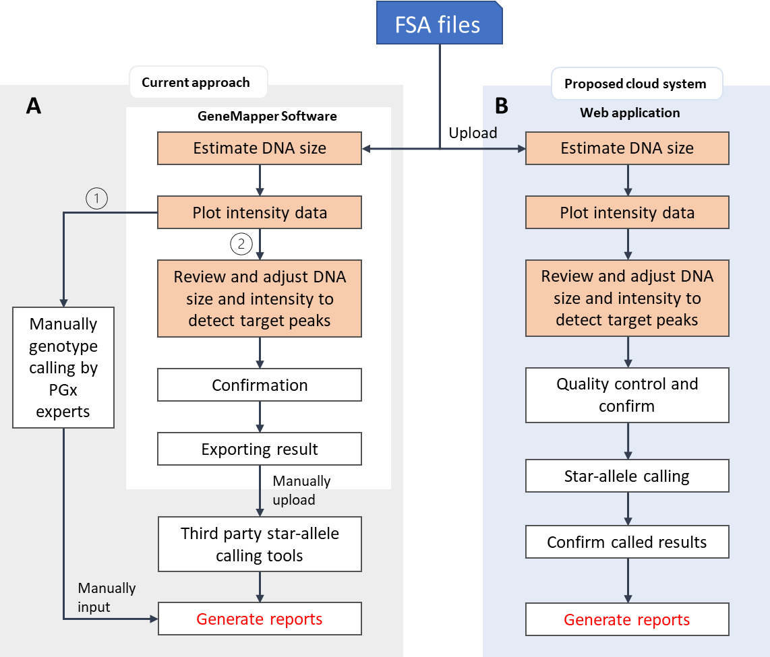

Figure 1. Overview of current approach and purpose system

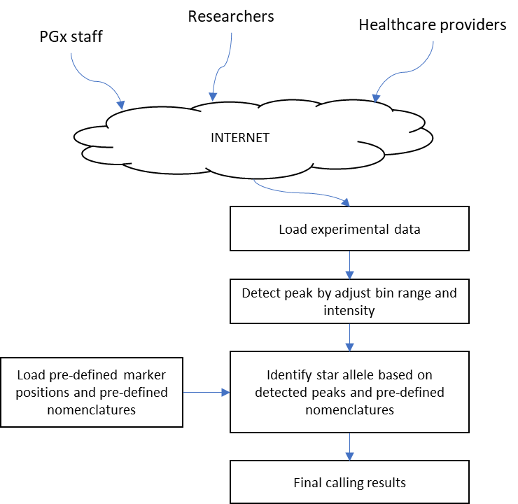

Figure 2. Main components of the genotype calling system for customized panel using single base extension method

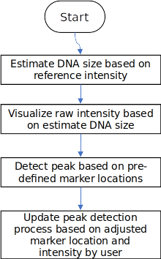Figure 3. displays the peak detection process

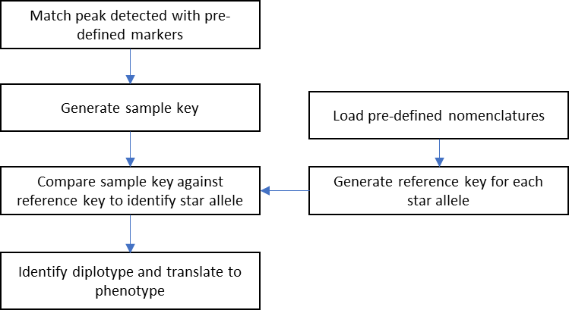

Figure 4. displays process of identifying star allele and translating diplotype into phenotype

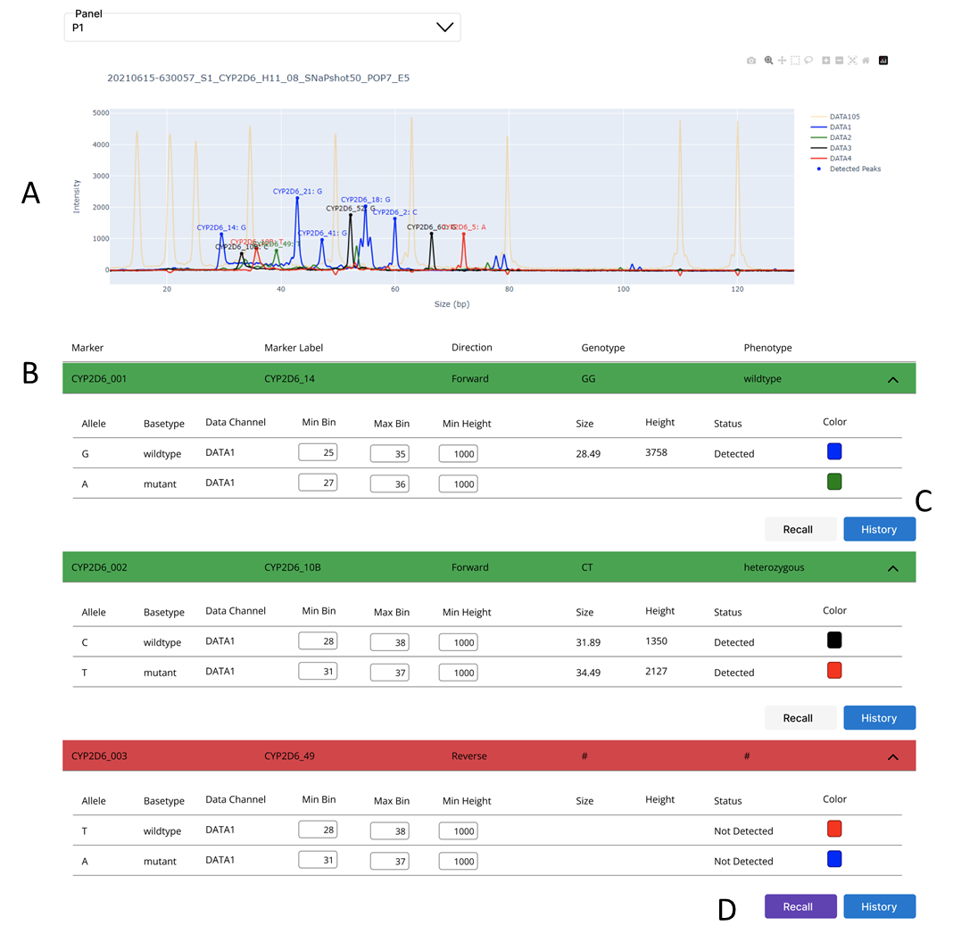

Figure 4. Prototype of the system implemented on web application; (A) raw intensity plot with detected markers; (B) genotype calling results of each marker in a panel; (C) history of each marker; (D) user can adjust data and re-identify genotype for a specific marker.

Figure 5. Diplotype and phenotype of target gene have been identified