A haplotype/phenotype translation system supporting PGx implementation

# Main idea

Single base primer extension method (SBE) is an effective and sensitive approach that can cover over 30 loci in a single reaction. As a cost-effective approach, this method has been widely used in many applications such as forensic, disease diagnosis, and pharmacogenetics (PGx).

Several studies confirmed the benefit of PGx testing in clinical settings. Identifying star-alleles (haplotypes) plays a role in PGx implementation. Many efforts have been developed such as PharmCAT, Stargazer, Astrolabe, and Aldy. However, most of them support only next-generation sequencing (NGS) data. Therefore, identifying haplotypes of a custom PGx testing remains challenges. Moreover, the genotyping software, (such as GeneMapper in our case), does not support matching star-alleles.

In a conventional way, PGx experts often have two options (Figure 1A); they manually identify the haplotypes from raw intensity data; or they export result from genotyping software and input into third-party tools to match haplotypes. Then they must manually manage the result to generate further reports. This way raises several following risks; firstly, manual processes increase human bias; secondly, it is hard to record and track the history of the whole process; finally, it requires more effort to manage the raw data, analyzed data, and reports.

To overcome these challenges, we developed a cloud system that integrates all processes (Figure 1B). Once PGx experts upload the raw intensity data to the system, they can do all further steps to identify genotype, quality control, and match haplotypes and phenotypes on this system. We also record all changes that support for any further tracking.

As an integration system, all history will be recorded and displayed transparently.

Because of customizable, Laboratory-developed test (LDT) genotyping panel is critical and cost-effective for PGx implementation in current setting. However, development of star allele calling function (genotyping) is needed for this panel to prevent human bias and increase efficiency.

Identification of haplotype (star allele)/phenotype of metabolizer plays an important role in PGx implementation. However, the genotyping software package for genotyping data (GeneMapper) does not include a module to identify star-allele based on the customized panel data.

In fact, it requires many extra steps from genotyping to haplotype/phenotype translation, and report generation since software and systems are separated.

We briefly describe here steps of the current approach and purpose integrated cloud system as a solution. For current approach, FSA file obtained from (AAAA) was processed and analyzed by GeneMapper. From that software, users can do many processes for genotype calling such as DNA sizing, adjust bin range and minimum intensity to detect the peak, after confirmation, user can get the plot intensity. There are two options for haplotype/phenotype translation.

Firstly, the user will see the intensity data and manually match haplotype/phenotype based on their experiences. Then the result will be manually input to the system to generate reports.

Secondly, the users can review the genotype calling data on the software. In this process, bin range and minimum intensity of each marker can be adjusted manually. The genotype calling result will then be exported as file after confirmation. The exported file can be loaded to star-allele calling tools to identify the haplotype/diplotype. Then the result can be automatically or manually put into the system to generate reports.

The two above options have some of the following drawbacks

It is difficult to track change and manage because of separate systems.

Increase the risk of human bias.

Difficult to maintain

Low efficiency

We proposed a cloud system that covers all these steps in one system.

We developed functions that support DNA sizing, automatically peak detection based on pre-defined bin range and minimum intensity. It also allows user to manual update these values and auto-update the genotype calling result.

Single base primer extension method (SBE) is an effective and sensitive approach that can cover over 30 loci in a single reaction. This method has been widely used in a broad range of applications such as forensic, molecular diagnosis, disease diagnosis, and pharmacogenetics/pharmacogenomics (PGx). SNaPhot multiplex system is a primer extension-based method for the analysis of single nucleotide polymorphism (SNPs)

Single base primer extension is a cost-effective approach

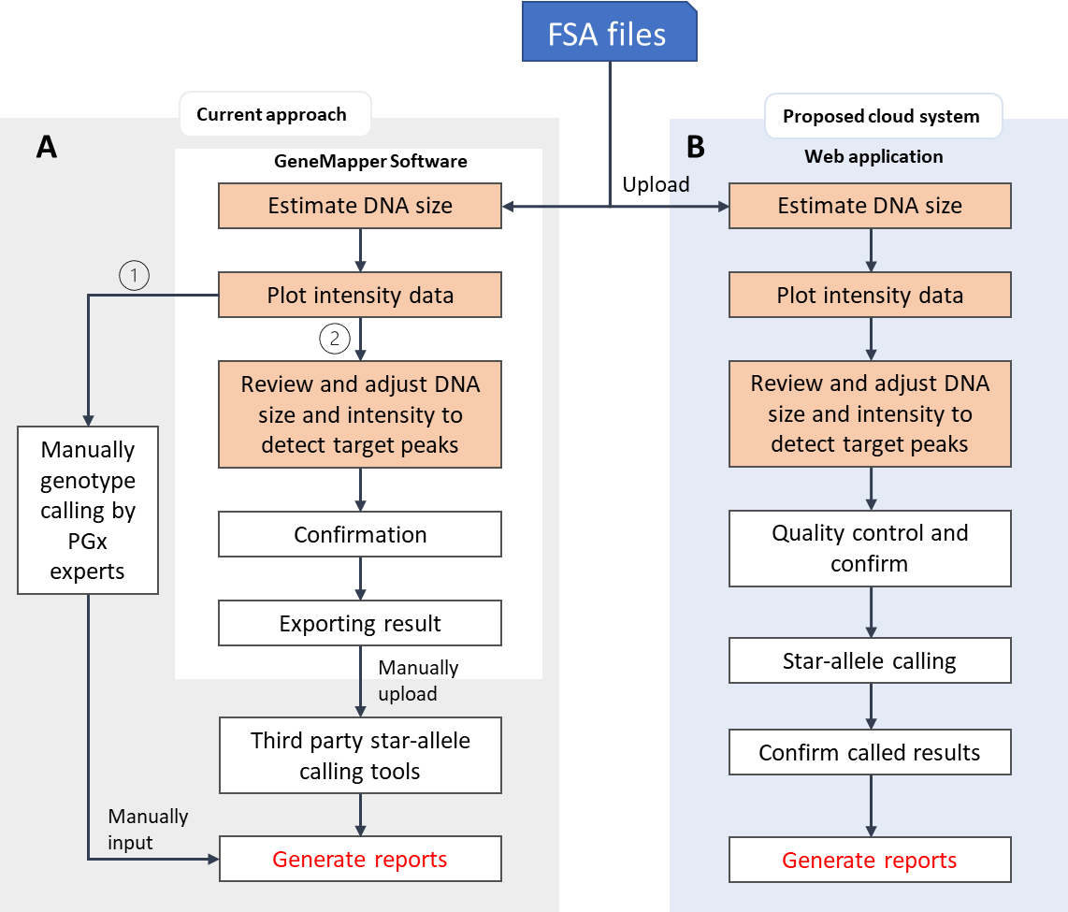

Figure 1. Overview about current approach and purpose solution

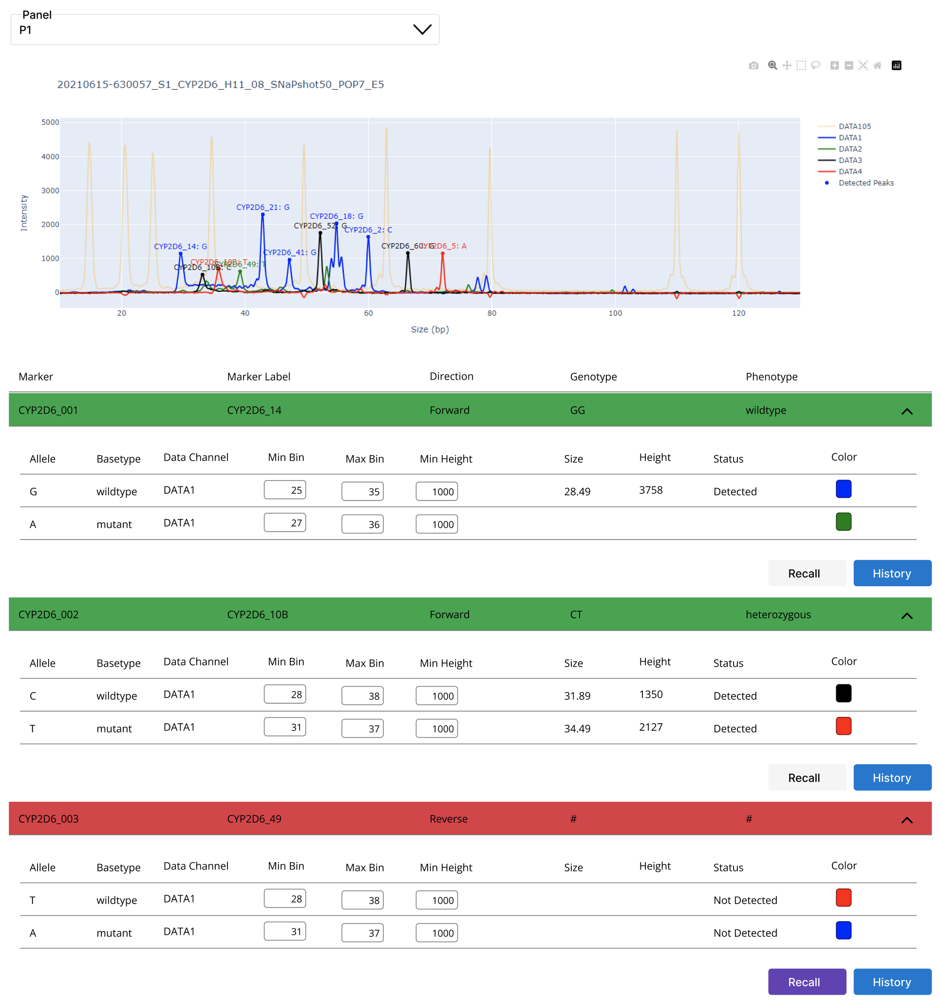

Figure 2. Prototype of the system implementing on web application; (A) raw intensity plot with detected marker; (B) present; (C) checking history by each marker; (D) user can adjust data and re-identify genotype for a specific marker.