**Home Poker Manager**

- **Objective** - App to help a host to manage a Holdem Poker Tournament game:

**Basic Functionalities**:

* Manage users (define security over participation in leagues)
* Manage leagues
* Manage tournaments schedule
  + Date
  + Late registration
  + Chips values and colors
  + Blinds structure – Levels/Time, next blinds
  + Payouts
  + Buy in, rebuy and add on value e total chips
  + Estimated players
  + Estimated rebuys
  + Estimated Add ons
  + Estimated Prize Pool
  + % payout for each position
  + Rules
  + Pre registration
* **Manage tournaments execution**
  + time control for tournaments
  + Registration, rebuys e addon
  + Prize Pool with % payouts for each position
  + Ranking
  + Chip count tracking
  + Average Stack
  + Players control (remaining and eliminated)
  + Break
  + Manual Adjustments (in case of error using elimination)
* For the MVP, the administration will be unique for all leagues and tournaments and for the future, improvements would be made to permit administration for each league with your own administrator.

**Administration functionalities:**

* **Deck of Chips:** Chips and values and colors: Create a deck with all chips available with values and colors.
  + Example: Red – 50, Blue – 100, White – 500 and Green – 1000
* Blinds structure: Values of small blind and big blind of each level.
  + Example: Level, Small, Big, Ante and duration (flag rebuy end, open reg, flag add on)
    - Level 1 - 50 – 100 – 0 – 15 minutes – open reg
    - Level 2 – 100 – 200 – 0 – 15 minutes – open reg
    - Level 3 – 150 – 300 – 0 – 15 minutes – open reg, Flag Rebuy end
    - Level 4 – 200 – 400 – 0 – 15 minutes – Flag add on
    - Level 5 – break – 15 minutes
    - Level 6 – 300 – 600 – 0 – 15 minutes
    - Level 7 – 400 – 800 – 0 – 15 minutes
    - Level 8 – 500 – 1000 – 50 – 15 minutes
    - Level 9 – 600 – 1200 – 50 – 15 minutes
* **Tournament model**
  + Choose deck of chips
  + Define Buy in value and Total of chips with suggested quantity of each (bagging and tagging)
  + Define Rebuy value and total of chips
  + Define Add on and total of chips
* **Tournament execution** 
  + Start clock and open functionalities
  + Example: <https://www.pokeratlas.com/table-captain> ( Advanced tournament technology)

Uma imagem contendo ao ar livre

Descrição gerada com muito alta confiança

* Execution screen should be available with a link for users logged in
* Clock starts using the first level and so on.
* Show level and value of blinds
* Calculate the time remaining of the actual level
* If registration is open until the level, calculate time remaining
* Calculate prize pool accordingly with the buy in, rebuy and add on
* Calculate total chips accordingly with the buy in, rebuy and add on
* Calculate Avg. Stack accordingly with the total chips/remaining players
* Show total of rebuys and add on
* Show next level blinds
* Show time of the blind and time remaining for the next break

**Functionalities during execution**

* Stop clock to solve problems
* Eliminate player and update ranking and Avg, Total and remaining
* Update total chips of 10 first players at anytime to show at ranking (used at adm discretion and it is not intended to be on line or accurate) – This information is different than the prize pool that is fixed. Normally update at breaks)
* Update ranking manually to permit deal between players

Screen 1 – home

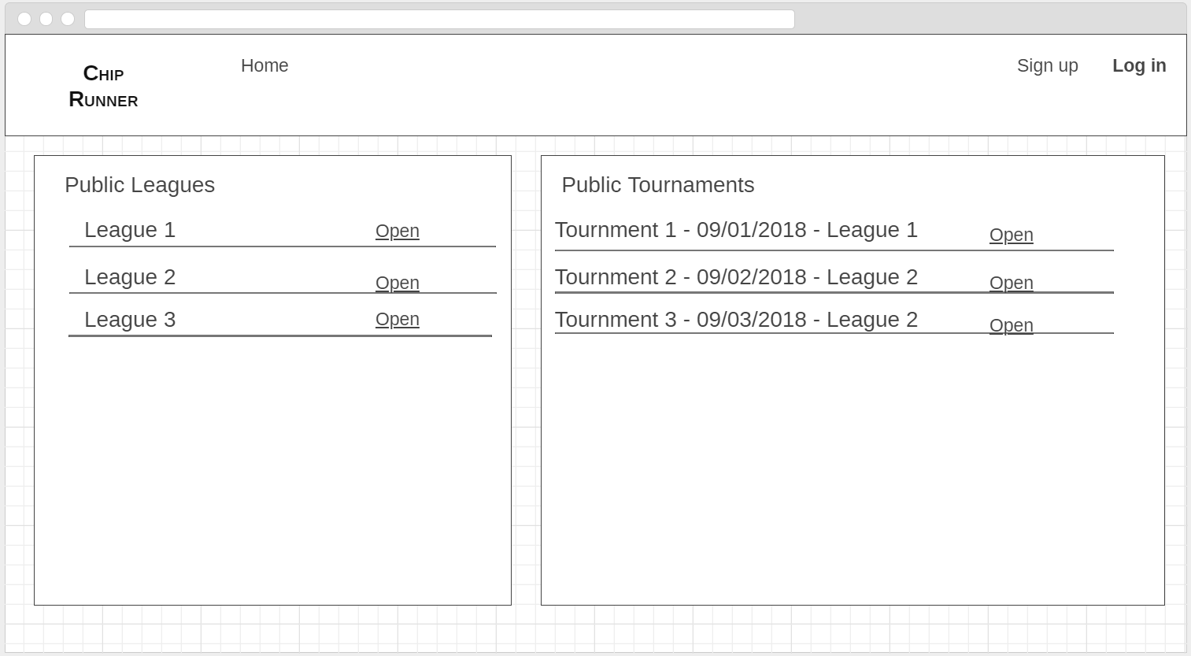

* Menu with login/sig in, logout
* Show scheduled and in execution public tournaments(link for registration should be logged). It should open screen with information of execution for tournaments already started and information for registering at scheduled tournaments
* Show APIs with available tournaments of official casinos or online games. (like <https://www.pokeratlas.com/poker-rooms/las-vegas-nevada> ) (nice to have)
* News about professional poker tournaments. (look for APIs) (nice to have)

Screen 2 – Login page

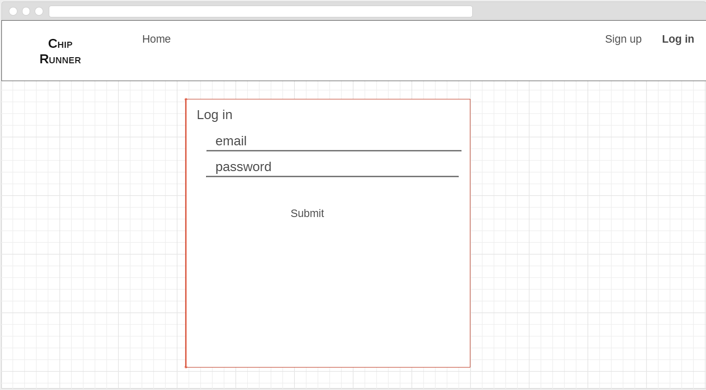

Screen 3 – Sign up page

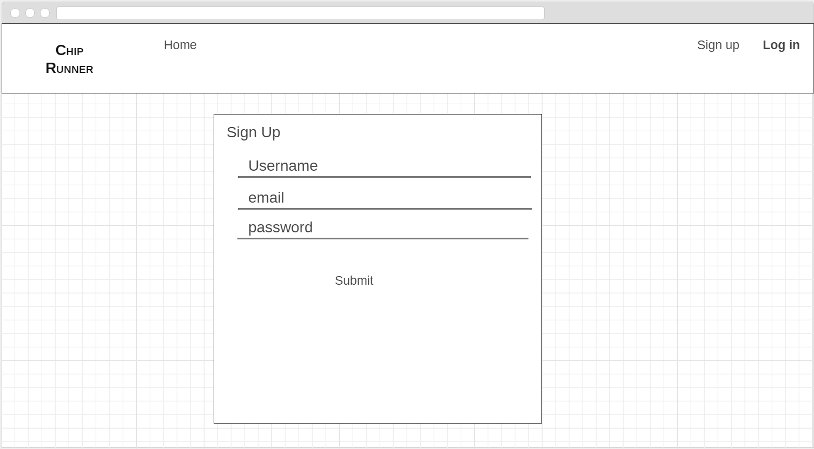

Screen 4 – home logged in as player user

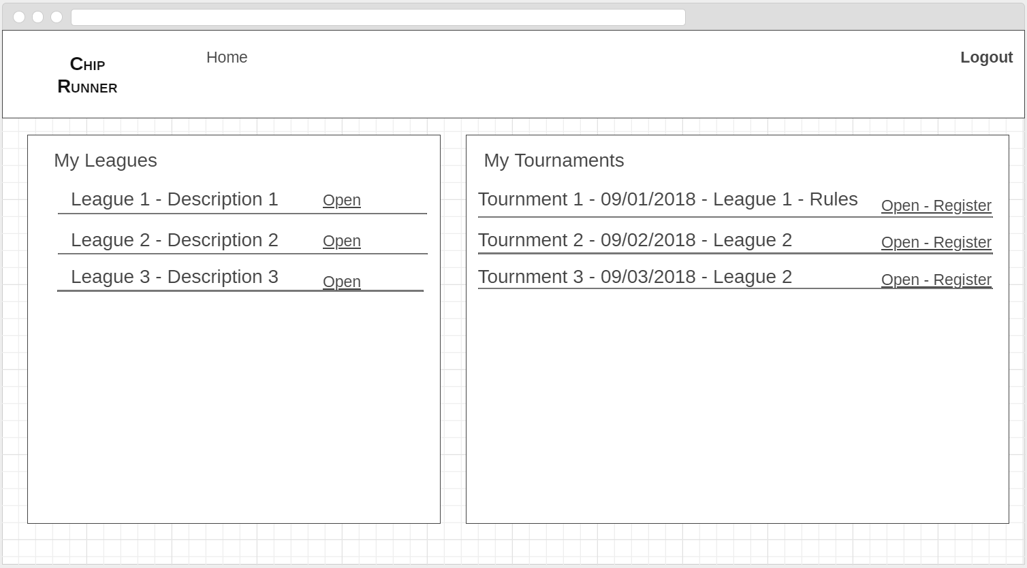

* Menu for ADM – logout(redirect to home). Cruds for league, tournament schedule, player, chip deck, blind structure, payout %
* Menu for user
  + Leagues of player with ranking
  + Tournaments scheduled with players registered and link for registration
  + Closed tournaments with history results
  + History of player games

Screen 4.1 – home logged in as admin user

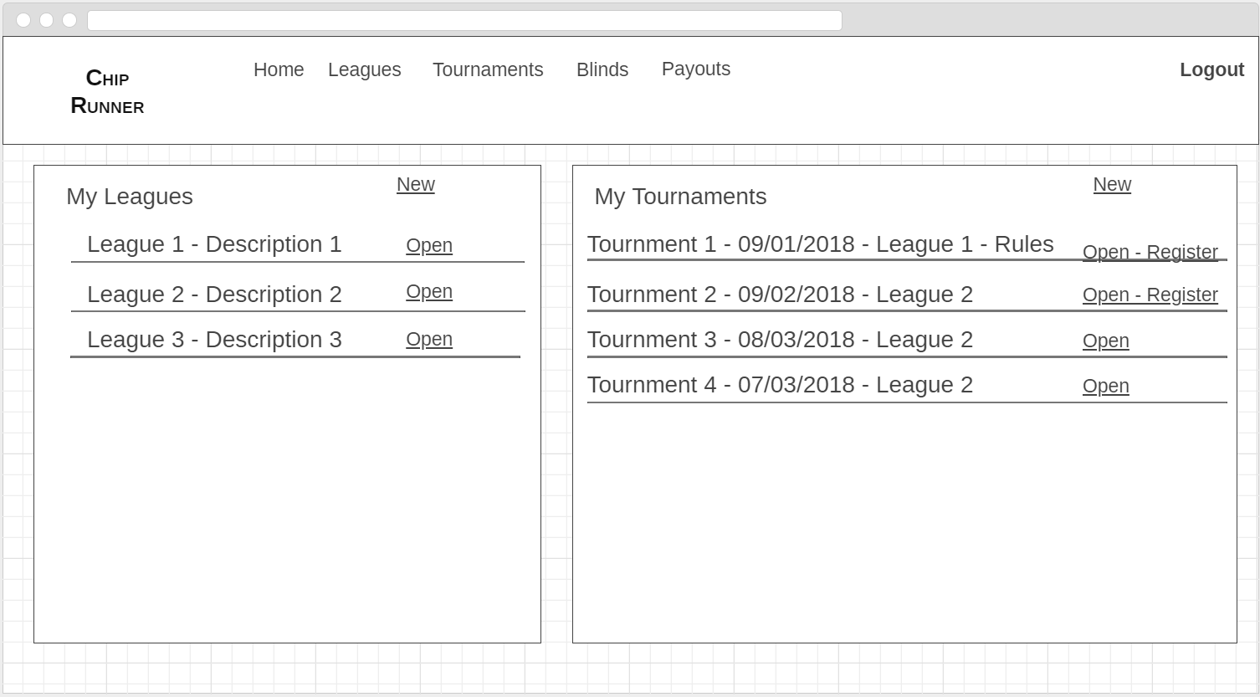

Screen 5 – CRUD for league

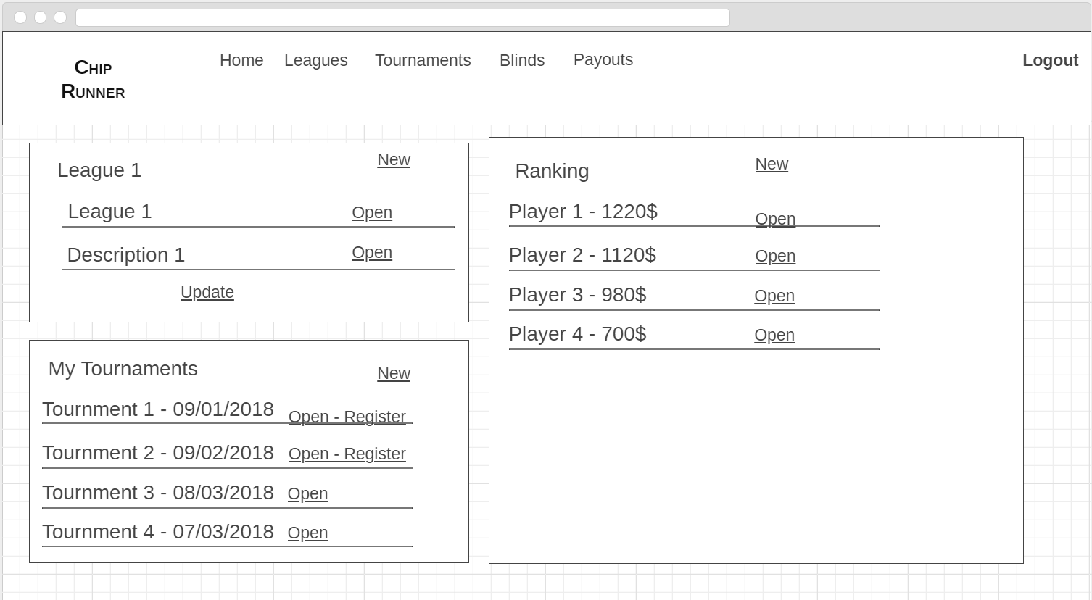

Screen 6 – Open Tounament – Choose league, chip deck, blind structure, payout % and type values for date, buy in, rebuy, add on etc…

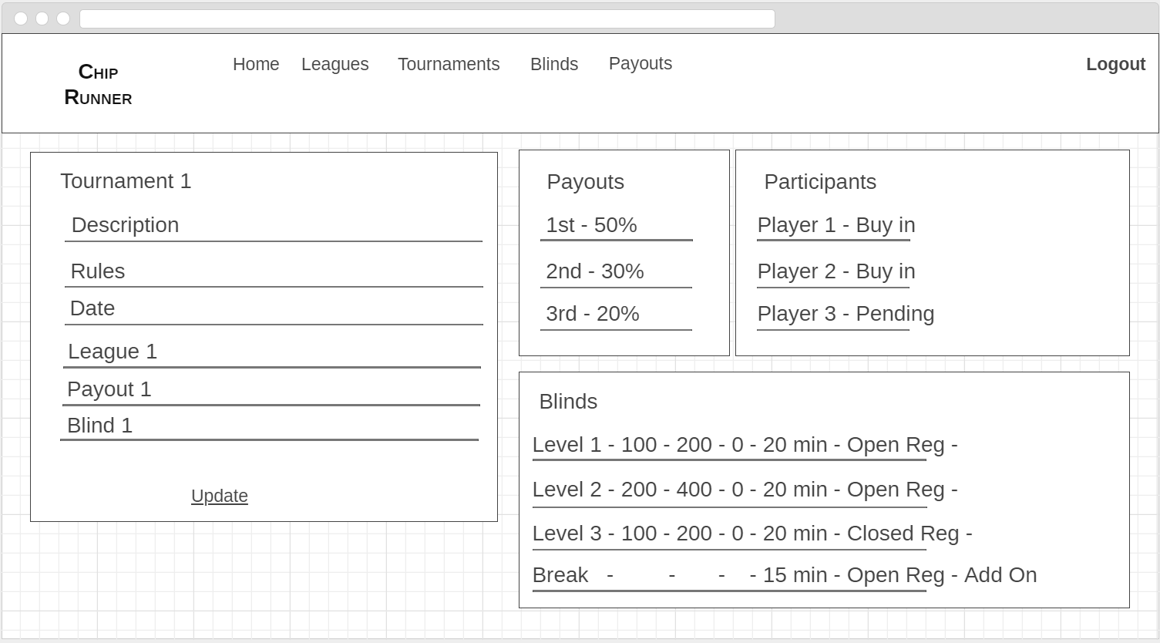

Screen 6.1 – Closed Tournament

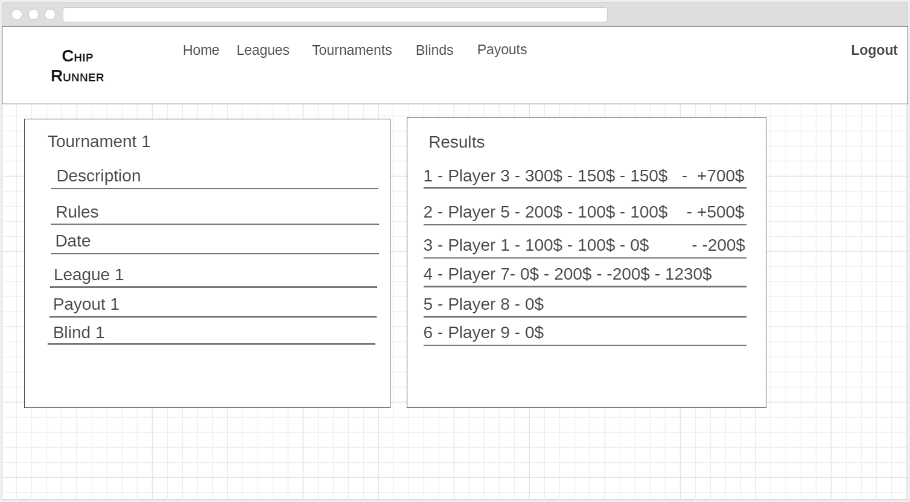

Screen 7 – Crud for Player (decide how to improve in the future to send invite for login)

Screen 8 – Crud for Chip Deck

Screen 9 – Crud for blind structure

Screen 10 – Crud for payout %

Screen 11

Tournament registration (link from tournaments scheduled)