USER Guide

TextFormatter

CSE360

Spring 2018

Jian Kang

Luis A Montano

Carlos Paz

**USER’S GUIDE**

**TABLE OF CONTENTS**

Page #

**1.0 Introduction ***************************************************1-0**

1.1 System Overview\*\*\*\*\*\*\*\*\*\*\*\*\*\*\*\*\*\*\*\*\*\*\*\*\*\*\*\*\*\*\*\*\*\*\*\*\*\*\*\*\*\*\***\***1-1

**2.0 Getting Started*************************************************2.0**

2.1 Installation **************************************************2.1

**3.0 User Interface**************************************************3.0**

3.1 Overview ***************************************************3.1

3.2 Description of Options ****************************************3.2

**4.0 Input and Output***********************************************4.0**

4.1 Sample Input/Output ******************************************4.1

4.2 Error/Messages **********************************************4.2

4.3 Other Problems **********************************************4.3

**Appendices\*\*\*\*\*\*\*\*\*\*\*\*\*\*\*\*\*\*\*\*\*\*\*\*\*\*\*\*\*\*\*\*\*\*\*\*\*\*\*\*\*\*\*\*\*\*\*\*\*\*\*\*\*\*\*\*\*\*\*\*\***

Sample Input Files **************************************** Appendix A

Sample Output Files ************************************** Appendix B

Glossary***********************************************AppendixC

1. **Introduction**
2. **Introduction**

Introduction is a comprehensive review of what service is the system meant to provide to the user.

**1.1 Overview**

TextFormatter is a system, which allows the user to format a text file (.txt extension). The system provides the user with the ability to format a text file of any size. It allows the user to format the text file either left justified or right justified. TextFormatter displays an analysis of the formatted text file, which includes number of words processed from the file, number of lines, number of lines removed, average words per line, and average line length. TextFormatter functions as a desktop application on any type of operating system.

1. **Getting Started**
2. **Getting Started**

This section walks you through on how to obtain and download TextFormatter on your computer.

**2.1 Introduction**

The latest version of TextFormatter is available for download from

<https://github.com/lamontano/CSE360_Project> and it is a .java file which

can be easily installed. For detailed instruction on how to install TextFormatter on personal computer, please refer to README file on the above website.

1. **User Interface**
2. **User Interface**

The user interface is meant to provide the user a simplified way to navigate through the application. Fig. 1 shows the user interface of TextFormatter. The user can choose the input file and output path. If the output path does not exist, we will automatically create it. The user has the option to specify whether to format the file left justified or right justified. To format the input file to the output path, simply click “Format File” button. We also provide a simple instruction about how to user TextFormatter on the user interface.

**3.1 Overview**

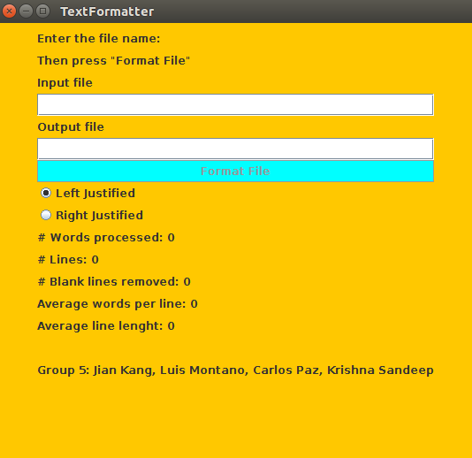

**Figure 1. User Interface**

**3.2 Description of Options**

The application consists of two text fields. The first one is where the user enters the name of the text file. The second text field the user enters the name of the preferred text file to write the output text. The button that it is contained in the user interface, after the user has entered the name of the input/output text file pressing the button will carry out the desired operation.

1. **Input and Output**
2. **Input and Outputs**

This section provides some samples of input and outputs for the system.

**4.1 Input and Outputs Samples**

**4.1.1 A text file with all characters in one line.**

**// left justified**

**Input text**

A text file is a kind of computer file that is structured as a sequence of lines of electronic text.

**Output text**

A text file is a kind of computer file that is structured as a sequence of lines of electronic text.

**Analysis**

# Words processed: 20

# Lines: 2

# Blank lines removed: 0

Average words/line: 10

Average line length: 49

**// right justified**

**Input text**

A text file is a kind of computer file that is structured as a sequence of lines of electronic text.

**Output text**

A text file is a kind of computer file that is structured as a sequence of lines of electronic text.

**Analysis**

# Words processed: 20

# Lines: 2

# Blank lines removed: 0

Average words/line: 10

Average line length: 49

* + 1. **A text file with different number of characters in lines.**

**// left justified**

**Input text**

A text file is a kind of computer file that is structured as a sequence of lines of electronic text.

**Output text**

A text file is a kind of computer file that is structured as a sequence of lines of electronic text.

**Analysis**

# Words processed: 20

# Lines: 2

# Blank lines removed: 0

Average words/line: 10

Average line length: 49

**// right justified**

**Input text**

A text file is a kind of computer file that is structured as a sequence of lines of electronic text.

**Output text**

A text file is a kind of computer file that is structured as a sequence of lines of electronic text.

**Analysis**

# Words processed: 20

# Lines: 2

# Blank lines removed: 0

Average words/line: 10

Average line length: 49

* + 1. **A text file with blank lines**

**// left justified**

**Input text**

A text file is a kind of computer file that is structured as a sequence of lines of electronic text.

**Output text**

A text file is a kind of computer file that is structured as a sequence of lines of electronic text.

**Analysis**

# Words processed: 20

# Lines: 2

# Blank lines removed: 2

Average words/line: 10

Average line length: 49

**// right justified**

**Input text**

A text file is a kind of computer file that is structured as a sequence of lines of electronic text.

**Output text**

A text file is a kind of computer file that is structured as a sequence of lines of electronic text.

**Analysis**

# Words processed: 20

# Lines: 2

# Blank lines removed: 1

Average words/line: 10

Average line length: 49

* + 1. **A text file with characters longer than 80 characters**

**// left justified**

**Input text**

A text file is a kind of computer file that is structured as a sequence of lines of electronic text.

**Output text**

A text file is a kind of computer file that is structured as a sequence of lines of electronic text.

**Analysis**

# Words processed: 11

# Lines: 2

# Blank lines removed: 0

Average words/line: 5.5

Average line length: 70.5

**// right justified**

**Input text**

A text file is a kind of computer file that is structured as a sequence of lines of electronic text.

**Output text**

A text file is a kind of computer file that is structured as a sequence of lines of electronic text.

**Analysis**

# Words processed: 11

# Lines: 2

# Blank lines removed: 0

Average words/line: 5.5

Average line length: 70.5

* 1. **Errors/Messages**

This section delivers some error samples for the system.

* + 1. ERROR: File type not supported.

4.2.2 ERROR: Output file path not specified.

4.2.3 ERROR: Input file does not exist.

4.2.4 ERROR: Error uploading file, please try again.

**4.3 Other problems**

4.3.1 Problem: Operating System compatibility. TextFormatter desktop application might not be compatible with the user operating system. TextFormatter is compatible with Windows, Mac and Linux type operating systems.

4.3.2 Problem: Not having enough space to install TextFormatter desktop application.

4.3.3 Problem: User enters file with the wrong extension. TextFormatter has been designed specifically for .txt extension files.

**Appendix A. Sample Input and Output Files**

Here, we provide the screenshots of sample input and output that mentioned in Section 4.

A.1 A text file with all characters in one line

Sample Input



Sample Output – Left Justified

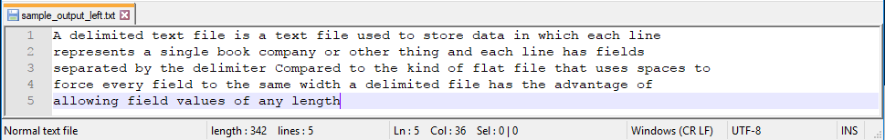

Sample Output – Right Justified



A.2. A text file with different number of characters in lines

Sample Input

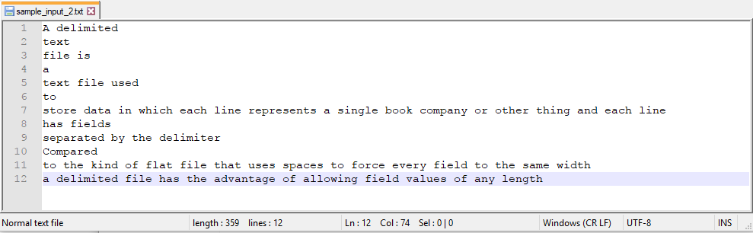

Sample Output – Left Justified



Sample Output – Right Justified



A.3. A text file with blank lines and tabs

Sample Input

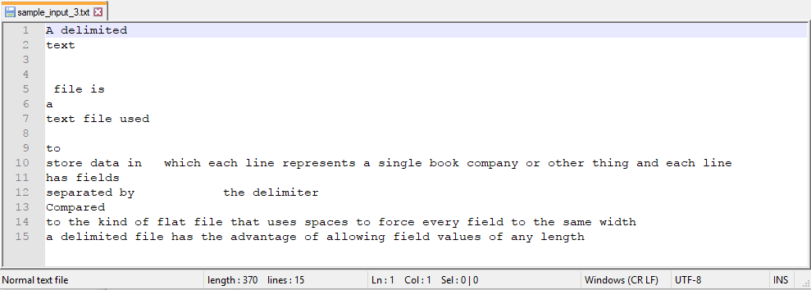

Sample Output – Left Justified



Sample Output – Right Justified



A.4. A text file with characters longer than 80 characters

Sample Input

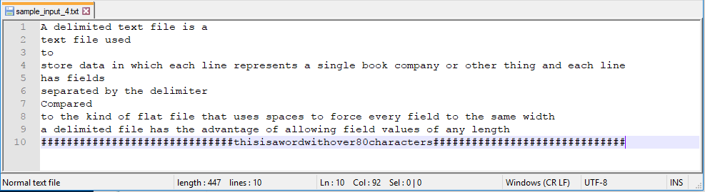

Sample Output – Left Justified

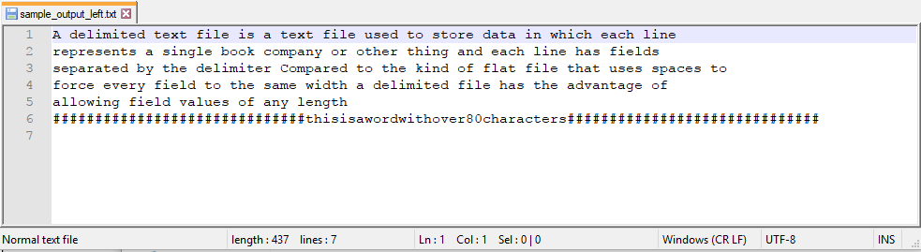

Sample Output – Right Justified

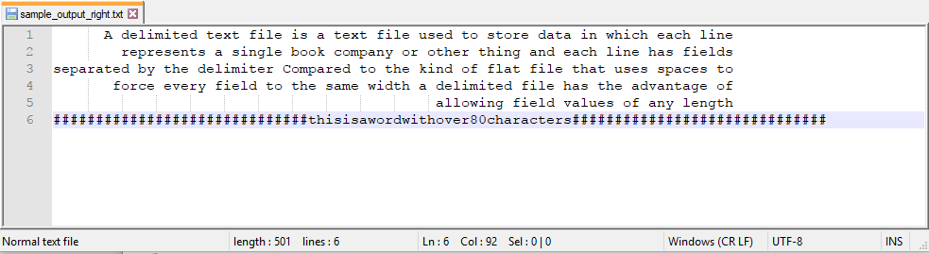

**Appendix B. Glossary**

TextFormatter: a system, which allows the user to format a text file (.txt extension).

Left justify: text is aligned along the left margin of the file.

Right justified: text is aligned along the right margin of the file.

File path: the general form of the name of a file or directory that specifies a unique location in a file system.

Desktop application: an application that runs stand-alone in a desktop or laptop computer.

Operating system compatibility: the ability that a particular software runs on different types of operating systems without having to be altered to do so.