USER’S

Guide

TextFormatter

CSE360

Spring 2018

Jian Kang

Luis A Montano

Carlos Paz

**USER’S GUIDE**

**TABLE OF CONTENTS**

Page #

**1.0 Introduction ***************************************************1-0**

1.1 System Overview\*\*\*\*\*\*\*\*\*\*\*\*\*\*\*\*\*\*\*\*\*\*\*\*\*\*\*\*\*\*\*\*\*\*\*\*\*\*\*\*\*\*\***\***1-1

**2.0 Getting Started*************************************************2.0**

2.1 Installation **************************************************2.1

**3.0 User Interface**************************************************3.0**

3.1 Overview ***************************************************3.1

3.2 Description of Options ****************************************3.2

**4.0 Input and Output***********************************************4.0**

4.1 Sample Input/Output ******************************************4.1

4.2 Error/Messages **********************************************4.2

4.3 Other Problems **********************************************4.3

**Appendices\*\*\*\*\*\*\*\*\*\*\*\*\*\*\*\*\*\*\*\*\*\*\*\*\*\*\*\*\*\*\*\*\*\*\*\*\*\*\*\*\*\*\*\*\*\*\*\*\*\***

Sample Input Files **************************************** Appendix A

Sample Output Files ************************************** Appendix B

Glossary***********************************************Appendix C

1. **Introduction**
2. **Introduction**

Introduction is a comprehensive review of what service is the system meant to provide to the user.

**1.1 Overview**

TextFormatter is a system, which allows the user to format a text file (.txt extension). The system provides the user with the ability to format a text file of any size. TextFormatter displays an analysis of the formatted text file, which includes right, or left justified output, number of words processed from the file, number of lines, number of lines removed, average words per line, and average line length. TextFormatter functions as a desktop application on any type of operating system.

1. **Getting Started**
2. **Getting Started**

Getting started section walks you though on how to obtain and download TextFormatter on your computer.

**2.1 Introduction**

The latest version of TextFormatter is available for download from

<https://github.com/lamontano/CSE360_Project> and it is a .java file which

can be easily installed. For detailed instruction on how to install TextFormatter on personal computer, please refer to read me file on the above website.

1. **User Interface**
2. **User Interface**

The user interface is meant to provide the user a simplified way to navigate through the application.

**3.1 Overview**

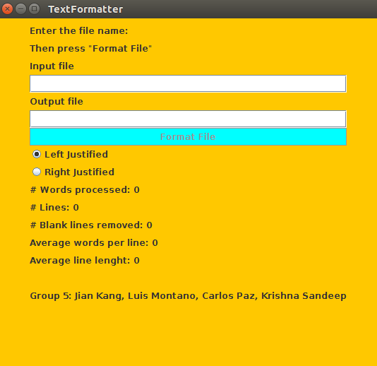

**Figure 1. User Interface**

**3.2 Description of Options**

The application consists of two text fields. The first one is where the user enters the name of the text file or the path to the text file. The second text field the user enters the name of the preferred text file to write the output text. The button that it is contained in the user interface, after the user has entered the name of the input/output text file pressing the button will carry out the desired operation.

1. **Input and Output**
2. **Input and Outputs**

This section provides some samples of input and outputs for the system.

**4.1 Input and Outputs Samples**

**4.1.1 A text file with all characters in one line.**

**// left justified**

**Input text**

A text file is a kind of computer file that is structured as a sequence of lines of electronic text.

**Output text**

A text file is a kind of computer file that is structured as a sequence of lines of electronic text.

**Analysis**

# Words processed: 20

# Lines: 2

# Blank lines removed: 0

Average words/line: 10

Average line length: 49

**// right justified**

**Input text**

A text file is a kind of computer file that is structured as a sequence of lines of electronic text.

**Output text**

A text file is a kind of computer file that is structured as a sequence of lines of electronic text.

**Analysis**

# Words processed: 20

# Lines: 2

# Blank lines removed: 0

Average words/line: 10

Average line length: 49

* + 1. **A text file with different number of characters in lines.**

**// left justified**

**Input text**

A text file is a kind of computer file that is structured as a sequence of lines of electronic text.

**Output text**

A text file is a kind of computer file that is structured as a sequence of lines of electronic text.

**Analysis**

# Words processed: 20

# Lines: 2

# Blank lines removed: 0

Average words/line: 10

Average line length: 49

**// right justified**

**Input text**

A text file is a kind of computer file that is structured as a sequence of lines of electronic text.

**Output text**

A text file is a kind of computer file that is structured as a sequence of lines of electronic text.

**Analysis**

# Words processed: 20

# Lines: 2

# Blank lines removed: 0

Average words/line: 10

Average line length: 49

* + 1. **A text file with blank lines**

**// left justified**

**Input text**

A text file is a kind of computer file that is structured as a sequence of lines of electronic text.

**Output text**

A text file is a kind of computer file that is structured as a sequence of lines of electronic text.

**Analysis**

# Words processed: 20

# Lines: 2

# Blank lines removed: 2

Average words/line: 10

Average line length: 49

**// right justified**

**Input text**

A text file is a kind of computer file that is structured as a sequence of lines of electronic text.

**Output text**

A text file is a kind of computer file that is structured as a sequence of lines of electronic text.

**Analysis**

# Words processed: 20

# Lines: 2

# Blank lines removed: 1

Average words/line: 10

Average line length: 49

* + 1. **A text file with characters longer than 80 characters**

**// left justified**

**Input text**

A text file is a kind of computer file that is structured as a sequence of lines of electronic text.

**Output text**

A text file is a kind of computer file that is structured as a sequence of lines of electronic text.

**Analysis**

# Words processed: 11

# Lines: 2

# Blank lines removed: 0

Average words/line: 5.5

Average line length: 70.5

**// right justified**

**Input text**

A text file is a kind of computer file that is structured as a sequence of lines of electronic text.

**Output text**

A text file is a kind of computer file that is structured as a sequence of lines of electronic text.

**Analysis**

# Words processed: 11

# Lines: 2

# Blank lines removed: 0

Average words/line: 5.5

Average line length: 70.5

* 1. **Errors/Messages**

This section delivers some error samples for the sytem.

* + 1. ERROR: File type not supported.

4.2.2 ERROR: File path not found.

4.2.3 ERROR: File does not exist.

4.2.4 ERROR: Error uploading file, please try again.

**4.3 Other problems**