USER GUIDE

TextFormatter

CSE360 Spring 2018

Jian Kang

Luis A Montano

Carlos Paz

Venkata Mangati

**TABLE OF CONTENTS**

Page #

1 INTRODUCTION 2

1.1 System Overview 3

2 GETTING STARTED 4

2.1 System Requirements 5

2.2 Download TextFormatter 5

3. USER INTERFACE 6

3.1 User Interface Overview 7

3.2 Description of Options 7

4. INPUT AND OUTPUT 8

4.1 A Text file with All Characters in One Line 9

4.2 A Text file with Different Number of Character in Lines 9

4.3 A Text file with Blank Lines and Tabs 11

4.4 A Text file with Words Longer Than 80 Characters 12

4.5 Errors/Messages 13

4.6 Other Problems 13

APPENDIX 15

A Sample Input and Output Files 16

B Glossary 21

**1 INTRODUCTION**

Introduction section is a comprehensive review of what services the system meant to provide to the user.

## 1.1 System Overview

TextFormatter is a system, which allows the user to format a text file (.txt extension). The system provides the user with the ability to format a text file of any size.

The system allows the user to format the file in three ways:

1. Left justified
2. Right justified
3. Full justification

Likewise, TextFormatter provides the user with the following options:

1. User-defined line length
2. Single / double spacing

Further, TextFormatter displays an analysis of the formatted text file. The statistics for analysis are listed below:

1. Number of words processed.
2. Number of lines in the output file.
3. Number of blank lines removed.
4. Average words per line in the output file.
5. Average line length in the output file.

**2 GETTING STARTED**

This section shows a series of steps on how to obtain and download TextFormatter on your computer.

## 2.1 System Requirements

TextFormatter is a program written in Java. The user is able to use TextFormatter on any types of operating systems, including Windows, Mac OS X, UNIX, Linux, etc. Before you run TextFormatter, please make sure you have Java installed on your computer.

## 2.2 Download TextFormatter

TextFormatter is an open source program. The latest version of TextFormatter is available for download from <https://github.com/lamontano/CSE360_Project>. It is a Java program that can be easily installed. For detailed instruction on how to install TextFormatter on your computer, please refer to README file on the above website.

**3 USER INTERFACE**

The user interface is meant to provide the user a simplified way to navigate through the application.

## 3.1 User Interface Overview

Fig. 1 shows the user interface of TextFormatter. The user can select the input and output files. If the output file does not exist, the system will automatically create it. The user also has the option to specify whether to format the file left justified, right justified, or full justification. The user can specify the line length as well. Further, the user can also choose between double space and single space. After the user has selected the desired options, pressing the *Format File* button will carry out the desired operations. The statistics for format analysis is clearly shown on the user interface. The system also provides a simple instruction on how to use TextFormatter.

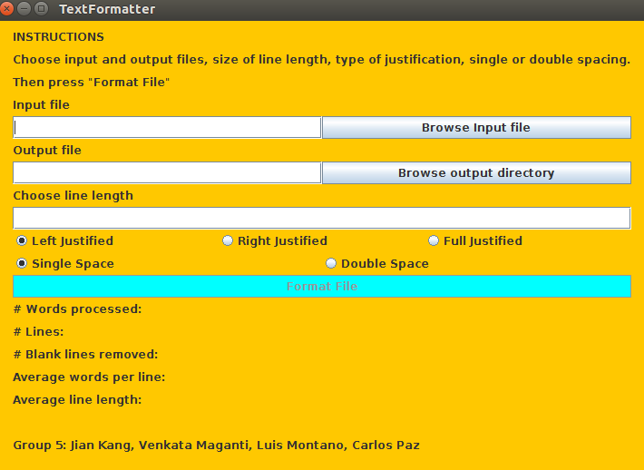

**Figure 1. User Interface of TextFormatter**

## 3.2 Description of Options

The application consists of three fields. The first one, named *Input file*, is where the user select the name of the input text file. The second field, named *Output file*, is the place where the user selects the preferred path to write the output text. The third one is where the user can specify the preferred line length (recommended ~ 80 characters). There are three options to choose the way the user wants to format the file (*left justified*, *right justified, full justified*). The default choice is set to be *left justified*. Once the user presses the Format File button, the system will start formatting the text in the input file to the output file.

**4 INPUT AND OUTPUT**

This section provides some examples of input and output files for the TextFormatter, as well as errors and problems the user may encounter in using TextFormatter. The screenshots of these inputs and outputs can be found in Appendix A.

## 4.1 A Text file with All Characters in One Line

### 4.1.1 Left Justified

1. **Input Text**

A delimited text file is a text file used to store data in which each line represents a single book company or other thing and each line has fields separated by the delimiter Compared to the kind of flat file that uses spaces to force every field to the same width a delimited file has the advantage of allowing field values of any length

1. **Output Text**

A delimited text file is a text file used to store data in which each line

represents a single book company or other thing and each line has fields

separated by the delimiter Compared to the kind of flat file that uses spaces to

force every field to the same width a delimited file has the advantage of

allowing field values of any length

1. **Analysis**

Number of words processed: 64

Number of lines: 5

Number of blank lines removed: 0

Average words per line: 12.8

Average line length: 10.8

### 4.1.2 Right Justified

1. **Input Text**

A delimited text file is a text file used to store data in which each line represents a single book company or other thing and each line has fields separated by the delimiter Compared to the kind of flat file that uses spaces to force every field to the same width a delimited file has the advantage of allowing field values of any length

1. **Output Text**

A delimited text file is a text file used to store data in which each line

represents a single book company or other thing and each line has fields

separated by the delimiter Compared to the kind of flat file that uses spaces to

force every field to the same width a delimited file has the advantage of

allowing field values of any length

1. **Analysis**

Number of words processed: 64

Number of lines: 5

Number of blank lines removed: 0

Average words per line: 12.8

Average line length: 10.8

## 4.2 A Text file with Different Number of Character in Lines

### 4.2.1 Left Justified

1. **Input Text**

A delimited text file is a text file used to store data in which each line represents a single book company or other thing, and each line has fields separated by the delimiter. Compared

to the kind of flat file that uses spaces to force every field to the same width

a delimited file has the advantage of allowing field values of any length

1. **Output Text**

A delimited text file is a text file used to store data in which each line

represents a single book company or other thing and each line has fields

separated by the delimiter Compared to the kind of flat file that uses spaces to

force every field to the same width a delimited file has the advantage of

allowing field values of any length

1. **Analysis**

Number of words processed: 64

Number of lines: 5

Number of blank lines removed: 0

Average words per line: 12.8

Average line length: 10.8

### 4.2.2 Right Justified

1. **Input Text**

A delimited text file is a text file used to store data in which each line represents a single book company or other thing and each line has fields separated by the delimiter. Compared

to the kind of flat file that uses spaces to force every field to the same width

a delimited file has the advantage of allowing field values of any length

1. **Output Text**

A delimited text file is a text file used to store data in which each line

represents a single book company or other thing and each line has fields

separated by the delimiter Compared to the kind of flat file that uses spaces to

force every field to the same width a delimited file has the advantage of

allowing field values of any length

1. **Analysis**

Number of words processed: 64

Number of lines: 5

Number of blank lines removed: 0

Average words per line: 12.8

Average line length: 10.8

## 4.3 A Text file with Blank Lines and Tabs

### 4.3.1 Left Justified

1. **Input Text**

A delimited text file is a text file used to store data in which each line represents a single book company or other thing and each line has fields separated by the delimiter.

Compared to the kind of flat file that uses spaces to force every field to the same width

a delimited file has the advantage of allowing field values of any length.

1. **Output Text**

A delimited text file is a text file used to store data in which each line

represents a single book company or other thing and each line has fields

separated by the delimiter Compared to the kind of flat file that uses spaces to

force every field to the same width a delimited file has the advantage of

allowing field values of any length

1. **Analysis**

Number of words processed: 64

Number of lines: 5

Number of blank lines removed: 0

Average words per line: 12.8

Average line length: 10.8

### 4.3.2 Right Justified

1. **Input Text**

A delimited text file is a text file used to store data in which each line represents a single book company or other thing and each line has fields separated by the delimiter. Compared to the kind of flat file that uses spaces to force every field to the same width a delimited file has the advantage of allowing field values of any length

1. **Output Text**

A delimited text file is a text file used to store data in which each line

represents a single book company or other thing and each line has fields

separated by the delimiter Compared to the kind of flat file that uses spaces to

force every field to the same width a delimited file has the advantage of

allowing field values of any length

1. **Analysis**

Number of words processed: 64

Number of lines: 5

Number of blank lines removed: 0

Average words per line: 12.8

Average line length: 10.8

## 4.4 A Text file with Words Longer Than 80 Characters

### 4.4.1 Left Justified

1. **Input Text**

A delimited text file is a text file used to store data in which each line represents a single book company or other thing and each line has fields separated by the delimiter

Compared to the kind of flat file that uses spaces to force every field to the same width

a delimited file has the advantage of allowing field values of any length

##############################thisisawordwithover80characters##############################

1. **Output Text**

A delimited text file is a text file used to store data in which each line

represents a single book company or other thing and each line has fields

separated by the delimiter Compared to the kind of flat file that uses spaces to

force every field to the same width a delimited file has the advantage of

allowing field values of any length

##############################thisisawordwithover80characters##############################

1. **Analysis**

Number of words processed: 65

Number of lines: 6

Number of blank lines removed: 0

Average words per line: 10.833333333333333

Average line length: 70.833333333333333

### 4.4.2 Right Justified

1. **Input Text**

A delimited text file is a

text file used

to

store data in which each line represents a single book company or other thing and each line

has fields

separated by the delimiter

Compared

to the kind of flat file that uses spaces to force every field to the same width

a delimited file has the advantage of allowing field values of any length

##############################thisisawordwithover80characters##############################

1. **Output Text**

A delimited text file is a text file used to store data in which each line

represents a single book company or other thing and each line has fields

separated by the delimiter Compared to the kind of flat file that uses spaces to

force every field to the same width a delimited file has the advantage of

allowing field values of any length

##############################thisisawordwithover80characters##############################

1. **Analysis**

Number of words processed: 65

Number of lines: 6

Number of blank lines removed: 0

Average words per line: 10.833333333333333

Average line length: 70.833333333333333

## 4.5 Errors/Messages

### 4.5.1 File Type Not Supported

TextFormatter only supports text files with .txt extension at present. If the user selects a file with other extensions, the system will raise an error with message “ERROR: File type not supported”.

### 4.5.2 Output File Path Not Specified

TextFormatter needs the user to specify the output path before formatting the input file. If the path is not declared before pressing the *Format File* button, the system will raise an error with message “ERROR: Output file path not specified”.

### 4.5.3 Input File Not Found

If the user does not select an input file, TextFormatter disables the *Format File* button. However, if the file is deleted or moved to other locations after the user selects the input file but before pressing the button, the system is unable to find the input file, then it will raise an error with message “ERROR: Input file not found”.

### 4.2.4 Error Uploading File

During uploading the file, system failures or other problems may occur. And file uploading may not be successful. If the above situation occurs, TextFormatter will raise an error with message “ERROR: Error uploading file, please try again”.

## 4.6 Other Problems

### 4.6.1 Operating System Compatibility

TextFormatter is a Java program. In most cases, the program is able to run on any types of operating systems that supports Java, which includes Windows, Mac OS X, UNIX, Linux, etc. However, if there is an operating system that do not supports Java, TextFormatter may not be able to run. To avoid this problem, please make sure your operating system supports Java before you download and install TextFormatter.

### 4.6.2 No Enough Space to Install

TextFormatter does not require much space for the user to install. But there could be a chance that the user does not have enough space to install the program. To avoid this problem, please make sure your disk has enough space to download and install TextFormatter.

**APPENDIX**

# SAMPLE INPUT AND OUTPUT FILES

Here we provide the screenshots of sample input and output that mentioned in Section 4.

## A.1 A Text file with All Characters in One Line

### A.1.1 Left Justified

Below are the sample input and output files in left justified format.



**Figure 2. Sample Input File**

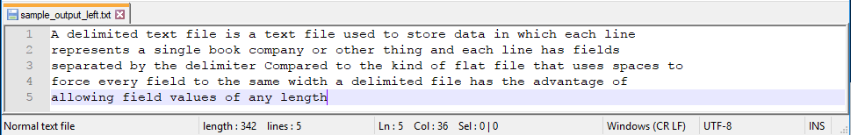

**Figure 3. Sample Output File**

### A.1.2 Right Justified

Below are the sample input and output files in right justified format.



**Figure 4. Sample Input File**

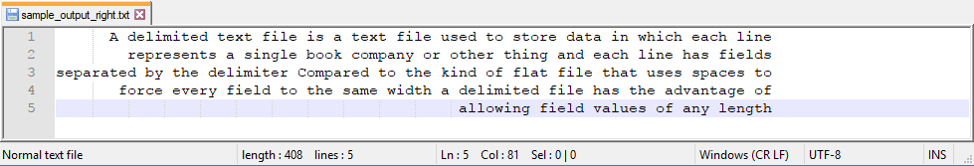 **Figure 5. Sample Output File**

## A.2 A Text file with Different Number of Character in Lines

### A.2.1 Left Justified

Below are the sample input and output files in left justified format.

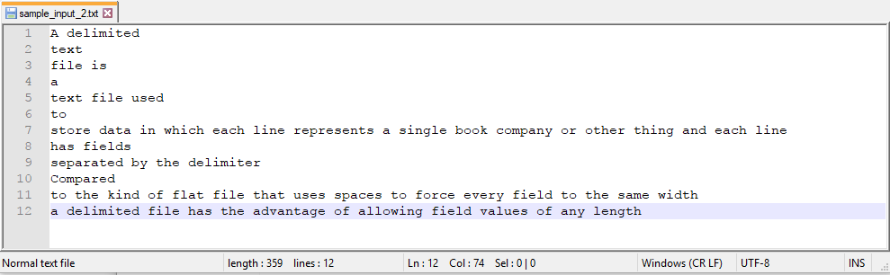

**Figure 6. Sample Input File**

 **Figure 7. Sample Output File**

### A.2.2 Right Justified

Below are the sample input and output files in right justified format.



**Figure 8. Sample Input File**

 **Figure 9. Sample Output File**

## A.3 A Text file with Blank Lines and Tabs

### A.3.1 Left Justified

Below are the sample input and output files in left justified format.

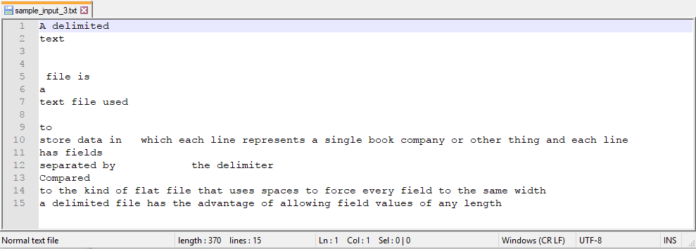

**Figure 10. Sample Input File**

**Figure 11. Sample Output File**

### A.3.2 Right Justified

Below are the sample input and output files in right justified format.



**Figure 12. Sample Input File**

**Figure 13. Sample Output File**

## A.4 A Text file with Words Longer Than 80 Characters

### A.4.1 Left Justified

Below are the sample input and output files in left justified format.

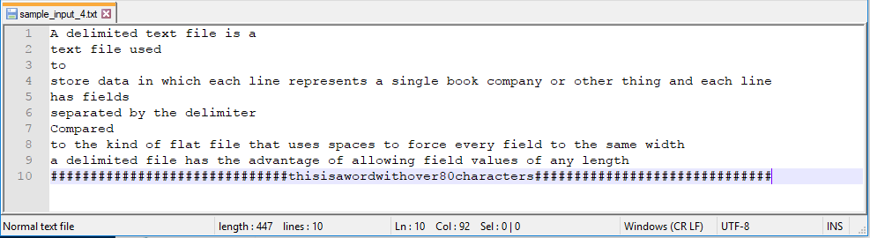

**Figure 14. Sample Input File**

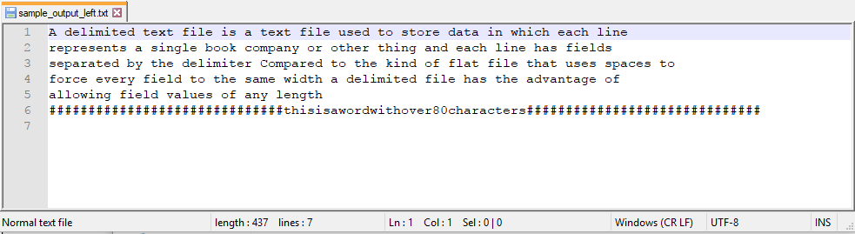**Figure 15. Sample Output File**

### A.4.2 Right Justified

Below are the sample input and output files in right justified format.



**Figure 16. Sample Input File**

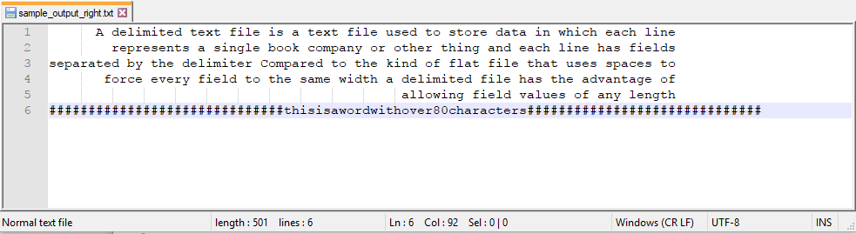 **Figure 17. Sample Output File**

# GLOSSARY

**TextFormatter**: a system, which allows the user to format a text file (.txt extension).

**Left justify**: text is aligned along the left margin of the file.

**Right justify**: text is aligned along the right margin of the file.

**File path**: the general form of the name of a file or directory that specifies a unique location in a file system.

**Desktop application**: an application that runs stand-alone in a desktop or laptop computer.

**Operating system compatibility**: the ability that a particular software runs on different types of operating systems without having to be altered to do so.