USER GUIDE

TextFormatter

CSE360 Spring 2018

Jian Kang

Venkata Mangati

Luis A Montano

Carlos Paz

**TABLE OF CONTENTS**

Page #

1 INTRODUCTION 2

1.1 System Overview 3

2 GETTING STARTED 4

2.1 System Requirements 5

2.2 Download TextFormatter 5

3. USER INTERFACE 6

3.1 User Interface Overview 7

3.2 Description of Options 7

4. INPUT AND OUTPUT 8

4.1 A Text file with All Characters in One Line 9

4.2 A Text file with Different Number of Character in Lines 11

4.3 A Text file with Blank Lines and Tabs 14

4.4 A Text file with Words Longer Than 80 Characters 16

4.5 Errors/Messages 19

4.6 Other Problems 21

APPENDIX 22

A Sample Input and Output Files 23

B Glossary 34

**1 INTRODUCTION**

Introduction contains a general overview of the service that TextFormatter is meant to provide to the user.

Besides, this user guide contains four more sections: Getting Started, User Interface, Input and Output, and Appendix. Getting Started section provides the user with details on how to obtain and install TextFormatter on the user’s computer. A pictorial representation of TextFormatter and its components once installed on the user’s computer is shown in User Interface section. Examples of what the input TextFormatter expects and the output it provides are offered in Section 4. Input and Output, as well as errors that can be encountered while using TextFormatter. Appendix section provides the user with text file sample inputs and outputs that can be tested once TextFormatter has been installed. Further, this section contains glossary of words that are used throughout the user’s guide.

## 1.1 System Overview

TextFormatter is a system, which allows the user to format a text file (.txt extension). The system provides the user with the ability to format a text file of any size.

The system allows the user to format the file in three ways:

1. Left justification
2. Right justification
3. Full justification

Likewise, TextFormatter provides the user with the following options:

1. User-defined line length
2. Single / double spacing

Further, TextFormatter displays an analysis of the formatted text file. The statistics for analysis are listed below:

1. Number of words processed.
2. Number of lines in the output file.
3. Number of blank lines removed.
4. Number of spaces added.
5. Average words per line in the output file.
6. Average line length in the output file.

**2 GETTING STARTED**

This section shows a series of steps on how to obtain and download TextFormatter on your computer.

## 2.1 System Requirements

TextFormatter is a program written in Java. The user is able to use TextFormatter on any types of operating systems, including Windows, Mac OS X, UNIX, Linux, etc. Before you run TextFormatter, please make sure you have Java installed on your computer.

## 2.2 Download TextFormatter

TextFormatter is an open source program. The latest version of TextFormatter is available for download from <https://github.com/lamontano/CSE360_Project>. It is a Java program that can be easily installed. For detailed instruction on how to install TextFormatter on your computer, please refer to README file on the above website.

**3 USER INTERFACE**

The user interface is meant to provide the user a simplified way to navigate through the application.

## 3.1 User Interface Overview

Fig. 1 shows the user interface of TextFormatter. The user can select the input and output files. If the output file does not exist, the system will automatically create it. The user also has the option to specify whether to format the file left justified, right justified, or full justification. The user can specify the line length as well. Further, the user can also choose between double space and single space. After the user has selected the desired options, pressing the *Format File* button will carry out the desired operations. The statistics for format analysis is clearly shown on the user interface. The system also provides a simple instruction on how to use TextFormatter.

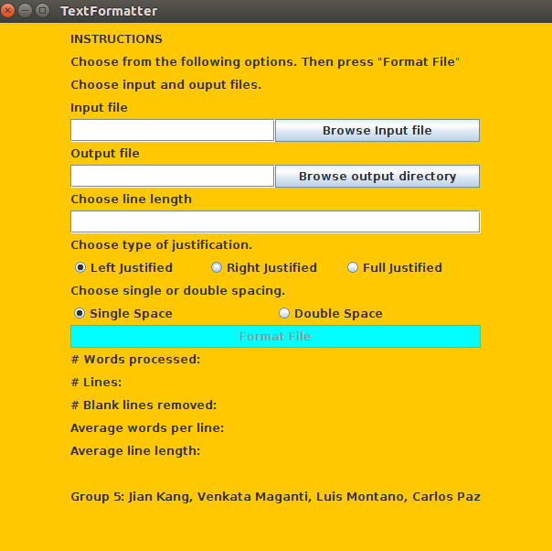

**Figure 1. User Interface of TextFormatter**

## 3.2 Description of Options

The application consists of three fields. The first one, named *Input file*, is where the user selects the name of the input text file. The second field, named *Output file*, is the place where the user selects the preferred path to write the output text. The third one is where the user can specify the preferred line length (recommended ~ 80 characters). There are three options to choose the way the user wants to format the file (*left justified*, *right justified, full justified*). The default choice is set to be *left justified*. Additionally, there are two options where the user can decide the spacing of the output file, either *single space* or *double space*. The default choice is set to be *single space*. Once the user presses the *Format File* button, the system will start formatting the text in the input file to the output file.

**4 INPUT AND OUTPUT**

This section provides some examples of input and output files for the TextFormatter, as well as errors and problems the user may encounter in using TextFormatter. The preferred line length in the following examples is set to be 80. However, the user can choose their own preferred line length. The screenshots of these inputs and outputs can be found in Appendix A.

## 4.1 A Text file with All Characters in One Line

### 4.1.1 Left Justified

1. **Input Text**

A delimited text file is a text file used to store data in which each line represents a single book company or other thing and each line has fields separated by the delimiter Compared to the kind of flat file that uses spaces to force every field to the same width a delimited file has the advantage of allowing field values of any length

1. **Output Text and Analysis in Single Space**

A delimited text file is a text file used to store data in which each line

represents a single book company or other thing and each line has fields

separated by the delimiter Compared to the kind of flat file that uses spaces to

force every field to the same width a delimited file has the advantage of

allowing field values of any length

Number of words processed: 64

Number of lines: 5

Number of blank lines removed: 0

Number of spaces added: 59

Average words per line: 12.8

Average line length: 66.8

1. **Output Text and Analysis in Double Space**

A delimited text file is a text file used to store data in which each line

represents a single book company or other thing and each line has fields

separated by the delimiter Compared to the kind of flat file that uses spaces to

force every field to the same width a delimited file has the advantage of

allowing field values of any length

Number of words processed: 64

Number of lines: 9

Number of blank lines removed: 0

Number of spaces added: 59

Average words per line: 7.11111

Average line length: 37.11111

### 4.1.2 Right Justified

1. **Input Text**

A delimited text file is a text file used to store data in which each line represents a single book company or other thing and each line has fields separated by the delimiter Compared to the kind of flat file that uses spaces to force every field to the same width a delimited file has the advantage of allowing field values of any length

1. **Output Text and Analysis in Single Space**

A delimited text file is a text file used to store data in which each line

represents a single book company or other thing and each line has fields

separated by the delimiter Compared to the kind of flat file that uses spaces to

force every field to the same width a delimited file has the advantage of

allowing field values of any length

Number of words processed: 64

Number of lines: 5

Number of blank lines removed: 0

Numer of spaces added: 59

Average words per line: 12.8

Average line length: 66.8

1. **Output Text and Analysis in Double Space**

A delimited text file is a text file used to store data in which each line

represents a single book company or other thing and each line has fields

separated by the delimiter Compared to the kind of flat file that uses spaces to

force every field to the same width a delimited file has the advantage of

allowing field values of any length

Number of words processed: 64

Number of lines: 9

Number of blank lines removed: 0

Numer of spaces added: 59

Average words per line: 7.11111

Average line length: 37.11111

### 4.1.3 Full Justified

1. **Input Text**

A delimited text file is a text file used to store data in which each line represents a single book company or other thing and each line has fields separated by the delimiter Compared to the kind of flat file that uses spaces to force every field to the same width a delimited file has the advantage of allowing field values of any length

1. **Output Text and Analysis in Single Space**

A delimited text file is a text file used to store data in which each line

represents a single book company or other thing and each line has fields

separated by the delimiter Compared to the kind of flat file that uses spaces to

force every field to the same width a delimited file has the advantage of

allowing field values of any length

Number of words processed: 64

Number of lines: 5

Number of blank lines removed: 0

Number of spaces added: 125

Average words per line: 12.8

Average line length: 80

1. **Output Text and Analysis in Double Space**

A delimited text file is a text file used to store data in which each line

represents a single book company or other thing and each line has fields

separated by the delimiter Compared to the kind of flat file that uses spaces to

force every field to the same width a delimited file has the advantage of

allowing field values of any length

Number of words processed: 64

Number of lines: 9

Number of blank lines removed: 0

Number of spaces added: 125

Average words per line: 7.11111

Average line length: 44.44444

## 4.2 A Text file with Different Number of Character in Lines

### 4.2.1 Left Justified

1. **Input Text**

A delimited

text

file is

a text file used

to

store data in which each line represents a single book company or other thing and each line

has fields

separated by the delimiter

Compared

to the kind of flat file that uses spaces to force every field to the same width

a delimited file has the advantage of allowing field values of any length

1. **Output Text and Analysis in Single Space**

A delimited text file is a text file used to store data in which each line

represents a single book company or other thing and each line has fields

separated by the delimiter Compared to the kind of flat file that uses spaces to

force every field to the same width a delimited file has the advantage of

allowing field values of any length

Number of words processed: 64

Number of lines: 5

Number of blank lines removed: 0

Number of spaces added: 59

Average words per line: 12.8

Average line length: 66.8

1. **Output Text and Analysis in Double Space**

A delimited text file is a text file used to store data in which each line

represents a single book company or other thing and each line has fields

separated by the delimiter Compared to the kind of flat file that uses spaces to

force every field to the same width a delimited file has the advantage of

allowing field values of any length

Number of words processed: 64

Number of lines: 9

Number of blank lines removed: 0

Number of spaces added: 59

Average words per line: 7.11111

Average line length: 37.11111

### 4.2.2 Right Justified

1. **Input Text**

A delimited

text

file is

a text file used

to

store data in which each line represents a single book company or other thing and each line

has fields

separated by the delimiter

Compared

to the kind of flat file that uses spaces to force every field to the same width

a delimited file has the advantage of allowing field values of any length

1. **Output Text and Analysis in Single Space**

A delimited text file is a text file used to store data in which each line

represents a single book company or other thing and each line has fields

separated by the delimiter Compared to the kind of flat file that uses spaces to

force every field to the same width a delimited file has the advantage of

allowing field values of any length

Number of words processed: 64

Number of lines: 5

Number of blank lines removed: 0

Number of spaces added: 59

Average words per line: 12.8

Average line length: 66.8

1. **Output Text and Analysis in Double Space**

A delimited text file is a text file used to store data in which each line

represents a single book company or other thing and each line has fields

separated by the delimiter Compared to the kind of flat file that uses spaces to

force every field to the same width a delimited file has the advantage of

allowing field values of any length

Number of words processed: 64

Number of lines: 9

Number of blank lines removed: 0

Number of spaces added: 59

Average words per line: 7.11111

Average line length: 37.11111

### 4.2.3 Full Justified

1. **Input Text**

A delimited

text

file is

a text file used

to

store data in which each line represents a single book company or other thing and each line

has fields

separated by the delimiter

Compared

to the kind of flat file that uses spaces to force every field to the same width

a delimited file has the advantage of allowing field values of any length

1. **Output Text and Analysis in Single Space**

A delimited text file is a text file used to store data in which each line

represents a single book company or other thing and each line has fields

separated by the delimiter Compared to the kind of flat file that uses spaces to

force every field to the same width a delimited file has the advantage of

allowing field values of any length

Number of words processed: 64

Number of lines: 5

Number of blank lines removed: 0

Number of spaces added: 125

Average words per line: 12.8

Average line length: 80

1. **Output Text and Analysis in Double Space**

A delimited text file is a text file used to store data in which each line

represents a single book company or other thing and each line has fields

separated by the delimiter Compared to the kind of flat file that uses spaces to

force every field to the same width a delimited file has the advantage of

allowing field values of any length

Number of words processed: 64

Number of lines: 9

Number of blank lines removed: 0

Number of spaces added: 125

Average words per line: 7.11111

Average line length: 44.44444

## 4.3 A Text file with Blank Lines and Tabs

### 4.3.1 Left Justified

1. **Input Text**

A delimited

text

file is

a text file used

to

store data in which each line represents a single book company or other thing and each line

has fields

separated by the delimiter

Compared

to the kind of flat file that uses spaces to force every field to the same width

a delimited file has the advantage of allowing field values of any length.

1. **Output Text and Analysis in Single Space**

A delimited text file is a text file used to store data in which each line

represents a single book company or other thing and each line has fields

separated by the delimiter Compared to the kind of flat file that uses spaces to

force every field to the same width a delimited file has the advantage of

allowing field values of any length

Number of words processed: 64

Number of lines: 5

Number of blank lines removed: 3

Number of spaces added: 59

Average words per line: 12.8

Average line length: 66.8

1. **Output Text and Analysis in Double Space**

A delimited text file is a text file used to store data in which each line

represents a single book company or other thing and each line has fields

separated by the delimiter Compared to the kind of flat file that uses spaces to

force every field to the same width a delimited file has the advantage of

allowing field values of any length

Number of words processed: 64

Number of lines: 9

Number of blank lines removed: 3

Number of spaces added: 59

Average words per line: 7.11111

Average line length: 37.11111

### 4.3.2 Right Justified

1. **Input Text**

A delimited

text

file is

a text file used

to

store data in which each line represents a single book company or other thing and each line

has fields

separated by the delimiter

Compared

to the kind of flat file that uses spaces to force every field to the same width

a delimited file has the advantage of allowing field values of any length

1. **Output Text and Analysis in Single Space**

A delimited text file is a text file used to store data in which each line

represents a single book company or other thing and each line has fields

separated by the delimiter Compared to the kind of flat file that uses spaces to

force every field to the same width a delimited file has the advantage of

allowing field values of any length

Number of words processed: 64

Number of lines: 5

Number of blank lines removed: 3

Number of spaces added: 59

Average words per line: 12.8

Average line length: 66.8

1. **Output Text and Analysis in Double Space**

A delimited text file is a text file used to store data in which each line

represents a single book company or other thing and each line has fields

separated by the delimiter Compared to the kind of flat file that uses spaces to

force every field to the same width a delimited file has the advantage of

allowing field values of any length

Number of words processed: 64

Number of lines: 9

Number of blank lines removed: 3

Number of spaces added: 59

Average words per line: 7.11111

Average line length: 37.11111

### 4.3.3 Full Justified

1. **Input Text**

A delimited

text

file is

a text file used

to

store data in which each line represents a single book company or other thing and each line

has fields

separated by the delimiter

Compared

to the kind of flat file that uses spaces to force every field to the same width

a delimited file has the advantage of allowing field values of any length

1. **Output Text and Analysis in Single Space**

A delimited text file is a text file used to store data in which each line

represents a single book company or other thing and each line has fields

separated by the delimiter Compared to the kind of flat file that uses spaces to

force every field to the same width a delimited file has the advantage of

allowing field values of any length

Number of words processed: 64

Number of lines: 5

Number of blank lines removed: 3

Number of spaces added: 125

Average words per line: 12.8

Average line length: 80

1. **Output Text and Analysis in Double Space**

A delimited text file is a text file used to store data in which each line

represents a single book company or other thing and each line has fields

separated by the delimiter Compared to the kind of flat file that uses spaces to

force every field to the same width a delimited file has the advantage of

allowing field values of any length

Number of words processed: 64

Number of lines: 9

Number of blank lines removed: 3

Number of spaces added: 125

Average words per line: 7.11111

Average line length: 44.44444

## 4.4 A Text file with Words Longer Than 80 Characters

### 4.4.1 Left Justified

1. **Input Text**

A delimited text file is a text file used to store data in which each line represents a single book company or other thing and each line has fields separated by the delimiter

Compared to the kind of flat file that uses spaces to force every field to the same width

a delimited file has the advantage of allowing field values of any length

##############################thisisawordwithover80characters##############################

1. **Output Text and Analysis in Single Space**

A delimited text file is a text file used to store data in which each line

represents a single book company or other thing and each line has fields

separated by the delimiter Compared to the kind of flat file that uses spaces to

force every field to the same width a delimited file has the advantage of

allowing field values of any length

##############################thisisawordwithover80characters##############################

Number of words processed: 65

Number of lines: 6

Number of blank lines removed: 0

Number of spaces added: 59

Average words per line: 10.833333333333333

Average line length: 70.833333333333333

1. **Output Text and Analysis in Double Space**

A delimited text file is a text file used to store data in which each line

represents a single book company or other thing and each line has fields

separated by the delimiter Compared to the kind of flat file that uses spaces to

force every field to the same width a delimited file has the advantage of

allowing field values of any length

##############################thisisawordwithover80characters##############################

Number of words processed: 65

Number of lines: 11

Number of blank lines removed: 0

Number of spaces added: 59

Average words per line: 5.90909

Average line length: 38.63636

### 4.4.2 Right Justified

1. **Input Text**

A delimited text file is a

text file used

to

store data in which each line represents a single book company or other thing and each line

has fields

separated by the delimiter

Compared

to the kind of flat file that uses spaces to force every field to the same width

a delimited file has the advantage of allowing field values of any length

##############################thisisawordwithover80characters##############################

1. **Output Text and Analysis in Single Space**

A delimited text file is a text file used to store data in which each line

represents a single book company or other thing and each line has fields

separated by the delimiter Compared to the kind of flat file that uses spaces to

force every field to the same width a delimited file has the advantage of

allowing field values of any length

##############################thisisawordwithover80characters##############################

Number of words processed: 65

Number of lines: 6

Number of blank lines removed: 0

Number of spaces added: 59

Average words per line: 10.833333333333333

Average line length: 70.833333333333333

1. **Output Text and Analysis in Double Space**

A delimited text file is a text file used to store data in which each line

represents a single book company or other thing and each line has fields

separated by the delimiter Compared to the kind of flat file that uses spaces to

force every field to the same width a delimited file has the advantage of

allowing field values of any length

##############################thisisawordwithover80characters##############################

Number of words processed: 65

Number of lines: 11

Number of blank lines removed: 0

Number of spaces added: 59

Average words per line: 5.90909

Average line length: 38.63636

### 4.4.3 Full Justified

1. **Input Text**

A delimited text file is a text file used to store data in which each line represents a single book company or other thing and each line has fields separated by the delimiter Compared to the kind of flat file that uses spaces to force every field to the same width a delimited file has the advantage of allowing field values of any length

##############################thisisawordwithover80characters##############################

1. **Output Text and Analysis in Single Space**

A delimited text file is a text file used to store data in which each line

represents a single book company or other thing and each line has fields

separated by the delimiter Compared to the kind of flat file that uses spaces to

force every field to the same width a delimited file has the advantage of

allowing field values of any length

##############################thisisawordwithover80characters##############################

Number of words processed: 65

Number of lines: 6

Number of blank lines removed: 0

Number of spaces added: 125

Average words per line: 12.8

Average line length: 81.833333333333333

1. **Output Text and Analysis in Double Space**

A delimited text file is a text file used to store data in which each line

represents a single book company or other thing and each line has fields

separated by the delimiter Compared to the kind of flat file that uses spaces to

force every field to the same width a delimited file has the advantage of

allowing field values of any length

##############################thisisawordwithover80characters##############################

Number of words processed: 65

Number of lines: 11

Number of blank lines removed: 0

Number of spaces added: 125

Average words per line: 5.90909

Average line length: 44.63636

## 4.5 Errors/Messages

### 4.5.1 File Type Not Supported

TextFormatter only supports text files with .txt extension at present. If the user selects a file with other extensions, the system will raise an error with message “ERROR: File type not supported”.

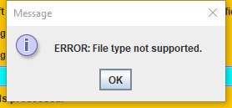

**Figure 2. ERROR: File Type Not Supported**

### 4.5.2 Input File Not Found

If the user does not select an input file, TextFormatter disables the *Format File* button. However, if the file is deleted or moved to other locations after the user selects the input file but before pressing the button, the system is unable to find the input file, then it will raise an error with message “ERROR: Input file not found”.

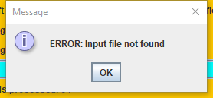

**Figure 3. ERROR: Input File Not Found**

### 4.5.3 Cannot Overwrite the Input File

TextFormatter requires the file path of input file and output file to be different. If the user choose the output file to be the same as input file, TextFormatter will fail to deliver its functionality. If the above situation occurs, TextFormatter will raise an error with message “ERROR: Cannot overwrite the input file”.

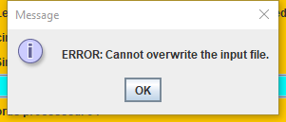

**Figure 4. ERROR: Cannot Overwrite the Input File**

### 4.5.4 Permission Denied

TextFormatter requires certain permissions of the input file (read) and output file (write). If the required permission is not granted, TextFormatter will raise an error with message “ERROR: Permission denied”.

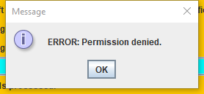

**Figure 5. ERROR: Permission Denied**

### 4.5.5 Line Length Not Specified

TextFormatter asks the user to set their own preferred line length. It does not support formatting a text file without user-defined line length. If the user does not set their preferred line length, TextFormatter will raise an error with message “ERROR: Line length not specified”.

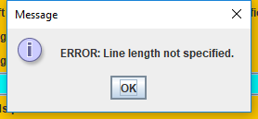

**Figure 6. ERROR: Line Length Not Specified**

### 4.5.6 Line Length Must Be An Integer

TextFormatter asks the user to set their own preferred line length. Intuitively, line length must be an integer. If the user-defined line length is not an integer, TextFormatter will raise an error with message “ERROR: Line length must be an integer”.

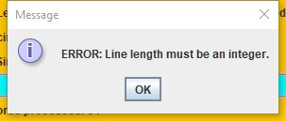

**Figure 7. ERROR: Line Length Must Be An Integer**

### 4.5.7 Error Uploading File

During uploading the file, system failures or other problems may occur. And file uploading may not be successful. If the above situation occurs, TextFormatter will raise an error with message “ERROR: Error uploading file, please try again”.

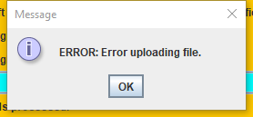

**Figure 2. ERROR: Error Uploading File**

## 4.6 Other Problems

### 4.6.1 Operating System Compatibility

TextFormatter is a Java program. In most cases, the program is able to run on any types of operating systems that support Java, which includes Windows, Mac OS X, UNIX, Linux, etc. However, if there is an operating system that do not supports Java, TextFormatter may not be able to run. To avoid this problem, please make sure your operating system supports Java before you download and install TextFormatter.

### 4.6.2 No Enough Space to Install

TextFormatter does not require much space for the user to install. But there could be a chance that the user does not have enough space to install the program. To avoid this problem, please make sure your disk has enough space to download and install TextFormatter.

**APPENDIX**

# SAMPLE INPUT AND OUTPUT FILES

Here we provide the screenshots of sample input and output that mentioned in Section 4. The preferred line length is set to be 80. However, the user can choose their own preferred line length in TextFormatter.

## A.1 A Text file with All Characters in One Line

### A.1.1 Left Justified

Below are the sample input and output files in left justified format.



**Figure 2. Sample Input File**

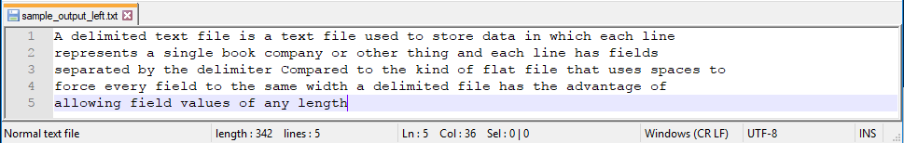

**Figure 3. Sample Output File in Single Space**

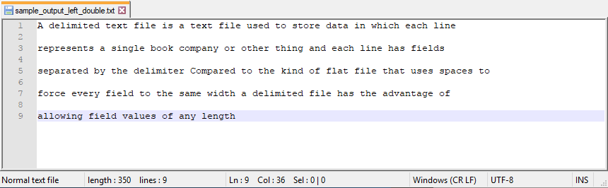

**Figure 4. Sample Output File in Double Space**

### A.1.2 Right Justified

Below are the sample input and output files in right justified format.



**Figure 5. Sample Input File**

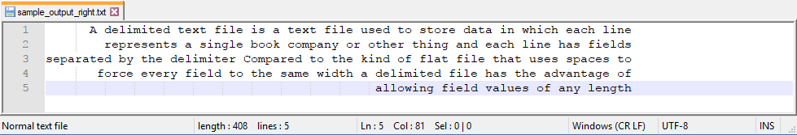 **Figure 6. Sample Output File in Single Space**

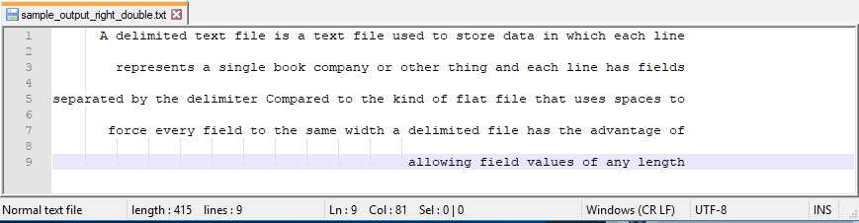 **Figure 7. Sample Output File in Double Space**

### A.1.3 Full Justified

Below are the sample input and output files in right justified format.



**Figure 8. Sample Input File**

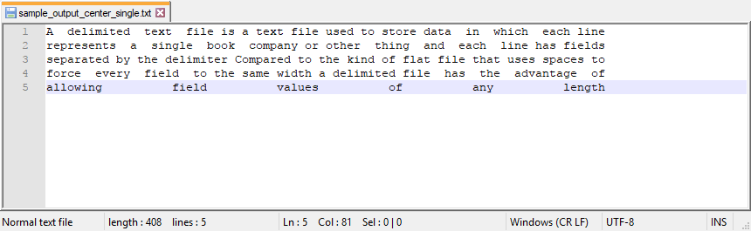 **Figure 9. Sample Output File in Single Space**

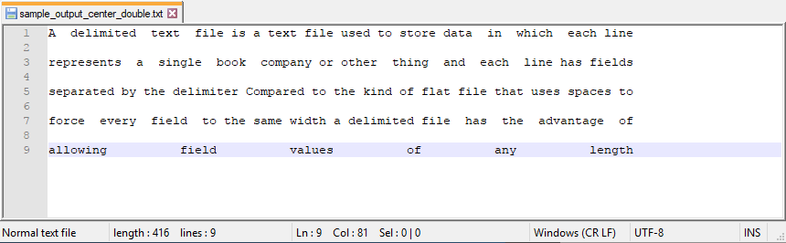 **Figure 10. Sample Output File in Double Space**

## A.2 A Text file with Different Number of Character in Lines

### A.2.1 Left Justified

Below are the sample input and output files in left justified format.

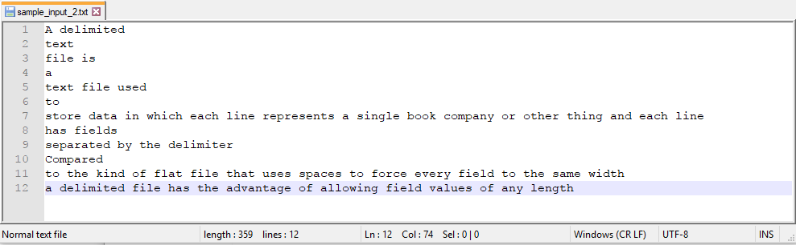

**Figure 11. Sample Input File**

 **Figure 12. Sample Output File in Single Space**

 **Figure 13. Sample Output File in Double Space**

### A.2.2 Right Justified

Below are the sample input and output files in right justified format.



**Figure 14. Sample Input File**

 **Figure 15. Sample Output File in Single Space**

** Figure 16. Sample Output File in Double Space**

### A.2.3 Full Justified

Below are the sample input and output files in right justified format.



**Figure 17. Sample Input File**

 **Figure 18. Sample Output File in Single Space**

 **Figure 19. Sample Output File in Double Space**

## A.3 A Text file with Blank Lines and Tabs

### A.3.1 Left Justified

Below are the sample input and output files in left justified format.

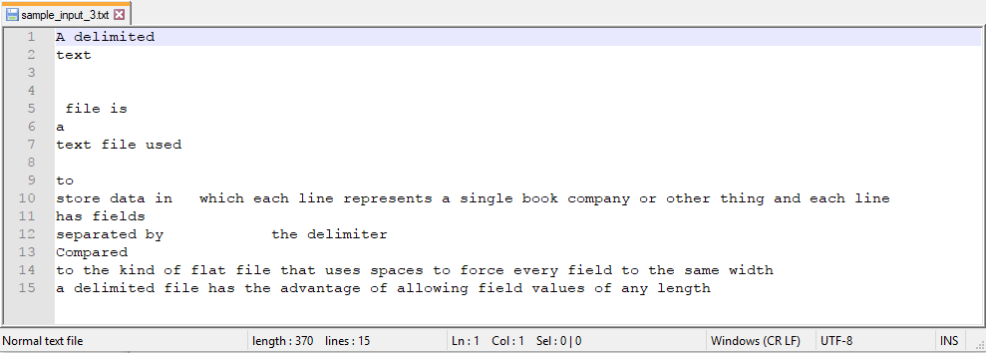

**Figure 20. Sample Input File**

**Figure 21. Sample Output File in Single Space**

**Figure 22. Sample Output File in Double Space**

### A.3.2 Right Justified

Below are the sample input and output files in right justified format.



**Figure 23. Sample Input File**

**Figure 24. Sample Output File in Single Space**

**Figure 25. Sample Output File in Double Space**

### A.3.3 Full Justified

Below are the sample input and output files in right justified format.



**Figure 26. Sample Input File**

 **Figure 27. Sample Output File in Single Space**

 **Figure 28. Sample Output File in Double Space**

## A.4 A Text file with Words Longer Than 80 Characters

### A.4.1 Left Justified

Below are the sample input and output files in left justified format.

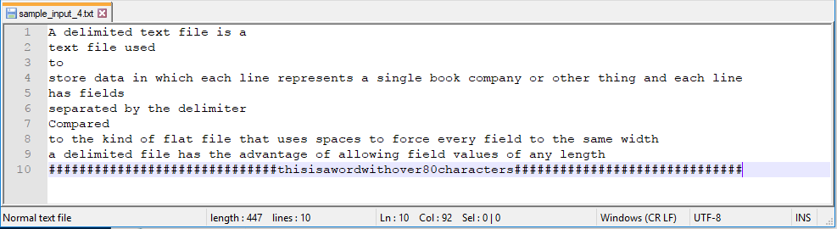

**Figure 29. Sample Input File**

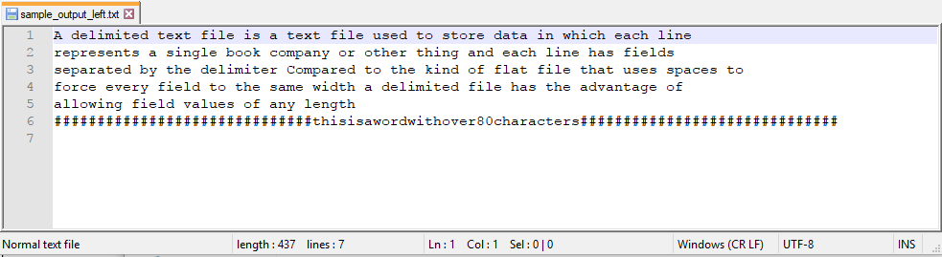**Figure 30. Sample Output File in Single Space**

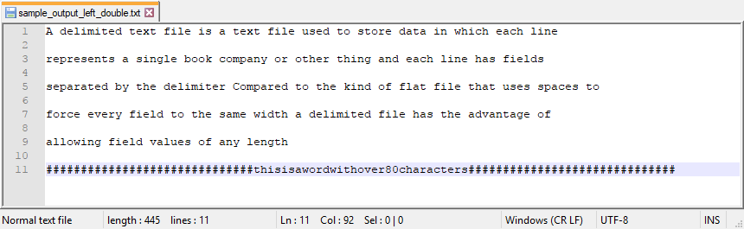**Figure 31. Sample Output File in Double Space**

### A.4.2 Right Justified

Below are the sample input and output files in right justified format.



**Figure 32. Sample Input File**

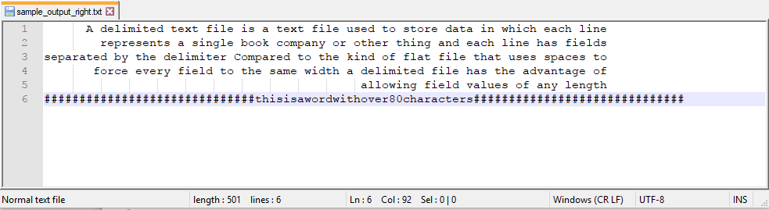 **Figure 33. Sample Output File in Single Space**

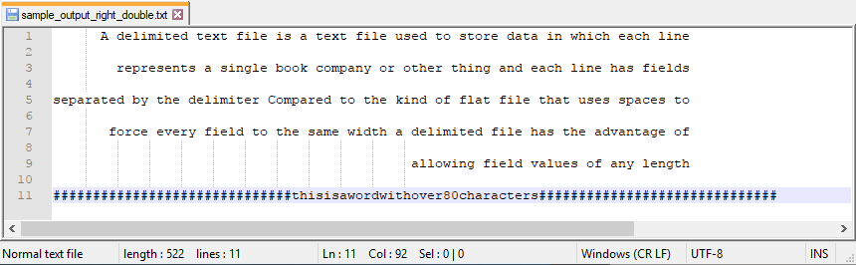 **Figure 34. Sample Output File in Double Space**

### A.4.3 Full Justified

Below are the sample input and output files in right justified format.



**Figure 35. Sample Input File**

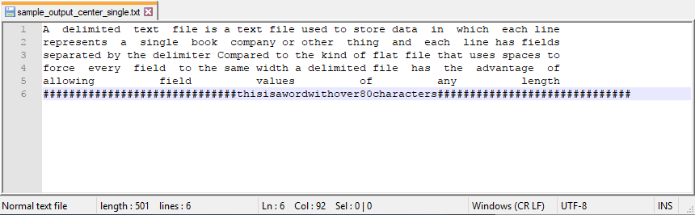 **Figure 36. Sample Output File in Single Space**

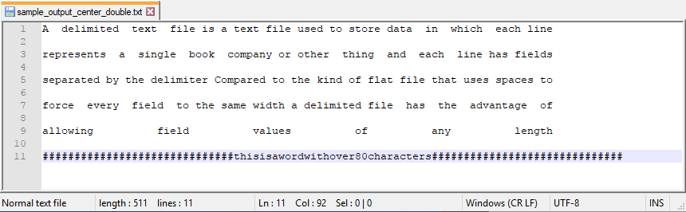 **Figure 37. Sample Output File in Double Space**

# GLOSSARY

**TextFormatter**: a system, which allows the user to format a text file (.txt extension).

**Left justify**: text is aligned along the left margin of the file.

**Right justify**: text is aligned along the right margin of the file.

**Full justify**: text is aligned along both the left and right margin of the file.

**File path**: the general form of the name of a file or directory that specifies a unique location in a file system.

**Desktop application**: an application that runs stand-alone in a desktop or laptop computer.

**Operating system compatibility**: the ability that a particular software runs on different types of operating systems without having to be altered to do so.