1. Reservations Shift=If(Not(IsNull([Cutoff Time]));If(ToNumber(FormatDate([Cutoff Time];"HH"))<=20;"AM";"PM"))
2. =[Number Of Reservations Future]/[DW Timeslot Availability].[Number Of Customers]
3. =[Number Of Orders Future]/[DW Timeslot Availability].[Number Of Customers]
4. =[Number Of Bounce]/[DW Timeslot Availability].[Number Of Customers]
5. Delivery Days Back=DaysBetween(CurrentDate();[Requested Date])
6. For Merchandising University, under Order folder there is a reservation;

* Status Code 15=Canceled; 10= Confirmed; 20=Dropped
* Type STD;OTR;WRR

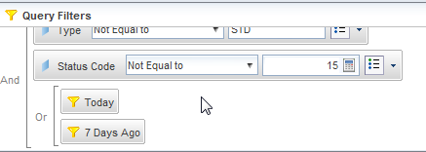

1. <http://home.freshdirect.com/confluence/display/DW/i.+FormatDate> and FormatDate(date;format_string)

=FormatDate([Timeslot Start Datetime];"HH:mm a")+" - "+FormatDate([Timeslot End Datetime];"HH:mm a")

1. Number of Truck=Count([Route Number]+[Requested Date])
2. SOH=DW Capacity Aggregate.Num SOH All Reservations
3. Number of Capacity Bounce= [Number Of Bounce Type 4]
4. % Utilization= =[DW Sales].[Number Of Orders]/[DW Capacity Aggregate].[Capacity Total]
5. Day Part

=[Requested Date] Where ([Delivery Days Back]=-7)

=Count([Reservation Id]) Where ([Status Code Description]="DROPPED" And [Delivery Days Back]=-7)